**Hoseholdingduties**

**Мета уроку:**

**1 розширити словниковий запас учнів за темою «Hoseholdingduties», тренувати учнів вести діалог та полілог у межах вивчених лексичних та граматичних тем;**

**2 розвивати навички критичного читання; розвивати вміння відстоювати свою точку зору;**

**3 навчити учнів складати ChoresChart; формувати шанобливе ставлення до виконання.**

**Перебіг уроку**

**1.Привітання та оголошення теми уроку.**

**Good morning dear pupils. I’m glad to see all of you here and today we are going to have a very interesting lesson. At the lesson we’ll discuss a very important problem. Look at the picture and try to tell me the topic of the lesson.**

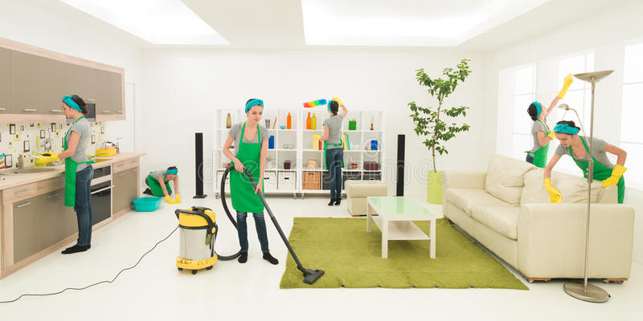

**2. *Стадія виклику***

**Warming-up. Сніговий ком.**

**My dear children can you tell me what is this lady doing?**

**Відповіді учнів**

**This woman is vacuuming.**

**This woman is vacuuming and doing washing up.**

**This woman is vacuuming, doing washing up and washing the floor.**

**…**

**This woman is vacuuming, doing washing-up, washing the floor, dusting, washing the windows and cleaning the furniture.**

**3.Making graphs**

**Do you like this picture?**

**If yes put you piece of paper with your name to the first part of the board and if have the different opinion put it on the second half. Give your comments.**

**4.Діскусія**

Do the women have more responsibilities about the house than men ?

**What other chores can people do? Brainstorming.**

Cleaning a room

Making a bed

picking up / putting away / hanging up some clothes

washing the dishes

washing the car

mowing the lawn / cutting the grass

picking up some toys

pulling weeds

vacuuming

repairing the computer

milking a cow

preparing / cooking dinner

setting the table

clearing the table

washing the dishes

cleaning out the fridge or freezer

cleaning the shower or tub

disinfecting the toilet

doing the laundry

washing the clothes

drying the clothes

putting away the clothes

mobbing the floors

raking the leaves in fall

**What do the men usually do ?**

**How often do your fathers cook? do the dishes? do the laundry?**

**What can make your mom happy?**

**What can you do to help your parents about the house?**

**Should your parents pay money to you for doing chores?**

***Стадія осмислення. Читання з маркуванням.***

**Знаки маркування**

***«V»-знаю***

***«-»- не знав***

***«!»-цікаво***

In many countries, children are required to do chores around the house. Chores can be defined as little jobs you do around the house to help [keep everything clean](https://www.thoughtco.com/multiple-choice-questions-cleaning-staff-1211317) and orderly.

Helping at home is a universal thing. (However much my own kids wish it weren’t!)Every family is different, and every child helps in their own way. But, working together to keep our homes happy and healthy (aka: chores) is one important thing we all have in common.Here are some of the things that One Globe Kids do to help at home.

In Haiti, Valdo washes his own school uniform by hand, helps sweep the porch, and pounds spices for his mother.

In Burundi, Jenissa helps feed and entertain her baby sister.

Both Floor and Lars in The Netherlands help with grocery shopping and making dinner.

In the United States, many parents ask their children to do chores in order to earn an allowance.

An allowance is an amount of money paid on a weekly, or monthly basis. Allowances allow children to have some pocket money to spend as they see fit. This can help them learn to manage their own money, as well as help them become more independent as they grow up.

**Обговорення прочитаного.**

**What information has been familiar to you?**

**What part is the most interesting?Shoсking?**

***3 Cтадія осмислення***

Учням пропонуються заповнити таблицю. Умовно пропоную позначити виконавців справ:

М-mommy

D-daddy

I-it’s me

B-brother

S-sister

Зразок таблиці додається.

Презентація окремих робіт

Рефлексія учбової діяльності

Метод незакінчених речень

• I thinkthatthelessonwas (interesting/ useful/boring/exciting)

• Myfavouriteactivitywas (reading/discussingproblems/fillingthechart/presentation/describingthepicture)

• Theeasiestpartofthelessonwas …

• Themostdifficultpartwas …

• Thepupilofthelessonis … because…

Вчитель виставляє оцінки та **дає домашнє завдання**: зробити у групах проект

**«I amthebiggesthelpfulhand»**. Можна застосовувати фото, відео, малюнки, інтерв’ю та інші

матеріали.

***Таблиця для заповнення***

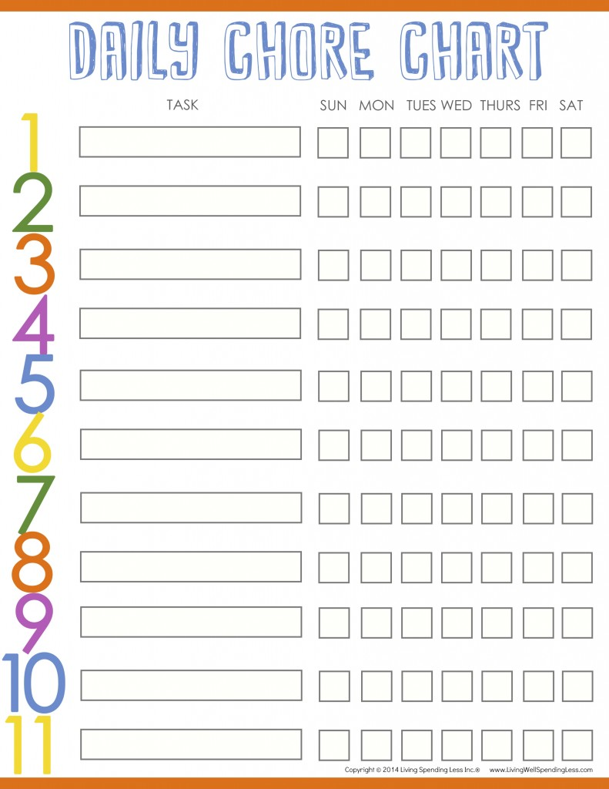

**Література**

Технологіїрозвитку критичного мисленняучнів / Кроуфорд А., Саул В., Метьюз С., Макінстер Д.; Наук.ред., передм. О. І. Пометун. — К.: Видво «Плеяди», 2006.. <https://osvita.ua/doc/files/news/487/48780/KritichneView.pdf>

Супрун А.В.Критичне мислення на уроках історії/ Режим доступу. <http://klasnaocinka.com.ua/uk/article/kritichne-mislennya-na-urokakh-istoriyi.html>

<http://blog.oneglobekids.com/chores-around-the-globe/>

<http://daphnedel.com/blank-calendar-for-kids/>