**Виховний захід**

**з англійської мови**

**на тему :**

**“ Любіть Україну”**

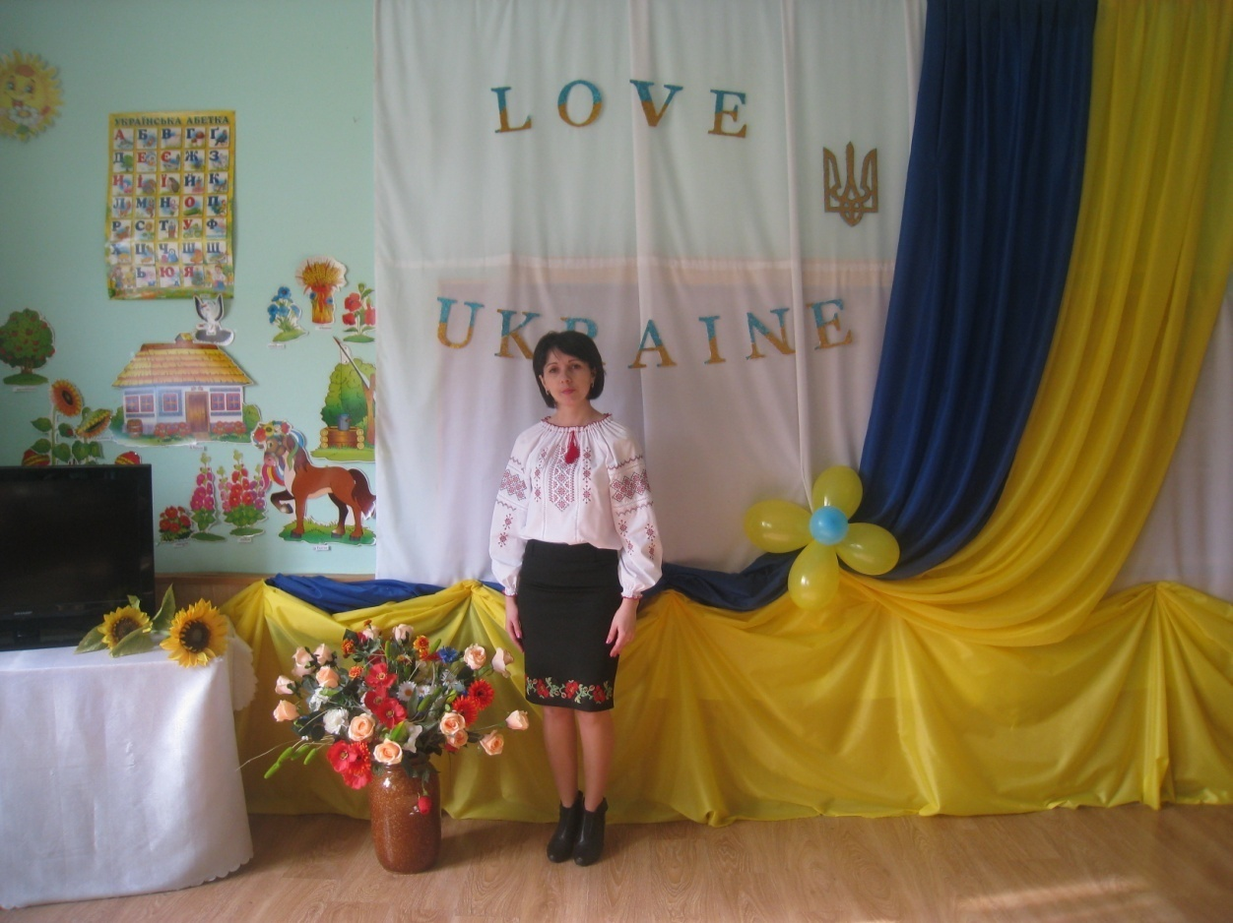

**Підготувала вчитель англійської мови**

**Бичківської ЗОШ I-IIступенів**

**Сорокопуд Наталія Ігорівна**

**2016р.**

**Мета заходу: -**розширити знання про Україну, як незалежну державу з давньою славетною історією, багатою культурною спадщиною, власними традиціями;

-розвивати у дітей прагнення бути свідомим громадянином України, її патріотом;

-формувати переконання у нетлінності духовних скарбів народу, повагу до символів України, до своїх батьків;

-спонукати учнів до усвідомлення ними необхідності бути корисними своїй державі;

- виховувати в учнів почуття патріотизму, національної гордості, любові до рідного краю.

##### Обладання: святково прибраний клас, символи України; мультимедійні презентації, фонограми українських пісень; колосся і калина; телевізор, ноутбук .

**Девіз заходу: *Любіть Україну, як сонце, любіть.***

**“ LOVE UKRAINE ”**

-Dear guests, colleagues, pupils and parents!

-Today we all gathered in this beautiful hall to prove to everyone again and ourselves that Ukraine is rich in beautiful songs, music, arts, and monuments of the past ….

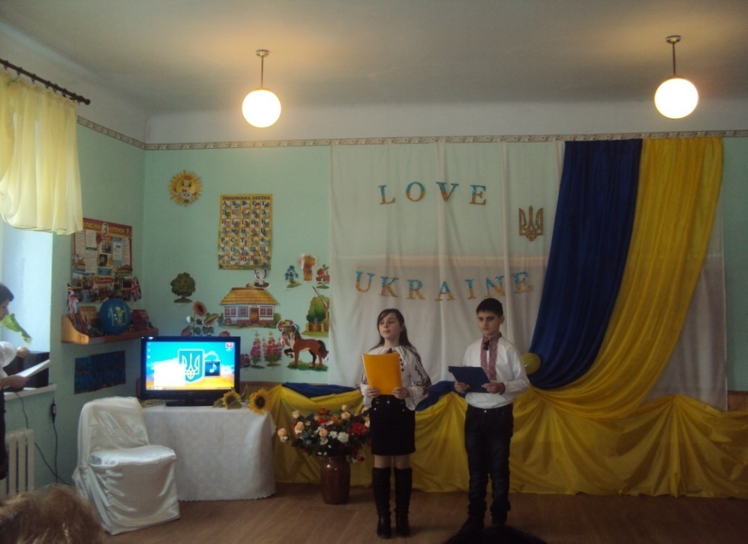

***Ukraine***

My dear friend,

I’d like to speak of land!

In which you must defend

The slightest bend,

Where spreading is the steppe,

Where’s done the first your step,

Where mother’s shortest nap

Was broken by your joyful clap.

We are sure all people of Ukraine

Want to live and not to die.

They want to laugh and not to cry!

They want to feel the summer sun.

They want to sing when the life is fun!

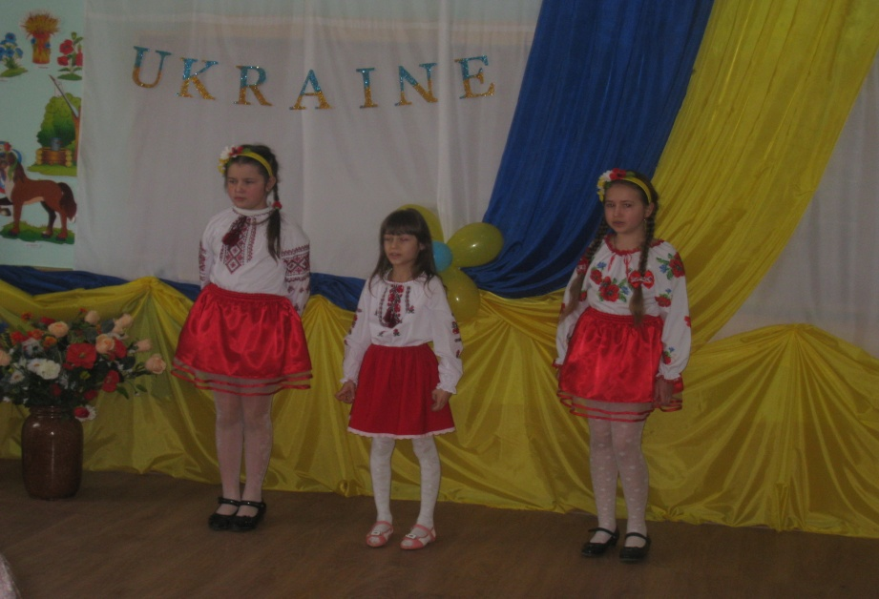

-Ukraine…Native land. Golden magic side.

-How gentle, meek people come up with words to express my warm love for the land where they were born and live.

- Boundless steppes, thick forests, towering mountains, warm and caressing seas, wide rivers, numerous nature preserves, parks, exotically rich museum collections, historical and cultural landmarks.

- This is our Ukraine, our Motherland, our native land, our only land.

- And now, we’ll show you some information about our native land.

***Video about Ukraine***

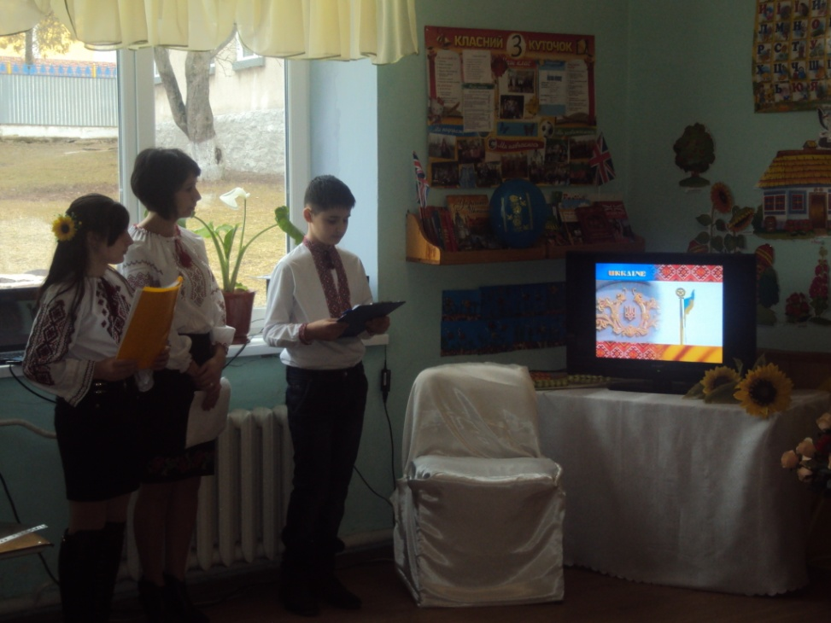

“Love Ukraine, like sun that you love

Like wind, like grass, and like water,

Whenever you're happy, in moments of gladness,

At times of trouble, do love.

Love Ukraine when asleep or awake

The glamorous your Ukraine

The beauty of it, always alive and new

And language of hers full of charm.

Amongst the brother-made nations, like garden in dew

She shines through the ages again

Love Ukraine with all of your heart

And all of the deeds that you make...”

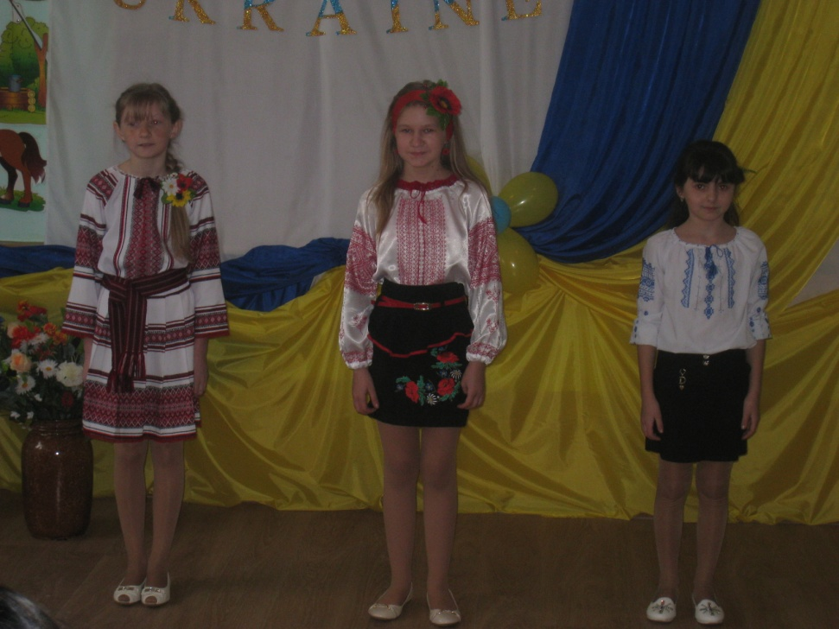

- Ukrainian songs have been existing from ancient times.

-We, Ukrainians are the most melodious people.

***Legend of girl Ukraine, who was endowed a song by God***

-According to the legend, once God decided to give the children of the talents: Frenchmen chose elegance and beauty, Hungarian – love to the management; German – discipline and order, exactness and punctuality; Russian – imperiosness, Poles – a capacity for trade; the Italians got talent for music.

Giving everyone the Lord rose from a throne and suddenly saw a girl in a corner. She was dressed in an embroidered shirt, a blond braid intertwined a blue ribbon and a crown of purple snowball was on her head.

-Why are you crying? – asked God.

-I’m Ukraine and I’m crying because my land has been moaning of the spilled blood, of fires… My sons are in exile land. The enemies mock above widows and orphans, there is no truth and freedom in our homes.

-Why didn’t you come to me before? I have already given all the talents. How can I help your grief?

She wanted have to go, but the Lord God, raising his hand, stopped her:

-I have a priceless treasure that will glorify you and your people on the whole world. It is a song.

A girl Ukraine took the gift and firmly pressed to her heart. She bowed and with a clear face and faith sang the song.

Since then the Ukrainian people enjoy songs wherever they are.

They say that a Ukrainian sings whole year and the whole age. So the song is really a gift from God. Ukraine is the only state in the world that has such a rich heritage of songs.

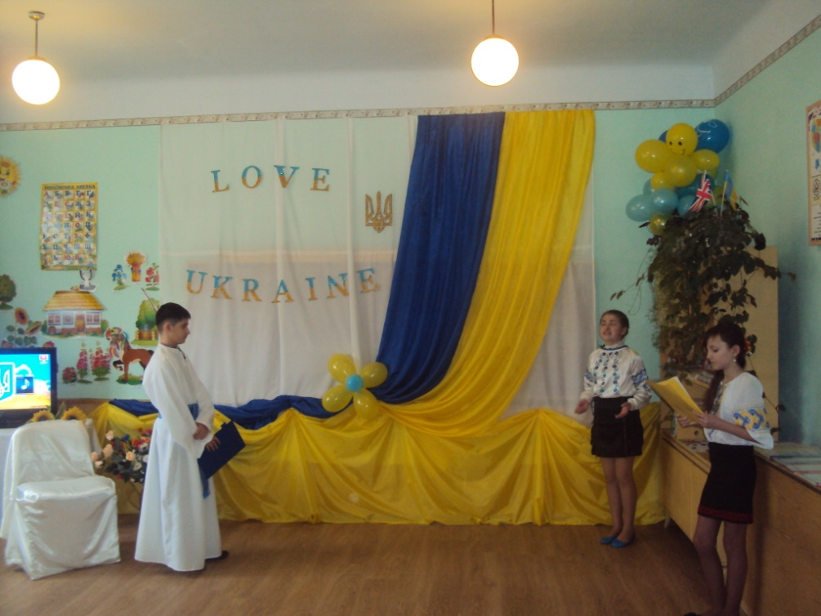

My land is beautiful and free

Ukraine, Ukraine.

The dearest land

a man can see!

When down the Dnieper I go boating

and birds are flying high above

I hear a song , and it is flowing

to those green trees, the land I love.

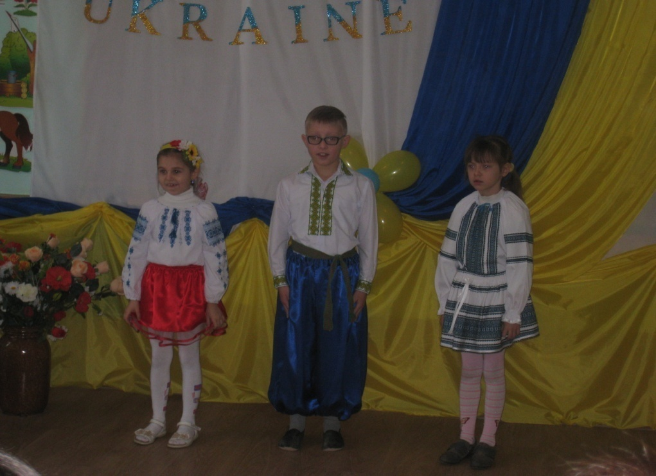

**Bird Cherries**

1.In a grove a nightingale keeps trilling   
And the loft with swallow tweets is ringing   
This boy's tending sheep up in the meadows   
Where the mountain tops cast misty shadows  
  
 Everywhere bird cherries sweetly blooming  
 Like a bride a girl is shyly grooming  
 In anticipation   
 She's a bit impatient   
 Waiting for that boy  
  
2.Every day she marvels at the mountains  
What a scene! Breathtaking and astounding!  
On the birches dew drops come to glisten  
Of bright, shiny stars so reminiscent  
  
 Everywhere bird cherries sweetly blooming  
 Like a bride a girl is shyly grooming  
 In anticipation   
 She's a bit impatient   
 Waiting for that boy  
  
3.When the mountain peaks begin to shadow   
Grassy pastures of the lofty meadows   
She can hear him sing "I am shortly coming  
Down to meet you there, oh, my sweet darling"  
  
 Everywhere bird cherries sweetly blooming  
 Like a bride a girl is shyly grooming  
 In anticipation   
 She's a bit impatient   
 Waiting for that boy

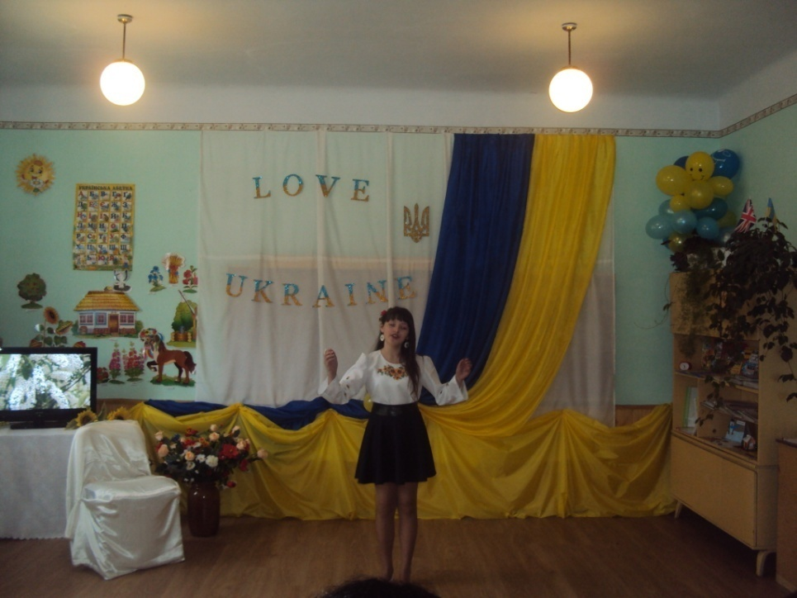

***Poems about Ukraine***

Blue sky and yellow field of grain

Is on the flag of my Ukraine.

Its emblem speaks to all the world

With freedom – such a lovely word.

Bread-salt will give to a friendly guest

Ukrainian people without request.

They work and sing the song of praise

To God who’s able from ash to raise.

Ukraine rejoices in the Lord

Reviving from His mighty Word

Forever lives who’s born again.

Long live and pray, my land Ukraine!

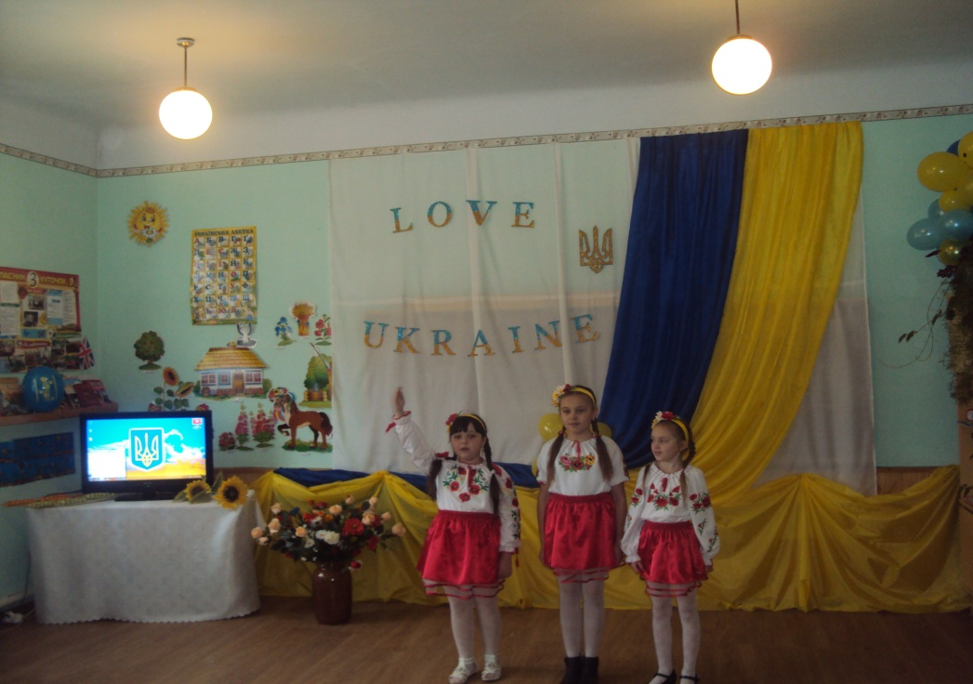

-Music for Ukrainians has always been a natural expression of feelings and emotions.

-The traditions of the Ukrainian folk music have a long history.

-Many folk songs have been transferred from generation to generation and some of them are so old that nobody even remembers who created them.

-Ukrainian folk songs were not created by someone’s order, but they existed as the internal human desire to express their feelings and share experiences with others.

-“Pidmanyla Pidvela ” is a popular humorous Ukrainian folk song.There are many different variations of the song, but all have pretty much the same format.

-Traditionally, it is about a man complaining to his girlfriend because she tells him she will meet him somewhere on each day of the week. Each day, the person shows up and her girlfriend does not.

**“*Pidmanyla Pidvela ”***

1.You have told me that on Monday  
We'll gather periwinkles together  
I've come, and there you aren't,  
You tricked me and let me down  
 Chorus:  
 You tricked me,  
 You let me down,  
 You're making me, a young man,  
 Lose my mind.  
2.You have told me that on Tuesday  
You will kiss me forty times  
I've come, and there you aren't,  
You tricked me and let me down  
 (chorus)  
3.You have told me that on Wednesday  
We'll wrangle up the cattle together  
I've come, and there you aren't,  
You tricked me and let me down  
 (chorus)  
4.You have told me that on Thursday  
We'll go to the concert together  
I've come, and there you aren't,  
You tricked me and let me down  
 (chorus)  
5.You have told me that on Friday  
We'll gather strawberries together  
I've come, and there you aren't,  
You tricked me and let me down  
 (chorus)  
6.You have told me that on Saturday  
We'll go to work together  
I've come, and there you aren't,  
You tricked me and let me down  
 (chorus)

7.You have told me that on Sunday  
We'll go to the wedding together  
I've come, and there you aren't,  
You tricked me and let me down  
 (chorus

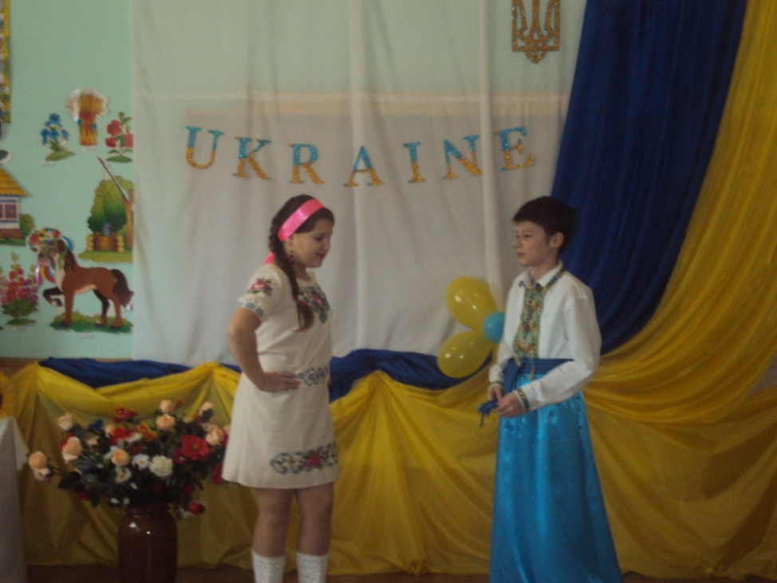

1.I love your towns, stars and blue sky…

My dear land, both in joy and grief.

I go with you to the top of life

How happy I am to be your son.

2.Native land of mine!

My mind is brighter,

Tenderness and love

In my soul grow.

3.When your mighty hopes

And dreams uplifting

In my life here strong

And steady flow.

4.You are bread for me,

My aim for living

From your soul I came

And shall return.

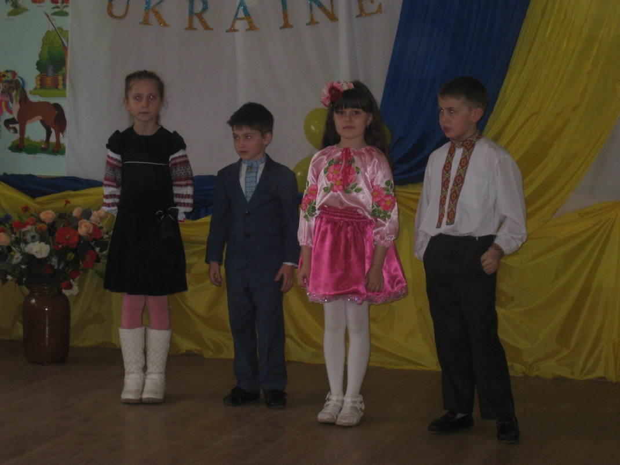

-They say if a person is talented it’s talented in everything.

-Ukrainians are well-known throughout the words for their numerous talents.

-Ukrainian dance music and dance itself are considered to be entertaining; fast-paced and energetic.

-These characteristics are bright and vivid example of the whole Ukrainian culture in general that is easily recognized, highly honored and appreciated all over the world.

-The most popular dances of that time were kozachok and hopak which are still extremely popular and actual through out the world.

-And today we want to present you one of the Ukrainian folk dance – hopak.

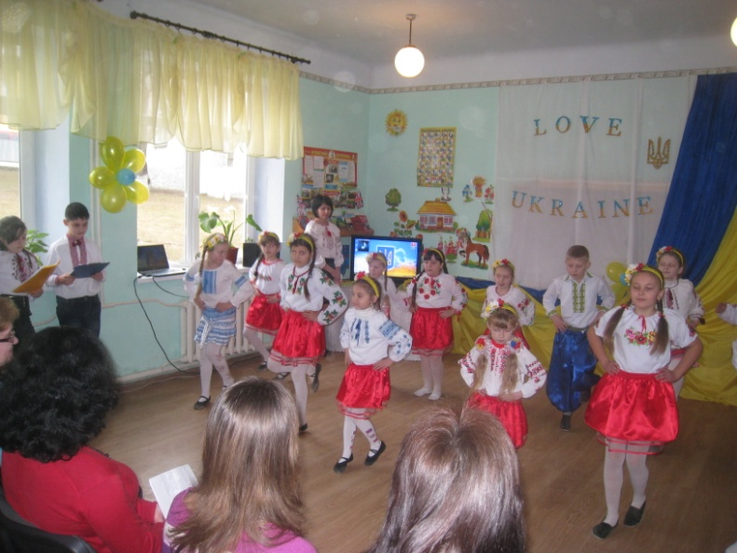***Ukrainian folk dance – hopak***

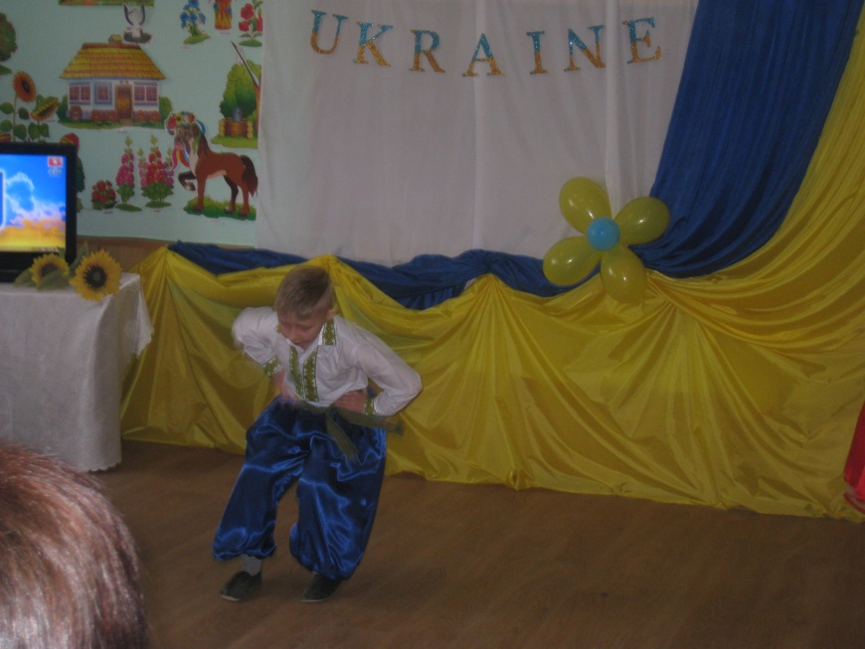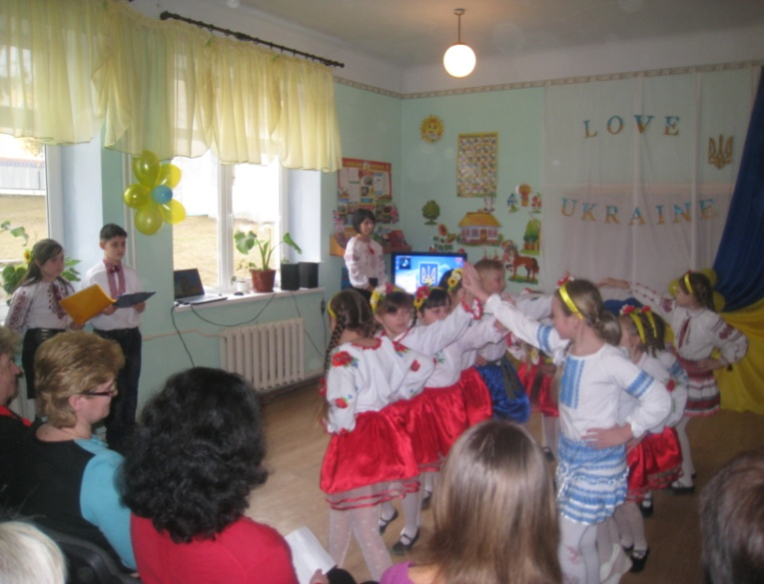

The land of spring flowers garlands

And fall fruit wreaths

Had to fight hard for its rights,

For fresh, pure air to breath.

-We can’t not forget about the events that happened two years ago in February at Independence Square.

-The Square became a symbol of struggle, a symbol of dignity ; a symbol of aspiration to the European values.

-And for our freedom and the justice is being paid a terrible price: of our compatriot gave their lives for our native country.

-And most of them – young, strong…Those who only began to live.

-To all heroes who stood as a live wall protected from snipers bullets only by sheets of plywood, and who saved the honour and dignity of the Ukrainian nation….

Ukraine, the native land of mine

You suffered much. You’ve lost the sons of thine.

But you managed to become free again

And stayed young through fights and pain.

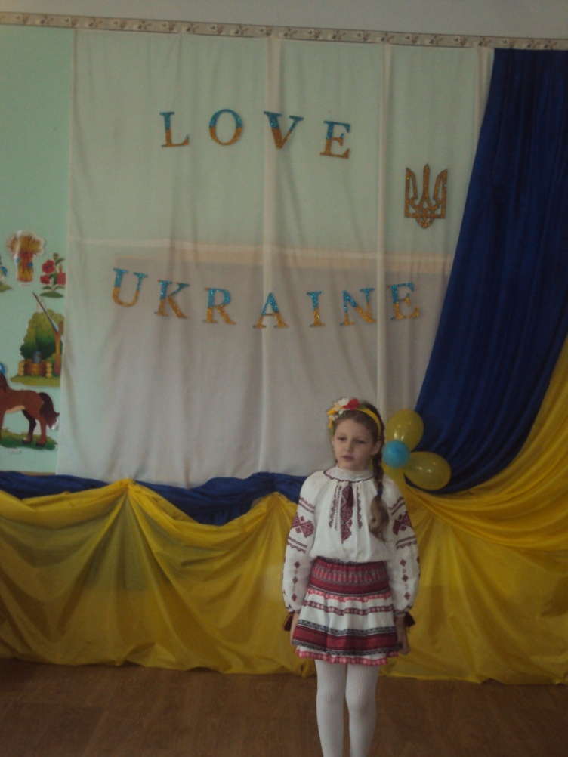

- Ukraine is my home so I'll stay here forever I'm with you I love you mama…

***“Mama don’t cry”***

1.mama don't cry i will comeback in springtime

just like the rain falls over the ground

will come in the morning with pearls in the sunshine

and fly like a bird in to your arms

mama forgive me for all that you feel now

for being alone everyday every night

Ukraine is my home so i'll stay here forever

i'm with you i love you mama don't cry

2.my darling don't cry no more tears no more sorrow

it feels very cold in my new home to night

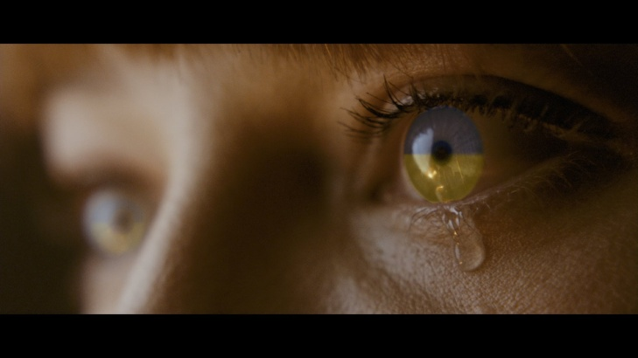i'll stay in your dreams you are not on your own now

so please keep me close i don't say goodbye

3.I hear lullaby that my angels are singing

no pain i can feel no more tears to cry

i miss you so much mama now i can feel it

i can't keep it strong it's just aching inside

- Today let  remember those, who left us with a moment of silence.

***The moment of silence***

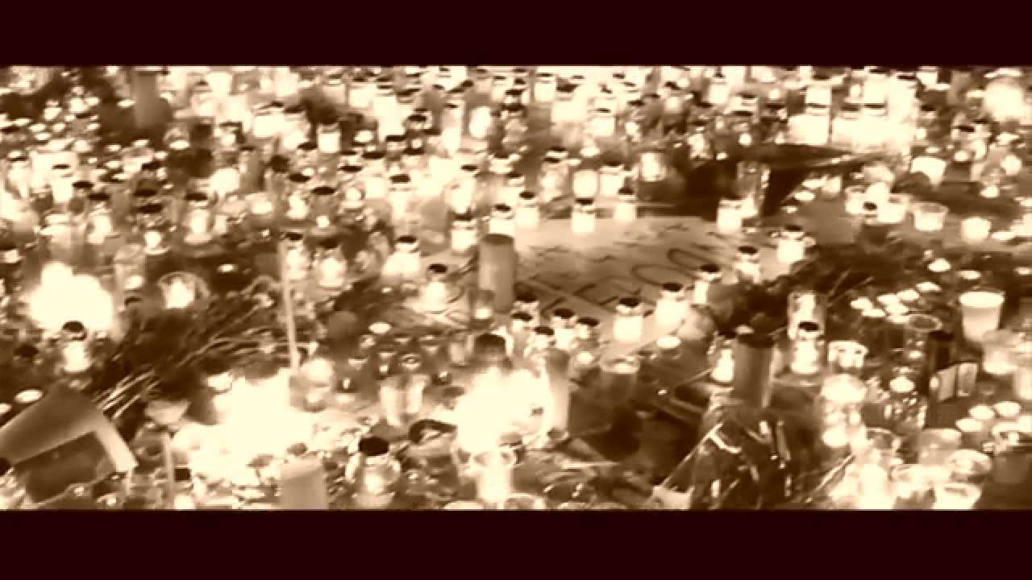

*-* This is our Ukraine, our Motherland, our native land, our only land.

- We have the only land for all of us, the only sun and the only sky.

- Love Ukraine with all your heart, and with exultant faces let all your deeds her majesty

maintain.

Love your dear Motherland,

Love it with your whole heart.

Love Ukraine when the days are happy,

Love it when they are dark.

Cherish your mother tongue,

Cherish your family root.

Never stop thinking of your parents

And their life good.

Love your Ukraine, love as you would the sun,  
the wind, the grass and the streams together...  
love her in happy hours, when joys are won,  
and love her in time of stormy weather.

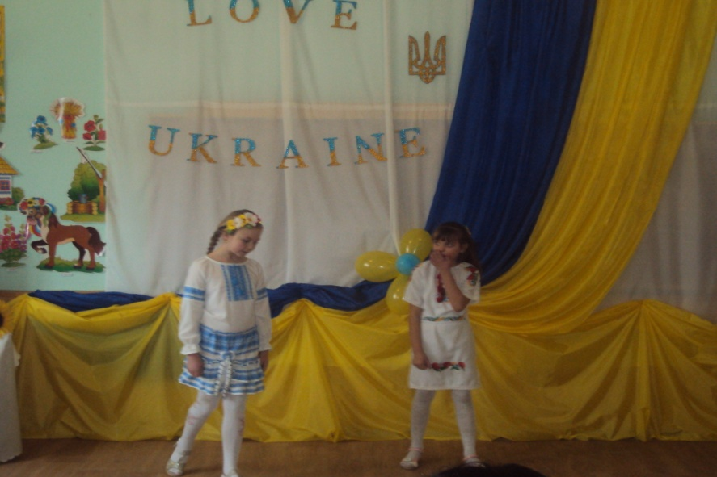

***Song “Ukraine”***

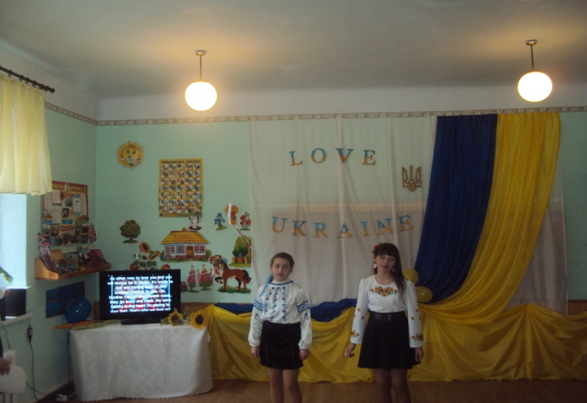1.I don’t know other road to go while

Milky way shines in the sky.

I’m happy and lucky to know

Your golden path in fields of rye.

There is no other way to love you

And you will always be in bloom

It’s worth to live and coming back to

My country I belong to you.

Oh, Ukraine, Oh Ukraine

Distant roads, they go away and meet

My son’s faithful loving heart

I’m placing to your feet.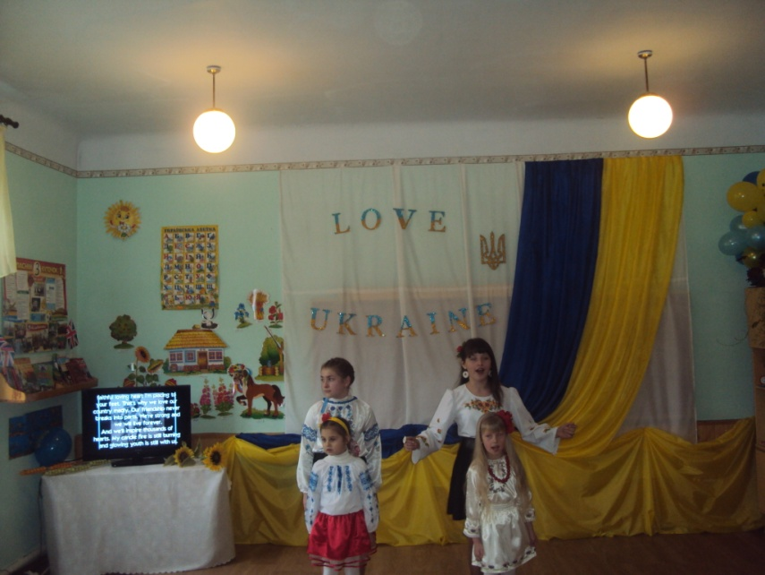

2.That’s why we love our country madly

Our friendship never breaks into parts

We’re strong and we will live forever

And we’ll inspire thousands of hearts.

My candle fire is still burning

And glowing youth is still with us

The acts were doing not for nothing

You’ll see the time and people will discuss.

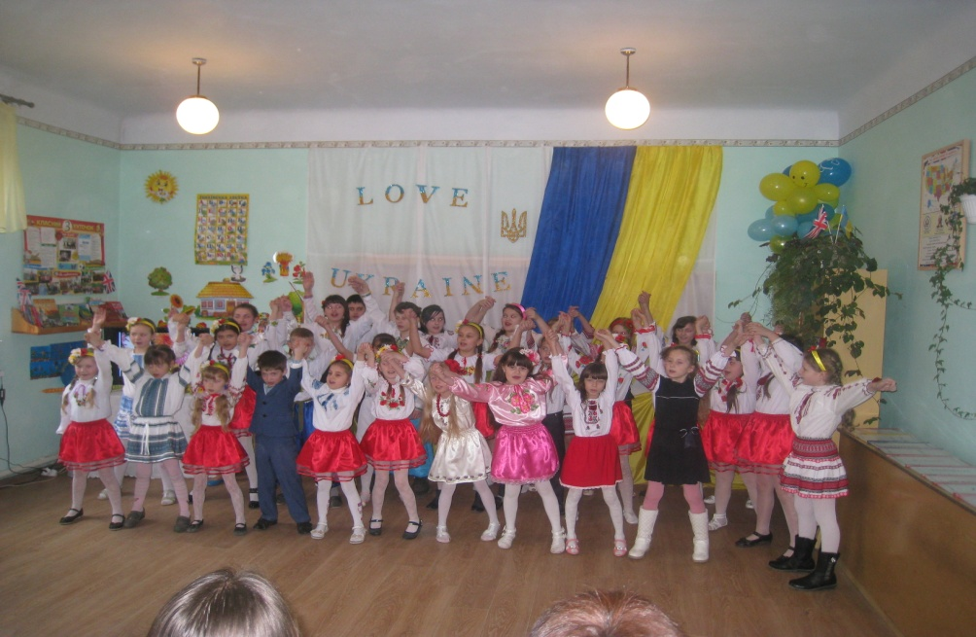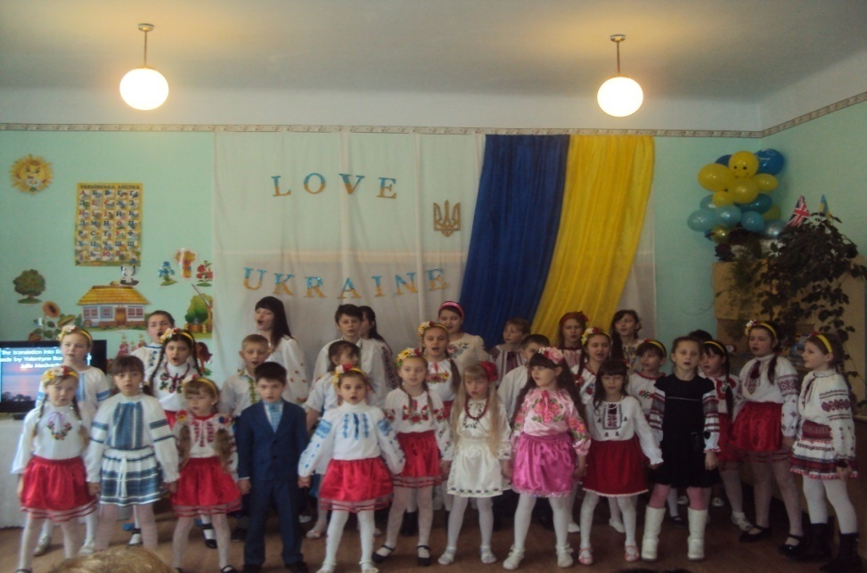

- We have always loved our Ukraine, we shall always love it. Let there always be peace and friendship on our land, in our Ukraine! Let us always be good friends and good neighbors in a village, in a town, in Ukraine in Europe and in the whole world!

