Комунальна установа «Навчально-виховний комплекс загальноосвітній навчальний заклад І-ІІІ ступеня – дошкільний навчальний заклад Миролюбівської сільської ради Нововоронцовського району, Херсонської області»

**Конспект урок з англійської мови**

**на тему**

**«Education in Ukraine, in the USA, in Great Britain»**

**10 клас**

*Підготувала: вчитель англійської мови Зайченко Світлана Костянтинівна*

2017р

***Theme: Education in Ukraine, in the USA, in Great Britain.***

***Objectives:***

To develop students communicative skills;

To develop a creative way of thinking;

To practice to work in groups;

To practice reading and speaking skills on the topic;

To help students be more aware of the school life in different countries;

To broaden students outlook;

To help to be more tolerant and understanding.

***Equipment***: posters, teachers and pupils presentations.

***Type:*** summarizing lesson

***Time***: 45 min.

Procedure

***1.Greeting and the Theme***

**T:** Good morning, pupils. Sit down please. Who is on duty today? Who is absent? What is the date today? We have unusual lesson. We revise all information about educational system of Great Britain, of the USA, and of Ukraine. Our task is to remember and to discuss all aspects of school education which are typical for Great Britain, the USA and our country and to find all advantages and disadvantages. We must to do different exercises. The topic of our lesson is “Education in Ukraine, Great Britain and the USA”.So let’s start.

***2. Warm-up***

**T:** First of all let’s make an association with words “school”

S-ubject

C-lass

H-omework,-olidays

bO-oks

lessO-ns

L-earn

**T:** Okey.Very good job. And now remember proverbs about education?

*Knowledge is power*

*Live and learn*

*To know everything is to know nothing*

*So many languages you know so many times you are a man*

*Soon learnt, soon forgotten.*

*It is never too late to learn.*

*By doing nothing we learn to do ill.*

*To teach one’s grandmother to suck eggs.*

*Who keeps company with the wolf will learn to howl.*

*A little learning is a dangerous thing.*

***3. Main part***

*Speaking:* **T:** In our time it is very important to be an education persone. To be sociable and tolerant, understanding and kind. To make friendship with other and to find an exit from difficult situations.Let’s start to speak about education in Great Britain. Some pupils have prepared the information and some table which are devoted to our lesson.

**P1:** All schools are mixed in Britain. There are state and private schools in Britain. Most of schools are state, where education is free. But there is private – where the education is very expensive and they are attended by about 7 % of the school population. The education in public school is of high quality, the discipline is very strict. Universities accept students with «A» level from 18. Higher education lasts for three or four years. The oldest and best-known universities are located in Oxford, Cambridge, London, Liverpool, Cardiff.

**P2:** Pupils in all schools have classes in the morning and after dinner. In the morning they have classes in main subjects and in the afternoon others. They have an hour break for lunch. The classes start at 9.00 a.m. They have uniform with the school badge bud not all. The secondary foreign language in most of English schools is French. Theirs marks from 1 to 10, at some schools from 1 to 100. Children study 13 subjects at the secondary school. Pupils take examinations at the age of 7,11,13,16. At the age of 16 pupils get General Certificate of Secondary Education. The school year divided into two terms in Britain. All schools have ten days holidays at Christmas, ten days at Easter and ten weeks in summer. English schoolchildren go to school six days a week.

|  |  |  |  |  |
| --- | --- | --- | --- | --- |
| Сума балів за поведінку | Оцінка по 4-х бальній системі | Зараховано | Оцінка | Градація |
| 90 - 100 | **5 (відмінно)**  **EXCELLENT** | **Зараховано** | **A** | **Відміно** |
| 85 -89 | **4 (добре)**  **GOOD** | **B** | **Дуже добре** |
| 75 - 84 | **C** | **Добре** |
| 70 -74 | **D** | **Задовільно** |
| 65 -69 | **3 (задовільно)**  **SATISFACTORY** |
| 60 -64 | **E** | **Погано** |
| НИЖЧЕ 60 | **2 (не задовільно)**  **BAD** | **Не зараховано** | **F** | **Не задовільно** |

**P3:** British education is unusual for us and has many different. Public (state) education – Pre-school, Primary (junior), Grammar, Middle, Secondary Modern and Comprehensive schools. Independent schools – Preparatory and Public schools. Pre-school education is provide in nursery schools and nursery classes for children from the age of 2 to 5 years. Primary schools consists of the *infant* and *junior* schools. At infant school children aged 5-7 in the form of games learn the 3R’s : Reading, Writing and Arithmetic. Children sit at the tables that are grouped into 6 to 8 places. Much of the time is devoted to playing, drawing, painting and music. They should count up 1000, use simple fractions, add, multiply and divider numbers. They must be able to use measures from rulers to computer software. Children learn basic electricity and physics. The Junior schools is for children aged 7 to 11. Most junior schools carry out a policy of streaming: A – for the cleverest, B – for the next in ability, and C – satisfactory. A typical classroom is divided into “areas” for different activities. The children can work alone or in groups under the guidance of the teacher. At the age of 11 passed the Eleven-Plus Examination of three papers: English, Arithmetic and Intelligence Test.

**P4:** **State Secondary schools** for children aged 11-16 fall into 4 main types: Secondary Modern, Grammar and Comprehensive (see the table). Grammar schools give the General Certification of Secondary Education (GCSE) of two levels O (Ordinary) and A (Advanced). Secondary Modern school concentrate on practical work. Boys are instructed in metal and woodwork, girls – in domestic science and cooking. The children leave this school at 15 with a certificate or Written Evidence of their studies. Comprehensive School provide secondary education for all children of the district irrespective of their intelligence. The comprehensive system aims to develop the gift of all children to the full. These schools are usually very large. At 14 children have to take an assessment test. At 16 they take exams for the GCSE (Maths, French and English) or the GNVQ (design, business and tourism). At the 18 pupils can take A – level examinations or AS – half of the content of A-level.

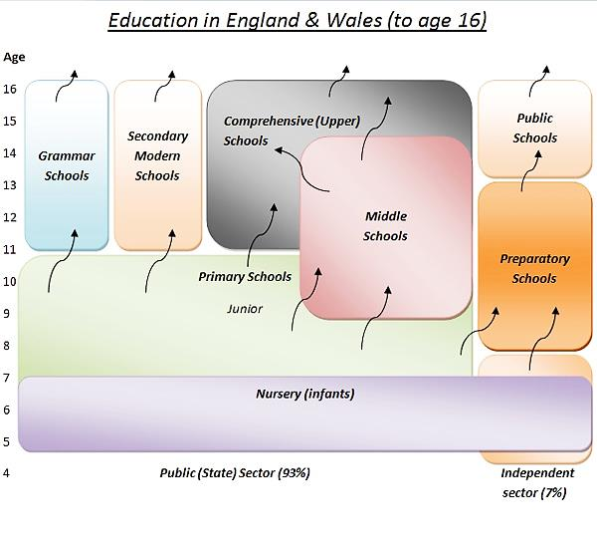

**P5:** **Independent schools** provide education of the grammar school type and are completely independent of local authorities. They include the preparatory schools and public schools for boys and girls over 13. Parents pay fees. Most of the schools are for boys. They live in separate houses. Much attention is paid to sport. Pupils of all ages take part in workplace activities and work-based projects. It gave the children experience of industry at first hand, and the school access to foreign language TV programmes to use in lesson.

T: So you have just listened to the information about the system of education in Great Britain. And now I may ask different questions all the members of the class and maybe to get to know more about schools and education in Great Britain.

* + How do you think, is it too difficult for small children to have the standard test at the age of 5-11?
  + What similar subjects with Ukrainian schoolchildren do English schoolchildren study?
* What is the Eleven Plus examination? ( It is an examination for children who are 11 years old or a little older (eleven plus some months) in English and Arithmetic. There is also intelligence testing. Each boy or girl was given a printed test paper: 100 questions and 5 answers to each question. The time was limited. All the examinations were in a written form).
* Are they punished for not doing their home task? (Yes, they are).
* Are there schools for boys only and for girls only? (Yes, there are).

T: Good! You are very attention and smart. Let’s listen to the information about Ukrainian schools. My pupils have prepared interesting information about the system of education in Ukraine.

**P1:** I would like to tell you that the system of education in Ukraine (let’s see the table). The system of secondary education in Ukraine includes primary forms and junior and senior secondary forms. Children usually go to school at the age of 6 or 7. There are some pre-school institutions, like nursery schools or kindergartens, but they are not obligatory. Primary forms comprise 1 to 4 forms. Junior secondary forms comprise 5 to 9 forms. After the 9th form children can enter technical schools of different types. Those who want to enter higher educational institutions should complete 10—11 forms. The system of higher education is presented by universities, polytechnic institutes or specialized institutes. Universities offer a five-year course of study and usually have from six to twelve departments.

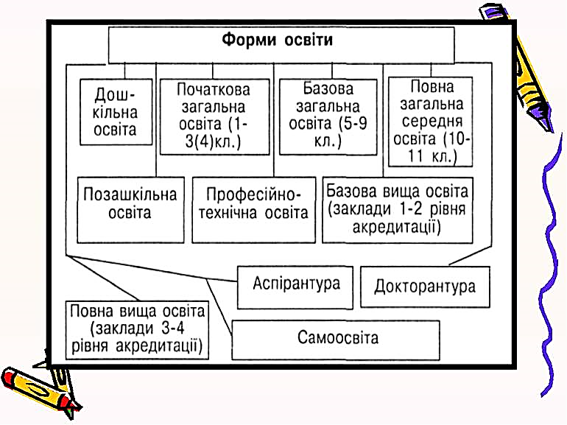

**P2:** There are state schools where education is free of charge and private primary and secondary schools where pupils have to pay for their studies. And of course there are schools only for girls or boys. Every school has a school curriculum. It includes: Ukrainian, Ukrainian Literature, Mathematics, Physics, Chemistry, Geography, World Literature and Foreign Language. Today we have a twelve mark system of appraisal of the pupil’s knowledge. We have five-days classes from Monday to Friday. Our classes begin at 8 or 8.30 a.m. Uniform isn’t obligatory , children can wear what they want to, but not in all schools. At the end of 9th grade we pass the State Final Examination and in 11th form – External Independent Evaluation (EIE).

***T:*** As you see the information about education in Ukraine was taken from different sources and it is rather new and interesting. So you may ask some questions about education in Ukraine.

* Is the twelve-mark system of appraisal of the student’s knowledge effective? (Yes, it is).
* Is it possible to have 10-15 pupils in Ukrainian state school in the nearest future? (Of course. Look at us! There are only 8 pupils in our class).
* Are Ukrainian schools provided enough with textbooks and modern equipment?

(It is difficult to answer correctly. From the one hand, we have got some textbooks, but from the other hand they are too difficult to the average student).

**T:**Thank you for your answers and listen the report about education in the USA.

**P1:** Education in the USA drastically differs from many other countries. There are 50 states in the country and each of them has its own peculiarities. Education in the USA comprises into three types of schools: public school, private elementary school and private secondary school. Only public schools are free and they have their own system in each state. Private schools require a certain fee. Elementary education from the age of six or seven. Children study at Elementary school till they are 16. After that, they can go to secondary school, which is also known as high school. The majority of American pupils continue their studies after school. Some go to the college, some to the university. Studying at college lasts for four years, and after that the student gets a Bachelor’s degree. Studying at university may take four or more years. After four years the students also get the Bachelor’s degree in Arts or Science. Some students, who wish to continue studying, go on for a Master’s degree. Studying at American colleges and universities requires certain tuition fees.

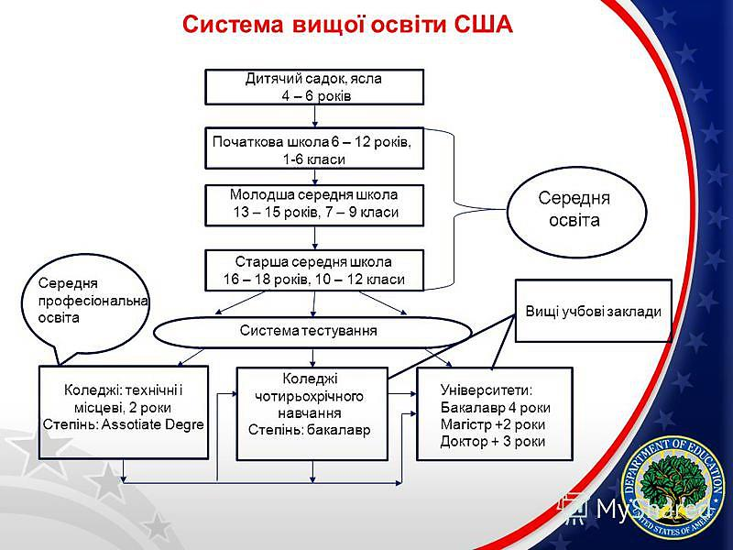

**P2:** A school year starts at the end of August or at the beginning of September and ends in late June or early July. The whole school year is divided into three terms/trimesters or four quarters. American students have winter, spring and summer holidays which last 2 or 3 weeks and 6 or 8 weeks, respectively. Students go to school 5 days a week. Members of each grade in high school have special names: students in the ninth grade are called freshmen, tenth graders are called sophomores, eleventh graders are juniors and as for twelfth graders, they are seniors.

**P3:** Students come to school, do their homework, go in for sports, play different national games. They are controlled by their parents and teachers. In the USA the system of appraisal of the student’s knowledge is quite different from our. This system is called the rating system. There are four levels of educational achievements at American school: A.B.C.D , where level A is considered to be the highest and level D- the lowest. Testing at all levels and in all types of educational establishment has already become traditional. It makes possible to check the level of knowledge for a short period of the time. TOEFL TEST in English is well known all over the world.

**T:** Ok. I think it was good, you are very responsible and well prepared.

*Writing:* **T:** So let’s play some game. You must think and write down on paper “What is school for you?”

Learning a lot of interesting things

Getting bad marks

Making new friends

Doing my endless homework

Hating getting up early in the morning

Associated with teachers, so strict and demanding

School parties and exciting preparation for them

Being worried about exams

**T:** Well – done! All answers were interesting and useful. Every school has many pupils. And when pupils come to school they must behave properly. They must follow certain school rules. Now I will divide you into 2 teams - the first team will write down what pupils must do and the second team will write down what pupils mustn’t do. You’ll have 3 or 4 minutes. Let’s start!

Pupils must… Pupils mustn’t…

Come to school in time Run in the corridors

Do their homework Talk (sleep) in the lessons

Be attentive in the lessons Late to lessons

Clean their classrooms Miss lessons

Listen to the teacher Forget things (dairy, books)

Study well Forget to do the lessons

Learn the rules Interrupt teachers

Be polite Be bad pupils

Prepare the lessons Cheat in the lessons and tests

Clean the blackboard Fight with classmates

**T:** Thank you very much. You have worked well. Let’s put these rules on our blackboard and follow them during our lessons. And you should show an example of behavior to younger pupils. I think that these rules are similar everywhere. Am I right?

**Ps**: Yes, you are!

**T:** And now I’d like ask you some question “*Would you like to study abroad? Why or why not?”*

**P1:** It’s very popular, but I think it’s very expensive!

**P2:** As for me I’ll try. It’s good possibility to improve language skills and to make new friends!

**P3:** High prices of foreign education but full of places of interest!

**P4:** I’ll try too, I can to contact with people from other cultural backgrounds, which is rather interesting.

**P5:** I**’**m not, because studying abroad is never easy. It requires hard work and a lot of effort.

**T:**So it’s you opinion and choice. I know that there was an interesting investigation about the level of knowledge of American and Ukrainian student. The experts came to the conclusion that the level of knowledge of Ukrainian students in all subjects is higher but the American students are better in practical usage of their knowledge in real life. To my mind our student study a lot of subjects which develop their intellect but these subjects do not give them practical advice.

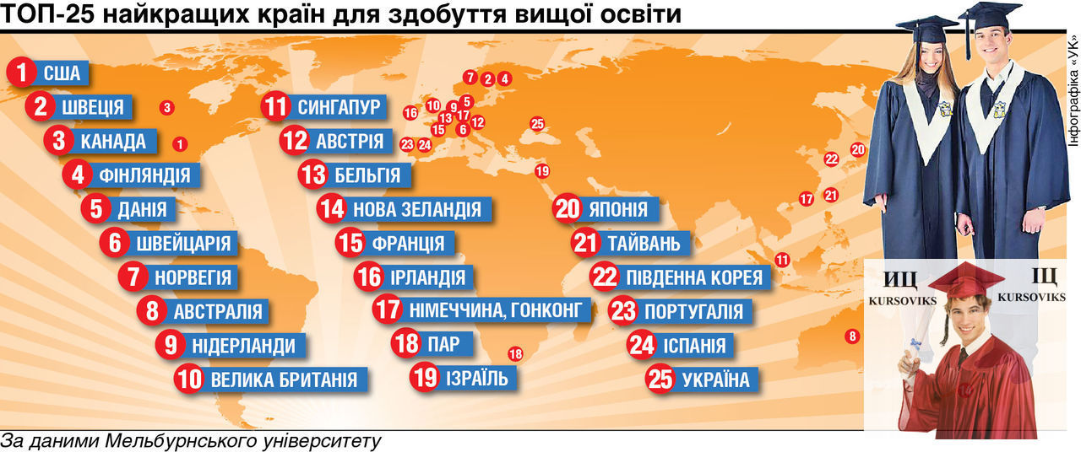And at the end let’s see the table” Top countries where it is better to get education”

**T:** Thanks for your thoughts and opinions today. It was interesting for me to hear them. All pupils work very hard and get marks. For the next lesson you must write a short composition. The theme of this composition is: Imagine that you have a chance to choose any country and any university you want to study in. What will you choose? Explain your points of view, please. Open your dairy and write down your homework. The lesson is over. You may be free. Goodbye!