**Урок англійської мови у 4 класі**

***Тема:* I know numbers**

***Мета****:*

• навчальна: презентувати новий лексичний матеріал за підтемою порядкові числівники, формувати навички вживання цифр уповсякденному житті, ацікавити учнів у вивченні математики і англійської мови,сформувати навики утворення,правопису та вимови порядкових числівників, вдосконалювати компетенції читання, збільшувати обсяг знань про лінгвістичну специфіку мови країни, що вивчається, вдосконалення умінь будувати своє мовне висловлювання;

• розвиваюча: уважно стежити за презентованою інформацією про походження римських цифр, ефективно співпрацювати у груповій роботі, мотивувати готовність брати участь в іншомовному спілкуванні, розвивати різні типи пам'яті, розвивати творчі здібності;

• виховна: виховувати уміння сконцентруватися, слухати інших, бажання мислити,формувати доброзичливу атмосферу в класі.

***Обладнання***:

плакат «Порядкові числівники», плакати з прикладами вживання порядкових числівників повсякденному житті, аудіоаписи, картки з числівниками 1-20, 10-100, картки з практичними завданнями.

***Хід уроку:***

***1****.Greeting.Good morning. Is the classroom ready for the lesson?*

*Sing the song “ What’s in the classroom?”*

What's in the classroom?

Let's have a look!

Posters and pictures,

And work in a book.

What's in the classroom?

What can you see?

Drawers and a cupboard

For you and for me.

What's in the classroom?

What's over there?

A door and a window,

A table and chair.

What's in the classroom?

What can you see?

A board and pegs

For you and for me.

**2.** Revising activities:

*Answer the questions:*

*How many boards have you got in your classroom?*

*How many windows have got you?*

*How many drawers have you got?*

*How many desks have you got?*

*How many chairs have you got?*

*How many pegs have you got?*

**3.** *You know the amount of the objects in the classroom*.

*Can you count to 20?*

Students gets cards with numbers in random , stand up and say numbers from 1 to 20.

Sing a song:

**There are ten in the bed**

There are ten in the bed,

And the little one says,

"Two more, two more.

Two more get in.

Eleven, twelve!

There are twelve in the bed,

And the little one says,

"Two more, two more.

Two more get in.

Thirteen, fourteen!

There are fourteenin the bed*,* ...

Fifteen, sixteen!

There aresixteen in the bed*,* ...

Seventeen*,* eighteen!

There areeighteen in the bed*,* ...

Nineteen, twenty!

Help!

**4.** Then the topic of the lesson is announced:

**We Know the Numbers**

**5**. Presentation

Pupils learn round numbers from 10 to 100.

Pupils practise in making cardinal numbers.

*Write on the board and say*:

72, 21, 35, 84, 49, 55, 83, 97, 68 etc.

Relaxation. *Sing the song* ‘Let's count to one hundred!’:

Let's count to one hundred.

It's time to start.

10,20,30 ...

Yes, good start!

Let's count to one hundred.

It's easy to do.

40,50,60 ...

Yes, clever you!

Let's count to one hundred.

It's easy if you try.

70,80 ...

The numbers are high.

Let's count to one hundred.

Now we are done.

90, 100.

counting is fun!

**6.** Brainstorming:

How many seconds in a minute?

How many minutes in an hour?

How many seconds in an hour?

How many seconds in a year? ( the answer to this question you’ll find

later)

How many days in a month?

How many days in a week?

*Chant the days of the week*:

Monday. Tuesday. Wednesday. Jump!

Thursday, Friday, down with a bump!

Saturday, Sunday, let’s say ‘Hi!’

Days of the week. Let’s say ‘Good bye!’

**7.** The teacher writes the date starting with the name of the week day and pays attention on the written form of the numeral – ordinal number.

The teacher sticks the table ‘Ordinal numbers’

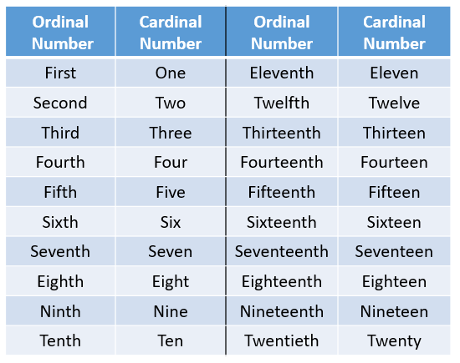

Show how ordinal numbers after first, second and third are similar to cardinal numbers, except the spelling changes for five-fifth and twelve-twelfth. In these two cases there is a small pronunciation change also. All the other ordinal numbers simply add *–th* to the end of the cardinal number.

8. Practical exercises:

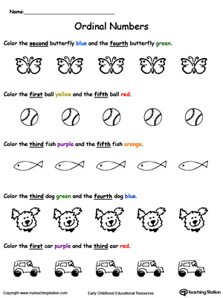 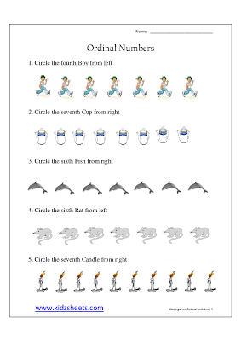

*The answer to How many seconds in a year? is 12: the second of January, the second of February, the second of March etc. This is a joke.*

**9**. Usage demonstration of ordinal numbers:

a) a queue line

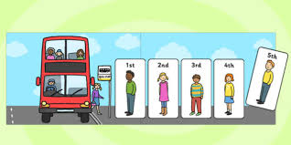

b) birthdays and anniversaries

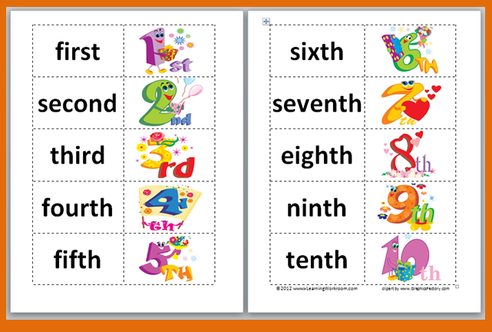

c) fractions, where the term is a cardinal number and the denominator is an ordinal number.

*Write fractions in the copybooks: one third, two fifth, three eighth, four ninth, two seventh, four fifth, seven ninth.*

d) the names of Royal family: Charles II, Edvard VI, Henry the VII:

**

10. Optional activity- Roman numerals. Children show the hand gestures for counting in ancient Rome :

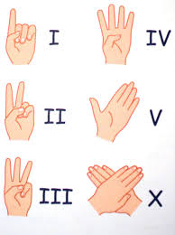

11.Comments on marks.

12. Homework.

13.Discussing the most interesting moments of the lesson.