This resource can be used by teachers for encouraging students’ reading, enlarging their vocabulary while learning different themes. It contains two short texts giving some information about one of the world-known persons. Post-reading activities include such tasks as *synonym match, phrase match, choosing the correct word, unscrambling sentences, spelling of the jumbled words.*

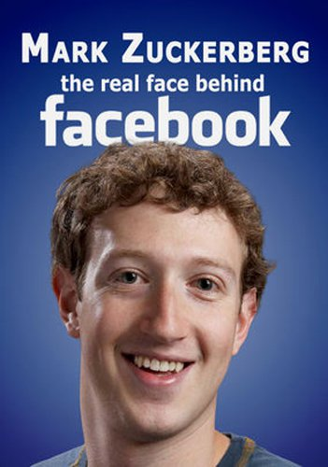

**Mark Zuckerberg**

Mark Elliot Zuckerberg was born on May the 14th, 1984. He is the creator of the social media site Facebook. He was a star student at school, winning prizes in astronomy, maths and physics. He also excelled in Classical studies. He studied Psychology and Computer Science at Harvard University, which is where he created Facebook. His invention led to his becoming Time magazine’s Person Of The Year for 2010.

Zuckerberg excelled in everything he did in his youth. He was captain of the school fencing team, spoke many languages and was a highly skilled computer programmer. While other kids played computer games, he designed them. He created his first network while in high school to connect all of the computers in his father’s dental surgery. He also built a media player which attracted the interest of Microsoft and AOL.

Zuckerberg started at Harvard in September 2002. In his first year, he created Facemash, a Facebook predecessor, that let students select the college’s best looking people from a selection of photos. He launched Facebook from his Harvard room in February 2004. It was the start of a rollercoaster ride that would connect half a billion people worldwide and make him the world’s youngest billionaire. Mark Zuckerberg is now one of the most influential people on the planet. He has dined with the president of the USA and regularly attends global economic summits and technology forums. He stated: "The thing I really care about is the mission, making the world open." In 2010, Zuckerberg signed a promise called the "Giving Pledge", in which he promised to donate at least half of his life wealth to charity.

**SYNONYM MATCH**

**Match the words from the article on the left with their synonyms on the right.**

|  |  |  |  |
| --- | --- | --- | --- |
| *Paragraphs 1 and 2* | |  |  |
| 1. | creator | *a.* | creation |
| 2 | star | *b.* | talented |
| 3. | invention | *c.* | top |
| 4. | excelled | *d.* | maker |
| 5. | skilled | *e.* | attention |
| 6. | interest | *f.* | shone |
| *Paragraphs 3 and 4* | |  |  |
| 7. | select | *g.* | link |
| 8. | launched | *h.* | frequently |
| 9. | connect | *i.* | choose |
| 10. | influential | *j.* | give |
| 11 | regularly | *k* | started |
| 12 | donate | *l* | important |

**PHRASE MATCH**

**Match the following phrases from the article.**

|  |  |  |  |
| --- | --- | --- | --- |
| 1. | creator of the social | *a.* | ride |
| 2 | He also excelled | *b.* | open |
| 3. | Zuckerberg excelled in | *c.* | of Microsoft |
| 4. | a highly skilled | *d.* | in Classical studies |
| 5. | attracted the interest | *e.* | wealth to charity |
| 6. | a selection | *f.* | media site Facebook |
| 7. | the start of a rollercoaster | *g.* | people |
| 8. | one of the most influential | *h.* | everything he did |
| 9. | making the world | *i.* | computer programmer |
| 10. | donate at least half of his life | *j.* | of photos |

## CHOOSE THE CORRECT WORD

**Delete the wrong word in each of the pairs of italics.**

Mark Elliot Zuckerberg was *born / birth* on May the 14th, 1984. He is the *creator / created* of the social media site Facebook. He was a *moon / star* student at school, winning prizes in astronomy, maths and physics. He also *excelled / excellent* in Classical studies. He studied Psychology and Computer Science at Harvard University, which is where he created Facebook. His *inventor / invention* led to *he / his* becoming Time magazine’s Person Of The Year for 2010. Zuckerberg excelled in everything he did in his *young / youth*. He was captain of the school *fences / fencing* team, spoke many languages and was a *highly / height* skilled computer programmer. While other kids played computer games, he designed them. He created his first network *wilt / while* in high school *to / by* connect all of the computers in his father’s dental surgery. He also built a media player which attracted the *interested / interest* of Microsoft and AOL.

Zuckerberg started at Harvard in September 2002. In his first year, he created Facemash, a Facebook *processor / predecessor*, that let students *choice / select* the college’s best looking people from a selection of photos. He *launched / lunched* Facebook from his Harvard room in February 2004. It was the start of a rollercoaster *attraction / ride* that would *joined / connect* half a *billion / thousand* people worldwide and make him the world’s youngest billionaire. Mark Zuckerberg is now one of the most *influence / influential* people on the planet. He has *dined / dimmed* with the president of the USA and *regularly / regilar* attends global economic summits and technology forums. He stated: "The thing I really care about is the mission, making the world *openly / open*." In 2010, Zuckerberg signed a promise called the "Giving Pledge", in which he promised to *donation / donate* at least *half / halves* of his life wealth to charity.

**SCRAMBLED SENTENCES**

|  |  |
| --- | --- |
| 1. | the     social     media    site    Facebook     He    is    the    creator    of. |
| 2. | excelled     Classical     also     in     studies     He. |
| 3. | did     Zuckerberg     in     he     excelled     everything. |
| 4. | programmer     computer     skilled     highly     A. |
| 5. | school     created     network     high     He     first     in     his     while. |
| 6. | Let     people     looking     best     college’s     the     select     students |
| 7. | room     Harvard     his     from     Facebook     launched     He. |
| 8. | planet     of     influential     the     One     most     on     the     people. |
| 9. | about     The     I     care     thing     really. |
| 10. | of     his     life     wealth    to     charity     Donate     at     least     half. |

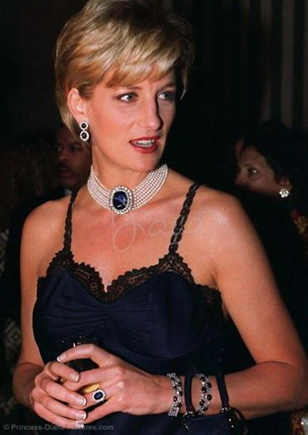 **Lady Diana**

Lady Diana Spencer was born in 1961. She had a normal, quiet upbringing. It could never have prepared her for the fame and glamour of being a British princess. Within a few years, she changed from being a shy teenager to the most photographed person on the planet. She hit newspaper headlines around the world, but the biggest one was for her death at the age of 36.

Diana was a kindergarten teacher in London when she caught the interest of Prince Charles. She won the hearts of a nation with her shy smiles and natural beauty. The whole world watched the fairytale royal wedding in 1981. A year later, she gave birth to Prince William, the first of her two sons.

Diana was nervous at first in public, but she soon developed a charming manner. She took a strong interest in many charities and important causes. She highlighted the suffering of the homeless, lepers and AIDS victims. She also campaigned for the abolition of landmines and many countries banned them.

Diana and Charles divorced in 1996. She struggled with depression and eating disorders for many years after. She finally found happiness with an Egyptian film producer, Dodi Al-Fayed. Their romance was closely followed by the paparazzi, which led to the fatal car crash that killed her in Paris in 1997. At her funeral, British Prime Minister Tony Blair called her the “People’s Princess". To many, she was simply the “Queen of Hearts".

## PHRASE MATCH

**Match the following phrases from the article:**

|  |  |  |  |
| --- | --- | --- | --- |
| 1. | She had a normal, | *a.* | headlines around the world |
| 2 | the most photographed | *b.* | and eating disorders |
| 3. | She hit newspaper | *c.* | in many charities |
| 4. | she caught the interest | *d.* | quiet upbringing |
| 5. | She won the hearts of a | *e.* | suffering of the homeless |
| 6. | She took a strong interest | *f.* | nation with her shy smiles |
| 7. | She highlighted the | *g.* | person on the planet |
| 8. | She also campaigned for the | *h.* | the “Queen of Hearts" |
| 9. | She struggled with depression | *i.* | of Prince Charles |
| 10. | To many, she was simply | *j.* | abolition of landmines |

## CHOOSE THE CORRECT WORD

**Delete the wrong word in each of the pairs of *italics*:**

Lady Diana Spencer was born in 1961. She had a *abnormal / normal*, quiet upbringing. It could never have prepared her for the fame and *glamour / glamorous* of being a British princess. Within a few years, she changed from being a shy teenager to the most photographed person on the planet. She *hits / hit* newspaper headlines around the world, but the biggest one was for her *death / dead* at the age of 36. Diana was a kindergarten teacher in London when she *catch / caught* the interest of Prince Charles. She won the hearts of a nation with her *shy / shyness* smiles and natural beauty. The *whole / all* world watched the fairytale royal wedding in 1981. A year later, she *given / gave* birth to Prince William, the first of her two sons. Diana was nervous at *one / first* in public, but she soon developed a charming manner. She took a strong *interesting / interest* in many charities and important causes. She highlighted the suffering of the *homes / homeless*, lepers and AIDS victims. She also campaigned for the *abolition / abolish* of landmines and many countries banned them. Diana and Charles divorced in 1996. She *struggled / struggling* with depression and eating disorders for many years after. She finally found happiness with an Egyptian film producer, Dodi Al-Fayed. Their *romantic / romance* was closely followed by the paparazzi, which led to the *fatal / fatality* car crash that killed her in Paris in 1997. At her funeral, British Prime Minister Tony Blair called her the “People’s Princess". To many, she was *simply / simple* the “Queen of Hearts".

## PUT THE TEXT BACK TOGETHER

**Number these lines in the correct order.**

|  |  |
| --- | --- |
| (    ) | landmines and many countries banned them. |
| (    ) | the “People’s Princess". To many, she was simply the “Queen of Hearts". |
| (    ) | manner. She took a strong interest in many charities and important causes. She highlighted the suffering of the |
| (    ) | royal wedding in 1981. A year later, she gave birth to Prince William, the first of her two sons. |
| (    ) | homeless, lepers and AIDS victims. She also campaigned for the abolition of |
| (    ) | British Prime Minister Tony Blair called her |
| (    ) | Diana was a kindergarten teacher in London when she caught the interest |
| (    ) | her for the fame and glamour of being a British princess. Within a few years, she changed from being a shy |
| (    ) | closely followed by the paparazzi, which led to the fatal car crash that killed her in Paris in 1997. At her funeral, |
| ( ***1*** ) | Lady Diana Spencer was born in 1961. She had a normal, quiet upbringing. It could never have prepared |
| (    ) | one was for her death at the age of 36. |
| (    ) | Diana and Charles divorced in 1996. She struggled with depression and eating |
| (    ) | of Prince Charles. She won the hearts of a nation with her shy smiles and natural beauty. The whole world watched the fairytale |
| (    ) | teenager to the most photographed person on the planet. She hit newspaper headlines around the world, but the biggest |
| (    ) | disorders for many years after. She finally found happiness with an Egyptian film producer, Dodi Al-Fayed. Their romance was |