Music in our life
"The magic of his music
lights the darkness of our lives"
(Schubert ).

Aims :
- to develop pupils’ listening, reading and speaking skills
- to review and develop grammar skills
- to increase pupils’ love to learning English and to listening to classical music
- to revise and enrich pupils’ knowledge on the topic
- to develop attention and memory
Equipment: a computer, a TV set, a video player, posters.
- Introduction
T. Good morning, my dear boys and girls. I have a hope you are OK. Today our lesson will be about music in our life.
Can you think a day without music? “Oh, that’s impossible” you may say. Yes, you are right. Music is very important to us and nobody is indifferent to it. May be we can live without music but we can’t imagine it. We can hear music everywhere: on the radio, on TV, in the cafes, in the street and parks, at home, in a concert hall, at the seaside and even in the wood. People have many modern devices to bring music to their lives and to listen to it everywhere they want. They listen to music, they dance to music, they learn to play musical instruments. Some people like classical music others prefer pop, jazz, rock or modern music. Music is a part of our life. It helps us to relax, to forget about our problems .
II. Relaxation
T. Now you’ll listen to music. When the music begins, close your eyes and try to relax. (Composed by Mozart)
Who is the composer? Who said these words: "The magic of his music lights the darkness of our lives" and whom about? (Schubert ).
- What do you think about while listening to music?
- How does this music make you feel?
- Can you tell me when the melody changes a little bit?
- Which music do you prefer classic or popular?
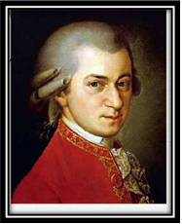
- Why do people need music?
- Is classical music necessary for modern life?
- Can you hear the sounds that are made by different instruments? What are they?
- Are you fond of music?

III. Main part.
1.Reading.
T. Now we shall read the text about the composer Wolfgang Amadeus Mozart.
Wolfgang Amadeus Mozart is one of the greatest composers ever born. Like Shakespeare, he stands at the summit of human achievement. In every form, from serenade to fugue, from piano concerto and symphony to the heights of grand opera, his music amazes, enchants and invades the memory.
Thousands of books have been written about Mozart. Few lives have ever been so well documented as his, and yet he is one of the most mysterious figures in the world.
Mozart was born in 1756 in Salzburg, Austria.
He began playing the piano at the age 4, and when he was 5 years old, he already composed serious music. His father took him on tours of Western Europe and Italy and the boy was always a success. Then the prodigy ripened into genius. The genius conquered Vienna and the world. Mozart's fame was great. He met all the great figures of his time, from Haydn to Goethe, from George III to the luckless Marie Antoinette. But then he suddenly fell from favour. The Vienna aristocracy grew tired of him. He lost pupils and contracts, had to move from his comfortable house in the centre to a modest flat in the suburbs. The genius was forgotten.
Mozart died in 1791, when he was only 35 years old. There's a legend that Mozart was poisoned by his rival composer Antonio Salieri. There's no truth in this legend, though it inspired many great poets, writers and composers. But it has been proved that in the last months of his life Mozart really believed that he was pursued by a spirit, "the grey messenger", who appeared and ordered him to write a requiem. In a state of depression Mozart imagined that he was to write the requiem for himself.
Not long ago a 150-volume edition of Mozart's works was published. His works include 41 symphonies, nearly 30 piano concertos, 19 operas, a vast quantity of orchestral and other instrumental music, and volumes of church music (he wrote it mostly for financial reasons). His most famous operas are Don Giovanni, The Magic Flute and The Marriage of Figaro.

2. Grammar Review
T. Write out all the verbs from the text. Divide them into regular and irregular. Give 3rd forms for the irregular verbs, pay attention to the pronunciation of the ending of the regular verbs, divide them into groups (/t/, /d/, /id).
- When was Mozart born?
- Where was he born?
- How old was he when he started to play musical instruments?
- When did he start to compose music?
- What countries did young Mozart visit?
- When did the real fame come to Mozart?
- Why is he one of the most mysterious figures in the world?
- What impress you most of all?
9. When did he die?
10. What works by Mozart do you know?
11. Would you like to read a book about Mozart? Why?

- Speaking
1.T.Retell this story using the following words and phrases (a composer, to spend, a piece of music, tours of Western Europe and Italy, a success, no truth in this legend , 150, 41, 30 , 19, famous).
Vocabulary:
composer — композитор
violinist — скрипач
clavier — клавесин
audience — аудитория
to be delighted — восхищаться
success — успех
burdens — тяготы
poverty — бедность
desease — болезнь
to speed up — ускорить

2. We have already read and spoken about Mozart.
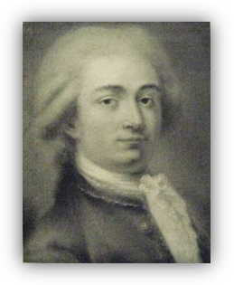
What other composers do you know?
(all pictures are shown on a screen)
- Whose portrait do you see on the screen?
- What music did they write?....
P 1. This is Antonio Vivaldi. He was born in Italy and composed most of his music for the pupils of a girl’s orphanage in Venice…
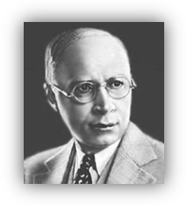
P 2. Look! This is Sergei Prokofiev, he was born in Donetsk region, in the village of Krasnoe. Prokofiev composed his first piece of music, when he was 5. At the age of 13 he entered the St. Petersburg Conservatoire. He emigrated to America. Prokofiev wrote eight operas, seven cantatas, seven ballets, seven symphonies… I like his “Swan Lake”, “The Nutcracker”, “The Sleeping Beauty”. They musical masterpieces…
T. Who is your favorite composer?
P. Joseph Haydn. He composed more than 80 string quartets 100 symphonies 52 sonatas, and 30 operas…
T. Thank you.

4. Project work.
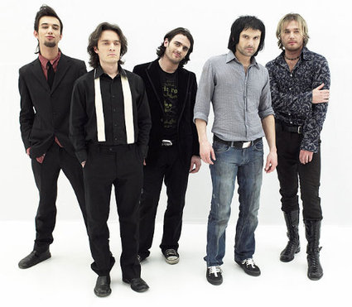
T. Your class was split into 3 groups. For today each group has prepared the information about music in Ukraine, Great Britain and the USA. Let’s see what is in common? And what is different?
P 1. Music plays a very important role in Ukrainian cultural life. Opera houses in many cities are famous all over the world. At present Ukraine has 6 opera houses, 3 operettas, 10 philharmonic societies, 5 higher music schools. Ukrainian composers are well known in many countries. Among them are S. Prokofiev, I. Stravinsky, Mykola Lysenko . Ukrainians love music. They love different styles of music. Folk music is very popular in Ukraine. Many Ukrainian people like to sing. They have good voices and a great talent of singing. Ukrainian folk songs are the finest songs in the world. “Okean Elzy” is the famous Ukrainian band. The band leader is Sviatoslav Vakarchuk. Its music is wonderful. The songs are about love, friendship and understanding. This group has been nominated “The Best Live Group 2007”.
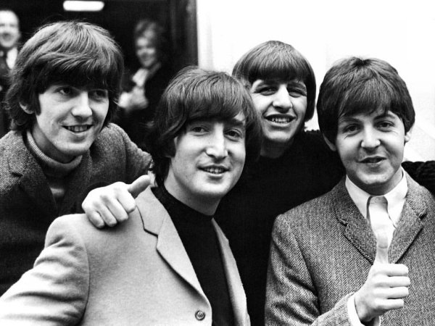
P 2. English people like music. They like jazz, folk and classical music. Music festivals are very popular. Royal Opera House at Covent Garden gives performances all the year round. The English National Opera Company is popular too. Folk music is not so rich and popular as in Ukraine. Elton John is a very popular singer, pianist and composer, his best album is “Good Bye Yellow Brick Road”. His other songs are “Rocket Man and Crocodile Rock”. The Beatles became famous in 1962. Liverpool is the birth place of the Beatles. The famous four singers were John Lennon, Paul McCartney, George Harrison and Ringo Starr. Their concerts were a great success, they made successful records and interesting films.
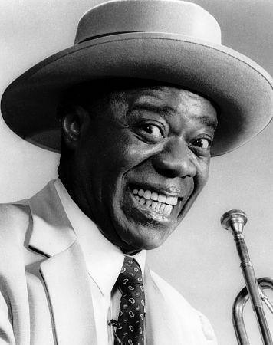
P 3. Americans are fond of music of all kinds. They are about 1572 Symphony orchestras in the USA. They are well known in the world. Opera is very popular in the USA. Jazz is very popular in the USA. Jazz players and singers such as Louis Armstrong, Duke, Ellington, Glenn Miller entered the history of music and became famous all over the world.
Louis Armstrong was born in a poor section of New Orleans known as “the Battlefield” on August 4, 1901. He was known around the world and widely recognized as a founding father of jazz—a uniquely American art form. He developed a way of playing jazz, as an instrumentalist and a vocalist. Louis Armstrong’s recorded hit songs for five decades, and his music is still heard today on television and radio and in films. He is truly the king of jazz.
IV. Summing-up.

