**We Are Special By Being Different**

**Ведуча:** -Have you ever thought what makes a personality?

-How is it to be a young person in a modern world?

-Why is nothing ever easy?

-Why are some boys so very sleazy?

-Why are teens under so very stress?

- If you want to answer all these questions, stay with us and see our program ”Let them speak”. And I, Oksana Yuhymchuk, will be with you in this studio all the time.

- Let me introduce our guests!

1. –a well known phycologist .
2. –a social worker, who knows a lot about teen’s life.
3. –a prominent doctor from a medical centre “Hope”.
4. –the next our guest is an executive police worker.
5. –a talented young writer.
6. –and Mr. Andrew- a famous reporter of a well-known magazine “Teens”.

-Nice to see you dear friends! I have invited you for the round table discussion about the problems and interests of young people. Our motto is “We are special by being different”.

Let`s a video about teens

-Mr. Andrew, I know you have prepared some interesting information for us.

**Reporter: -**O, I see, it’s an interesting and urgent problem and I think I’ll have to meet young people and interview them to collect true information about young people’s life.

**Ведуча: -** I’m sureyou’ll cope with the task and I wish you good luck.

*(Іде на сцену)*

**Reporter:** -Hello, boys! As far as I understand, you are graffiti fans. What does it mean for you?

**Boy 1:** You see, I’m crazy about graffiti and I’ve learned a lot about it. It appeared in big American cities in sixties (1960) and it was considered as the work of vandals seeking to express their identity or even political points.

**Boy 2:** Oh, I’d like to add there is a special website of graffiti for young graffiti artists. Moreover, it’s widely used for advertising. We express our fillings in music, nature by means of this kind of art.

**Boy 1:** We are sure to involve more and more young people in еnjoying this art.

**Reporter:** Is it difficult to paint with sprays?

**Boy 2:** Yes, it’s not an easy task, but if you do it all the time, you can do it well due to the practice.

**Reporter: -**Thanks guys! It was really interesting to talk with you. I wish you good luck and success.

*(звертається до глядачів)*

As far as I know, a new hair and beauty saloon “A new style” has been opened in our town, Which offers new kinds of service and one of them is piercing.

*(заходить в салон)*

Good morning, lady! Your beauty saloon is very popular in our town, especially among teens. Will you tell us a couple of words about piercing?

**Expert:** -Yes, I’ll do it with pleasure. I’m a qualified body piercer and I only pierce teenagers. They have to be over fifteen to have their naval pierced.

**Reporter:** -Is it an expensive fashion?

**Expert:** -That depends on your tastes. Ears cost 15 hr and it’s too cheap, eyebrows- 100 hr, tongue and navel- 150 hr.

**Reporter:** Thank you very much, may be one day I’ll become your client.

**Expert:** You are welcome!

**Reporter:** look at those strange girls sitting on the bench and discussing something. I go there.

*(підходить до дівчат)*

Hello, girls! Who are you?

**Girl 1:** We are emos. Emo stands for emotional. It’s associated with depression, self-injury. The sadness, the love, the sense of guilt is the basic topic in the lyrics of the emo-culture.

**Reporter:** What is the state of your soul?

**Girl 2:** Emo- culture is associated with being emotional, sensitive.shy, introverted or angsty. We need love and seek it all the time. Just in the process of our search we fall into the dark bottom of our soul, sometime we suffer.

**Reporter:** What do the colours of your clothes mean?

**Girl 1:** Black stands for sadness, pink means love, romance.

**Reporter**: I wish you were happy!

Age and youth cannot live together

Youth is full of pleasance,

Age is full of care.

Youth like summer brave,

Age like winter bare.

Youth is full of sport,

Age is weak and cold.

Youth is wild and age is tame

I adore my teenager years.

What does it mean to be a teenager?

-having a problem of freedom;

-having cool hairstyles, piercing;

-communicating with friends;

-having emotional problems;

-being in love;

-being fond of music;

-taking a lot of exams;

-having conflicts with parents.

*(звучить пісня “It’s my life”)*

**Ведуча:** Our teens are so talented , they thing , dance and act. They are different and it makes our live more interesting and exciting. I ask our phycologist to comment what we have just seen.

**Phycologist:** Young people are so similar and so different. They express their self-identity in clothes, hairstyle and slang. They have conflicts with their parents and teachers. But they still need somebody to open their heart to. They are talented, creative and dream of the bright future for themselves and their future children. They are not afraid of risk. They are romantic and skeptical. They are sincere and rude, honest and impolite. They demand our help, respect, attention. They are the future of our planet.

**Ведуча:** Thank you for your optimistic foresight. But nowadays teenagers face a certain number of problems. Let’s see a video.

*(video about teens’ problems)*

I’m so impressed and I suppose so you are. I’d like to invite to our discussion our doctor. Share your ideas with us.

**Doctor:** Smoking is a serious problem today. Unfortunately it has become a part of life of many young people. If you don’t want to degrade, if you want to live a meaningful life we advise you to lead a healthy way of life. You should care for your own health and not be lazy. You should do morning exercises with the windows wide open because they warm, invigorate and purify your body; you should have a good rest, you must be moderate in eating – eat the right food and a lot of vitamins because healthful habits make healthy bodies; you should have positive thinking.

**Ведуча:** O`K. I think it`s time to have a musical break. So meet our young generation.

(Britney Spears “Baby one more time”)

**Ведуча:** They are fantastic. Let`s continue our round table discussion about teens` problems .I am sure a police executive can tell us something interesting.

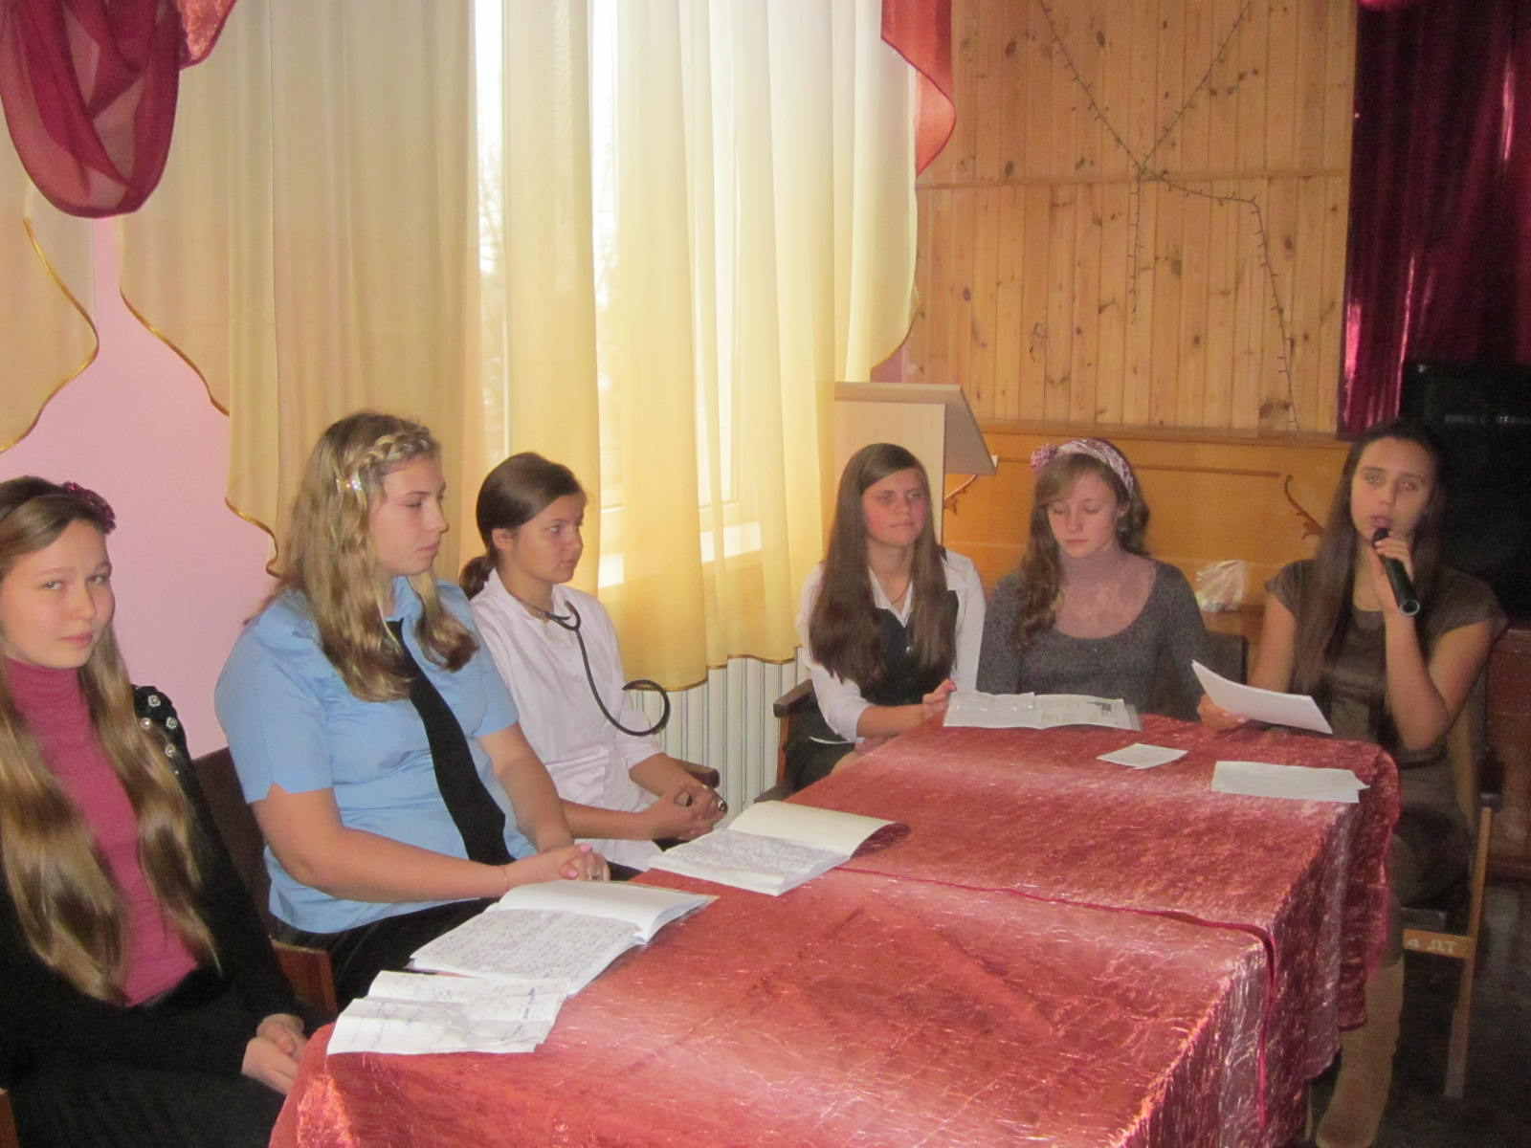

**Police executive:** Alcohol is another problem which has became an important one. Some young people try to escape reality by turning to alcohol or drugs.

By the age of 12 a growing number of teens know the taste and the effects of alcohol. Alcohol ruins young body and makes negative effects on emotional and physical state of a person. Drug abuse the biggest problem the youth faces today. Young people with drugs problems must be in the focus of everybody’s attention: government, community, parents and school.

**Ведуча:** What about homeless children? Does this problem exist?

**Police executive:** According to official data, 36 thousand children in Ukraine were registered as homeless, beggars and those who lost their parents.

We don’t think very often about the problem of homeless children but we can’t ignore it and pass by this problem in silence.

According to an old native American sawing:”The hurt of one is the hurt of all”, we should unite all our efforts and reduce the number of homeless children.

Dear friends, life is the most precious gift. Do not destroy it. Life is worth living.

**Ведуча:** I’m grateful for your advice! We often hear the phrase “a generation gap”. What this? Let’s see an episode from a typical Ukrainian family life and try to clear up the situation.

Betty *is 16, she is a high school student. In this dialogue, Betty is getting ready to go out on a date with her boyfriend, Jeff. Her father and mother are sitting in the living room.*

**Betty:** Mum, where's my new sweater? I can't find it. I have to hurry.

**Mother:** It's in your closet. Look again.

**Father:** Are you going out with Jeff tonight? You have school tomorrow.

**Betty:** I'm not going to stay late. Jeff and I are going to a party.

**Father:** Oh, no, you aren't. Your grades were terrible last semester - D in History and F in Math. And you have to get up early for school tomorrow.

**Betty:** But, Dad, I finished all my homework tonight.

**Father:** You spent about half an hour on your homework. Sit down and study an hour more. No dates on school nights.

**Betty:** But Mum gave me permission to go out tonight Mum, tell him.

**Mother:** That's right, dear. Today's Jeff’s birthday.

**Father:** Well, all right, but in the future no date! on school nights. And don't stay out late tonight.

**Betty:** OK, Dad. What time do I have to be home?

**Father:** Tell Jeff that he has to bring you home at 11 p.m.

**Betty:** 11p.m.? Dad, I’m17. My friends don't have to be home so early. Kathy doesn't have to be home until 1 a.m. Mum, do I have to be home until 1 a.m.?

**Mother: I** agree with your father. When I was your age I had to be at home at 10 p.m.

**Betty:** Oh, Mum. That was a hundred years ago. Thing are different now.

**Father:** Don't talk to your mother that way! And wait a minute - what about the dishes, young lady? You have to wash them up before you go out.

**Betty:** The dishes! Why do I have to wash the dishes Kathy didn't have to wash the dishes when she was at high school.

**Father:** I don't care about Kathy.

**Betty:** But **I** don't have time now. I have to get ready

**Father:** No dishes, no dates.

**Betty:** Oh, all right.

**Ведуча:** I want a social worker to comment this situation.

**Social worker:** Good afternoon, dear friends! A problem of family relations touches nearly each family nowadays. Parents have to remember that family must be filled with love, respect, understanding and children must not forget about their obligations to be hard-working and obedient.

**Ведуча:** Why does the problem of misunderstanding occur in some families?

**Social worker:** Some parents don’t understand their children. They try to choose school, university, job or even friends. They are busy earning money for living and don’t pay enough attention to their children. And it leads to a very bad end.

**Ведуча:** What is the main aim of parents in upbringing children?

**Social worker:** Parents should be more attentive to their children, because most of them are active, talented, they want to love, to be happy. Rising a kid into an honest, healthy and decent person is the main goal of all parents.

**Ведуча:** Let`s relax .I am eager to invite українські бабки on the stage. Meet them.

(виступ тріо)

**Ведуча:** They are so talented. They impressed me so much. I know it`s time to recite poetry.

**WHAT IS THE ART Of LIVING?**

*By Emily Matthews*

Taking time to smell the flowers,

Counting joys instead of hours,

Delighting in the simplest things,

Letting all your thoughts have wings,

Feeling peaceful deep inside,

Facing everything in stride,

Balancing both work and play,

Learning all along the way...

Moving toward a dream or goal,

Nurturing your heart and soul,

Showing others that you care,

Finding beauty everywhere,

Understanding true success,

Choosing love and happiness,

Sharing with a special friend,

Enjoying all that life can send!

**A children`s writer:** I can`t help but saying that a person who feels the poems

with the heart is always kinder ,more patient and an optimistic, believes in beauty.

Learn to trust people and then people will trust you .Don`t make your life complicated. We should love people , be kind ,faithful and honest . I want to bring you the translation of this poem.

**ЩО ТАКE МИСТЕЦТВО ЖИТТЯ?**

*Еміді Метьюз*

Знайди час для насолоди ароматом квітів,

Замість голин рахуй радості миті,

Надай велике значення простим речам,

Дозволь мати крила своїм думкам.

Спокій відчуй в середині себе,

Помічай, як навколо трудиться все,

Між працею й дозвіллям баланс віднайди,

Життєвою дорогою вчися і йди.

Стрімко до мрій або цілі лети,

Серце своє і душу зрости.

Проявляй до інших турботу свою,

Шукай і знаходь усюди красу.

Справжнього успіху смак зрозумій,

Любов і щастя обрати зумій.

З другом найкращим усе поділи,

Насолоджуйся всім, що життя шле тобі!

**Ведуча:** We are finishing our meeting on such romantic and optimistic not

Don`t live in vain, dear friends ! Teenager years are the most sweet period in our life. Try to be happy and make others happy! That`s the wisdom of life!

(звучить фінальна пісня’’ We are the world, we are the children “

