КИЇВСЬКИЙ УНІВЕРСИТЕТ ІМЕНІ БОРИСА ГРІНЧЕНКА

ІНСТИТУТ ПІСЛЯДИПЛОМНОЇ ПЕДАГОГІЧНОЇ ОСВІТИ

Кафедра методики мов та літератури

**ВИПУСКНА РОБОТА НА ТЕМУ: « ВИКОРИСТАННЯ ЕФЕКТИВНИХ ФОРМ РОБОТИ НА УРОКАХ АНГЛІЙСЬКОЇ МОВИ» (розробка уроку на тему: « Мій робочий день» для 3 класу)**

**Виконала:**

Костенко Юлія Миколаївна,

учитель англійської мови СЗШ №104 імені О. Ольжича

Оболонського району м. Києва

Навчальна група: ФЛО4-13

Направлення № 171804529

Замовлення №22469

Моб.тел.:0505056739

**Перевірила**: Жарікова Л.М.,

старший викладач

кафедри методики мов та літератури

Київ 2018

**Дозволяю**

використання повного тексту або фрагментів моєї роботи при формуванні інформаційно-методичного фахового середовища міста Київ із зазначенням імені автора (хочу друкуватися).

06.01.18 Костенко Ю.М.

The lesson: Every day activities

Lesson objectives:

to identify every day activities

to teach the words (get up, have breakfast, go to school, go home, have dinner, go to bed)

to understand a short story

Equipment: CD, activities flashcards, a CD player, a ball.

Greeting.

T: Good morning pupils. It is an English lesson now. Today we`re going to play a game, do some listening, reading and of course writing and colouring.

But now let`s repeat our classroom rules (teacher shows the flashcards or the poster and revises for the lesson)

1. Be polite.
2. Keep calm.
3. Listen to the teacher, do with the teacher.
4. Don`t interrupt the teacher and your mates.
5. Don`t take away the ball if the ball isn`t for you.
6. Enjoy the games.

Warmer.

A teacher says the rhyme and do the movements to show children the exercises.

I wake up (stretch the arms)-я прокидаюсь

I wash my face (wash face)- я умиваюсь.

Sing and dance (show how you can sing and dance)-співаю, танцюю

Write and draw (show how you can write and draw)-пишу, малюю

Pupils repeat and do exercises but every new time the teacher repeats faster and faster.

After 3 or 4 times of the rhyme the teacher asks some pupils to help her.

She begins saying the rhyme but stops and throws a ball to some pupils who catches the ball can finish the line.

At the end of this part some pupils have to proclaim this rhyme. If they do it clearly and correctly they`ll get a card (a special sign or a picture like a smile to provide pupils achievement).

Lead-in

1. The teacher uses flashcards (get up, have breakfast, go to school, go home, have dinner, go to bed) to elicit the vocabulary for this lesson.

Hold them up one at a time for children to name the everyday activities.

Hold the flashcards up in a different order and repeat.

2. Listen, point and repeat.

Ask children to look at the pictures of the everyday activities.

T: Now everyone opens our books, do exercise 1 and look at the pictures, listen and point.

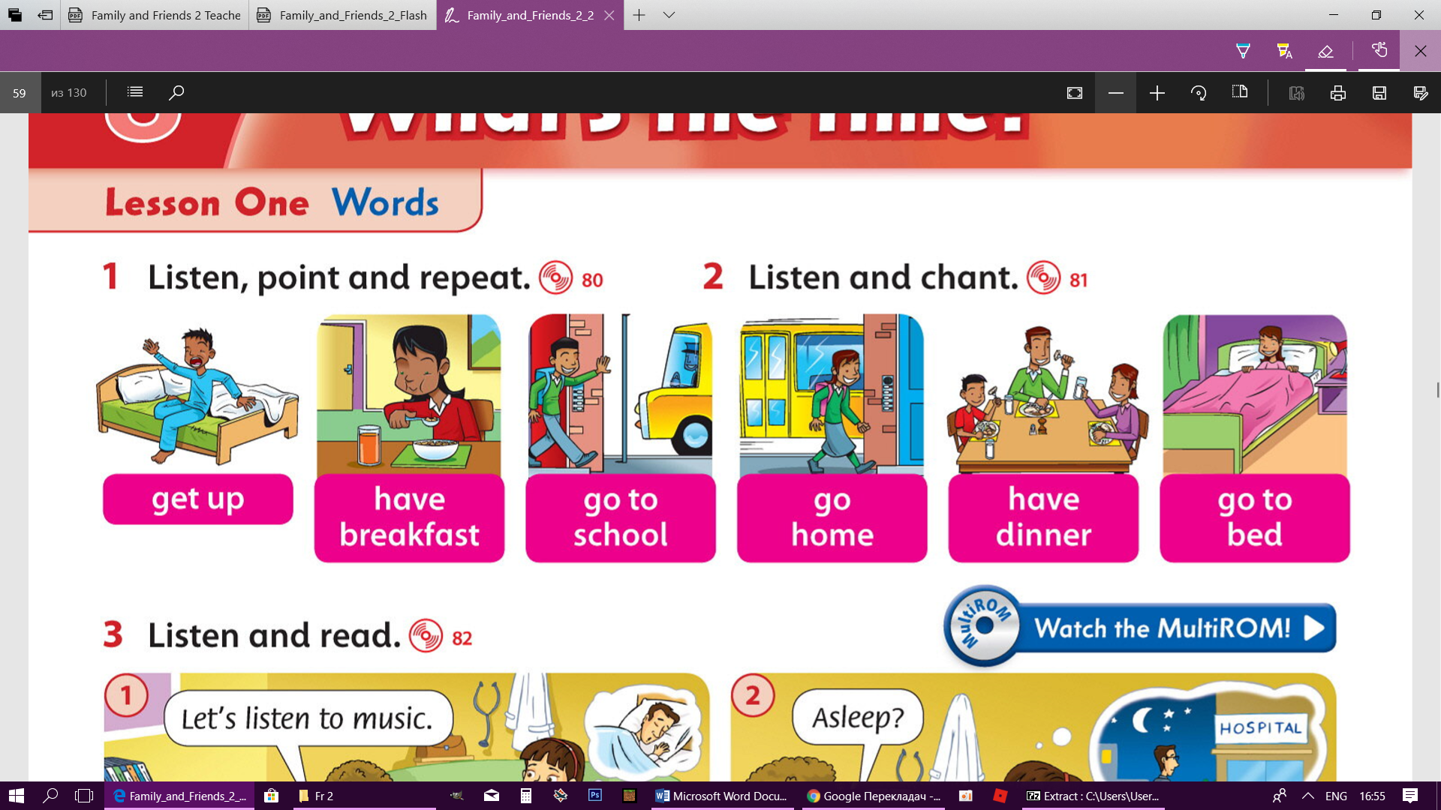

Play the first part of the recording for children to listen and point to the appropriate picture. Hold up the appropriate flashcard as each phrase is said.

Play the second part of the recording, pausing after each phrase for children to repeat.

Play the recording all the way through for children to listen and point and then repeat the phrase.

T: Very well. Let`s repeat.

T: Do exercise 2, listen and chant.

The chant.

Get up, get up, get up

Have breakfast, have breakfast, have breakfast

Go to school, go to school, go to school

Go home, go home, go home

Have dinner, have dinner, have dinner

Go to bed, go to bed, go to bed

3. Feedback

1. An interactive game “Musical cards”

T: My dears, now is the time for a game. You`ll pass the cards to children next to you around the class while the music is playing. I`ll stop the music suddenly. You`ll answer my questions and get a special sign.

Play lively music. Hand the unit flashcards out to different children around the class. They pass the cards to children next to them around the class while the music is playing. Stop the music suddenly. Ask the children. Play the game, give signs.

T: Who are holding the flashcard …?

T: That`s very good…(names), read the flashcard, well done, get a sign.

Language focus

1.Listening

T: Do you remember Rosy`s family? And today is the next comics about her family. I put on my CD, listen and clap your hands when you hear the words from the flashcards.

T: Well done.

T: Now open your class books on the page number… listen and read.

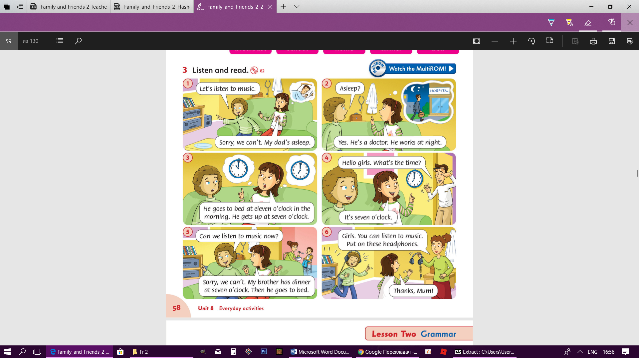

Children listen the comics and point to different speech of bubbles as they hear the words.

2. Controlled reading practice

The game “The rain” the teacher gives the ball to a pupil, the pupil reads the first sentence and throws the ball to another pupil (pupils should be very attentive to follow the turn of the sentences, the teacher is allowed to take away the sign if the pupil doesn`t follow the turn of the sentences, give sings to pupils who read correctly).

T: Play the game “The rain”

T: Please (name), begin… (the teacher corrects the mistakes), throw the ball…

3. Feedback

T: Where is Rosy? What does Alice want to do? Who gets up at seven o`clock?

Who has dinner at seven o`clock? Can the girls listen to music? Why? (the teacher gives the signs for the correct answers)

Controlled written practice

1.The children practice recognizing and writing the new words from the lesson.

T: I want you to practice your writing in your workbooks. Find page…exercise 1,

write the words, colour your favourite activity.

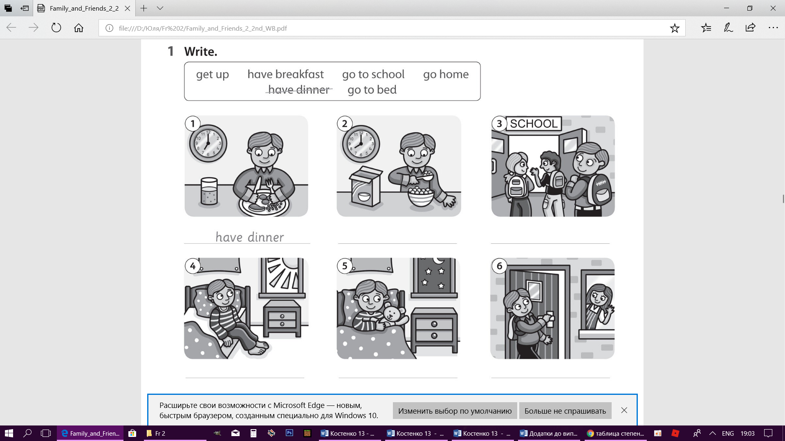

2.Feedback

T: (name) What`s your favourite activity?

What do you like doing?

Children who answer correctly get signs.

Exercise 2

T: So, let`s do the next exercise. Please, finish the sentences. Ok (name), read number one…good, (name) number two...excellent… (don`t forget to give signs to excellent pupils)

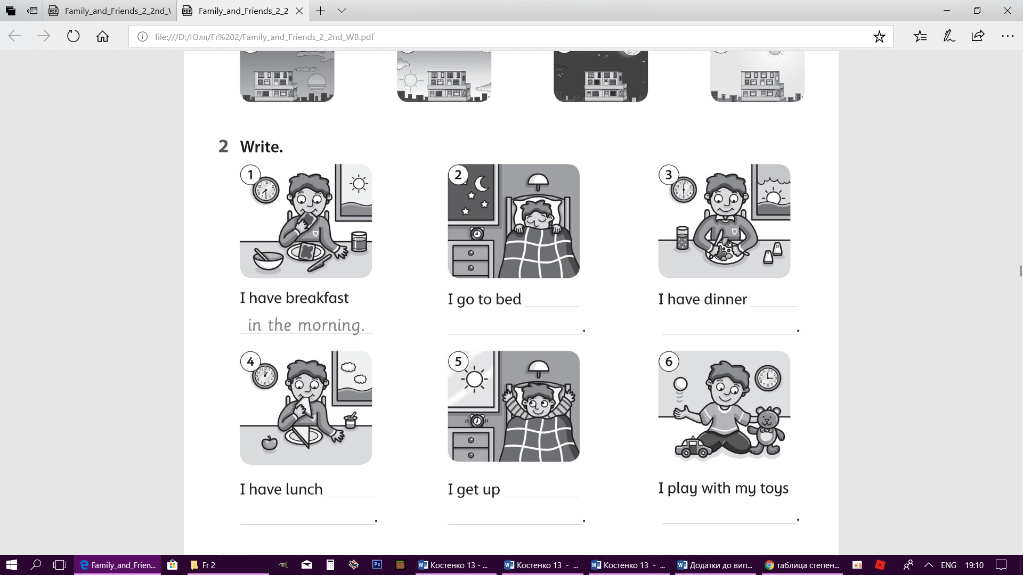

Results

T: Now our lesson is nearly over and I want you to count your signs. Who gets… signs-your mark is…Please, open your dairies and write down your homework…

T: Goodbye, my pupils. See you soon. Don`t forget about your marks, give me your dairies.