**Topic:** Where Were You?

**Grammar** *Past Simple Tense*

**Structure:**  A: Where were you last Tuesday?

B: I was at the park.

A: What did you do there?

B: I went jogging.

**Objectives:**

By the end of this lesson students will be able to:

1. Identify the places and activities they did in the past

2. Ask and answer about what happened in the past

Procedure

**Warm-up:** Greeting.

1. Having shown pictures to the class, the teacher asks students to look at pictures of different activities and randomly asks a few students to review the past simple-tense questions they learnt from a previous class.

*For example,*

The teacher shows the school picture and asks

T: Were you at school last Monday?

Ss: (Yes, I was. / No, I wasn’t.)

T: Where were you yesterday?

Ss: (Answers must related to the place shown in the picture)

T: What did you do there? etc.

Ss: (Answers must related to the activity shown in the picture)







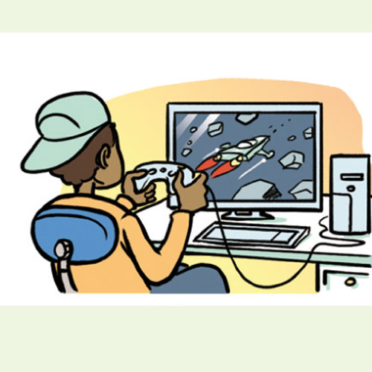



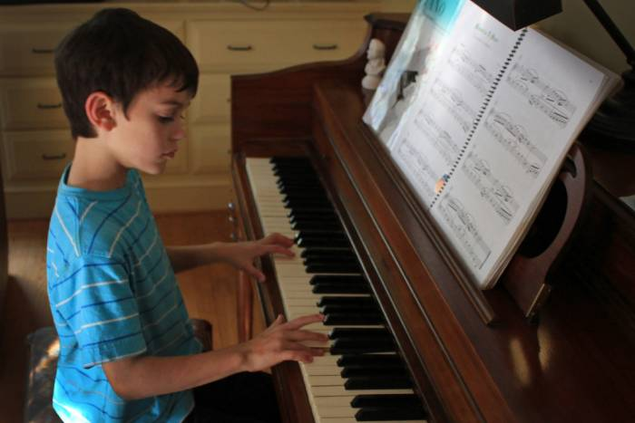

2. The class brainstorms on words and phrases about other activities. The teacher organizes on board as a word mind map about frequent activities, such as hang out, study extra class, have a meeting, etc.

3. Having distributed pictures to the class, students are supposed to match the vocabularies about activities with their pictures.

4. The teacher randomly asks 5-8 students to rehearse answering past simple-tense questions that they are going to talk during the task.

T: Where were you last Tuesday?

Ss: I was at the beach.

T: What did you do there?

Ss: I went swimming/ I played the ball.

………………

T: Were you at the park last week?

Ss: Yes, I was, on Tuesday.

T: What did you do there?

Ss: I went jogging.

5. Students are assumed that they were on vacation last week.

- The students choose *five* places and write the day they were at each place: M, Tu., W., Th., F. in the box next to the selected pictures of different places.

- The students write one activity they did at each place on the line below.

6. The students find out where their partner was on Monday through Friday last week and explain what activity they did on each particular day.

7. - The students walk around and talk to their classmates. They are supposed to find someone who went to any place that they or their partner did not go. The students write the day and a sentence for what their classmates did at each picture.

8. In a group of five, students sit in circle. Using their result of the Mini survey, everyone writes seven sentences about where their friends were and did each day last week.

9. Resuming the lesson, grading.