**The World of Nature.**

**Objectives:**

-to revise vocabulary related to topic;

-to develop all types of pupils’ language skills;

-to acquaint pupils with English children’s poetry related to the topic;

-to develop pupils’ creative thinking and attention;

-to encourage pupils to the work in groups.

**Procedure**

**I Warming up.**

**T:** Good morning ,children! I am glad to see you. Today many guests have come to our classroom. They are all teachers. Greet them, please.

**Pupils:** Good morning, teachers.(учні розміщені в центрі класу по колу сидячі)

**T:** Sit down, please. How are you?

Pupil:I am fine.P2:I am fantastic, happy (etc.) **T**: If you are happy, I am happy too.Today we are going to speak about the world of nature. We are going to refresh lexical and grammar material,do different activities and play games.I want you to be active and diligent at the lesson.

First let’s interview each other for our guests to know you better. *(dialogues Olena-Maksym, Uliana-Julia, Ira-Sasha).*

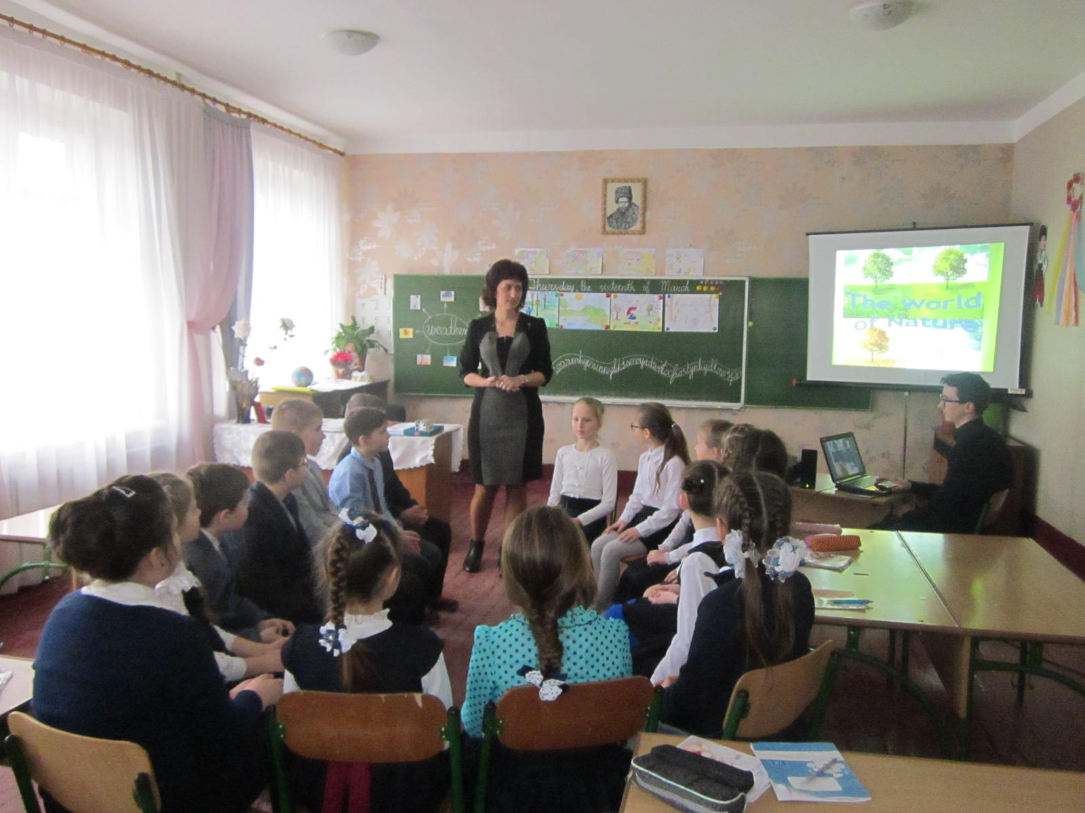

**T:** And, now let’s do our favourite activity ***wondering box*** (While music is playing, you are passing a box each other, when music stops, you have to throw out the questions from the box and answer it). Let’s start. (e.g.Name two yellow fruit. Turn aroud and clap your hands)

It’s time to form you in groups. Choose the card of colour you like and take your seats according to the colours on your desks. (учні сідають по групах за парти)

**II Vocabulary revision.**

**T:** Children, look at the pictures and answer my questions.

1. How many seasons are there in a year?
2. What are they?
3. What season is it now?
4. What is the weather like in spring?
5. What are spring months? Listen to the poem .One pupil recites:

Spring -the season of delight

Apple blossoms- pink and white

Welcome sping with all your joys for merry boys and merry girls.

1. What kind of season is spring?

And now let`s listen to the melody of spring(pupils watch slide-show”Melody of spring”

1. What changes can you notice in spring nature? Say one sentence about spring and stick apple blossom on the bare branch. Help the apple branch to blossom.

P1:Spring is a beautiful season.P2:Everything is green and fresh in spring.P3:Birds build their nests and sing merrily.P3:Snowdrops are the first spring flowers and etc.

1. Look at this picture (summer) What season is it?
2. What’s the weather like in summer?
3. What are summer months?
4. What season comes after summer?
5. What’s the weather like in autumn?
6. What season is it (winter)?
7. What’s the weather like in winter?
8. How many months are there in a year?

Let’s call out the 12 months!(Pupils recite the poem

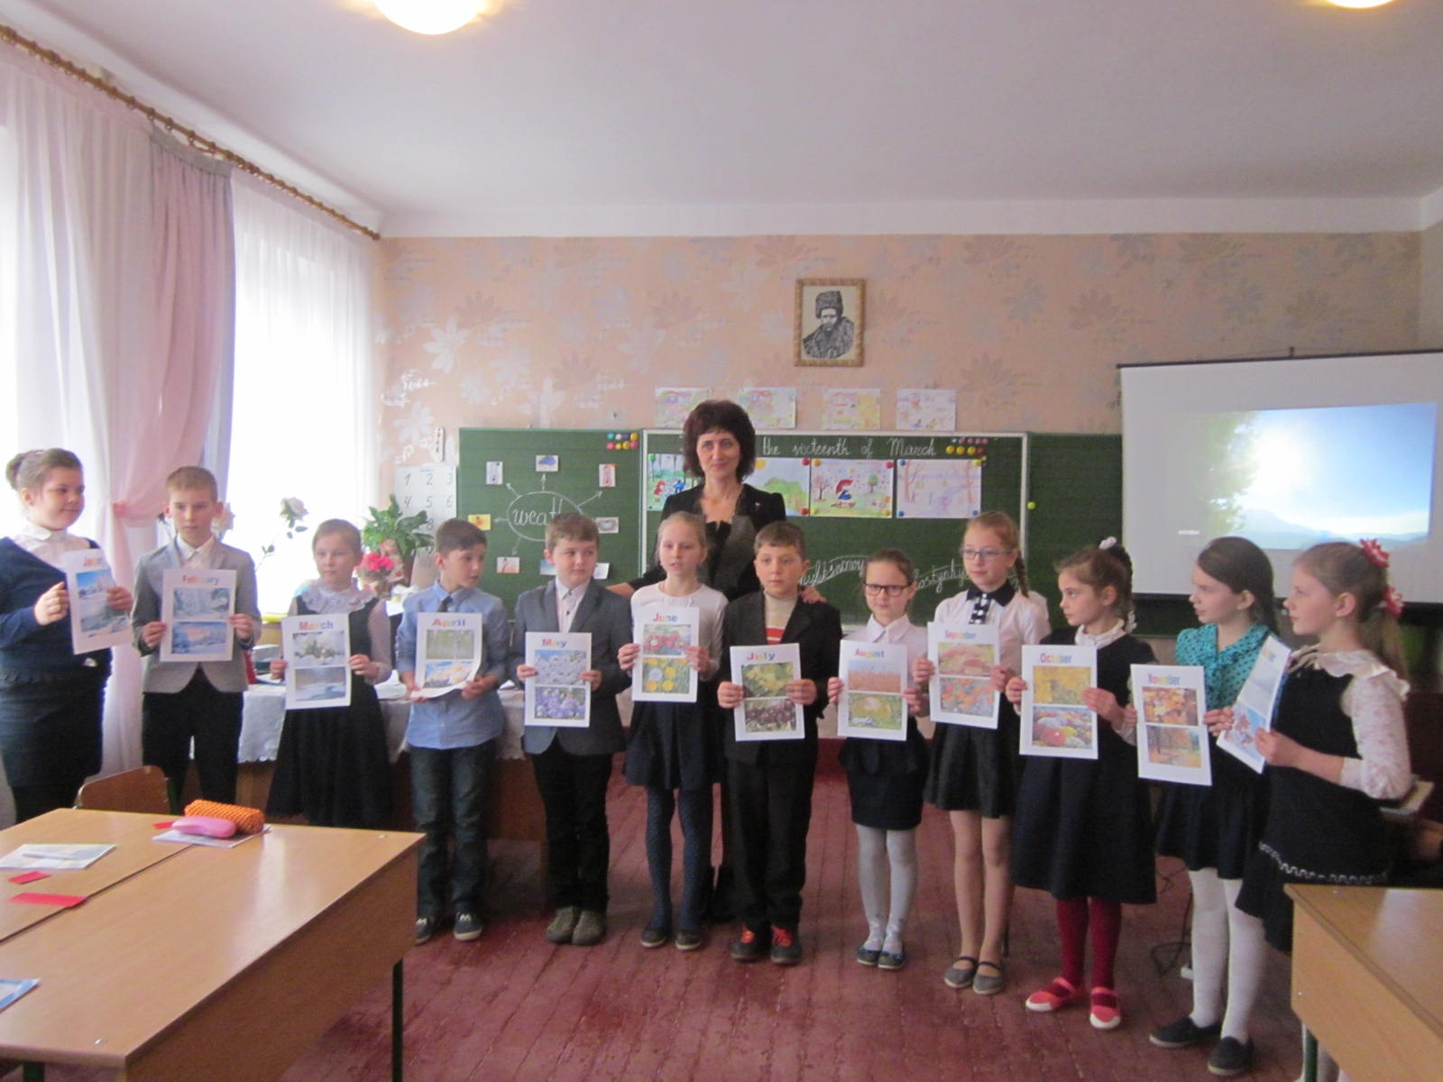

**January** brings the snow ,makes our feet and fingers glow;

**February** snows again and sometimes it brings us rain

**March** brings sunny days and winds, so we know that spring begins

**April** brings the primrose sweet ,we see daisies at our feet

**May** brings flowers,joy and grass and the holidays for us,

**June** brigs tulips,lilies ,roses fills the children's hands with posies;

Hot **July** brings apples and cherries and a lot of other berries;

**August**  brings us golden corn, then the harvest home is born.

Warm **September** brings us school , days are shorter, nights are cool.

Fresh **October**  brings much fruit ,Then to gather them is good

Red **November** brings us joy, Fun for every girl and boy

Cold **December** brings us skating , For the New Year we are waiting.

Teacher: It`s time to sing a song (Pupils watch video ``What is your favourite season``

**Ball-game** What`s your favourite season?)

Pupils` answers:

-I like spring because the nature awakens from the winter sleep.I like warm weather.

-My favourite season is summer because I like summer holidays and l like swimming and playing outdoors.

-I like autumn .It`s a rich season I like eating watermelons and apples.

-I like winter .I like snowy and frosty weather .I can ski and skate .

**Vocabulary Practice**

**Word-chain**

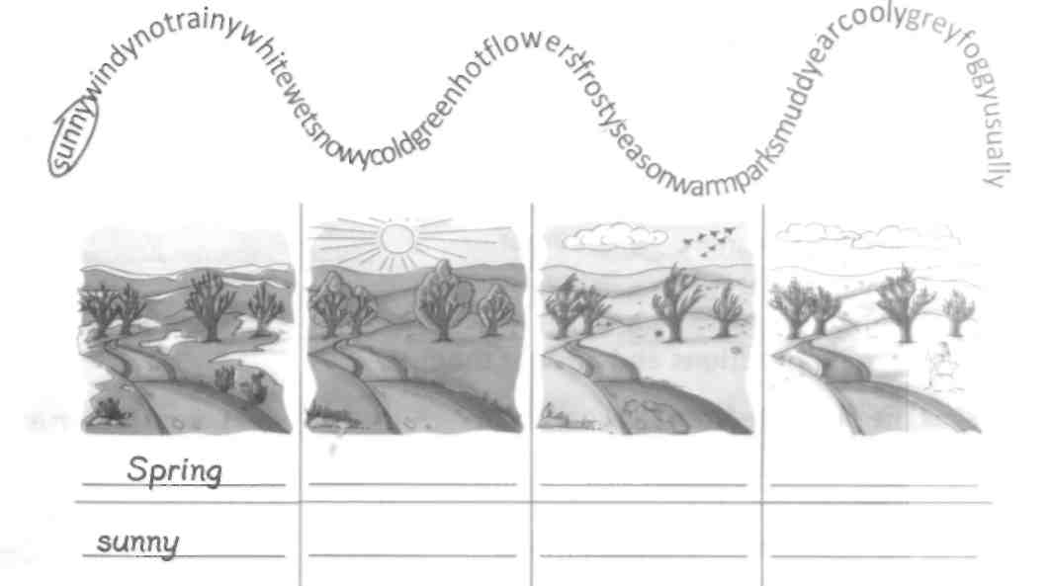Find and circle the weather-words and write them in the correct columns according to the season.

**Brainstorming**

Which adjectives can you use to describe the word **weather.**

These pictures will help you.(There are weather cards on the blackboard)

Pupils` ideas:

WEATHER

cold windy

hot rainy

frosty wet

snowy cloudy

cool foggy

**T:** Say what weather do you like and which dislike.

**Pupils:** I like …..

I don’t like …..

**T:** Everyone can find some favourite occupation in any weather.

**Pair-work**

Choose any card you like and your partner has to respond.

e.g.P1 It’s rainy today ….. . P2Let’s stay at home and play chess.

Choose the picture and respond.

**Relaxation.**

**Miming game** ( One pupil mime action verb e.g. play games, watch TV, ski, ride a bike…), another guess what the verb is.

**Practice**

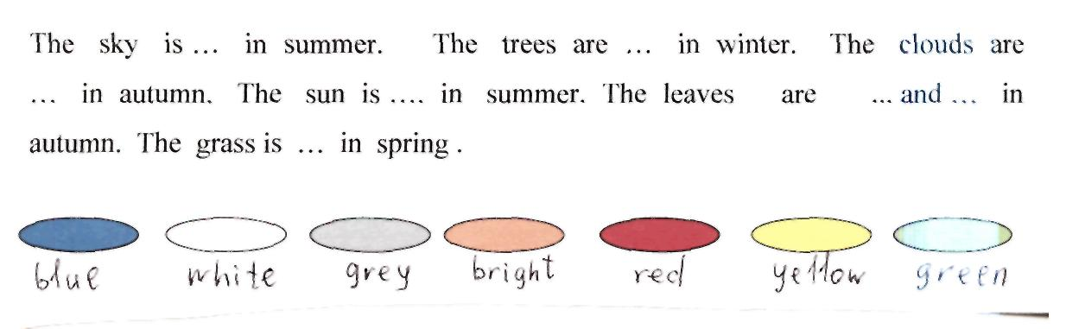**T:** Every season has its colour. Complete the sentences using colour.

**Weather Quiz.(**аудіювання з елементами прогнозування)

Complete my sentences:

1. There are 12 months in a ….. (year).
2. June, July and August are ….. (summer months).
3. It often rains in …..(autumn).
4. It usually snows in …..(winter).
5. The snow melts in ….. (spring).
6. The trees are in blossom in …..(spring).
7. The coldest season is …..(winter).
8. The leaves fall down from the trees in ….. (autumn).
9. Christmas is in ….. (winter).
10. The streets are slippery in ….. (winter).
11. Easter is in …..(spring).
12. March, April and May are ….. (spring) months.
13. We eat strawberries in ….. (summer).

**Grammar practice.**

**T:** Look at the blackboard and connect the verb with the pronouns.

It I We You

were

was

He She they

And now look at the screen. Use the table and make up sentences.

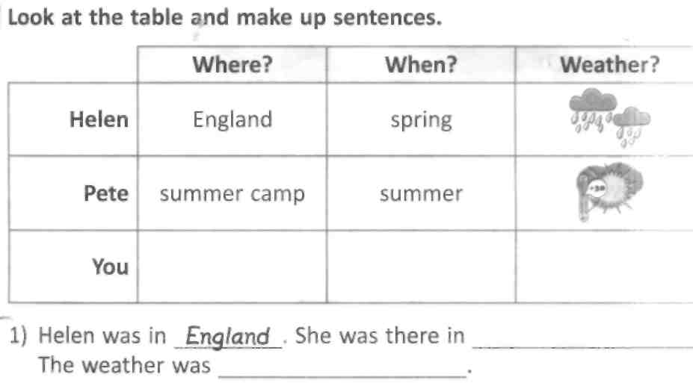

**T:** One of our classmate was in Belgium last year. Ask him questions about the weather.

You are welcome:

1. Was it snowy in Belgium?
2. Was it hot in summer?
3. Did it rain in autumn?
4. What was the weather in spring?
5. How did you spend your summer holidays?

**T:** Let’s stand in a circle. Say spring, summer, autumn, winter.(regrouping). Pupils are split into 4 groups.

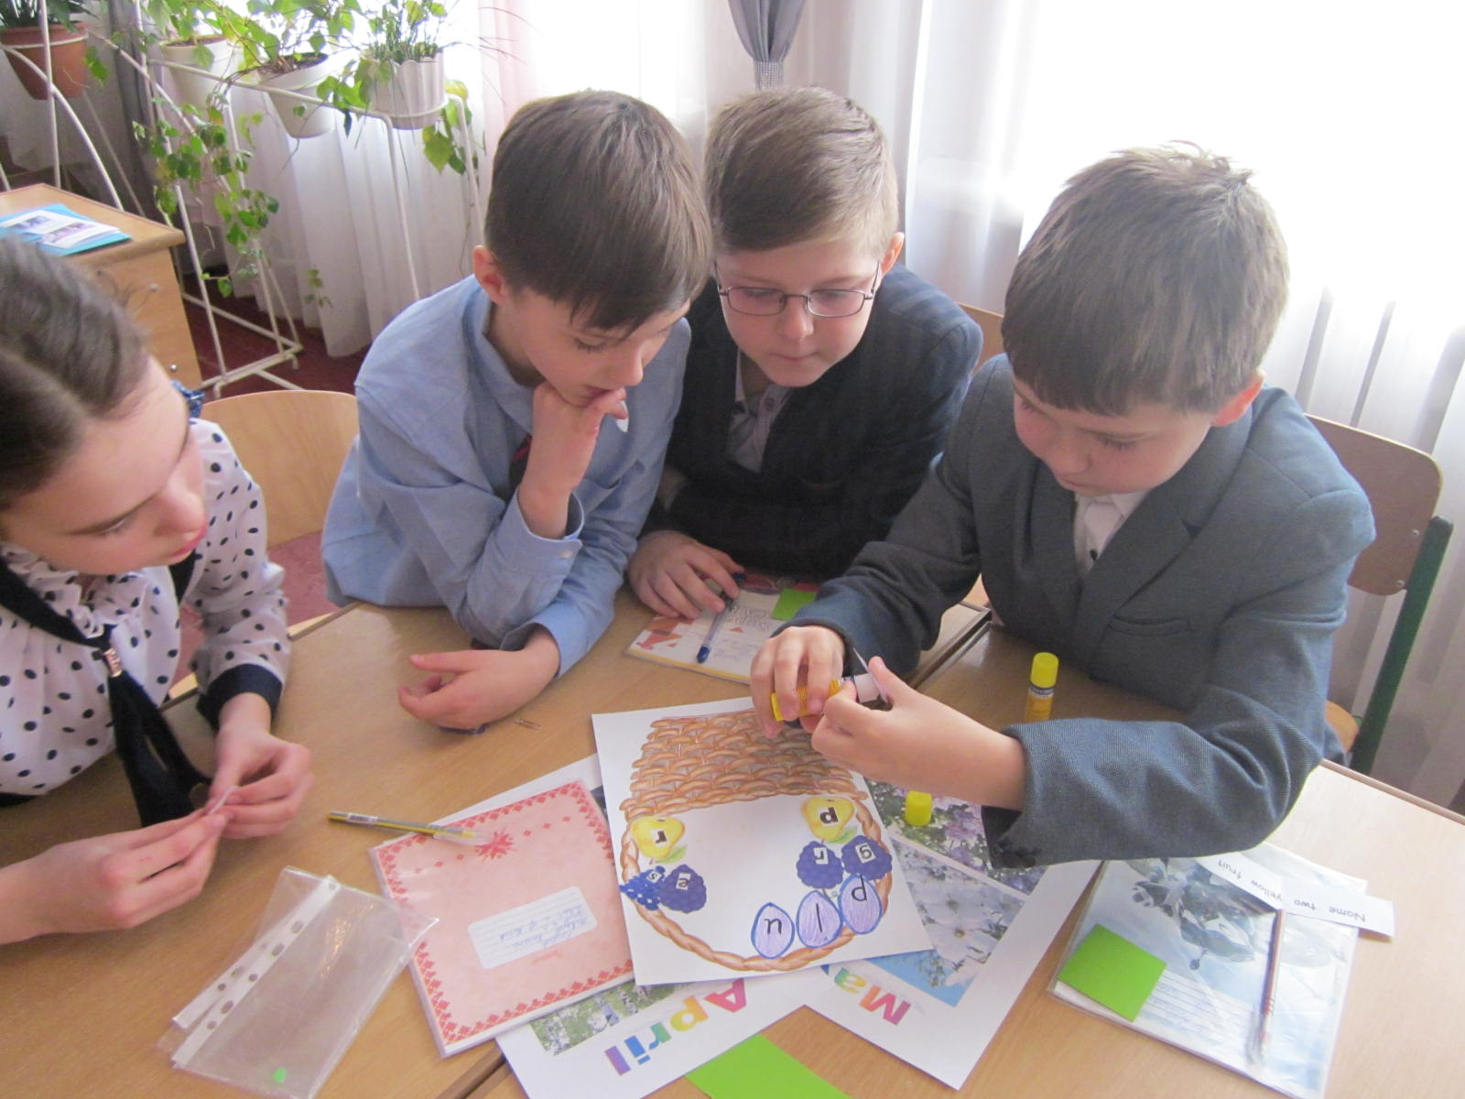 I have got a spring basket, summer basket, autumn and winter basket. Each group is given a picture of basket with scrambled words and they have to unscramble the words)

Teacher:

It’s time to refresh degrees of comparison.

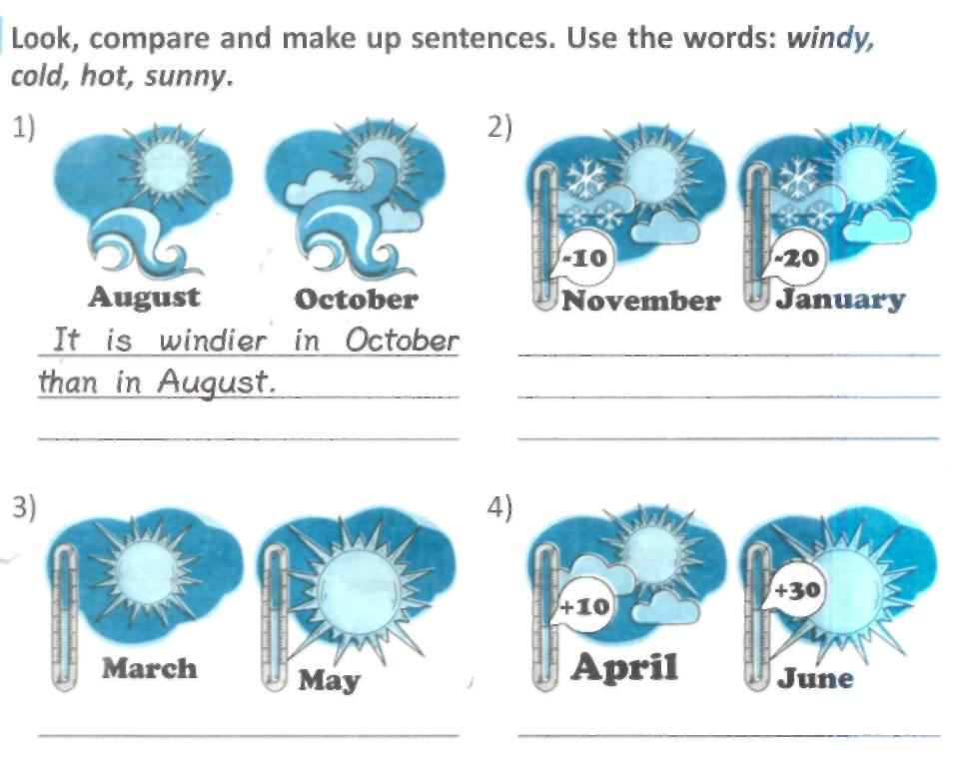

Relaxation -video ``Happy Dance``

**Reading.**

T:Pre-reading Which planet do we live on?

P1:We live on the earth.

Reading  **The Earth**

We live on Earth. It is round. There is a lot of water on Earth. It is in rivers, lakes, seas and oceans. The largest of the oceans is the Pacific Ocean1. The Mediterranean Sea is the largest of the seas. There are five continents . The oceans and the seas are between the continents.

There are a lot of forests and fields, hills and mountains on Earth. Men and animals live on it. Different plants grow on it. The Earth is beautiful. It is full of wonders.3

There are large countries and small ones. There are warm countries and cold ones.

Post-reading activities:

***Agree or disagree****.(pupils use red signal cards when they disagree)*

1. The Earth is not round.
2. There is a lot of water on Earth.
3. There are lots of forests and fields, hills and mountains on Earth.
4. There are ten continents.
5. The largest of the oceans is the Atlantic Ocean.
6. The Black sea is the largest.
7. Men and animals live on Earth.
8. Different plants grow on Earth.

**T:** People in different animals live on our planet. Look at the screen and fill in the table.

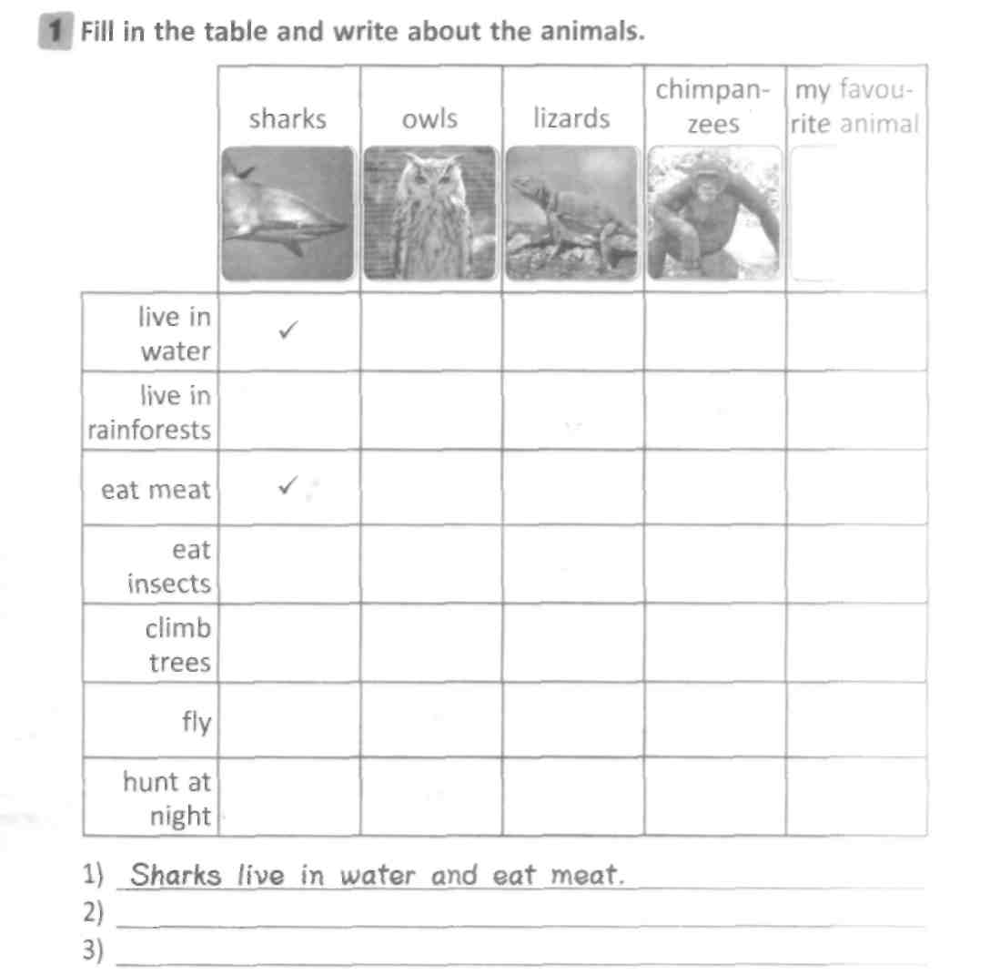

**Game - Hot Seat.**

Describe the picture so that another pupils can guess the word on topic ``Animals``

e.g.1.This animal lives in water.It is dangerous.(a shark)

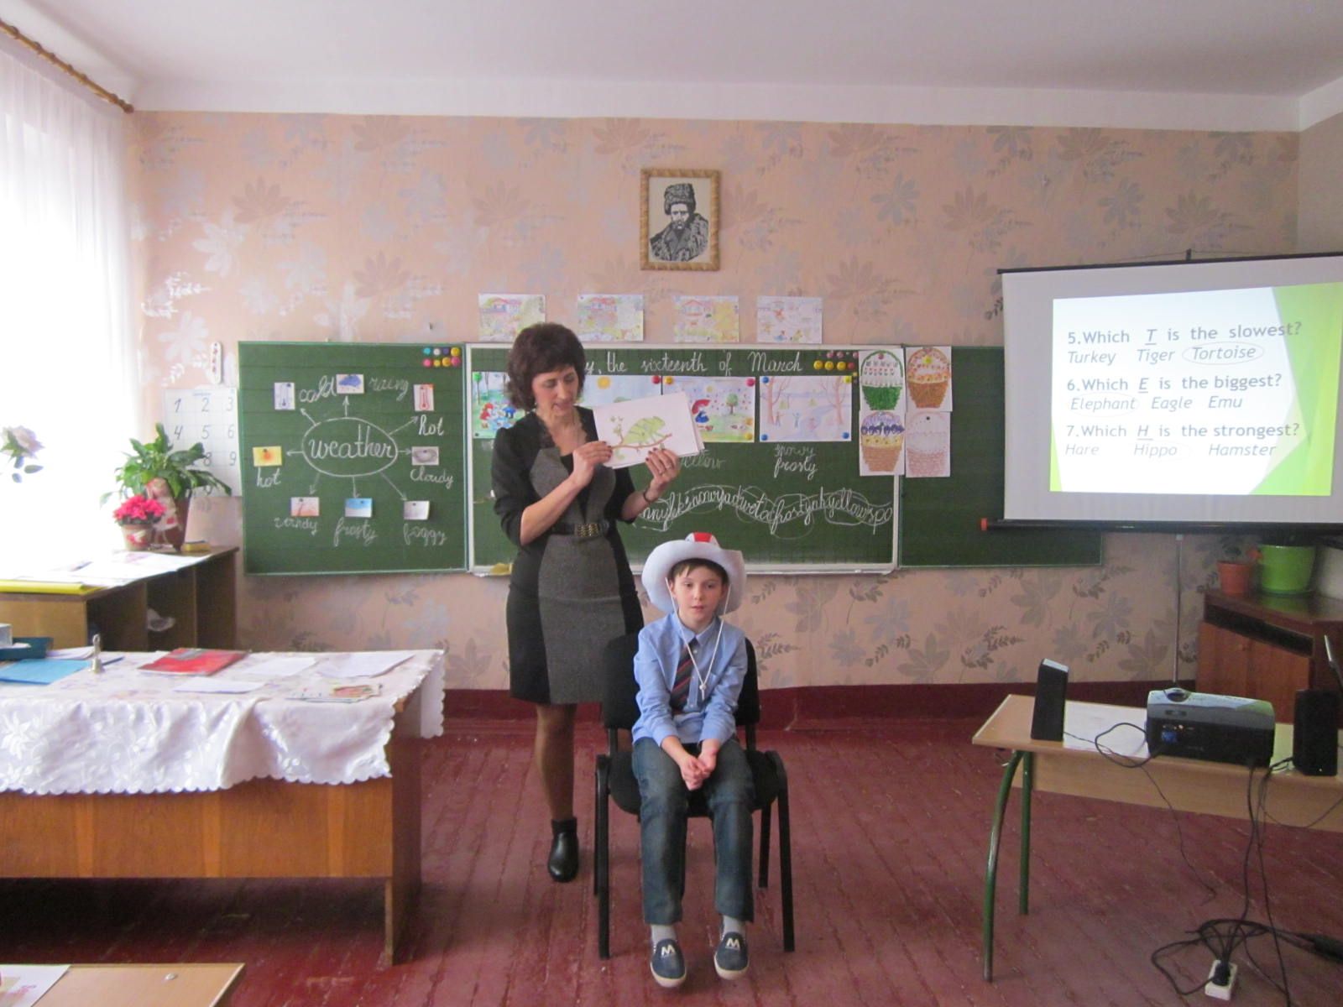 2. This animal eats insects(a lizard) 3.It is big and strong. It lives in Arctic.(a polar bear) 4.It flies and hunts at night.(an owl) 5.It lives in water. It is clever.(a dolphin)

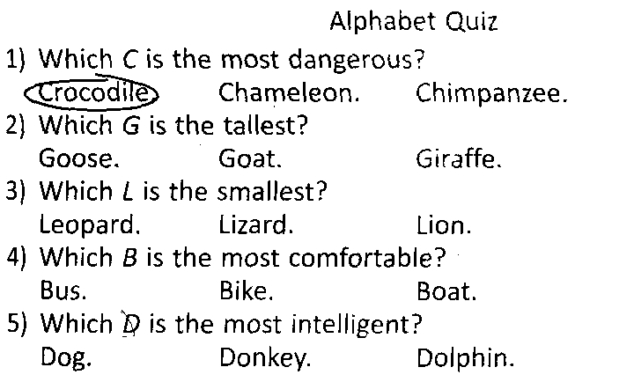

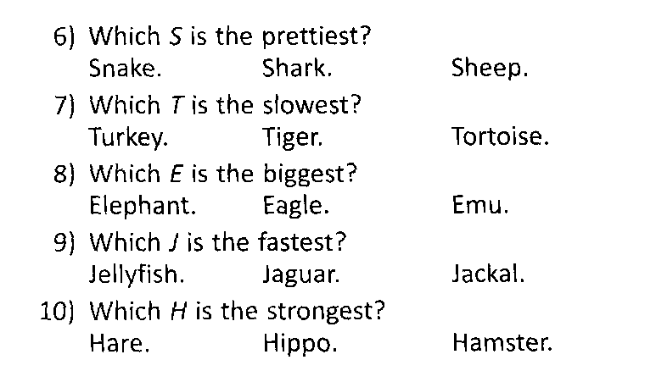

**Use Mingle activity to split learners into groups.**

We have got 4 groups. Each group has to design a poster. Present your poster to the class.

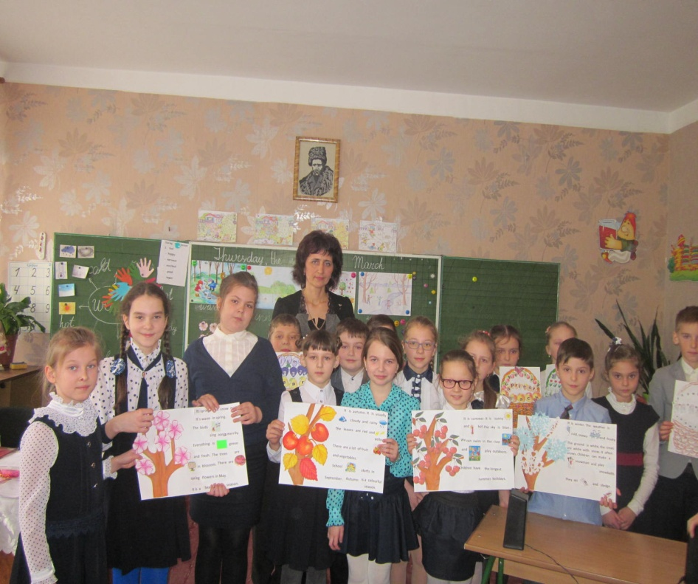

**Feedback.**

Choose the palm you like. Write your name in the middle of the palm. Then write three

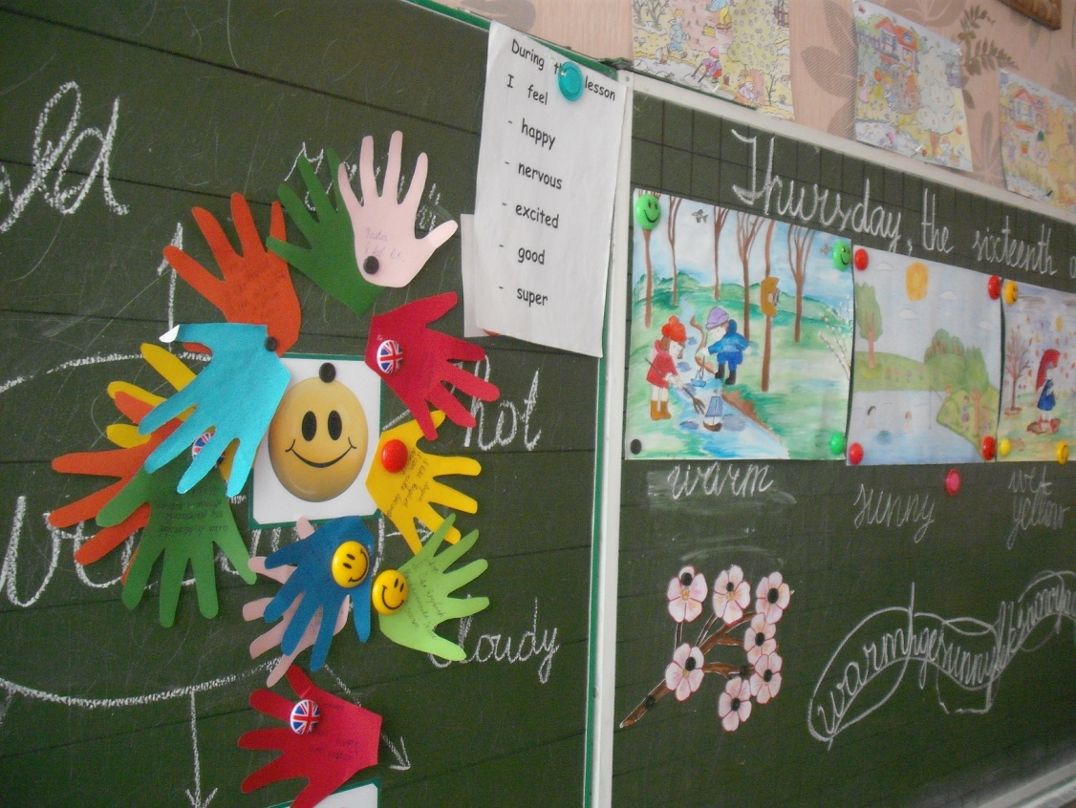 the most important things you’ve learned at the lesson. Stick your palm around positive or negative smile.

One day I came across a poem. It impressed me greatly. Today I want to share this poem with you.

THE BIRD OF LUCK

Every year, spring by spring,

I wait for the Bird of Luck.

She visits us in our dreams

And we forget about the dark.

I wish I knew the secret place,

The place where this bird exists

I think that it's so far away,

Somewhere where it's always peace.

I'd like to take this Bird of Luck

And bring it to my Motherland.

And this will give a magic spark

That drives all hardships to the end.

The Bird gives birth to Love and Trust

That flourish in the souls.

So, dear Bird, remember us and visit our homes.

Let’s listen to the Ukrainian version.

Від весни до весни Я чекаю Пташку Щастя.

Вона з'являється у сні, щоб забулось про ненастя.

Де, скажіть її знайти, щоб невдача відступила?

До Вкраїни привезти, щоб надію в нас вселила. Не літай, крилата, всюди,приласкай надію. Ох, чекають тебе люди. Подаруй нам мрію.

Teacher: I wish everyone peaceful and happy life in any weather.

Thank you for the lesson. I give all of you excellent marks.

