«ЛУЦЬКИЙ НАВЧАЛЬНО-ВИХОВНИЙ КОМПЛЕКС  
«ГІМНАЗІЯ № 14 ІМЕНІ ВАСИЛЯ СУХОМЛИНСЬКОГО»

*Відкритий урок*

*з англійської мови*

*на тему:*

«Екскурсія містом»

*Вчитель:*

*Швек І.Ф.*

Form 3

**Topic:** *City tour*

**Level:** elementary

*Objectives:*

* to enrich pupils` knowledge about the activities in places to go;
* to practice their skills in analytical reading and writing;
* to practice vocabulary on the topic;
* to teach listening skills;
* to revise grammar tense forms;
* to develop pupils` creative thinking;
* to develop pupils` communication skills.

***Materials:*** CD 98, piece of paper for each group of children, flashcards.

PROCEDURE

***I. Introduction***

*1*. Greeting

- Good morning, boys and girls! Glad to see you!

How are you? (Fine, super, so-so, not bad, OK).

I see you look great. Are you ready to start the lesson?

2. Speaking about objectives

- So, let’s start our lesson. But repeat the rules of the lesson:

* ***Smile a lot***
* ***Communicate with classmates.***
* ***Enjoy reading and speaking.***
* ***Be creative and active.***

The topic of our lesson is “City tour”. Our lesson is unusual. We’ll visit different places. You’ll get tickets for each task.

3. Phonetic drills

- We’ll have an English excursion. Let’s get use to English:

A FAT CAT SAT ON A MAT AND ATE A FAT RAT

Let’s repeat individual and choral.

4. Warming up

- Today we’ll use the words. You are my echo. Let’s repeat the words:

(hospital, school, airport, police station, fire station, shop, bank, zoo, supermarket)

***II. The main part of the lesson***

5. Checking homework

- Open your books on p.62. Let’s read the story about an English girl.

- Tell me. It’s true or false

a) Molly works at the zoo.

b) Her favourite animals are lions.

c) There are ten elephants at the zoo.

d) Molly gets up at eight o’clock.

e) The tigers eat apples.

f) The animals drink milk.

6. Speaking

- We’ll have a trip to different places. We’ll go on foot. Let’s go!

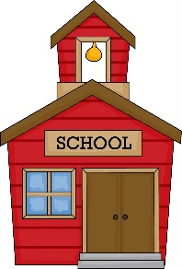- The first stop is **School**. In Lutsk there are 26 schools. Let’s write rules for new school № 27.

* Don’t be late.
* Listen to the teachers.
* Don’t run and jump.
* Raise the hands.
* Don’t talk in class.

7. Project

(put children in groups of four, give a piece of paper and each group makes rules)

So, join a group. You must write rules for your place.

The first group is **“Hospital”**

* 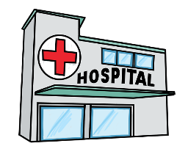Be quiet!
* You must visit a doctor when you are sick!
* Don’t run!
* Don’t wear your coats and hats!

The second group is **“Library”**

* Don’t shout!
* 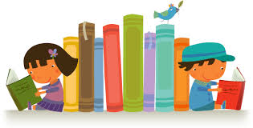You must put the books on the shelf!
* You must turn off your phone!
* Don’t eat!
* Don’t play games!

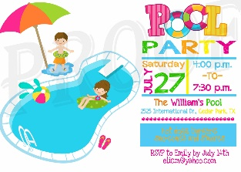The third group is **“Pool”**

* You must have a shower!
* You must wear swimming cap!
* Don’t jump into the pool!
* Don’t eat!

The fourth group is **“Zoo”**

* 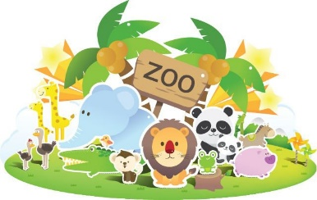Don’t touch the animals!
* Don’t feed the animals!
* You must walk on the path!
* You must put litter in the bin!
* Don’t pick the flowers!

(pupils present their work to the class)



8. Relaxing

- Our next stop is **Karaoke club**. Let’s go!

(pupils sing the song “Places to go” and do actions)

Places to go, things to see,

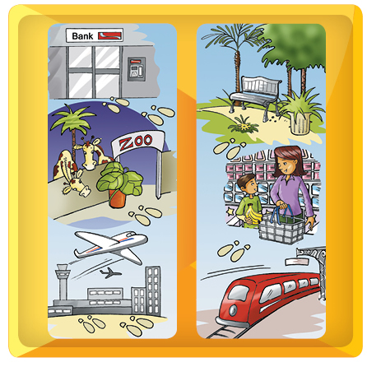Out and about, my mom and me.

We go to the bank,

We go to the park.

We go to the zoo

Until it is dark.

Places to go, things to see,

Out and about, my mom and me.

We go to the airport,

We see some planes.

We go to the station

And see some trains.

Places to go, things to see,

Out and about, my mom and me.

9. Writing

- We must complete the sentences:

***Complete the sentences:***

*(station, zoo, café, pool, park, supermarket, bank, hospital, cinema)*

1. We play with your kite at the _______.

2. We buy fruit and vegetables ________.

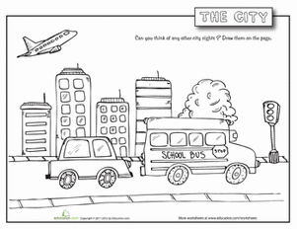3. We swim ___________.

4. We watch films ________.

5. We see the doctor _______.

6. We get on a train _______.

7. We eat food _______.

8. We keep money ______.

9. We see animals ______.

10. Watching the video

- Our next stop is **Cinema.** Let’s watch the video.

(pupils watch and repeat without sound)

* Let’s repeat without sound.

BACERY I buy bread at the bakery.

BANK I keep money in the bank.

BOOKSTORE I buy books at the bookstore.

BUS STOP I catch the bus stop.

CAKE SHOP I buy cakes at the cake shop.

***III. The final part of the lesson***

11. Summarizing

- Our travelling is finished. Did you like it? What stops did you visit?

12. Homework

- Write rules “In the park”

13. Marks

- The last stop is **bank.** You have got happy tickets. Let’s exchange them.

Four tickets – 12

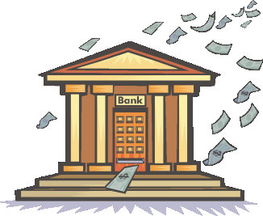Three tickets – 10

Two tickets – 9

One ticket – Try better

* The lesson is over. Good bye.