**THE MITTEN**

***Characters:***

***Grandfather***

***Dog***

***Mouse***

***Fox***

***Wolf***

***Wild Boar***

***Walking Bear***

***Frog***

***Rabbit***

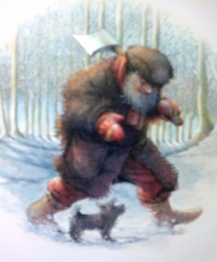 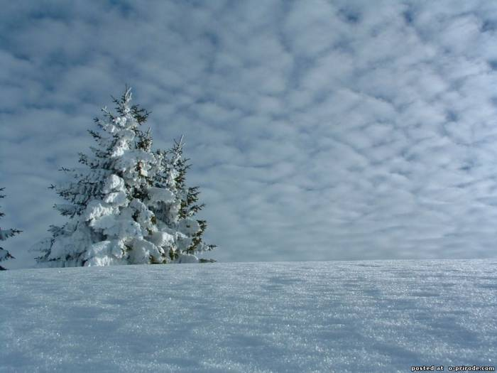

***Narrator :*** *One day an Old man went to the forest for the twigs,*

*He took his dog to help him and lost his mitten between trees.*

*It was cold and snowy winter. The wind was blowing at that time.*

*Grandfather was walking through the snow and knew nothing,*

*He sang his song about village’s life.*

***Jingle Bells***

***Dashing through the snow, in a one – horse open sleigh,***

***Over the fields we go, laughing all the way.***

***Bell on bob – tails ring, making spirits bright,***

***What fun it is to ride and sing a sleighing song tonight.***

***Jingle bells, gingle bells ,gingle all the way.***

***O what fun it is to ride in one – horse open sleigh.***

***Gingle bells , gingle bells, gingle all the way!***

***O what fun it is to ride in a one – horse open sleigh.***

***Narrator:*** *The old brown mitten lay on the glade.*

*A little Grey Mouse was running at that place.*

*She saw the mitten. The Mouse said : 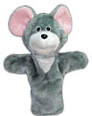*

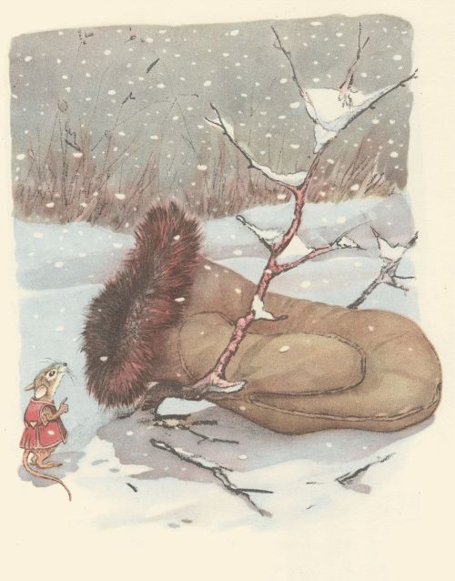

*Plays music…*

***Mouse :***

*What a beautiful warm mitten ! Does anybody live here? This is where I`m going to live!*

*I am a little Grey Mouse. I have no my own house.*

*The winter days are cold and cool.*

*What can I do ?*

*I am not afraid of winter now,because I have a very warm and pretty house.*

*Pee – pee – pee, my legs are cold.*

*I should make them warm and hot.*

*I will make my own flat, after that I will be glad.*

*I will bring some wheet and seeds*

*I will live inside of it !*

***Narrator :*** *So the little Grey Mouse lives in the Mitten – house. She is very happy. Plays music…*

*Then a frog came up and said: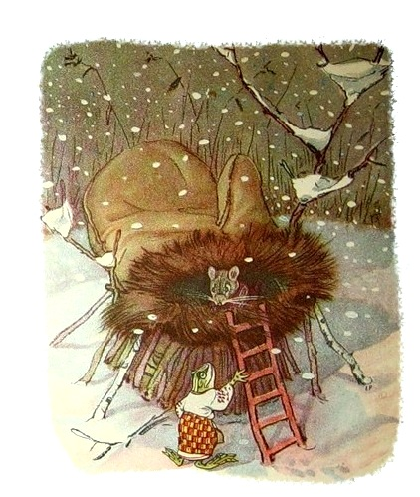*

***Frog :*** *Croak – croak – croak.*

*Who is living in this mitten ?*

***Mouse:*** *I am Squeaking Mouse ! And who are you ?*

***Frog :***  *I am a croaking Frog as you can see !*

*I have no friends to talk with me.*

*My legs are cold and my tummy is cold.*

*I need a nice warm place.*

*Let me go inside. Let`s live together.*

*I will help you to keep the house in order.*

***Mouse :*** *O.K. Jump in!*

***Narrator :***  *Mouse opened slowly door and the Croaking Frog went inside to*

*warm. Now there were two animals in the mitten.*

***Mouse :*** *Look ! The pretty snowflakes*

*Falling from the sky*

*On the trees and house tops*

*Soft and thick they lie.*

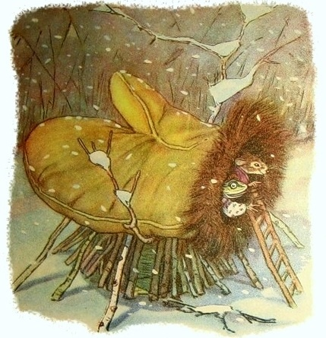***Frog :*** *Now the trees and bushes*

*Look so soft and white.*

*See the snowflakes are falling,*

*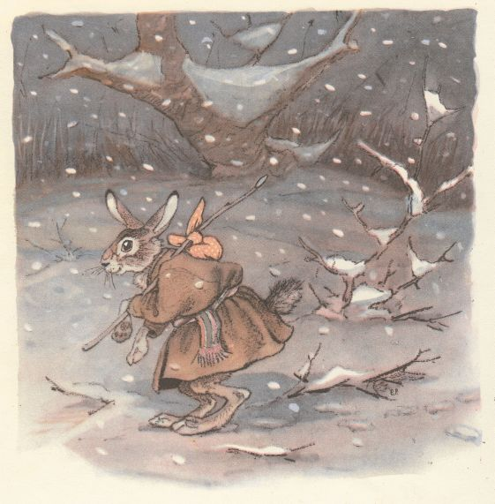 What a pretty sight !*

***Narrator :*** *Dark night was coming to the forest.*

*The wind was cold and strong those days.*

*A poor Fast Rabbit saw the mitten while He was running in the wood.*

*Plays music… He came to the mitten and called out :*

*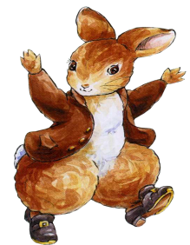****Rabbit:*** *Hello there ! Who is living in this mitten?*

***Mouse :*** *I am Squeaking Mouse and this is Croaking Frog !*

*And who are you ?*

***Rabbit :*** *My name is Fast Rabbit !*

*The mitten is warm and nice.*

*I want to get inside!*

*I have got some tasty food.*

*Let me in and live with you !*

***Mouse and Frog :*** *All right ! Jump in !*

***Narrator :*** *So the Rabbit jumped in and the Mouse and the Frog  
 moved over and the three of them made their home in the mitten.*

*They are living all together. Now they are eating peas pancakes*

*In the forest, in the mitten they became good friends.*

*Berries tea smelt nice in the forest at that night…*

*Suddenly a Fox was running through the forest and saw the old mitten…*

*Plays music…*

*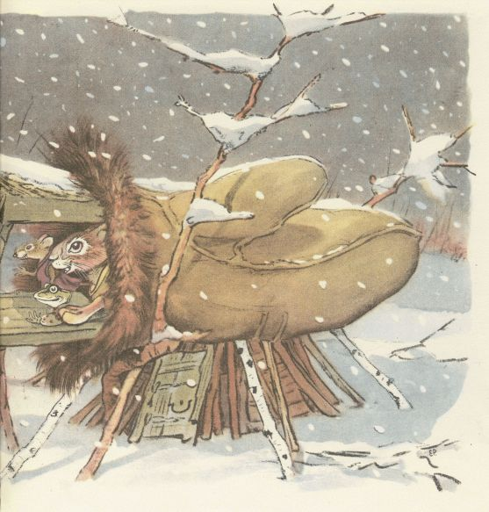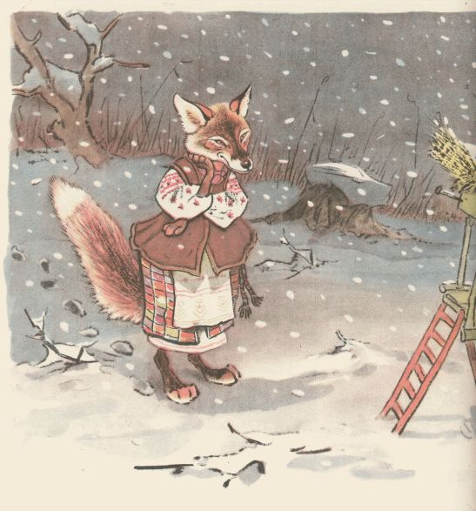She asked :*

*«Who is living in the mitten? »*

***Mouse: I am Sqeaking Mouse and this is Croaking Frog and Fast Rabbit.***

*** And who are you ?***

***Fox : My name is Sister Fox . Please, let me in! Let me in !***

***I will go to the bed in the corner of your flat.***

***I will put my fluffy tail like a pillow on the bed.***

***I`ll keep calm and sleep, please let me in !***

***Mouse , Frog, Rabbit : « All right . Jump in !»***

***Narrator: Just they helped the Sister Fox***

***But the mitten became close!***

***Plays music…***

***Somebody is knoking at the door again and all the animals are afraid of that***

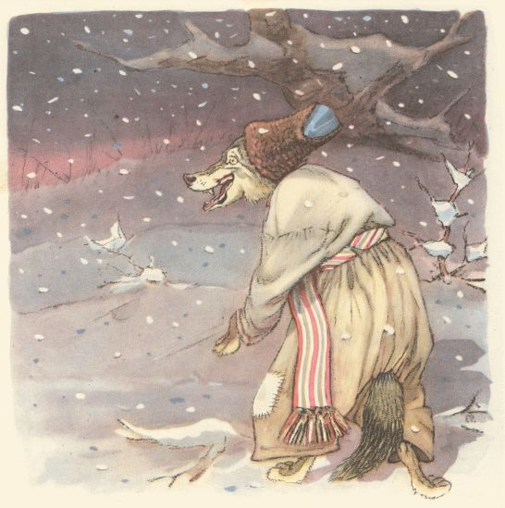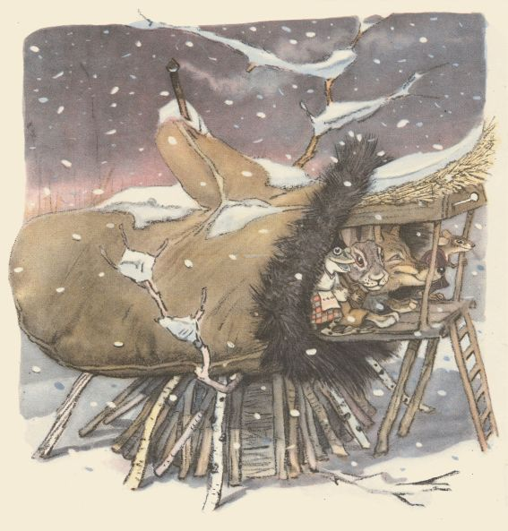

***Wolf: « Hello ,friends ! Who is living***

***in this mitten ? »***

***Animals: « We are. I am Sqeaking Mouse and this is Croaking Frog, Fast***

***Rabbit and Sister Fox. And who are you ? »***

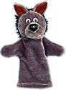 ***Wolf : « My name is Brother Wolf !»***

***My nose is cold ! My ears are cold!***

***Narrator: Grey Wolf is crying near the mitten.***

***Wolf: Open, please! Open the door!***

***May I sit on the floor ?***

***Animals: Yes, you may! Come in, please!***

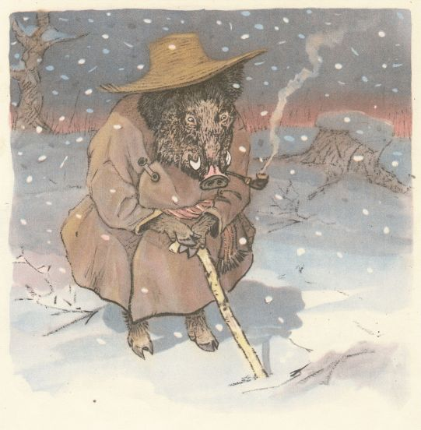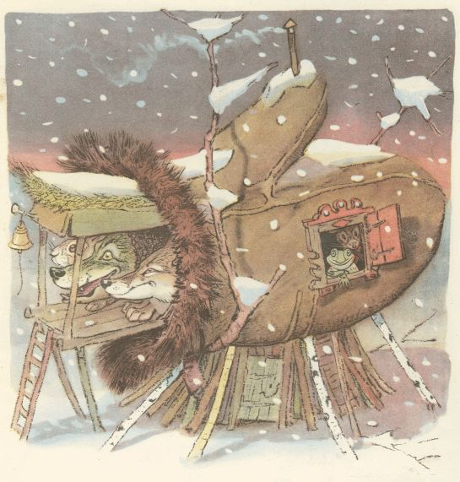***Narrator: Now five animals live in the mitten and here comes a Wild Boar.***

***Plays music…***



***Boar: « Who is living in this mitten ? »***

***Animals : « We are. I am Sqeaking Mouse and this is Croaking Frog, Fast***

***Rabbit , Sister Fox , Grey Wolf . And who are you ? »***

*** Boar: « My name is Buck Tooth Boar ! I am standing at the door.***

***I need some corn to eat. I need some wormth.***

***Animals: « You won`t find it easy to get in!»***

***Boar : « Never mind ! I `ll manage !»***

***Narrator: So the Boar squeezed in and then there were six of them in the mitten and they were so cramped that they couldn`t move !***

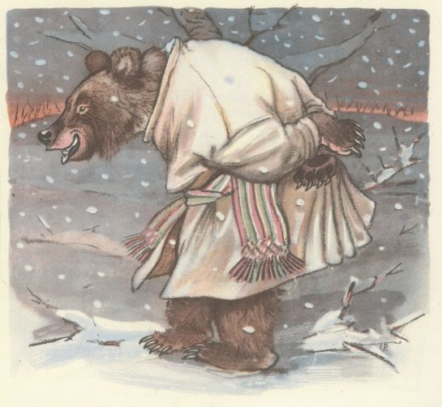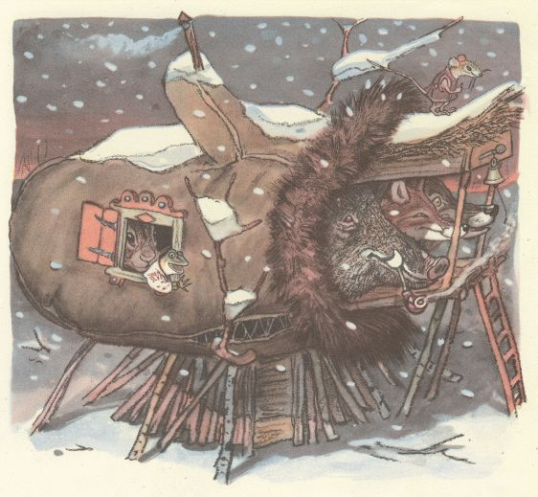

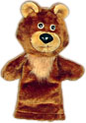 ***By- and- by with a crackling of twigs a bear came to that place.***

***Plays music…***

***He saw the mitten , stopped and bellowed:***

***Walking Bear:« Hello, good people ! Who is living in this mitten? »***

***Animals: We are! I am Sqeaking Mouse and this is Croaking Frog, Fast***

***Rabbit , Sister Fox , Grey Wolf , Buck Tooth Boar !***

***And who are you?***

***Walking Bear: My name is Walking Bear. There are many of you in there.***

***Let me in! May be you will make the room for me ?***

***Animals: « How can we ? We are so cramped ! »***

***Walking Bear: « Somehow I will fit ! »***

***Sister Fox: « So come in, at the edge. Well done !***

***But don`t forget that you` re not the only one! »***

***Walking Bear: O.K !***

***Narrator : So the Bear squeezed in too and now there were seven of them***

***in the mitten.***

***It was getting very crowded inside the mitten. It almost ripped.***

***It was just about then that the old man missed his mitten***

***and decided to go back for it.***

***He walked and walked and his dog ran ahead and ran until at last he saw the mitten lying in the snow and moving.***

***The dog began barking: « Bow- wow – wow »***

***All the animals inside the mitten were so frightened that***

***they jumped and ran away as fast as their legs could carry them.***

***The grandfather picked up his mitten and put it into his pocket…***

