Theme: An apple a day

Situation: “Eat well – feel well”.

By the end of the lesson pupils will be able to…

- Use new words, words – combinations and expressions.

- Related to theme Healthy food. Eat well – feel well.

- Practice new phrases to ask for help, advice and to respond them.

- Answer the questions after reading the text.

- Complete the sentences after reading the text.

- Match the words with their definitions.

- Present their own research on the topic given before.

- Present their own recipe.

Equipment: multimedia whiteboard, projector, laptop computer, boards with sayings and proverbs about food, table with pictures, ways to be healthy, text to read(HO)

Procedure

Greeting:

Good morning pupils. I’m glad to see you. How are you?

Lets start our lesson

What we’ll speak about? Now you’ll see some proverbs. I suppose, you’ll guess.

Match the proverbs with their equivalents.

1. Tastes differ.
2. An apple a day keeps the doctor away.
3. The appetite comes with eating.
4. Too much butter won’t spoil the porridge.
5. Хто по яблуку за день з’їдає – той лікаря не відвідує.
6. Кашу маслом не зіпсуєш .
7. Про смаки не суперечать.
8. Апетит приходить під час їжі.

На екрані картинки з підписами:

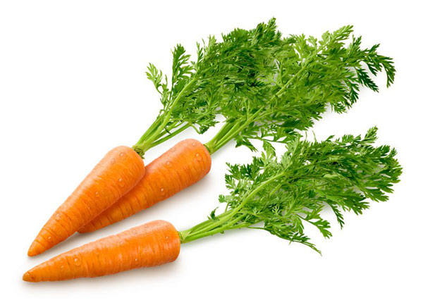

Carrot

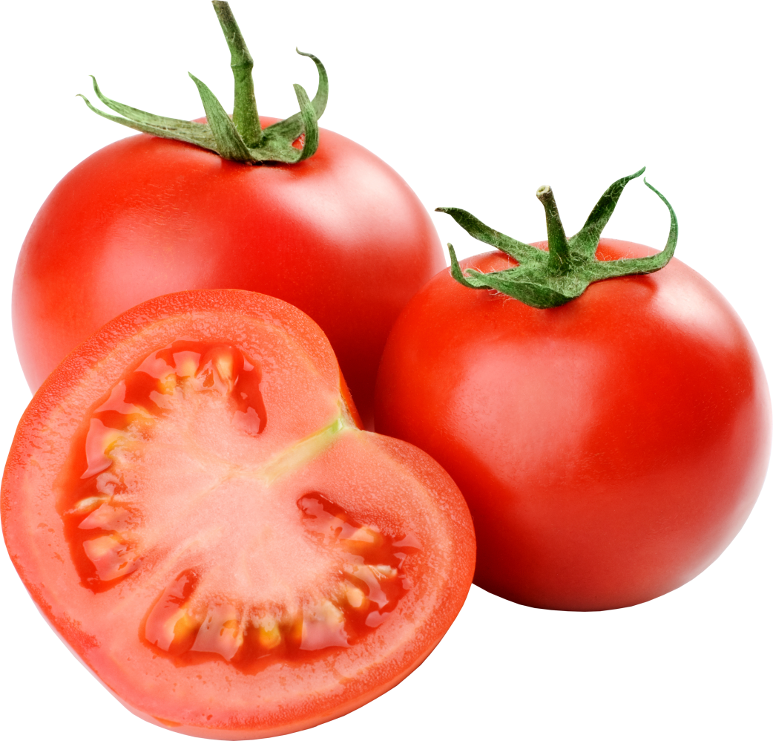

Tomato

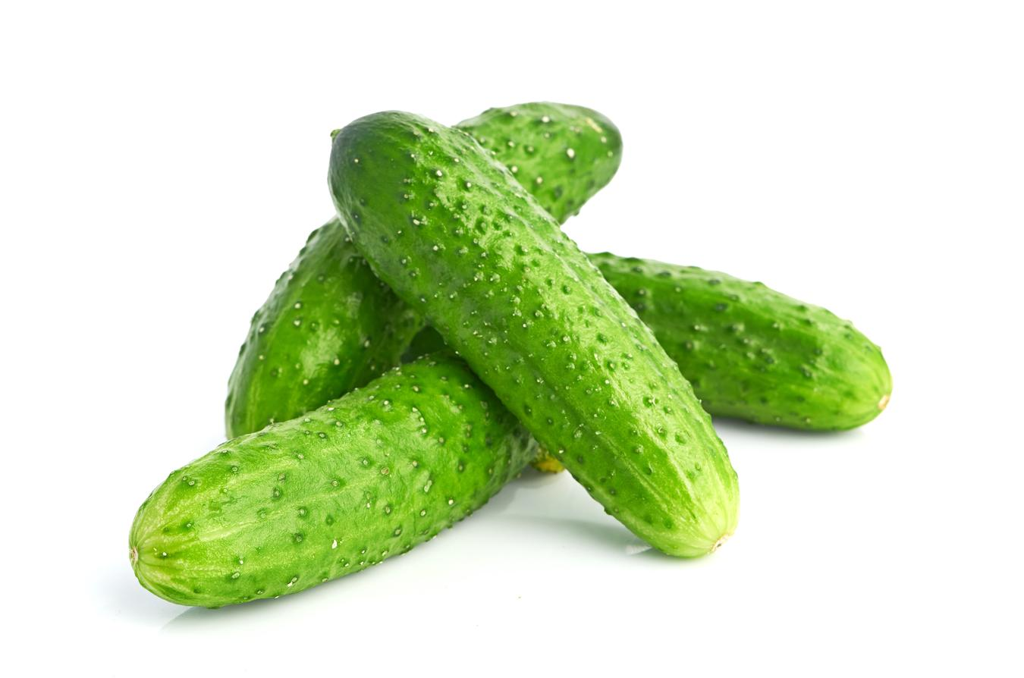

Cucumber

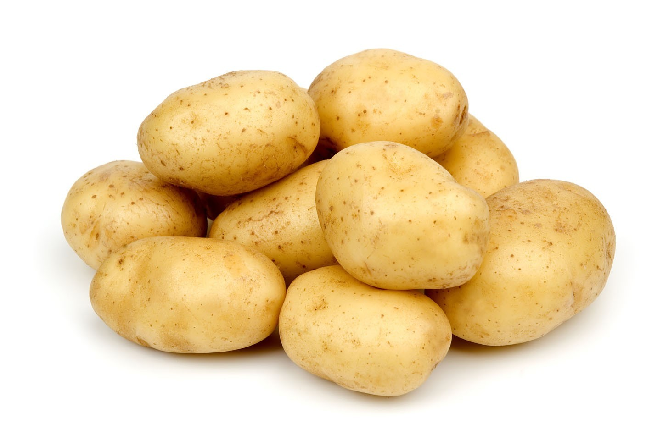

Potatoes

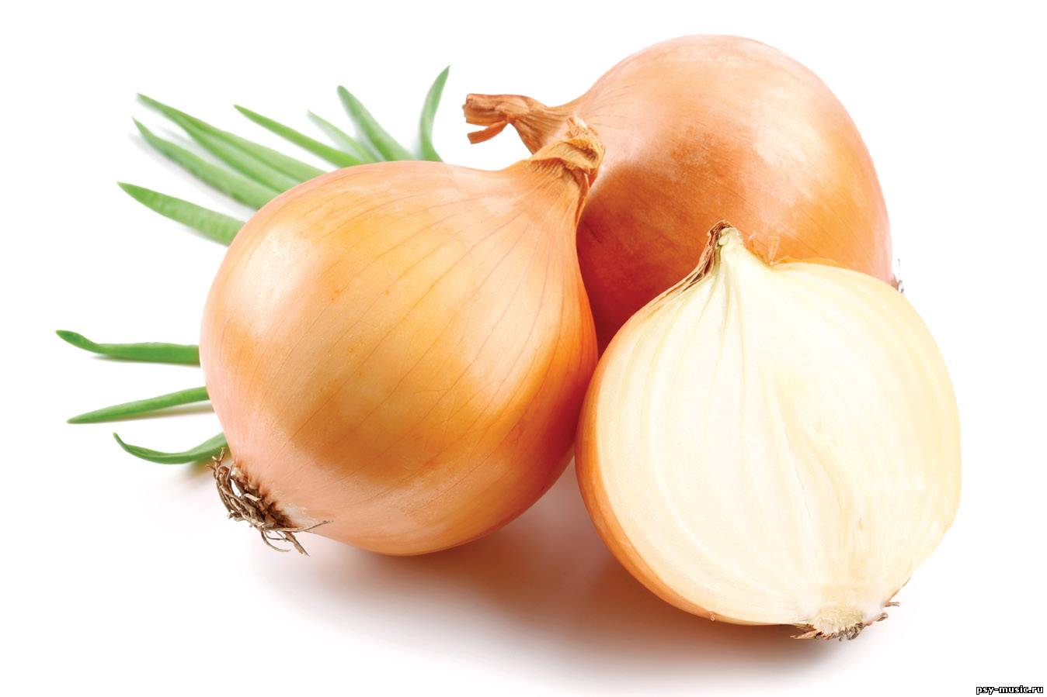

Onions

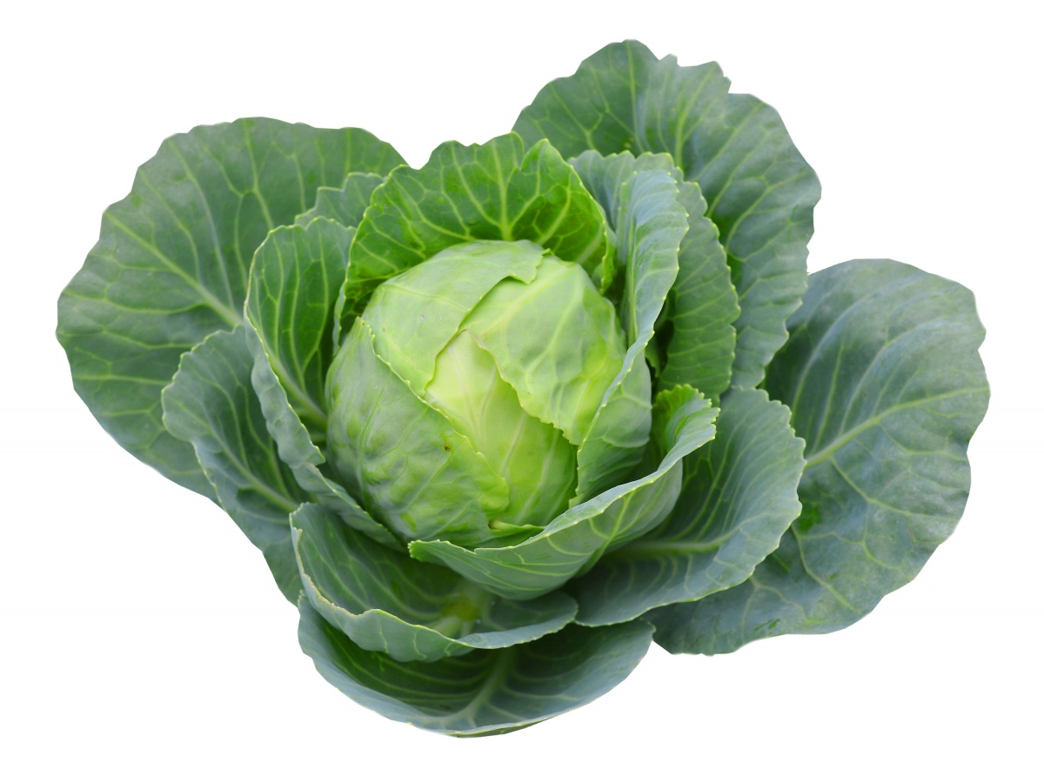

Cabbage

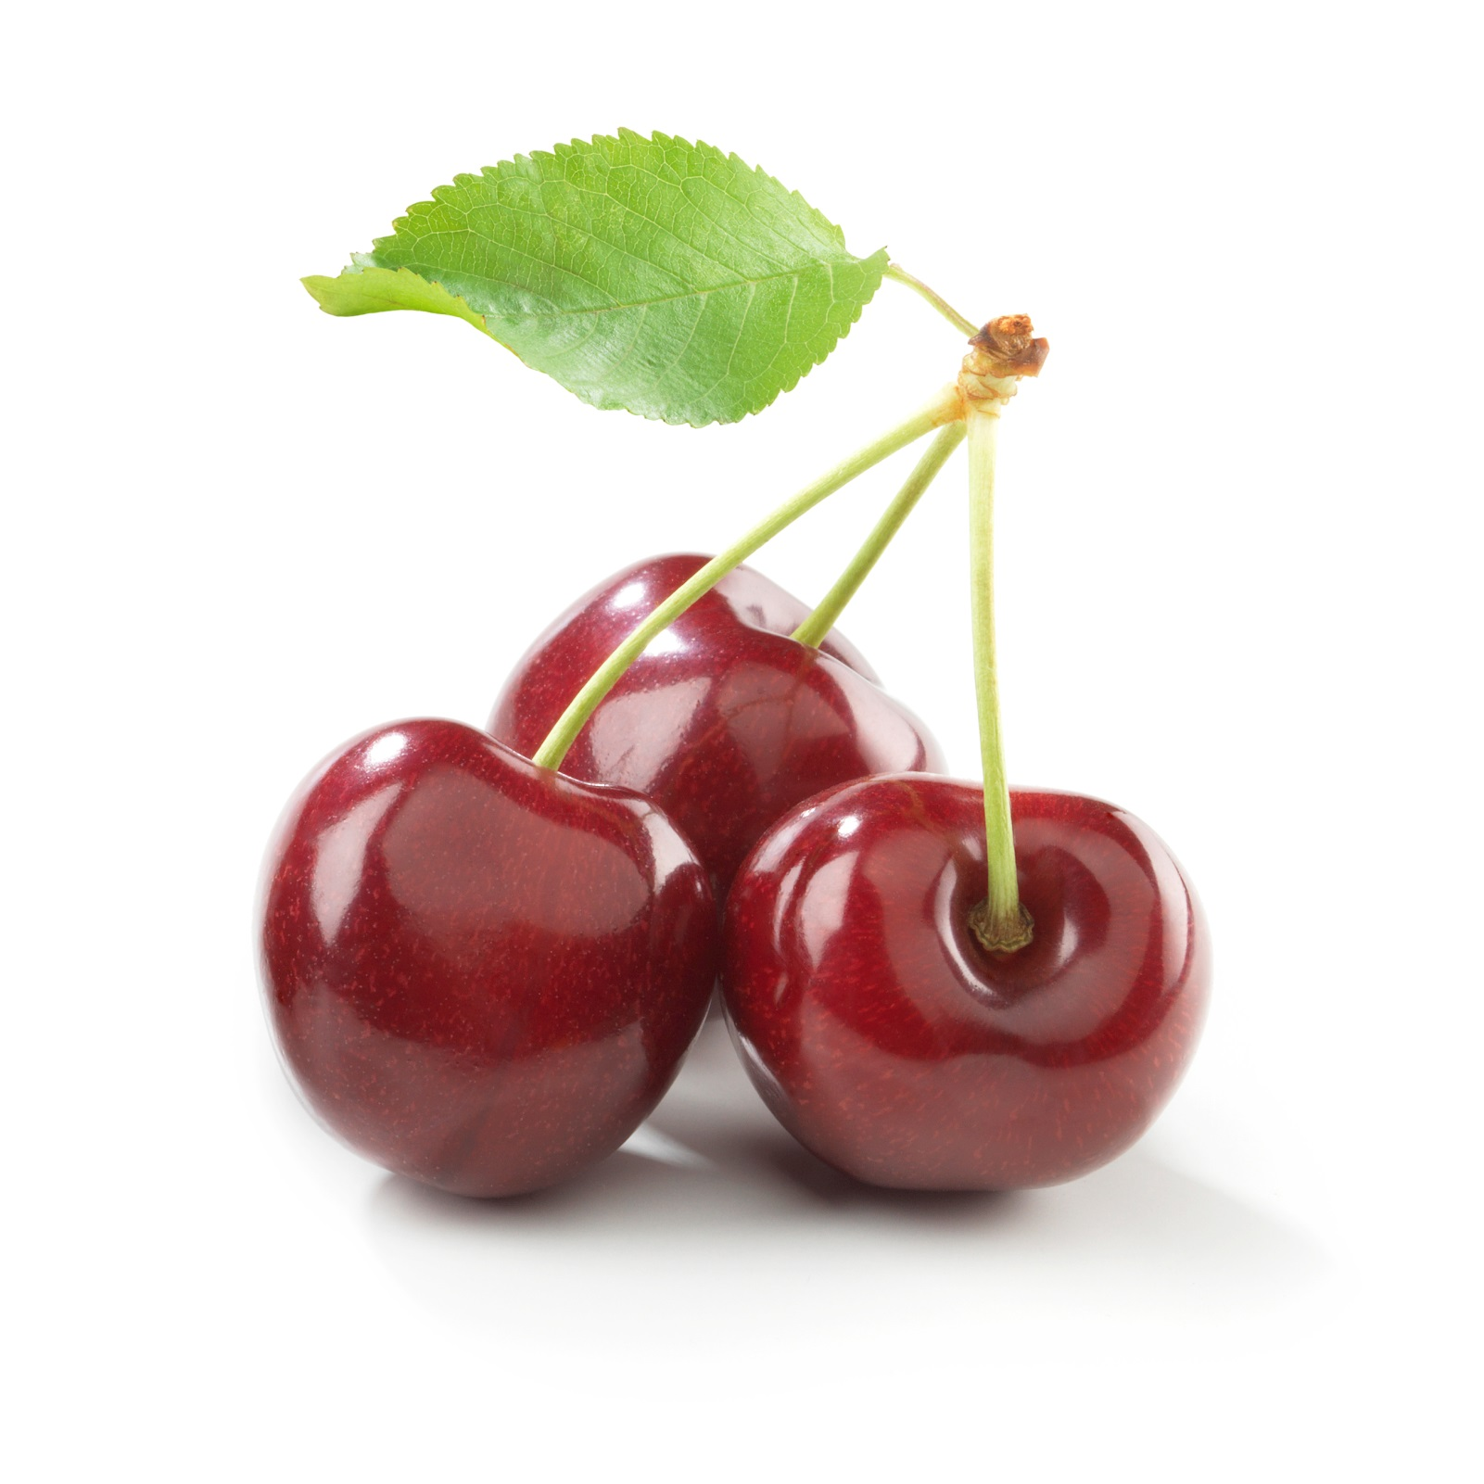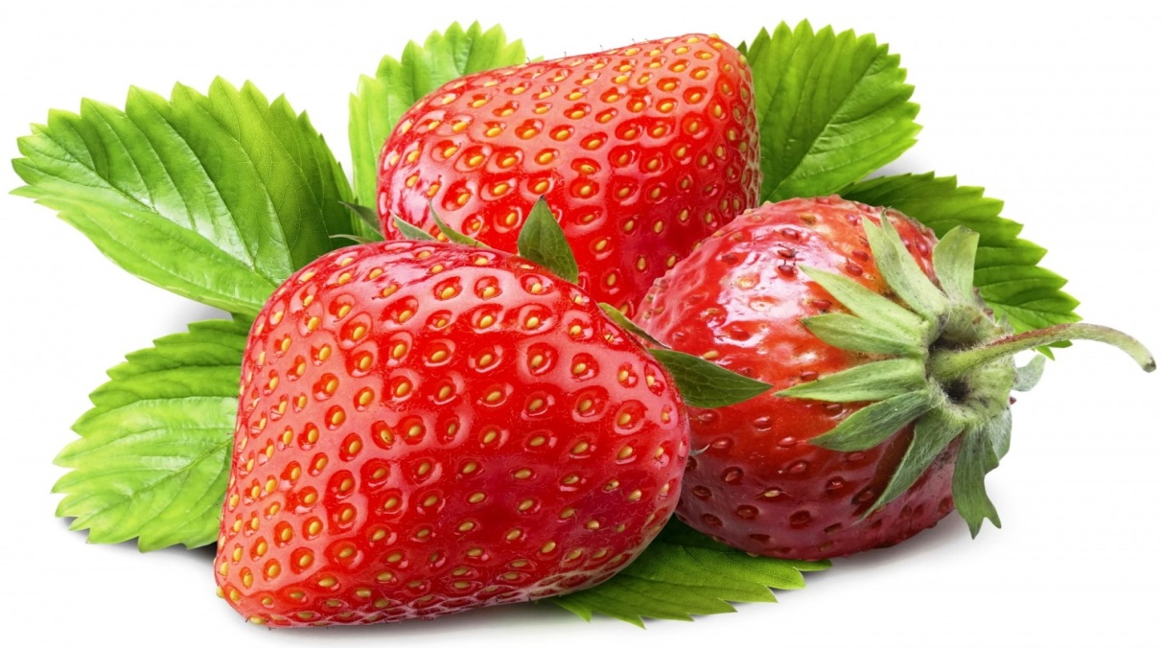

Strawberry

Cherry

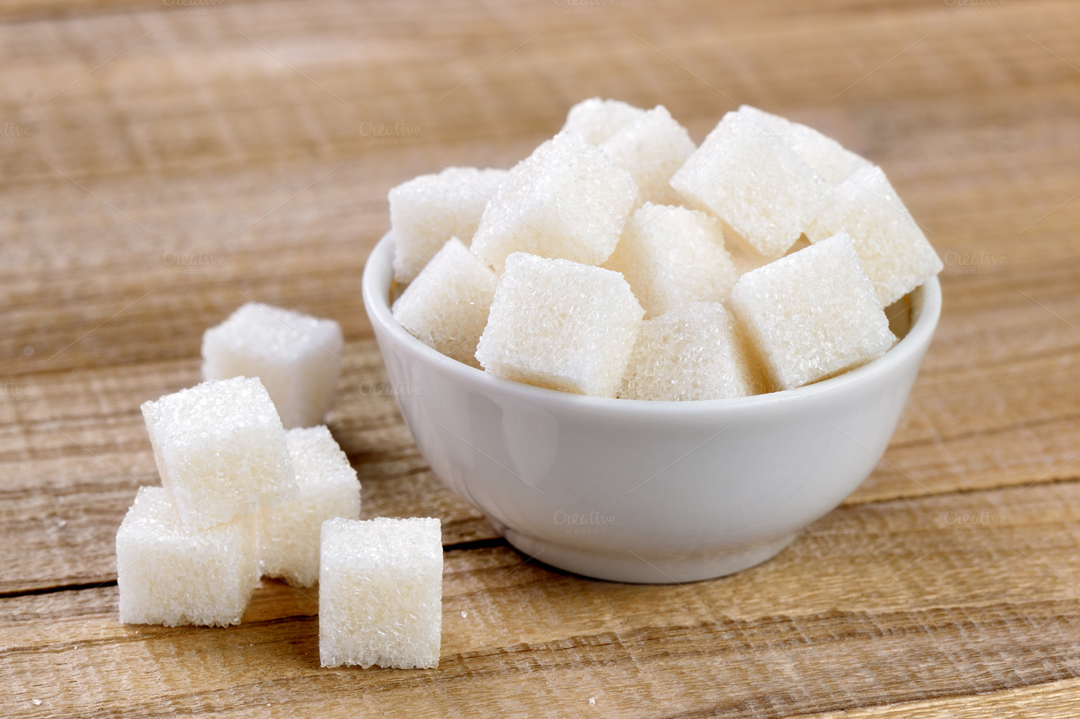

Sugar



Salt

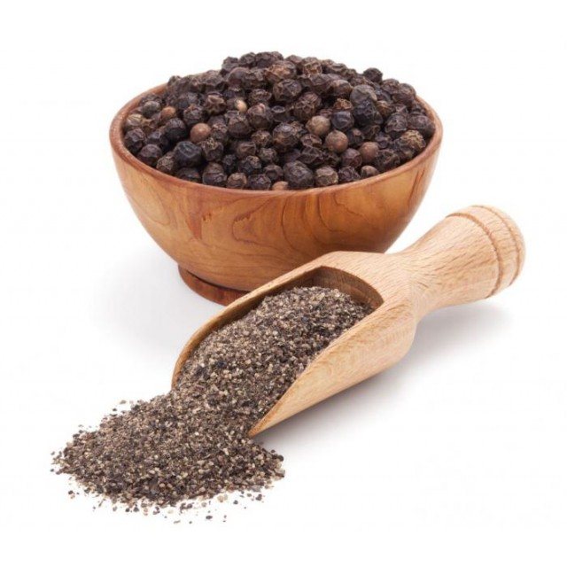

Pepper

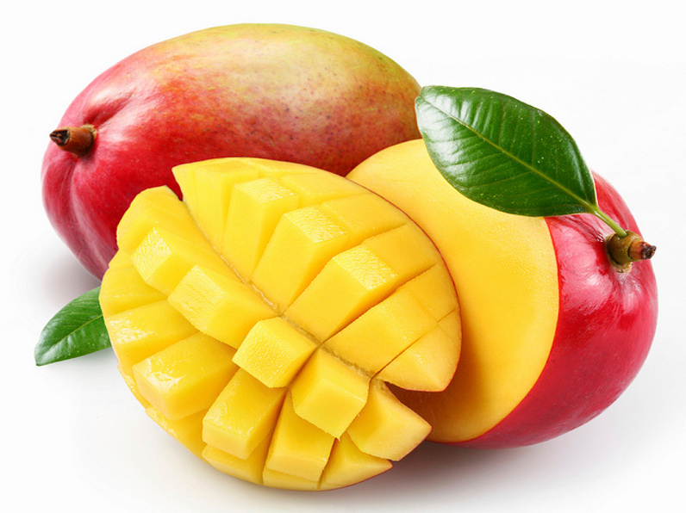

Mangoes

Після того як учні промовили ці слова, малюнки зникають, а учням потрібно читати підписи та перекладати їх.

*And now it’s time to relax.*

*Stand up! Clap! Clap!*

*Hands up! Clap! Clap!*

*Step! Step!*

*Arms down! Clap! Clap!*

*Please, sit down!*

На дошці надписи з малюнками:

Fruits and vegetables.

You must devide these words into two columns:

Strawberry, onion, carrot, watermelon, cherry, pear, cabbage, pumpkins, plum, apple, potatoes, beets, mango, cucumber, grapes,

garlic.

Після того як учні розподілили фрукти та овочі на дві колонки .далі вони підходять і називають.

Cherries are fruits,beets are vegetables and ….

Listen and guess what is it.

It is small. It is round. It is red. It grows on the tree.

It is green and yellow. It grows on a tree. Bears like it.

It doesn`t grow on a tree. It is small and red.

It doesn`t grow on a tree. It is big and green.

It is red. It is round. We make ketchup from it.

They are small. They are round. They are green.

It has got green leaves.

It is long. It is orange. Rabbits like it very much.

(It is…..)

And now grammar materials. Let`s learn some new verbs.

На дошці

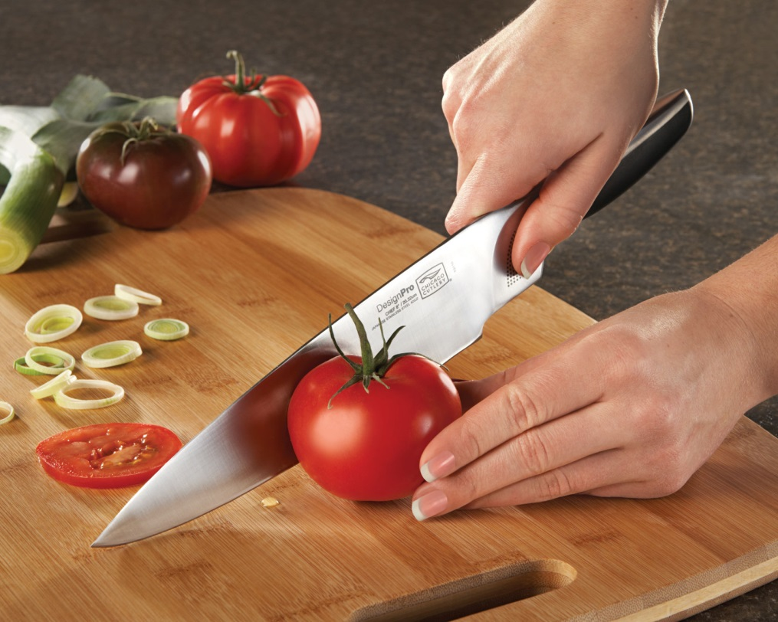

Cut

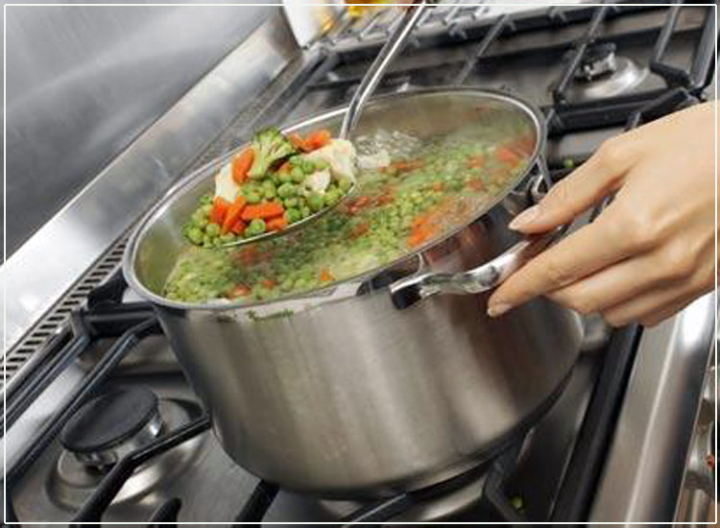

Boil

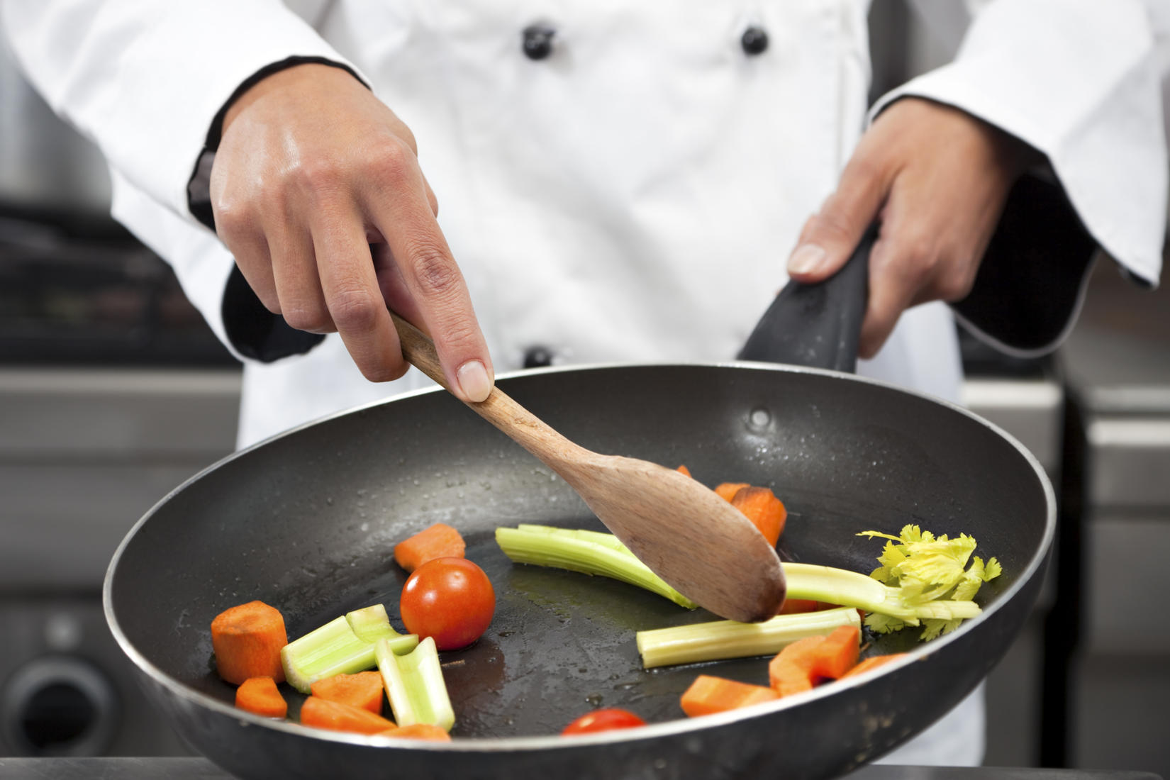

Fry

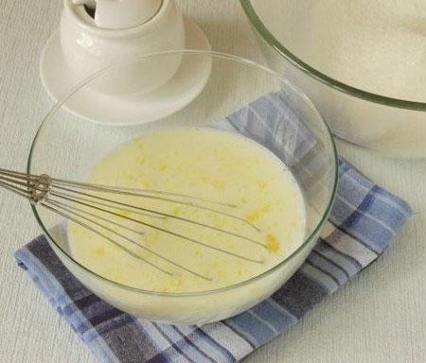

Mix

Listen and repeat

-під малюнками читаємо та повторюємо їх;

- читаємо слова без малюнків, перекладаємо їх;

Робота в групах

To match a word with a noun. You’ve got 1 minute.

-fry eggs, fish, meat.

-add sugar, milk, salt.

-cut cucumber, cabbage, potatoes.

-boil eggs, meat, potatoes.

Name the phrase and show to your class.

And your homework for the next lesson is write down your own recipe.