Розробка уроk з англійської мови для 3 класу на тему: « Тварини зоопарку»
Topic: Zoo animals
Objectives:
- to identify different animals
-to understand short story
- to develop speaking skills
-to teach respecting nature
Materials: CD 40-41, animals flashcards, masks (zoo animals), poster ”Respecting nature”, Get Set Go! 1 p.26,MultiROM unit 5, Family and Friends-3.
Procedure
1.Warmer
Let`s start our lesson with a poem
Z is for zoo
Let`s go to the zoo
I like to go to the zoo. And you?
Do you like to go to the zoo?
2.Lead-in
The topic of our lesson is
“Zoo animals”
a)The guessing game
I’ll draw some parts of the animals.
Ask me’ Is it a ..?
(lion, snake ,giraffe ,elephant, tiger)
b)Let`s sing the song “Zoo song”, Get Set Go! 1 p.26.
lions and cats – 2 times
lions and cats and a kangaroo
All the animals in the zoo
Parrots and bats – 2 times
Parrots and bats and a kangaroo
All the animals in the zoo
Elephants – 2 times
Elephants and kangaroo
All the animals in the zoo
Question:
Do all animals live in the zoo?
3. Presenting vocabulary
- Ask children to open their CB and look at the pictures of the zoo animals.
Listen, point and repeat.
- Play the first part of the recording for children to listen and point to the appropriate picture.
- Play the second part of the recording for children to repeat.
- Play the recording all the way through for children to listen and point, and then repeat the word in chorus.
4.Practicing vocabulary
MultiROM Unit 5
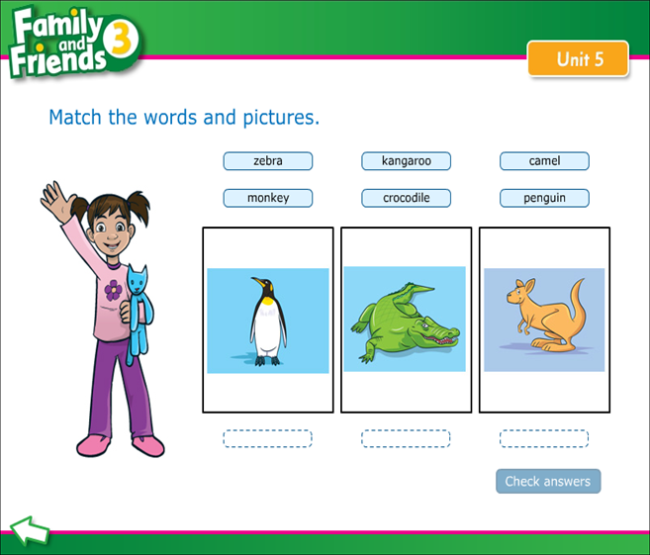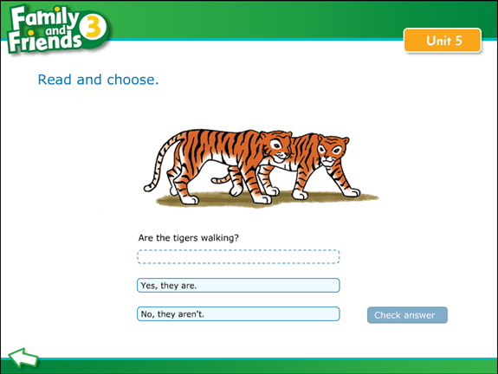

Now let`s have a rest and sing a song
I can see a monkey (tiger, lion)- 2 times
In the zoo
I can a monkey, I can see a monkey
I can see a monkey in the zoo
5.Reading
Listen and read.
- Focus children's attention on the story. Talk about each frame with the class and ask questions, e.g. Where are the children? Who is with them? What animals can you see? What has Leo / Max / Amy got? Encourage predictions about the story.
- Play the recording for children to listen and follow the words of the story in their books and read the story
- Ask comprehension questions, e.g. Can Holly see? What does the monkey take from Leo / Max/ Amy? Does the monkey eat the sandwich? Who does the monkey like?
6.Speaking
Children perform their projects about zoo animals.

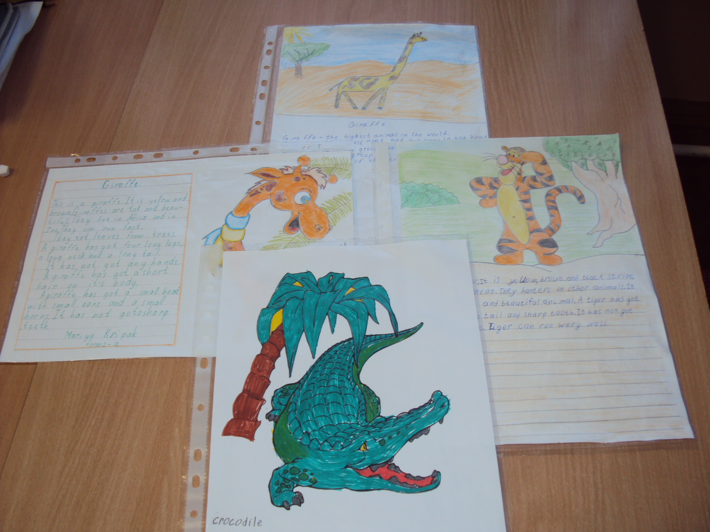
Respecting nature. Use Values 2 poster and Values worksheet.
What`s safe? What`s dangerous?
7.Summering
Homework. PB p.36; WB p.34

