**Позакласний захід з англійської мови**

**для учнів 7-8 класів**

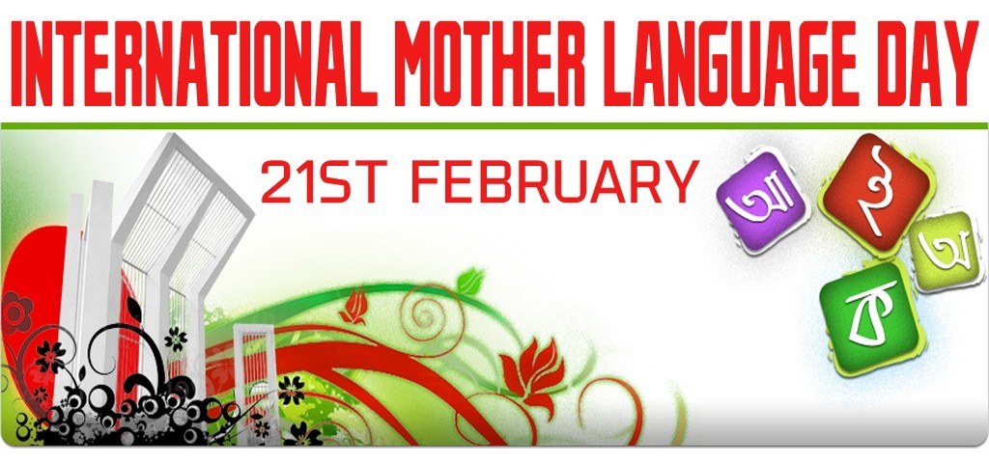

**Автор**:  **Тетяна Миколаївна Компанієць**

вчитель англійської мови КЗ «Орлівщинський НВК»

Новомосковського району Дніпропетровської області

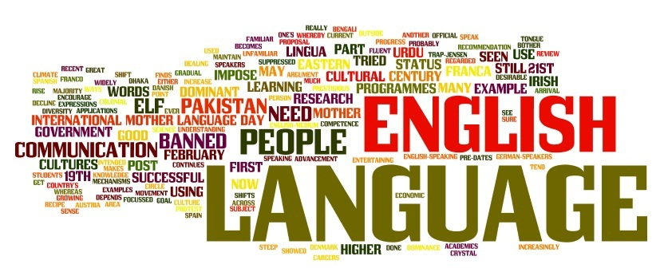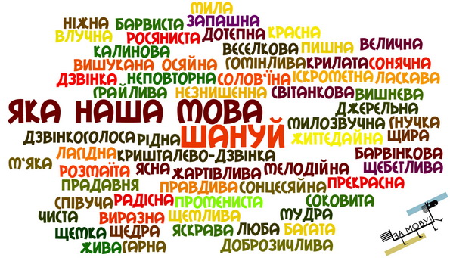

**2018**

Позакласний захід з англійської мови “International Mother Language Day” - вид позаурочної роботи з англійської мови. Захід проводиться для того, щоб створити позитивну мотивацію в учнів до вивчення англійської та української мов; ознайомити їх з історією походження свята; популяризувати вивчення пісень англійською та українською мовами; привити любов до рідної та англійської мов.

**Мета: Освітня** - розширювати мовленнєву компетенцію учнів; вчити пояснювати англійською мовою українські слова та фрази; формувати соціокультурну компетенцію.

**Розвиваюча** - розвивати музичні здібності дітей, критичне мислення.

**Виховна** - виховувати повагу до культури та традицій рідного народу;виховувати моральні цінності.

**Обладнання**: відеозаписи пісень українською мовою;телевізор; малюнки.

**Teacher:** Good afternoon, dear children! What date is it today?

**Student 1:** The 21st of February.

**Teacher:** You are right. Today is the International Mother Language Day. This day has been observed annually since 2000 to promote peace and multilingualism around the world and to protect all [mother languages](https://en.wikipedia.org/wiki/First_language).

**Student 2:** The day was proclaimed by the General Conference of the United Nations Educational, Scientific and Cultural Organization (UNESCO) in November 1999.

**Student 3:** «Languages are the most powerful instruments of preserving and developing our tangible and intangible heritage. All moves to promote the dissemination of mother tongues will serve not only to encourage linguistic diversity and multilingual education but also to develop fuller awareness of linguistic and cultural traditions throughout the world and to inspire solidarity based on understanding, tolerance and dialogue.»

— *From the United Nations International Mother Language Day.*

**Student 4:** We live in multilingual and multicultural societies with multilingual citizens. We exist through our languages; it is through language we express ourselves, we communicate, we participate in social and public life, and we transmit traditional knowledge, knowledge and cultures in a sustainable way.

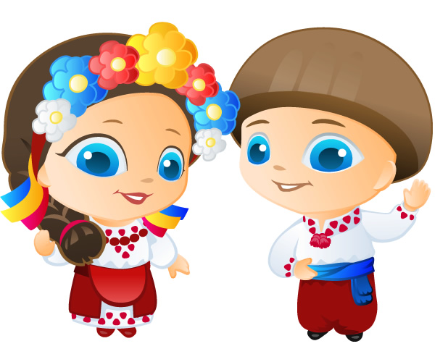**Teacher:** Sometimes foreigners find it difficult to understand some of the cultural and social phenomena that are unique to Ukraine. They are incomprehensible and unrecoverable for residents of other countries. In linguistics they received a special name "lacunae". These concepts are not in a particular language, but are available in another. We will try to translate and explain in English original Ukrainian words and phrases in English today. It's time to explain these words and expressions to foreigners.

**Student 1: “А голову ти не забув?** – Haven`t you forgotten your head as well?”

A most common “pun”, used by teachers to tease a pupil who is forgotten his journal or/and homework. It became a popular meme which is used by adults as well to make fun of a forgetful person in various situations.

**Student 2:**  “**Останній дзвоник**. – The Last Bell.”

Annual prom celebration, which marks the bell ringing for school-leavers, denoting their last lesson at school.

**Student 3: “Маршрутка –** “marshrutka”

An unusual combination of public transport and taxi: mini-bus in a poor condition (usually yellow, but other colorings also possible), which runs along the routes of buses and trams more frequently than other types of public transport, but tickets for which are more expensive.

**Student 4: “Оселедець під шубою**. – Herring in a fur-coat.”

Traditional salad, which consists of herring, covered with layers of onions, potatoes, carrots, chopped eggs, beetroot and mayonnaise. May sound unusual, but has been approved by numerous generations of foodies and is an essential dish on every New Year`s menu.

**Student 5: “Говорили-балакали, сіли та й заплакали**. – We were chit-chatting, than we sat down and began crying.”

Idiom is used to describe a situation, when you`ve been negotiating and thought, that you`ve reached some consensus, but in the end of the conversation you suddenly realize that the whole argument was useless and didn`t lead to any important results.

**Student 6: “Подвійний листочок**.– Double sheet.”

Ukrainian schools are still using specific types of notebooks for pupils, their size and formatting being strictly regulated (for example, usually you are not allowed to use blank A4 sheets for your notes or tests). When the teacher announces that “Everyone should tear a double sheet out of their notebooks right now”, it usually means that the class is going to have a test, answers for which are written on the abovementioned papers.

**Student 7: “Перший хлопець на селі**. – The best guy in the whole village.” (First bloke on the block.- English proverb)

Used to ironically describe “the coolest person” of some company or the one, who`s trying to appear that way, but fails.

**Student 8: “А ваша Галя балувана**. – And your Galya (Ukrainian name) is a spoiled girl.”

An idiom, used to describe a person, who`s not satisfied while he or she actually should be; a person, who`s asking for too much.

**Student 9: “Будьмо, гей!** - It will be, hey! (toast when drinking – **cheers!**)”

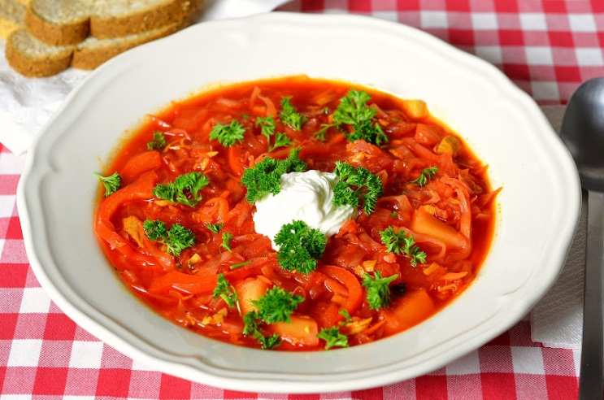**Student 1:**

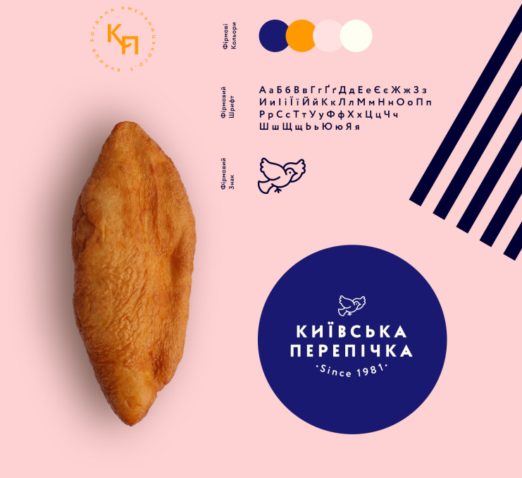Typical Ukrainian **BORSCHT** (alternative names borsch, borshch, borsht, bortsch) is traditionally made from meat or bone [stock](https://en.wikipedia.org/wiki/Stock_(food)), [sautéed](https://en.wikipedia.org/wiki/Saut%C3%A9ing) vegetables, and beet sour (i.e., fermented [beetroot](https://en.wikipedia.org/wiki/Beetroot) juice). Depending on the recipe, some of these components may be omitted or substituted for.

**Student 2: “Perepichka”**

Traditional Kyivan patty with sausage filling. Really greasy and nourishing, it`s sold at one exact catering stand down at Bohdana Hmelnitskogo street in the citycenter: this place can be easily recognized by a long line of hungry people, queuing to buy a perepichka for 20 cents.

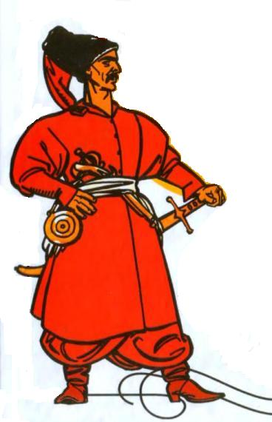

**Student 3: “Cossack”**

is a name of an ordinary soldier of Ukrainian army in XVII-XVIII century.

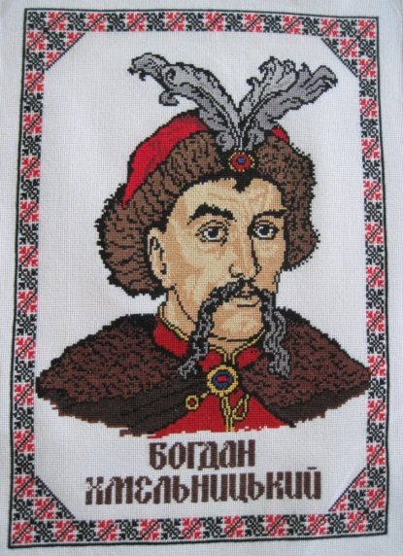

**“Hetman”**

is Commander

in Chief of the

whole army and Head of State at the same time.

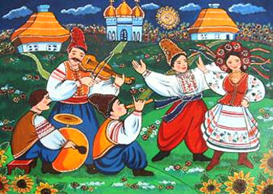**Student 4: “Vechornitsi”**

Traditional Ukrainian mass events, that historically were a common type of social entertainment (mostly in villages): people gathered to sing, dance and communicate. Nowadays this tradition is still alive in some universities and as part of festivals, dedicated to praising Ukrainian culture.

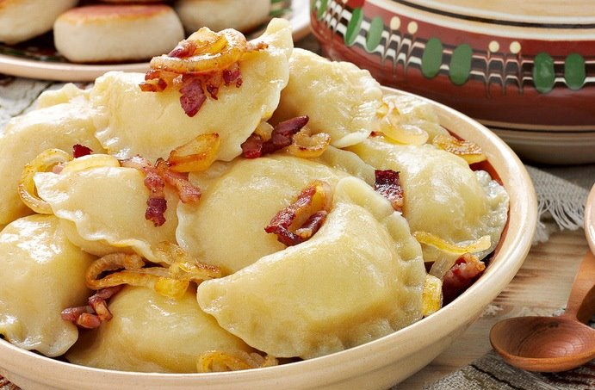

**Student 5: “Varenyky”**

is a popular Ukrainian dish made of boiled dough with diverse fillings, such as meat, mushrooms, vegetables, fruits, cheese.

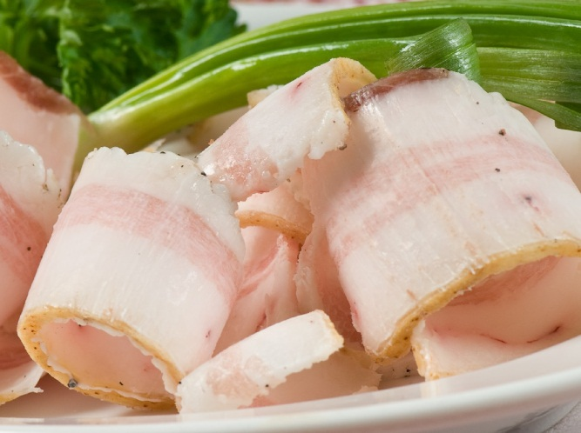

**Student 6: “Salo“**

is a traditional Ukrainian food consisting of cured slabs of [fatback](https://en.wikipedia.org/wiki/Fatback) (rarely [pork belly](https://en.wikipedia.org/wiki/Pork_belly)), with or without skin.

The word "salo" is often translated to English as "[bacon](https://en.wikipedia.org/wiki/Bacon)" or "[lard](https://en.wikipedia.org/wiki/Lard)".

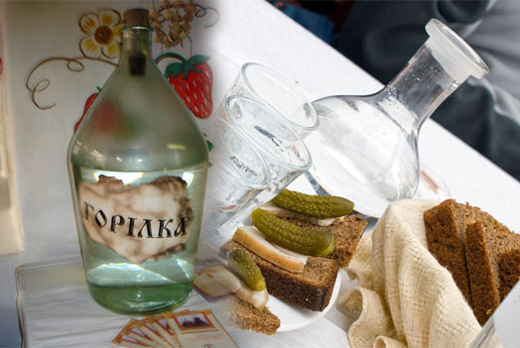

**Student 7: “Horilka”**

is an [Ukrainian](https://en.wikipedia.org/wiki/Ukraine) [alcoholic beverage](https://en.wikipedia.org/wiki/Alcoholic_beverage).

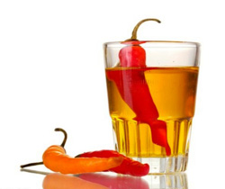 **Pertsivka or horilka z pertsem**

(English: pepper flavoured horilka) is the most widely associated type of horilka outside of Ukraine.

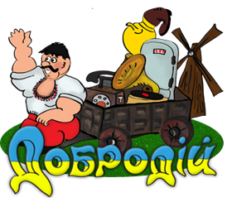**Student 8: “Dobrodiy”**

is a form of polite appeal in the Ukrainian language. A person who does good works, good deeds. ( [Man](http://slovnenya.com/dictionary/Man), [gentleman](http://slovnenya.com/dictionary/gentleman))

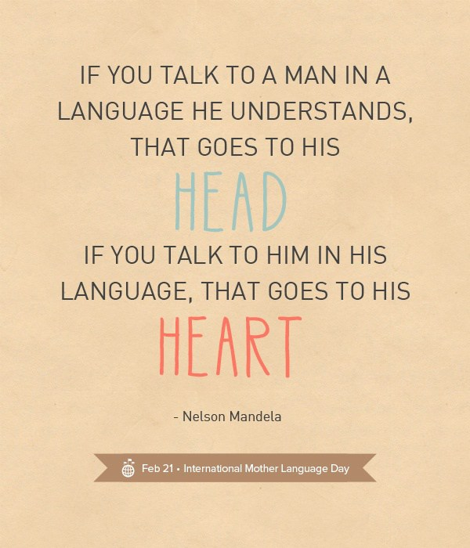**Teacher:** Dear friends, let’s remember some International Mother Language Day Quotes. Read them together.

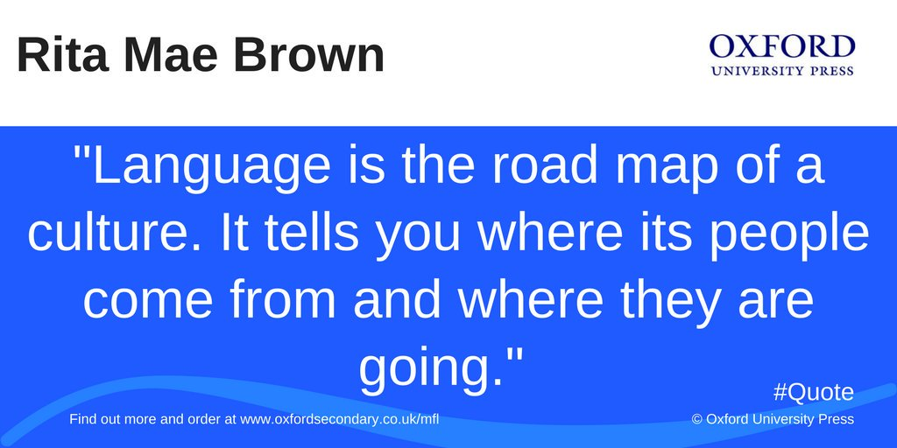

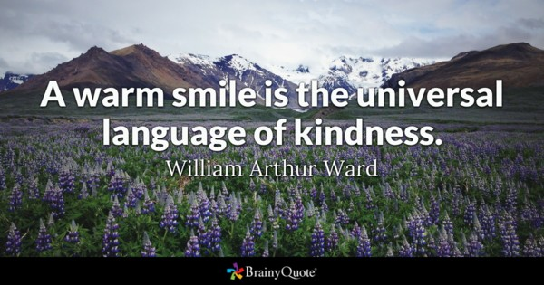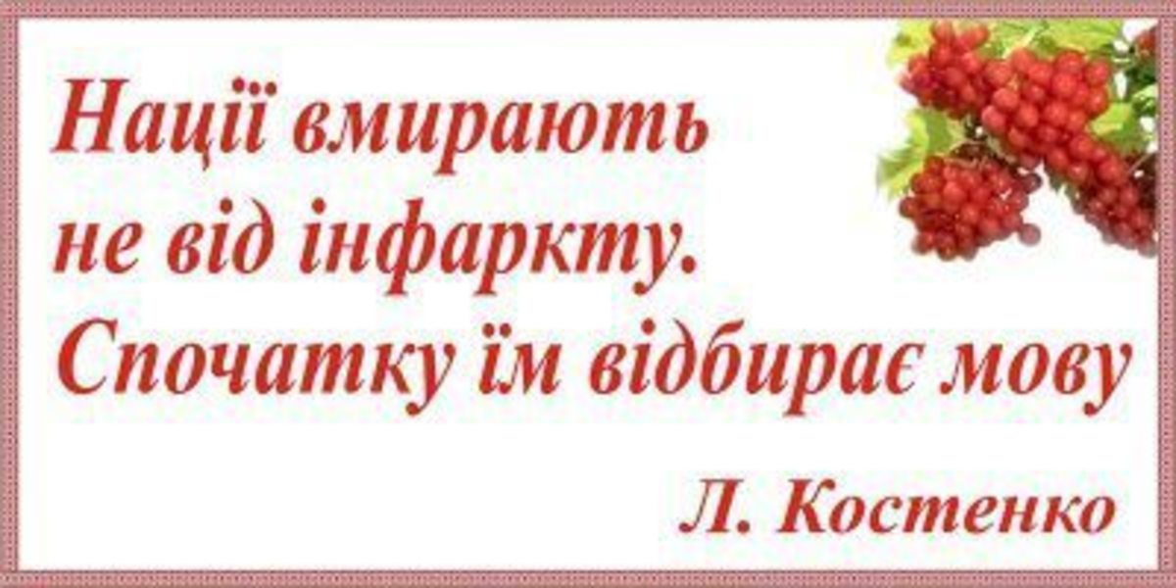

**Teacher:** Now, dear students, you can explain some Ukrainian words and phrases to your foreign friends. They can understand our native language. Let’s sing some Ukrainian folk songs at the end of our Native Language Party.

<https://www.youtube.com/watch?v=p1x7M6gLNXs>

<https://www.youtube.com/watch?v=t0kzIVPZ_pg>

Додаток:

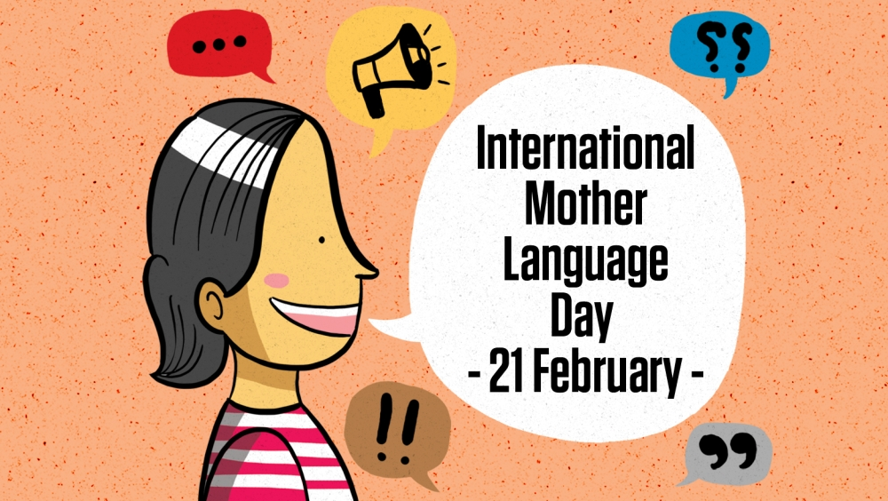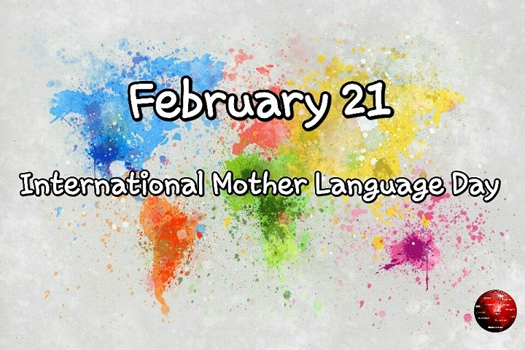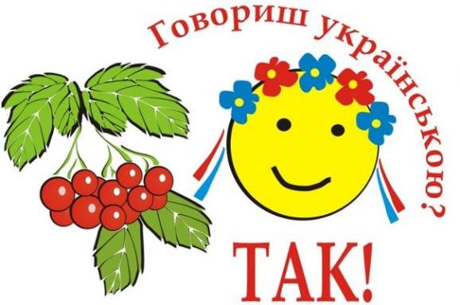Малюнки, які розміщені на стенді.