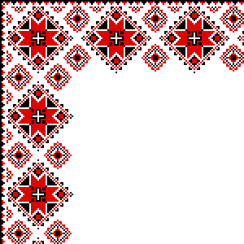

***Розробка уроку***

***в рамках місячника***

***педагогічної майстерності***

***Англійська мова***

***Урок № 59***

***Клас 6***

***Тема уроку: Travelling***

***Підготувала***

***Мороз Ірина Іванівна***

***вчитель англійської мови***

***Малобурімської загальноосвітньої***

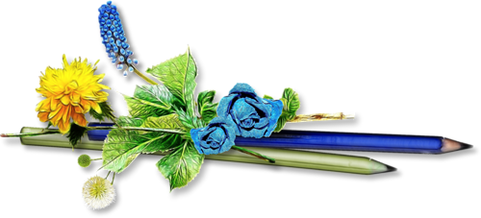 ***школи І-ІІІ ступенів***

***Чорнобаївської районної ради***

***2018 р***

***Тема: Travelling in our life.***

**Мета**: - узагальнити і систематизувати лексичний матеріал з теми «Подорож»; сприяти удосконаленню

навичок усного мовлення, комунікативні навички;

- розвивати пам’ять, увагу, логічне , критичне та асоціативне мислення; формувати вміння

висловлювати власну точку зору та аргументувати свій вибір;

- виховувати позитивне ставлення до подорожування як до активного відпочинку;підвищувати

пізнавальний інтерес до англійської мови, прищеплювати інтерес до подорожування

**Тип уроку**: урок узагальнення та систематизації набутих знань

**Обладнання і матеріали:** картки для індивідуальної та групової роботи, мультимедійна презентація, аудіо записи

Хід уроку

***Підготовка до іншомовного сприйняття***

1. ***Привітання***

**The lesson has begun**

Good morning, everyone!

It’s time to have some fun,

And we have come today

To write and read and play

The day is warm and bright,

Our class is very light

Be ready, everyone!

The lesson has begun

1. **Передбачення теми і мети уроку**

***T:*** Look at the screen. What is the theme of our today’s lesson? You are right, “Travelling”, and this lesson is devoted to this theme. Try to guess, what we are going to do on the lesson. Do you have any ideas? What would you like to do during our lesson?

***Основна частина уроку***

1. **Уведення в іншомовну атмосферу.**

You see, modern life is impossible without travelling. Remind me, please, what means of travelling do you know? (Word-Map)

Mind-Map

by ship by bus

by car

by plane

TRAVELLING **Передбачення теми і мети уроку (Слайди 1, 2)**

***T:*** Look at the screen. What is the theme of our today’s lesson? You are right, “Travelling”, and this lesson is devoted to this theme. Try to guess, what we are going to do on the lesson. Do you have any ideas? What would you like to do during our lesson?

NG

on foot by train

1. **Робота в групах. Розвиток логічного мислення**

Everybody knows that modern life is impossible without travelling. We often travel for pleasure. While travelling you learn a lot of interesting things about the places you have visited, relax, have rest, or work.

On our last lesson we spoke about reasons for travelling. Now let’s revise. Tell me why people travel?

**Reasons for travelling:**

To have a rest

For pleasure

To study

On business

To get new information

To make friends

To get to know about traditions and culture

To get new impressions

(кожна група офрмляє постер та презентує його)

1. **Говоріння (складання діалогів). Робота в парах**

And now I think it’s high time to plan our trip. Take cards and make up dialogues “Where do you want to go?”

P1: Where do you want to go?

P2: I want to go to …

P1: How do you want to go there?

P2: I want to go to there by …

P1: What do you want to see there?

P2: I want to see…

1. **Письмо.**

Тhe words in these sentences have been pushed together. Find out what they are by separating them.

Modernlifeisimpossiblewithouttravelling.

Manypeopleliketotravelbycar.

Theycantravelbyair,byrail,byseaorbyroad.

Travellingbytrainisslowerthanbyplane,butithasitsadvantages.

1. **Мовна гра на активізацію монологічного мовлення та закріплення лексики «Complete the sentence in the circle»**

Make a circle and send each other a card with a word for a hint for music. When music stops you need to сomplete a sentence about the trip. Then the cards are added and so until all the children participate in the game Структура речення : *People can get from (one place) to (another) by plane*

Example: Village-*lake*

*London –Kyiv etc*

1. ***Фізкультхвилинка. Rolly-Polly***
2. **Групова робота. Розвиток критичного мислення. Метод « Fishbone»**

There are different thoughts about travelling. Some people say travelling has only advantages. Other don’t think so positively. What is your opinion? Ground up.

Клас поділяється на дві групи. Учні І групи складають Mind Map зі словами, які асоціюються з перевагами в

подорожуванні. Інша група складає Mind Map зі словами, які асоціюються з недоліками в подорожуванні. Потім біля дошки утворюють схему по методу **« Fishbone»** та роблять висновок.

***COMFORTABLE***

***CHEAP***

***ENJOYABLE***

TRAVELLING

***INTERESTING***

***FAST***

***USEFUL***

***SAFE***

***BORING***

***TIRING***

TRAVELLING

***DANGEROUS***

***SLOW***

***TROUBLESOM***

***E***

***EXPENSIVE***

Переваги в подорожуванні

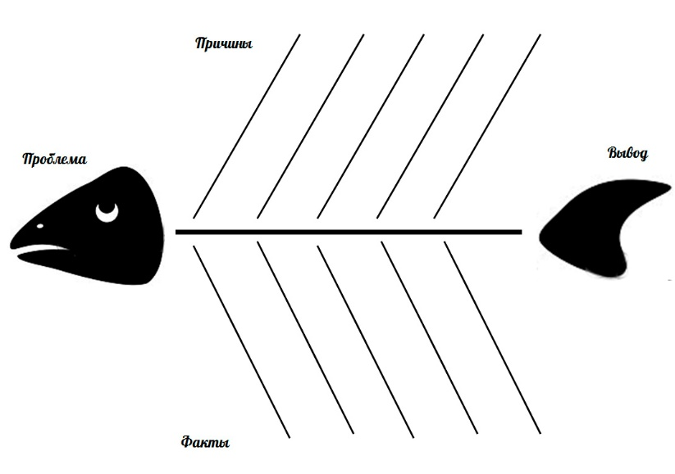

Travelling in our life People should to travel

because it is part of our life

Недоліки в подорожуванні

**ІІІ. ЗАКЛЮЧНА ЧАСТИНА УРОКУ**

1. **Метод «Мікрофон».**

Now try to express your own opinion and say why people travel. All you need is to complete the sentences in your cards.

1. Most people like to travel _________________________________________.
2. Usually they travel ______________________________________________.
3. When they travel they like to ______________________________________.
4. People like to travel because it is ___________________________________.
5. Of course sometimes travelling can be _______________________________.
6. And still travelling _______________________________________________.
7. **Рефлексія**

T: Now please answer the questions

What did we do at our lesson today?

What did you like the most?

What was easy for you? What was difficult?

1. **Підсумок уроку.**

It’s time to finish our lesson. There is a saying: *“The world is the book, and those do not travel, read only one page”*. Do you agree? That’s all for now. Good-bye! Thank you for your work.

**Song: “ Thank you on this special day”**

1. Most people like to travel _________________________________________.
2. Usually they travel ______________________________________________.
3. When they travel they like to ______________________________________.
4. People like to travel because it is ___________________________________.
5. Of course sometimes travelling can be _______________________________.
6. And still travelling _______________________________________________.
7. Most people like to travel _________________________________________.
8. Usually they travel ______________________________________________.
9. When they travel they like to ______________________________________.
10. People like to travel because it is ___________________________________.
11. Of course sometimes travelling can be _______________________________.
12. And still travelling _______________________________________________.
13. Most people like to travel _________________________________________.
14. Usually they travel ______________________________________________.
15. When they travel they like to ______________________________________.
16. People like to travel because it is ___________________________________.
17. Of course sometimes travelling can be _______________________________.
18. And still travelling _______________________________________________.
19. Most people like to travel _________________________________________.
20. Usually they travel ______________________________________________.
21. When they travel they like to ______________________________________.
22. People like to travel because it is ___________________________________.
23. Of course sometimes travelling can be _______________________________.
24. And still travelling _______________________________________________.
25. Most people like to travel _________________________________________.
26. Usually they travel ______________________________________________.
27. When they travel they like to ______________________________________.
28. People like to travel because it is ___________________________________.
29. Of course sometimes travelling can be _______________________________.
30. And still travelling _______________________________________________.