PROFESSIONS. Clothes.

Form 3

**Тема:** Професії . Одяг.

**Мета:** Ознайомити з лексикою теми. Навчати діалогічного й монологічного мовлення за темою. Ввести питальні займенники Who? Where? , запитання Whose is this?

**Обладнання:** Підручник, робочий зошит, тематичні картки.

**1.Match each person with the place where he/she works.**

|  |
| --- |
| Librarian car  Milkmaid office  Nurse library  Singer farm  Business police station  Driver post  Cook studio  Postman plant  Worker restaurant  Policeman hospital |

**2. Point and say what is his/her job:**

** **

**__________________________ ___________________________**

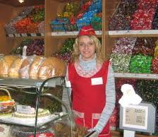 

**__________________________ _________________________**

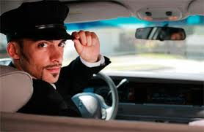 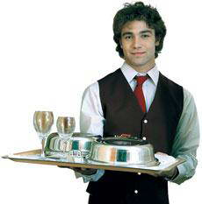

______________________________ ___________________________

**3.Read and complete the table with the appropriate words:**

|  |  |
| --- | --- |
| Teacher |  |
| Mechanic |  |
| Baker |  |
| Driver |  |
| Milkmaid |  |
| Doctor |  |

Cow, oven glove, thermometer, spanner, car, pen.

**4. “Magic box”.**

One person takes a piece of paper from the box and reads loud. You must guess the profession.

1. This person makes cakes, bread.

________________________

1. This person works at school.

________________________

1. This person wears a uniform and helps sick people in a hospital.

________________________

1. This person has got a whistle.

________________________

1. This person drives the fire engine and wears a special hat.

________________________

1. This person uses a computer.

________________________

1. This person sings on TV.

________________________

1. This person gives books.

________________________

1. This person builds houses.

________________________

1. This person mends cars.

________________________

1. This person wears a red nose for work.

**5. Crossword**

You have the cards. You have to find the words to the topic CLOTHES and then say them.

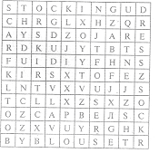

1.__________________

2.__________________

3.__________________

4.__________________

5.__________________

6.__________________

7.__________________

8.__________________

9.__________________

10._________________

11._________________

12._________________

**6.** **Listening**

Do you want to play a game? Split into two groups: the boys’ group and the girls’ group. Each group will have the dolls and the clothes for them. Listen to me attentively, choose the correct clothes and put it on him/her. The girl’s name is Meg and the boy’s name is Pete.

***TEXT***

1. ***Meg is wearing a green dress.***
2. ***Pete is wearing a red T-shirt and jeans.***
3. ***She is wearing a blue dress, white socks and blue shoes.***
4. ***He is wearing pink T-shirt and black shorts.***
5. ***She is wearing a yellow and brown dress.***
6. ***He is wearing jeans and a white jacket.***

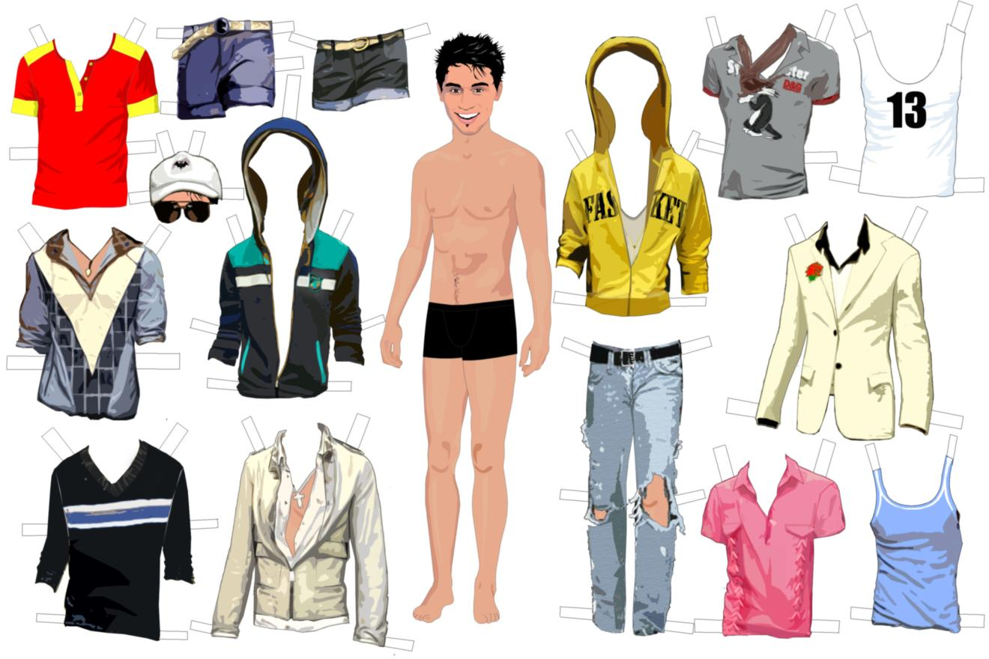

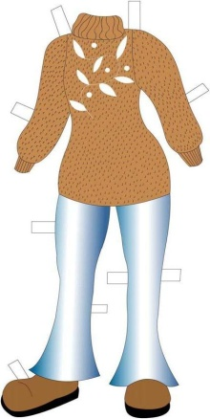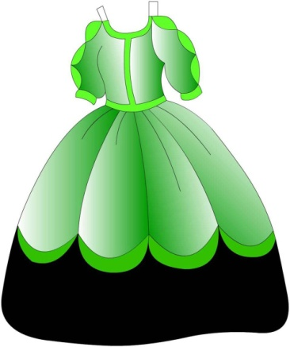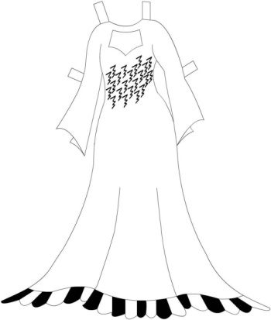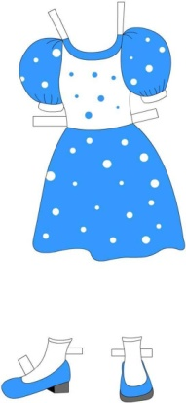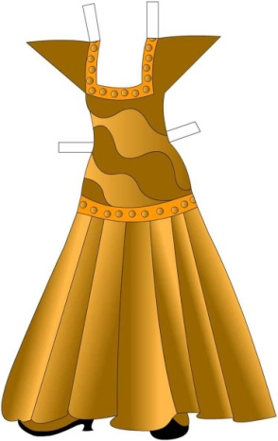 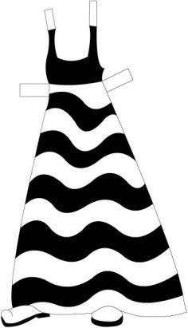 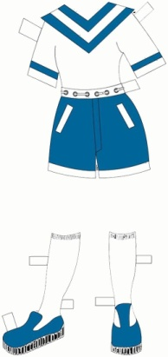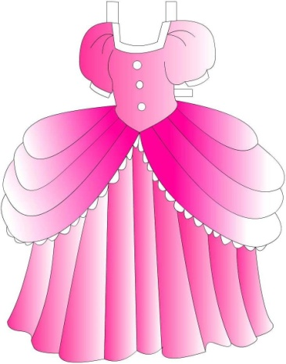 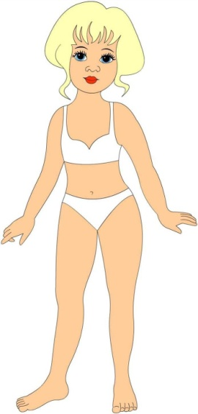

**7.What kind of clothes are these?**

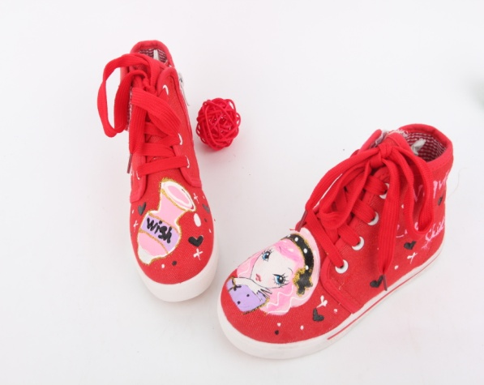 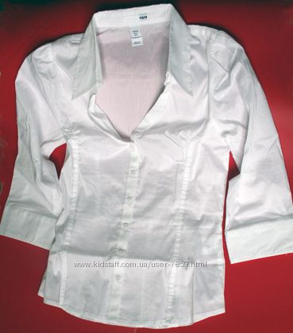

**____________________________ __________________________________**

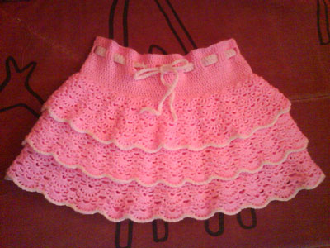 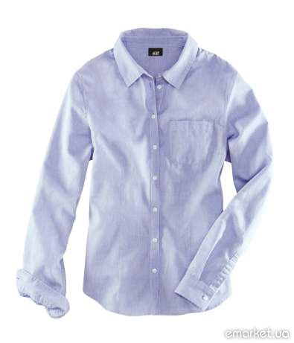

**____________________________ ________________________________**

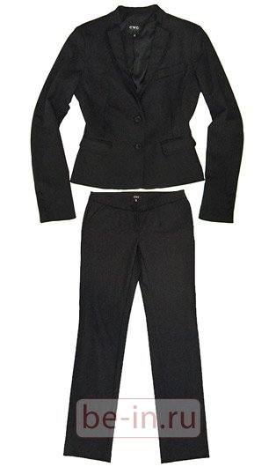 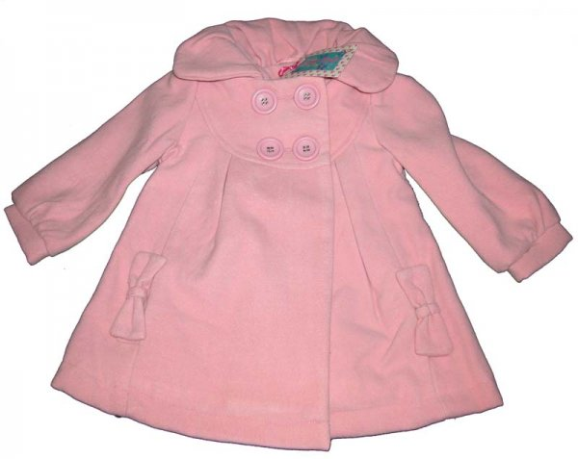

**____________________________ _______________________________**

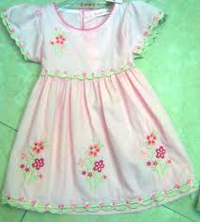 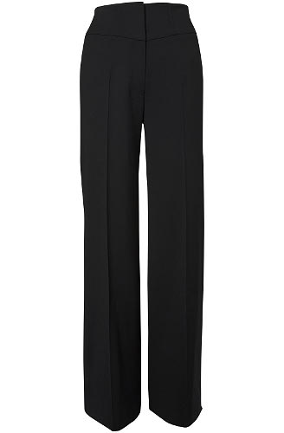

**__________________________ _______________________________**

**8.Fill in *Who* or *Whose*.**

1._____________clothes are these? They are Bill’s.

2. ____________is this? This is Taras.

3. ____________are these apples? They are Tom’s.

4._____________is that girl? That is my friend.

5. ____________are those toys? They are mine.

6._____________is that man? He is my teacher.

**9.Fill in the missing words.**

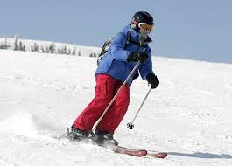 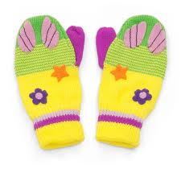

s_i mit_ _ ns

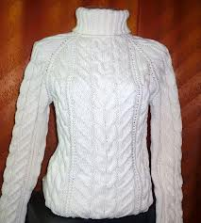 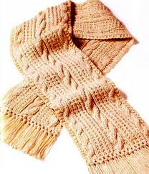

sw_ _ ter s _ a _ f

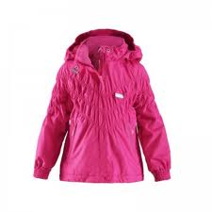 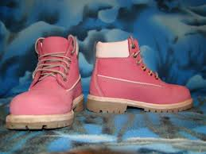

ja _ _ et a p_ _ r of bo _ ts

**10. Complete as in the example**

1. This is my dress. It is mine.

2. That are his trousers. They are __________.

3. That is our toys. They are __________.

4. This is your car. It is ________.

5. These are her mittens. They are _______.

6. These are their boots. They are _______.