EASTER TRADITIONS
Fragments of the lesson

PROCEDURE

1. WARMING-UP
Pronunciation drill
I have a basket, it’s for Easter.
What’s in the basket, please, tell me.
Paska, babka, cheese and butter,
Ham, horse-radish and kovbasa.
We are going to light a candle,
Go to church and have it blessed.
And together we’ll all sing out:
“Christ has risen!
Indeed He has risen!”
T: Next Sunday we’ll celebrate Willow Sunday, commemorating Christ’s triumphant entry into Jerusalem. In Ukraine people tap each other with willow branches and repeat the wish. You know it. There are pussy-willow branches on the desks, take them and let’s tap each other and repeat the wish: “Be as tall as the willow, as healthy as the water, as rich as the earth. Not l am tapping, the willow is tapping. Easter is In a week”.

II. COMMUNICATIVE ACTIVITIES
T: People celebrate many holidays during the year. There is a Maypole on the blackboard. Look at the ribbons. The sentences will help you to guess the holiday. Let’s choose the leader. S/he will read the ideas and the rest of the class will have to match the ideas to a holiday.
(The leader reads the sentences and the pupils guess the holiday.)
T: What is the main spring holiday? Why do you think so?
P1: I think that Easter is the main spring holiday because it is the feast of Christ Resurrection.
P2: Easter is a big Christian religious holiday for children and grown-ups.
P3:1 know that Easter means the coming of spring.
P4: Easter has a long history, many traditions and customs.
P5: Nowadays Easter is a national holiday in Ukraine.

III. VOCABULАRY PRAСTIСЕ

1. Revising Vocabulary
T: Open your copybooks, please. Let’s write “Picture Dictation”. I’ll show you a picture and you are to write down this word.

2. Lexical Game “Hurry Up”
T: I’ll divide you into two teams. The first team is called “Golden Seeds” and the second one is called “Easter Basket”. There are 2 identical lists of 20 words each on the blackboard. The words are familiar for both teams. When I read out one of the words from this list, one member of each team has to run to the blackboard and cross out this word from his/her team’s list. The fastest player will get one point. At the end of the game well count your points and choose the winner. Are you ready? Let’s start.
Team 1“Golden Seeds”: willow, Easter, Resurrection, to bless, to tap, candle, basket, church, calendar, krashanka, tradition, Great Lent, sausage, horse-radish, cheese, provision, national, poppy seeds, nowadays, smoked meat.
Team 2 “Easter Bosket”: tradition, to bless, candle, willow, church, krashanka, Resurrection, basket, to tap, Easter, Great Lent, calendar, cheese, provision, sausage, horse-radish, nowadays, smoked meat, poppy seeds, national.

IV. READING
Pre-reading
T: Is Easter a happy day? Why do you think so? Do you like this holiday? Why?
While-reading
T: You see pictures in the text. While reading you are to name them.

EASTER IS A SPRING HOLIDAY
Easter is a holiday of spring, joy and gladness.
The ,the , the grass are .There are many
nice, bright everywhere. The sing their lovely songs and
have their

In spring we celebrate Easter. People go to the

They go there at . They sing and pray. People take their
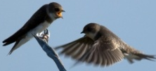
with different provision to bless it. It is a very happy day. , ,
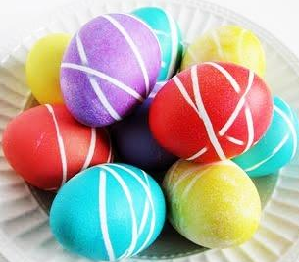
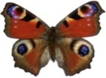
, are all sings of Easter because they ate signs of new life. In England

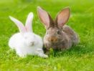 аге signs of Easter. Little believe in the .
It has many with coloured and .

On Easter morning children hunt for their . Children like to colour
People in Ukraine eat Easter bread . All are happy.

Post- reading
T: Say if the sentences are true or false. Use the signal cards - red cards for right sentences,
blub - for wrong sentences.
1. Easter is a summer holiday.
2. Easter is a Christian holiday.
3. It is always on Monday.
4. Christians go to school on Easter Sunday.
5. People go to church at midnight.
6. English children hunt for their baskets.
7. English boys and girls believe in Easter Flower.
8. Children like to colour eggs.
9. People eat pasky on Easter.
10. I lowers, childrens, eggs are signs of autumn.
V. PAIR WORK. QUESTION TIME
Т: Many Easter rabbits came to see you. They have questions to you. Read their questions and ask your neigh bour to answer them.
1. What kind of holiday is Easter?
- Does everyone celebrate this holiday?
- What special food do people eat?
- Do people go to church on this day?
- Do people sing special songs and prayers?
- Do people have a big family dinner or party?
- Do people send greeting cuds?
- How do people decorate their homes, towns, yards?

VI. MIND MAP
T: Do you have baskets at home? What things do people put into their Easter baskets? You see the basket on the board. Please, write all the words you connect with it.
Sample mind map:
candle babka
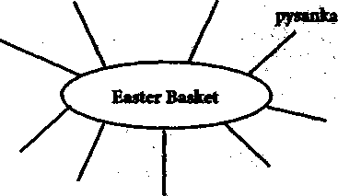
poppy seeds

smoked meat
horse-radish
krashanka

paska leaf lard

VII. SUMMING-UP. HOMEWORK.

