Професійно-технічне училище № 36
смт Новгородка

Методична розробка уроку
з іноземної (англійської) мови
з теми «Моя майбутня професія»



Підготувалa:
Остання Альбіна Станіславівна
викладач англійської мови

2018 р
Схематичний план уроку
1.Початок уроку. Організаційний момент. 3хв
2.Повідомлення теми, мети уроку.
Перевірка домашнього завдання. 5хв
3. Мовна зарядка. Введення в іншомовне середовище. 5хв
4.Словникова робота. 5хв
5. Читання. 8хв
6. Аудіювання 8хв
7. Письмо 7хв
8. Пояснення домашнього завдання. Підсумки уроку. 4хв

ПЛАН УРОКУ
Професія: «Слюсар з ремонту с/г машин та устаткування ІІІ розряду, тракторист – машиніст с/г виробництва категорії «А», «В», «С», водій категорії «С»
Тема програми : Плани на майбутнє. Вибір професії.
Тема уроку: Моя майбутня професія.
Мета уроку:
навчальна: формування лінгвістичної компетентності учнів: використовувати фразові дієслова та ЛО по темі «Плани на майбутнє. Вибір професії.» в усному мовленні, ставити питання та відповідати на питання використовуючи програму “ Popplet“, розуміти та передавати нову інформацію, використовуючи нові технології.
розвиваюча: формувати та розвиваим мовленнєву компетентність учнів, перекладати текст , відтворювати події в їхній логічній послідовності та висловлювати власну думку про почуте та прочитане, розвивати навички аудіювання, мовлення, читання та письма.
виховна: формування поведінкових компетенцій ефективно співпрацювати під час парної та групової роботи, загальну культуру учнів, прищеплення позитивного ставлення до англійської мови.
МЕТОДИЧНА: Використання проектної технології на уроках англійської мови.
Тип уроку: комбінований урок
Вид уроку: навчально – практичне заняття з використанням інтерактивних технологій.
МЕТОД ПРОВЕДЕННЯ: словесний, наочний, практичний.
ОБЛАДНАННЯ ТА НАОЧНІСТЬ:
- підручник,комп’ютер, проектор.
- Ілюстрована картки з лексикою
текст (Exercise 4 page 61) для розвитку навичок читання та тестові завдання до нього ;
- відео для розвитку навичок аудіювання Francis Chan „ The big red tractor and the little village“ та завдання до нього;
- вправа на платформі https://learningapps.org/display?v=pko9yhzmn18
ОЧІКУВАНІ РЕЗУЛЬТАТИ
Учень повинен знати:
- лексику з теми;
- назви професій англійською мовою;
- правила будови англійського речення,
- правила читання та перекладу тексту.
Учень повинен уміти:
- давати відповіді на питання учнів та викладача, підтримувати бесіду;
- презентувати думки та твердження за допомогою методу проектів;
- виконувати тестові завдання;
- отримувати нові знання та застосовувати їх у практичній діяльності;
- сприймати на слух інформацію англійською мовою;
- використовувати ІКТ під час виконання завдань.
Міжпредметні зв’язки: предмет « Сільськогосподарські машини »,
« Трактори»
ХІД УРОКУ
I. | підготовка до сприйняття іншомовного мовлення
Greeting | 1. Привітання, організація учнів  Т: Good day pupils!Are you in good mood?  What is the day/date today?  Who is absent today?  Do you like the holiday which we have today?
Theme of the lesson  Aim  Checking homework | 2. Повідомлення теми та мети уроку. Перевірка домашнього завдання.  T: The theme of today's lesson is “my future profession ” and our aim is to get to remember the names of professions, talk about disadvantages and advantages of being tractor driver and car repair, learn how to write it and send the answer with a help of program Popplet. We will learn remember synonyms words (A job, a work, an occupation, a profession, a career) which learn we in previous year,than read,speak ,watch the video and do the writing activities.  T: But firstly lets check the homework for today. What is the homework for today?  P: Make the poster of advantages and disadvantages of being tractor driver and car repair.  ( презентація проектів)
Theme of the lesson  Aim  Checking homework | T: You see there are a lot disadvantages and advantages of being a tractor driver and car repair. So you only need to study hard and be a good worker. But I think you maybe could have another dream when you were a child?
Warming up | 3. Уведення в іншомовну атмосферу.  T:It is the time to remember your dream and write down in the imaginary dream clouds.    (Addition 1)  What are you going to do  When you are twenty-two?  I’ll be a pilot,  I’ll be a doctor,  I’ll be a teacher,  I’ll be a worker.  I’ll be in London,  I’ll be in Rome,  I’ll be in Africa,  I’ll be at home.
II. | ОСНОВНА ЧАСТИНА УРОКУ
Presentation  and Practice | T: What words are called synonyms?  Synonyms are words with the same or similar meanings  And now I suggest you to remember the difference between the following words:  A job, a work, an occupation, a profession, a career  — Your job is the work that you do regularly in order to earn money, especially when you work for a company or public organization;  — Work is used in a more general way to talk about activities that you do to earn money, either working for a company or for yourself;  — We use occupation to talk about the kind of work that someone usually does. Occupation is used mainly on official forms;  — A profession is a kind of work for which you need special training and a good education;  — Your career is the type of work that you do or hope to do for most of your life  And now let’s do an exercise with these words.  1.My last job was with a computer firm.  2.He finally got a job in a supermarket.  3.I started work when I was 18.  4. State your name, age, occupation in the box below.  5. The legal profession. I am interested in a career in television. 6.His career is more important to him than his family.
Reading | T: Well, we know your dreams and now we have the opportunity to know the dreams of Andy, Linda, if their dreams come true.  Pre-reading  (Exercise 4 page 61)  Look through the text and find unknown words to you:  Suits somebody [suːt 'sʌmbədɪ] відповідати вимогам  Advance [əd'vɑːns] удосконалюватися  Involve [ɪn'vɒlv] втягати, вплутувати  Communicative [kə'mjuːnɪkətɪv] говіркий; товариський,  Spontaneous [spɒn'teɪnɪəs] мимовільний; спонтанний  Purpose ['pɜːpəs] цілеспрямованість, воля  Amaze [ə'meɪz] вражати  Reading Exercises 4 on page 61  4_{a}) Read and guess the jobs of the people (see pages 61-62).  Speaker A ( Andy ):  This isn't the job for someone who likes routine, because you never know what the next day is going to be like. This suits me, because I don't like to plan far in advance anyway. Every day is different, and every day involves meeting new people. My problem is that I quickly get bored, so it’s good for me to have a job that gets me out and about. To do this job, you have to be a communicative person and be able to talk with anybody, because you meet all sorts of people. And you have to be spontaneous and react to the moment as it comes. I don't think I could stand a job where you sit in an office all day. I like to be where the action is.  Speaker B (Linda)  When I tell people what my job is they say it must be very difficult and depressing but I don't think so. I think it's a wonderful job. People say that it must involve a lot of personal sacrifice, I mean, there are all sorts of things that you have to do that most people wouldn't like to do, but personally I don't see it this way at all. In fact, I think I'm being selfish, because I'm doing what I want to do. I've always liked helping others. It gives me a good feeling and a sense of purpose. What amazes me is the sense of optimism my patients have. We have fun together and play games together. And, unlike in other jobs, you don t have to put on an act. I used to feel sorry for such people before I got this job, but not any more. I wouldn't change my job for the world.  Post reading  T:Well done. Our next activity for today is to do Exercise 4b,4c p.63  4b)Match the people with their jobs.  1)accounting  Andy 2)salesperson  Linda 3)landscape gardener  4) hospice nurse  5) journalist  4c) Match the people with their personality types.  1)worried  Andy 2) living life to the full  Linda 3) nothing ventured,  nothing gained  4) warm- hearted  5) reliable
Listening | Francis Chan The big red tractor and the little village  Once upon a time in a little field, in a happy little village lived a big red tractor. Every morning during the ploughing season the village people no not those much would come out and start the red tractor everyone loved the tractor and powerful noises it would make they would cheer for the big red tractor because he would help them trough plowing season .The people work together to move the tractor half of the villages would push from behind while the other half pull they have been doing it this way for many generations.Some day some days they move the tractor ten feet,some days they moved to 20 they did this for three whole months every year because of their hard work the villagers always managed to plow the field just in time to plant and just before the rainy season the rains would come to water the field then the Sun would come out to make the crops grow and then the people would come out and harvest all the new crops it was just enough food to feed the entire village one day farmer Dave was cleaning out his attic to his surprise he found an old book tucked beneath his great Grandpa's belongings it was the owner's manual - the big red tractor this book told about how the tractor was made and all the great things it could do farmer Dave studied the book all I he was shocked by what he was reading according to the book if the big red tractor was running properly it could plow the whole field in just one day early the next morning farmer Dave gathered the villagers to tell them the good news but nobody believed him there's no way that tractor can move on its own some said one lady said it sounds like you're reading a fairy tale the people laughed at him this made farmer Dave very sad this didn't stop farmer Dave from believing what he read every night while the other villagers were asleep farmer Dave spent time repairing the big red tractor one night farmer Dave fix the tractor completely he jumped on the tractor and had so much fun driving it he ended up plowing the whole field in one night the next morning the villagers woke up and were in shock the whole field had been plowed it's a miracle one man said maybe aliens came down said an old woman no look over there a little boy shouting it was farmer Dave sleeping it was then the people shouted he was right the tractor book is true the villagers ended up plowing many fields that year and harvesting way more food than they could ever eat they had so many leftover boxes of food that they began taking the boxes to other villages where food was scarce the big red tractor in his little village soon became famous throughout the land they became known as the most generous and life-giving people in the whole wide World.  https://www.youtube.com/watch?v=Bf-4IsinRI0  Pre listening  Guess the Ukrainian translation of the words using pictures.  1.Plough [plau] оранка  2.Plow [plau] оранка  3.generation[ˌʤenə'reɪʃ(ə)n] покоління;  4.crop[krɒp] урожай; пашня  5. harvest['hɑːvɪst] жнива; збирання врожаю  6.manual['mænjuəl] підручник, посібник  7.scarce [skɛəs] убогий  Listening and  Post - listening.  https://learningapps.org/display?v=pko9yhzmn18
  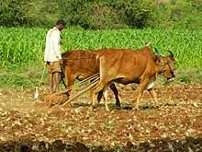
  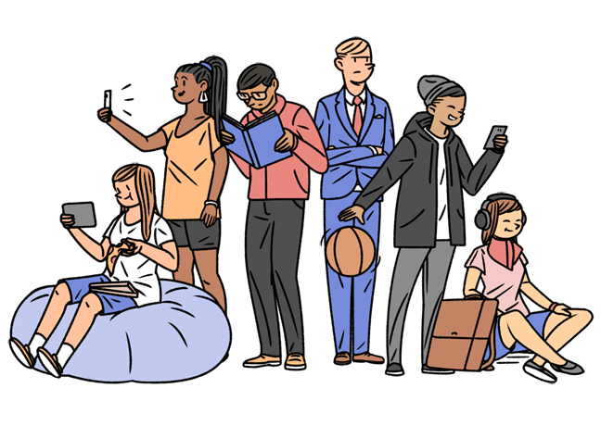
  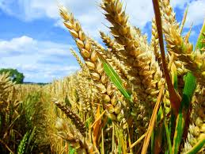
  
  
  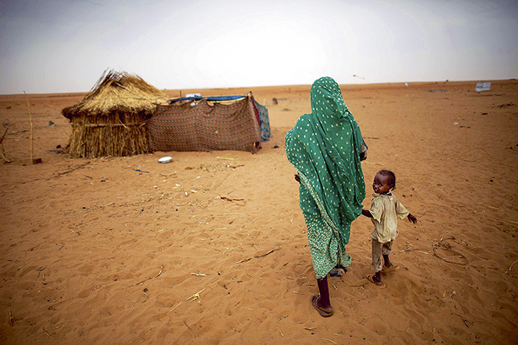
Writing | T: Now I suggest you to use the programm popplet and write me answer the question : “ Will you do the same what did the farmer Dave?explain why yes or why not?
III. | ЗАКЛЮЧНА ЧАСТИНА УРОКУ
Homework | Exercise 4 page 62 to read the text to the end and translate.
Summarizing | 2. Підведення підсумків уроку.  Т: Our lesson soon will come to its end, lets summarize what we learn today.  What do we learn today?What do we remember today? What activities do you like more?  Do not you change the mind and want to work on your profession? Is it was useful for you to know how to use the program popplet?

Addition 1
What are you going to do
When you are twenty-two?
I’ll be a pilot,
I’ll be a doctor,
I’ll be a teacher,
I’ll be a worker.
I’ll be in London,
I’ll be in Rome,
I’ll be in Africa,
I’ll be at home.
Addition 2

And now let’s do an exercise with these words.
My last job was with a computer firm. He finally got a job in a supermarket. I started work when I was 18. State your name, age, occupation in the box below. The legal profession. I am interested in a career in television. His career is more important to him than his family.

Addition 3
Look through the text and find unknown words to you
Suits somebody [suːt 'sʌmbədɪ] відповідати вимогам
Advance [əd'vɑːns] удосконалюватися
Involve [ɪn'vɒlv] втягати, вплутувати
Communicative [kə'mjuːnɪkətɪv] говіркий; товариський,
Spontaneous [spɒn'teɪnɪəs] мимовільний; спонтанний
Purpose ['pɜːpəs] цілеспрямованість, воля
Amaze [ə'meɪz] вражати

Addition 4
1.Plow [plau] оранка
2.generation[ˌʤenə'reɪʃ(ə)n] покоління;
3.crop[krɒp] урожай; пашня
4. harvest['hɑːvɪst] жнива; збирання врожаю
5.manual['mænjuəl] підручник, посібник
6.scarce [skɛəs] убогий

Advantages of being tractor driver and car repair | Disadvantages of being tractor driver and car repair
- a worker can assemble, adjust, adjust and test, and during operation - to service and repair.  - A prestigious work,  - To work in other sectors of the national economy,agricultural sphere.  - The modern tractor driver possesses knowledge and skills of many agricultural trades: a driver, a tractor operator, a mechanic, knows the structure and rules of operation of tractors and agricultural machines, a system of maintenance of a machine-tractor park, signs of major malfunctions and ways of their elimination. He has the necessary knowledge of the basic rules of agrotechnics and advanced technology of mechanized crop cultivation.  - Highly|well-paid work | - Various hand tools - keys and screwdrivers, hammers, sailors, measuring devices, pneumatic equipment, stands, electrical mechanisms and devices, etc. what can cause harm to your health.  - Hard work  - Need a lot of time to work  - The place of work is not the place somewhere in the office.

