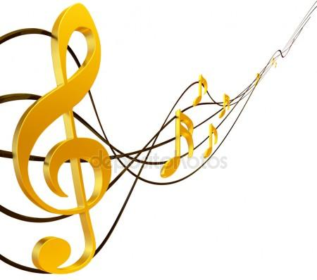

Level B1

Вивчення мови – це не тільки розуміння його граматичних та лексичних особливостей, але й прагнення правильно відтворювати вимову і інтонацію. Заняття музикою – це гарна підмога у вивченні іноземної мови. Коли розвивається музичний слух, набагато простіше освоювати звукові премудрості іноземної мови. Тож вивчаємо англійську, говорячи про музику.

Liubov Hrushko, a teacher of English, Nizhyn Maria Zankovetska College of Culture and Arts, Chernihiv Region

Objectives:
- to develop students’ speaking skills;
- to tell about music styles and express their attitude to art;
- to cultivate students’ aesthetic taste and bring students closer to the world of music.

procedure

I. WARMING-UP

T: If you are the students of our college, you are keen on music. Everyone knows that music is a universal language of mankind. Music can be inspiring force only if it is itself inspired. Music influences us because we all have different physical, mental and emotional tendencies. Each person will absorb from the music the kind of feeling natural for him. As we absorb the feeling of the music our inner nature grows. This growth is an enrichment of the psyche.
Music can open new phases of our inner life because the way of expression of music is limitless. There may be talents lying dormant within us which music can stimulate into activity. We can be affected in many different ways by the same composer. Beethoven’s Eroica Symphony inspires heroic actions; his Moonlight Sonata brings into play our deepest emotions and longing for the Ideal.

II. MAIN PART

T: Music divides into different styles. Can you name them?

(Відповіді студентів)(Symphonic music, Chamber, Classical, Folk, Dance, Light, Contemporary, Pop or Popular, Rock, Heavy Metal, Jazz, Country, Reggae, Rap…)

READING

T: You know many styles of music. Look at the screen and read about famous composers. Have you ever heard their names?

Wolfgang Amadeus Mozart ['moutsα:rt] (1756—1791) — a celebrated Austrian composer. “Don Giovanni”, togehter with “The Marriage of Figaro” and “The Magic Flute”, are his most popular operas.
Ludwig van Beethoven ['beitouvən] (1770—1827) — a great German composer, the giant of the world music, especially celebrated for his powerful mutinous symphonies, among which the 3rd (“Eroica”), the 5th and the 9th enjoy the greatest popularity.
Robert Schumann ['∫u:mα:n] (1810—1856) — a famous German composer, representative of the Romantic school. Among his most popular works are, certainly, his songs (e. g. “Love and Life of Woman”), his piano concerto and some piano pieces (e. g. “The Carnival”).
Frederic Chopin ['∫oupən] (1810—1849) — a famous Polish composer and pianist. Most of his music was written for piano (concertos, ballads, sonatas, preludes, mazurkas, polonaises, nocturnes).

SPEAKING

Suggested characters and situation.

a) A young man who doesn’t like classical music, nor does he believe that anyone else does. In his opinion, those who attend symphony concerts do it just to pose as connoisseurs and cultivated people. Music of this sort seems to him an incoherent mass of sound, without sense or beauty. Of course, he has never made any serious attempt to listen to it attentively or without prejudice.

Use the following:
I’m a simple chap, and I’ve no use for...
All this classical stuff is dull as ditch-water.
It bores me stiff.
There’s nothing to understand: it’s all humbug.
No one really wants it anyhow.
Old-fashioned stuff: our time calls for snappy tunes, not for...

b) A young man with a genuine appreciation of classical music. His favourite composers are Beethoven and Wagner. He explains that these two are fighters, and their music does not caress or lull but is full of power and protest. He considers Beethoven’s Ninth Symphony, with its Ode to Joy in the fourth movement, to be a triumph of human courage and willpower. He dislikes weakness both in life and in art and that’s why Schumann, Schubert, Chopin don’t appeal to him: their music, in his opinion, is sentimental and lacks strength.

Use the following:
I take the greatest delight in...
Serious music appeals to our intellect as well as to our senses.
Music has ethical effect as well: take Beethoven, he...
An artist has no right to give in.
Isn’t it wonderful that...?
Of course, I appreciate composers of the Romantic school but...
Music must call to fight and not...

Group discussion

T: Are you a lover of classical music?
Let’s devide into two groups.
Study the following arguments and develop the ideas.

a. For and Against Classical Music

For
- Classical music gives the listener a keen sensual delight.
- Music has a deep intellectual appeal.
- Music has a strong ethical effect: it ennobles the listener, makes him better and more humane.
- Music condemns evil and supports the ideals of good.
- Music creates a special spiritual world for the listener which immensely enriches his inner life and makes him happy.

Against
- Classical music is a complicated art: it is difficult to find one’s way in it.
- It is also an exclusive art: most people don’t like or understand it. It is not a popular art.
- The very length of most classical pieces can send any listener to sleep.
- People want the kind of music to which they can dance or just talk to friends. It should be simple, cheerful and up-to-date.

b. Classical Music? Jazz? Pop-Music? Why not All of Them?

Brainstorm:

Instruments
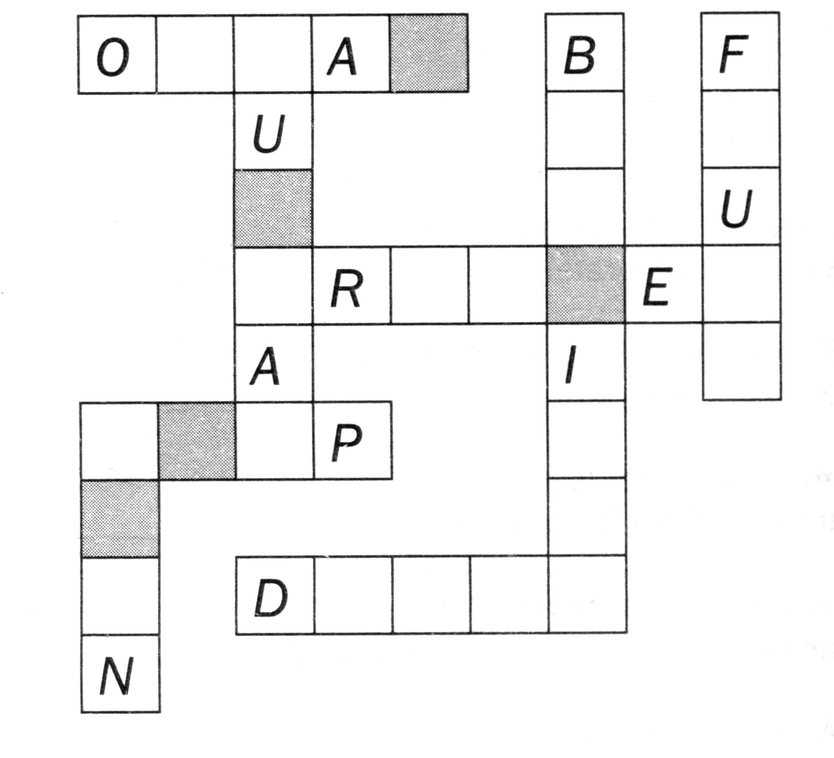
Find the missing letters and complete the names of musical instruments. Then unscramble the highlighted letters to reveal another instrument.

Hidden word: _ _ _ _ _

(Key: organ, guitar, bagpipes, flute, trumpet, harp, horn, drums, hidden word: piano.)

WRITING

T: And now it’s our turn to test our knowledge. You should do it as soon as possible.
(The students are given a set of test each.)

Pop Artists of the 2000s
Test your knowledge with the questions below.

a.. He is the most successful male solo artist in British history.

R _____________ W _____________

b. The controversial lead singer of this funk pop group is called Jay Kay.
J _____________

c. The lead singer of this alternative rock band from London is married to actress Gwyneth Paltrow.

C _____________

d. This is a virtual band, composed of four fictional animated band members: 2D, Murdoc, Noodle and Russel.
G _____________

e. This girl band was formed in 1998. In 2005 their single «Push the Button» reached number one in the UK.

S _____________

(Key: a. Robbie Williams; b. Jamiroquai; c. Coldplay; d. Gorillaz; e. Sugababes.)

III. SUMMING-UP

T: It is obvious that everybody likes music; some people enjoy classical music, others are fond of light music. Life wouldn’t be interesting if we didn’t hear music. Music fills our heart and makes people happy, it helps us work and relax, to think and to create.

T: Your home assignment is to make a presentation about your favourite style of music and performers.

RESOURCES
- Карп’юк О.Д. English Study. Підручник з англійської мови для Х класу шкіл з поглибленим вивченням англійської мови, гімназій, ліцеїв, коледжів. 2005p.
- Valerie Gulotta. English Raetsel-lernspass. 2008p.
- Newspaper “English”.

