**Конспект уроку:**

**,, Sport”**

***Підготовила:***

***вчитель англійської мови***

***Єльнівського НВК ,,ЗНЗ I-II ст. - ДНЗ”***

***Прокопович Наталія Миколаївна***

**Objectives:**

* to develop students' listening, reading, speaking and grammar skills;
* to revise and enrich students' vocabulary on the topic;
* to practise group work;
* to motivate students to communicate with each other.

**Level: Pre – Intermediate**

**Equipment**: a computer, a multimedia projector, a CD player, a CD, HO (a text for reading).

**PROCEDURE I. INTRODUCTION**

1. GREETING

T: Good afternoon, dear children. How are you today? I see you are in a good mood, full of energy and ready for the lesson.

*II. WARMING – UP slide 1*

T: The topic of the lesson is “Sport”. Today we will talk about different kinds of sport. You will develop your listening, reading, speaking and grammar skills through various creative activities, to write down the proverb; to translate it; to tell us your opinion about its meaning;

(One student works at the board.)

A sound mind in a sound body.

(У здоровому тілі – здоровий дух.)

Possible answers:

S1: I agree with this proverb. I think, everyone must do all he can to be healthy.

S2: To my mind, physically inactive people get old earlier than those who have plenty of exercises.

T: You are right. I can add that being in good health means having both body and mind in good working order free from disease and pain. So, what is the topic of our lesson?

III. MAIN PARt

Poem *slide2*

I like riding by bicycle

I’m fond of playing chess

My friend is good at judo

We are keen as you can guess

On every kind of sport for sure

As it can even the illness cure

And can for every girl and boy

Bring many moments of joy.

The proverb reads for everybody

’’A sound mind in a sound body’’**.**

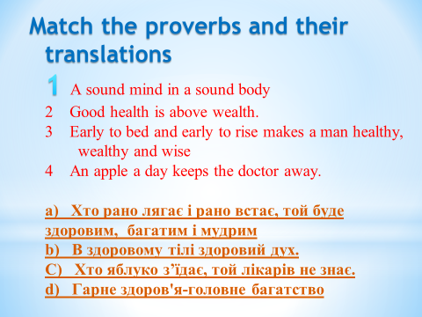

**VOCABULARY PRACTICE**

T: There are lots of different kinds of sports and games. What are they?

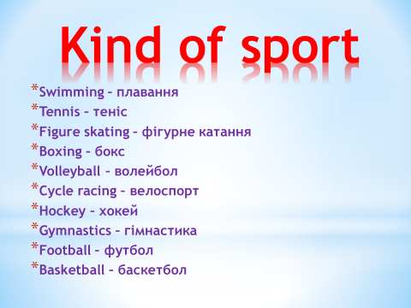

**2. LISTENING**

**T:** Listen to the descriptions of the sports and try to guess what kind of sport is it.

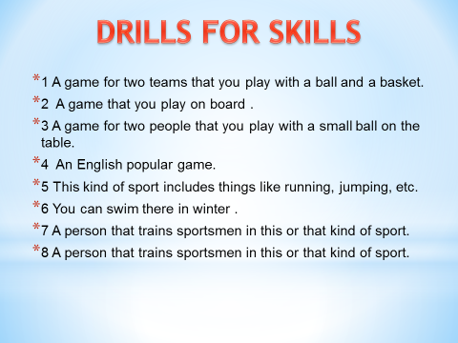

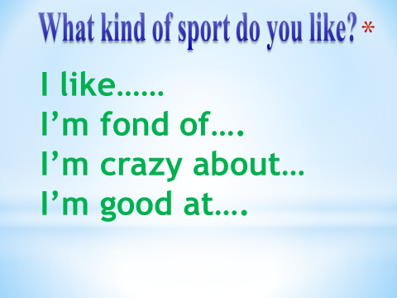

- I like swimming. And what about you?

- As for me I’m fond of …

I’m keen on…

**GRAMMAR PRACTICE**

**3.1 When do we use…?** )

**GO** – if you speak about sport ending in –ing.

(e.g. I go swimming.)

**PLAY** – if you speak about ball games (or chess).

(e.g. I play football.)

**DO** – if you speak about other sports.

(e.g. I do athletics.)

**Write in: *play, go or*  *do.***

_____ tennis ______ athletics ______football

_____ exercises ______ volleyball ______fishing

_____ jogging ______ aerobics ______skiing

T: Complete the sentences using do, play, or go. (Slide 30)

1. Every morning I _________ jogging.

2. On Saturday mornings my brothers ________ football.

3. I _______ gymnastics on Saturdays.

4. My mother and I ___________ aerobics every week.

5. My father and mother _________ golf at the weekend.

6. In winter we ________ skiing.

7. In summer we ________ tennis and ________ swimming.

Key: 1-go, 2-play, 3-do, 4-do, 5-play, 6-go, 7- play, go.

**READING**

**T:** Read the paragraphs below and see if you were right.

I am Alison and I am not very fond of sports. I am a bit plump and it is difficult for me to run and jump. I don’t like to compete, but I like to watch sports on TV. Best of all I like watching figure skating. I sometimes go skating myself.

I am Peter. Sport plays a great role in my life. I love every kind of sports – football, hockey, volleyball and basketball. I also play chess and I love to play football. I go to our local football club every spare minute and my dream is to become a football player. I also watch football on TV a lot.

I am Ann. I am not crazy about sports, but I think it is very important to keep in good form and stay healthy. I want to become a model, so I take great care about my body. I go jogging every day and I attend fitness room three times a week. When I have time, I also attend classes of aerobics, but they are quite expensive, so I can't go as often as I want.

My name is Alex. I don’t understand people who think only about sports and physical perfection of their body or watch others doing the same on TV. Such people miss out a lot in their lives. It is much more fun to train brains. In the modern world people do not need muscles, difficult things can be done by machines. I am happy sitting on my sofa with a book or in front of the computer.

Post – reading

**Write down only a name.** (Slide

Who is fond of training brains?

Who likes training football?

Who likes figure skating?

Who keeps fit for health and good figure?

Who hates competing?

Who is fond of many kinds of sport?

Key: a) Alex; b) Peter; c) Alison; d) Ann; e) Alison; f) Peter.

**Answer the questions (Slide**

What is Ann's ambition?

Why doesn’t Alison like sports?

How does Alex spend his spare time?

Why doesn’t Ann often attend classes of aerobics?

Where does Peter play football?

**Key:** a) She wants to become a model.

b) She is a bit plump and it is difficult for her to run and jump.

c) He sits on his sofa with a book or in front of the computer.

d) Because they are quite expensive.

e) At the local football club.

**6. TRUE/FALSE GAME**

**T: Repeat the sentence if it's true for you, but say nothing if it's false.**

We go in for sports.

Sport is popular in Ukraine.

Sport isn’t very important in our life.

We are fond of sports.

I don’t like playing football.

I like swimming.

I take part in sport competitions.

I do morning exercises every day.

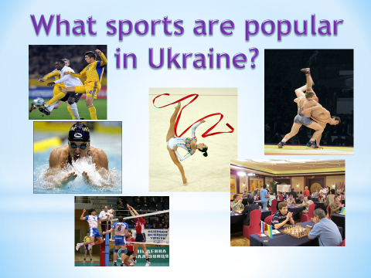

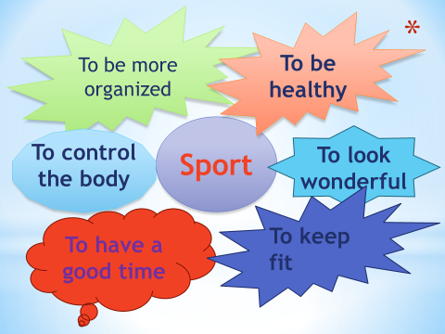

**8. ROLE – PLAY. INTERVIEVING**

**T:** Now imagine that a reporter came to you and he wants to interview you about your favourite kind of sports.

**Possible questions:**

Do you like sport? Why?

Are you fond of playing football?

Does sport help you to keep fit?

How often do you go to the sports ground?

What sports are popular in your family?

Are you good at running (swimming, skating…) ?

Do you want to be a sportsman?

. SPEAKINg

**T:** As a result of our lesson, tell us about your favourite kind of sports.

**IV. SUMMING – UP**

**T:** What have you learnt at today's lesson? What can you do now?

**S1:** I can recognize different kinds of sports.

**S2:** I can speak about my favourite kind of sports.

**V. HOME ASSIGNMENT** (Slide 34)

**T:** Write about your favourite kind of sports using the writing guide.

My favourite kind of sports is… .

I think that… .

I go (play, do)… every … (two times a week).

I want to… (take part in…, win cups, medals…).