9 клас

Урок – подорож

Тема : Велика Британія

Мета :

* розвивати навички аудіювання , читання ;
* навчати використовувати лексичний та тематичний матеріал у спілкуванні;
* розвивати світогляд ;
* виховувати позитивне ставлення до культури Великої Британії .

Обладнання : СД – диск , карта – схема Лондона , картини , географічна карта Великої Британії .

Хід урока .

І. Вступна частина .

Good morning ! Very glad to see you ! Today we are going to travel to Great Britain . It’s a very interesting and unusual country . Our guides will tell you about all parts of this kingdom , about the capital and people of Great Britain . I hope that mutual understanding and respect will be between us .

II. Основна частина .

So , the subject of our travelling is “Great Britain”.

I want to tell you our plan . First of all we are listening to the guides about the situation of the UK , about England , Scotland , Wales and Northern Ireland . We’ll have a short rest and continue our travelling in London . We’ll make acquainted with traditions and Royal Family . So , let’s start !

Guide 1:

**The Geographical Position of Great Britain**

The United Kingdom of Great Britain and Northern Ireland is a part of a group of islands to the north-western coast of Europe . Great Britain is not large . It takes just 6 hours to travel in a fast train from London , the capital of London to Edinburgh , the capital of Scotland . Great Britain also lies not far from the continent . It is separated from the continent by the North Sea and the English Channel . The Channel in its narrowest part ( the Strait of Dover ) is only 32 km wide and when the weather is fine one can easily see from the middle of the Channel the French coast . Great Britain has a very good geographical position as it lies on the crossways of the sea routes from Europe to other parts of the world . The main sea route from Europe to America also passes through the Channel . The sea connects Britain with Belgium , Holland , Denmark , Norway . There are no big rivers in Great Britain . The largest river is the Thames . London , the capital of Great Britain , is on the Thames .

Guide 2:

**The United Kingdom**

To the west of the continent of Europe lie two large islands called the British Isles . The larger of these is known as Great Britain , the smaller , Ireland . The North Sea and the English Channel separate the British Isles from the European continent . The larger island of Great Britain consists of three parts : England , Scotland and Wales which were once separate kingdoms . After centuries of war at the beginning of the 18th century England , Scotland and Wales were united . In 1800 Ireland was included in the United Kingdom of Great Britain and Northern Ireland . The Irish , however , continued to struggle for self-government and in 1922 twenty - two 0f the thirty - two Irish counties formed the independent Irish Republic , now called Eire , with the capital in Dublin . Six northern counties remained a part of the UK , and since that time the official name of the state has become the United Kingdom of Great Britain and Northern Ireland .

The country is washed by the Atlantic Ocean , the North Sea and the Irish Sea , which between Great Britain and Ireland .

Thousands of years ago , the mainland of Europe stretched much further west than now , and by the sinking 490 of the land , the ocean covered a great deal of the continent . The British Isles and the neighbouring small islands were left above the surface of the sea , because they were the highest parts of the land . The water flowed into the valleys among the hills , thus producing an uneven coast and many good harbours .

The first thing that people see when they cross the English Channel is the chalk cliffs near Dover. That is why the Romans called this country Albion ( from the Latin word which means “white”.) It is a sort of symbol of England .

The highest mountains are in the central and northern parts of Scotland , in Wales and in the north – west of England , but they are by no means high as we understand high mountains . The mountains of the British Isles are much the same height as those of the Crimea . In North – west England , there are many beautiful lakes . This is called the “Lake District”. It is one of the most beautiful places on the British Isles .

Teacher :

The flag of great Britain has three crosses – St. George’s Cross from , the flag of England , St. Andrew’s Cross , from the flag of Scotland , St. Patrick’s Cross , from the flag of Ireland .

It got the name of Union Jack from James I under whome Scotland and England were united in the 17th century .

So , historically , the territory of the United Kingdom is divided into four parts : Scotland , England , Wales and Northern Ireland . Let’s start our travelling . Our guides will tell you about all these countries .

At first , welcome to England !

Guide 1 :

I’m from England . I want you to listen to my story about this part of the UK .

Teacher : Before speaking about Scotland I want you to listen to the poem “ My Heart’s in the Highlands ” by Robert Burns .

Guide 1 :

My Heart’s in the Highlands.

*My heart’s in the Highlands, my heart is not here;   
My heart’s in the Highlands, a chasing the deer;   
A chasing the wild deer, and following the roe -   
My heart’s in the Highlands wherever I go.   
Farewell to the Highlands, farewell to the North,   
The birthplace of valour, the country of worth:   
Wherever I wander, wherever I rove,   
The hills of the Highlands for ever I love.   
Farewell to the mountains high covered with snow;   
Farewell to the straths and green valleys below;   
Farewell to the forests and wild-handing woods;   
Farewell to the torrents and loud pouring floods.   
My heart's in the Highlands, my heart is not here;   
My heart's in the Highlands, a chasing the deer;   
A chasing the wild deer, and following the roe -   
My heart’s in the Highlands wherever I go*

**Scotland**

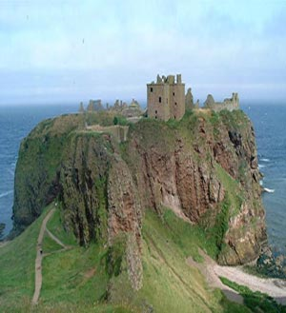

Guide 2 :

Scotland lies to the north of England . People who live in Scotland are Scots . The capital of Scotland is Edinburgh . Edinburgh is not the largest city in Scotland . Glasgow which has population of over one million , is twice as large as Edinburgh . Edinburgh has no large factories . Publishing is its well-known industry . Edinburgh is a beautiful city . The first thing you see in Edinburgh is the Rock . It is in the middle of the city . The Edinburgh castle stands on this hill . The Castle looks like a castle from a fairy tail , and parts of it are more than a thousand years old . From the top of the Castle there is a beautiful view of the hill and the sea .

Scots built fortress – like castles in the Highlands to keep off the enemy . Their territory was divided by the clans ( or tribes ) to which they belonged . The clans were social groups of common ancestors, in other words , they were related to each other and had same surnames . The head of the clan had a distinct title by using the definite article before his name like the Mac – Greggors or the clan Mac – Greggor . Scottish surnames that begin with Mac mean the descendant of and not as many people think , son of . Therefore MacDonalds belong to the tribe of MacDonalds as long as the father is a MacDonald , the wife can be of another clan .

The Stuart clan was famous for their Queen – Mary Stuart , Queen of Scots ( 1560 – 1567 ) who was beheaded by Elizabeth I , queen of England ( 1533 – 1603 ) , in 1567 . Later her son James I became king of Great Britain ( 1603 – 1625 ) . It was only in 1747 that the clan chiefs in . Scotland lost their distinctive powers .

So , let’s continue our travelling in Wales .

**Wales and Welsh**

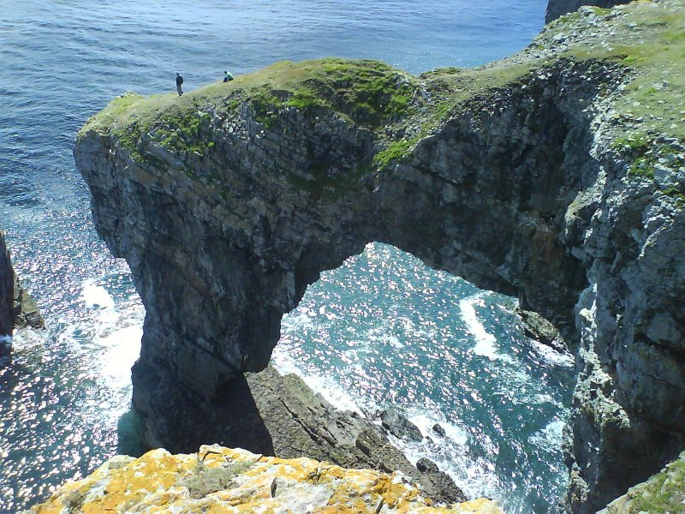

Wales is a lovely country with great mountains , some of them beautiful and green and wooded , others bare and wild . There are gentle , fertile valleys with little farmhouses or cottages sheltering on the slopes of the mountains . Snowdon , the highest mountain in England and Wales is dark and wildlooking . The Welsh are natives of the British Isles , the only nation that has preserved its original language – Welsh , that is one of the Celtic tribes . They lived on their territory long before the Roman invasion . They fought the Anglo – Saxons and won great victories over them under the leadership of King Arthur . No one has a deeper love of his home and family than the Welshman . King Arthur was a semilegendary figure who fought the Saxon invaders and won a great battle at Mount Badon . These old stories tell us of Arthur’s miraculous coming , of how he became King and established the famous order of the Round Table . The round table was to show that no knight , not even the King himself , was “ head of the table ”; all were equal and the King was just “ first among equals ” . The Welsh are a nation of singers .

Welcome to **Northern Ireland !**

   Northern Ireland, also known as Ulster, is still a part of the United Kingdom. It is made up of six countries: Antrim, Armagh, Down, Fermanagh, Londonderry, Tyrone. One third of the population lives in and around the capital, Belfast. Belfast is also the most important port and commercial and industrial centre. Some parts of the territory, those that are not close to the capital, have remained mainly rural.   
   The Irish population is divided into two groups: the Protestants and the Catholics. The Protestants are of British origin. They are descendants of British settlers who came to Ireland in the XVI-th and XVII-th centuries, during and after the Reformation. The Catholics are mostly natives of Ireland.   
   The Protestants were the majority and dominated the Catholics with strong discrimination. In 1968 the Catholics began the movement for equal civil rights. The fightings between the two groups of the population continue to this day.   
   Northern Ireland has a strong cultural tradition: songs, dances, literature and festivals. It has its own Art Council, and there are orchestras, theatres, ballet and opera companies.

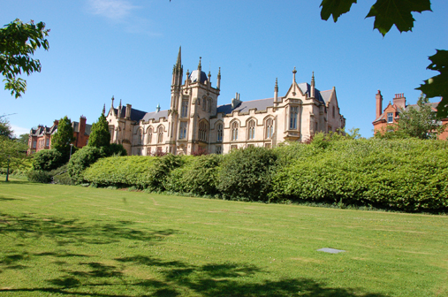

Speaking about Great Britain we must speak about climate and weather . The weather is the main subject of conversation of Great Britain .

**Climate**

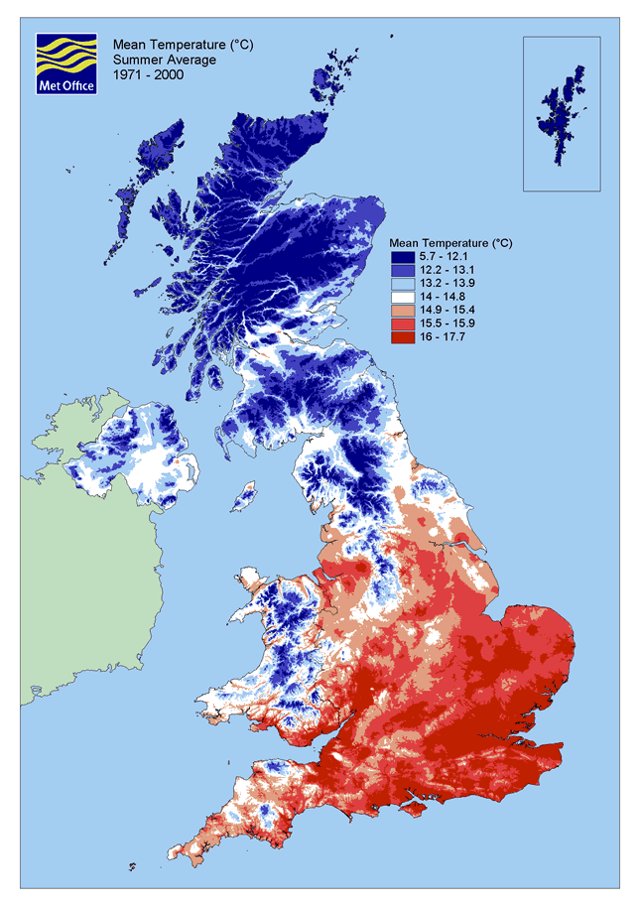

The climate of Great Britain is generally mild and humid because of the Gulf Steam , which brings warm water and air across the Atlantic from the Gulf of Mexico . That means that it is never too hot or cold , too wet or dry .

The winds bring rain from the Atlantic to the hills of the west . That means that the west of Britain is wetter than the east . The average rainfall during the year is more than 1600 mm in the mountainous areas of the west and north , but less than 800 mm over the central and eastern parts . It rarely snows heavily in winter . Snow does not stay for long , except in the Scottish Mountain . November , December and January have the least sunshine – only an hour a day in northern Scotland and two hours a day on the south coast of England .

The southern parts of England and Wales are little warmer and sunnier then the rest of the country . Average temperatrure are from 4ºC in January to 16ºC in July and August . During a normal summer , the temperature sometimes rises above 25ºC in the south .

The weather in Great Britain is so changeable that the British often say they have no climate but only weather . They also say they have three variants of weather : when it rains in the morning , when it rains in the afternoon , or when it rains all day long . In general , weather is a favoutite topic of conversation in the UK .

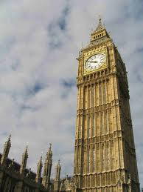 **London**

Teacher : You know that London is the capital of Great Britain .

Guide 1 : London is one of the largest cities in the world . More then 10 mln people live in London and its suburbs . London is a city of striking contrasts . Here one can come across the past and the present , the old and the modern , live side by side in mutual tolerance and respect .

In London , one can se architecture of different centuries and styles . It is inseparably connected with the history of the city . The Romans , the Saxons and the Danes settled here in turn , after them came the Normans , and brought the French civilization . London survived the Plague and Great Fire , which followed in 1666 . During the Fire all wooden houses were smashed to the ground and a New London , London of stone with bigger 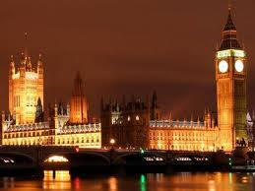 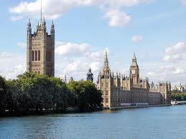

houses and wider streets was built . During the World War II , many buildings of great historic value lay in ruins and today the face of London is changed .

Traditionally London is divided into several parts : the City , Westminister , the West End and the East End .

The city first started in the place , which is known as the City . It is the Heart of London , it’s commercial and business centre . It occupies a territory of a square mile . During a day , it is full of people , nearly half a million people work there.

The West End is the richest part of the city with its beautiful avenues , parks and gardens , grandhotels , theatres and fashionable shops . It is a symbol of wealth and luxury.

While the City is the money of London and the West End is the good of London , the East End is the hands of London , that built the banks of the City and beautiful mansions and hotels of the West End . It is a district , inhabited by the workers . There are many factories and the Port of London there .

Guide 2 : As for me , I cannot imagine London without Thames . In fact , painters and writers regard the river as the source of inspiration . Turner , Monet , Canatello painted it countless times and their impression of the river in all seasons can be seen on the walls of museum , throughout the world . Pope , Spensor and many other poets sang it in their poems . The most famous books about the Thames are “ Three men in a boat ” by Jerom.K.Jerom and “ The wind in the willows ” by K. Graham . If there had been no Thames , there would be not London . It was born many centuries ago in the place , which is known as the City . The City is not only the centre of business . It’s the burth place of London . London was born in the place not far from St.Paul’s cathedral hundreds of years before our era . It was called Lynn – din ( the lonely port ) at that time . After the Norman Conquest , it became Londinium .

Guide 1 : If you want to get some glimpses of London , you’d better start sightseeing with the Tower of London , that comes first among the historic buildings of the city . It was built as the fortress after the Norman invasion of England in 1066 . It has been used as the Royal palace , as an observatory , an arsenal and a prison . For many visitors the principal attraction is the Crown Jewels, the finest precious stones of the nation .

A twenty minutes walk from the Tower will take you to another historic building – St.Paul’s Cathedral , the greatest of English churches . It was built by a famous English architect Sir Christopher Wren . St.Paul’s Cathedral , with it’s famous Whispering Gallery , is considered to be a masterpiece of Renaissance architecture . In one of its towers hangs one of the largest bells in the world – Great Paul .

Guide 2 : Not far from Cathedral is Westminster Abbey . It was founded by Edward the Confessor in 1050 . The best part of the Abby is a wonderful chapel , dating to the 16th century . It is famous for its magnificent architecture . There are many monuments and statues there . Many English kings and queens are buried . Since William the 1st almost ever monarch has been crowned in this great church . One of the greatest treasuers of the Abbey is oaken Coronation Chair made in 1300 . On the south side of Westminster Abbey is Poet’s Corner , where the greatest English writers are buried . Here also are memorials to Shakespeare , Burns , Scott and so on .

Across the road from Westminster Abbey is Westminster Palace , which is spread magnificently on the north bank of the Thames . It is a remarkable example of Gothic architecture .

Guide 1 : Trafalgar square is one of the tourists’ centers of the city . In the middle of the square there is Nelson’s Column , erected in the 1840s to celebrate the victory of Admiral Nelson at the Battle of Trafalgar in 1805 . The north side of the square is formed by the long , low National Gallery , housing the national collection of art and containing some of the world’s greatest paintings .

Guide 2 : Trafalgar Square is a place for rallies , marches and political meetings . If you return to Trafalgar Square and walk along Pall Mall ( a street running parallel to the Mall ) , you’ll come up to St.James’s Palace , which was the London home of the British kings and queens in the 17th – 19th centuries . Although the Palace is no longer the royal residence , the court of the British monarch is still officially known as the Court of St.James’s. This is an old tradition .

Guide 1 : The area around St.James’s Palace , bounded on the south by the Mall , on the north by Piccadilly , on the east by Lower Regant Street and on the west by St.James’s Street , is one of the very few areas of London whose plan has barely changed from the time it was laid out in the late 17th .

Guide 2 : Close to the Houses of Parliament stands Westminster Abbey . The first church on this site was abbey dedicated to St.Peter .

In Westminster Abbey most British monarchs since William the Conqueror have been crowned , and here you may see the ancient Coronation Chair .

The kings of Scotland were crowned on it . It was carried , away from Scotland by the English king Edward I in 1297 but has become a symbol of Scottish independence .

Many British kings and queens are buried in the Abbey .

Guide 1 : South – east of the centre of the City is the Tower of London . The Tower was first built for the purpose of protecting and controlling the city . In the past it has been a fortress , a palace , and a state prison . Now it is a museum visited by about two million people a year .

The Bloody Tower is the most infamous , for here many important prisoners in bygone days were confined and tortured . Many dukes , kings and queens , other aristocratic pretenders to the throne lost their heads on the block that stands in the Tower’s courtyard .

Guide 2 : Buckingham Palace is the British monarch’s residence in London . It was built as a country house for the Duke of Buckingham in 1703 , and was bought by King George III in 1762. Today the Palace contains 600 rooms . The Chaging of the Guard at Buckingham Palace is one of London’s most important tourist attractions .

The Palace is also the venue for great Royal ceremonies . State Visits and Investitures , all of which are organized by the Royal Household .

Although Buckingham Palace is furnished and decorated with priceless works of art that form part of the Royal Collection , one of the major art collections in the world today . It is not an art gallery nor is it a museum .

Guide 1 : Westminster Hall was part of an ald palace .

The present Houses of Parliament occupy the site of the palace and hence received the name the Palace of Westminster .

The Houses of Parliament contain the universal symbol of London ,Big Ben .

The great bell got its name in the 19th century after Sir Benjamin Hall , First Commissioner of Works .

The bell and the clock are on the clock tower of the Houses of Parliament and Westminster Abbey .

Guide 2 : Piccadilly Circus is famous for its lights and for the statue of Eros ; it is always crowded , especially on the evenings of big football matches or other events . Now Piccadilly Circus is the punks’ favourite – gathering ground .

Teacher : And dear tourists , what do you think about British people ?

Tourists .

P1 : People are polite in Great Britain . They always say “ please ” , “ thank you ” . I like their sense of humour .

P2: Oh , I don’t agree with you . British people are polite in small towns and villages , but not in big cities like London , Manchester and others .

P3: Yes , you are right . Especially drivers and shop assistants are rude . But I think that British people are more relaxed . They don’t get so angry and stressed about things .

P4: Oh , I don’t think so . I disagree with you . British people are relaxed only in public . They hate showing their feelings .

P5: And I know that British people are all different . They are all individuals . In general they are kind . British people are always ready to help and give money to charities . They can seem unfriendly but a lot of them are very friendly . British people keep their traditions from the oldest time .

III. Заключна частина

Teacher: We’ve traveled across Great Britain . I hope that you have got new knowledge about this country . And now , as a conclusion , I want you to do this quiz .

I.

1. Where is Great Britain situated ?
2. What countries does the UK consists of ?
3. Where is England situated ?
4. What towns of England do you know ?
5. Where is Scotland situated ?
6. What is the capital of Scotland ?
7. What famous places of London do you know?
8. What holidays are celebrated in Great Britain?
9. What can you say about Royal Family ?

II.

Well, I think that you were really working hard at the lesson . We have learned many facts about this country . And if you were attentive , it would be easy for you to pass the test . Open your exercise – books and write down the word “ Test”. It will be a multiple choice test . Choose ‘a’ , ‘b’ or ‘c’ . (5 min )

1. The United Kingdom consists of four different countries …
   1. England , Scotland , Wales and Ireland .
   2. England , Scotland , Wales and Northern Ireland .
   3. Britain , Scotland , Wales and Northern Ireland .
2. Great Britain is separated from the continent by …
   1. the English Channel .
   2. the North Channel .
   3. the Irish Sea .
3. The highest peak in Great Britain is …
   1. Ben Nevis .
   2. Snowdon .
   3. Loch Ness .
4. The longest rivers in the UK are …
   1. the Trent and the Tweed .
   2. the Wye and the Strait of Dover .
   3. the Severn and the Thames .
5. The British Isles are surrounded by the shallow waters of …
   1. the Irish Sea and the North Sea , the North Channel and the Indian Ocean .
   2. the Irish Sea and the Black Sea , the North Channel and the Atlantic Ocean .
   3. the Irish Sea and the North Sea , the North Channel and the Atlantic Ocean .
6. The population of the UK is …
   1. 48 mln people .
   2. 56 mln people .
   3. 244 mln people .

III.Read and say : What is the emblem England , Scotland , Wales and Northern Ireland .

1. The different parts of Britain have their own emblems . They are all plants . In the 15th century there was a series of wars in England , which were called The Wars of the Roses . They were between the Dukes of Lankaster and the Dukes of York . The emblem of Lankaster was the Red Rose and the emblem of York was the White Rose . The Dukes of Lancaster won , so the emblem of England is the Red Rose .

2. The thistle , the national emblem of Scotland , was chosen because it saved the country from the enemy . This is what a legend says about it . In ancient times the Norsemen raided the east coast of Scotland intending to plunder it and settle in the country . The Scots took their stations behind the river Tay , the largest in Scotland . Not expecting the enemy before the next day and being weary and tired after a long march they pitched their camp and were resting . The Norsemen saw that no guards protected the camp so they crossed the river intending to make the Scots by surprise . On coming quite near they took off their shoes not to make noise . But one of the Norsemen stepped on a thistle and shrieked with a pain . The alarm was given in the Scots camp and the Norsemen were put to flight . Scots , thankful for timely help , chose the thistle as their national emblem .

3. The leek and daffodil are Welshmen’s national emblem . Welshmen all over the world celebrate ( in March ) St.David’s Day by wearing either leeks or daffodils . St.David is supposed to have lived for several years on bread and wild leeks , so the link between the leek and St.David is a strong one . The daffodil is also closely associated with St.David’s Day . It became an alternative to the leek as a Welsh emblem in the present century , because some thought the leek vulgar . The Welsh national flag is called Welsh dragon . It bears the red dragon on the white and green background .

4. The shamrock , the national emblem of the Irish , is proudly worn on St.Patrick’s Day , March 17 . It is worn in memory of Ireland’s patron saint , who when explaining the idea of the Trinity to the Irish used the shamrock ( a small white clover with three leaves on the stem ) as an illustration of the mystery .

The lesson is over . Marks .