План - конспект уроку у 4 класі до підручника О. Карпюк.
Тема: Світ природи.
Мета: Повторити назви днів тижня і різновидів погоди. Розвивати вміння вести бесіду про погоду і сприймати на слух прогноз погоди. Закріпити граматичні навички: ступені порівняння прикметників. Практикувати учнів у читанні речень з перевіркою розуміння граматчного явища і змісту прочитаного. Навчати учнів описувати тварин вживаючи ступені порівняння. На кінець уроку учні зможуть запитувати і розповідати про погоду, описувати тварин застосовуючи вищий і найвищий ступені порівняння прикметників.
Обладнання: Підручник, зошит, аудіододаток, карти для заповнення (диктоглас), картки для роботи в групах, тематичні картки з зображеннями погоди, тварин та природи.
Тип уроку: урок узагальнення і систематизації знань.
Хід уроку:
І. Початок уроку
1. Привiтання: Good morning, pupils. How are things with you?
2. Повідомлення теми та мети уроку: At this lesson we are going to recollect how to speak about the material that we have learnt at the previous lessons. So by the end of the lesson you will be able to speak about the weather and animals.
3. Фонетична розминка: Let’s say the tongue twister to practice the pronunciation of the sounds [w] and [ð] (The tongue twister is printed on the paper or written on the blackboard)
T: Pronounce the sounds [w], [ð]
T: Say the tongue twister slowly.
T: Now say it faster / as quickly as possible.
Whether the weather is warm, whether the weather is hot, we have to put up with the weather, whether we like it or not.
4. Мовна розминка:
T: So, what is the weather like today?
P: It is cold/ snowy/icy… .
2. Основна частина уроку
1 Розвиток діалогічного мовлення.
1) T: Open your books at page 126 and look at task 1. What days can we see / what kinds of weather can we see in the chart?
2) T: What’s the weather like on Sunday /Monday …?
3) T: Ask your friend about the weather on Tuesday/ Wednesday?
P1 --- P2, (a couple of pairs ask each other out loud)
4) T: Work in pairs. Ask and answer about the weather.
P --- P (pupils work in pairs)
2. Розвиток навичок аудіювання і письма. Диктоглас.
1) T: Look at the picture of exercise 2. We can see a man pointing to the map. What country is on the map? What is this man telling about? What is the weather like in these pictures? (On the blackboard there are weather flashcards) (Attachment 1)
2) T: Now we are going to listen to the weather forecast. Look through the sentences of exercise 2 and say what parts of the day are mentioned here?
P: Morning, lunchtime, afternoon.
3) Т: Listen to the beginning of the forecast and say if it is for today, tomorrow or yesterday.
4) T: Work in groups of four. You have got the cards to complete. Listen to the weather forecast and complete the sentences while you are listening. Listen one more time and add to your notes. In your groups compare the forecast and make all the sentences complete. Work on the task together. Choose the speaker from your group and report on the forecast. (Attachment 2)
Weather Forecast
This is the weather forecast for ______________________. We’ll have four _______________________________.
In the morning it is going to be ______________________. At lunchtime __________________________________.
In the afternoon ________________________________________________________________________________.
3. Розвиток граматичних навичок.
1) T: Good job, kids! You are so bright and intelligent pupils aren’t you? You study English and your English is getting better every day, isn’t it. Things are getting better, aren’t they? (Pupils say the grammar chant which is printed and attached to the back side of the blackboard)
a) Things are getting better, much better.
Things are getting better every day.
I’m glad.
The homework is getting easier, much easier.
The homework is getting easy every day.
That’s good.
Your English is improving.
Your writing is getting stronger.
Your grammar’s getting better every day.
Hooray!
Your accent’s getting better, much better.
Your accent‘s getting better every day.
Hooray!
b) T: Let’s say the chant in parts. (Pupils say first two sentences and the teacher responds and so on)
2) Ex. 3, p. 127
a) T: You are doing very well! At school you study a lot of interesting things. I wonder how much do you know about our world. What planet do we live on? The Earth is a beautiful planet, isn’t it? There are so many different places and interesting animals here. I want you to look at the pictures and match them to the words. (The words and the pictures are attached to the blackboard; pupils go to the blackboard and match the pictures and the words) (Poles, polar bear, tropical forest, the Dnieper) (Attachment 3)
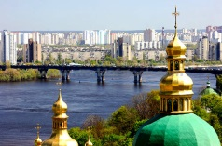
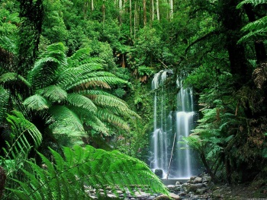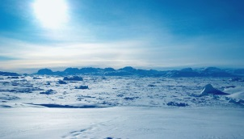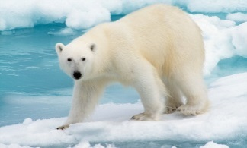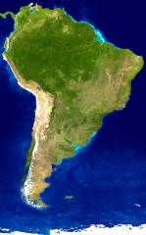
b) T: Work in pairs. Read the sentences of exercise 3 and choose the correct word. You have got two minutes to do this task.
c) T: Now answer my questions. What are the coldest places on the Earth? What animals live in the Arctic? What season is the happiest time for polar bears in the Arctic? Where are the biggest tropical forests in the world? What is the biggest river in Ukraine?
3) T: It’s time to relax a bit. Let’s sing and act out the grammar song. (While singing the song pupils act out every word) (Attachment 4)(you tube- https://www.youtube.com/watch?v=872gqAJjc1g)
Good- better- the best
Bad – worse – the worst
Big – bigger –the biggest
Small – smaller – the smallest
Colourful – more colourful – the most colourful
4) Ex. 4, p.127
a) T: During this unit we’ve learnt a lot about wild and domestic animals. Look at the pictures on the blackboard and say which animal is fatter, a pig or a sheep?
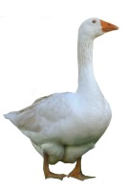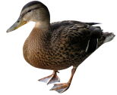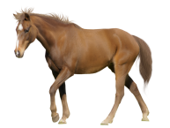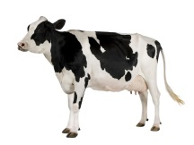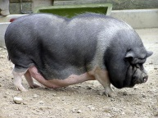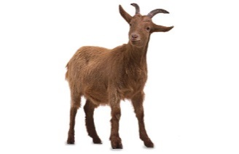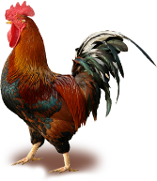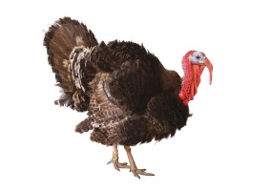

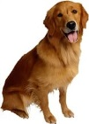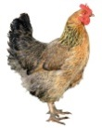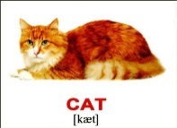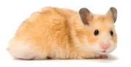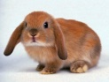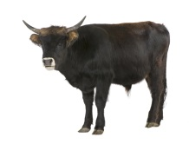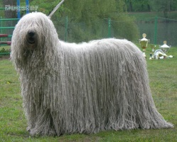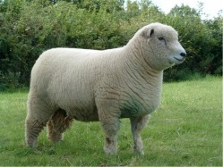

b) T: Open your copybooks. Write down todays date. Now work in groups of four. You’ve got the pictures of domestic animals. Compare them. Use the words from the box of exercise 4. Write down the sentences into your copybooks. Help each other. Work quietly. You’ve got five minutes. The speaker reads the sentences. (Every group gets small pictures to compare domestic animals) (Attachment 5)
short |  | fast
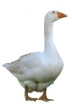 | 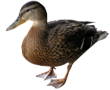 | 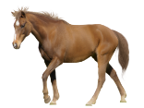 | 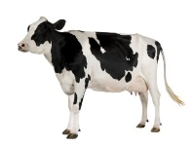
a goose | a duck | a horse | a pig

5) T: Look at exercise 5, p. 127. Say which of the animals is the biggest/ the best / the most intelligent / the most dangerous / the strangest / the fastest / the longest / the funniest / the most interesting / the worst. (On the blackboard there are pictures of wild animals) (Attachment 6)
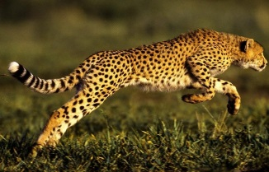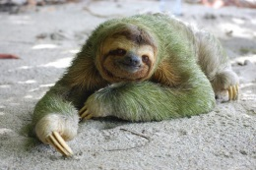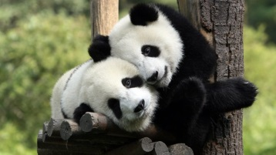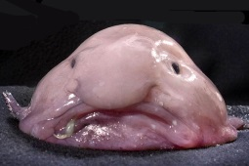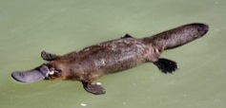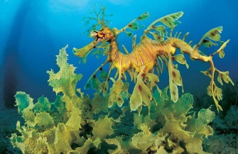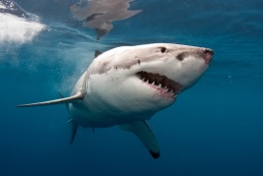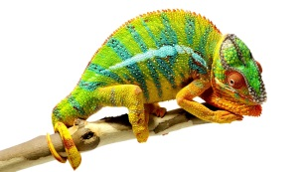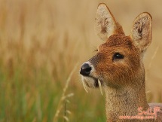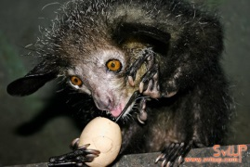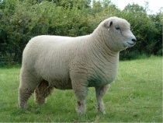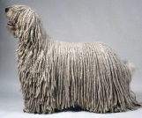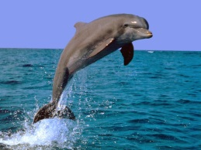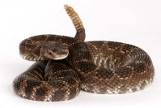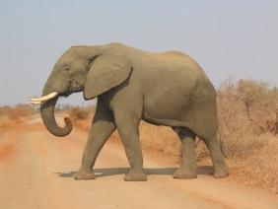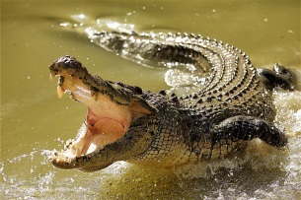
4. Розвиток навичок письма. Ex. 6, p.127
1) T: Imagine, you are poets. You have to write a rhyme – cinquain about the animal. First let’s do it together.
A tiger
Strong, intelligent
Run, jump, climb
It’s very dangerous.
Animal
5. Розмова з дітьми про бездомних тварин.
T: So today we are speaking about wild and domestic animals. But we don’t have to forget that there are other animals – homeless animals. They are suffering greatly in winter. When it is frosty and animals are hungry they can die in some hours. They need our help and protection. What can we do for them? At least we can feed them. (The pictures are on the blackboard) (Attachment 7)
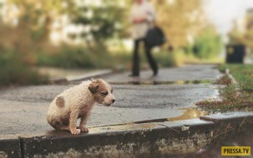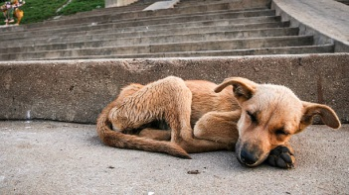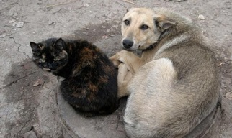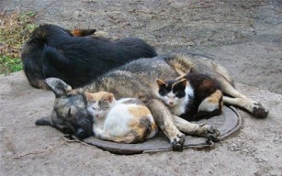

3. Заключна частина уроку.
1. Домашнє завдання: Впр. 6, с. 127 – виконати письмово.
2. Підведення підсумків уроку

Attachment 1

thunder and lightning
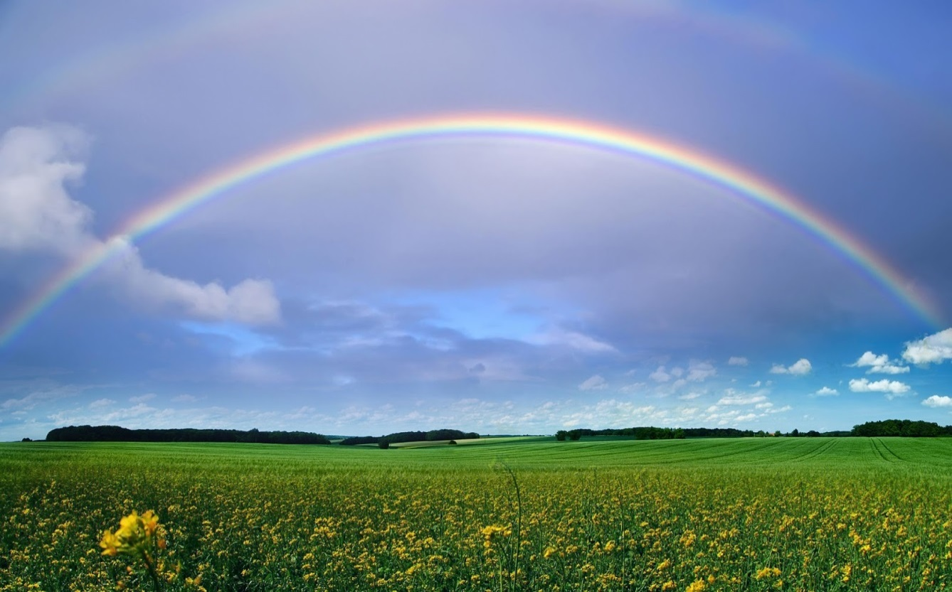
rainbow
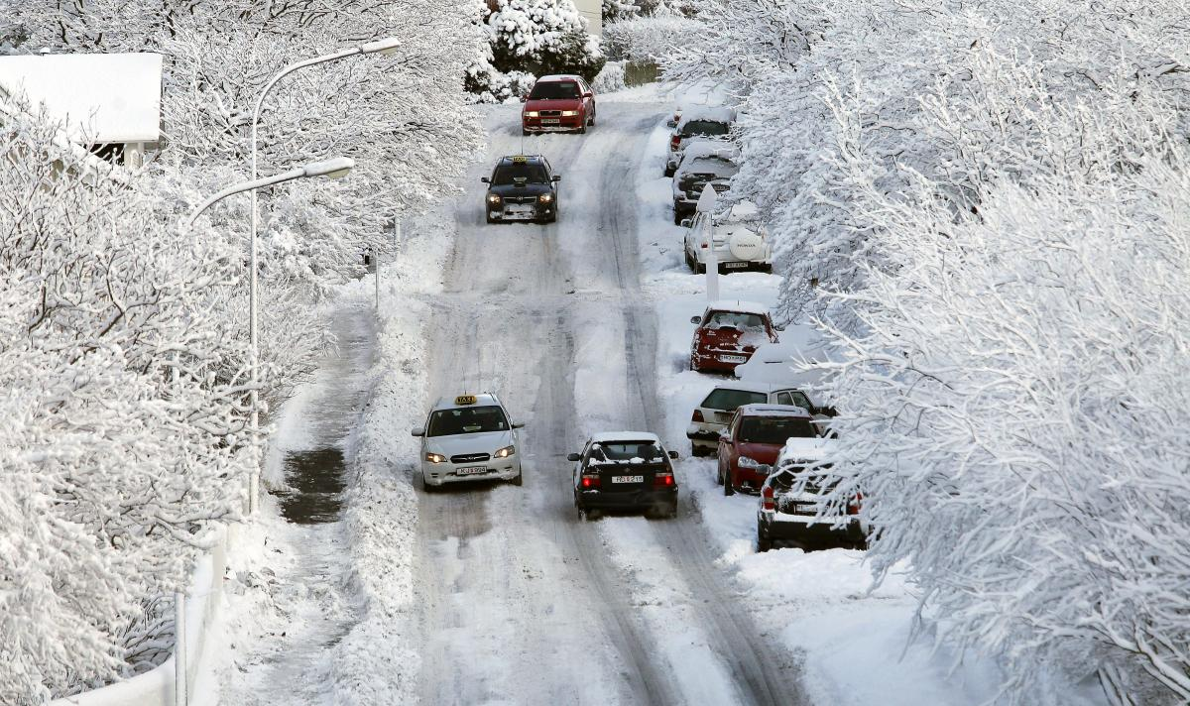

Attachment 2
Weather Forecast  This is the weather forecast for ______________________  We’ll have four ___________________________________  In the morning it is going to be ______________________  At lunchtime _____________________________________  ________________________________________________  In the afternoon __________________________________  ________________________________________________ | Weather Forecast  This is the weather forecast for ______________________  We’ll have four ___________________________________  In the morning it is going to be ______________________  At lunchtime _____________________________________  ________________________________________________  In the afternoon __________________________________  ________________________________________________
Weather Forecast  This is the weather forecast for ______________________  We’ll have four ___________________________________  In the morning it is going to be ______________________  At lunchtime _____________________________________  ________________________________________________  In the afternoon __________________________________  ________________________________________________ | Weather Forecast  This is the weather forecast for ______________________  We’ll have four ___________________________________  In the morning it is going to be ______________________  At lunchtime _____________________________________  ________________________________________________  In the afternoon __________________________________  ________________________________________________
Weather Forecast  This is the weather forecast for ______________________  We’ll have four ___________________________________  In the morning it is going to be ______________________  At lunchtime _____________________________________  ________________________________________________  In the afternoon __________________________________  ________________________________________________ | Weather Forecast  This is the weather forecast for ______________________  We’ll have four ___________________________________  In the morning it is going to be ______________________  At lunchtime _____________________________________  ________________________________________________  In the afternoon __________________________________  ________________________________________________
Weather Forecast  This is the weather forecast for ______________________  We’ll have four ___________________________________  In the morning it is going to be ______________________  At lunchtime _____________________________________  ________________________________________________  In the afternoon __________________________________  ________________________________________________ | Weather Forecast  This is the weather forecast for ______________________  We’ll have four ___________________________________  In the morning it is going to be ______________________  At lunchtime _____________________________________  ________________________________________________  In the afternoon __________________________________  ________________________________________________
Weather Forecast  This is the weather forecast for ______________________  We’ll have four ___________________________________  In the morning it is going to be ______________________  At lunchtime _____________________________________  ________________________________________________  In the afternoon __________________________________  ________________________________________________ | Weather Forecast  This is the weather forecast for ______________________  We’ll have four ___________________________________  In the morning it is going to be ______________________  At lunchtime _____________________________________  ________________________________________________  In the afternoon __________________________________  ________________________________________________
Weather Forecast  This is the weather forecast for ______________________  We’ll have four ___________________________________  In the morning it is going to be ______________________  At lunchtime _____________________________________  ________________________________________________  In the afternoon __________________________________  ________________________________________________ | Weather Forecast  This is the weather forecast for ______________________  We’ll have four ___________________________________  In the morning it is going to be ______________________  At lunchtime _____________________________________  ________________________________________________  In the afternoon __________________________________  ________________________________________________
Attachment 3



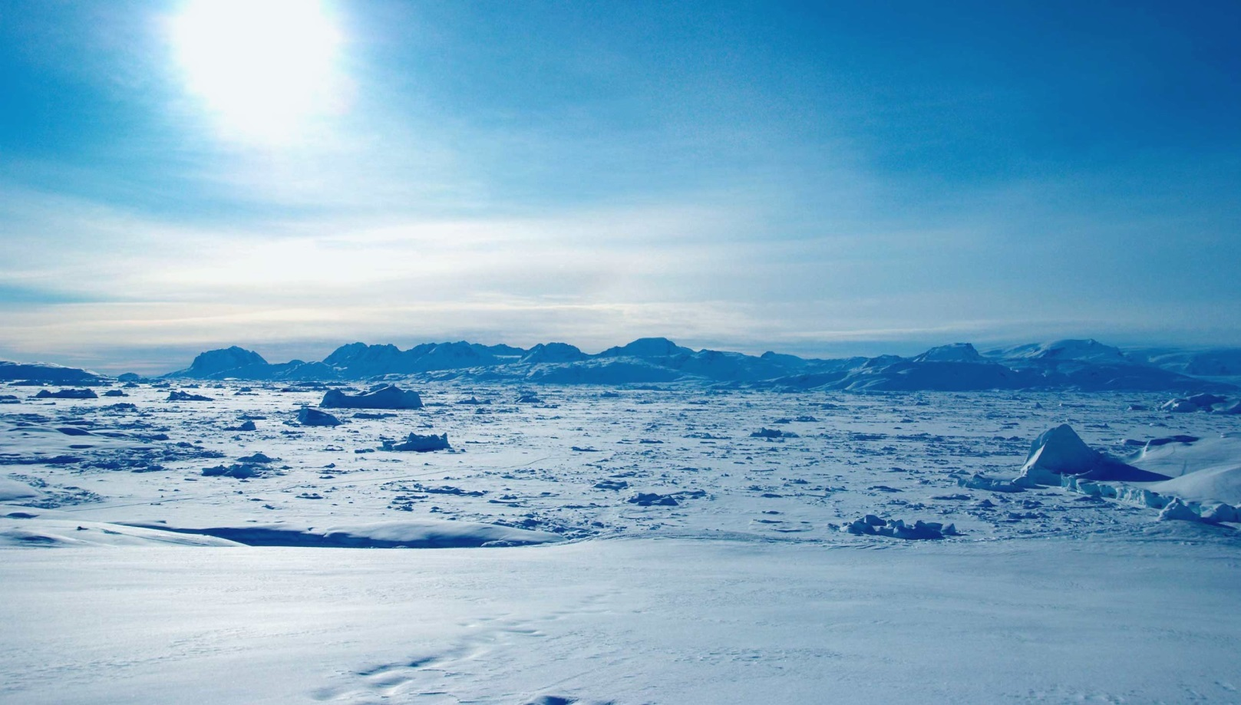

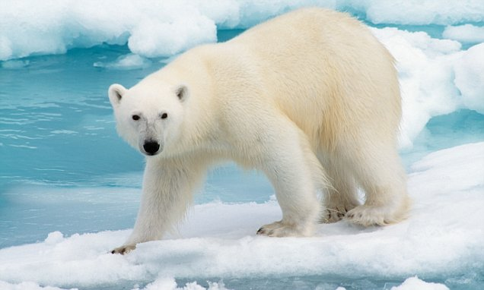
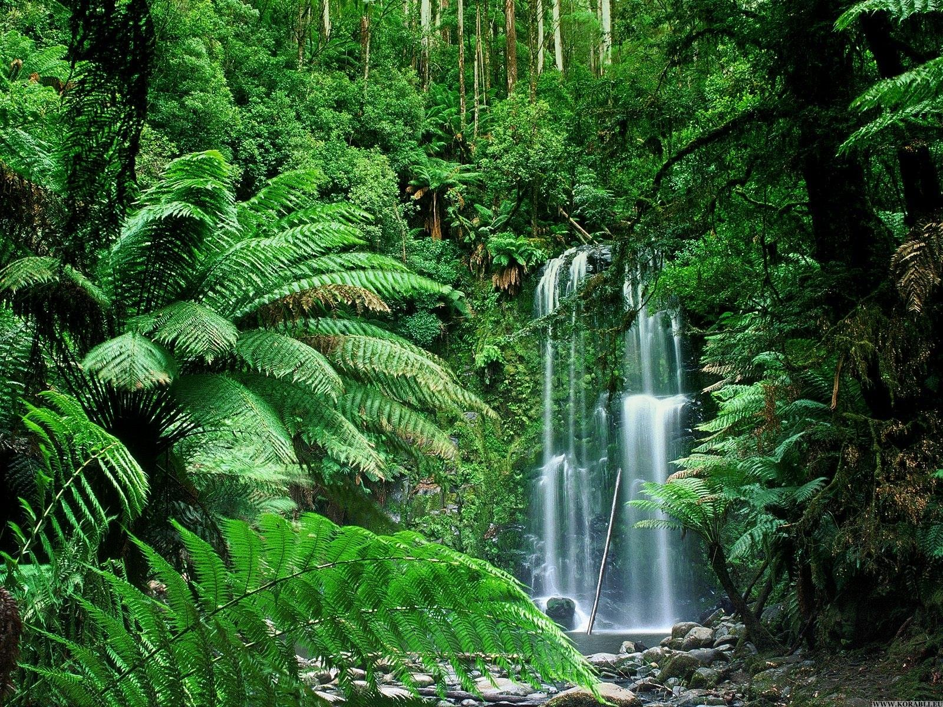
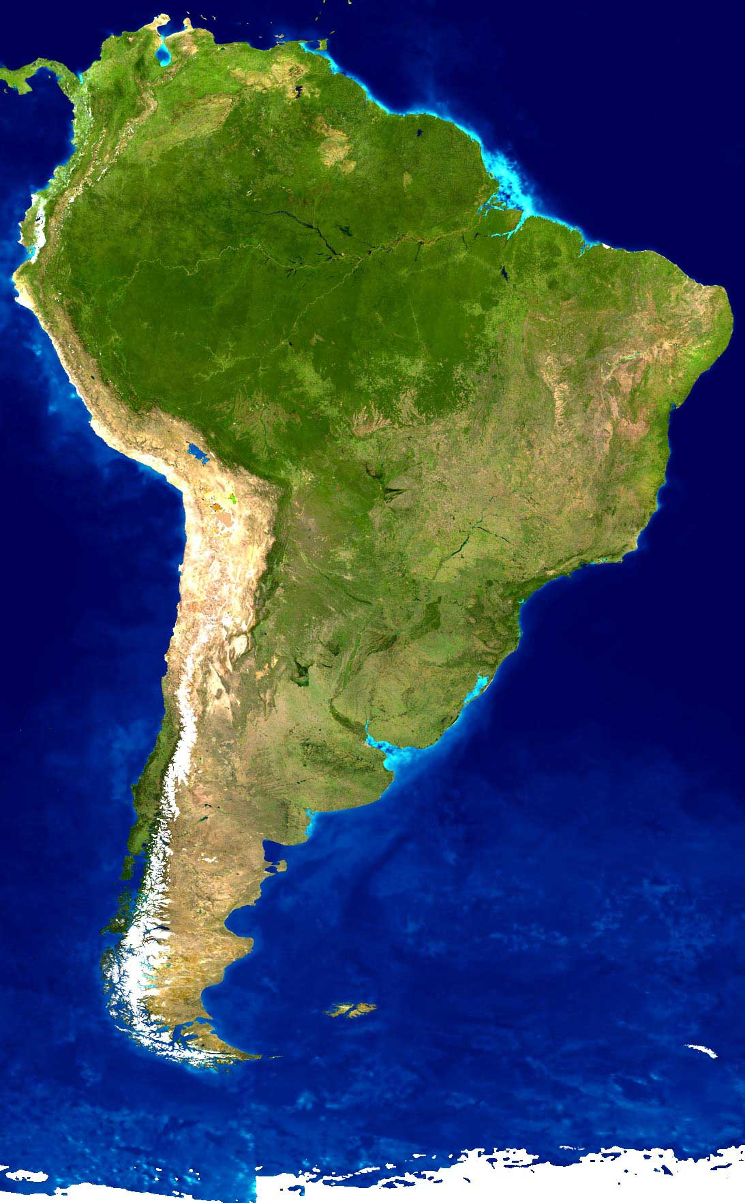
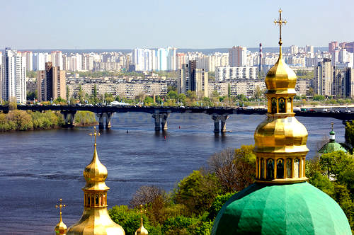

the Earth

poles
polar bear

the Arctic

tropical forest

South America

the Dnieper
Attachment 4
good 
better
the best   
bad 
worse
the worst 
big
bigger
the biggest

small
smaller
the smallest
colourful
more colourful
the most colourful
Attachment 5
short |  |  | fast
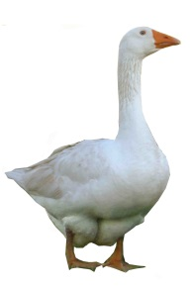 | 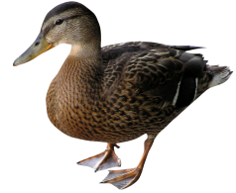 |  | 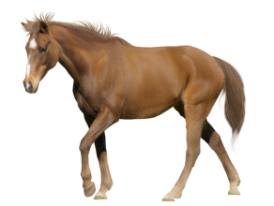 |  | 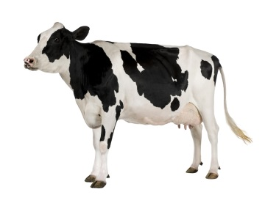
a goose | a duck |  | a horse |  | a pig
fat |  |  |  | intelligent
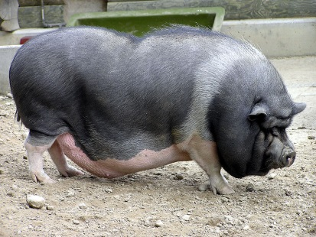 |  | 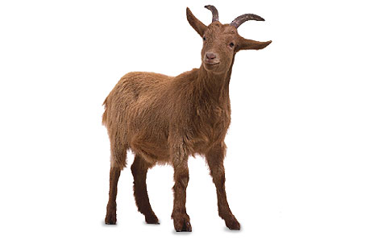 |  | 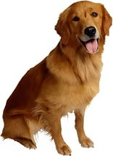 |  | 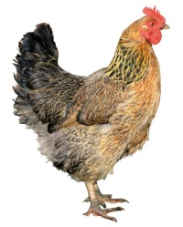
a pig |  | a goat |  | a dog |  | a hen
long |  |  |  | interesting
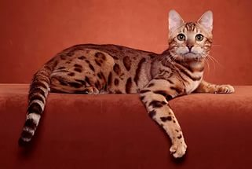 |  | 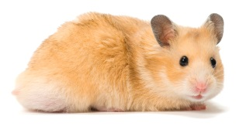 |  | 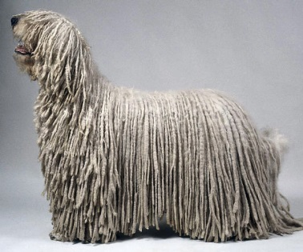 |  | 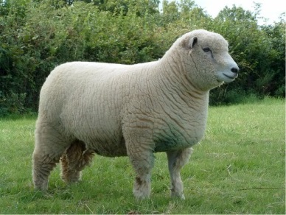
a cat |  | a hamster |  | a sheep dog |  | a sheep
thin |  |  |  | beautiful
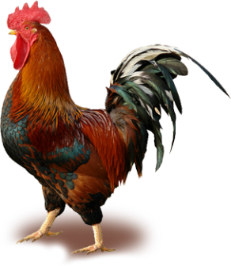 |  | 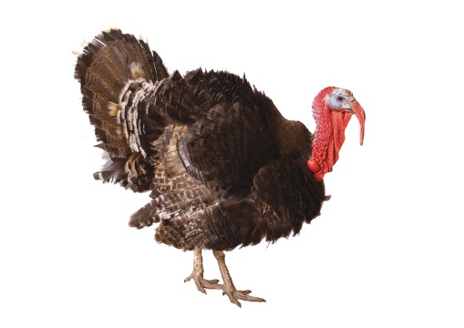 |  | 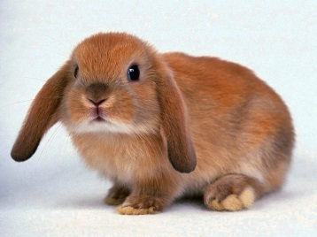 |  | 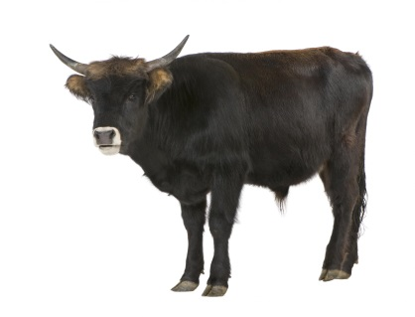
a rooster |  | a turkey |  | a rabbit |  | an ox

Attachment 6
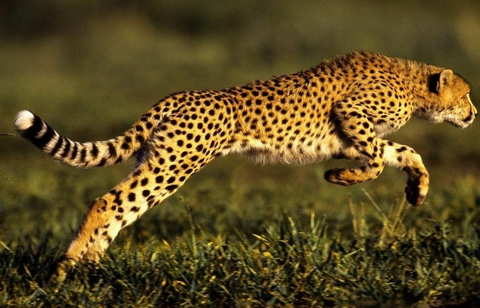
Cheetah
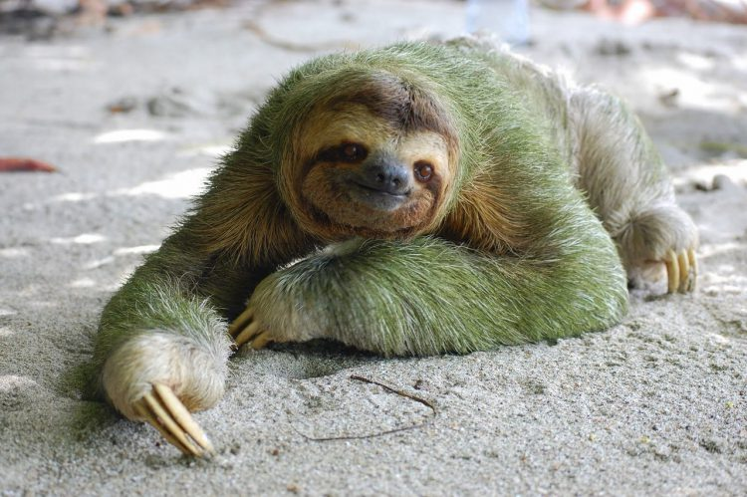
Sloth
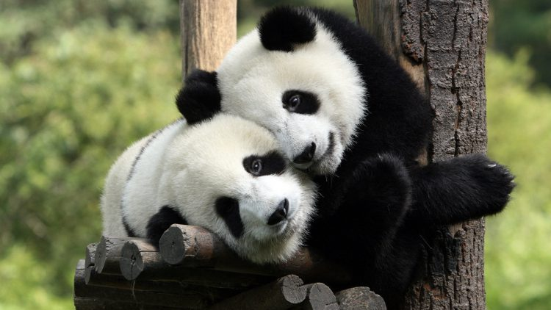
Panda
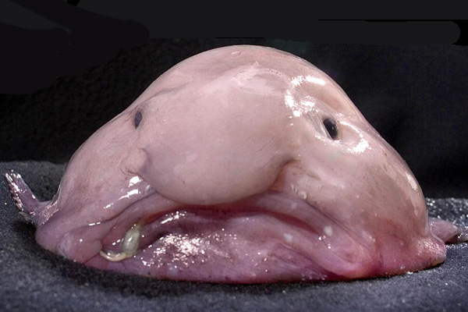
Blobfish

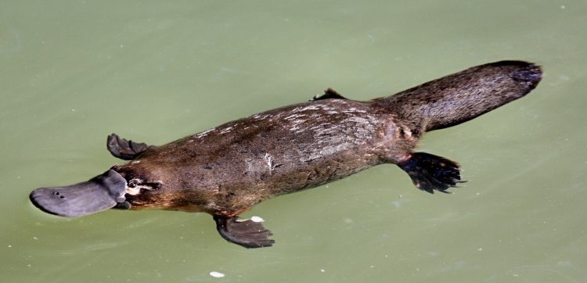
Platypus
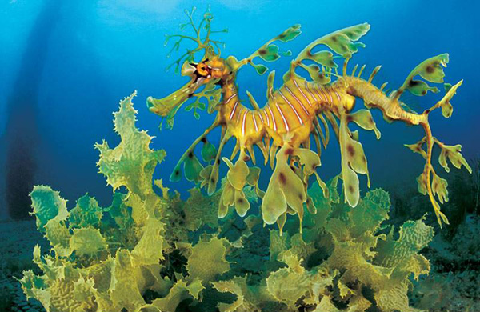
Leafy seadragon
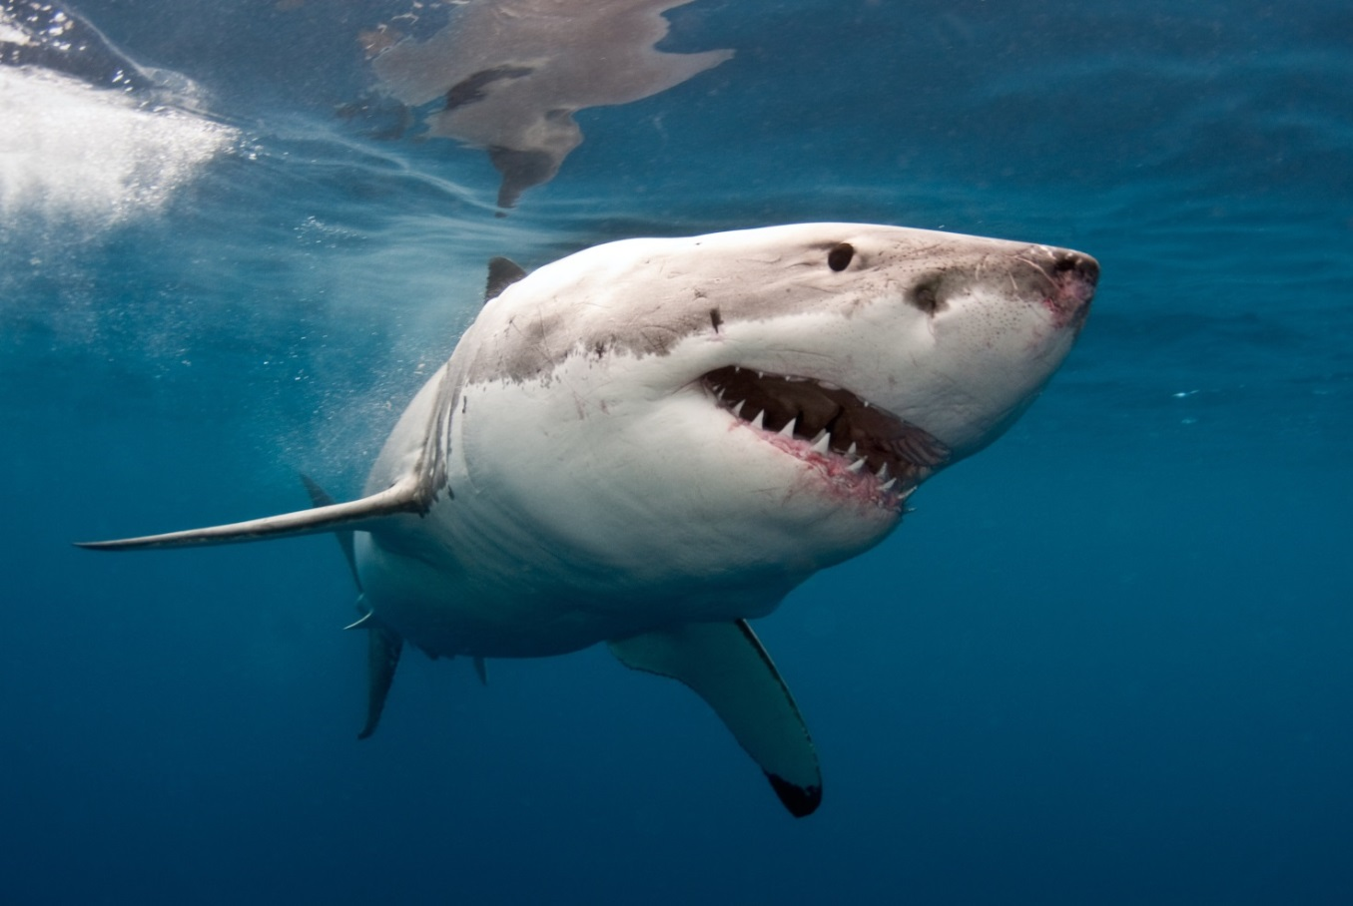
Shark
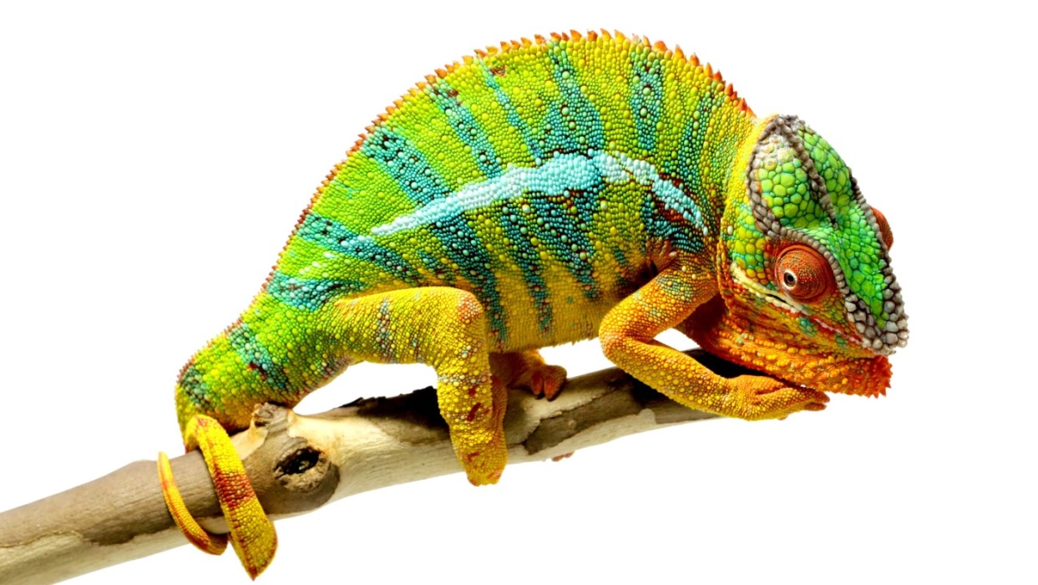
Chameleon
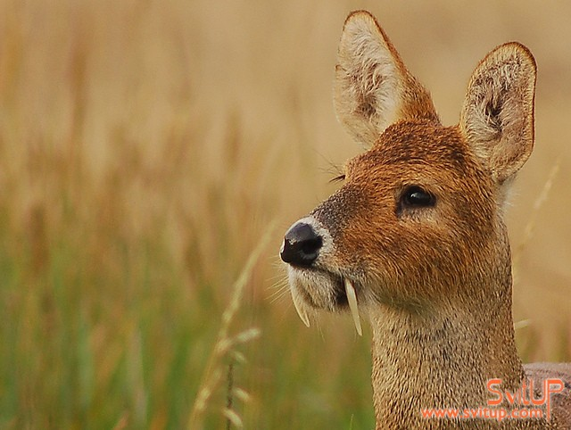Water deer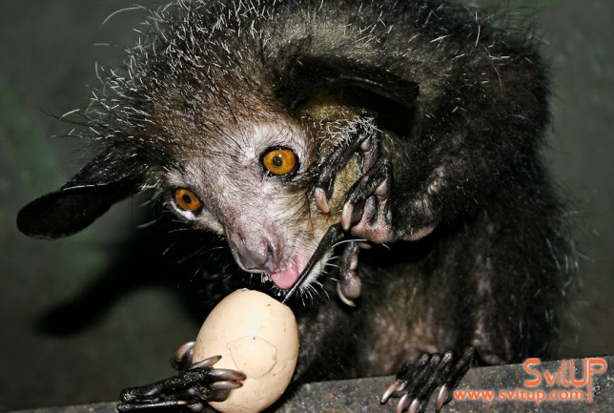
Aye-aye
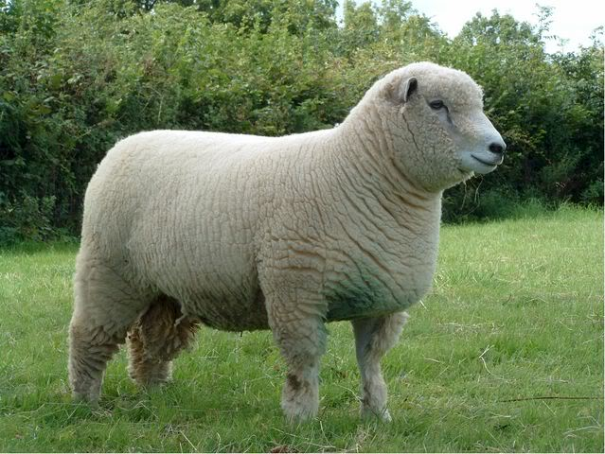Sheep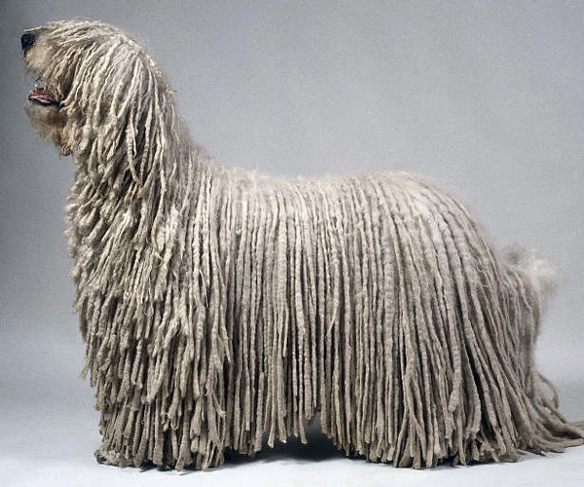Komondor
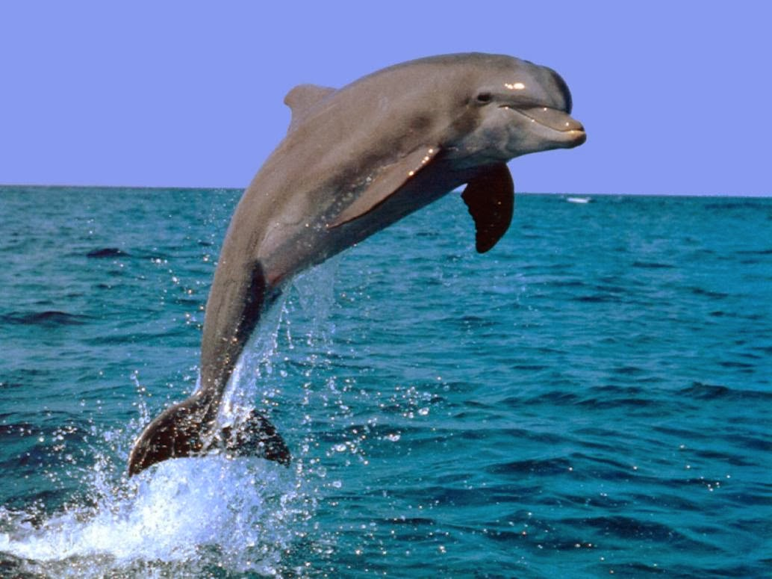
Dolphin
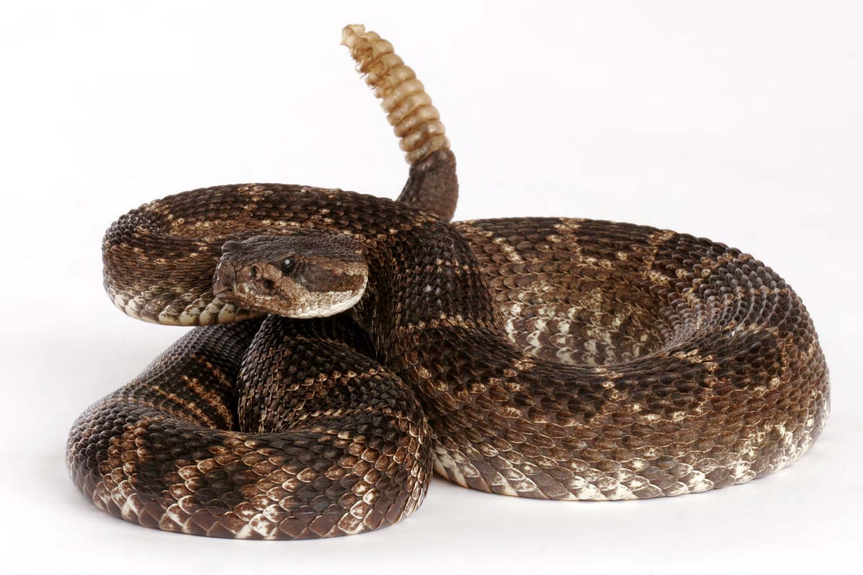
Snake
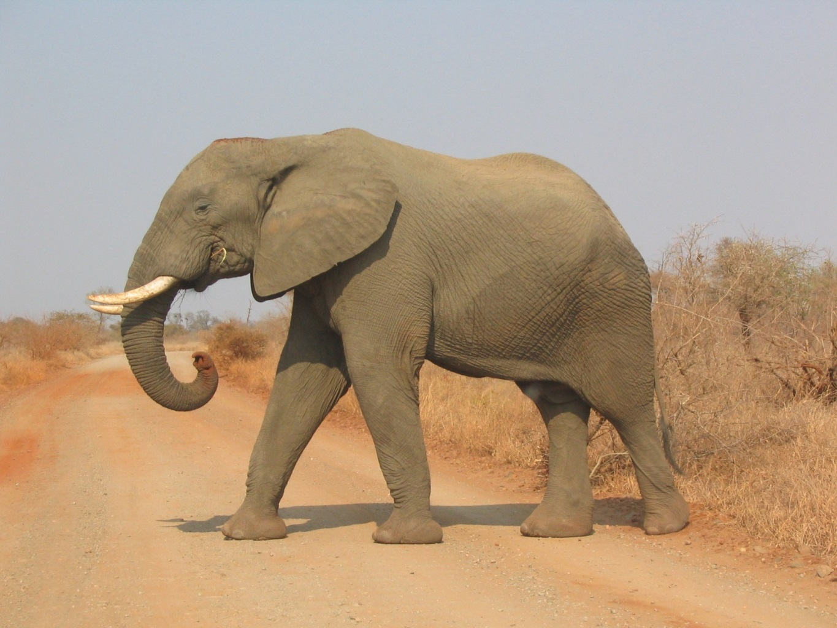
Elephant
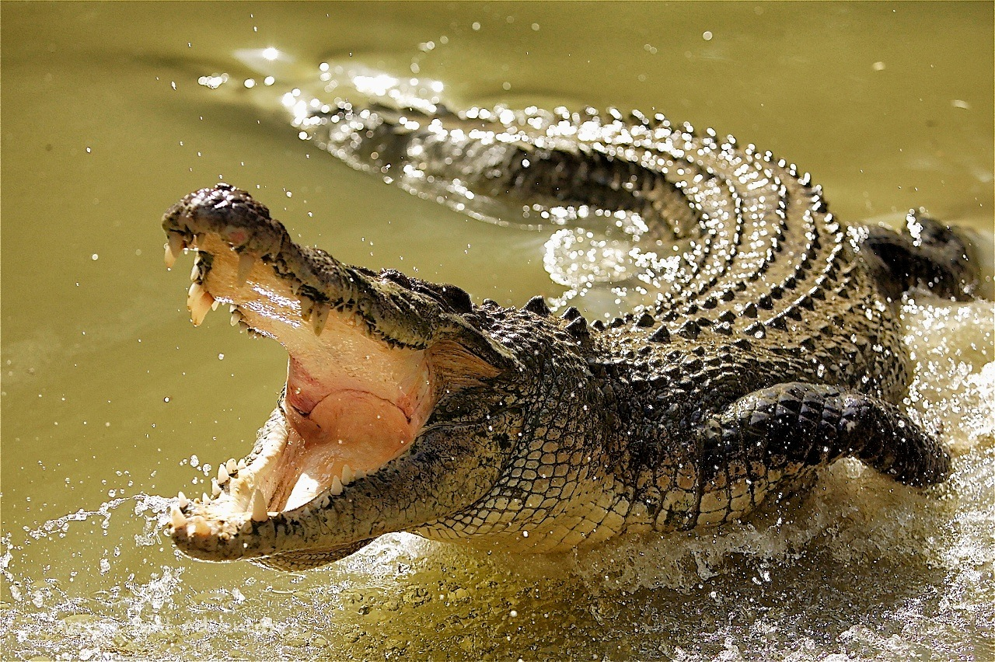
Crocodile
Attachment 7
