**Урок англійської мови 11 клас**

Тема : Мистецтво (Art)

Живопис (Painting)

Підтема : Cвіт картин.

Мета :

*практична:*

* навчити учнів використовувати мовний матеріал з теми «Мистецтво»;
* навчити описувати картини.

*загальноосвітня:*

* розвивати навички мовлення;
* продовжувати формувати навички аудіювання і письма;
* удосконалювати техніку читання.

виховна:

* прищеплювати інтерес до витворів мистецтва;
* виховувати усвідомлення важливості впливу мистецтва на естетичний розвиток людини.

Тип уроку: мовний комбінований

Обладнання : постери‚ слайдова презентація ‚ картки для індивідуальної і групової роботи‚ висловлювання відомих людей про витвори мистецтва‚підручник.

Епіграф до уроку: \слайд\

«Painting is poetry that is seen rather than felt‚ and poetry is painting that is felt rather than seen»

Leonardo da Vinci (1432-1513)‚

Italian draftsman‚ painter‚ sculptor‚

architect and engineer

PROCEDURE

ХІД УРОКУ

І. Підготовка до сприйняття іншомовного спілкування.

1.Greeting.Привітання.

- Hello‚ children! I’m very glad to see you! How are you?

- Good morning! We are glad to see you too. We are fine.

2. Aim. Мета.

Today we’ll continue to speak about art. We are visiting a museum of the Renaissance. We’ll try to describe works by famous painters.

3. Warming up. Уведення іншомовну атмосферу.

Game.Sentence Star. \ слайд\

We have a star with five words. Give a definition of each word. Make up sentences with these words.

ART

PAINTING EPOCH

COLLECTION MASTERPIECE

Key :Art is beautiful objects;

painting, drawing, sculptures;

non-scientific subjects;

film;

theatre;

special skills … F. ex. I like modern art.

Epoch is a long period of time in the history of people or place. We can

mention the epoch of ancient art.

Masterpiece is an excellent painting, book;

piece of music;

the best work of art;

an extremely good example of something.

F. ex. “Madonna of the Rocks” is one of the masterpieces of Leonardo

da Vinci.

Collection is a group of things, interesting or valuable objects that

someone collects;

works of art that are kept together;

clothes or other products that become available at a particular

time of year.

F. ex. Goya’s brilliant series “The Disasters of War” (“Лиха війни”), a

collection of eighty-two etchings gives us his personal view of thewar.

Painting is a picture made using paint; the activity of using paint.

F. ex. Our museum has many paintings by famous artists.

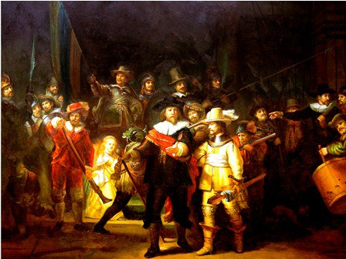

II. Основна частина уроку.

1. Reading. \читання\ слайд
2. Pre-Reading Activity\ Етап підготовки до читання. Бесіда з учнями.

T: Look at the pictures!

№1- the portrait of Rembrandt

№2- “Night Watch”

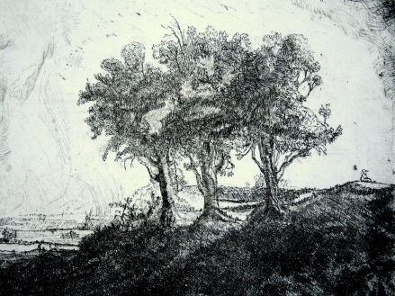№3- “Three Trees”

* Whose portrait is this?
* Do you know these pictures?
* What are the names of these pictures?
* What can you see in these masterpieces?

2)Reading. \Читання\

Let’s read the text about Rembrandt and some of his works. Fill in the table. \ Учні читають текст і заповнюють таблицю.\

|  |  |
| --- | --- |
| Painter | Rembrandt , July 15, 1606-October 4, 1669 |
| Name of the picture |  |
| Dates |  |
| Object. Face |  |
| Background |  |
| Сolours |  |

Rembrandt van Rijn ['rembræntvæn ‘raın]

Rembrandt and his masterpieces

Rembrandt Harmenszoon van Rijn (July 15, 1606-October 4, 1669) was a Dutch painter and etcher. He is generally considered one of the greatest painters and printmakers in European art history. His contributions to art came in a period that historians call the Dutch Golden Age.

In the “Night Watch” (Rijksmuseum, Amsterdam) commissioned by a company of the Civil Guard of Amsterdam for its assembly hall (1642), the lightning is conceived as the element determining the composition and structure of the painting. Breaking with the traditional scheme of a single or double row of standing figures, facing the spectator, the young artist has shown the guards at a moment of striking activity, each making his preparations to fall in at the expected command. Since the figures are life-size, an overwhelming effect is produced by the outward movement in wedge-shaped formation from the dark doorway. The composition is tilted to give a three-dimensional effect. The group is arranged as a triangle but the central figure is projected toward the spectator and accentuated by being strongly lit.

The contrast with the flanking groups and figures moving in opposite directions, the diagonals furnished by standard, muskets, halberds, and pikes, and the distribution of colours intensify the impression of forward movement which centers in the outstretched right arm of the captain.

The “Night Watch” is a recapitulation of the ideals of Rembrandt’s first ten Amsterdam years, and is the last painting in which he strives for brilliant external effects. From now on he sets himself the aim of recreating in visual terms the intangible essence of man, his inner life.

Rembrandt’s greatest landscape etching, the “Three Trees” (1643), represents the country after a rain as the storm retreats before a flood of sunlight. Trees are damp and clouds are drifting off; the sky behind the dark, silhouetted trees has cleared so that the trees once more cast shadows. Note the breeze turning the branches and the light along the contours of the trees. A farm wagon is seen behind the trees on the right, and road and shrubbery at the end of the bluff stand out in full sunlight. As we look over the flat countryside the misty distance is streaked with cloud shadows, producing a spectacle of light and shade and transparent atmosphere. Rembrandt was also a sensitive designer. The trees as a group contribute to the general spatial effect would be lost.

In his masterly landscape drawings he recalls to the mind’s eye the work of the great Sung artists of China, by dispensing with all that is not essential. In the expressiveness and delicate balance of a few magic strokes he creates a vibrant, yet quiet air and a sense of distance.

1. Post-Reading Activity. \ Етап перевірки розуміння змісту тексту.

Учні, спираючись на текст і на заповнену таблицю, по черзі описують картини Рембрандта.

Example : Let’s describe these pictures.

|  |  |
| --- | --- |
| Painter | Rembrandt van Rijn ,July 15, 1606-October 4, 1669, a Dutch painter and etcher, a representative of the Dutch Golden Age |
| Name of the picture | ‘’ Night Watch’’ |
| Dates | 1640-1642 |
| Object | Group portrait; the guards at a moment of striking activity, each making his preparations to fall in at the expected command,  figures are life-size; it’s a triangle of figures. |
| Background | Dark doorway |
| Сolours | Dark and light; distribution of colours and contrast with groups and figures moving in opposite direction |

Учні описують картини “Night Watch” і“Three Trees”.

1. Speaking. Розвиток умінь мовлення.

And now let’s visit a museum where many paintings by great artists of the Renaissance are exhibited. \ слайдовa презентація\

T1: Welcome to our museum. I want to show you some paintings of the Renaissance. The Renaissance, an age of discovery, found painters deeply concerned with investigations and experiments. New importance was given to the human figure. Renaissance painting was stimulated by antique sculpture to an intensive study of the human body – its structure and mechanism. Renaissance Art is divided into the Early Renaissance and the High Renaissance. Giotto [‘dƷ(i)ɔtɒu], Masaccio [mǝ'za:tʃ(i)ou], Van Eyck [vænaik], Botticelli [bɔtı'tʃeli] are the representatives of the Early Renaissance. So, we’ll start with Botticelli and his work.

Т2: Sandro Botticelli is one of the great poetic painters – sensitive, withdrawn from the world. Botticelli’s work is a gentle, lyrical, poetic style. Emotionally it is never brutal but diffident, reserved, subtly suffering.

T3: look at this picture! It’s “The Birth of Venus” by Botticelli. It’s the poet – painter’s evocation of the goddess of love out of the sea. She stands on a cockleshell, blown shoreward by breezes represented on the left. This composition is completed by the woman on the right who eagerly waits to receive the nude goddess. The painter is interested in evoking emotional effects through the restlessness of outline and mood. The movement begins with the interwined 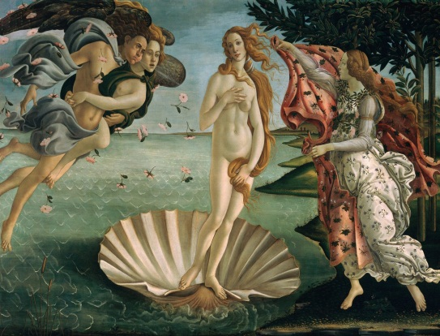forms of the breezes as they fly toward the right. It continues with the deliberately off-centered Venus and her curling snake-like hair. It ends in the forward-moving, draped woman and the sinuously curved, almost metallic covering she holds ready for the goddess. Although Venus is the central figure, the artist has placed for enough to the right to lead us in that direction. It’s dramatic and significant.

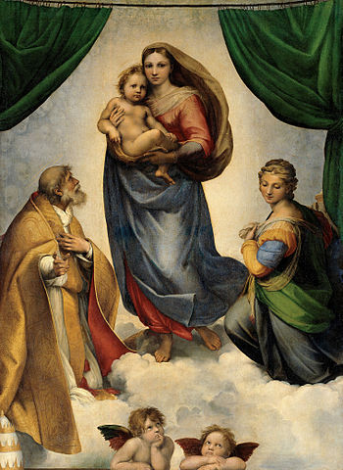T4: And now I want you to look at these masterpieces by Raphael(картини).

Before describing one of these pictures, I want to say some words about this great artist. Raphael was one of the finest artists and draftsmen in the history of Western Art. He is a representative of the High Renaissance. His figures are true to life and reveal a complete command of the human form.

He used drawings to plan his compositions. Raphael’s art marks “a shift of resources away from production to research and development”. He created an astonishing number of masterpieces such as “Madonna Connestabile”, “Marriage of the Virgin”, “Madonna Della Tenda”, “Madonna with the Rose”, “Madonna with St. Sixtus and St. Barbara”, “The Coronation of the Virgin”, “The Wedding of the Virgin”, “Galatea” and others.

So, let’s describe one of the masterpieces by Raphael “Madonna with St. Sixtus and St. Barbara”. This was the last Madonna which Raphael painted. It was painted on canvas of very fine texture. This masterpiece by Raphael has been regarded by many critics as the first painting in the world. In force and sentiment and in the ease and harmony of its composition, this work has hardly an equal: no work can be compared with it. The peculiar “divine” expression of the Madonna’s face is due in part to an exaggerated breadth between the eyes, and partly to the peculiar non-focussing of the eyes by which they are made to look at no particular point, but into indefinite distance. There is a child in her hands. St. Sixtus is on the right hand and St. Barbara is on her left hand. And at the base of the picture we can see two angles.

T1: The history of western civilization records no man as gifted as Leonardo da Vinci. He was outstanding as painter, sculptor, musician, architect, engineer, scientist and philosopher, was the most glittering personality of the High Renaissance in Italy. Leonardo was renowned in a period that produced such giants as Raphael, Michelangelo and Titian. He was born in Tuscany in 1452. Few of Leonardo’s paintings have come down to us: only about eighteen in all, some left unfinished, some damaged or deteriorated as a result of his experimental techniques.

Among Leonardo’s famous paintings we can see “The Baptism of Christ” (the earliest one), “The Last Supper”, “The Virgin of the Rocks”, “St. Gerome in the Wilderness”, unfinished masterpiece “Adoration in the Magi”, “Mona Lisa” or “La Gioconda”. And now we are speaking about this great picture “Mona Lisa”. This small portrait was created in the 16th century, in 1503-1507. But in the present era, it’s the most famous painting in the world. The personality of Mona 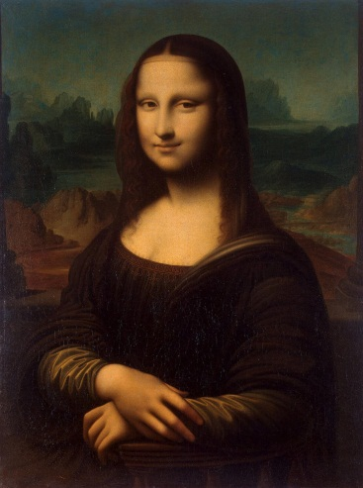Lisa impresses itself upon us vividly. “Mona Lisa” is one of Leonardo’s greatest works because of its plasticity, the delicate rendering of light and shade, the poetic use of his “sfumato” (Leonardo’s smoke) to emphasize the gentleness and serenity of the sitter’s face, elusive and mysterious smile on the woman’s face. “The smile was so pleasing that it seemed divine rather than human “, said Vasari. “Mona Lisa”is the example of Leonardo’s ability to create a masterpiece which lies between the realm of poetry and the concrete realism of a portrait. Other feature of this painting is the unadomed dress, in which the eyes and her beautiful hands have no competition from other details. The dramatic landscape background is a splendid page of romanticised geology, a natural lock, below holding back the blue lake and the river. In this landscape background the world seems to be in a state of flux. Actually, the portrait is the fusion of Leonardo’s artistic beliefs: the idea that it’s possible to represent nature visually in all the fullness of its realism; the deep nostalgia, characteristic of Leonardo’s generation, for a calm and remote beauty; and the individual characterization which was the aim of Renaissance portraiture. This masterpiece “Mona Lisa” is in Louvre now.

Speaking about ‘’Mona Lisa’’ we can mention the sonnet # XVIII by W. Shakespeare.

Sonnet XVIII

*Shall I compare thee to a summer's day?*

*Thou art more lovely and more temperate:*

*Rough winds do shake the darling buds of May,*

*And summer's lease hath all too short a date:*

*Sometime too hot the eye of heaven shines,*

*And often is his gold complexion dimm’d;*

*And every fair from fair sometime declines,*

*By chance or nature's changing course untrimm’d;*

*But thy eternal summer shall not fade*

*Nor lose possession of that fair thou owest;*

*Nor shall Death brag thou wander’stin his shade,*

*When in eternal lines to time thou growest:*

*So long as men can breathe or eyes can see,*

*So long lives this, and this gives life to thee.*

*Сонет 18*

*Чи ж порівнять тебе із літнім днем?*

*Миліша ти й чарівнішa за нього.*

*Буває, в травні холодом війне,*

*Та й літо наше – кілька тижнів всього:*

*То спекою сяйне з усіх сторін,*

*То лиш прогляне з хмар небесне око,*

*Природа в круговерті примх і змін*

*То нас леліє, то гнітить глибоко.*

*Але твоя не кінчиться краса,*

*І літо твоє вічне не зів’яне,*

*Безсила смерть тут і її коса,*

*Бо охоронцем твоїм вірш мій стане.*

*Ти будеш в ньому жити до тих пір,*

*Допоки дишуть груди й бачить зір.*

*Переклад Віктора Марача*

1. BrainRing. \ Перевірка знань учнів \

So, we’ve already found out about Rembrandt, one of the famous artists of Dutch Golden Age. And now let’s check up your knowledge.

Brain Ring

Answer my questions (to the 1st group):

1. What was Rembrandt van Rijn? \ a Dutch painter and etcher\
2. What Rembrandt’s paintings do you know? \ ‘’ The Night Watch’’, ‘’ A Portrait of an Old woman ‘’, ‘’Three Trees’’, ‘’ Portrait of Saskia van Vylenburg’’, ‘’ The Storm on the Sea of Galilee’’, ‘’ The Stoning of Saint Stephen’’, ‘’ The Raising of Cross’’, ‘’ The Abduction of Europa’’, ‘’ The Blinding of Samson’’, ‘’ Cottages before a Stormy Sky’’, ‘’ The Three Crosses’’, ‘’The Polish Riders’’, ‘’ Man in a Golden Helmet’’ and many others.\
3. When was the ‘’ Night Watch’’ created? \1642\
4. How has Rembrandt shown the guards? \at a moment of striking activity\
5. How does he intensify the impression of forward movement? \ The contrast with the flanking groups and with figures moving in oppositions, the distribution of colours. \
6. Is the ‘’ Three Trees’’ a landscape etching? \Yes \
7. What does the painting represent? \ the country after a rain \
8. What can you say about trees? \ Trees are damp. They cast shadows. Note the freeze turning the branches and the light along the contours of the trees. \
9. What about background of this etching? \
10. Rembrandt creates a vibrant, yet quiet air and a sense of distance, doesn’t he ? \Yes \

Group 2

Now let’s check up your knowledge of the Renaissance and its representatives.

1. What painters of the Early Renaissance do you know? \ Giotto, Masaccio, Van Eyck, Botticelli \
2. What can you say about Botticelli’s work? \ a gentle, lyrical, poetic style \
3. What paintings of Botticelli do you know? \ ‘’ The Birth of Venus’’, poetic drawings of ‘’ Abundance’’, drawings for Dante’s ‘’ Divine Comedy’’ and others\
4. Raphael is one of the finest artist of Western Art, isn’t he ? \ Yes \
5. What works by Raphael do you know? \ ‘’ Madonna Connestabile’, ‘’ Marriage of the Virgin’’, ‘’ Madonna della Tenda’’, ‘’ Madonna with the Rose’’, ‘’ Madonna with St. Sixtus and St. Barbara’’, ‘’ The Coronation of the Virgin’’, ‘’ Galatea’’ and others. \
6. What are the main figures in the painting ‘’ Madonna with St. Sixtus and St. Barbara’’? \ Madonna with a child is in the centre of painting. St. Sixtus and St. Barbara, two angels at the base of this picture. \
7. Leonardo da Vinci is a legend of the High Renaissance. What was he?\ He was a painter, sculptor, musician, architect, engineer, scientist and philosopher, famous personality of the High Renaissance in Italy. \
8. What masterpieces by Leonardo do you know? \ ‘’ The Baptism of Christ’’, ‘’The Last Supper’’, ‘’ the Virgin of the Rock’’, ‘’ Mona Lisa’’ or ‘’ La Gioconda’’, ‘’ The Virgin and Child with St. Anne’’ and others.\
9. Why is ‘’ Mona Lisa’’ one of the greatest works? \ Because of its plasticity, the delicate rendering of light and shade, the poetic use of his ‘’smoke’’.\
10. What do you think about Gioconda’s smile? \ Pleasant and unusual, elusive and mysterious\

\ Results \

4.Writing. \ Письмо \

Task. \ Завдання \

Match the paintings with their authors. What movement do these painters belong to?

|  |  |  |  |
| --- | --- | --- | --- |
| 1 | Ivan Aivazovski | A | ‘’Vase with Twelve Sunflowers’’ |
| 2 | Leonardo da Vinci | B | ‘’Reply of the Zaporizhian Cossacks to  Sultan IV  of the Ottoman Empire’’ |
| 3 | Raphael | C | ‘’The Night Watch’’ |
| 4 | IlyaRepin | D | ‘’Jeanne Samary’’ |
| 5 | Van Gogh | E | ‘’La Gioconda’’ |
| 6 | Rembrandt van Rijn | F | ‘’ Madonna of the Meadow’’ |
| 7 | Augustе Renoir | G | ‘’Ship in Stormy Sea’’ |
| 8 | Eugene Delacroix | H | ‘’Liberty Leading the People’’ |

So , we’ve checked up your knowledge. I hope that you’ll continue to study Art, to find out about different movements, painters and their works. You know that the beauty of the work of art has to be felt. The best way to gain better understanding and greater enjoyment of art is to view many paintings, looking at them thoughtfully and earnestly. Great painters paint objects ‘’as they think them, not as they see them’’ (Pablo Picasso). ‘’Every artist dips his brush in his own soul, and paints his own nature into his pictures’’ (Henry Ward Beecher). As Leonardo said ‘’Painting is poetry that seen rather than felt, and poetry is painting that is felt rather than seen.’’

III. Заключна частина.

1. Homework. Домашнє завдання. Describe a painting of any artist.

Example:

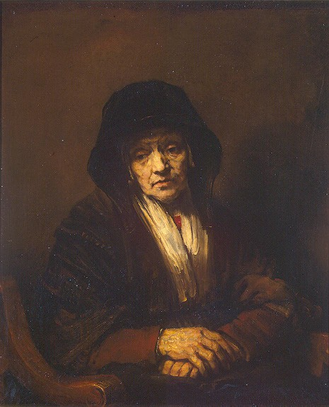Emotion is read in this portrait of an old woman. The sorrowful turn of the head , the hunched figure of the old woman were certainly copied from nature . The dominant mood of passive hopeless reconciliation with the incomprehensible cruelty of life is characteristic of several of Rembrandt’ s late paintings. From the portrayal of a concrete state of mind, no matter how typical, the painter turns to a deeper generalization of the human condition, of a human fate as an indissoluble whole. He depicts a human being face to face with eternity. The centre-point of the painting is the face; all other elements are subordinated to it. The layers of paint are applied with extremely varied techniques: around the eyes and in the shaded area of the face there is an interplay of semi-transparent dabs and patches of colour; in the lit areas, a layer of impasto. The characteristic technique here is the constant change of colour in each of the painter’s open strokes. The old men and women of the 1654 portraits possess a deeply tragic outlook, they know life to be full of cruelty and injustice. They find this outlook to be the only normal one, since it represents a conclusion reached long ago, the result of their life experience.

1. Summarizing. Підведення підсумків уроку.
2. Assessment. Оцінювання.

