Olha Korchagina

A teacher of English

Nickiphorivka School

Bakhmut district

Donetsk region

**Theme: Sports and Games**

**Aim**: to develop learners’ speaking, reading, writing, and listening skills.

**Objectives:**

-to teach learners to use the vocabulary on the given topic;

-to teach learners to use information from the text in dialogues and stories;

- to practice the Present Simple, the Present Continuous, the adjectives;

-to develop phonetic ear, memory, attention and quick reaction;

-to improve learners’ kinetic abilities while learning English;

-to offer learners the opportunity to express themselves through dramatization and movement;

-to involve learners with different levels of knowledge in taking an active part in the suggested work;

-to form the interest to learning English.

**Equipment**: a CD, a computer

**Materials required:** handouts, cards, balls, the ABC, pictures

**Activities**: group and individual work, work in pairs, physical activities

**The type of the lesson:** combined

**The form of the lesson**: English-speaking Olympics

**The Plan of the Lesson**

**I.Introduction**

1. Greeting and aim.
2. Warming up.

**II. Main Part**.

1. Vocabulary Practice.
2. Physical Minute Break.
3. Listening and Viewing.
4. Relaxation.
5. Speaking.
6. Sport Contest for Fans.

**III. Summing up.**

\

**Procedure**

1. **Introduction**

**1. Greeting and Aim.**

**T.**: Glad to see you, dear friends.

The theme of our lesson is ‘’Sports and Games’’. We’ll listen, read, speak about different kinds of sport. But it will be an unusual lesson, we’ll have an English-speaking Olympics.

So we’ll take part in some competitions, games and have a lot of fun.

You will be split into two teams. And we also need a jury. The members of our strict but fair jury are our senior students. Greet them warmly. Some guests have come to our lesson. They are 2 British reporters and a famous English teacher. Their names are Mary Poppins, Dan, and Pam.

**2. Warming up**.

M.P.: Hello, dear friends!

1) Are you ready to speak English? Yes, we are.

2) Are you ready to play games!? Yes, we are.

3) Are you ready to win? Yes,we are.

4) Are you ready to be champions? Yes,we are.

Our reporters will help us to split you into 2 teams of 6.Dan and Pam have cards in their caps. The pupils should take the card, read the question, answer it and join the team. Dan forms the Red Team. Pam forms the Blue Team.

Questions.

1. What’s your name?
2. How old are you?
3. What is your favourite school subject?
4. What is your hobby?
5. Do you do your morning exercises?
6. What is your favourite sport?

M.P.: Now let’s start our contest. It will have 4 steps.

**Step 1.**

1. **M:** Listen to the jazz chant and suit gestures to the words. Do it quicker and quicker.

This, that, these, those,

Snap your fingers,

Touch your toes.

This, that, those, these,

Shrug your shoulders,

Bend your knees.

1. Guess the word (using the letters of the ABC).
2. (*Supplement 1*)

Red Ball Team (RBT)-----19\16\15\18\20. (*sport*).

Blue Ball Team(BBT)-----7\1\13\5\19\. (*games*).

(*The jury announces the number of the points).*

1. **Main Part.**

**3. Vocabulary Practice.**

**M.P**.: Now we’ll see that our teams are ready to start our contest.

**Step 2.**

1. **Brainstorming.**

**M**.: What words do you associate with the topic ‘’Sports and Games’’?

Remember that one word gives one point.

**Ps**.: football, volleyball, basketball, team, play, tennis, running, jumping, swimming, skating, badminton, Olympic Games

**b)Word Finder**.

Teams are given some time to make as many words as they can out of the phrase ‘’Olympic Games’’.

(magic, mom, me, camp, lamp, pig, mime, is, leg, etc.)

**c) Interactive game ‘’Find the Partner’’**.(*Supplement 2*)

**M.**: Cards with the names of different kinds of sport are cut into two parts. Your task is to find your partner, to make up a word and read it.

**d) Find the transcription to this word:**

**e) Match the word to the picture:**

**f) Boasting game.**

**M.P.:** Now, teams in turn will mime their kinds of sports ask and answer the questions.

-RBT---the 1st P. mimes the game.

The 2nd P. : What is he doing?

BBT---the 1st P. : He is playing tennis.

Mimes the next game, etc.

*(The jury announces the number of points*).

**4. Physical Minute Bre**ak.

**Pam:** Let’s do some exercises ‘’Funny Position’’.

Do the actions quickly.

1. Put your hands on your knees.
2. Take your hands off your knees.
3. Put your hands on your forehead.
4. Take your hands off your forehead.
5. Put your chin on your knees.
6. Take your chin off your knees.
7. Show how you put on your T-shirt.
8. Show how you take off your T-shirt.
9. Show how you put on your sneakers.
10. Show how you take off your sneakers.

**5. Listening and Viewing.**

**Step 3.**

**a) Pre-viewing**.

**M.P.:** Now, the pupils of the fifth form show us a play about unusual sport contest. But before viewing look at the picture and answer the questions:

*(Supplement 3)*

1) What can you see in the picture? (*a hare, a turtle*)

2) Can a hare run? (*Yes*)

3) Can a turtle run? (*Yes*)

4) Who can run fast? (*a hare*)

5) Who can run slowly? (*a turtle)*

6) Who will win?

**b) While viewing.**

**M.P.:** Let’s watch a play and do the following tasks:

**Answer the questions**:

1. What is the hare doing?
2. What is the turtle doing?
3. Who is winning?

*(the hare is running, sleeping, talking, with his friends, dancing;*

*the tortoise is running, running, running and winning)*

A Race *(a play*)

**Hare:** Hello, you, forest people! Hello, all you who have legs! (*The forest animals*

*come in*). We’ll have a race.You will race with me, the Hare! We’ll run three times

round the forest. Who will run with me? Who can outrun me, the Hare? Who can?

**Animals:** (*in turn*)I can’t. I can’t. I can’t. Indeed, I can’t. No! And I can’t, either.

**Turtle**: I will try. I am slow, but I will try.

**Animals**: Oh, how bold you are!

**Hare** (*laughing*): Ha-ha-ha! You are bold, indeed! (*To the audience*)

He is silly, very silly, isn’t he?

**Turtle**: When shall we start the race?

**Hare:** We’ll start right now.

(*The animals bring in a post with the notice START on it.The Hare and the Turtle*

*stand side by side.)*

**Animals**: Attention! One! Two! Three! Go!

(*The Hare and the Turtle start running. The Hare runs across the stage and goes*

*out. The Turtle follows him slowly.The animals take the post away.*

*The Hare appears from the right, crosses the stage quickly and comes up to his*

*friends*): Well, you see, I am running a race with the Turtle.Isn’t that funny?

My legs are not bad, are they? Now I must be off. Good-bye!

(*The Hare runs off the stage.*

*The Turtle enters*.)

**Turtle** (*moving on*): I can’t stop now. I can’t stop. I can’t talk.

(*The Turtle moves slowly on and on and leaves the stage.)*

**The Hare** *(comes in and stops in the middle of the stage):* The Turtle is still far

behind me. He will never overtake me. Never, never, never! (*To the audience*).

Look at my legs! (*Begins to dance*) Tra-la-la, tra-la-la! How hot it is! What if I

have a rest for a little while? (*Sits down and falls asleep*).

*(The Turtle enters the stage, crosses it slowly and goes out. The animals come in,*

*Bringing the post with the notice FINISH on it. They stand in a row on the stage, so*

*That the sleeping Hare cannot be seen. The Turtle enters and alowly but steadily moves up to the post.).*

**Animals** (*clap their hands*): Hurrah! Hurrah! Three cheers for the Turtle.

The Turtle is the winner! Hurrah!

**The Hare** *(jumps up and pushes the animals aside; they separate to let him pass):*

Let me pass, quick, quick! (*Runs up to the post and sees the Turtle).*

What’s this? Who’s this?

**Turtle**: It’s me the Turtle.

**Hare**: But how? Why? And I, with my beautiful legs, not the winner?

How could that happen?

**Animals**: (*coming forward; to audience*): You know, children, how that

happened, don’t you?

1. **Post viewing**.

Answer the questions:

1. Who is the winner? (*The Turtle*)
2. The hare doesn’t win. Why? (*He stops three times*).
3. Why does the Turtle win? (*He is clever. He doesn’t run fast but he*

*doesn’t stop).*

(*The jury announces the number of points)*.

**6. Relaxation**.

**Dan**: Repeat the words after me, doing the actions.

**D**.: Now, children, have some fun!

**Ps**.: Have some fun, have some fun!

**D**.: Cross your legs, cross your arms!

Cross your legs, cross your arms!

Breathe in deeply through your nose!

Stand a little on your toes!

Put your hands on your chest!

Thank you, have a rest!

**Ps.**: (*turning to the left and to the right).*

Thank you, have a rest! (*Twice.*)

**Step 4**

**7. Speaking.**

**T**.: The leaders of both teams should go to the blackboard, draw a ball and tell about themselves.

**T**.: (to the leader of the Red Ball Team.) Pick up a red crayon. Draw a ball.

(to the leader of the Blue Ball Team.) Pick up a white crayon. Draw a ball.

**P1**: My ball is red. My name is Ted. I am a sportsman. I can play basketball. I can play basketball after the lessons. I can play basketball after the lessons. I can play basketball on the playground. Can you play basketball? (*turning to the leader of the BBT)*.

**P2**: Yes, I can. (No, I can’t.) My ball is white. My name is Mike. I am a sportsman. I can play volleyball. I play volleyball after the lessons. I play volleyball on the playground. Can you play volleyball?(*turning to the leader of the RBT.)*

**P1**: Yes, I can.

**T:** Now, the next pair of the pupils go to the blackboard.

**T:** (*to P3*) Pick up a green crayon. Draw a ball.

*(to P4*) Pick up a blue crayon. Draw a ball.

**P3**: My ball is green. My name is Tim. I am a sportsman. I can play handball. I can play handball after the lessons. I play handball on the playground. Can you play handball? (*turning to P4*).

**P4**: Yes, I can. (No, I can’t.) My ball is blue. My name is Sue. I am a sportsman. I can play tennis. I play tennis after the lessons. I play tennis on the sports ground.

**M.P**.: Now we invite 2 fans of different teams to the centre of the playground. Your task is to hop on one leg as long as you can. (*The fans hop on one leg as long as they can.)*

(*Pam interviews the leaders of both teams.)*

**P.:** Who hops on one leg better, Chris or Ann?

**Ps**; Ann hops better.

**P.:** Who is the best sportsman?

**Ps**: Ann is the best sportsman.

**P**.: Who is the winner?

**Ps**: She is the winner.

1. **Summing up.**

*(While jury is counting the points Dan and Pam interviewing some fans).*

1. Do you like the contest?
2. What activity do you like most of all?
3. Who will be the winner?

(*The jury announces the points).*

(*Dan interviews the leader of the winning team)*.

**D**.: Hi! My name is Dan.

**P**.: Hi! I am Mike. Are you a British reporter?

**D**.: Yes,I am. Can you answer my questions?

**M**.: With great pleasure!

**D**.: Do you like sport?

**M**. Yes, I do. I like sport.

**D**.: Do you jump?

**M**.; No, I don’t jump. I can run well.

**D**.: Are you a champion?

**M**.: Yes, I am.

**D**.: Thank you, Mike. I wish you success?

**M**.: Thanks, Dan.

*(The winning team get prizes. The fans sing a song for winners).*

You are the winners,

We are sport fans.

You’ll get your prizes,

You are strong sportsmen.

You are adroit,

You are great stayers,

You are the winners,

You are great players!

**M.P.**: Thank you for your work, for being active and enthusiastic.

**Mary, Dan, and Pam:** Goodbye! Have a nice day.

**T**.: You’ve worked hard today. Well done, my dear friends. Goodbye!

**LITERATURE**

1. Л. Назар, English Parties. Тернопіль, 2008 р.
2. My Favourite English Rhymes, Part 1, 2. Укладник Л. Вознюк, Н. Вітушинська.

Тернопіль, 2010 р.

1. M. Jaroshenko, English for Young Learners. Тернопіль, 2010 р.
2. Sing along book. Тернопіль, 2005 р.
3. Kicktenko. Warming Up. Харків, 2008 р.
4. Л. Пащенко. Англійська мова. Дидактична мозаїка. Харків, 2004 р.
5. Svyrydiuk. Teaching Visual and Auditory Learners Using Multimedia Resources

Лібра Терра, 2010 р.

**Supplement 1.**

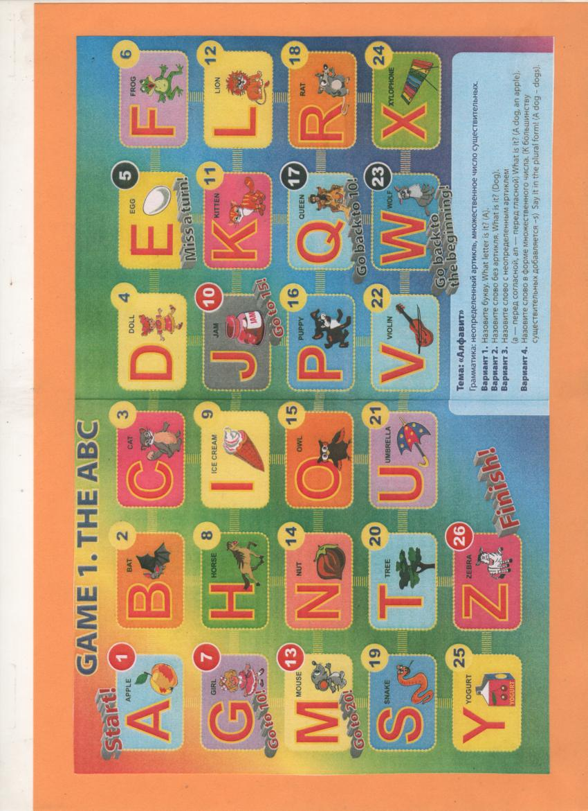

**Supplement 2**

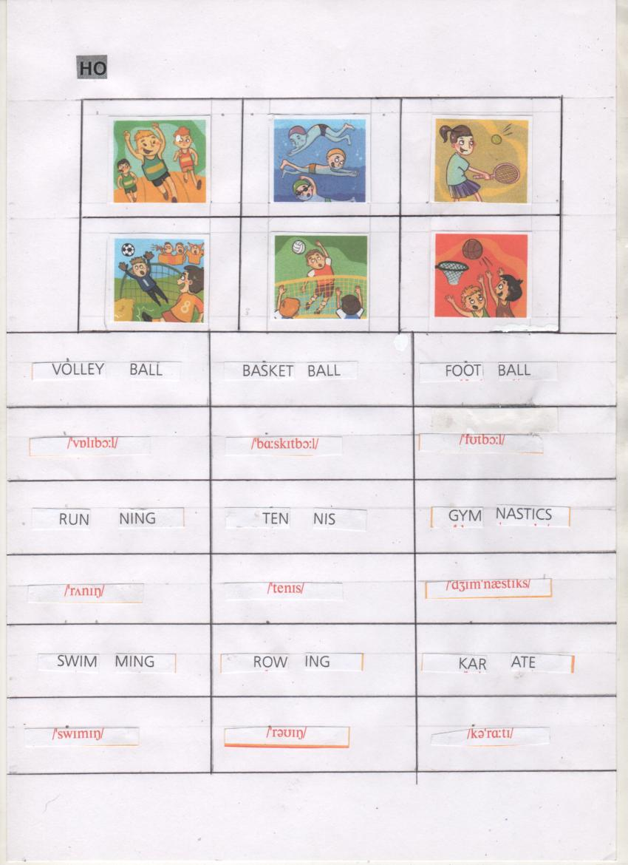

**Supplement 3**

