**History of photography**

Photography – the art, profession, or method of producing photographs or the scenes in films [16].

History of photography, method of recording the image of an object through the action of light, or related radiation, on a light-sensitive material. The word, derived from the Greek photos (“light”) and graphein (“to draw”) [5].

If we talk about photography as a form of art, the definition could be: a creative process of searching and creating a theoretically correct and artistic composition, which, in turn, albeit partially, determined vision of the photographer. The term itself appeared in 1839 [18].

In 1614, Angelo Sala demonstrated that "powdered silver nitrate is blackened by the sun", as was paper that was wrapped around it. This discovery of the sun's effect on powdered silver nitrate was not supported and was subsequently disregarded by then-respected scientists who said that his discovery "had no practical application."

Around 1717, Johann Heinrich Schulze, a German professor of anatomy and physics, set down a bottle containing silver nitrate and chalk by the window. unintentionally in the path of incoming light from the sun. The mixture, unsurprisingly, turned dark but what he found to be strange was that part was still white and formed a line across the bottle. Schulze observed a cord hanging down and going across in front of the window, which, he found out, was the cause. On further examination, he found that the entire mixture inevitably reverted to its original white color. Experimenting further, Schulze succeeded in transferring words he pasted on the bottle printed into the substance. Describing his achievement, Schulze wrote that “the sun’s rays, where they hit the glass through the cut-out parts of the paper, wrote each word or sentence on the chalk precipitate so exactly and distinctly that many who were curious about the experiment but ignorant of its nature took occasion to attribute the thing to some sort of trick.” He put the silver nitrate in an oven, which had no effect on its color. This proved to him, definitively, that heat had not facilitated the transformation, as popularly suspected. Rather, it was the light [4].

In 1777, the chemist Carl Wilhelm Scheele was studying the more intrinsically light-sensitive silver chloride and determined that light darkened it by disintegrating it into microscopic dark particles of metallic silver. Of greater potential usefulness, Scheele found that ammonia dissolved the silver chloride but not the dark particles. This discovery, which could have been used to stabilize or "fix" a camera image captured with silver chloride, was little-noticed at the time and unknown to the earliest photography experimenters.

It was not until around the year 1800 that Thomas Wedgwood made the first known attempt to capture the image in a camera obscura by means of a light-sensitive substance. He used paper or white leather treated with silver nitrate. Although he succeeded in capturing the shadows of objects placed on the surface in direct sunlight, and even made shadow-copies of paintings on glass, it was reported in 1802 that "the images formed by means of a camera obscura have been found too faint to produce, in any moderate time, an effect upon the nitrate of silver." The shadow images eventually darkened all over because "no attempts that have been made to prevent the uncoloured part of the copy or profile from being acted upon by light have as yet been successful." Wedgwood may have prematurely abandoned his experiments due to frail and failing health; he died aged 34 in 1805.

In 1816 Nicephore Niepce, using paper coated with silver chloride, succeeded in photographing the images formed in a small camera, but the photographs were negatives, darkest where the camera image was lightest and vice versa, and they were not permanent in the sense of being reasonably light-fast; like earlier experimenters, Niepce could find no way to prevent the coating from darkening all over when it was exposed to light for viewing. Disenchanted with silver salts, he turned his attention to light-sensitive organic substances [4].

The oldest surviving photograph of the image formed in a camera was created by Niepce in 1826 or 1827. It was made on a polished sheet of pewter and the light-sensitive substance was a thin coating of bitumen, a naturally occurring petroleum tar, which was dissolved in lavender oil, applied to the surface of the pewter and allowed to dry before use. After a very long exposure in the camera (traditionally said to be eight hours, but now believed to be several days), the bitumen was sufficiently hardened in proportion to its exposure to light that the unhardened part could be removed with a solvent, leaving a positive image with the light areas represented by hardened bitumen and the dark areas by bare pewter. To see the image plainly, the plate had to be lit and viewed in such a way that the bare metal appeared dark and the bitumen relatively light [5].

In partnership, Niepce in Chalon-sur-Saone and Louis Daguerre in Paris refined the bitumen process, substituting a more sensitive resin and a very different post-exposure treatment that yielded higher-quality and more easily viewed images. Exposure times in the camera, although substantially reduced, were still measured in hours.

Niepce died suddenly in 1833, leaving his notes to Daguerre. More interested in silver-based processes than Niepce had been, Daguerre experimented with photographing camera images directly onto a mirror-like silver-surfaced plate that had been fumed with iodine vapor, which reacted with the silver to form a coating of silver iodide. As with the bitumen process, the result appeared as a positive when it was suitably lit and viewed. Exposure times were still impractically long until Daguerre made the pivotal discovery that an invisibly slight or "latent" image produced on such a plate by a much shorter exposure could be "developed" to full visibility by mercury fumes. This brought the required exposure time down to a few minutes under optimum conditions. A strong hot solution of common salt served to stabilize or fix the image by removing the remaining silver iodide. On 7 January 1839, this first complete practical photographic process was announced at a meeting of the French Academy of Sciences, and the news quickly spread. At first, all details of the process were withheld and specimens were shown only at Daguerre's studio, under his close supervision, to Academy members and other distinguished guests. Arrangements were made for the French government to buy the rights in exchange for pensions for Niepce's son and Daguerre and present the invention to the world (with the exception of Great Britain, where an agent for Daguerre patented it) as a free gift. Complete instructions were made public on 19 August 1839.

After reading early reports of Daguerre's invention, Henry Fox Talbot, who had succeeded in creating stabilized photographic negatives on paper in 1835, worked on perfecting his own process. In early 1839, he acquired a key improvement, an effective fixer, from his friend John Herschel, a polymath scientist who had previously shown that hyposulfite of soda (commonly called "hypo" and now known formally as sodium thiosulfate) would dissolve silver salts. News of this solvent also benefited Daguerre, who soon adopted it as a more efficient alternative to his original hot salt water method [14].

Talbot's early silver chloride "sensitive paper" experiments required camera exposures of an hour or more. In 1840, Talbot invented the calotype process, which, like Daguerre's process, used the principle of chemical development of a faint or invisible "latent" image to reduce the exposure time to a few minutes. Paper with a coating of silver iodide was exposed in the camera and developed into a translucent negative image. Unlike a daguerreotype, which could only be copied by rephotographing it with a camera, a calotype negative could be used to make a large number of positive prints by simple contact printing. The calotype had yet another distinction compared to other early photographic processes, in that the finished product lacked fine clarity due to its translucent paper negative. This was seen as a positive attribute for portraits because it softened the appearance of the human face. Talbot patented this process, which greatly limited its adoption, and spent many years pressing lawsuits against alleged infringers. He attempted to enforce a very broad interpretation of his patent, earning himself the ill will of photographers who were using the related glass-based processes later introduced by other inventors, but he was eventually defeated. Nonetheless, Talbot's developed-out silver halide negative process is the basic technology used by chemical film cameras today. Hippolyte Bayard had also developed a method of photography but delayed announcing it, and so was not recognized as its inventor [8].

In 1839, John Herschel made the first glass negative, but his process was difficult to reproduce. Slovene Janez Puhar invented a process for making photographs on glass in 1841; it was recognized on June 17, 1852 in Paris by the Academie Nationale Agricole, Manufacturiere et Commerciale. In 1847, Nicephore Niepce's cousin, the chemist Niepce St. Victor, published his invention of a process for making glass plates with an albumen emulsion; the Langenheim brothers of Philadelphia and John Whipple and William Breed Jones of Boston also invented workable negative-on-glass processes in the mid-1840s [4].

In 1851 Frederick Scott Archer invented the collodion process. Photographer and children's author Lewis Carroll used this process. (Carroll refers to the process as "Tablotype" in the story "A Photographer's Day Out") [6].

Herbert Bowyer Berkeley experimented with his own version of collodion emulsions after Samman introduced the idea of adding dithionite to the pyrogallol developer. Berkeley discovered that with his own addition of sulfite, to absorb the sulfur dioxide given off by the chemical dithionite in the developer, that dithionite was not required in the developing process. In 1881 he published his discovery. Berkeley's formula contained pyrogallol, sulfite and citric acid. Ammonia was added just before use to make the formula alkaline. The new formula was sold by the Platinotype Company in London as Sulpho-Pyrogallol Developer.

Nineteenth-century experimentation with photographic processes frequently became proprietary. The German-born, New Orleans photographer Theodore Lilienthal successfully sought legal redress in an 1881 infringement case involving his "Lambert Process" in the Eastern District of Louisiana.

The daguerreotype proved popular in response to the demand for portraiture that emerged from the middle classes during the Industrial Revolution. This demand, which could not be met in volume and in cost by oil painting, added to the push for the development of photography.

Roger Fenton and Philip Henry Delamotte helped popularize the new way of recording events, the first by his Crimean war pictures, the second by his record of the disassembly and reconstruction of The Crystal Palace in London. Other mid-nineteenth-century photographers established the medium as a more precise means than engraving or lithography of making a record of landscapes and architecture: for example, Robert Macpherson's broad range of photographs of Rome, the interior of the Vatican, and the surrounding countryside became a sophisticated tourist's visual record of his own travels [5].

In America, by 1851 a broadside by daguerreotypist Augustus Washington was advertising prices ranging from 50 cents to $10. However, daguerreotypes were fragile and difficult to copy. Photographers encouraged chemists to refine the process of making many copies cheaply, which eventually led them back to Talbot's process.

Ultimately, the photographic process came about from a series of refinements and improvements in the first 20 years. In 1884 George Eastman, of Rochester, New York, developed dry gel on paper, or film, to replace the photographic plate so that a photographer no longer needed to carry boxes of plates and toxic chemicals around. In July 1888 Eastman's Kodak camera went on the market with the slogan "You press the button, we do the rest". Now anyone could take a photograph and leave the complex parts of the process to others, and photography became available for the mass-market in 1901 with the introduction of the Kodak Brownie [4].

In the XXI century, photography has become an affordable and effective way to display actually quite decent shots can make even a novice easily. Over time, the picture has turned into a special kind of art. Thanks to her, we can visually be transferred anywhere in the world, to see its beauty, admire the uniqueness, variety and bright colors.

Bibliography

1) History of photography [Electronic resource]. – Access mode: <https://en.wikipedia.org/wiki/History_of_photography> .

5) History of photography / Andy Grundberg, Naomi Rosenblum, Helmut Erich Robert Gernsheim, Beaumont Newhall [Electronic resource]. – Access mode: <https://www.britannica.com/technology/photography> .

6) History of Photography Timeline / Philip Greenspun [Electronic resource]. – Access mode: <http://photo.net/history/timeline> .

7) Invention of photography1830s [Electronic resource]. – Access mode: <http://www.bl.uk/learning/timeline/item106980.html> .

9 ) Long T. H. Longman Dictionary of English Idioms / T. H. Long. – Edinburgh: Longman, 1979. – 387 p.

10) Long T. H. Longman dictionary of English Language and Culture/ T. H. Long. - Edinburgh : Longman, 1997. - 1587 p.

11) Topic: Photography [Electronic resource]. – Access mode: <http://www.ldoceonline.com/Photography-topic/> .

12) История фотографии / Елена Федорова [Electronic resource]. – Access mode: <http://blogphotografelena.ru/istoriya-fotografii/> .

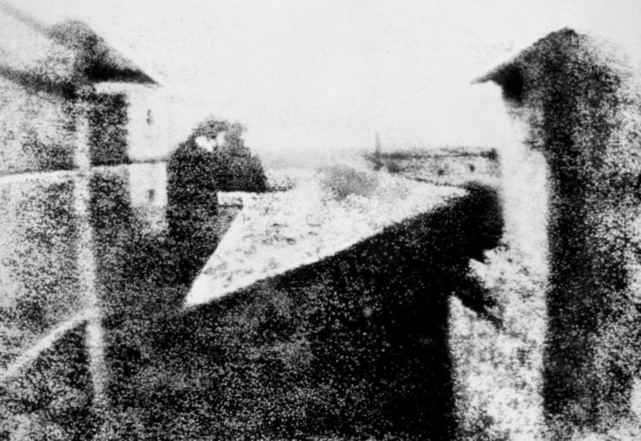

Application A. "View from the Window at Le Gras" first picture of the world by Joseph Niepce, 1826