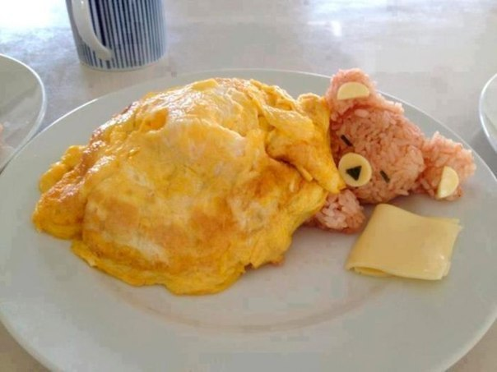Form 8+ Lesson 10. **A HEALTHY LIFESTYIE**

**Мета:** практичні - активізувати знання, вміння і навички учнів по темі; розвивати вміння працювати з текстом: вправи, перед-розглядати графічне зображення тексту; вчити логічно будувати висловлювання на основі прочитаної і переробленої інформації;

розвиваючі - розвивати кругозір учнів, розвивати здібності до розподілу уваги, стимулювати навик критичного мислення та самостійного осмислення отриманої інформації;

виховні - створювати можливість для прояву індивідуальних здібностей учнів; вчити учнів дбайливо ставитися до свого здоров'я, правильно харчуватися, відмовитися від шкідливих звичок.

**Очікувані результати** на кінець уроку: учень зможе логічно будувати висловлювання на основі прочитаного, матиме бажання дбайливо ставитися до свого здоров'я.

**Обладнання:** аудіозапис, CD, comp, картки с роздатковим матеріалом, підручник О.Карпюк.

**Тип уроку:** комбінований.

**Procedure**

I. Організаційний момент. Організація класу. Привітання. **ツ** Введення у іншомовну атмосферу.

l.Warm-up Answer the questions.

1. Do you think you have a healthy life style? 2. Is it possible to have a healthy life style in modern world?

3. Why do many people try to have a healthy life style?

2. Speaking **►** Do ex. 1, p. 30.

* Work in pairs. Talk to your partner.

1 How many hours’ sleep do you need every night?

2 Do you fall asleep easily?

3 What helps you fall asleep?

4 Do you wake up during the night or do you sleep like a log?

5 Do you sometimes not sleep a wink? When does it happen?

6 Do you dream?

7 Do you remember your dreams in the morning?

8 Do you wake up easily in the morning?

II. Основна частина уроку 3. Readіng **►** Do ex. 2, p. 30.

4.Vocabulary practice **►** Do ex. 3, p. 31.

* Find in the text the words for:

quickly — r...

find and answer a problem — s...

a very frightening dream — n...

take and let out air — b...

a period or a step in a process — s... **Key:** rapid, solve, nightmare, breathe, stage.

**☆** Фізкультхвилинка.

5. Reading and speaking **►**Do ex. 4, p. 31.

* Say if the following statements are true or false.

1 We go through 4 stages of sleep.

2 We dream in the last stage.

3 We dream only once.

4 REM means “remember everything in the morning”.

5 Our body is more active in the REM stage.

6 Dreams are good for us.

7 Chocolate in the evening is a good idea.

8 Exercising before bedtime helps you fall asleep.

6. Speaking **►**Do ex. 5, p.32.

a) Explain the meanings of the following expressions. **⇨** **sleep like a log be fast asleep not sleep a wink**

b) Choose the expressions from (a) and complete the sentences below. Mind the correct tense forms.

The baby was crying all night and I did .......................................

I didn’t hear any noise last night because I was ..........................

I didn’t hear the phone this morning because I ...........................

7. Grammar practice **►**Do ex. 6, p. 32.

* Fill in the sentences with the adverbs of manner.

1 Some people can’t fall asleep … (easy).

2 I often dream that I’m running … (fast).

3 “I didn’t sleep a wink last night”, she said … (nervous)

4 “I slept like a log”, he said … (happy)

8.Vocabulary practice **⇨** What time do you usually go to bed? Do you get enough sleep? Complete the sentences with the words from the box.

|  |
| --- |
| Alarm clock, asleep, bedtime, fall asleep, get up, go to bed, insomnia, morning  person, nightmares, night owl, oversleep, sleep-in, take a nap, wake up, yawn |

*1. I love to stay up very late and watch TV or surf the Net. All my friends call me 4... . 2. When I worry too much about my school grades, I have ... . I can't sleep very well. 3. My ... is really very loud. It wakes me up, and it also wakes my neighbors upt 4. I often sleep late, or ... , on weekends. 5. Watching scary movies gives me .,. . 6. Yes, he is ... . I can hear him snoring. 7. My classmate is a ... . He loves to get up at 6:00 every morning and exercise before*

*class. 8. In many countries, it's common to sleep for a short time in the afternoon. Do you ever ... ? 9. When I feel sleepy, I open my mouth very wide and I ... . 10. I always go to bed at tO:30 p.m., but our son is only four years old, so his ... is at 8:30. l1. I have to get up at ?:00 tomorrow morning. I hope I don't ... and get up at I 12. Getting enough sleep is very important. I usually go to bed at 10 p.m. ant at 6 a.m. 13. I wake up at 6 a.m., but I don't ... right away. I like to stay in bed for five o minutes. 14. It's 11 pm. It's time to ... . It's bedtime. 15. After I go to bed, I like to read a book for a while before I "' '*

**Key:** I night owl, 2 insomnia, 3 alarm clock, 4 sleep-in, 5 nightmart 6 asleep, 7 morning person, 8 take a nap, 9 yawn,

10 bedtime, 11 overs 12 wake up (or "get up"), 13 get up, 14 go to bed, 15 fall asleep'

* III. Заключна частина уроку**.** 9. Summary

**►**Answer the questions.

1. What time did you go to sleep last night? Why? 2. What time did you get up this morning? Are you tired now?

* Work in groups **+** Discuss the following statements**.**

**⇨Possible answers: ►**

|  |
| --- |
| 1.I mostly disagree 2. I'm not sure 3. I mostly agree |

**►**

|  |  |
| --- | --- |
| Falling asleep is easy  Everyone should take afternoon naps  You should drink coffee if you feel sleepy at school or work  It's impolite to yawn  Watching a scary movie just before you sleep will make you have a nightmare  People should go to bed early and get up early  Dreams can sometimes tell us about our future  If you have insomnia, you should take a sleeping pill  Everyone should get eight or nine hours of sleep each night  Not getting enough sleep can lower your grades in school  Sleeping is fun | 1 2 3  1 2 3  I 2 3  1 2 3  I 2 3  1 2 3  1 2 3  1 2 3  I 2 3  1 2 3  1 2 3 |

* 10. Homework Do ex.7, p.32.

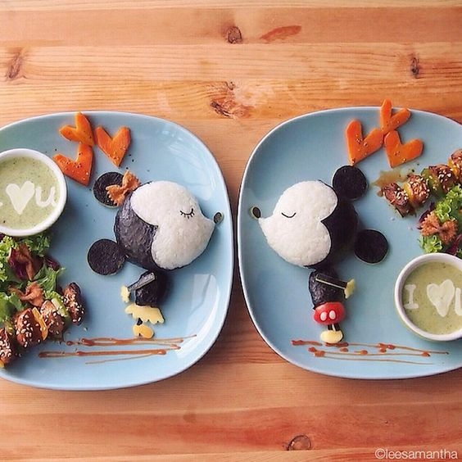Form 8+ Lesson 11. **HEALTH HABITS** Їжа та смаки

**Мета:** практичні - активізувати знання, вміння і навички учнів по темі; вчити логічно будувати висловлювання на основі прочитаної і переробленої інформації;

розвиваючі - розвивати вміння працювати з текстом: вправи, перед-розглядати графічне зображення тексту; розвивати кругозір учнів, розвивати здібності до аналізу і синтезу; = критичного мислення та самостійного осмислення отриманої інформації;

виховні - створювати можливість для прояву індивідуальних здібностей учнів; вчити учнів дбайливо ставитися до свого здоров'я, правильно харчуватися, відмовитися від шкідливих звичок; освітні - знайомити учнів з науковими фактами про здоров'я.

**Очікувані результати** на кінець уроку: учень зможе критично осмислювати інформацію

**Обладнання:** аудіозапис, CD / диск, картки с роздатковим матеріалом.

**Тип уроку:** комбінований.

**Procedure**

1. Організаційний момент. Організація класу. Привітання. **ツ** Повідомлення мети, задач уроку. Мотивація.

Введення у іншомовну атмосферу.

l. Warm-up **ツ♥ツ** Do ex, 1, p. 33.

* Ask and answer in pairs.

What’s your favourite food?

Is there any food you don’t like?

Do you regularly have breakfast? What do you have?

What snacks do you usually have? (chocolate bars, crisps, sandwiches)

Can you cook anything?

1. 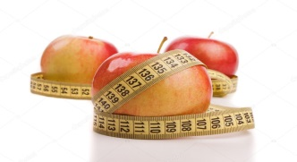Основна частина уроку 2. Speaking **►**Do ex.2, p. 34

* Find the wrong defi nition of the word **DIET**. Explain your choice.

1 a drink with sugar

2 the food that you eat every day

3 the food that you eat when you want to get thinner

3. Reading **►**Read the text. What health habits is it about? Which of them are good and which are bad health habits?

Вeing ovegrveight and physical inactivity are known from ancient times. They are joined by the modern bad habits: smoking and drinking too much alcohol, … much or too little, snaking and skipping meals are not quite as dangerous as smoking, overweight and drinking, but they are signs of dangerously chaotic lifestyles. Regularity in life promotes your health. Sleеping seven or eight hours, getting up early, having a healthy diet, eating a variety of foods, taking regular exercise is really a good way to live.

**☆** Фізкультхвилинка.

4. Writing and speaking *complete the chart below and say what a good way to live is according to the text.

**►** Bad health habits **►** Good health habits

5. Vocabulary practice Complete the follolving sentences with the words from the text above.

|  |
| --- |
| 1. You shouldn't ... meals. It is not a good way to lose weight.  2.The children have mid-morning ... at about 11 o'clock - usually fruit and a drink.  3. Regular exercise is a good ... for kids to develop.  4. Many of teens are ...because they eat too much junk food.  5. Overeating ... to being overweight.  6. It is important to have a balanced, healthy ... .  7. Regular exercise is part of a healthy ... .  8. Abalanced diet ... good health and normal development.  9. She's always complaining that the meals here don't have enough ... . |

**Key;** 1 skip, 2 snacks. 3 habit, 4 overweight, 5 leads, 6 diet, 7 lifestyle, 8 promotes, 9 variety.

6. Reading and speaking Do ex. 3, p. 34.

Choose the sentences that are true for you in thе questionnaire1. If you have more happy faces than sad faces, you eat a healthy diet. **►HOW HEALTHY IS YOUR DIET?**

7. Vocabulary practice Do ex. 6, p. 36.

8. Speaking Here are some causes that children name to explain why they are …

* Are they the same as you might have?
* Can you add more?

|  |
| --- |
| 1. Teenagers sit at a desk all day long. 2. Teens miss PE lessons.  3. Children get too tired to exercise. 4. Children eat a lot of chocolate and sweets.  5. Children don't go outside much. 6. Teenagers use computers a lot.  7. Pupils eat unhealthy school dinners. 8. Teenagers prefer junk food to healthy food.  9. Teenagers often visit fast food places like McDonald's. |

9.Writing What has to be done to make teenagers healthier? **►** = **should =**

1. a health or fitness club.
2. a variety of activities to find what you enjoу
3. adverts about things like chips.
4. eating junk food.
5. regular exercise.
6. healthy fast food places.
7. healthy food that tastes as nice as junk food
8. the junk food with less calories and fat.
9. to watch what you eat.
10. TV, computer and video game time.

l0. Speaking Do ex. 4, p. 35. a) Look at the following statements, discuss them with your partner and decide

if they are true or false.

1 It’s very important to have a proper breakfast every morning.

2 It’s enough to have two meals a day.

3 We need to drink at least two litres of water a day.

4 Portions have become much larger nowadays.

5 We should eat as much food as our body uses.

6 You can eat as much sugar and salt as you want.

7 Eat your food as fast as possible.

* III. Заключна частина уроку**.** 1 1. Summary Do ex. 5, p. 35.
* 12. Homework Write down more sentences from the table above and express your opinion for your lifestyle. Is it

really good?

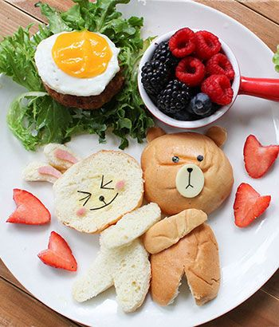Form 8+ Lesson 12. **BEING HEALTHY lS IMPORTANT**

Удосконалення граматичних навичок

**Мета:** практичні - повторити й активізувати лексику теми. Розвивати комунікативні вміння учнів. Формувати навички діалогічного мовлення за темою.

розвиваючі - навчати учнів висловлювати власні думки та обґрунтовувати їх. Виховувати повагу до точки зору інших людей,  учить учащихся бережно относиться к своему здоровью, правильно питаться, отказаться от вредных привычек;

виховні - • розуміння важливості оволодіння іноземною мовою і потреби користуватися нею як засобом спілкування.

**Очікувані результати** на кінець уроку: учень навчиться висловлювати власні думки та обґрунтовувати їх.

**Обладнання:** аудіозапис, CD, картки с роздатковим материалом, підручник, робочий зошит, картки для роботи в групах , для самостійної роботи

**Тип уроку:** комбінований

**Procedure**

I. Організаційний момент. Організація класу. Привітання. **ツ**Введення у іншомовну атмосферу.

1.Warm-up Which way to choose? After classes you are short of time. *You can: eat in a fast food place and then visit a sports club to do some exercises; buy and cook homemade food. But then you have no time to visit a sports club.

What will you choose?

II. Основна частина уроку

2. Grammar practice Introduce the rule (p. 37). Do ex. I, 2, p. 37. **FUTURE TENSES**

**Ех. 1** Compare to see the difference between general facts written in the present simple, and future plans written in the present continuous.

|  |  |
| --- | --- |
| 1 I play tennis.  2 I travel to Scotland every summer.  3 She works every day until five. | 1 I am playing tennis tomorrow at ten.  2 I am travelling to Scotland in the summer.  3 She is working until seven tomorrow. |

**Ех. 2** Use the Present Continuous in these sentences.

1 We … for Kyiv next week. (leave)

2 She … a new project next week. (start)

3 I … at my granny’s when I get to Kharkiv. (stay)

4 He … until next week. (not come)

5 We … shopping our first day there. (go)

6 I … home and … tonight. (stay, read)

3. Writing Do ex. 3, p. 38. Write six sentences about what you are doing in the next few days.

4. Speaking **►**Answer the questions.

1. What do you prefer: to watch sports competitions or to take part in them? 2. Does sport help you to keep fit?

3. How often do you go to the sports ground . 4. What sports are popular in your family? 5. Can you say that sport is your hobby? 6. What do you do to keep fit? 7. Are there any fitness clubs in your town? 8. Have you ever gone to a fitness club?

**☆** Фізкультхвилинка.

5. Listening Why is exercising wise? Listen to the information and do the task.

* *You've probably heard many times how exercise is "good for you". People who exercise burn calories and look better than those who don't. In fact, exercise is one of the most important parts of keeping your body at a healthy weight. But do you know that exercising can actually help you to feel good too? If you feel strong, it can help you to see yourself in a better light. There are three components to a well-balanced exercise routine: aerobic exercise, strength training and flexibility training. Try to get 30 to 60 minutes of activity every day (like walking to school). Besides teens should get more energetic activity (Iike playing football or skating) for three times a week. Some team sports that give you aerobic exercise are swimming, basketball, football and hockey. But if you don't play team sports, don't worry; there are a lot of ways to get aerobic exercise on your own or with friends, for example, biking, running, swimming, dancing. Strong muscles are also a plus because they actually help to protect you when you exercise. Different types of exercise are good for different muscles groirps, for example: For strong arms, try skiing. For strong legs, try running, biking or skating.*
* ***True or false.***

|  |
| --- |
| 1 Exercising can help you look better. 2 Exercising can help you feel good. 3 Уou should combine aerobic exercise, strength training and flexibility. 4 it is necessary to play team sports to get aerobic exercise. 5 To have strong muscles train for 60 minutes every daу. 6 Skiing helрs to make arms strong. 7 Doing karate is a good way to stay flexible.  8 It is difficult to choose the right type of exercise for you. 9 The more You exercise the better. |

* ***+*** Discussing healthy lifestyle

6.Writing Do ex. 4, P. 38. Make questions. All the sentences are about future.

* Example: you / go / out tonight? Are you going out tonight?

1 what time / Bob and Sue/come?

2 you / work / next week?

3 when / Liz/go/on holiday?

4 what / you / do / tomorrow evening?

7. Grammar Practice Do ex. 5, р. 38. Use the words to make sentences about the future.

Use the Present Continuous or Present Simple.

1 I / meet / my friends this evening)

2 I / not / go out/tonight

3 the concert / start/at 8.15

4 Tom / not / come / to the party on Thursday

5 The English course / finish / on 7 May

6 I / not / go / to London tomorrow

7 my sister / get / married next December

8 my train / leave / at 8.45 + взаємоперевірка

* III. Заключна частина уроку**.** 8.Summary What does being healthy mean to you?

**⇨** As for me, **⇨**I..., because... **⇨**Besides I... **⇨**It means that...

* 9. Homework Do ex. 6, 7, p. 38- 39. = I think people should... May be I... Being healthy for me is..

**Appendix: KEY:**

1.

**HEALTHY FOOD** **UNHEALTHY FOOD**

1. grapes 2. french fries

3. muscles 4. butter

6. apple 5. hamburger

11. nuts (hazels) 7. ketchup

12. olive oil 8. hot dog

14. carrots 10. biscuits

15. eggs? 13. chocolates

16. fish 15. fried eggs

17. water 18. meat

19. watermelon

20. cherries

2.

1. cut down on salt …… H

2. brush your teeth …… H

3. go jogging …… H

4. sleep 12 hours a day …… U

5. give up smoking …… H

6. walk …… H

7. have fizzy drinks …… U

8. do yoga …… H

9. work long hours …… U

10. eat junk food …… U

11. exercise …… H

12. sunbathe at midday …… U

PICTURES

5 8 10

9 3 6

7 12 2

4 1 11

2. 1. Say what habits are healthy (H) or Unhealthy (U). Write H/U after the sentences.

2. Put the number of the sentence in the heart.

|  |  |  |  |
| --- | --- | --- | --- |
| HEALTHY / UNHEALTHY HABITS  1. CUT DOWN ON SALT ……  2. BRUSH YOUR TEETH ……  3. GO JOGGING ……  4. SLEEP 12 HOURS A DAY …  5. GIVE UP SMOKING ……  6. WALK ……  7. HAVE FIZZY DRINKS ……  8. DO YOGA ……  9. WORK LONG HOURS ……  10. EAT JUNK FOOD ……  11. EXERCISE ……  12. SUNBATHE AT MIDDAY …… | cartel de prohibido fumar,carteles de prohibido fumar,cigarrillos,fumar,iconos,no fumar,signos,símbolos | ejercicio físico,ejercicios,ejercitar,estirarse,mujeres,ocio,yoga | bebidas,bebidas sin alcohol,cenar,comidas rápidas,hamburguesas,hamburguesas con queso,licores,sándwiches,sodas |
| cartas,dormido,equipos,equipos informáticos,gafas para ver,gente,hombres,hombres de negocios,negocios,pupitres,sillas de oficina,símbolos,sueños,tecnología,varones,Zs | audífonos,auriculares,chicas,coletas,corredores,correr,ejercicios,entrenamiento,escuchar,gimnasia,MP3,mujeres,ocio,personas,recreo,reproductor de MP3,reproductores de MP3,tecnologías | caminando al trabajo,hombres,hombres de negocios,maletín,maletines,negocios,pasear,personas |
| bebidas,bebidas gaseosas,bebidas sin alcohol,cenar,latas,refrescos,sodas | broncearse,hombres,personas,personas tomando el sol,tiempo libre,tomar el sol,tumbonas,vacaciones | adolescencia,adolescentes,cepillarse los dientes,cepillos de dientes,chicas,dental,infancia,niñas,niños,objetos domésticos,pasta de dientes,personas |
| adolescencia,adolescentes,camas,chicos,dormir,habitaciones,infancia,mobiliario,niños,objetos domésticos,personas,Z,Zs | aderezos,artículo del hogar,comida,condimentos,especias,pimenteros,pimienta,sal,saleros | actividades,ejercicio físico,ejercicios,ejercitar,estiramientos,estirarse,mujeres,ocio,yoga |

HEALTHY/ UNHEALTHY LIFE

1. Write the name of the food. Put the words under the correct heading: HEALTHY/UNHEALTHY

|  |  |  |  |  |  |  |  |  |
| --- | --- | --- | --- | --- | --- | --- | --- | --- |
| comidas,frutas,naturaleza,plantas,uvas | comer,comida,comida rápida,patatas,patatas fritas | animales,animales acuáticos,animales marinos,fauna,invertebrados,mejillones,naturaleza,seres vivos | comida,condimentos,mantequilla,productos lácteos | **HEALTHY**  **FOOD** | UNHEALTHY  FOOD | 14. | 15. | 16. |
| 1. | 2. | 3. | 4. |
| almuerzos,bollos,burgers,cenar,comida,comidas,hamburguesas,hamburguesas de queso,panecillos,sandwiches | comida,conservación,conservación medioambiental,cuestiones medioambientales,ecología,ecologistas,elementos web,entornos,frutas,iconos,manzanas,naturaleza,orgánico,símbolos | aderezos,botellas de salsa de tomate,cenar,dosficadores,salsas | alimento,almuerzos,perritos calientes,salchichas |
| 5. | 6. | 7. | 8. |
| cenar,comida,frutas,tomates | cenar,comida,galletas | avellanas,cenar,comida,frutos secos | ver detalles |
| 9. | 10. | 11. | 12. |
| alimento,amor,bombones,caramelos,corazones,Día de los enamorados,enamorados,ocasiones especiales,símbolos | cenar,comida,verduras,zanahorias | cáscaras de huevo,comida,huevos,huevos fritos | ver detalles |
| 13. | 14. | 15. | 16. |
| agua en botellas,alimento,bebidas,botellas,botellas de agua,productos de alimentación,tiendas de comestibles | cuatro grupos de alimentos básicos,patas de pollo,pollos,baquetas,alimento,grupos de alimento,jamones,salud,saludable,carnes,proteínas,carnes rojas,filetes,chuletas | comer,comida,estaciones,frutas,productos,sandías,verano | cenar,cerezas,comida,frutas |
| 17. | 18. | 19. | 20. |

KEY

1.

HEALTHY FOOD UNHEALTHY FOOD

1. GRAPES 2. FRENCH FRIES

3. MUSCLES 4. BUTTER

6. APPLE 5. HAMBURGER