English can be easy!
Objectives To revise grammar and lexis
To practice dialogical speech and using present indefinite tense
To develop reading, speaking and listening skills
Teach students to work in groups
To bring up interest to learning English
Aids Tablet, song, cards
Procedure
- Warming up
“Fruit salad” game
- Main part.
Let’s divide into two teams. Create the name and motto of each team.
- How many words can you make out of the word HALLOWEEN
Hello, hell, we, all, when, owl, hall, alone, whale, allow, wall, new, he, law, low….
- Do you like reading? Believe me, it can be very interesting. So let’s try.

- Picture game (using prepositions of place)
- Guess who (revise appearance lexis and descriptive techniques)
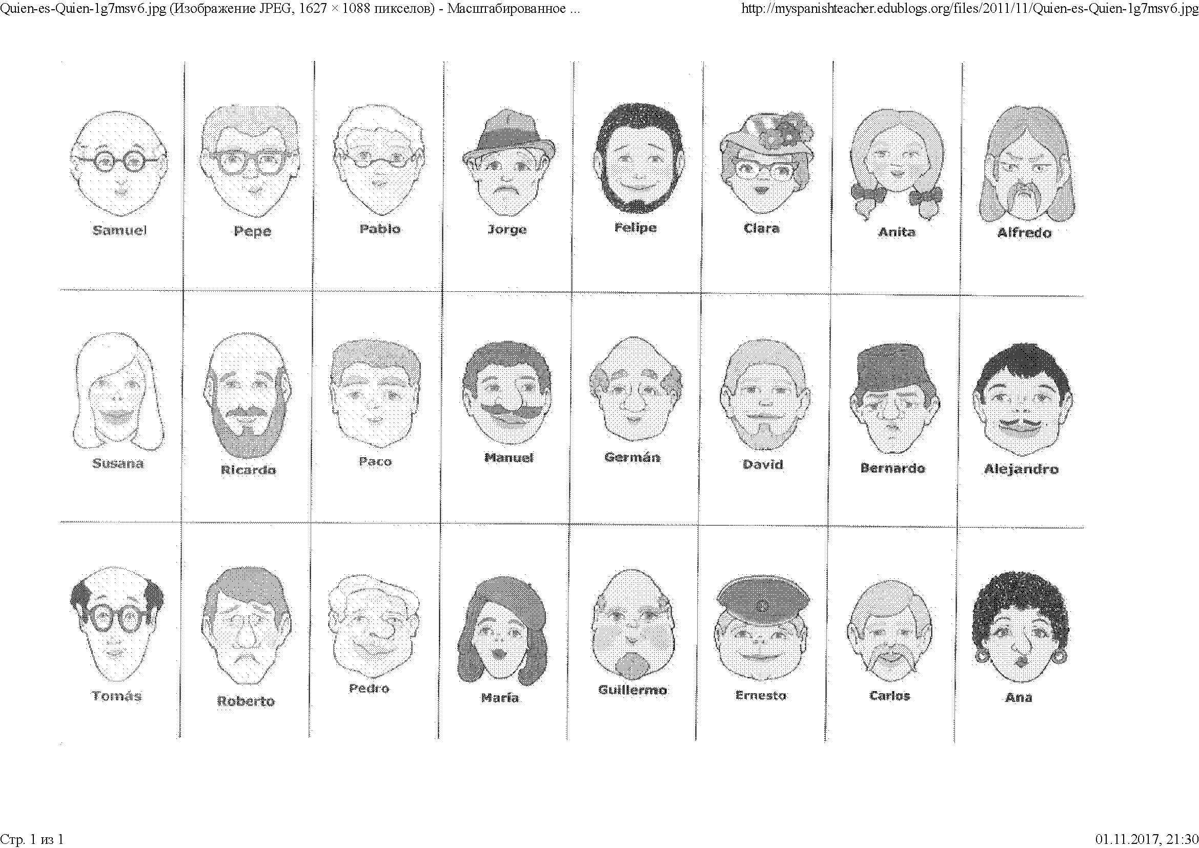
- Corrections of mistakes.
Correct the following sentences:

- We study Maths in Monday. ___on____
- She are Sally. __________
- We live on Madrid. __________
- The man and the woman is happy. __________
- There is shops, pubs and restaurants in my city. __________
- She am not Italian. __________
- My favourite day is sunday. __________
- Are horses your favourites animals? __________
- Has you got a cat? __________
- They haven’t got bigs ears. __________
- He cans swim. __________
- Do he Know Helen? __________
- There isn’t plates on the floor. __________
- We have maths at the morning. __________

- Song – Tim MC Morris “What a beautiful day”. Your task will be tо listen twice and to fill in the gaps.
The sun shines bright
As it moves across my face
I feel the light
And everything is in it's place
I woke up feeling great
Today was made for me
And life is good, the way it should,
the way it was meant to be
And it’s a beautful day
It’s a beautiful day
It’s a beautiful day
It’s a beautiful day
The wind is blowing, the bells are ringing
Children playing in the park
While birds are singing
And I’m walking, and I’m laughing
Life is perfect, I’m not tryin’, it’s just happening

- Summing up.
So, lets count our points and choose the winner of our today’s competition.
Evaluations

