Чигиринський навчально-виховний комплекс
«Дошкільний навчальний заклад-спеціалізована школа І-ІІІ ступенів №2»
Чигиринської районної ради Черкаської області

Навчальний посібник

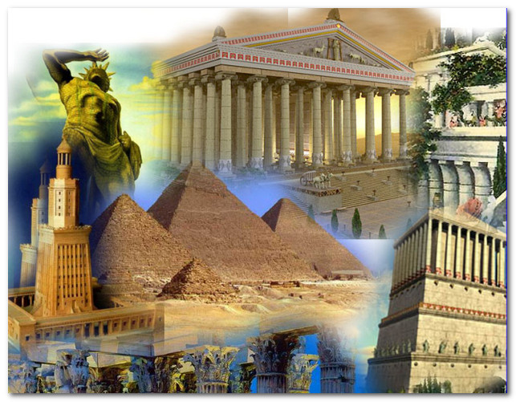

Чигирин 2016

Ковальчук О.В.. -Чигирин, 2016.- 26с.

Автор:
Ковальчук О.В., вчитель англійської мови Чигиринського навчально-виховного комплексу І-ІІІ ступенів №2 Чигиринської районної ради Черкаської області

Рецензент: Лещенко Н.Л., старший вчитель англійської мови
Чигиринського навчально-виховного
комплексу І-ІІІ ст. №2 Чигиринської
районної ради Черкаської області.

Посібник складено з метою запровадження історичних елементів стародавнього світу в практику викладання окремих тем на уроках англійської мови та в позакласній роботі з предмету і містить збірку текстів із вправами на закріплення.

CONTENTS

- Introduction
- Great Pyramid of Giza
- Colossus of Rhodes
- Hanging Gardens of Babylon
- Statue of Zeus at Olympia
- Temple of Artemis at Ephesus
- Mausoleum at Halicarnassus
- Lighthouse of Alexandria

Introduction

The amazing works of art and architecture known as the Seven Wonders of the Ancient World serve as a testament to the imagination and sheer hard work
of which human beings are capable. They are also, however, reminders of the human capacity for disagreement, destruction and, possibly. As soon as ancient writers compiled a list of “seven wonders,” it became fodder for debate over
which achievements deserved inclusion. Ultimately, human hands joined with natural forces to destroy all but one of the wonders. Furthermore, it is possible
that at least one of the wonders might not have existed at all. Still, all seven continue to inspire and be celebrated as the remarkable products of the creativity and skill of Earth’s early civilizations.
Seven wonders of the ancient word:
- Great Pyramid of Giza
- Colossus of Rhodes
- Hanging Gardens of Babylon
- Statue of Zeus at Olympia
- Temple of Artemis at Ephesus
- Mausoleum at Halicarnassus
- Lighthouse of Alexandria

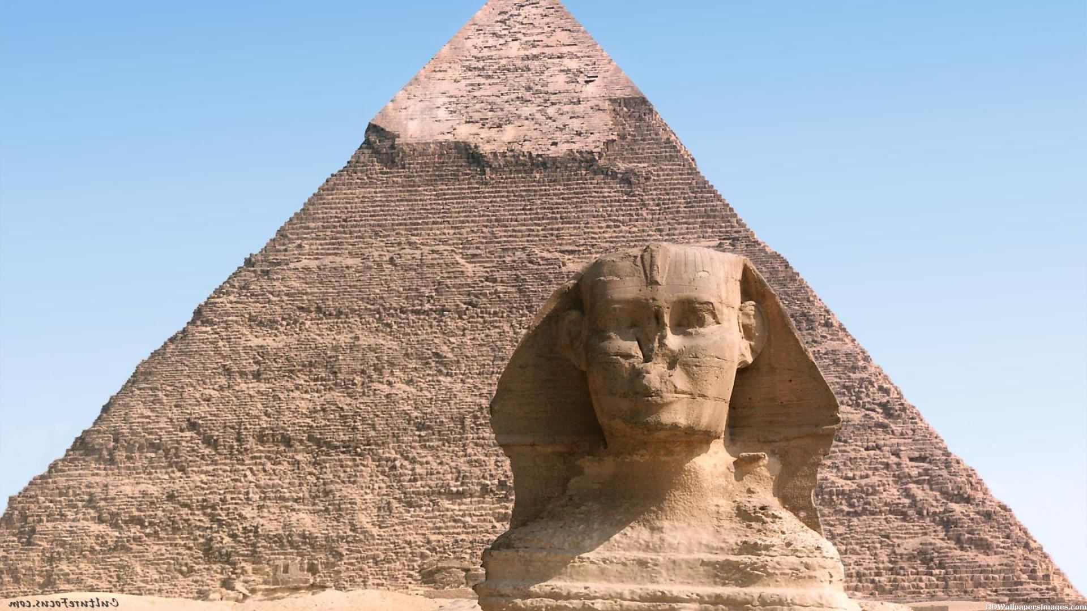

The Great Pyramid of Giza (also known as the Pyramid of Khufu or the Pyramid of Cheops) is the oldest and largest of the three pyramids in the Giza Necropolis bordering what is now El Giza, Egypt. It is the oldest of the Seven Wonders of the Ancient World, and the only one to remain largely intact.
Based on a mark in an interior chamber naming the work gang and a reference to fourth dynasty Egyptian Pharaoh Khufu, Egyptologists believe that the pyramid was built as a tomb over a 10 to 20-year period concluding around 2560 BC. Initially at 146.5 metres (481 feet), the Great Pyramid was the tallest man-made structure in the world for over 3,800 years. Originally, the Great Pyramid was covered by casing stones that formed a smooth outer surface; what is seen today is the underlying core structure. Some of the casing stones that once covered the structure can still be seen around the base. There have been varying scientific and alternative theories about the Great Pyramid's construction techniques. Most accepted construction hypotheses are based on the idea that it was built by moving huge stones from a quarry and dragging and lifting them into place.
There are three known chambers inside the Great Pyramid. The lowest chamber is cut into the bedrock upon which the pyramid was built and was unfinished. The so-called Queen's Chamber and King's Chamber are higher up within the pyramid structure. The Great Pyramid of Giza is the only pyramid in Egypt known to contain both ascending and descending passages. The main part of the Giza complex is a setting of buildings that included two mortuary temples in honour of Khufu (one close to the pyramid and one near the Nile), three smaller pyramids for Khufu's wives, an even smaller "satellite" pyramid, a raised causeway connecting the two temples, and small mastaba tombs surrounding the pyramid for nobles.

It is believed the pyramid was built as a tomb for Fourth Dynasty Egyptian pharaoh Khufu (often Hellenicised as "Cheops") and was constructed over a 20-year period. Khufu'svizier, Hemon, or Hemiunu, is believed by some to be the architect of the Great Pyramid.

Materials
The Great Pyramid consists of an estimated 2.3 million blocks which most believe to have been transported from nearby quarries. The Tura limestone used for the casing was quarried across the river. The largest granite stones in the pyramid, found in the "King's" chamber, weigh 25 to 80 tonnes and were transported from Aswan, more than 800 km (500 mi) away. Traditionally, ancient Egyptians cut stone blocks by hammering into them some wooden wedges, which were then soaked with water. As the water was absorbed, the wedges expanded, causing the rock to crack. Once they were cut, they were carried by boat either up or down the Nile River to the pyramid. It is estimated that 5.5 million tonnes of limestone, 8,000 tonnes of granite (imported from Aswan), and 500,000 tonnes of mortar were used in the construction of the Great Pyramid.
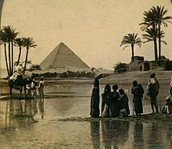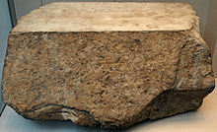
Great Pyramid of Giza from a 19th-century Casing stone in the British Museum
stereopticon card photo

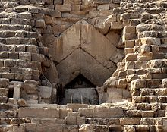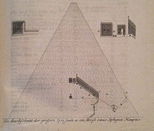
The entrance of the Pyramid Richard Pocockes sketch of Pyramid of Cheops from 1754.

Answer the questions.

- Is the Great Pyramid of Giza the oldest of the seven wonders of the ancient world?
- Was the pyramid was built as a tomb?
- Was the Great Pyramid the tallest man-made structure in the world for over 3,800 years?
- Was it built by moving huge stones?
- Are there three known chambers inside the Great Pyramid?
- What is the main part of the Giza complex?
- How many blocks the Great Pyramid consist of ?
- What materials were used in the construction of the Great Pyramid?

Choose the right answer.

1. The Great Pyramid of Giza is ………of the three pyramids in the Giza Necropolis.
a. the oldest and largest
- the smallest
- the largest and smallest
2. The pyramid was built as a tomb around ……..
- 2056 AD
- 2560 BC
- 2346 BC
3. The Great Pyramid was the tallest ……structure.
- woman – made
- child - made
- man-made
4. There are …… known chambers inside the Great Pyramid.
- two
- three
- ten

5. The Great Pyramid consists of an estimated …… million blocks
- 5.9
- 2.3
- 7.9

Keys: a; b; c; b; b.

The Colossus of Rhodes

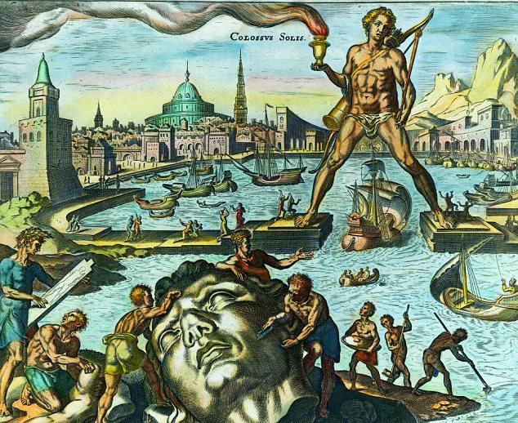

The Colossus of Rhodes is familiar to almost everyone. Its history begins with the siege of Demetrious Poliorketes, successor of Alexander the Great, in 305 BC. When Demetrious was defeated, he abandoned all his siege machinery on Rhodes. The Rhodians decided to express their pride by building a triumphal statue of their favourite god, Helios. The
task was assigned to the sculptor Chares of Lidos, a pupil of Lysippus himself, and twelve years (from 304 to 292 BC) were needed to complete it.
To build the statue, the workers cast the outer bronze skin parts. The base was made of white marble, and the feet and ankle of the statue were first fixed. The structure was gradually erected as the bronze form was fortified with an iron and stone framework. To reach the higher parts, an earth ramp was built around the statue and was later removed. When the Colossus was finished, it stood about 33 miters (110 ft) high. And when it fell, "few people can make their arms meet round the thumb", wrote Pliny.
For almost a millennium, the statue lay broken in ruins. In AD 654, the Arabs invaded Rhodes. They disassembled the remains of the broken Colossus and sold them to a Jew from Syria. It is said that the fragments had to be transported to Syria on the backs of 900 camels.

Why is this wonder of the ancient world?
We can say that the Colossus of Rhodes is part of the seven wonders because of its exemplary vastness. Moreover, it should well be realized that this Greek monuments is the result of a very hudge technical prowess which is characterized, among other things.

- Read the text and decide if the statements are T (True) or F (False).

- The Colossus of Rhodes is familiar to almost everyone.
- The Rhodians decided to express their pride by building a triumphal statue of their favourite god, Helios.
- To build the statue, the workers cast the outer gold skin parts.
- The base was made of red marble.
- The structure was gradually erected as the bronze form was fortified with an iron and stone framework.
- In AD 640, the Arabs invaded Rhodes.

Keys: T;T;F;F;T;F

2. Complete the sentences with the correct prepositions: in, by, to, of,
from.

- The Colossus of Rhodes is familiar ____ almost everyone.
- The base was made ___ red marble.
- The structure was gradually erected as the bronze ____ was fortified with an iron and stone framework.
- The Colossus of Rhodes is part ____ the seven wonders.
- The Rhodians decided ___ express their pride ___ building a triumphal statue of their favourite god.
- For almost a millennium, the statue lay broken ___ ruins.

Keys: 1. to; 2. of; 3. from; 4. of; 5. to/by; 6. in.

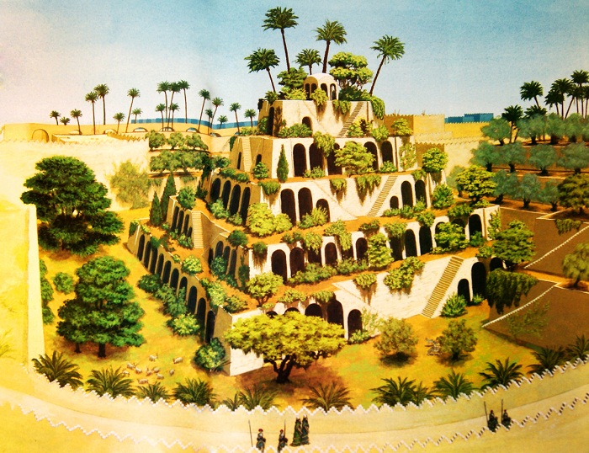

The Hanging Gardens of Babylon were one of the Seven Wonders of the Ancient World, and the only one whose location has not been definitely established.
The Hanging Gardens were a distinctive feature of ancient Babylon. They were a great source of pride to the people, and were often described in accounts written by visitors to the city. Possibly built by King Nebuchadnezzar II in 600 BC, the gardens are believed to have been a remarkable feat of engineering: an ascending series of tiered gardens containing all manner of trees, shrubs, and vines. The gardens were said to have looked like a large green mountain constructed of mud bricks, rising from the center of the city.
Traditionally they were said to have been built in the ancient city of Babylon, near present-day Hillah, Babil province, in Iraq. The Babylonian priest Berossus, writing in about 290 BC and quoted later by Josephus, attributed the gardens to the Neo-Babylonian king Nebuchadnezzar II, who ruled between 605 and 562 BC. There are no extant Babylonian texts which mention the gardens, and no definitive archaeological evidence has been found in Babylon.
According to one legend, Nebuchadnezzar II built the Hanging Gardens for his Median wife, Queen Amytis, because she missed the green hills and valleys of her homeland. He also built a grand palace that came to be known as 'The Marvel of the Mankind'.
Because of the lack of evidence it has been suggested that the Hanging Gardens are purely mythical, and the descriptions found in ancient Greek and Roman writers including Strabo, Diodorus Siculus and Quintus Curtius Rufus represent a romantic ideal of an eastern garden. If it did indeed exist, it was destroyed sometime after the first century AD.

Read the text and decide if the statements are T (True) or F (False).

- The Hanging Gardens of Babylon were one of the Seven Wonders of the Ancient World.
- The Hanging Gardens were a distinctive feature of ancient Egypt.
- It was built by King Nebuchadnezzar II in 600 BC.
- The gardens were said to have looked like a large green mountain constructed of mud bricks, rising from the center of the city.
- According to one legend, Nebuchadnezzar III built the Hanging Gardens for his Median wife.

Keys: T,F,T,T,F.

Answer the questions.

- Were the Hanging Gardens of Babylon one of the Seven Wonders of the Ancient World?
- Were the Hanging Gardens a distinctive feature of ancient Babylon?
- Who was built the Hanging Gardens?
- For whom the Hanging Gardens were built?
- When the Hanging Gardens were built?

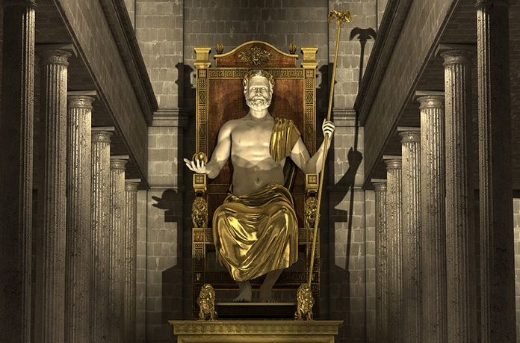

In the ancient world, there were many temples dedicated to Zeus, the king of the Greek gods. But, there was only one temple to Zeus that housed one of the seven wonders of the ancient world. The Temple of Zeus at Olympia was home to one of greatest sculptural achievements of ancient history. The Statue of Zeus at Olympia represented the pinnacle of Classical sculptural design, as well as showcased the engineering that was required to construct such a massive chunk of marble and gold.

The city-state of Olympia was a center of religious worship, and was also the birthplace of the Olympic games. Believed to have begun in 776 B.C., the Olympic games demonstrated the physical prowess as well as the political strength of the participating Greek poleis. The Olympic games were considered to be a part of religious rituals that revolved around the king of the Greek gods, Zeus. So it was only fitting that a grand temple and an even grander cult representation were constructed for the many Greeks who made pilgrimages there in order to worship their father god.

The temple of Zeus was built between 466 - 456 B.C., during the height of Classical Greek architecture and artistic endeavors. It was designed by Libon, an architect from neighboring Elis. The temple was constructed of local shell stone in the Doric style, the predominant architectural style of the time, and the same style as the Parthenon in Athens. The temple itself acted merely as a protective home for the real showpiece, the cult statue of Zeus himself.

The renowned Greek sculptor Pheidias brought Zeus to life with his creation around 435 B.C. After creating the cult statue of Athena for the Parthenon, Pheidias left Athens in shame as a result of a political scandal and an erroneous embezzlement charge. He immediately came to Olympia to begin work on Zeus.

Pheidias had developed a technique that allowed his enormous creations of ivory and precious metals to be formed without crumbling under their own weight. Beginning with a wooden frame built on site, he would lay thin plates of ivory soaked in a liquid to make them moldable, and place them upon the mold along with sheets of gold (for Zeus draping clothing). The pieces matched up perfectly, and the joints were nearly invisible.

The appearance of the statue must have been imposing, impressive, and awe-inspiring. The seated statue was over 40 feet tall. Zeus' throne was just as impressive, constructed of cedar and inlaid with ivory, gold, and ebony. He held a statue of Nike, the Greek goddess of victory, in his left hand, and a staff with an eagle perched atop it in his right hand.

The statue inspired reverence for over 800 years in its temple home in Olympia. Kings and even Roman Emperors who gazed upon it were known to cry in veneration. In fact, the Roman Emperor Caligula even tried to have the statue taken for himself in the late 30's A.D., with no success. In the 450's A.D., it was taken from the temple to Constantinople, where it sat in a palace. The palace was destroyed by fire in 462 A.D., and one of the seven wonders of the ancient world was unfortunately lost forever.

Choose the correct answer.

- In the ancient world, there were many temples dedicated to…….
- Zeus
- Roman Emperor Caligula
- Nike
- The temple of Zeus was built between…….
- 440-462 A.D
- 466 - 456 B.C
- 457-455 B.C
- The seated statue was over……..
- 50 feet tall
- 80 feet tall
- 40 feet tall

- Zeus' throne was just as impressive, constructed of cedar and inlaid with ……………….
- ivory, gold, and ebony
- ivory and gold
- gold and ebony

- He held a statue of Nike, the Greek goddess of victory, in his left hand, and a staff with an eagle perched atop it in his …
- right hand
- left hand
- both hands
- The statue inspired reverence for over … … years in its temple home in Olympia.
- 900 years
- 800 years
- 500 years

- The palace was destroyed by fire in ……..
- 500 A.D.
- 462 A.D.
- 352 A.D.

- The ……………….even tried to have the statue taken for himself.

- Greek Emperor Caligula
- Scandinavian Emperor Caligula

- In the ……it was taken from the temple to Constantinople, where it sat in a palace.
- 350's A.D.
- 450's A.D.
- 250's A.D.

10. Nike was the Greek goddess of

- victory
- love
- beauty

Keys: 1) a; 2) b; 3) c; 4) a; 5) b; 6) b; 7) b; 8) a; 9) b; 10) a.

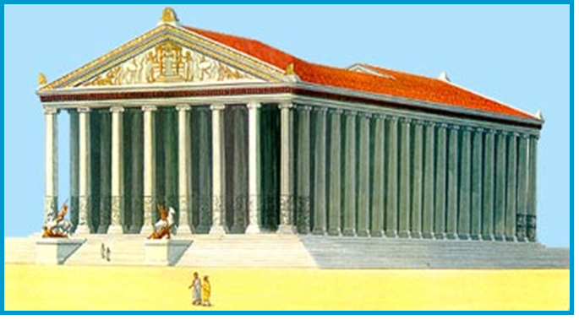

Temple of Artemis, sometimes called the Artemisium, was a huge, beautiful place of worship, that was built around 550 BCE in the rich, port city of Ephesus (located in what is now western Turkey). When the beautiful monument was burned down 200 years later by the arsonist Herostratus in 356 BCE, the Temple of Artemis was built again, just as large but even more intricately decorated. It was this second version of the Temple of Artemis that was awarded a place among the Seven Ancient Wonders of the World.
The Temple of Artemis was again destroyed in 262 CE when the Goths invaded Ephesus, but the second time it was not rebuilt.

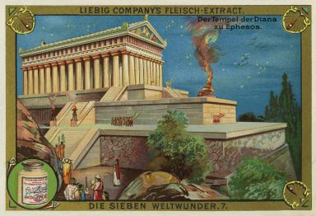
A depiction of the Temple of Artemis at Ephesus, one of the Seven Wonders of the Ancient World. (1895).

Who Was Artemis?
For ancient Greeks, Artemis (also known as the Roman goddess Diana), the twin sister of Apollo, was the athletic, healthy, virgin goddess of hunting and wild animals, often depicted with a bow and arrow. Ephesus, however, was not purely a Greek city. Although it had been founded by Greeks as a colony on Asia Minor around 1087 BCE, it continued to be influenced by the original inhabitants of the area. Thus, at Ephesus, the Greek goddess Artemis was combined with the local, pagan goddess of fertility, Cybele.
The few sculptures that remain of Artemis of Ephesus show a woman standing, with her legs fitted tightly together and her arms held out in front of her. Her legs were wrapped tightly in a long skirt covered with animals, such as stags and lions. Around her neck was a garland of flowers and on her head was either a hat or a headdress. But what was most pronounced was her torso, which was covered with a large number of breasts or eggs.
Artemis of Ephesus was not only the goddess of fertility, she was the patron deity of the city. And as such, Artemis of Ephesus needed a temple in which to be honored.

The First Temple of Artemis
The first Temple of Artemis was built in a marshy area long held sacred by locals. It is believed that there was at least some sort of temple or shrine there at least as early as 800 BCE. However, when famously-rich King Croesus of Lydia conquered the area in 550 BCE, he ordered a new, larger, more magnificent temple to be built.
The Temple was 350 - feet long and 180-feet wide, larger than a modern, American-football field. What was truly spectacular, though, was its height. The 127 Ionic columns, which were lined up in two rows all around the structure, reached 60 feet high. That was nearly twice as high as the columns at the Parthenon in Athens.
The entire Temple was covered in beautiful carvings, including the columns, which was unusual for the time. Inside the Temple was a statue of Artemis, which is believed to have been life-sized.

The Second Temple of Artemis
When the Ephesians sorted through the charred remains of the Temple of Artemis, it is said they found the statue of Artemis intact and unharmed. Taking this as a positive sign, the Ephesians vowed to rebuild the temple.
It is unclear how long it took to rebuild, but it easily took decades. There is a story that when Alexander the Great arrived in Ephesus in 333 BCE, he offered to help pay for the rebuilding of the Temple as long as his name would be engraved on it. Famously, the Ephesians found a tactful way of rebuffing his offer by saying, "It is not fitting that one god should build a temple for another god."
Eventually, the second Temple of Artemis was finished, equal or just a bit taller in size but even more elaborately decorated. The Temple of Artemis was well-known in the ancient world and was a destination for many worshippers.
For 500 years, the Temple of Artemis was revered and visited. Then, in 262 CE, the Goths, one of the many tribes from the north, invaded Ephesus and destroyed the Temple. This time, with Christianity on the rise and the cult of Artemis on the decline, it was decided to not rebuilt the Temple.

Swampy Ruins
Sadly, the ruins of the Temple of Artemis were eventually plundered, with the marble being taken for other buildings in the area. Over time, the swamp in which the Temple was built grew larger, taking over much of the once-grand city. By 1100 CE, the few remaining citizens of Ephesus had completely forgotten that the Temple of Artemis ever existed.
In 1864, the British Museum funded John Turtle Wood to excavate the area in the hopes of finding the ruins of the Temple of Artemis. After five years of searching, Wood finally found the remains of the Temple of Artemis under 25 feet of swampy mud.
Later archaeologists have further excavated the site, but not much has been found. The foundation remains there as does a single column. The few artifacts that have been found were shipped to the British Museum in London.

1. Find the right variant endings of the following sentences.
- Ephesus…
- The few sculptures that remain of Artemis of …
- Artemis of Ephesus was not only the goddess of fertility…
- In 1864, the British Museum funded John Turtle Wood…
- This time, with Christianity on the rise and the cult of Artemis on the decline…
- When the Ephesians sorted through the charred remains of the Temple of Artemis…
- show a woman standing, with her legs fitted tightly together and her arms held out in front of her.
- it is said they found the statue of Artemis intact and unharmed.
- to excavate the area in the hopes of finding the ruins of the Temple of Artemis.
- it was decided to not rebuilt the Temple.
- she was the patron deity of the city.
- was not purely a Greek city.
Keys: 1-f; 2-a; 3-e; 4-c; 5-d; 6-b.

- Read the text and decide if the statements are T (True) or F (False).

- Temple of Artemis was a huge, beautiful place of worship, that was built around 550 BCE in the rich, port city of Ephesus.
- The Temple of Artemis was again destroyed in 262 CE.
- The few sculptures that remain of Artemis of Ephesus show a woman sitting, with her legs fitted tightly together and her arms held out in front of her.
- It is believed that there was at least some sort of temple or shrine there at least as early as 600 BCE.
- The Temple was 250 - feet long and 280-feet wide, larger than a modern, American-football field.
- The entire Temple was covered in beautiful carvings, including the columns, which was unusual for the time.
Keys: 1.T 2.T. 3. T. 4. F. 5. F 6. T.

Mausoleum at Halicarnassus

The Mausoleum at the ancient city of Halicarnassus was the tomb of the king, Mausolus.

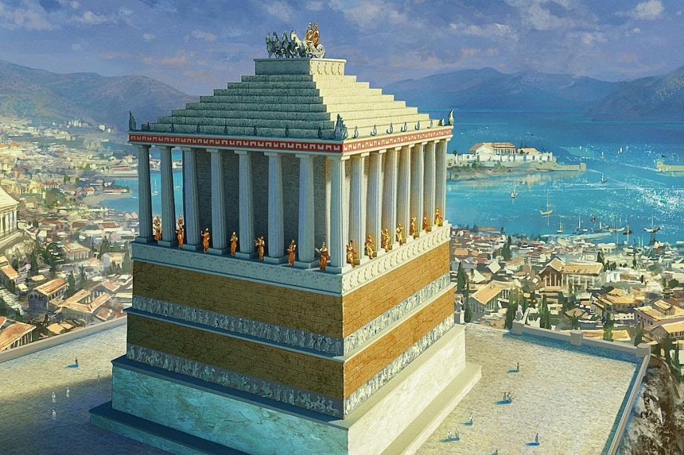
The Tomb of Maussollos, Mausoleum of Maussollos or Mausoleum at Halicarnassus (in Greek,Μαυσωλεῖον Ἁλικαρνασσεύς, Μαυσωλεῖον τοῦ Ἁλικαρνασσοῦ (Ἀλικαρνασσοῦ)) was a tomb built between353 and 350 BC at Halicarnassus (present Bodrum, Turkey) for Mausolus, a satrap in the Persian Empire, and Artemisia II of Caria, his wife and sister. The structure was designed by the Greek architects Satyrus and Pythius. It stood approximately 45 metres (135 feet) in height, and each of the four sides was adorned with sculptural reliefs created by each one of four Greek sculptors — Leochares, Bryaxis, Scopas of Paros and Timotheus. The finished structure considered to be such an aesthetic triumph that Antipater of Sidon identified it as one of his Seven Wonders of the Ancient World.
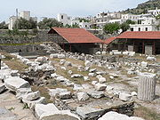
At the center of the platform was the tomb itself. Made mostly of marble, the structure rose as a square, tapering block to about one-third of the Mausoleum's 140 foot height. This section was covered with relief sculpture showing action scenes from Greek myth/history. One part showed the battle of the Centaurs with the Lapiths. Another depicted Greeks in combat with the Amazons, a race of warrior women. On top of this section of the tomb thirty-six slim columns rose for another third of the height. Standing in between each column was another statue. Behind the columns was a solid block that carried the weight of the tomb's massive roof.
The roof, which comprised most of the final third of the height, was in the form of a stepped pyramid with 24 levels. Perched on top was the tomb's penultimate work of sculpture craved by Pytheos: Four massive horses pulling a chariot in which images of Mausolus and Artemisia rode.

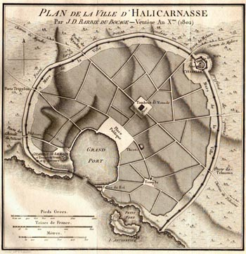
A map of the city of Halicarnassus drawn by the archeologist JD Bocage in 1802 showing the tomb in the middle of the city.

Lives of Mausolus and Artemisia

Conquest
In 623 BC, Halicarnassus was the capital of a small regional kingdom in the coast of Asia Minor. In 377 BC the ruler of the region, Hecatomnus of Milas, died and left the control of the kingdom to his son, Mausolus. Hecatomnus, a local satrap under the Persians, took control of several of the neighboring cities and districts. After Mausolus and Artemisia, he had several other sons and daughters: Ada (adopted mother of Alexander the Great), Idrieus and Pixodarus. Mausolus extended its territory as far as the southwest coast of Anatolia. Mausolus and Artemisia ruled from Halicarnassus over the surrounding territory for twenty-four years. Mausolus, although descended from local people, spoke Greek and admired the Greek way of life and government. He founded many cities of Greek design along the coast and encouraged Greek democratic traditions.

Halicarnassus
Mausolus decided to build a new capital; a city as safe from capture as it was magnificent to be seen. He chose the city of Halicarnassus. If Mausolus' ships blocked a small channel, they could keep all enemy warships out. He started to make of Halicarnassus a capital fit for a warrior prince. His workmen deepened the city's harbour and used the dragged sand to make protecting breakwaters in front of the channel. On land they paved streets and squares, and built houses for ordinary citizens. And on one side of the harbour they built a massive fortified palace for Mausolus, positioned to have clear views out to sea and inland to the hills — places from where enemies could attack.
On land, the workmen also built walls and watchtowers, a Greek–style theatre and a temple to Ares — the Greek god of war.
Mausolus and Artemisia spent huge amounts of tax money to embellish the city. They commissioned statues, temples and buildings of gleaming marble. In the centre of the city Mausolus planned to place a resting place for his body after his death. It would be a tomb that would forever show how rich he and his queen were.

Death and memorial

Artemisia Prepares to Drink the Ashes of her Husband, Mausolus (1630)
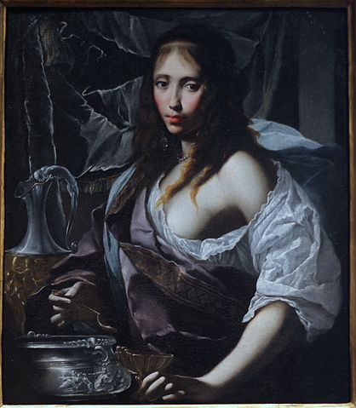

In 353 BC Mausolus died, leaving Artemisia broken-hearted. It was the custom in Caria for rulers to marry their sisters; suchincestuous marriages kept the power and the wealth in the family. As a tribute to him, she decided to build him the most splendid tomb, a structure so famous that Mausolus's name is now the eponym for all stately tombs, in the word mausoleum. The construction was also so beautiful and unique it became one of the Seven Wonders of the Ancient World.
Soon after construction of the tomb started, Artemisia found herself in a crisis. Rhodes, a Greek island at the Aegean Sea, had been conquered by Mausolus. When the Rhodians heard about his death, they rebelled and sent a fleet of ships to capture the city of Halicarnassus. Knowing that the Rhodian fleet was on the way, Artemisia hid her own ships at a secret location at the east end of the city's harbour. After troops from the Rhodian fleet disembarked to attack, Artemisia's fleet made a surprise raid, captured the Rhodian fleet and towed it out to sea. Artemisia put her own soldiers on the invading ships and sailed them back to Rhodes. Fooled into thinking that the returning ships were their own victorious navy, the Rhodians failed to put up a defense and the city was easily captured, quelling the rebellion.
Artemisia lived for only two years after the death of her husband. The urns with their ashes were placed in the yet unfinished tomb. As a form of sacrifice ritual the bodies of a large number of dead animals were placed on the stairs leading to the tomb, then the stairs were filled with stones and rubble, sealing the access. According to the historian Pliny the Elder, the craftsmen decided to stay and finish the work after the death of their patron "considering that it was at once a memorial of his own fame and of the sculptor's art."

The construction of the Mausoleum
Artemisia spared no expense in building the tomb. She sent messengers to Greece to find the most talented artists of the time. These included Scopas, the man who had supervised the rebuilding of the temple of Artemis at Ephesus. The famous sculptors were (in theVitruvius order) Leochares, Bryaxis, Scopas and Timotheus, as well as hundreds of other craftsmen.
The tomb was erected on a hill overlooking the city. The whole structure sat in an enclosed courtyard. At the center of the courtyard was a stone platform on which the tomb sat. A stairway flanked by stone lions led to the top of the platform, which bore along its outer walls many statues of gods and goddess. At each corner, stone warriors mounted on horseback guarded the tomb. At the centre of the platform, the marble tomb rose as a square tapering block to one-third of the Mausoleum's 45-meter (135-foot) height. This section was covered with bas-reliefs showing action scenes, including the battle of the centaurs with the lapiths and Greeks in combat with theAmazons, a race of warrior women.
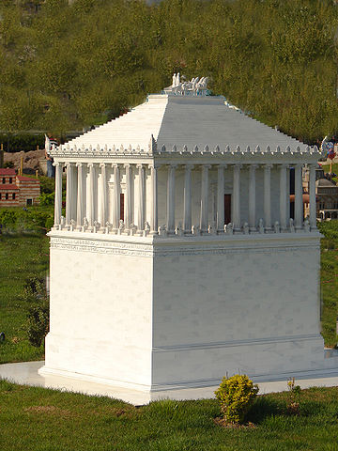
On the top of this section of the tomb thirty-six slim columns, nine per side, rose for another third of the height. Standing between each column was a statue. Behind the columns was a solid cella-like block that carried the weight of the tomb's massive roof. The roof, which comprised most of the final third of the height, was pyramidal. Perched on the top was a quadriga: four massive horses pulling a chariot in which rode images of Mausolus and Artemisia.

Scale model of the Mausoleum at Miniatürk, Istanbul

- Find the English equivalent in the text to the next word.

- Могила
- Приблизно
- Мармур
- Жінки-войовниці
- Чудовий
- Гавань
- Сторожова вежа
- Розбите серце
- Повстали
- Війська
- Висадка
- Щебінь

Keys: 1. The tomb 2. Approximately 3. Marble 4. Warrior women 5. Magnificent 6. Harbor 7. Watchtower 8. Broken-heart 9. Rebelled 10. Troops 11. Disembark 12. Rubble

- Read the text and decide if the statements are T (True) or F (False).

- The Tomb of Maussollos was a tomb built between 353 and 350 BC at Halicarnassus.
- In 624 BC, Halicarnassus was the capital of a small regional kingdom in the coast of Asia Minor.
- In 353 BC Mausolus died, leaving Artemisia broken-hearted.
- The construction was also so beautiful and unique it became one of the Seven Wonders of the Ancient World.
- Artemisia lived for only four years after the death of her husband.
- The urns with their ashes were placed in the yet unfinished tomb.
- The tomb was erected on a hill overlooking the village.
- At the center of the courtyard was a wood platform on which the tomb sat.
- At the centre of the platform, the marble tomb rose as a square tapering block to one-third of the Mausoleum's 45-meter (135-foot) height.
- On the top of this section of the tomb thirty-seven slim columns, nine per side, rose for another third of the height.

Keys: 1. T 2.F 3.T 4.T 5.F 6.T 7.F 8.F 9.T 10.F

Lighthouse of Alexandria

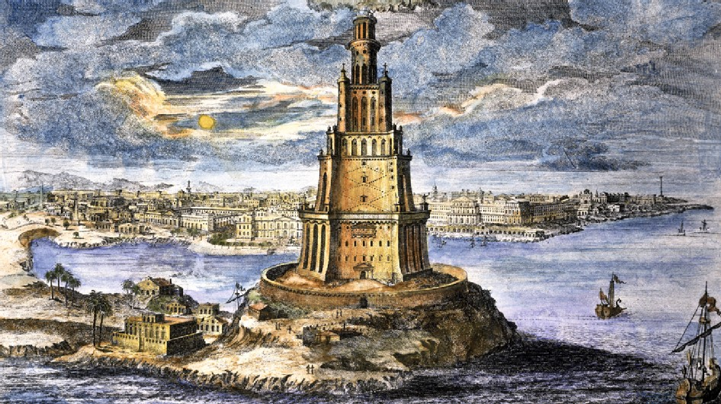
This light house of Alexandria was one of the wonders among all the seven wonders of the world, which was constructed to serve a practical purpose. Besides being a marvelous example of architectural elegance, it ensured a safe return for the sailors to the Great Harbor. The mirror that was mounted at the top of the lighthouse could reflect light more than 35 miles off-shore. The scientists were fascinated by this mysterious mirror.
The Lighthouse of Alexandria was conceived in the early 3rd century BC by the ruler Ptolemy I, an ex-general of Alexander the Great, the conqueror who founded and gave his name to Alexandria. Ptolemy II (the son of Ptolemy I) finished constructing the Lighthouse of Alexandria about 25 years later. This lighthouse was built around 280 BC and was around 134 m in height. This was built in the city of Alexandria. Alexander the Great had seventeen cities named after him. Most of them are no longer in existence except for Alexandria, Egypt. The city needed a mechanism to guide the trade ships into its harbor. Ptolemy started building the lighthouse in 290 B.C. It was completed 20 years later and was the first lighthouse of the world. It was also the tallest building with the exception of the Great Pyramid. In the 10th century A.D., the lighthouse stood about 300 cubits high. That means that the lighthouse stood between 450 to 600 feet. The lighthouse was designed by a man named Sostrates of Knidos. The design of the lighthouse was not similar to the modern slim lighthouse towers. It had three basic structural elements. A rectangular base, an octagonal midsection, and a cylindrical upper section which housed the beacon. It was built in 3 stages, each built on top of the lower. The lowest level was about 200 feet square and had the shape of a huge box. The lighthouse was built on marble blocks. A staircase within the lighthouse led the keepers to the beacon chamber, containing a curved mirror used to project a fire's light into a beam. Ships could detect the beam from the tower at night or the smoke from it could be seen during the day from up to 100 miles away.
For centuries, the Lighthouse of Alexandria (occasionally referred to as the Pharos Lighthouse) marked the harbor, using fire at night and reflecting sun rays during the day. It was even shown on Roman coins, just as famous monuments are depicted on currency today. When the Arabs conquered Egypt, they admired Alexandria and its wealth. The Lighthouse continues to be mentioned in their writings and travelers accounts. An earthquake shook Alexandria in AD 956 but caused little damage to the Lighthouse. It was later in 1303 and in 1323 that two stronger earthquakes considerably damaged the structure. The final blow was dealt by the Egyptian Mamelouk Sultan in AD 1480 when he decided to fortify Alexandria's defense. He built a medieval fort on the same spot where the Lighthouse once stood, using the fallen stone and marble.
Sostrates of Knidos, who designed the lighthouse, wanted to have his name carved on the structure. But Ptollemy II wanted his own name carved instead. Sostrates, being a clever man, first carved his name underneath, concealed it with plaster and then carved Ptolemy II's name. After some time the plaster worn out and his name was revealed. On the virtue of being solidly constructed, the lighthouse survived the assaults of fierce sea storms and many earthquakes for some 1600 years.
Although the Lighthouse of Alexandria did not survive to the present day, it undoubtedly leave an impact in many respects. The monument has been used as a model for many prototypes along the Mediterranean, as far away as Spain. And from a linguistic standpoint, it gave its name -- Pharos -- to all the lighthouses in the world!!

Answer the questions.
- Was the Light house of Alexandria one of the wonders among all the seven wonders of the world?
- When was the Light house of Alexandria built?
- What was the design of the lighthouse?
- Did the Lighthouse of Alexandria survive to the present day?
- When was the final blow dealt?
- How many basic structural elements had the Lighthouse of Alexandria ?
Choose the correct answer.

- The mirror that was mounted at the top of the lighthouse could reflect light more than … off-shore.
- 25 miles
- 35 miles
- 15 miles
- The Lighthouse of Alexandria was conceived in the early 3rd century BC by the ruler..........
- Ptolemy II
- Ptolemy IV
- Ptolemy I
- The lighthouse was built around …………………………………
- 280 BC and was around 134 m in height.
- 280 BC and was around 135 m in height.
- 180 BC and was around 134 m in height.
- Ptolemy started building the lighthouse in 290 B.C. It was completed ………and was the first lighthouse of the world.
- 20 years later
- 15 years later
- 50 years later
- The Lighthouse of Alexandria had…………..
- two basic structural elements
- three basic structural elements
- seven basic structural elements
- For centuries, the Lighthouse of Alexandria marked the harbor, using fire at night and reflecting sun rays during the day.
- water
- oil
- fire
Keys: 1. b; 2. c; 3. a; 4. a; 5. b; 6. c.

