РАЙОННИЙ МЕТОДИЧНИЙ КАБІНЕТ
ВІДДІЛУ ЩСВІТИ ЧИГИРИНСЬКОЇ РАЙДЕРЖАДМІНІСТРАЦІЇ

Чигиринський навчально-виховний комплекс
«Дошкільний навчальний заклад-спеціалізована школа І-ІІІ ступенів №2»
Чигиринської районної ради Черкаської області

Ковальчук Ольга Василівна
Top 5 universities
in the world


CHYHYRYN 2018

Ковальчук О.В.. «Топ 5 університетів світу» - Чигирин, 2018.- 16с.

Автор:
Ковальчук Ольга Василівна вчитель англійської мови Чигиринського навчально-виховного комплексу І-ІІІ ступенів №2 Чигиринської районної ради Черкаської області

Рецензенти:
Голінько Л.С., методист районного методичного кабінету відділу освіти Чигиринської райдержадміністрації Черкаської області
Головко С.І., заступник директора з навчально-виховної роботи Чигиринського навчально-виховного комплексу І-ІІІ ступенів №2 Чигиринської районної ради Черкаської області

Посібник складено з метою ознайомлення учнів з різноманітністю університетів світу та використання матеріалу на уроках англійської мови та в позакласній роботі з предмету. Посібник містить збірку текстів із вправами та лексикою на закріплення. Матеріали рекомендовано вчителям англійської мови для використання у роботі з учнями старших класів. Підручник розраховано для учнів 10-11 класів згідно шкільної програми та на основі підручника Калініна Л.С. та Самойлюкевич І.В. для поглибленого вивчення англійської мови.

Схвалено рішенням методичної ради
Чигиринського навчально-виховного комплексу «Дошкульний навчальний заклад – спеціалізована школа І-ІІІ ступенів № 2»
Протокол 3 від 02.03.2018 року

CONTENT
- Introduction………………………………………………………... 4
- Top 5 universities in the world
1. University of Oxford………………………………………………. .5
2. California Institute of Technology………………………………… .7
3. Stanford University……………………………………………….... 8
4. University of Cambridge…………………………………………… 9
5. Harvard University ………………………………………………… 11
III. Exercises to the texts……………………………………………… 12
IV. Vocabulary ……………………………………………………….. 15
IV. Literature …………………………………………………………. 16

Introduction

What are the benefits of studying at a university?

In general, it’s easier to find a job if you have a university degree. You can also have other benefits in areas such as salary and personal development. It’s hard to say if you’ll make more money if you decide to pursue university studies as there are many other factors at play. Some jobs require quite a few years of study, but don’t offer a high salary. Looking at the averages, however, it becomes clear that a university education is of benefit.
Looking at the big picture, it’s easier to get a job if you have a higher education degree. Many careers that require a degree also pay a better salary. This can vary depending on the degree subject, but more doors will be open to you with a degree than without one.
There are other reasons other than economic for studying at the higher education level. For example, in addition to facts about a subject you can learn:
- how to on your own discover and apply new knowledge
- how to understand complex contexts and solve problems
- to develop critical thinking and questioning
- something new in the subject area

University rankings can focus on many different factors, including attractiveness of campus, satisfaction of students and alums, extracurricular benefits (such as top athletics programs), affordability of tuition, and expected income of graduates.

But if the focus is on academic prestige, scholarly excellence, and intellectual horsepower, this article provides the ranking you want. At the universities in this ranking, you’ll be rubbing shoulders with the brightest faculty and students in the world, developing your knowledge and skills so that you yourself will be in a position to join the world’s elite academics, scientists, and thinkers.

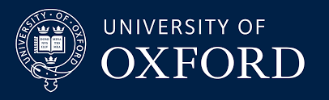

There's a reason why Oxford is the world's most famous university, and it's not because of the nice old buildings or pretty countryside. It's not even because we wrote the English dictionary. It's because you'll find here the best academics, widest range of resources and the finest cohort of fellow students anywhere in the world. Oxford students come from more than 140 countries.
Oxford University is world-famous for academic excellence. We pick the best and brightest students purely on their academic merit and passion for their chosen course. If that sounds like you, and you like to think for yourself, Oxford could be the right university for you.
The University of Oxford offers a unique experience to graduate students, including the opportunity to work with leading academics and with some of the very best libraries, laboratories, museums and collections worldwide. This website is designed for those seeking admission for graduate study in 2018-19.
Oxford’s Department for Continuing Education runs over 1000 courses per year, offered on a part-time basis. Programmes include Oxford awards and degrees at undergraduate and postgraduate level, online short courses, weekly classes, day and weekend events, continuing professional development and summer schools.
Over 50 undergraduate and postgraduate Oxford qualifications: certificates, diplomas, advanced diplomas, Master's and Doctoral degrees, offered part-time, in the arts, social sciences, diplomatic studies, human rights law, health care and biomedical sciences. Many recruit internationally. Course duration ranges from one year to several years part-time. The Department also runs a Graduate School to provide the support and guidance needed by those following part-time graduate programmes.
Approximately 500 part-time accredited classes, open to all, and held in Oxford, Reading and other locations. Topics are studied in depth over a period of 10 or 20 weeks.
Courses of 1 or 2 days duration, usually held at weekends and taught by lecturers and speakers who are noted authorities in their field of research. Many courses are offered in conjunction with national or ganisations. Over 150 offered per year.
200 courses per year, ranging from day schools to short refresher courses to full degree programmes. Subjects include health sciences, public policy, diplomatic studies, nanotechnology, electronics, historic conservation, environmental sciences, public administration, higher education leadership and more.
Education costs £10,000 - £14,000 per year.
Known people who studied in Oxford

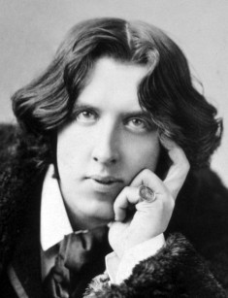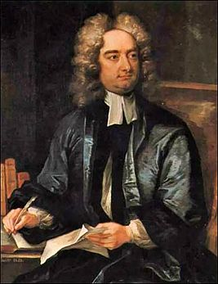
Oscar Wilde Margaret Thatcher Jonathan Swift


California institute of Technology
The California Institute of Technology is a private doctorate-granting university located in Pasadena, California, United States.
Although founded as a preparatory and vocational school by Amos G. Throop in 1891, the college attracted influential scientists such as George Ellery Hale, Arthur Amos Noyes and Robert Andrews Millikan in the early 20th century. The vocational and preparatory schools were disbanded and spun off in 1910 and the college assumed its present name in 1921. In 1934, Caltech was elected to the Association of American Universities and the antecedents of NASA's Jet Propulsion Laboratory, which Caltech continues to manage and operate, were established between 1936 and 1943 under Theodore von Kármán. The university is one among a small group of institutes of technology in the United States which is primarily devoted to the instruction of technical arts and applied sciences.
Caltech has six academic divisions with strong emphasis on science and engineering, managing $332 million in 2011 in sponsored research. Its 124-acre (50 ha) primary campus is located approximately 11 mi (18 km) northeast of downtown Los Angeles. First-year students are required to live on campus and 95% of undergraduates remain in the on-campus House System at Caltech. Although Caltech has a strong tradition of practical jokes and pranks, student life is governed by an honor code which allows faculty to assign take-home examinations. The Caltech Beavers compete in 13 intercollegiate sports in the NCAA Division III's Southern California Intercollegiate Athletic Conference.
Caltech is frequently cited as one of the world's best universities. Caltech alumni and faculty include 34 Nobel Prizes (Linus Pauling being the only individual in history to win two unshared prizes), 1 Fields Medalist, 6 Turing Award winners, 4 Chief Scientists of the U.S. Air Force and 71 have won the United States National Medal of Science or Technology. There are 112 faculty members who have been elected to the United States National Academies. In addition, numerous faculty members are associated with the Howard Hughes Medical Institute as well as NASA. According to a 2015 Pomona College study, Caltech ranked number one in the U.S. for the percentage of its graduates who go on to earn a PhD. Education costs 42 000 $ per year.

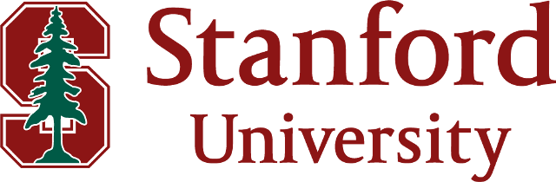
The third best university in the world according to our latest rankings, Stanford University ranks among the top five universities in the world across all QS subject areas:
- Art and humanities
- Engineering and technology
- Life sciences and medicine
- Social sciences and management
- Natural sciences
Stanford University is a private institution that was founded in 1885. It has a total undergraduate enrollment of 7,034, its setting is suburban, and the campus size is 8,180 acres. It utilizes a quarter-based academic calendar. Stanford University's ranking in the 2018 edition of Best Colleges is National Universities, 5. Its tuition and fees are $49,617.
In 1885, Jane and Leland Stanford established Stanford University in memory of their son, Leland Junior. Their intent was to establish a "University of high degree" that would "qualify students for personal success and direct usefulness in life and promote the public welfare by exercising an influence on behalf of humanity and civilization." Today, Stanford is a research university where teaching, learning and research are integral to the university's mission.
Stanford follows a quarter system with Autumn quarter usually starting in late September and Spring Quarter ending in early June. The full-time, four-year undergraduate program has an arts and sciences focus with high graduate student coexistence. Stanford is accredited by the Western Association of Schools and Colleges.
Stanford is one of the most successful universities in creating companies and licensing its inventions to existing companies; it is often held up as a model for technology transfer. Stanford's Office of Technology Licensing is responsible for commercializing developments. Education costs 45 921$ per year.
University of Cambridge

The University of Cambridge (informally Cambridge University) is a collegiate public research university in Cambridge, England. Founded in 1209 and granted a royal charter by King Henry III in 1231, Cambridge is the second-oldest university in the English-speaking world and the world's fourth-oldest surviving university. The university grew out of an association of scholars who left the University of Oxford after a dispute with the townspeople. The two medieval universities share many common features and are often referred to jointly as "Oxbridge".
Cambridge is formed from a variety of institutions which include 31 constituent colleges and over 100 academic departments organised into six schools. Cambridge University Press, a department of the university, is the world's oldest publishing house and the second-largest university press in the world. The university also operates eight cultural and scientific museums, including the Fitzwilliam Museum, as well as a botanic garden. Cambridge's libraries hold a total of around 15 million books, eight million of which are in Cambridge University Library, a legal deposit library.
Examination in mathematics was once compulsory for all undergraduates studying for the Bachelor of Arts degree, the main first degree at Cambridge in both arts and sciences. From the time of Isaac Newton in the later 17th century until the mid-19th century, the university maintained an especially strong emphasis on applied mathematics, particularly mathematical physics. The exam is known as a Tripos. Students awarded first-class honours after completing the mathematics Tripos are termed wranglers, and the top student among them is the Senior Wrangler. The Cambridge Mathematical Tripos is competitive and has helped produce some of the most famous names in British science, including James Clerk Maxwell, Lord Kelvin and Lord Rayleigh. However, some famous students, such as G. H. Hardy, disliked the system, feeling that people were too interested in accumulating marks in exams and not interested in the subject itself.
As an institution with such a long history, the university has developed a large number of myths and legends. The vast majority of these are untrue, but have been propagated nonetheless by generations of students and tour guides.
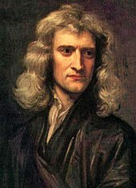
A discontinued tradition is that of the wooden spoon, the 'prize' awarded to the student with the lowest passing honours grade in the final examinations of the Mathematical Tripos. The last of these spoons was awarded in 1909 to Cuthbert Lempriere Holthouse.
Known people who studied in Cambridge

Sir Isaac Newton was a student of the University

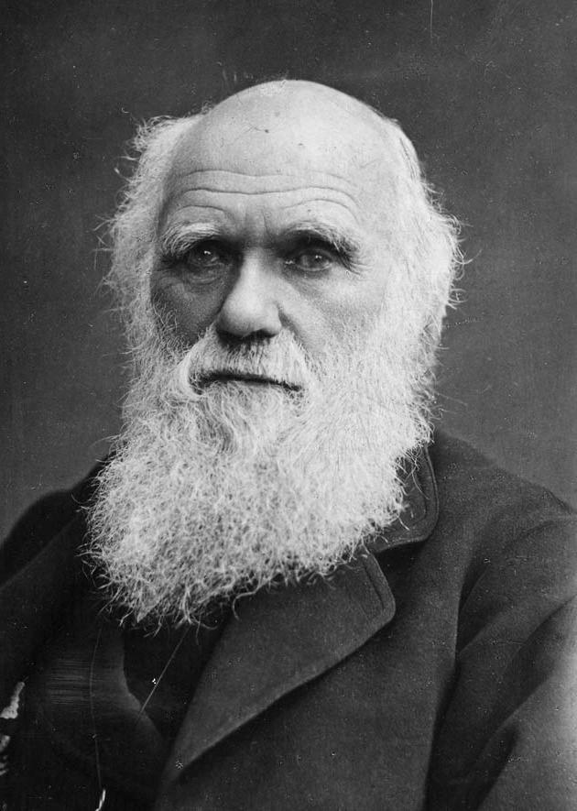Charles Darwin was a student of the University

 Hugh Laurie was a student of the University

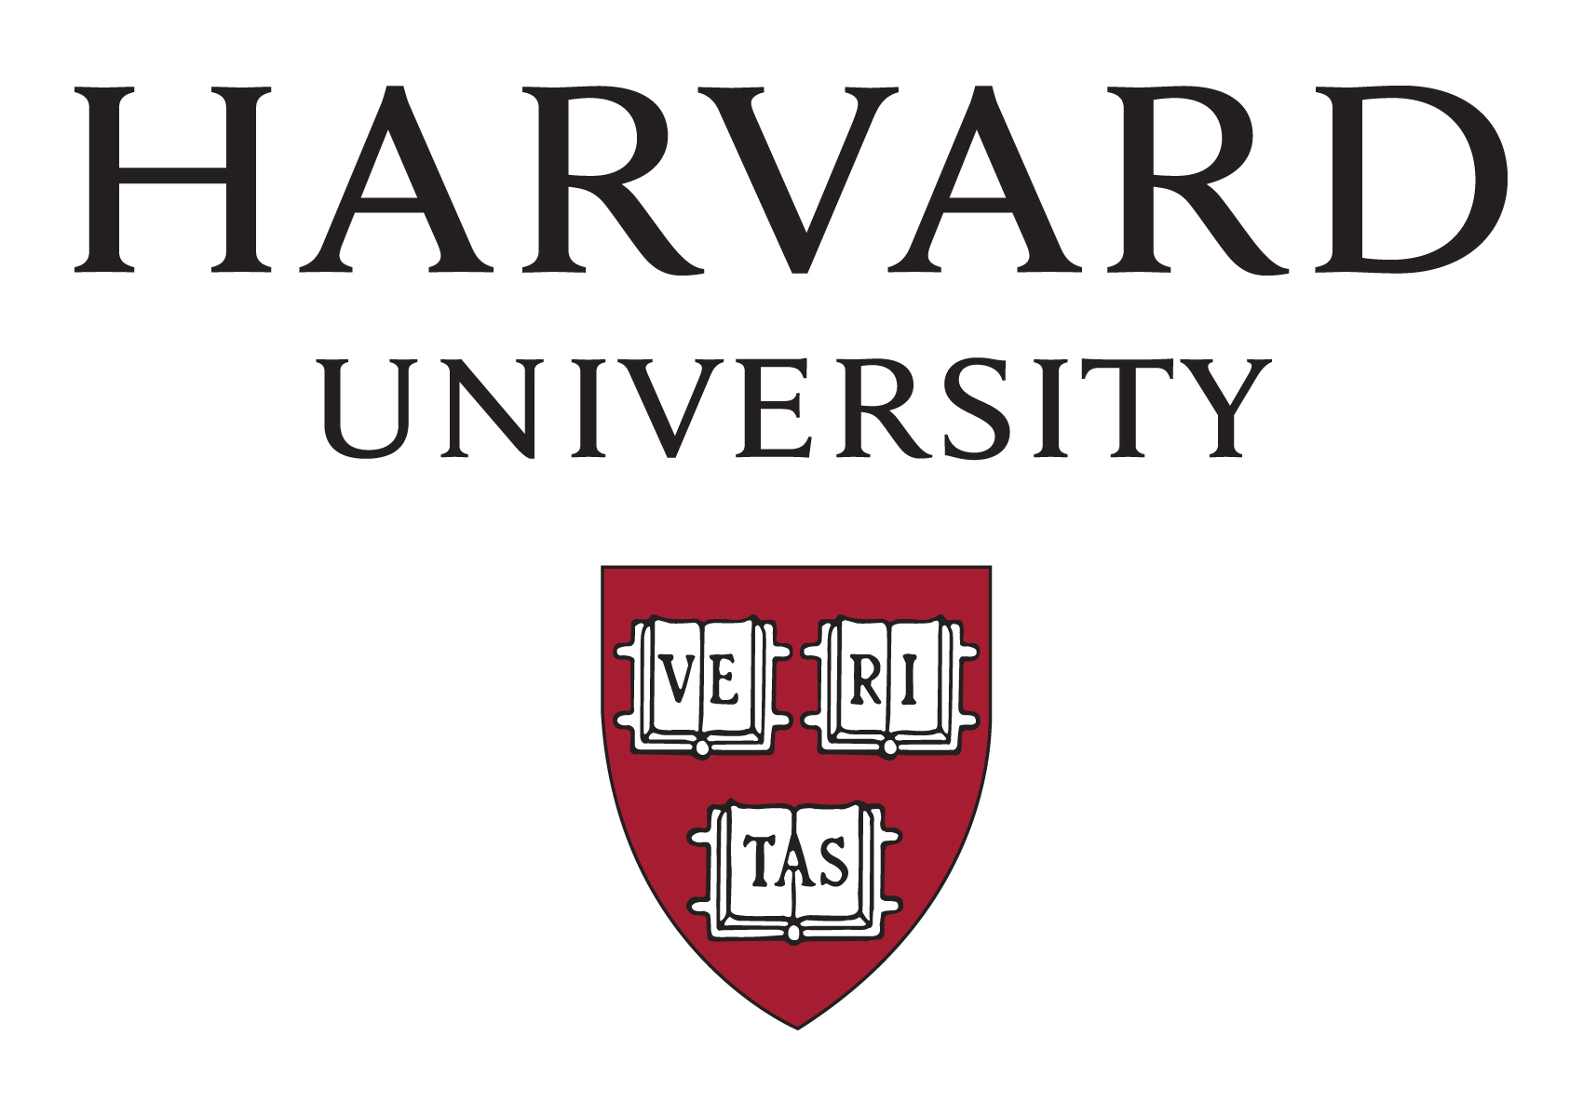
Harvard University, oldest institution of higher learning in the United States (founded 1636) and one of the nation’s most prestigious. It is one of the Ivy League schools. The main university campus lies along the Charles River in Cambridge, Massachusetts, a few miles west of downtown Boston. Harvard’s total enrollment is about 20,000.
Harvard’s history began when a college was established at New Towne, which was later renamed Cambridge for the English alma mater of some of the leading colonists. Classes began in the summer of 1638 with one master in a single frame house and a “college yard.” Harvard was named for a Puritan minister, John Harvard, who left the college his books and half of his estate.
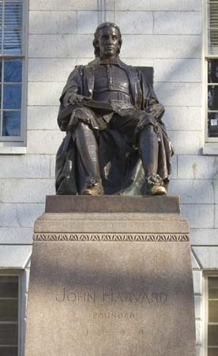
Harvard, John
John Harvard, sculpture by Daniel Chester French; in front of University Hall, Harvard University, Cambridge, Massachusetts.
Exercises
Task 1. Match the words with their definitions:
1. antecedents a. жителі
2. townspeople b. зарахування
3. jointly c. минуле
4. coexistence d. благополуччя
5. welfare e. спільно
6. enrollment f. співіснування
Keys: 1. c: 2. a; 3. e; 4. f; 5. d; 6. b.
Task 2. Put the statements (A-F) in the correct order according to what the text says. (University of cambridge)
- Examination in mathematics was once compulsory for all undergraduates studying for the Bachelor of Arts degree, the main first degree at Cambridge in both arts and sciences.
- The University of Cambridge (informally Cambridge University) is a collegiate public research university in Cambridge, England.
- From the time of Isaac Newton in the later 17th century until the mid-19th century, the university maintained an especially strong emphasis on applied mathematics, particularly mathematical physics.
- Cambridge is formed from a variety of institutions which include 31 constituent colleges and over 100 academic departments organised into six schools.
- The Cambridge Mathematical Tripos is competitive and has helped produce some of the most famous names in British science.
F. Some famous students, such as G. H. Hardy, disliked the system, feeling that people were too interested in accumulating marks in exams and not interested in the subject itself.
1 | 2 | 3 | 4 | 5 | 6
Keys: 1.B; 2.D; 3.A; 4.C; 5.E; 6.F.

Task 3. Read the statements and decide if they True or False according to what the texts say. (California institute of Technology)
- The California Institute of Technology is a private doctorate-granting university located in New York.
- The vocational and preparatory schools were disbanded and spun off in 1910.
- The university is one among a small group of institutes of technology in the United States.
- First-year students are required to live in a privet flat.
- Caltech is frequently cited as one of the world's best universities.
- There are 100 faculty members who have been elected to the United States National Academies.
Keys: 1. F; 2. T; 3. T; 4. F; 5. T; 6. F.
Task 4. Spell the jumbled words from the text correctly.
- Harvard’s total lroenelmtn is about 20,000. (enrollment)
- Oxford University is world-famous for academic lencelexec. (excellence)
3. The vast yojamitr of these are untrue, but have been propagated nonetheless by snegortaein of students and tour guides.( majority, generations )
4. Stanford University is a vpeirat institution that was founded in 1885. (private)
5. Stanford is one of the most ucsesucsfl universities. (successful)
6. The exam is known as a pTiros.(Tripos)

Task 5. WRITING TASK
You want to get more information about top universities in the world .
Write a letter of 50-80 words in which you:
- ask your friend to write you some information about famous universities.
- ask him/her about his attitude to some of them.
- invite him/her to visit your country tell him/her about our universities.

Task 6. Write an advice-seeking letter about some famous universities.

Task 7. Your pen friend in England has to write a project on education around the world. She/ He has written to ask you for details about Ukraine. Write a letter to your pen friend, in which you:
- describe the kind of university you go to;
- say how your university is different to other universities;
- explain what you like or dislike about the education system.
Write a letter of at least 150 words. Start your letter in an appropriate way.
Task 8. Suggest how you could complete these sentences.
- It would be good if ______________________________.
- The only complaint I have got is ___________________.
- I love that fact that ______________________________.
- The education system in Ukraine means that___________.
Task 9. Name the University according to the emblem.
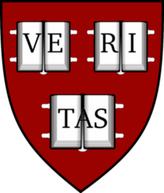

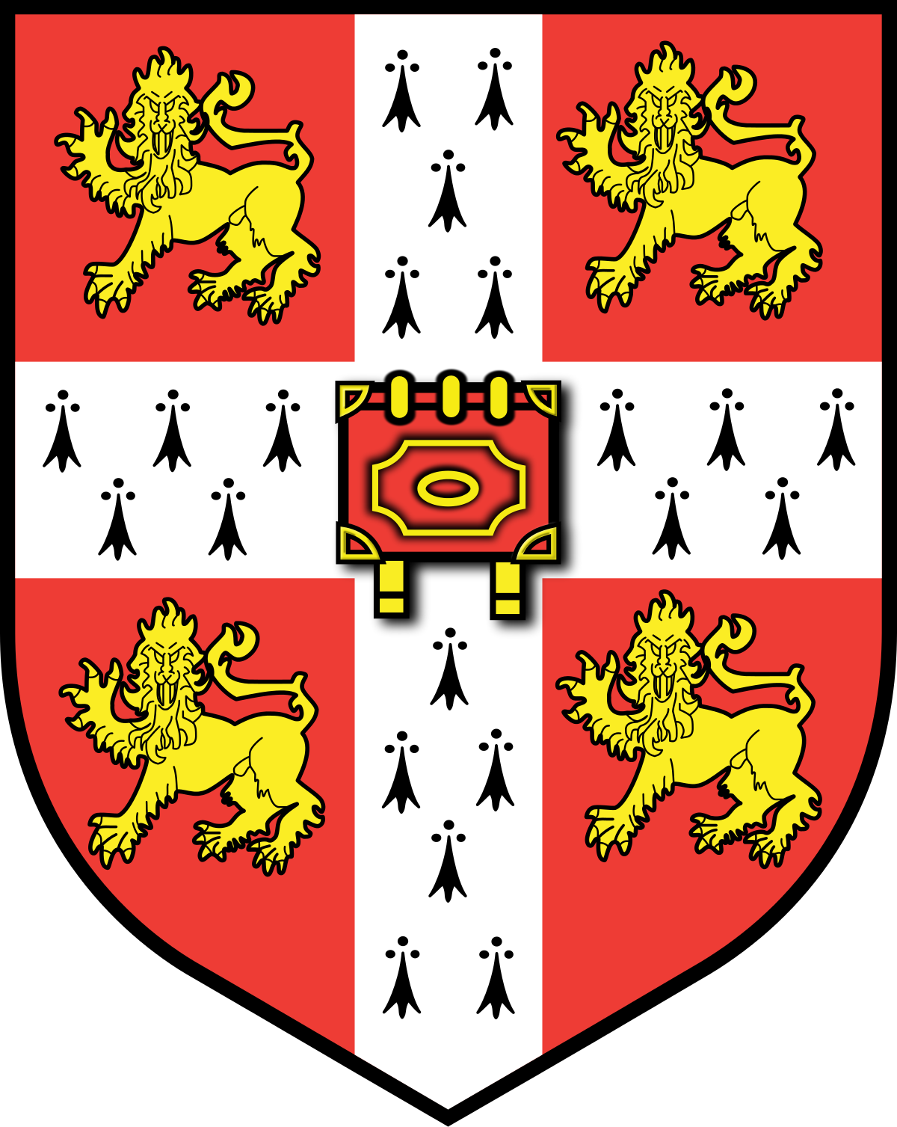

Vocabulary
Text 1
cohort [ ˈkəʊ.hɔːt]- когорта
purely [ˈpjʊəli]- доброчесно
merit [ˈmer.ɪt]- заслуговувати
admission [ədˈmɪʃ.ən]- визнання, впуск, вступ
advanced diplomas [ədˈvɑːnst dɪˈpləʊ.mə] – передовий( прогресивний) диплом
approximately [əˈprɒksɪmətli]- майже, наближенo
Text 2
doctorate [ˈdɑːktərət] – ступінь лікаря
spun off [spʌn ɒf] –розділяти
antecedents [ˌæntəˈsiːdənts] – минуле
alumni [əˈlʌmnaɪ] - випускник
Text 3
enrollment [enˈrolmənt]- зарахування
welfare [ˈwɛlfɛː]- благополуччя
coexistence [kəʊɪɡˈzɪstəns]- співіснування
technology transfer [tɛkˈnɒlədʒi trænsˈfɜː(r)]- обмін технологіями
Text 4
townspeople [ˈtaʊnzpiːp(ə)] – місцеві жителі
jointly [ˈdʒɔɪntli] - спільно
Text 5
Enrollment [enˈrolmənt] –зарахування
“college yard” – подвір’я університету

Список використаної літератури:
- Збірник завдань для підготовки до ЗНО, олімпіад та для роботи з обдарованими учнями з англійської мови. Вижниця: - Черемош, 2013,-408ст.
- New destinations H.Q.Mitchell (mm publications).
- https://www.topuniversities.com
- https://thebestschools.org
- ЗНО. Англійська мова. Типові тестові завдання, Літера, 2015.
- https://www.usnews.com
- Get 200! Book 1 - mm publications. Exam preparation course for Ukraine.
- Калініна Л.В. Англійська мова для спеціаліз.шк. з поглиб. вивч. англ. мови.

