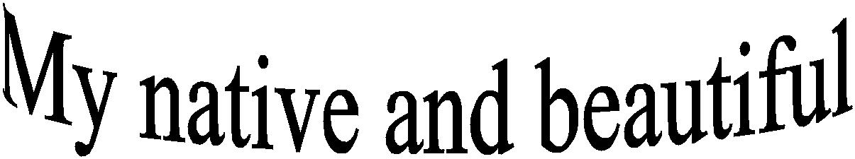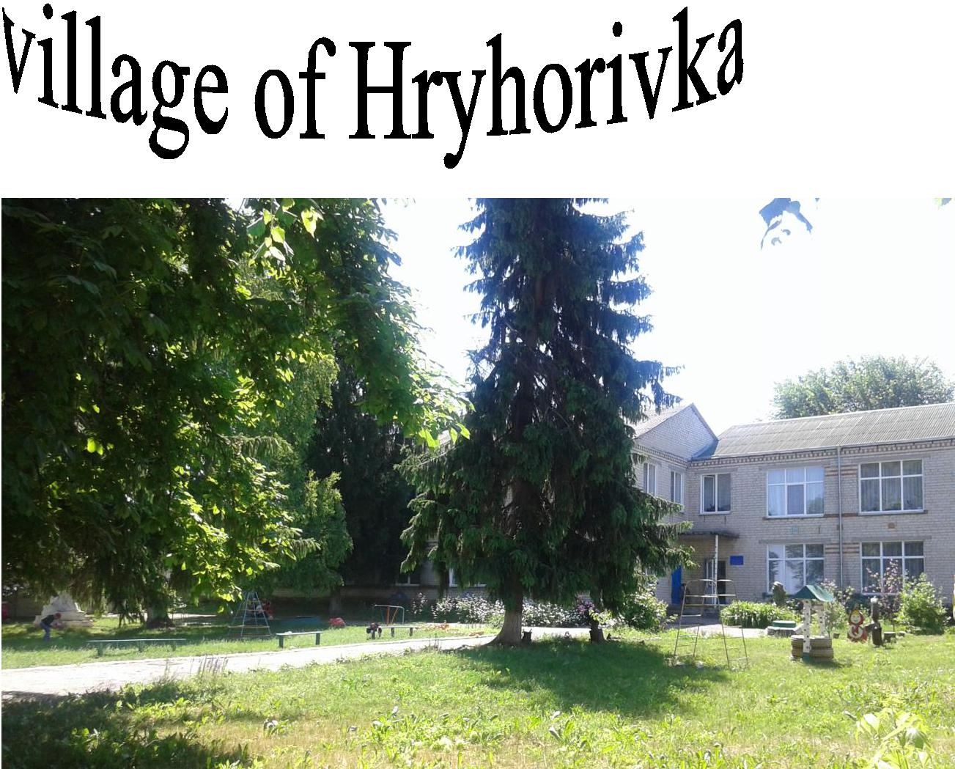

***ENGLISH GROUP “FAIRYLAND” HRYHORIVKA SCHOOL SVITLOVODSK DISTRICT KIROVOGRAD REGION ENGLISH TEACHER: KRYVORUCHKO S. L.***

***МЕТА:*** підвищити рівень володіння англійською мовою серед учнів,сприятиподоланню мовного бар’єру, удосконалювати розмовну мову учнів, поєднати навчання із захоплюючим відпочинком, підвищувати мотивацію для подальшого удосконалення англійської мови.

***THE LIST OF THE PARTICIPANTSOF THE ENGLISH GROUP “FAIRYLAND”***

1. BoklazhukOlha
2. KulynychIryna
3. Kosiachko Diana
4. KlymenkoAnzhela
5. Mostova Victoria
6. Lytvyn Liza
7. VelievaDasha
8. SalamashenkoNazar
9. RiznichenkoValentyn
10. VelychkoDanylo

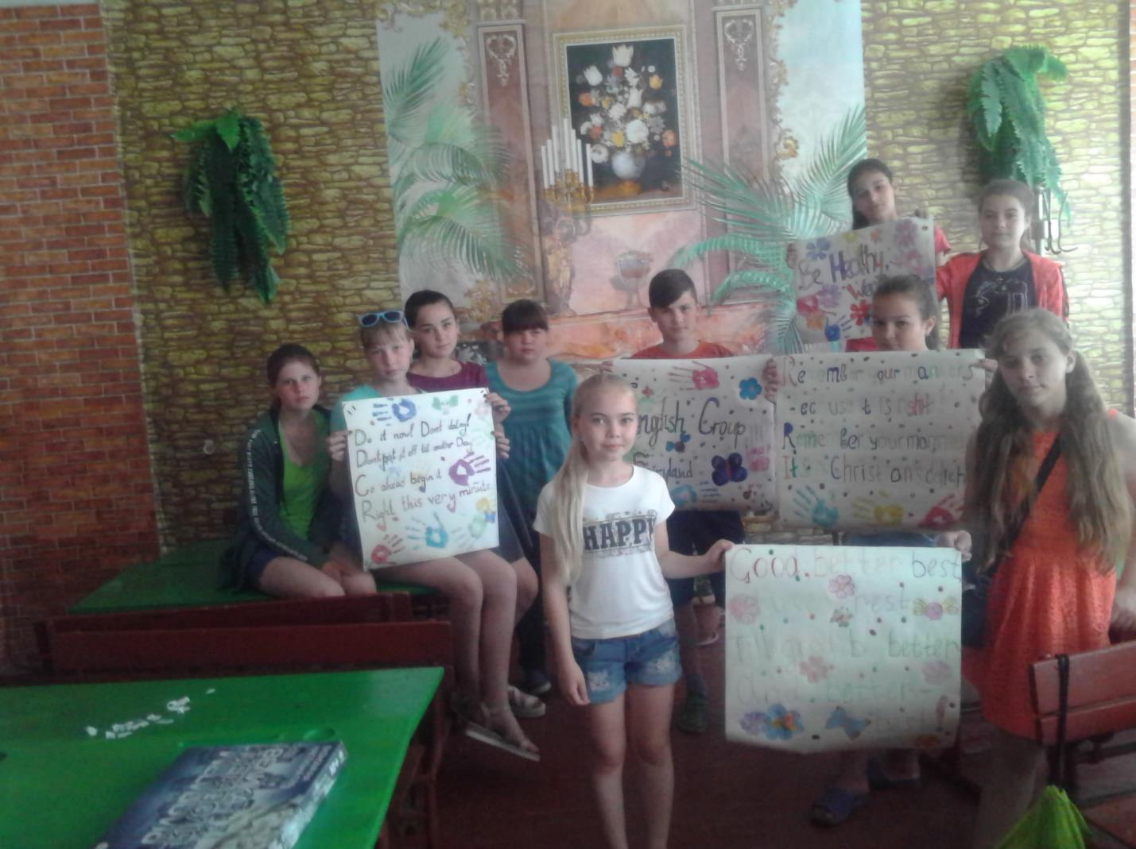

2

***MINDMAP OF THE PROJECT***

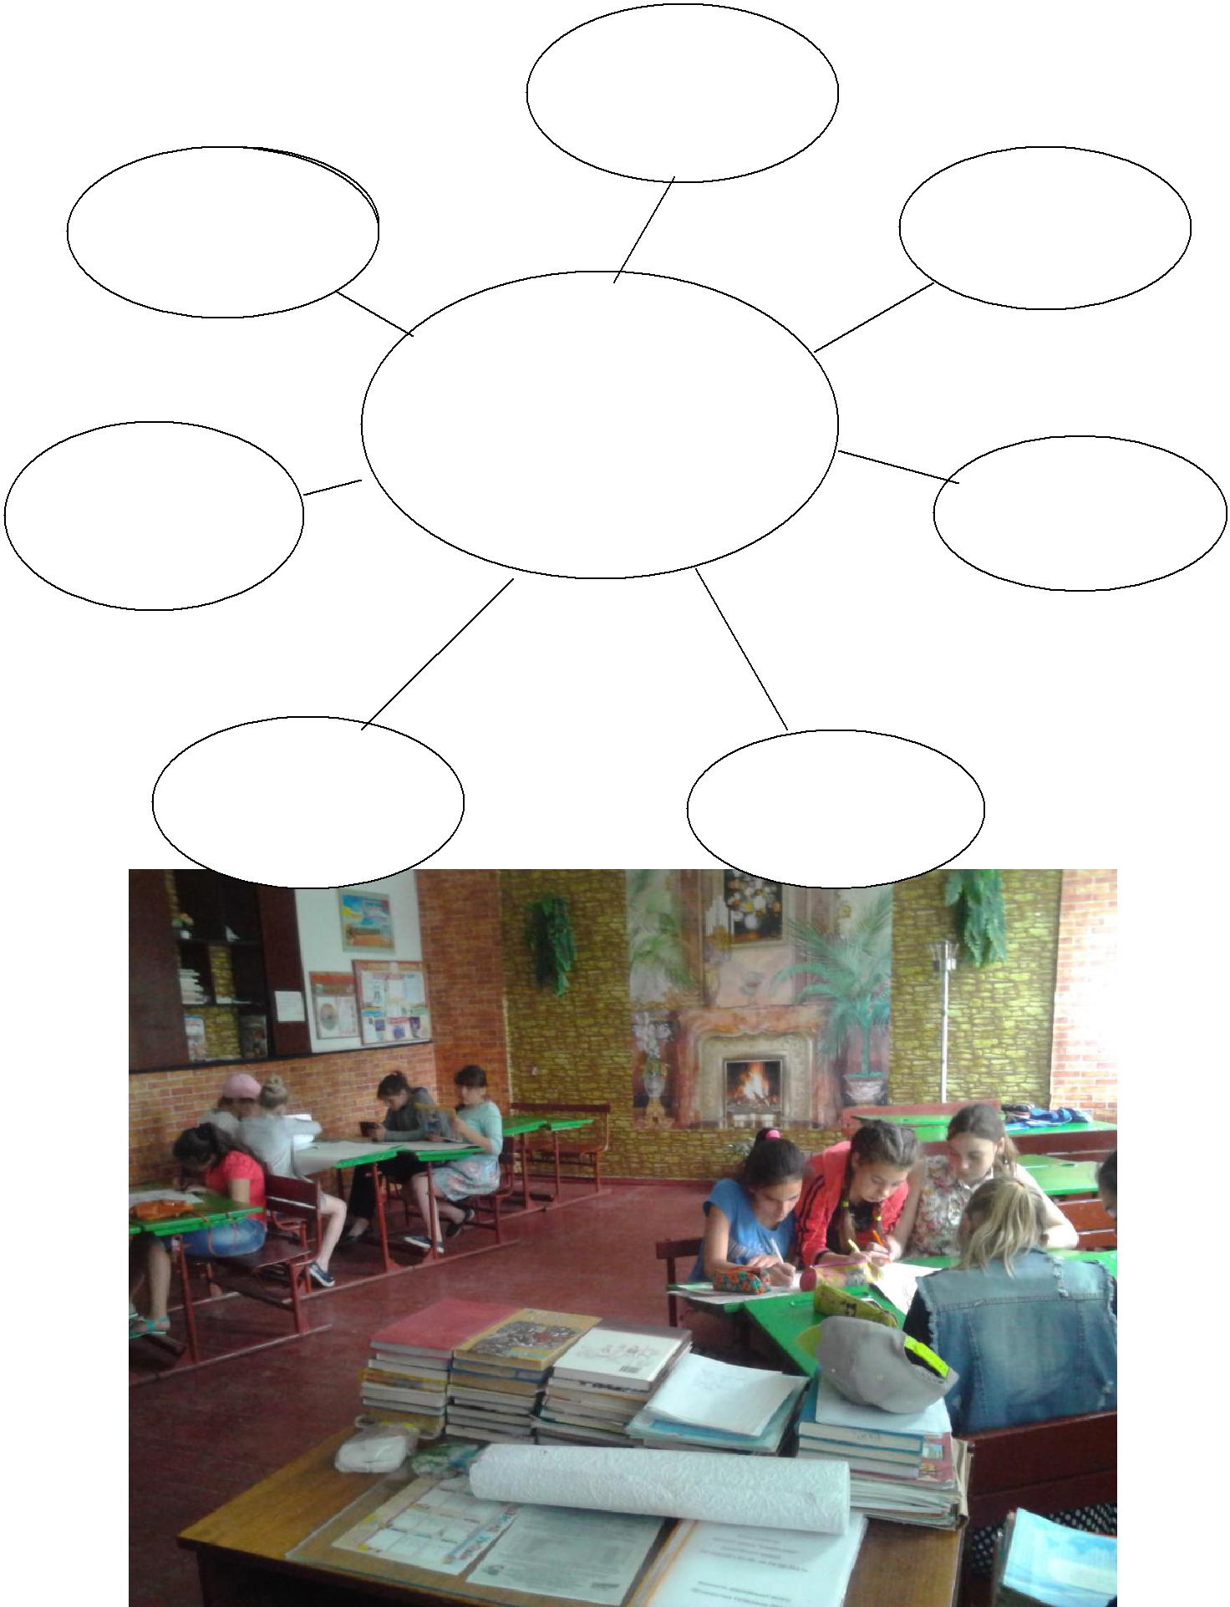

THE FAMOUS

PEOPLE OF THE

VILLAGE

THE HISTORY

OF THE VILLAGE

MY NATIVVE AND

BEAUTIFUL

THE VILLAGE VILLAGE OF HRYHORIVKA

SCHOOL

|  |  |  |
| --- | --- | --- |
| THE NATURE | THE LOCAL |  |
|  |  |
| OF THE VILLAGE | FESTIVALS |  |
|  |  |

3

THE LOCAL

AUTHORITY

CULTURE

***INTRODUCTORY***

We want to tell you about our native and beautiful village of Hryhorivka. Our village is situated in the central part of Ukraine, in Svitlovodsk District of Kirovograd Region. It is not big but it is nice, picturesque and cosy.

In the center of the village there is a small square with some shops and cafes near it. The building of the local authority is on the other side, opposite the village club.

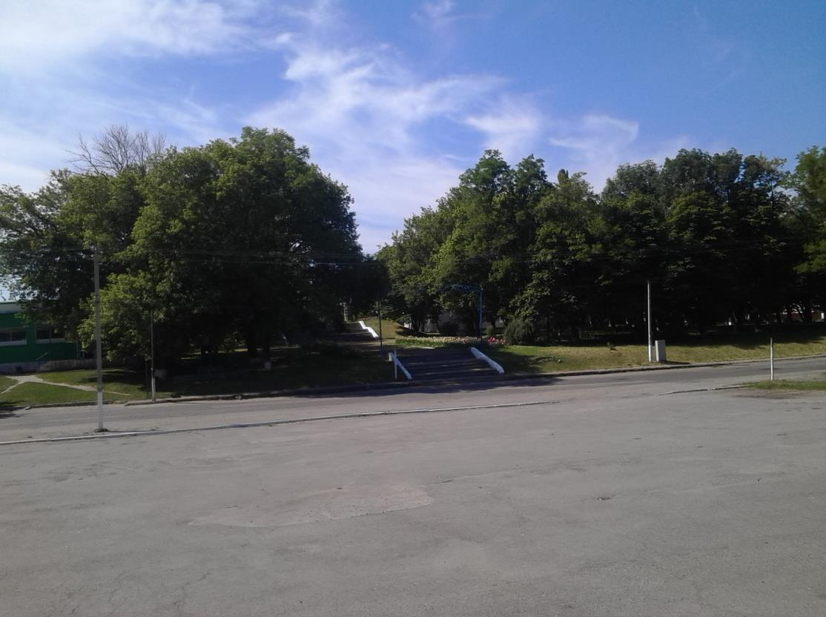

The houses in Hryhorivka are tidy and nice. Some of them have got two floors. There is gas, cold and hot water in many houses.

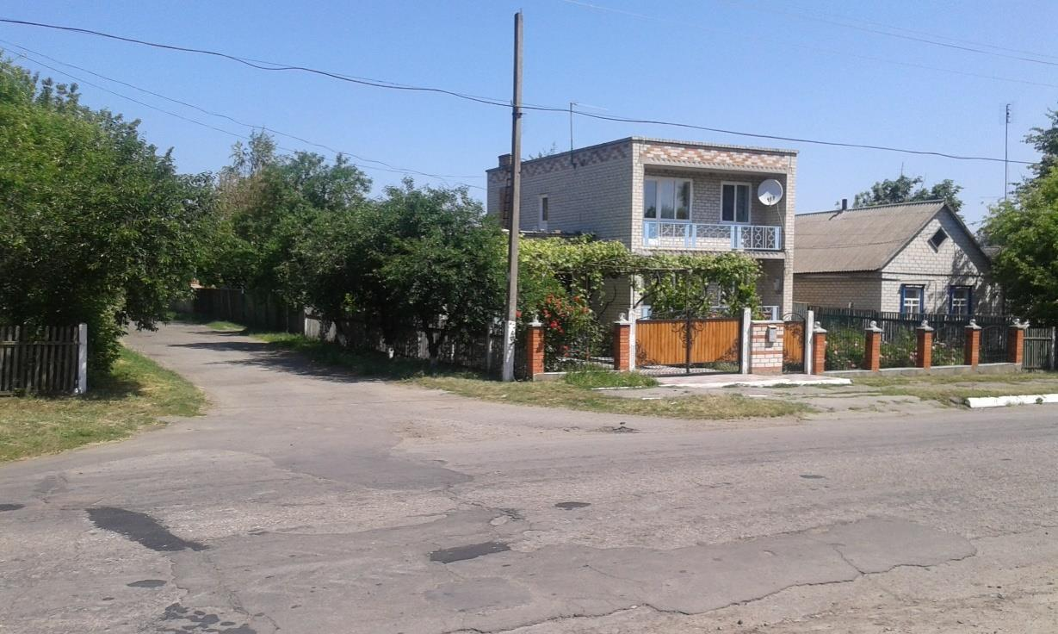

4

There are a lot of trees in the gardens and lots of flowers and lawns along the streets. The traffic is not heavy in the village.

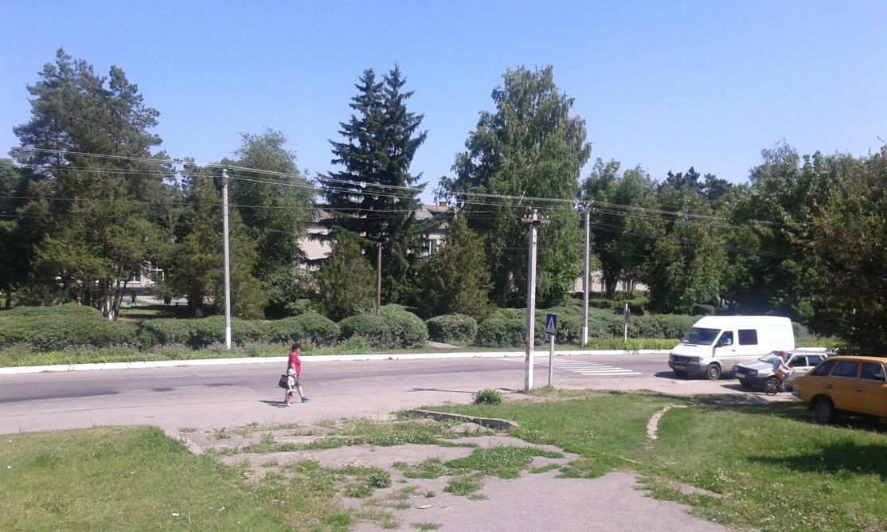

***THE HISTORY OF THE VILLAGE OF HRYHORIVKA***

The village of Hryhorivkahas got the rich and colorful history. In the Cossack times the lands of the modern village of Hryhorivkawere not settled. There was only the Cossack observing tower there. It was situated on the hill--the highest point of Hryhorivka. It is named “Shpyl” now. In the cases of Turkish invasions the fire was burnt on the top of the tower, which was seen in Chyhyryn.

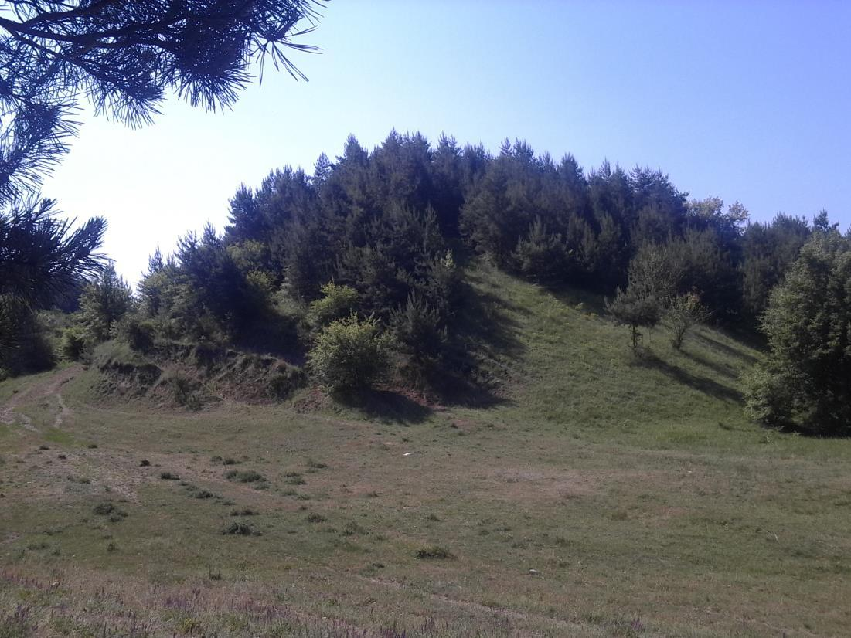

5

The first facts about our village were mentioned in the written documents of the 18th century.In those times the village was named Popivka-Lastuhino. The people were resettled from Sambrosovka. The lands of the village were granted to the priest Leontiy in 1720. Since that time those fertile lands were passing to the different owners. In 1766-1767 those lands belonged to the major Angelov and the widow of the captainPopovych. The new church was founded in the village Popivka-Lastuhino in 1785 and it was named after St. Nicholas.

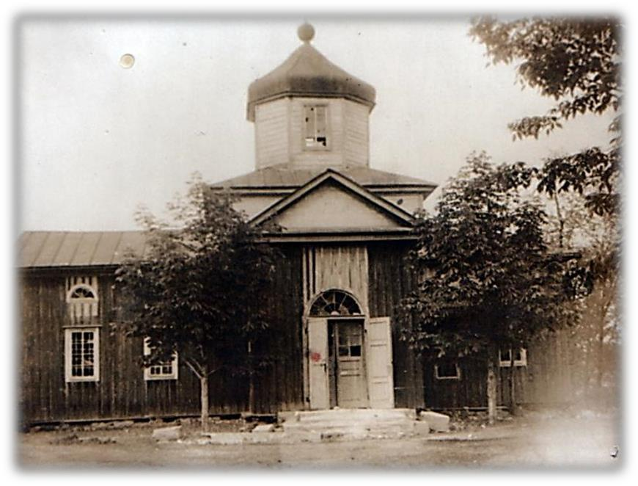

According to the records of 1858 there were 79 yards with 559 inhabitants in the village of Hryhorivka andit had got two landowners. But in 1886 there were 169 yards and the population of the village was 950 people. The centre of the village life was the church of St. Nocholas. In 1880s the receipts of the church was more than 2000 people, including the inhabitants from the small farmsteads such as Kahovo, Yaremivka, Kobzarivka, Perehrestivka,

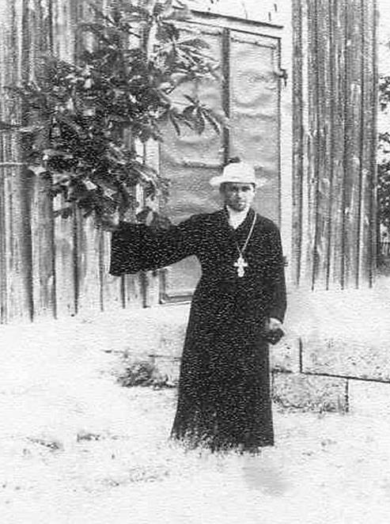

Sakinovka,Zenfironka, Chernikovka, Novo-Fedorivka, whichvisited the church too.

The life of the peasants was hard, poor and miserable. They had been working for 12-16 hours a day for their masters. After the revolution of 1917 the peasants received their long-waited pieces of land and began to work for their families. But then the Soviet Government began to force the peasants to unite into the collectively-working organizations which were named collective farms.

6

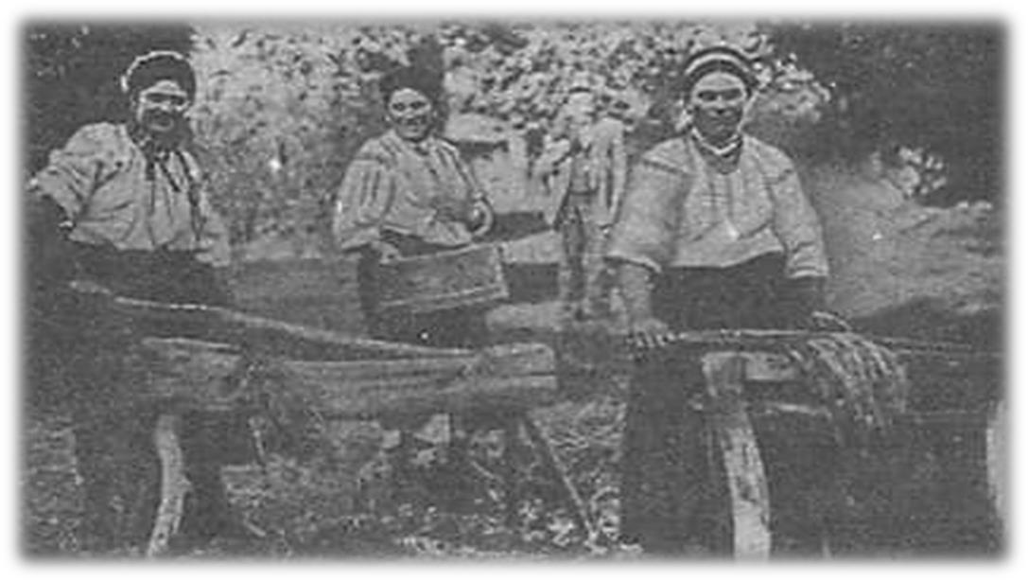

In 1923 the first Young Communist Cell and the first Communist Party Cell were formed in the village. In 1924-1928the common tillage of land was organized in the villages of Hryhorivka and Antonivka.In 1930 three small collective farms were formed in Hryhorivka. But they were very weak and poor economically. And in 1953 the large collective farm was formed. The construction of the new agricultural and social buildings began on the territory of the village of Hryhorivka.

The hungry years of 1932 and 1933 were the awful and terrible period for the inhabitants of Hryhorivka so as for the whole Ukrainians. There is not the exact number of the people dead of hunger. But according to the previous data the names of 194 people were established. They were men, women and children. These sad years will be never forgotten.

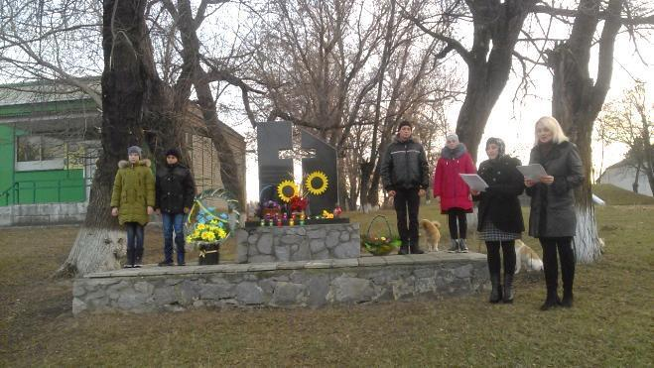

7

During the Second World War the territory of Hryhorivka village council was occupied by the fascist invaders fromthe 6th of August 1941 till the 7th of December 1943. Our 516

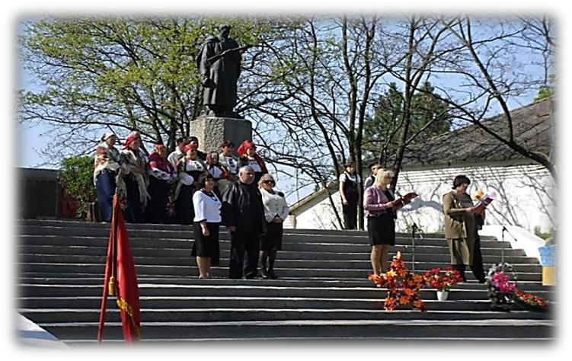

countrymen defended our Motherland. 400 of them didn’t come back home. But we remember our heroes.

During the period of the

Independence of Ukraine Hryhorivka has become the example of the modern European prosperous and rich village.

***THE LOCAL AUTHORITY***

The life, the prosperity and the well-being of the village depend first of all upon the local authority. Till March 1923 all the small communities on the territory of the village council of Hryhorivka belonged to HlynskVolost. In 1923Hlynsk District was formed and Hryhorivka was a part of it.

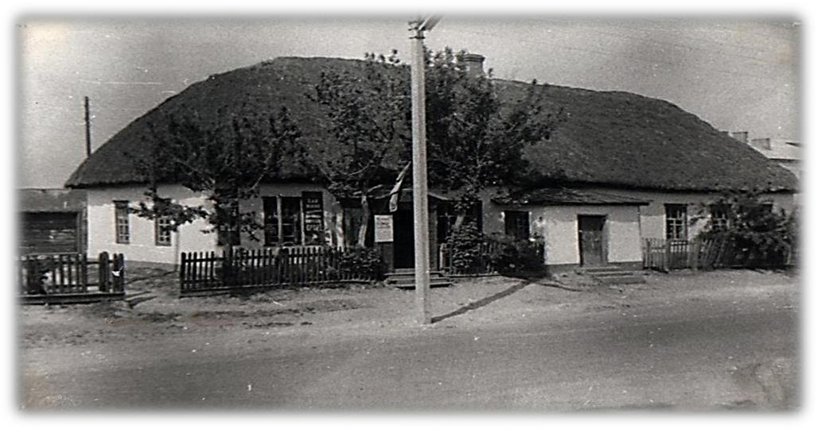

In 1932

after the liquidation of Hlynsk District Novoheorhiivs

k District appeared and

in 1939 Kirovograd

Region was

formed. Since

that time there were many heads of the village council. All of them did and tried to do their best for the prosperity and the enrichment of the village. This is the list of these honorable people: Bulaienko Ivan Klymovych, PetrovaOlexandraSavelievna, Hrebeniuk Ivan Artemovych, Volovyk Ivan Romanovych, Miroshnyk Ivan

Savych,HavrylenkoMykhailoKindratovych, YepikFedirPylypovych, AndruschenkoVasylOlexiyovych.

8

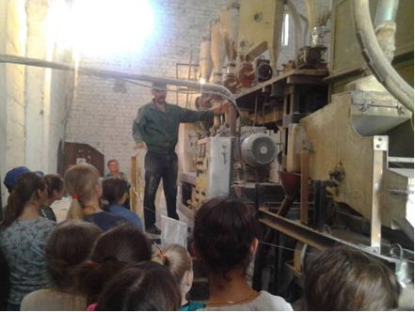Such villages as

Yaremivka,

Kobzarivka,

Ovragovo,

Perehrestivka belong

to Hryhorivka Village

Council. On its territory there is a school, a club, a library, a kindergarten, a club-library (in

Yaremivka), three medical dispensaries (in the villages of

Hryhorivka, Yaremivka, Ovragovo), a post office, a vet station and the St. Nicholas Church. There are many private agricultural enterprises on the territory of Hryhorivka Village Council too.

***Nowadays the head of Hryhorivka Village Council is Nadia***

***MykolaivnaNevkryta.***

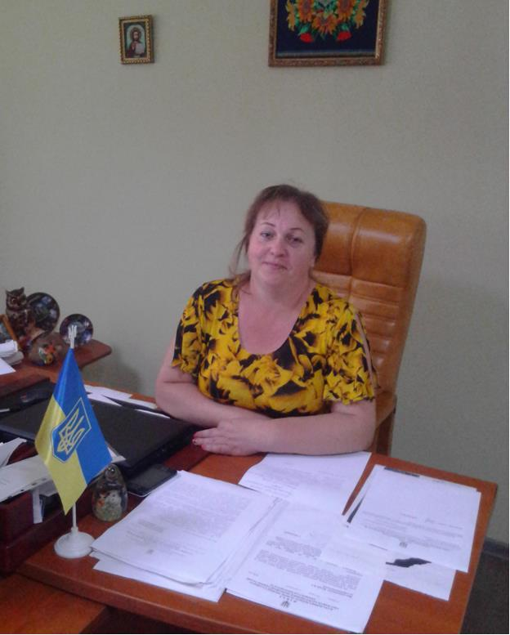

9

This strong and fair woman rules the village affairs skillfully. She co-operates with the local farmers and businessmen and draws them to the socially active life of the village. Besides she helps our school to solve the different points of our everyday school life, she draws the sponsors while repairing and renovating the school or organizing the excursions for our schoolchildren.

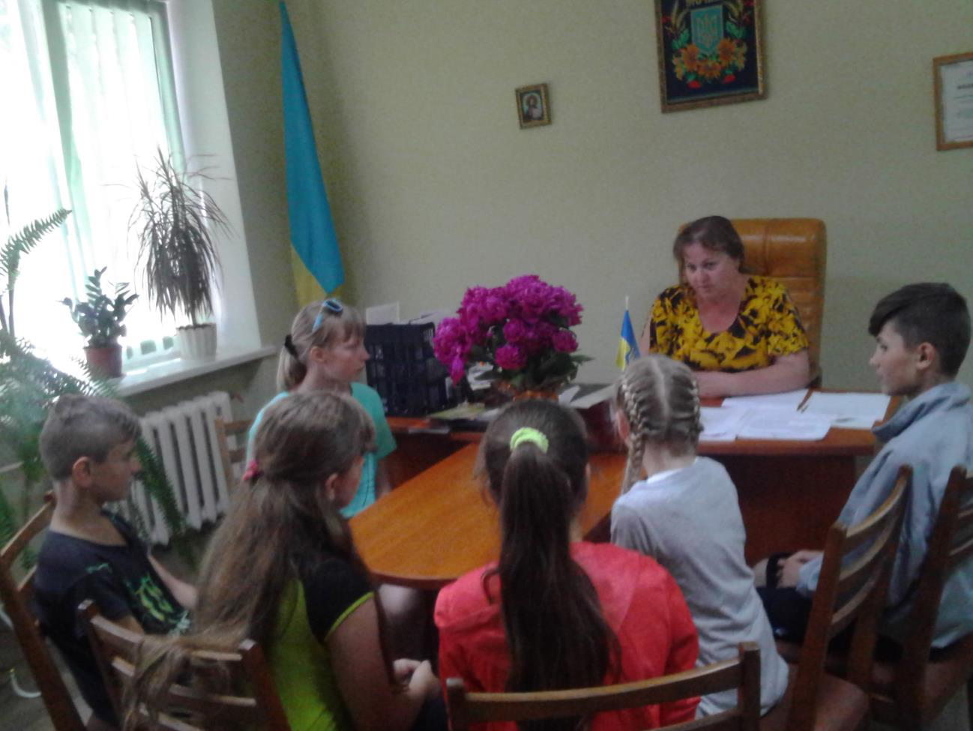

***THE NATURE OF OUR BEAUTIFUL VILLAGE***

“Study nature, love nature, stay close to nature. It will never fail you”—said Frank Lloyd Wright. Nature is a very important part of our life and we depend on it. The nature of our village is majestic and enchanting. There are many picturesque views and marvelous breathtaking landscapes in our village.

10

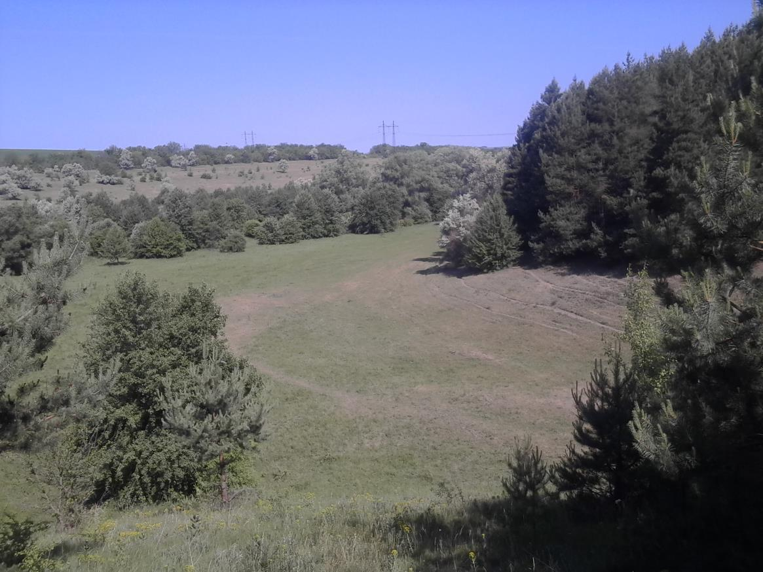

The beautiful countryside offers everything you could wish for. You can wander through stunning countrysideunder the high sky in Hryhorivka. You can feel the warmth of the sun rays while walking along the meadows, fields and steppes. You can get fresh air in your lungs strolling through woodland.

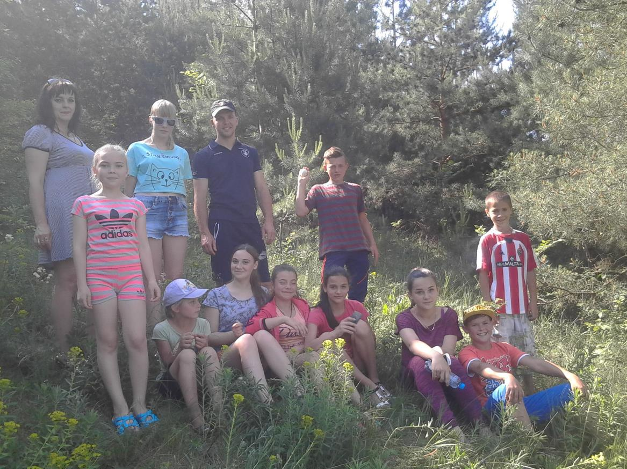

11

You can admire the wonderful views and listen to the sounds of nature. But the most exciting thing is having a picnic near the lake or near the ponds, surrounding by the willow trees.

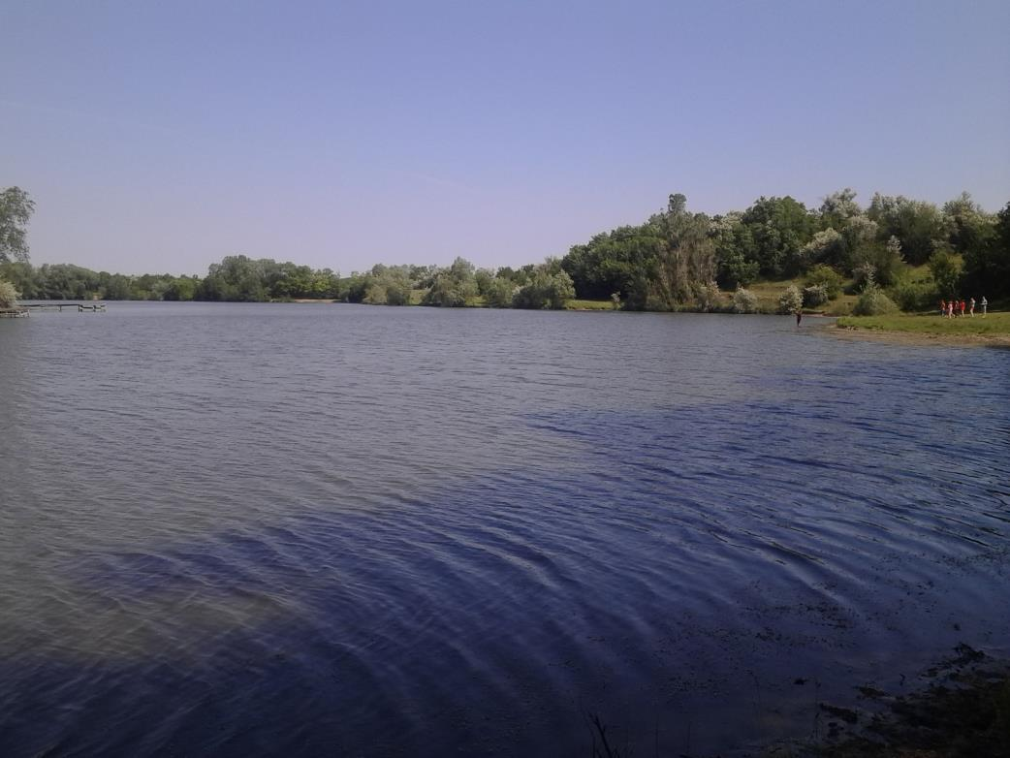

Here you can swim, lay in the sun on the bank or prepare tasty food on the open fire. You can spend some quiet relaxing and restful time with your families and friends among the nature in our village. Any visit to our village will be a memorable and highly enjoyable experience.

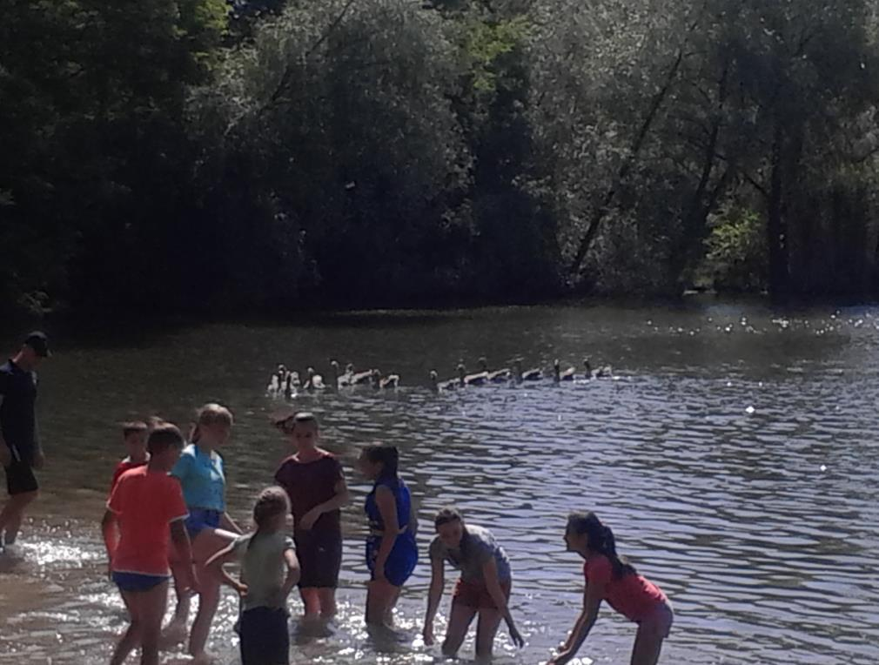

12

***THE FAMOUS PEOPLE OF THE VILLAGE OF HRYHORIVKA***

Our village is rich in the woods, ponds, fields, gardens, meadows but the largest wealth and pride of Hryhorivka is its hard-working, hospitable and sincere people.

The village of Hryhorivka is proud of the

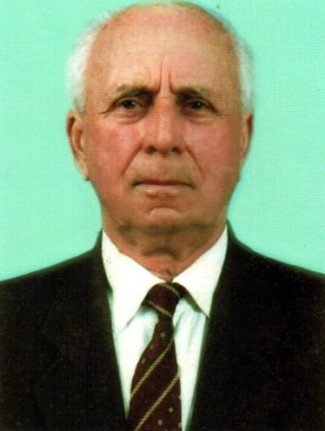

former collective farm’s head PetrovVolodymyrYevdokymovych.

He ruled the local collective farm from 1966 till 1979. Local old inhabitants remember the years when they together with their collective farm’s head raised the agriculture of the village, how the cattle-farms were built.

KulishStanislavPetrovych worked after him. During the years of his work the local agriculture developed rapidly and received the high results. He received many state awards for his devoted and useful work.

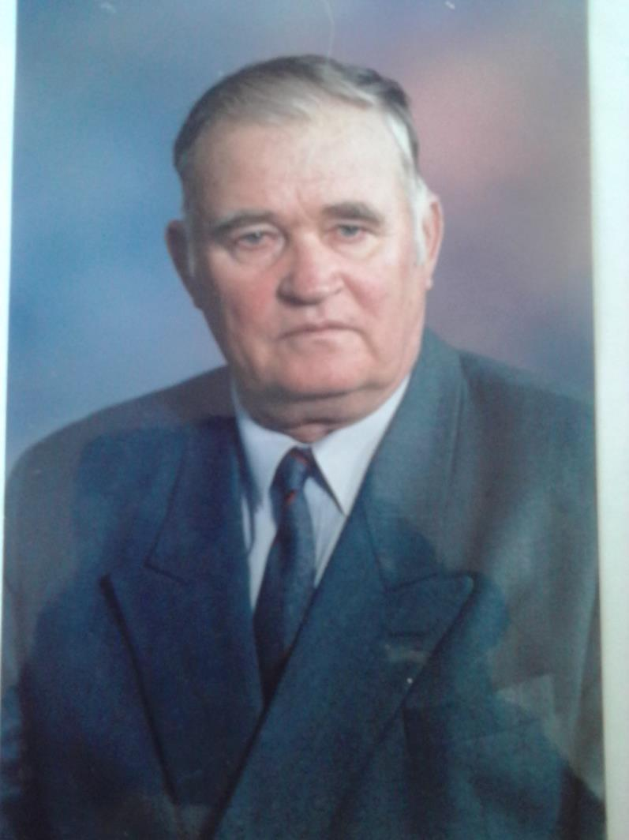

It should be also mentioned about the famous scientists from our village.

They are BurianskyiFedirSerhiyovyc h, the professor of history of BilaTserkva University and Oliynyk Ivan Ivanovych the famous doctor and professor of cardiology (Moscow), Bublyk Ivan Omelianovych the professor of Philosophy of Kirovograd Pedagogical University.

Nowadays the local businessmen and farmers do their best for the prosperity of our village. They support and sponsor our school, kindergarten, culture and

supply the village

inhabitants with the working places and the deserved salaries.

We also should mention here about AikaramRashydovychTartykian, SkopychSerhiyAnatoliyovych and VadymVasyliovychDmitriev. They, as the

13

deputies of the District Council, help to solve the different administrative and financial questions of our village. And the villagers trust them, are proud of them and hope for them.

***CULTURE***

The cultural life of our village is concentrated upon the local library and the village club. The village library was opened in 1950 according to the decision of the Village Council. It was situated in the centre of the village in the old house. That house was both the club and the library. The director of the club was also a librarian. But at the end of 1950 the library was separated from the club and it was

transferred to another house. The well-educated woman

OvcharenkoVarvar

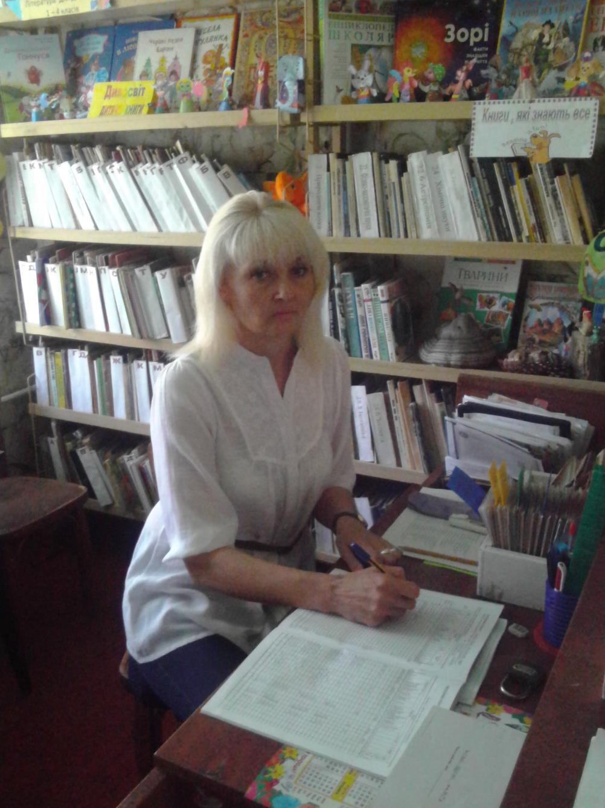

aDanylivna

became to work as

the librarian. There

were more than

500 books in the

library at that time.

The interesting

literary parties, disputes, lectures and readings were held in the library.

In 1970 the new two-storied building appeared in the village. The library and the kindergarten were situated there. The

local natural

museum was

openedin that building too. The library and the

museum co-operated creatively

together. The

festival of the flowers, the harvest festival, different meetings were held in the

library.

14

In the 1990ththe young, energetic librarian,MarynaStanislavivnaKulish, began to work at the library.

And she is working now. She organizes the interesting reading conferences, literary mornings, discussions. She has formed the circle “The Books’ Hospital” and the club of “The Lovers of Nature”.

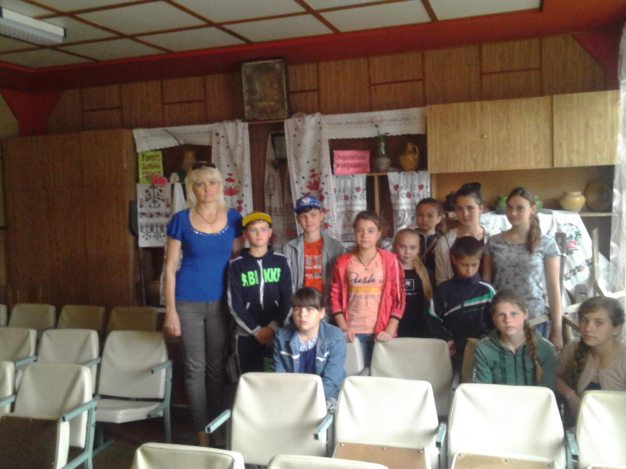

Nowadays our library is the educational, cultural and informational centre of the village. There are 13612 books there. 750 readers visit the village library. The adults and the children come to the library to communicate, to receive an advice, to choose an interesting book and to rest among the books. The library has been working according to the program “The Native Family House” for more than 5 years already. Our librarian, MarynaStanislavivna, is a hard-working, creative, responsible worker. She plans and coordinates her work for the satisfying the needs of the readers.

15

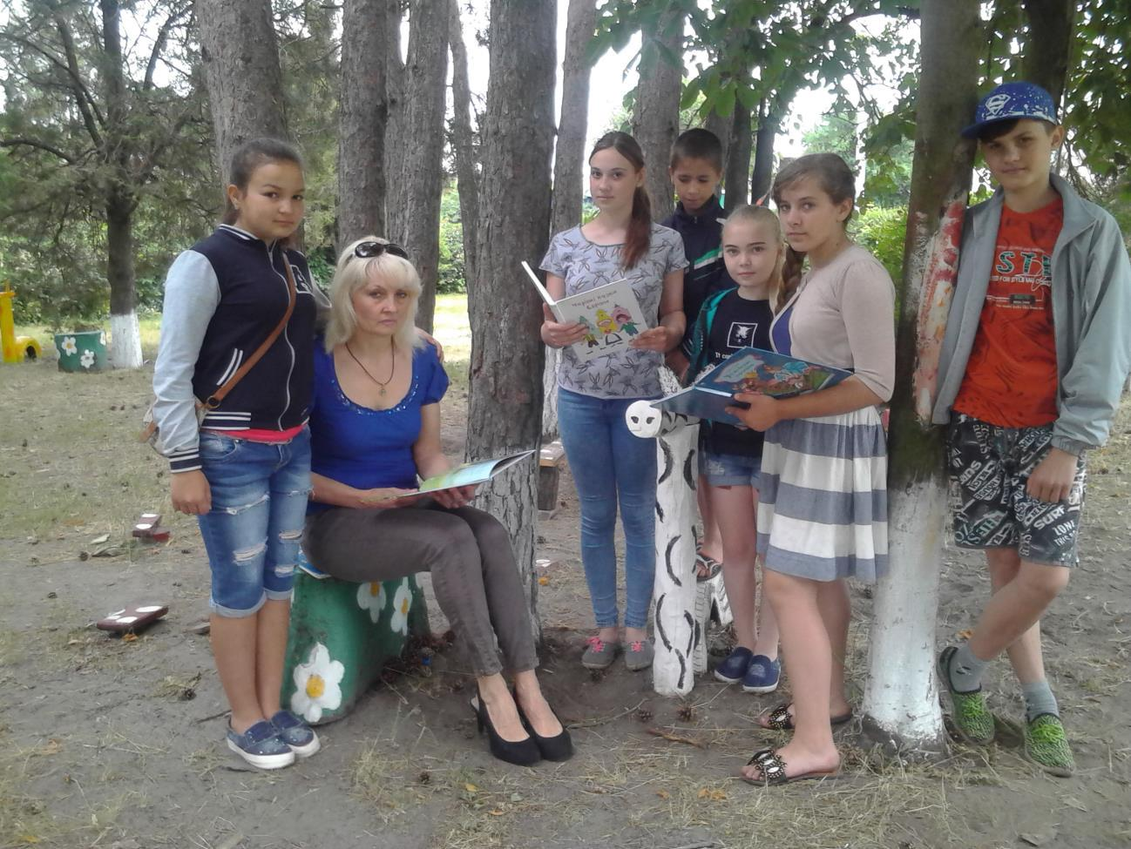

There is a village club in the center of Hryhorivka. It was opened at the beginning of 1960s. It has got a big hall, where people can watch films and concerts. In the evening the people of the village gather there to talk, to sing and to dance. Traditionally the different shows, lectures, meetings and other mass actions are held here too. Our club is the place of entertainment for the villagers. The director

of the club Viktor MykolayovychSerdiuchenko and his creative club’s workers organize the interesting leisure time for the inhabitants of our village. There is an amateur chorus, a drama circle and a dancing circle too. They prepare the concerts devoted to the different fests. And the people enjoy them very much.

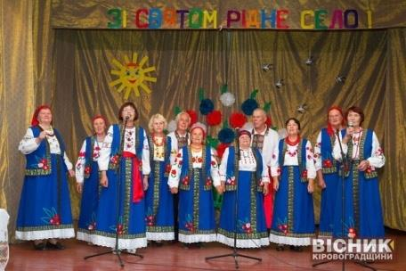

There is a Memorial Complex and the

Monument to the Unknown Soldier to the warriors perished in the Second World

War. This monument has got a long history. As it was told by the old inhabitants

during the rigid battle with the fascist invaders for the village of Hryhorivka many

soldiers perished and the inhabitants of our village buried them there where the

battles took place. The burying became the fraternal tomb. And only in 1970s the

memorial complex and the Monument to the Unknown Soldier were erected in the

centre of the village and the reburying of the perished warriors took place.The

large park near the Memorial and the garden behind the club were planted.

16

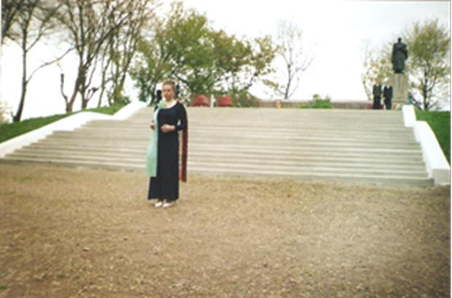

On the Victory Day people come to the monument and put flowers to it. They honor the memory of the perished defenders of our land. The monument to the victims of starvation was erectedin our village in 2008.

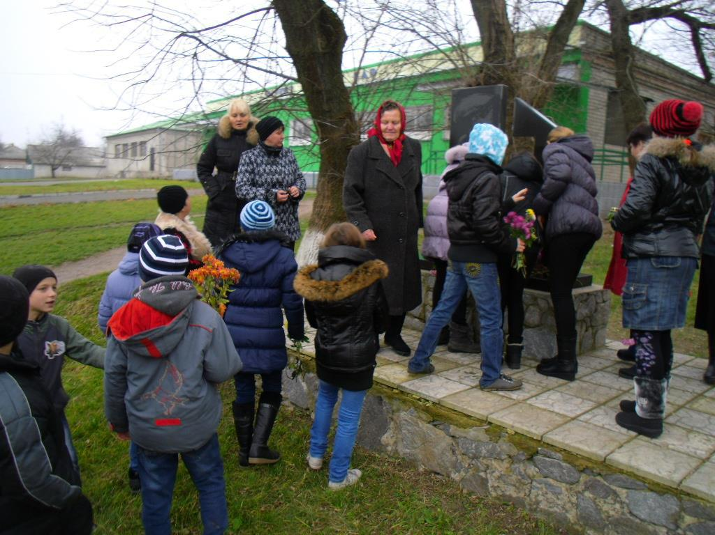

Annually the people of our village and guests gather here to honor the

memory of the people innocently dead of artificially-done starvation of 1932-1933.

17

***THE LOCAL FASTIVALS***

The village of Hryhorivka is the place, where the different fests, festivals, fairs and competitions are held. As it was told by the old inhabitants there was a tradition to organize “The Lastuhino fairs” (Lastuhino is the former name of Hryhorivka) in the 18th century. The people gathered on the village square, showed and praised goods, sang songs, danced and told the different fables and laughed.

That tradition, to organize the fests, has preserved till nowadays. Hryhorivka marked its first Village Day for the first time in the history of our Svitlovodsk district in 1988.

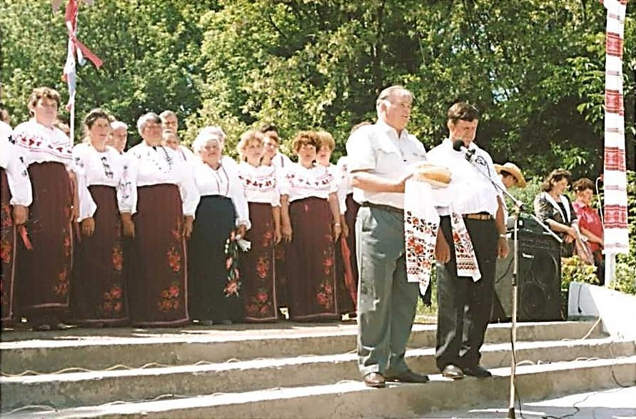

It was a grandiose and spectacular fest. Many guests from the neighboring villages and Svitlovodsk came to our village. There was a traditional fair,where different goods were sold, an exhibition of the works of the native craftsmen: embroidery, wood works, pottery, ceramics and paintings.

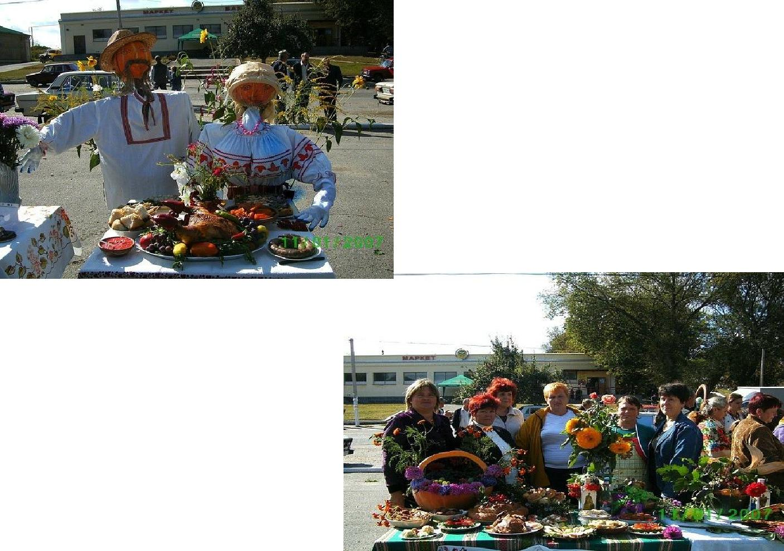

Besides the people had an opportunity to see the collection of the ancient agricultural working tools. There also was a concert where the creative groups from other villages performed. The lottery with the valued prizes was organized for people of Hryhorivka and for the guests. Since that time the tradition of celebrating the Village Day was established in our village and was lent by other villages of our district.

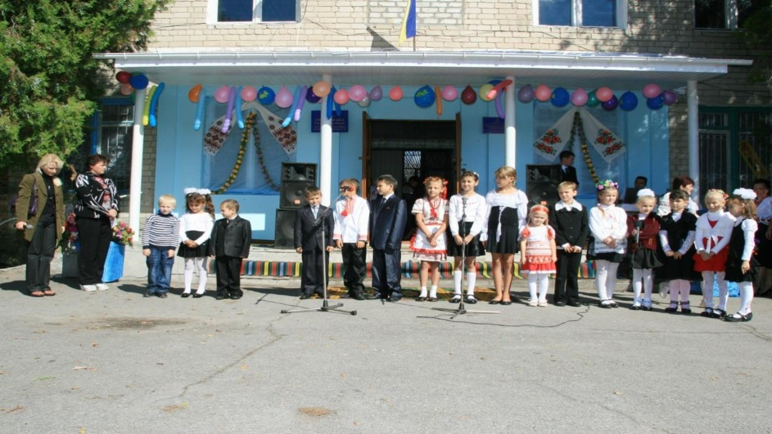

Nowadays such district festivals as Shrovetide, the Independence Day, the Village Day, the Victory Day and many sports fests are traditionally held in the village of Hryhorinka annually.

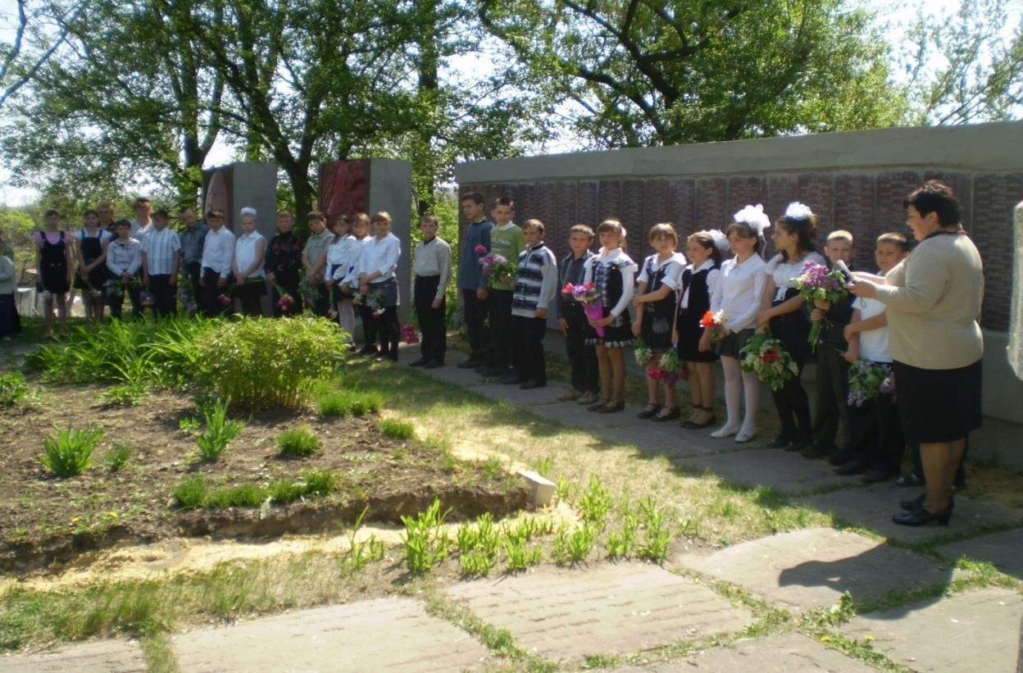

Besides the district festivals the different local fests, concerts, celebrations and anniversaries are celebrated in our village every year. If you want to have a highly enjoyable experience you are welcome to our village!

19

***OUR SCHOOL***

Our school was openedin 1968.The first-formers of 1968 came to the first form in a new beautiful school. The pupil of the first form Latyshova Natalia cut the ribbon, opening the door of the new school.

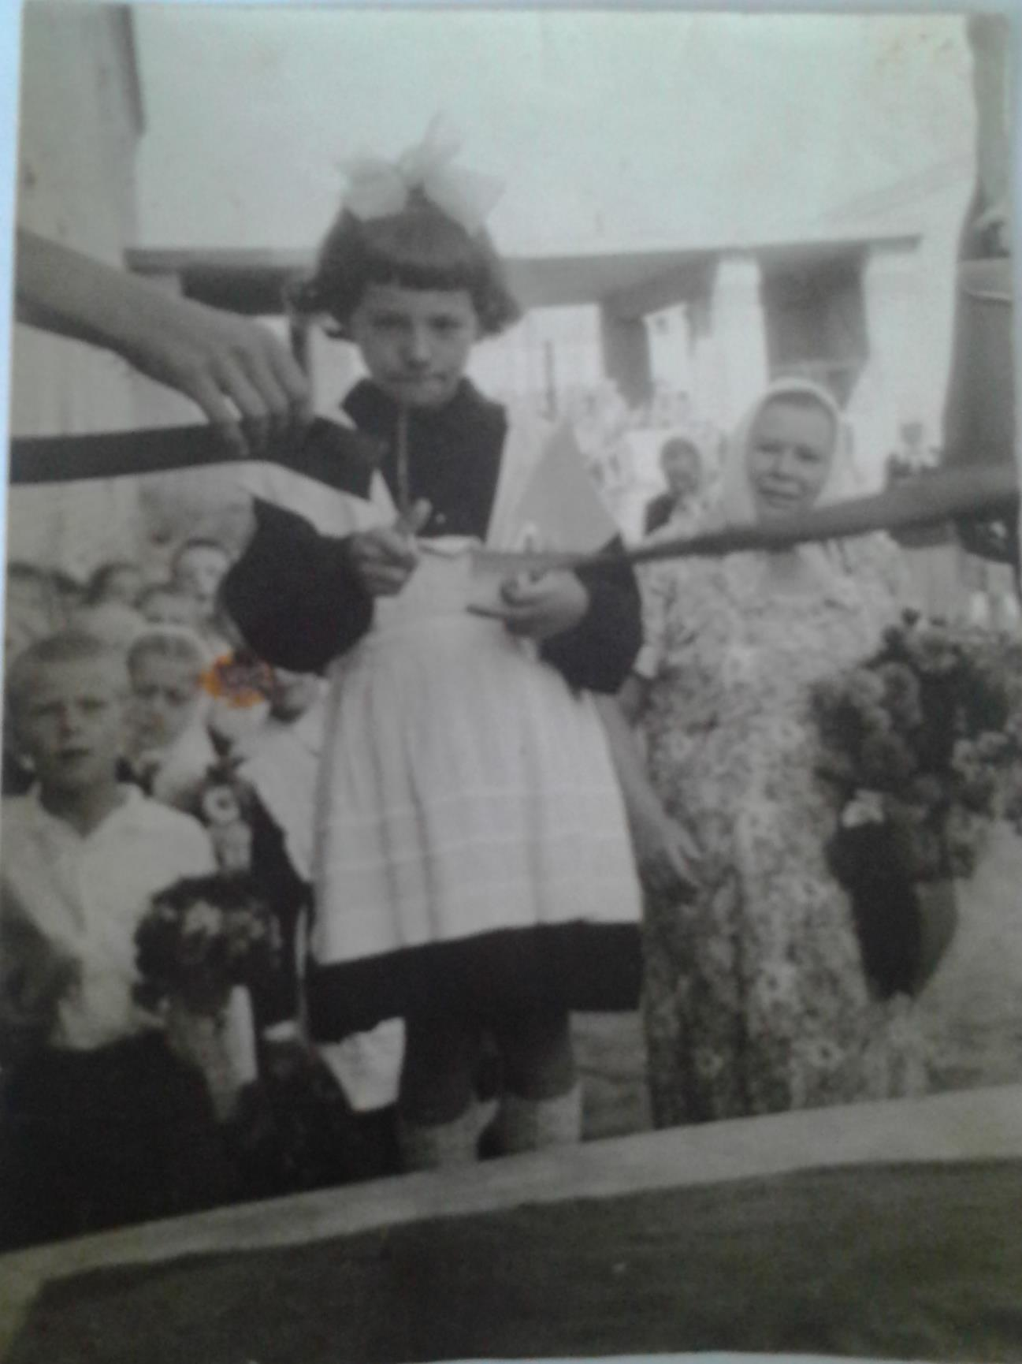

20

Since that time there were three directors of Hryhorivka School: the first one was Trybko Ivan Terentiyovych, the second—PerekoshkoAnatoliyPavlovych and till 2016 the director of the school was YarovyiSerhiyMykolayovych. They were leading the school in different times but they were devoted to their work, loved children, did their best for the prosperity of the school. Now we have a new

director—PadalytsiaTetianaDmytrivna (the former school-leaver of HryhorivkaSchool). She is a young determined, purposeful, hard-working, initiative woman.

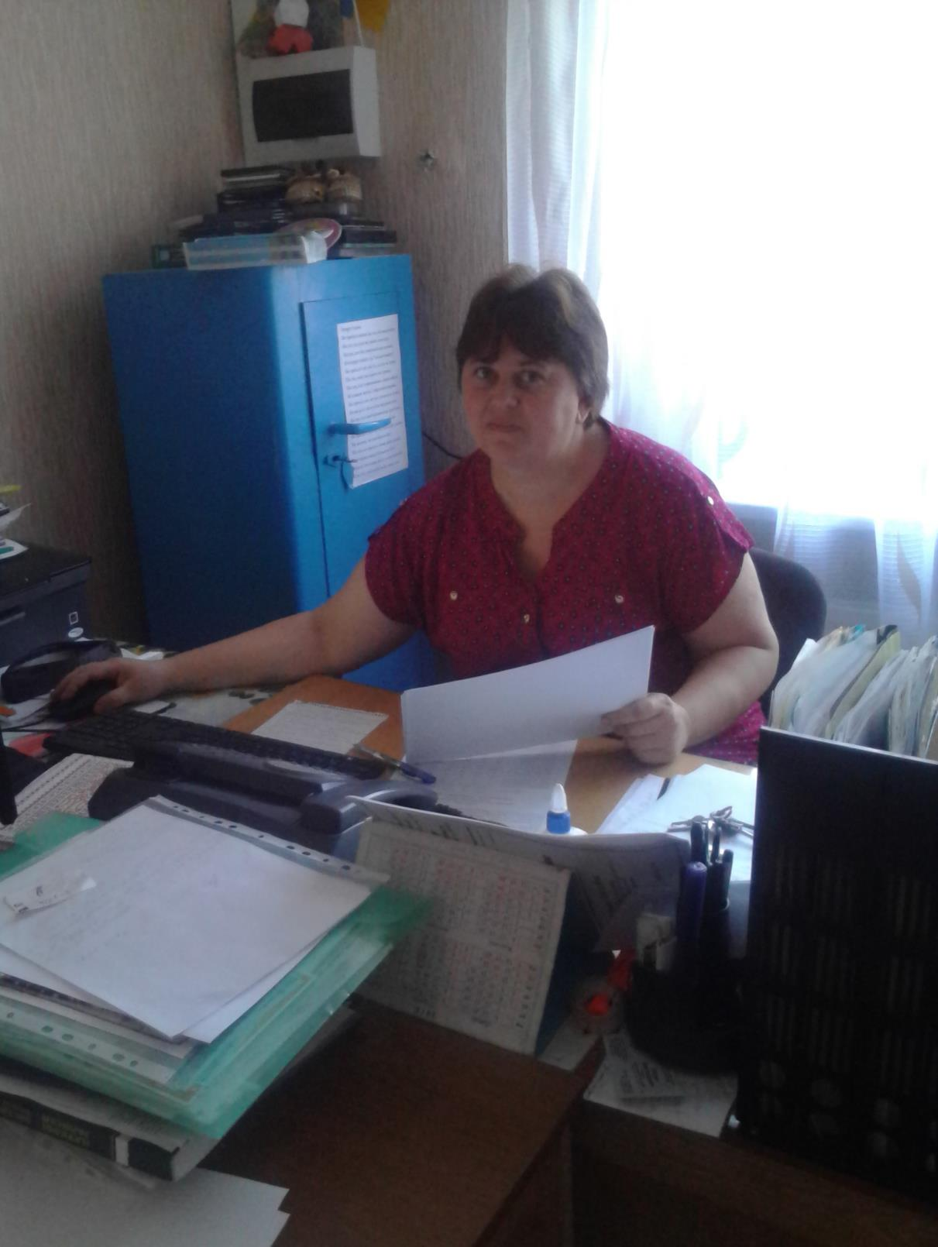

21

Our pedagogical stuff is a single, creative team. Our teachers are intelligent, highly -qualified, they are attentive and sympathetic to the pupils. They take part in the different competitions, conferences, teachers’ readings, seminars.

And the teachers have got the deserving pupils. Our schoolchildren are the winners of many school, district, regional and all-Ukrainian contests and subject olympiads.Besides they are talented singers, dancers and actors.

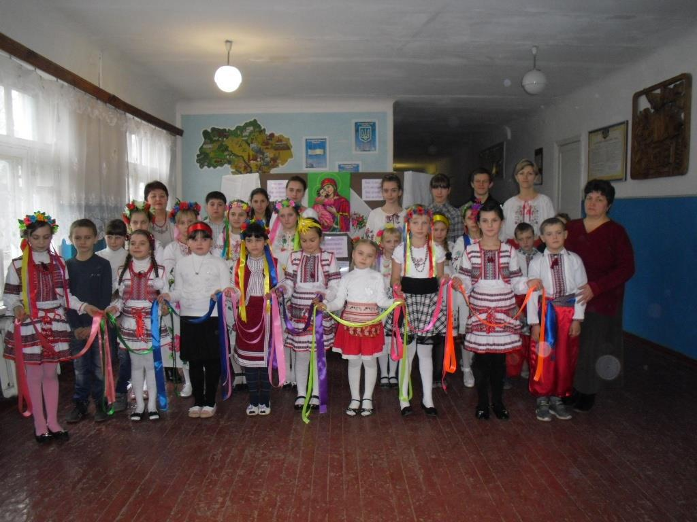

Our school is not big but it is nice.

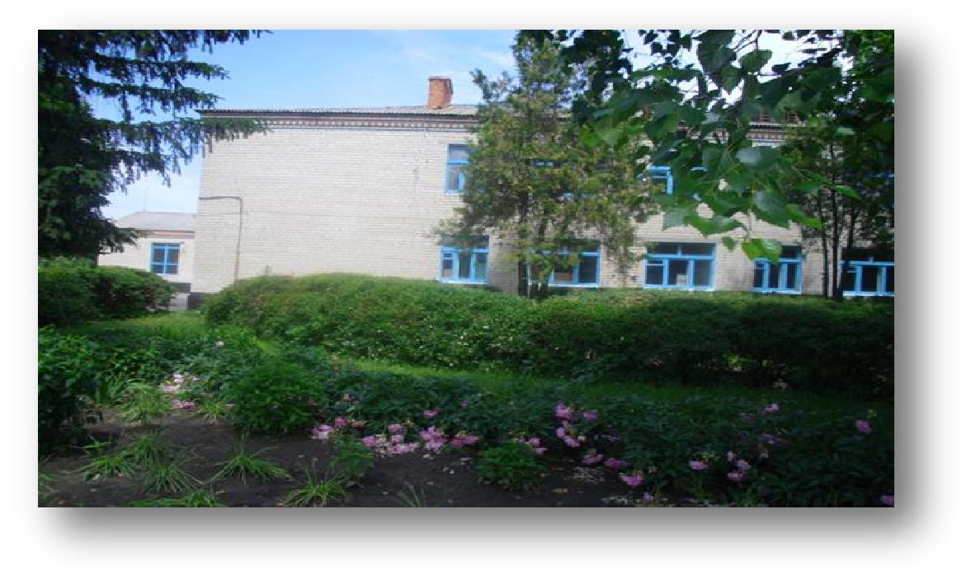

22

It is a two-storeyed building situated in the centre of the village. There is a mini-park near the school. The beautiful poplars, chestnut-trees and maples were planted by the pupils of our school. The pupils had left the school and became workers, teachers, doctors, engineers, businessmen, but their trees grow in the park.

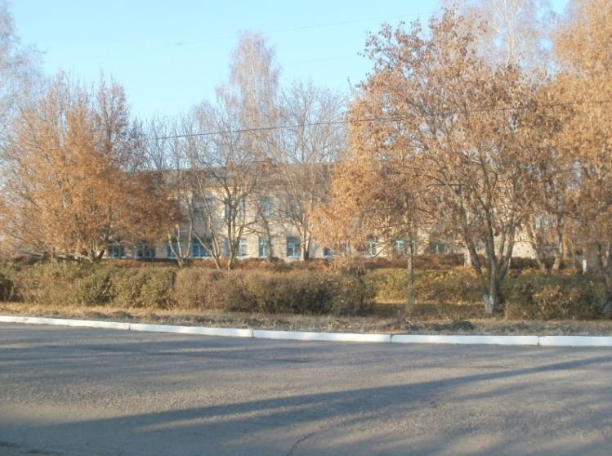

The school has got many classrooms and specialized rooms for studying different subjects. All the classrooms are cosy and light. The cloak-room, the dining-hall, the headmaster’s room and the teacher’s room are on the first floor. The gym and workshop are on the first floor too. The pupils have Physical Training lessons in the gym in winter and on the sports-ground behind the school in spring and in autumn.

23

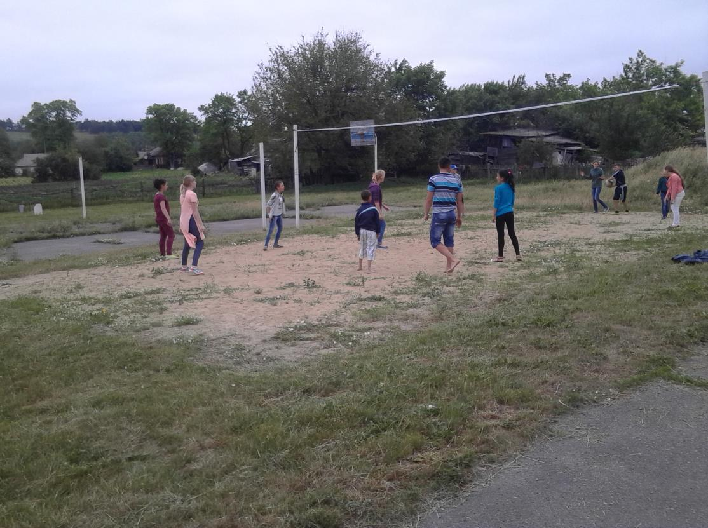

At the lessons of labor training the pupils get practical skills in wood-working and metal-working, besides they learn to use many different tools. We have a large hall, where different events such as meeting and concerts are held.

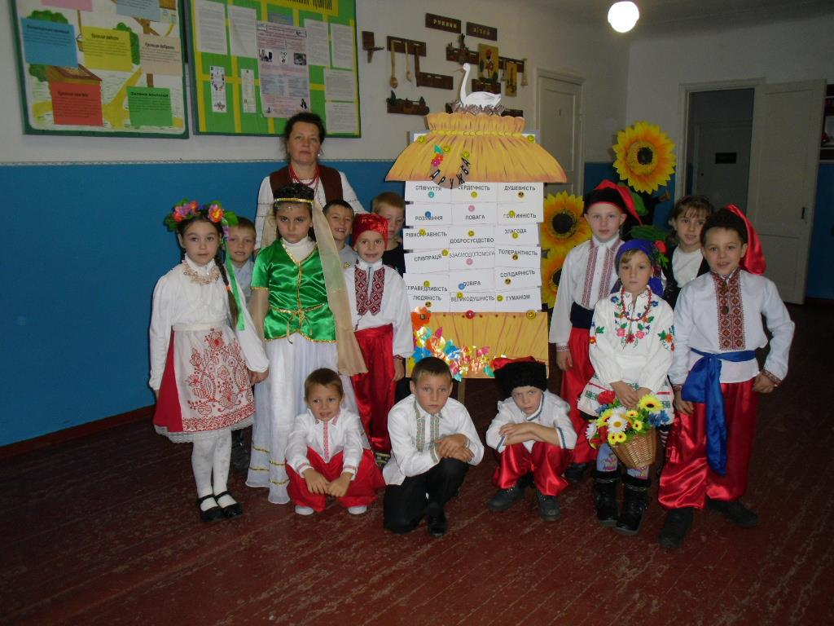

The teachers’ stuff, pupils, parents, by the help and support of our sponsors, try to do all the possible things our school to be a modern, European, advanced school of XXI c.

24