

TOURIST GUIDE

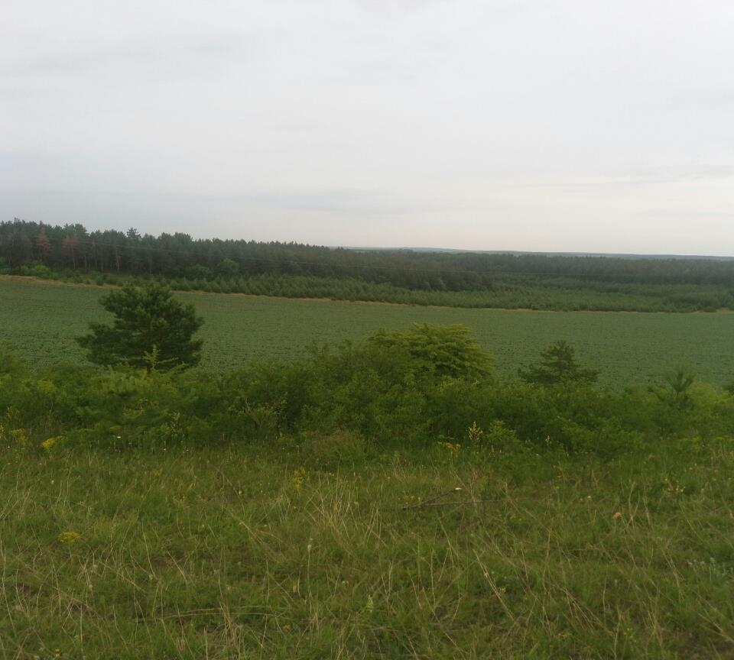

ENGLISH GROUP “FAIRYLAND”

TEACHERS:

KRYVORUCHKO S. L.

YAROVYI S. M.

HRYHORIVKA SCHOOL

SVITLOVODSK DISTRICT ADMINISTRATION

***INTRODUCTION***

***To enjoy the village to the fullest, regardless of whether you are visiting Hryhorivka, just for a short time or for a full week, our guide will be there to help you discover the best of it. Our simple travel guide, a pack with essential information, is here to make your visit to Hryhorivka enjoyable by suggesting where to have a picnic, to go fishing, to wander, admiring picturesque scenery and breathing fresh air, or to camp out.***

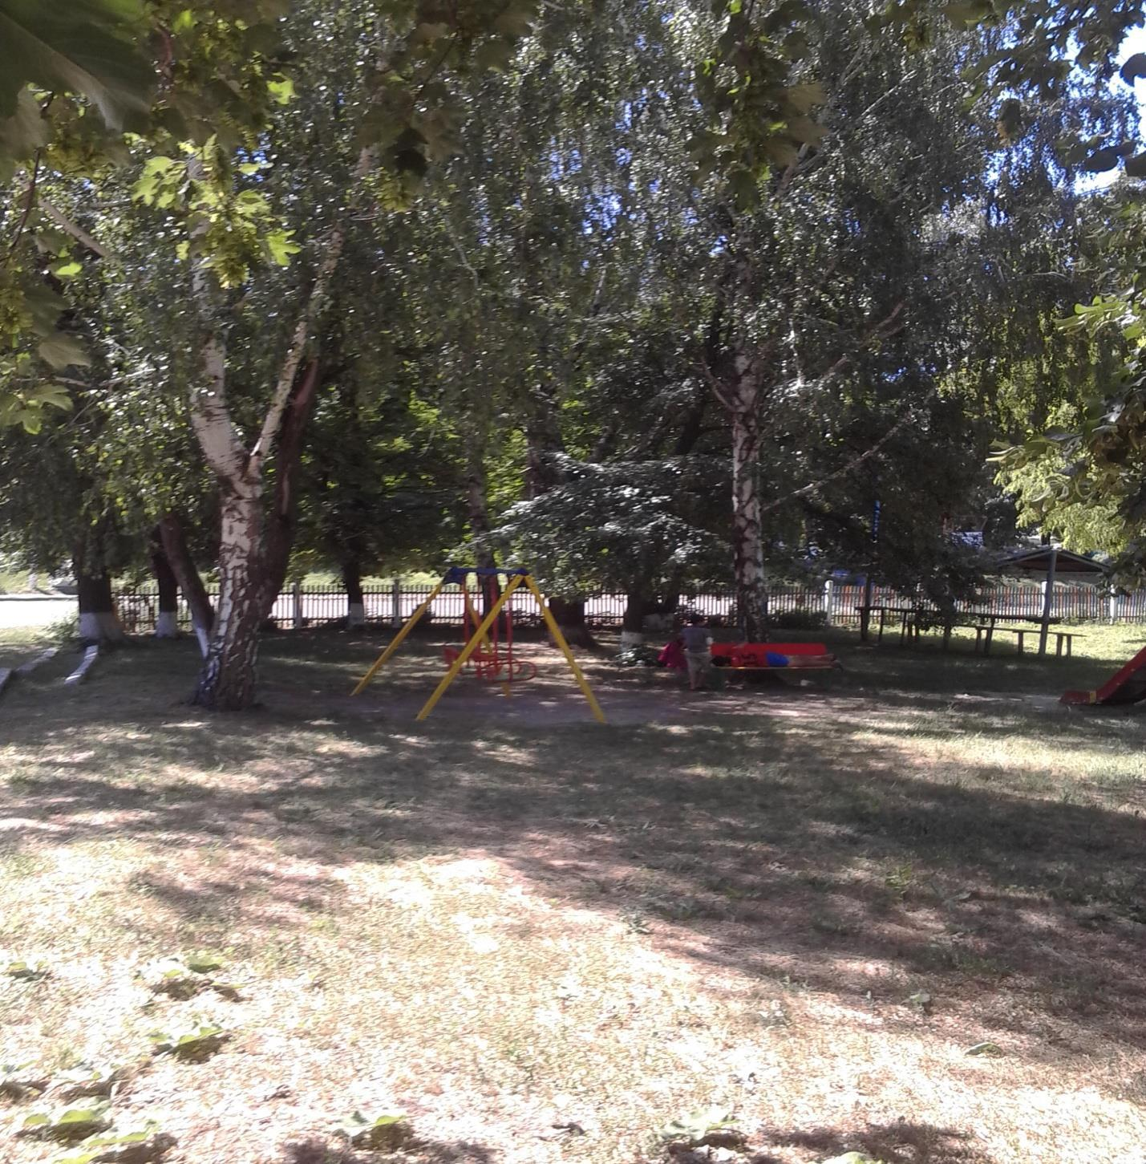

***Just take our guide, enjoy and explore!***

***THE BEST TIME TO VISIT***

***Although Hryhorivka is a beautiful village no matter what season of the year, probably the best time to visit it is around from May to September, when the weather is warm and sunny, so as Hryhorivka has a continental climate, with hot summers and cold winters.***

***It is not unusual during the summer for temperature to reach as high as 35-40 degrees centigrade and in the winter it can be as cold as minus 20 degrees. The average high temperature from May to September is 22 degrees, with an average low of 12 degrees and an average seven hours of sunshine per day. Spring and summer are likely to be the sunniest month, but sudden storms and showers are common, therefore don’t forget your umbrella. But even in summer the nights are cool, that’s why you should take the warm clothes and a pair of comfortable shoes as you will probably be doing a lot of walking.***

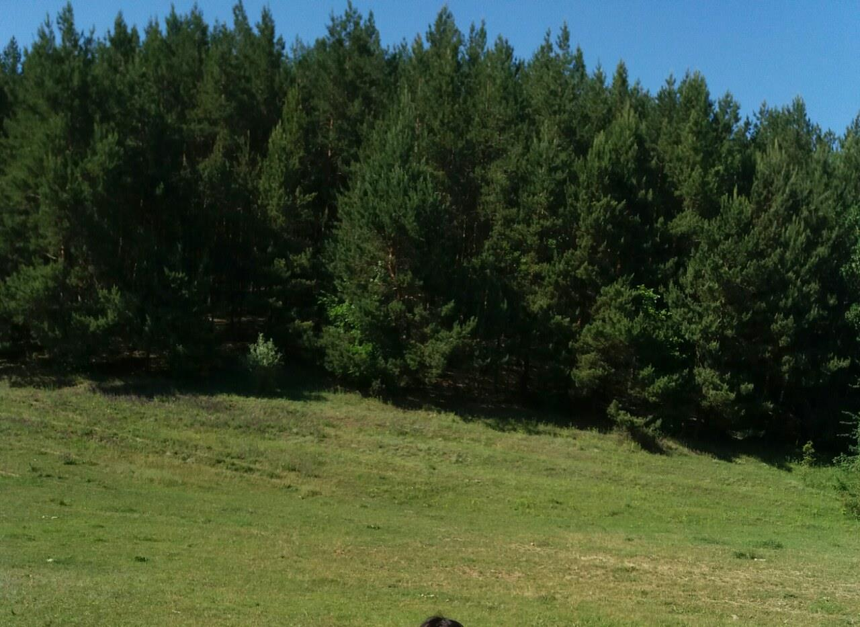

***HISTORY OF HRYHORIVKA***

***The village of Hryhorivka has got a rich history. During the Cossack time the lands of Hryhorivka were not settled. Only Cossack observing tower was situated on the highest point of that territory. Now this point is called “SHpyl”.***

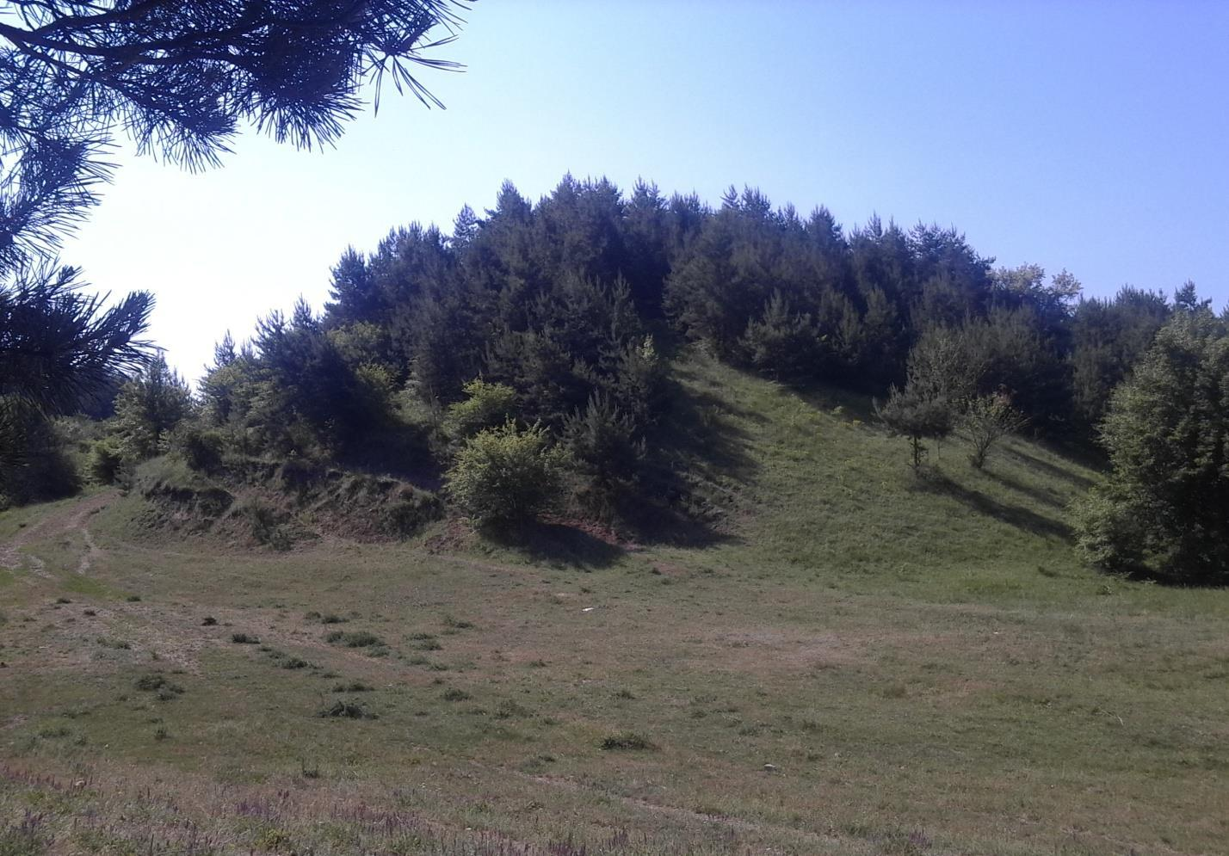

***The first facts about the village were mentioned in the 18th century documents. Those lands were inhabited by peasants and were granted or passed from time to time to different owners. In 1785 the new church was built and named after St. Nicholas. It became the center of the village life.***

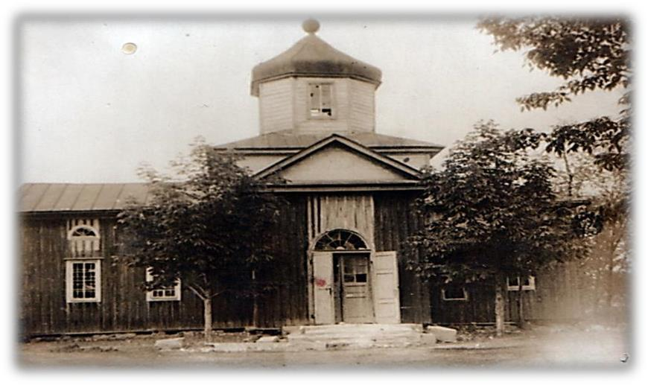

***The life of peasants was very difficult. They had to work hard for their masters during 12-16 hour a day. After the October revolution they received the pieces of land and were forced to unite into the collective farm. The several collective farms were formed, but they were poor. The large collective farm was formed in 1953 by uniting the smaller ones. The construction of the new agricultural and social buildings began in Hryhorivka.***

***During the period of Independence Hryhorivka has become a vivid example of the modern, prosperous village with the further perspectives of European development.***

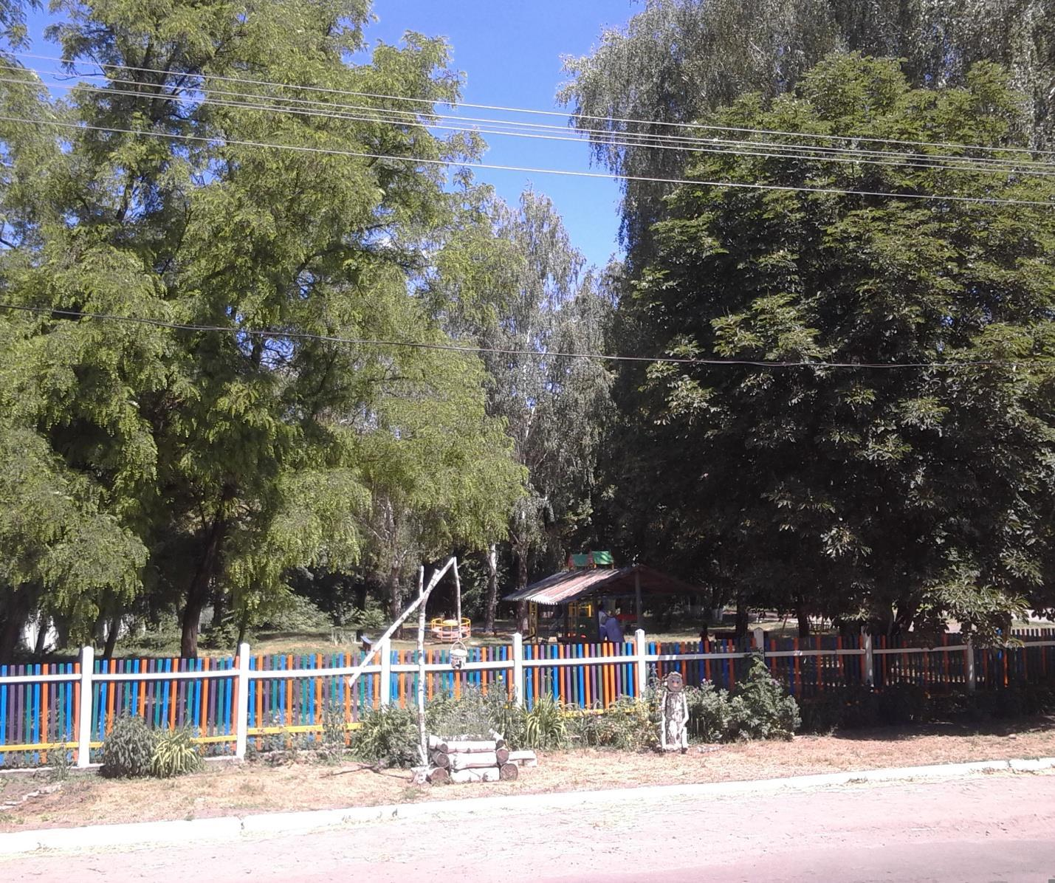

***ENJOY THE PEACEFUL PICNIC NEAR THE LAKE!***

***If you want to have a nice picnic with your family or friends visit our local lake, which is situated in the center of our village.***

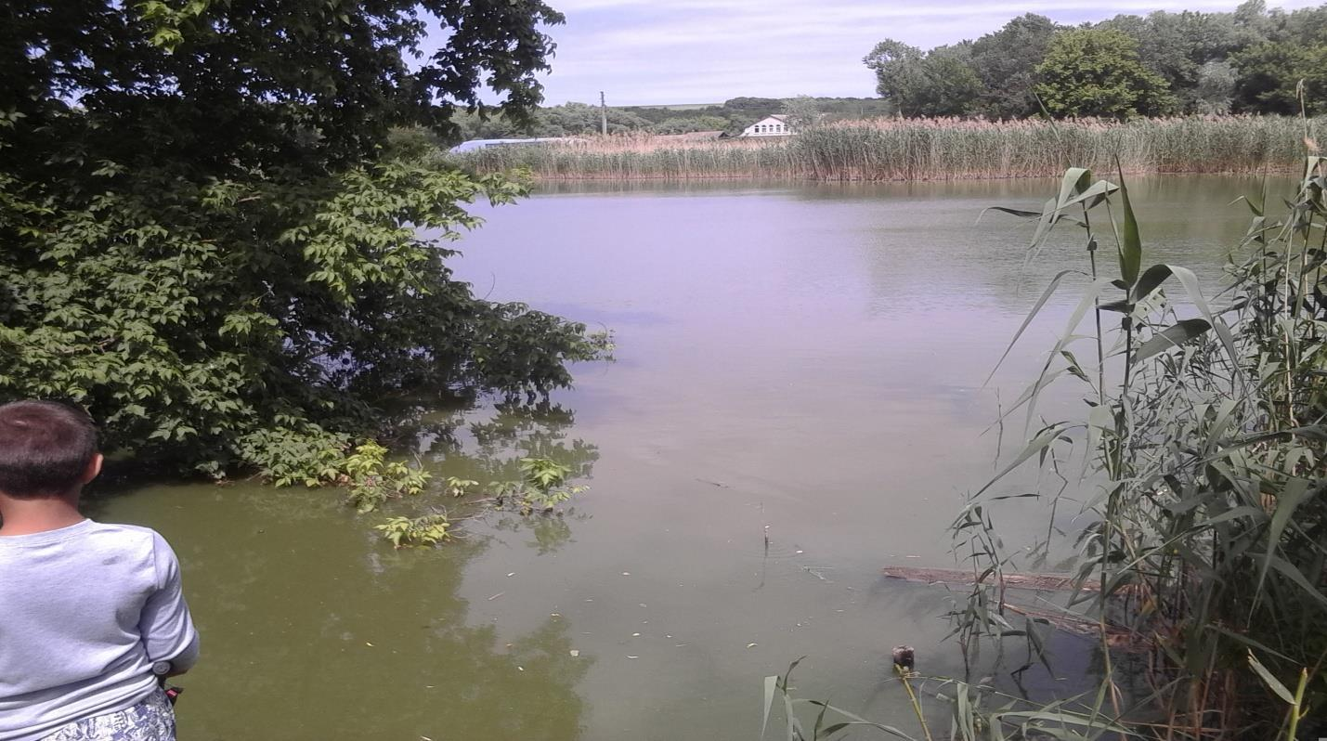

***This beautiful lake offers everything the visitors could wish for. You can fish and then prepare your food on the fire. If you like sport games you may play here!***

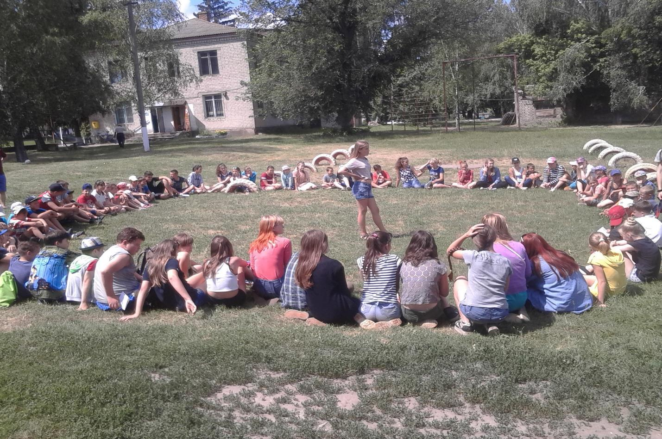

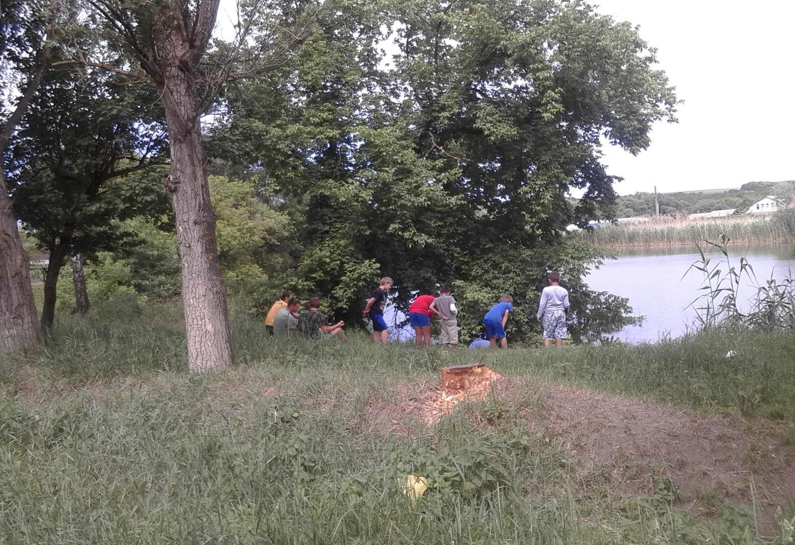

***You can feel the warmth of the sun rays while resting there and admiring the enchanting scenery.***

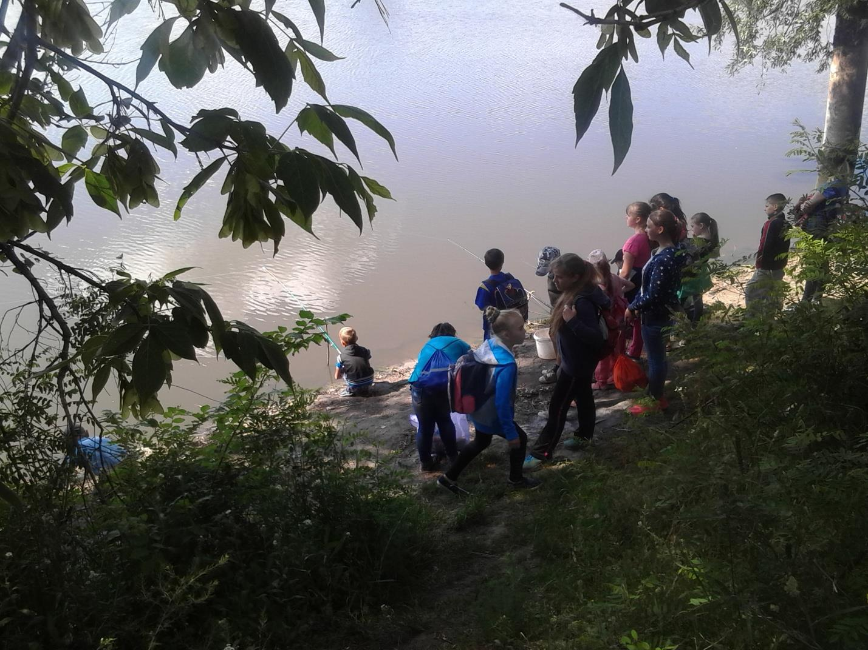

***DISCOVER THE WONDERS OF THE WOOD!***

***Our village is rich in the fantastic woods growing on the hills which surround Hryhorivka.***

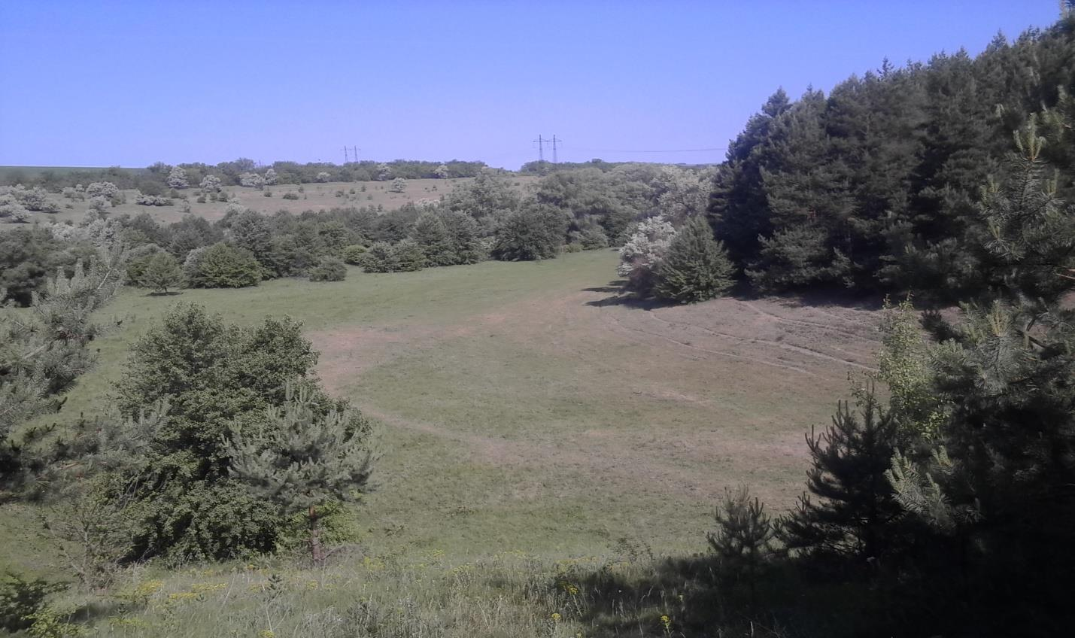

***You can wander through the stunning woody hillsides if you like hillwalking or ride a bike if you like cycling.***



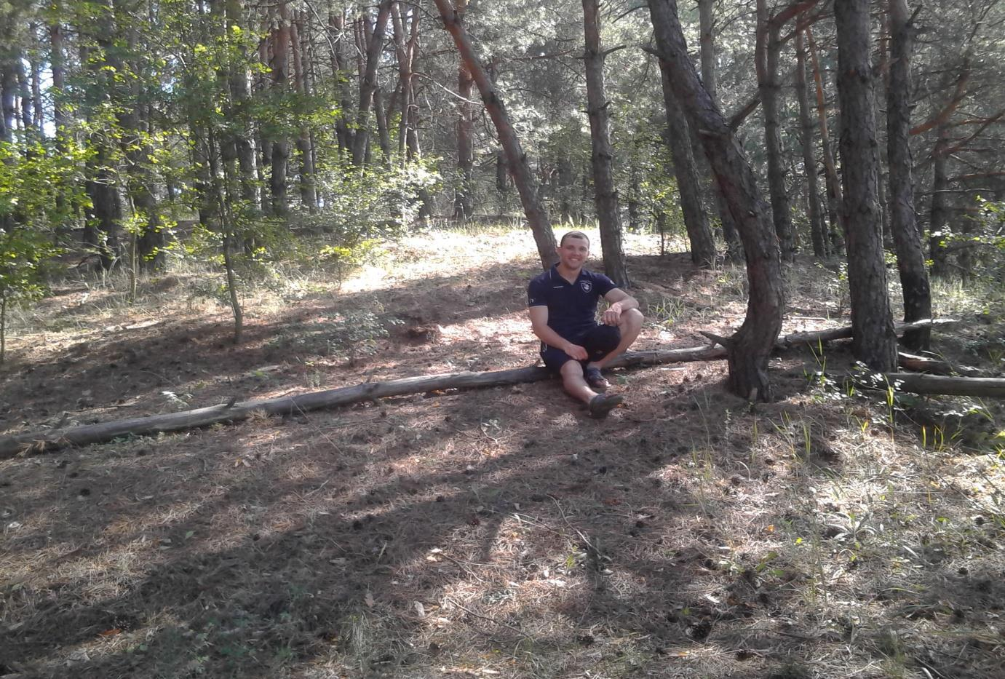

***Besides you can enjoy wildlife watching. Everyone can spend some quiet time watching the rare, colourful and sometimes spectacular plants and creatures that live there.***

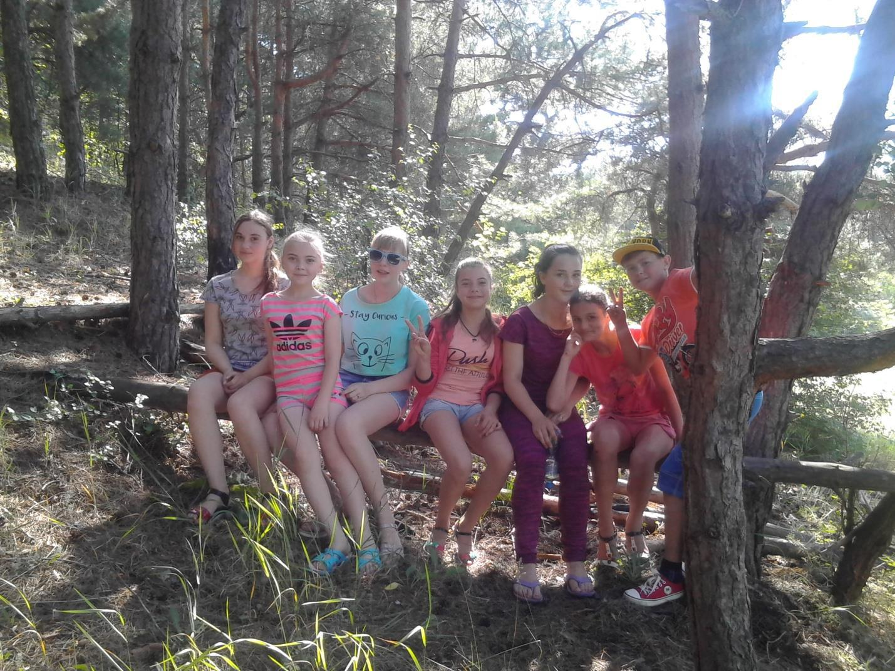

***Put a tent, kindle the fire, prepare your favourite food on the fire and enjoy it! It will become an unforgettable moment of your life.***

***THE QUIET SOLITARY RECREATION NEAR THE OLD POND***

***The mysterious place of Hryhorivka is the Old Pond, which is situated to the South of the village. From the ancient times that pond was famous for its fish and clean water, that’s why it was the favourite place for recreation among the inhabitants of the village.***

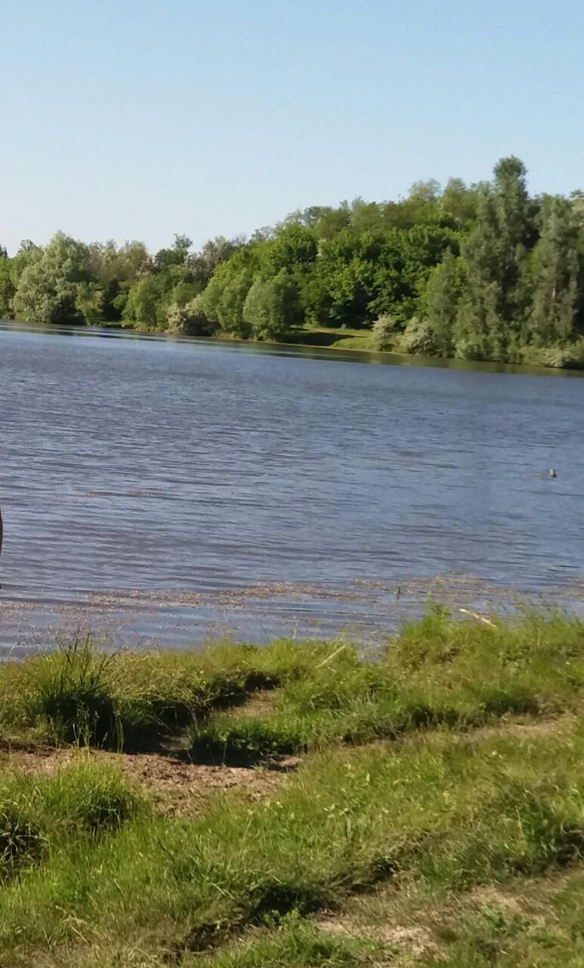

***The Cossack source with clean icy water flows near the pond.***

***The old inhabitants of the village tell that in the Cossack times the Cossacks liked to rest near it and they kept the source clean.***

***Nowadays the Old Pond is a quiet, solitary place for those who want to be alone with the nature and to spend their time in the stillness and solitude. You can swim in the pond or do boating, the lie in the sun and sunbathe on the shore.***

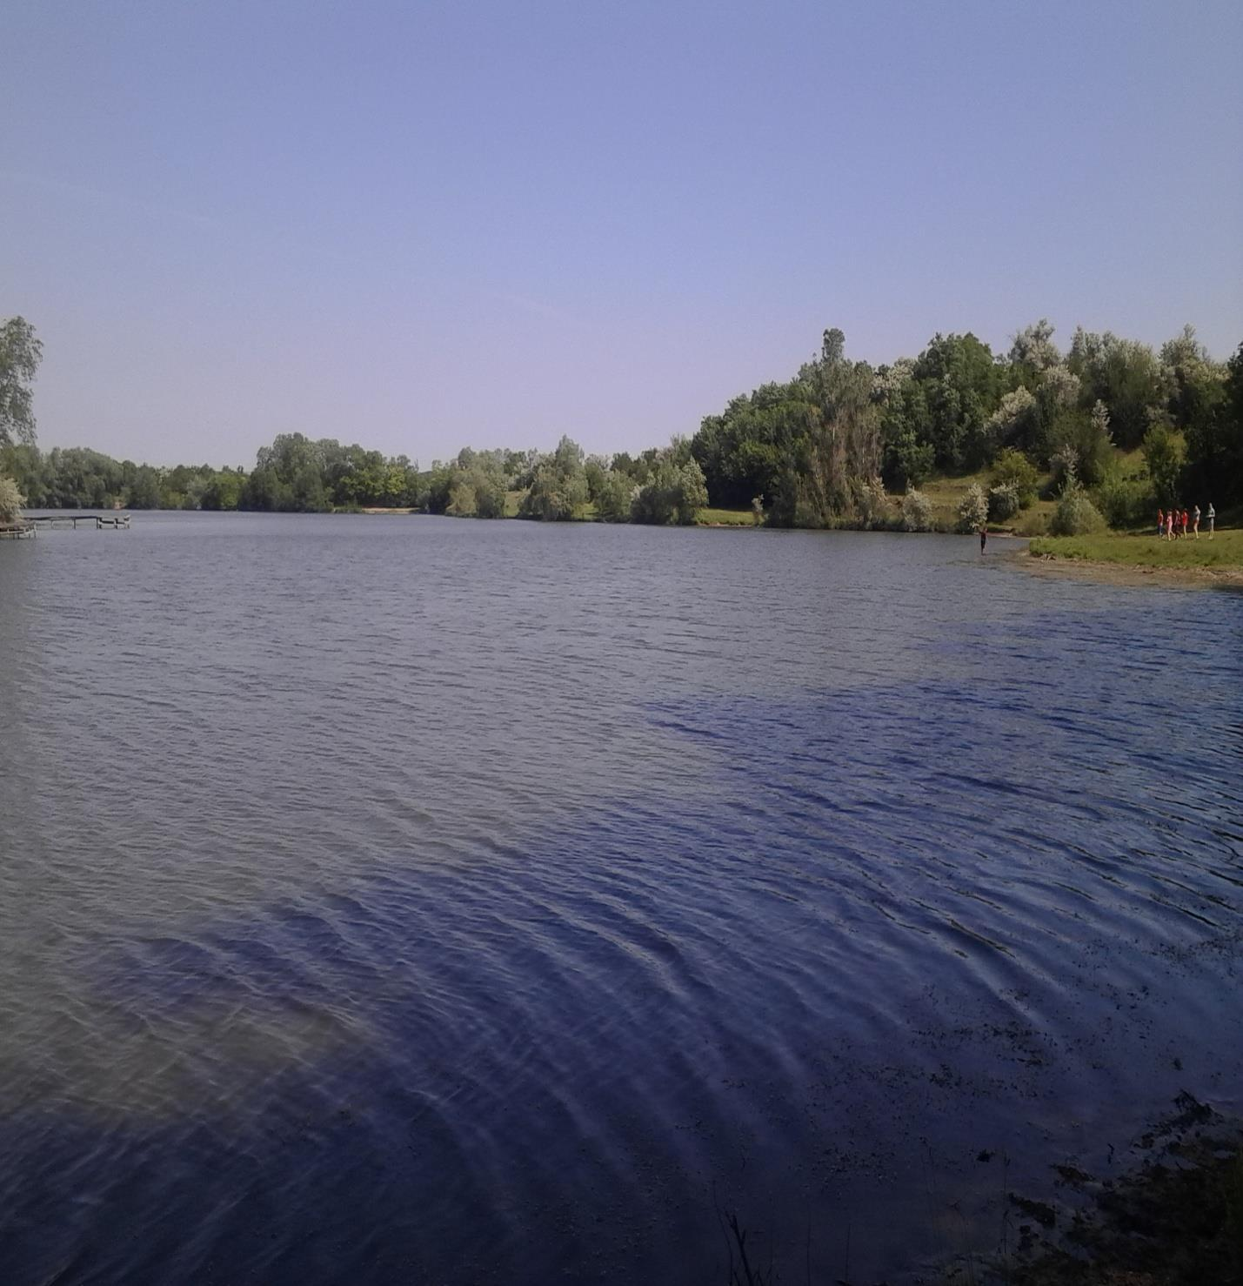

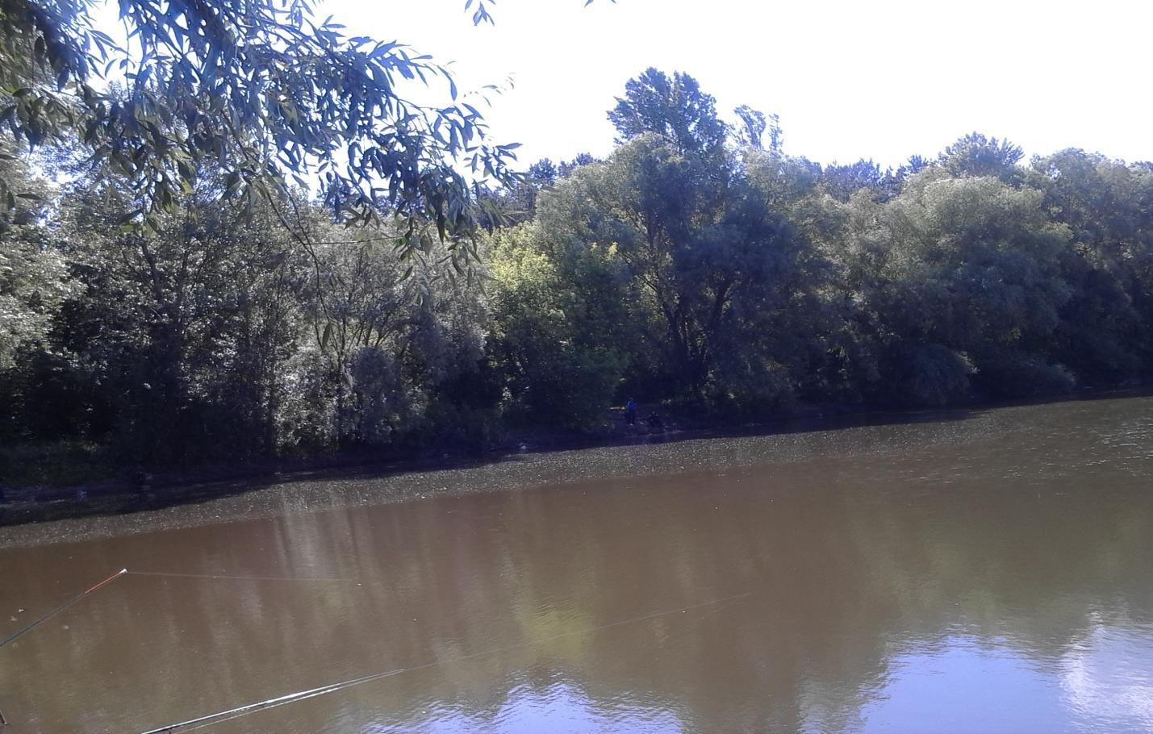

***Enjoy your holiday in this picturesque place!***

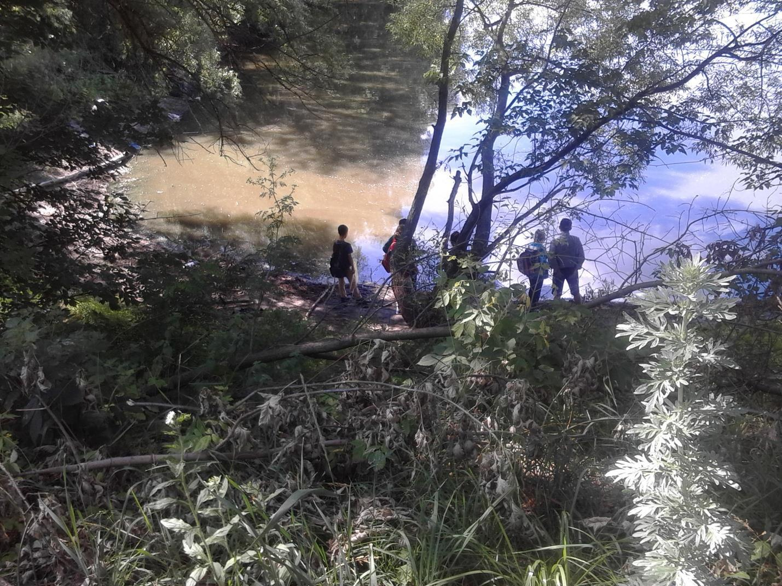

***FOR SILENCE AND CALM TO “SOLOMIA”***

***“SOLOMIA” was opened on the 19th of August 2016 as the first green farmstead. The founders of it are the inhabitants of the village Yaremivka—mother and daughter—Koshulko Lina and Salamashenko Natalia.***

***This green farmstead is a harmonious combination of the national traditions and the Ukrainian hospitality. You can come here and enjoy the beauty of the majestic scenery.***

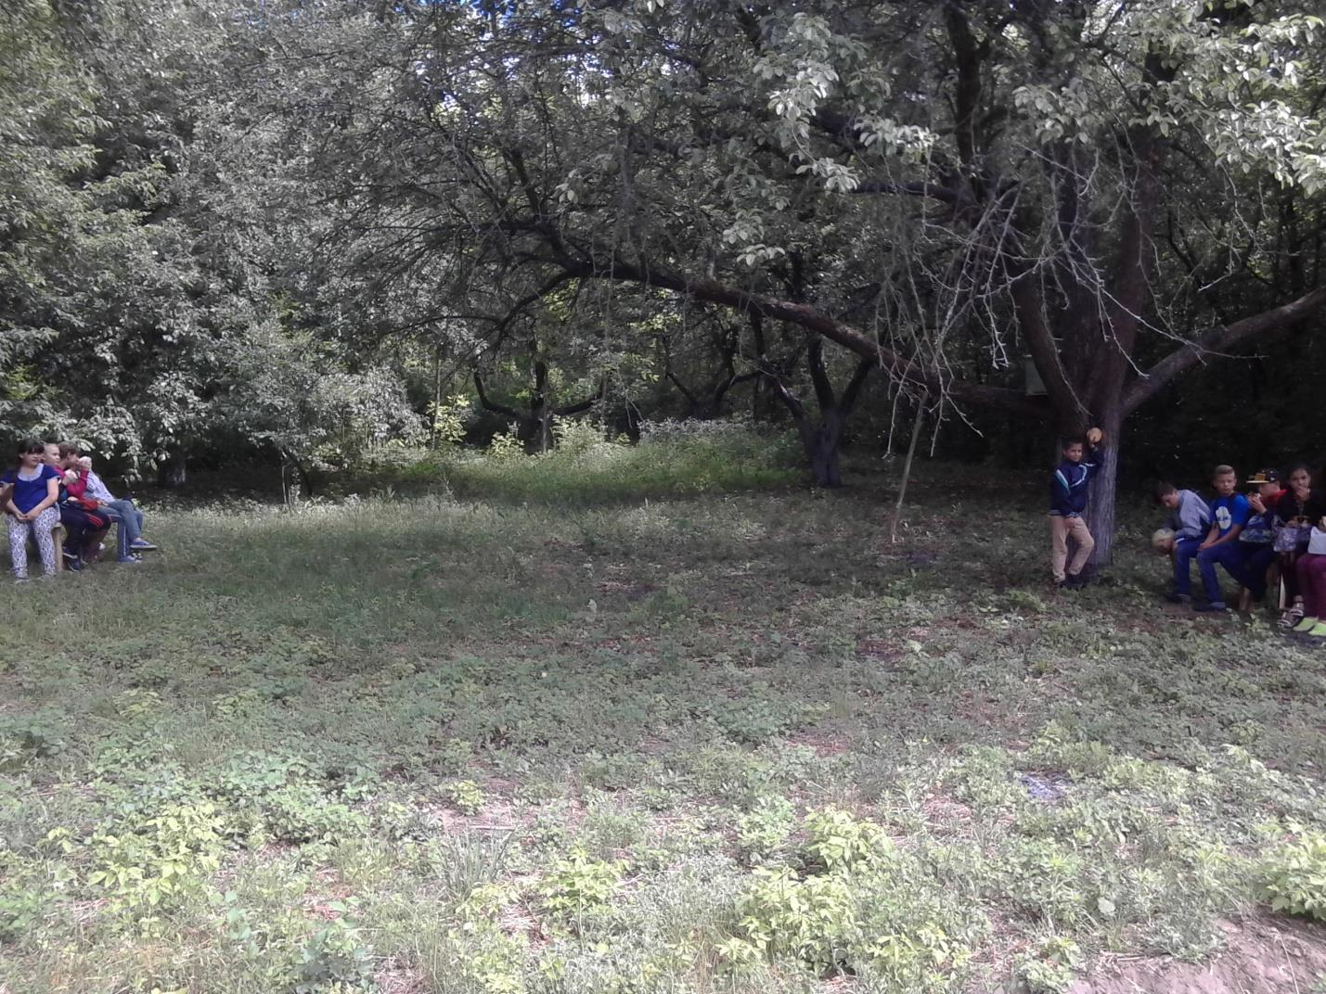

***It is not only the place for the recreation, but also a peculiar museum of the folk creativity. It shows the history of the former generations, their way of living, their traditions and customs. It transfers the spirit of those times.***

***The farmstead is situated on the outskirts of the village. It is an ideal place for those who tired of the noisy crowded city life, who want to enjoy the calm and dream about the soul rest.***

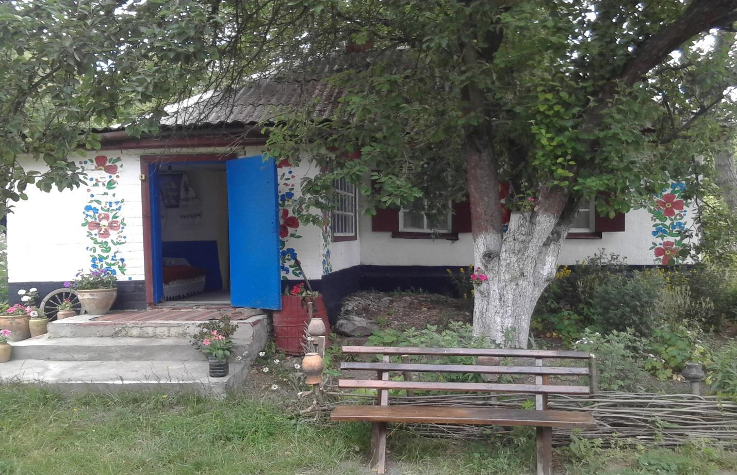

***There is a lake, a wood and a river near it. You can order and taste the traditional Ukrainian dishes here. You’ll also be shown the master classes how to cook food in a real Ukrainian stove and to use different kitchen utensils. The payment for the accommodation a day is 60 hrv. All the rest are by appointment and according to the preferences of our guests.***

***Our address: str. Lesia Ukrainka 30, Yaremivka, Svitlovodsk District.***

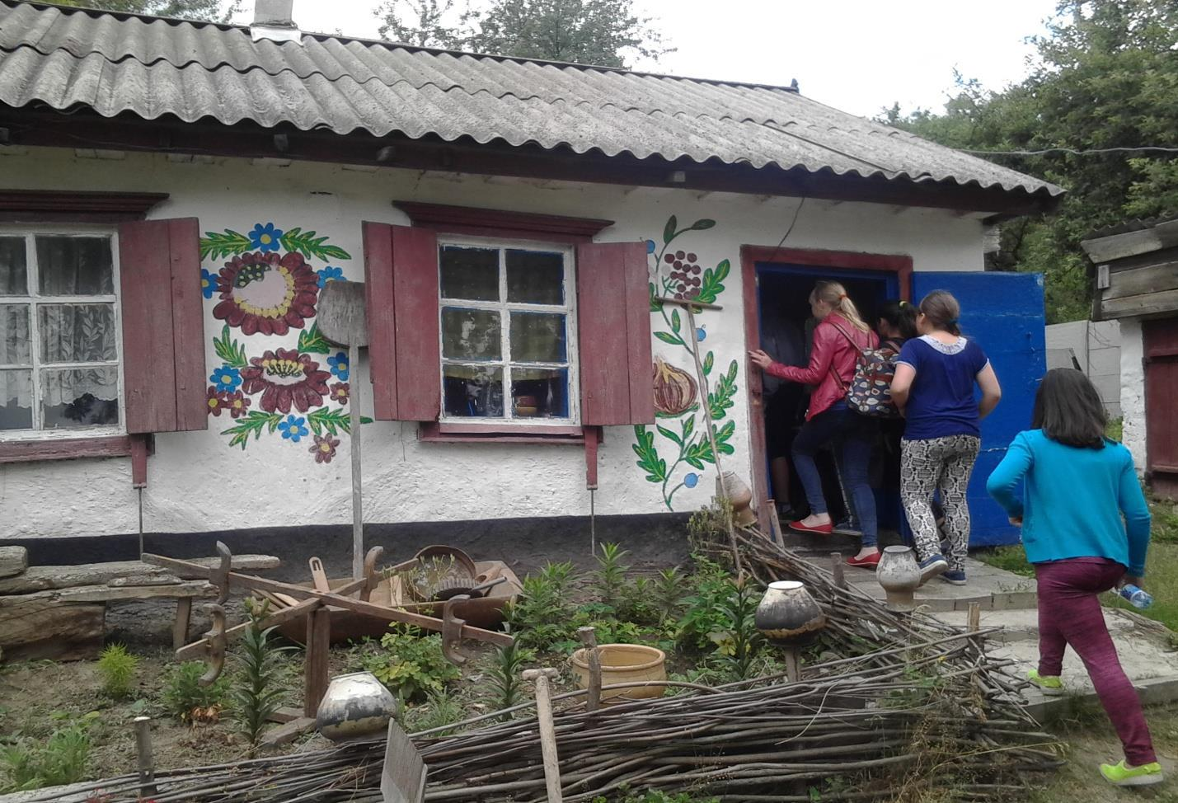

***Welcome to our cosy green farmstead!***

***THE MOST POPULAR PLACE FOR THE REST—THE POND “BIRCHES”***

***With the picturesque pond view in all directions, the recreation area “Birches” is Hryhorivka’s jewel in the crown.***

***The sandy beach is a popular spot among the sunbathers and swimmers***

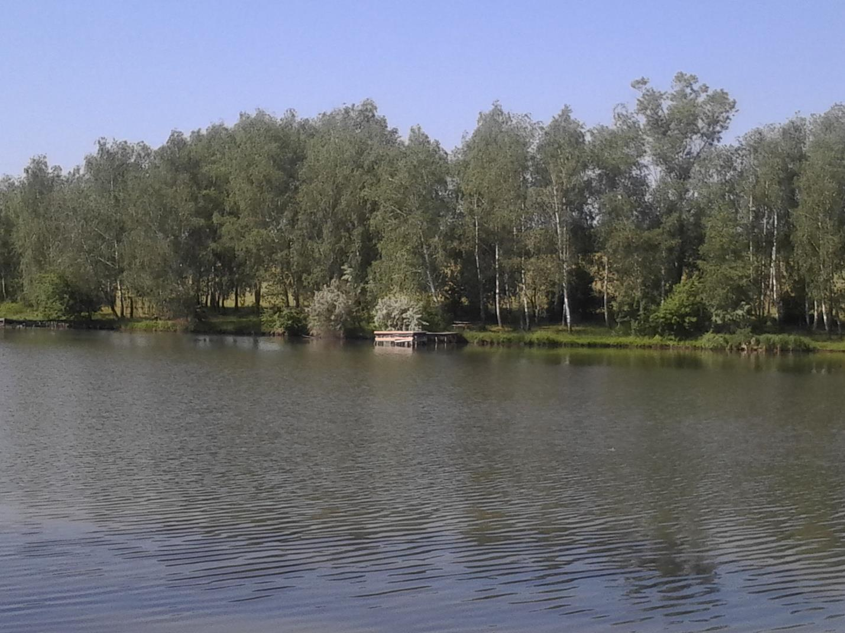

***on the hot summer days. It’s so pleasant to lie in the sun or to fish.***

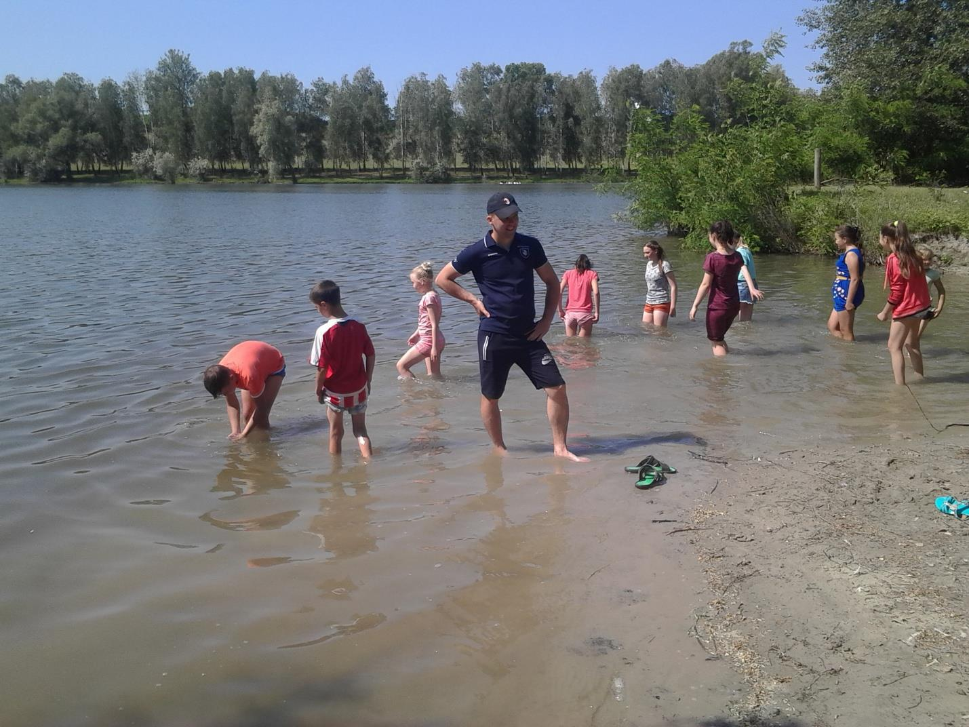

***You may come here to enjoy the scenery, peace and quiet.***

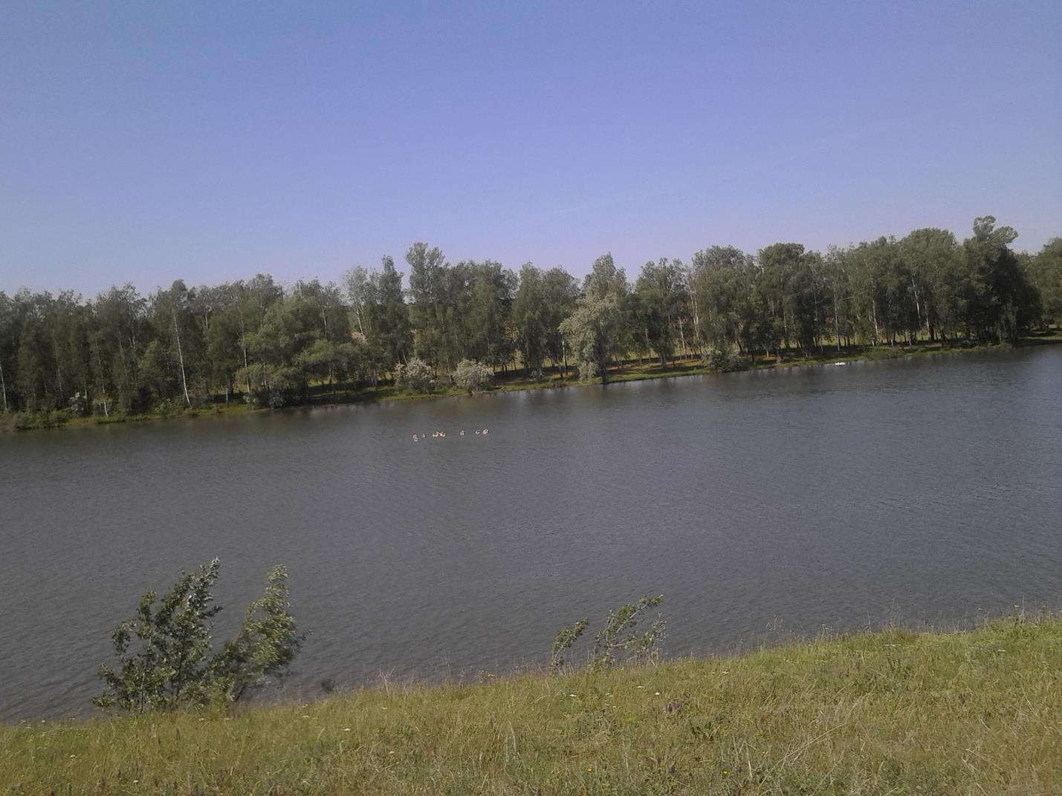

***You may stroll among the wonderful birches along a dramatic coastlinadmiring the enchanting, breathtaking landscape.***

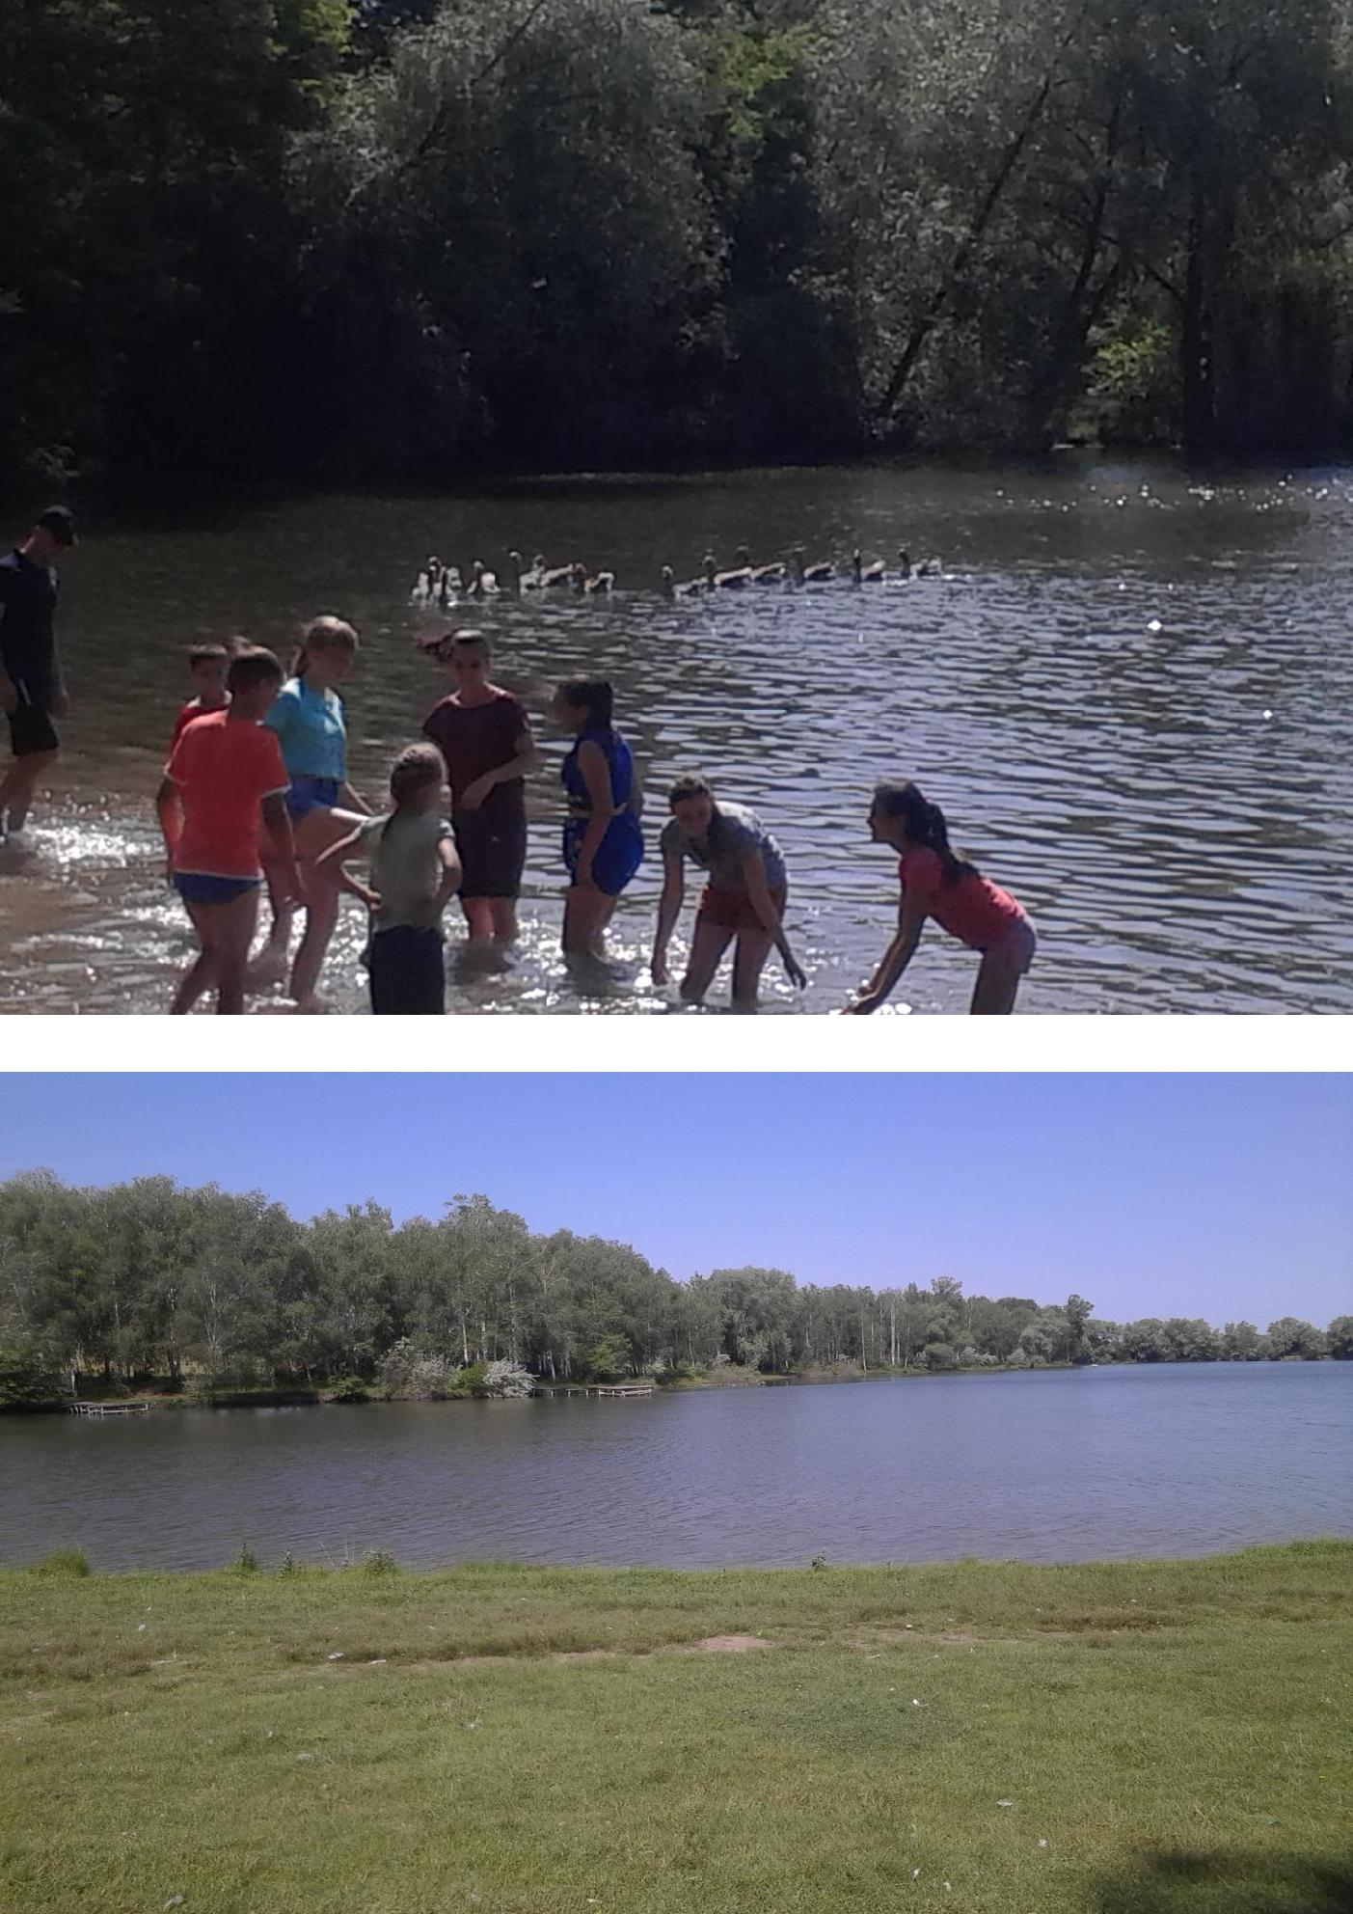

***WHATEVER HOLIDAYMAKERS ARE LOOKING***

***THEY’LL FIND IN HRYHORIVKA!***

