**Supersnake**

I. Read the text and then choose the right item to finish the sentence.

Supersnake was born on the planet Viper. He weighed 18 grams. He was 8 centimeters long. He had his first tooth when he was five weeks old. He said his first word at 9 months. His favorite toy was a big blue rattle. He got a pet fish called Sink. He got his first bike when he was 2 years old and he started school when he was four.

1. Supersnake was born...

A. on the Earth B. in the wood C. on the other planet

2. He was...... centimeters long.

A. ten B. eighteen C. eighteen

3. His first tooth appeared...

A. at five weeks B. at one year C. at five years

4. At nine months he.....

A. had his first tooth B. said his first word C. made his first step

5. His favorite toy was....

A. a bike B. a rattle C. a fish

6. His pet fish's name was...

A. Sank B. Snick C. Sink

7. When he was two years old he.....

A. went to school B. got his pet C. got a bike

8. He started his school.....

A. at two B. at four C. at six

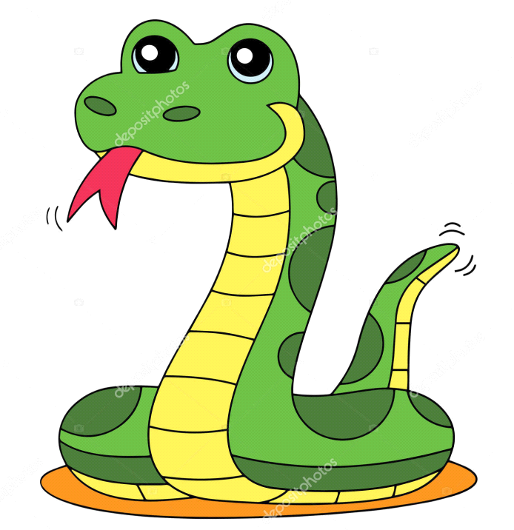

**Supersnake’s Fun**

II. Read the text and put the statements in the logical order.

Once upon a time Supersnake lived in a thick wood near the big lake. He liked sliding very much. It was winter Sunday. The weather was frosty. The sun was shining brightly in the blue sky. So Supersnake decided to go to the lake. There was a hill near it. His friend monkey Charlie sledged down the hill. They were very glad to meet each other. Supersnake slid very fast. Suddenly he felt into the water because the ice was thin. Charlie saw his friend into the water and helped him to get out the lake. Supersnake thanked Charlie and they went home to drink warm milk with honey and eat tasty pies. They were happy.

1. It was winter Sunday.

2.Supersnake thanked Charlie.

3. He liked to slide very much.

4. Charlie sledged down the hill.

5. Supersnake went to the lake.

6. Supersnake lived in the thick wood.

7. Charlie saw his friend and helped him to get out.

8. They were very happy.

9. Supersnake slid very fast and fell into the water.

10. They went home to drink warm milk with honey.

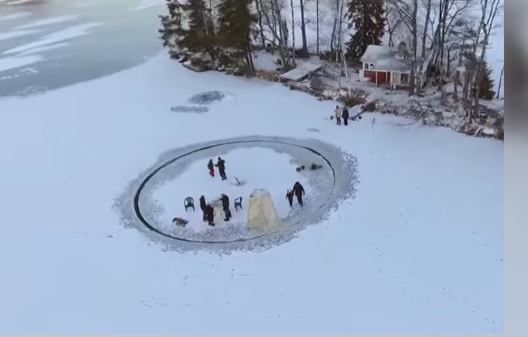

**Supersnake Is Afraid Nothing**

III. Read the text and mark True/False to the text.

Our well-known Supersnake wants everybody to consider him as a brave friend. He boasts about his courage among his friends.

Once he sees a very big dog running along the path. Supersnake runs away and hides himself into the high grass. But after some minutes he sees a big grey wolf. He runs away home and hides himself behind the wardrobe in his house. But under the wardrobe the mice live in the hole. When he sees them he hides himself under the bed not to see a mouse. The little mouse is also afraid everything. She sees the snake and runs away in the hole.

Supersnake's friends laugh at him.

1. Supersnake wants to be brave. True/False

2. He boasts about his wisdom. True/False

3. He runs after a big dog. True/False

4. Supersnake sees a little mouse in the grass. True/False

5.The wolf runs away from the snake. True/False

6. He hides himself into the wardrobe. True/False

7. The little mouse is brave. True/False

8. Supersnake is afraid of the mice. True/False

9. His friends laugh at him. True/False

10. The hole is in the wardrobe. True/False

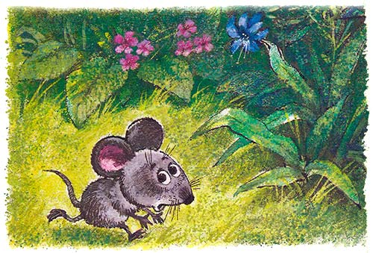

**Supersnake doesn't Want to Eat Soup.**

IV. Read the text and correct the sentences underneath.

It's morning. Mother wakes Supersnake because it's time to get up. He has to go to school. He gets up, dresses, washes his face, makes his bed. His mother calls him to have breakfast. For breakfast he has a tasty chicken soup. But Supersnake looks at the plate full of soup and says:” I won't eat this soup!” “Why? It is very tasty!”-says his mother.-” Now, I'll call a dog to bite you”.

But the dog doesn't want to bite Supersnake. Mother looks for a birch to beat the dog which doesn't want to bite Supersnake. The birch doesn't

want to beat the dog because the dog is not angry, it is kind and clever. Mother goes to look for a fire to burn the birch which doesn't like to beat the dog which doesn't like to bite Supersnake. But the fire also refuses to burn the birch.

Mother goes on looking for a stream to flood the fire which doesn't want to burn the birch which doesn't want to beat the dog which doesn't want to bite Supersnake. But the stream refuses to flood the fire.

Then Mother looks for a cow to drink the entire whole. The cow can't drink all water in the stream.

Mother looks for a butcher who can slaughter the cow which can't drink all water in the stream to flood the fire to burn the birch to beat the dog to bite Supersnake.

And the butcher says “Yes”. When the cow heard it, it agrees to drink the water, but the water will flood the fire, and the fire agrees to burn the birch, and the birch will beat the dog, then the dog will bite Supersnake.

When Supersnake learnt all it he eats very tasty chicken soup very fast.

1. I'll call a dog to eat this soup.

2. Mother has made peas soup.

3. Supersnake wants to eat this soup.

4. The dog bites the snake.

5. Mother looks for a string to beat the dog.

6. The stream agrees to flood the fire.

7. Mother looks for a cow to milk it.

8. The cow can drink all the water.

9. The butcher doesn't agree to slaughter the cow.

10. Supersnake eats his soup very slowly.

**V. Supersnake Is a Painter**

Supersnake likes drawing very much. He can draw everything: trees, flowers, animals.

One day he invited his friends to see his pictures. When they came, Supersnake showed them an empty canvas, without any paints.

-What is it represented here? - the monkey Charlie asked.

-The horse is eating the grass.

-Eating the grass? Then, where is the grass? -asked the hare.

-The horse has eaten all the grass.

-But, Where is the horse? We can't see it. - said the fox.

The horse? It has left the canvas as it wants to drink. -explained the snake.

-Where has it gone?-asked the donkey.

-It has eaten all the grass and gone to the farm to have a rest. - said Supersnake.

-What clever you are! How nice it is! Not bad as regularly.-noticed the monkey.

- Thank you very much you are pleased. I'll put my sign on it and give it for you as my present.

**Who said the following?**

1. Eating the grass? Where is the grass?

2. Where is the horse? We can't see it.

3. The horse has eaten all the grass.

4. Where has it gone?

5. What clever you are!

6. It has left the canvas to drink the water.

7. What is it represented here?

8. I'll put my sing on it.

**Supersnake Is Learning to Drive.**

Supersnake lives far from the school so he decides to learn to drive a car for getting to school faster.

He gets into the car and is driving along the road, then along the bank of the river. The birds are flying over the river. They see our pet and they are shouting: “Supersnake is driving a car.” He looks up the birds and his car has fallen into the river. What a pity! Poor thing! After some minutes he comes out of the water without his cap. He asks his friend Elephant to get the car from the water. Using the trunk the Elephant puts out the car.

A friend in need is a friend indeed! When the car is on the ground Supersnake sees that it has no one wheel, it's awful! There is neither a wheel nor a cap.

But a nice bird on the tree is shouting: “Look up! Look up!” And a poor snake sees his cap on the tree. The birds want to use it as a nest for little baby-birds.

What can he do? He is crying and going home without the cap and without the car.

**Chose the Wright items to complete the sentences.**

1. Supersnake lives...

A. near the school B. Next to the school C. far from the school

2. To get to school faster he....

A. takes a taxi B. learns to drive a car C. runs

3. The birds are flying...

A. over the wood B. over the river C. over the field

4. He drives the car...

A. along the road B. along the path C. over the field

5. His car has fallen...

A. into the pond B. into the river C. into the lake

6. He comes out of the water without...

A. a cap B. a boot C. a coat

7. Supersnake asks the Elephant to...

A. gets out the car B. get out his cap C. get out the wheel

8. The Elephant pulls out the car...

A. using the string B. using the legs C. using the trunk

9. Our pet sees his cap...

A. on the grass B. on the water C. on the tree

10. He is crying and...

A. going home B. asking birds to return his cap C. shouting at them.

**A Capricious Monkey**

**Read the text and mark True/False or I don't know.**

Supersnake is at the table. He is drawing. The door-bell rings and the monkey Charlie comes into the room. She is wearing a very nice dress. The monkey is coming up to the picture, looking at it very attentively. She sees that Supersnake is drawing a very nice house.

-Whom are you drawing this house for? - asks the monkey.

- For you, of course! Look! Here is a roof, a chimney, some trees.

- What will I do in this house? - Wonders Charlie. - There is neither a door nor a window in it.

The snake is drawing a big door and three large windows.

- But where can I swim, walk, lay in the sun? - asks his friend.

Supersnake is drawing a nice garden, a little swimming pool in the middle of the yard, different flowers. How beautiful it is!

- OK! It's better than it was before, but what will I eat in this wonderful house?-wonders the monkey.

Supersnake is drawing a kitchen-garden with carrots, salad, bananas, and radish.

- But who will look after all it when I come to see you? - asks Charlie.

Our pet is drawing a big dog near the house.

- A dog! It will bark all day long and at night. I don't like it.-says his friend.

Supersnake is getting angry, he is lifting his tail, his eyes are full of anger, he is coming up to the monkey. Charlie is frightened; she sees an open window and jumps through the window.

1. Supersnake is drawing the house.

2. His friend Charlie comes into the room.

3. Supersnake is drawing the house for himself.

4. Charlie doesn't like this house.

5. There are many windows and three doors in it.

6. There are five rooms in the house.

7. Supersnake is drawing a kitchen-garden near the house.

8. He is drawing a big garden with fruit-trees.

9. The dog will bark all day long.

10. Carlie is very happy to have this picture.

11. Supersnake is angry and wants Charlie to go away.

12. The monkey is running away through the open door.

**On the Way to School**

**Read the text and choose the right answer to the questions.**

It's Monday. The working day begins. The alarm-clock rings at 7 o'clock. Supersnake wakes up, looks through the window and shouts:” Good morning everybody! What a beautiful morning!” He jumps out the bed quickly. He opens the window, does his exercise to feel good the whole day and takes cold shower, as he does every morning. Then he dresses, drinks his glass of milk with a bun and leaves for school.

- On the way to school Supersnake meets a tortoise.

- Where are you going, tortoise? Aren't you going to school?-asks our pet.

- No. The warm days are over and it's time to prepare a bed for myself. I'll be sleeping under the ground the whole winter-answers the tortoise.

- Good luck, my friend!- says Supersnake and goes on. He walks through the wood. Autumn is here. The trees are brown, red and yellow. There are many mushrooms with their round hats. Crash!!! The nut has fallen, Supersnake looks up and sees a nice squirrel in the tree.

- What are you doing there? Aren't you going to school?- asks the snake.

- No. The warm days are over, I'm preparing for winter.- he answers. -I'm bringing nuts, mushrooms in my hole. I'll eat them when I wake up.

- Good luck! Have a nice dream! Supersnake goes on, singing.

On the way he meets a hedgehog.

- Aren't you going to school?-wonders our pet.

- No. I'm preparing my bed for winter. I'll be sleeping the whole winter- answers he.

Supersnake goes by a lake. There he sees big green frogs.

- Aren't you going to school either?- he asks them.

- No. We are going to hide under the ground and we’ll be sleeping till spring- answer the frogs.

Supersnake runs fast. Suddenly a strong wind begins blowing, the leaves are falling down on the ground one by one. He looks up and sees birds flying in the sky. They are shouting to him

- Good-bye, Supersnake! We are leaving for warm countries for winter. We'll be back in spring! Wait for us!

- Good luck, my friends! See you in spring!- says Supersnake.

He looks at his watch and understands that he is late. He comes back home to ask mother what he will do in winter.

1. What time does the alarm-clock ring at?

A. at 9 o'clock B. at 8 o'clock C. at 7 o'clock

2. What is the weather like that day?

A. it is bad B. it is nice C. it is rainy

3. What does Supersnake have for breakfast?

A. a glass of milk B. a cup of tea C. a glass of juice

4. Whom does he meet the first?

A. a tortoise B. a squirrel C. a snake

5. What has fallen down from the tree?

A. a nut B. a leaf C. a mushroom

6. Whom does he meet at the lake?

A. big green frogs B. many snails C. a big brown frog

7. Has the weather changed suddenly?

A. no. it hasn't B. yes, it has C. it; s the same

8. Where are the birds flying?

A. to the wood B. to the south C. to the north

9. What does Supersnake understand looking at his watch?

A. he has to go to school B. he is late C. he is in time

10. Why does he come back home?

A. to learn what time is B. to prepare for winter C. to learn what to do in winter

**Read the sentences and put them in a logical order to make up the story.**

Dear Santa Clause,

1. This year I have been very obedient though sometimes it is so difficult.

2. That’s all.

3. My name is Supersnake.

4. But if you wants to bring me more presents, no problem, I’ll be agree.

5. Do you know, my elder sister doesn’t want to play with me. She says I’m little but I am six years old.

6. I live in a small house in the wood.

7. I ask you for only two presents: a new bike (because my old one is broken) and many books (because my Mum says I have to read them).

8. It is a very picturesque place not far from the lake.

Love. Supersnake.

**It Is Time To…**

**Read the text and choose the best phrase from A-F to fill in gaps 1-6.**

All day on the wall the clock says “ Tick-tock, tick-tock. How busy am I? I am working without stopping. 1 ____________

In the morning Dad wakes up the first. He looks at the clock and asks :

- What is the time?

- It’s time to shave-says the clock.

And Dad shaves. 2 ______________

- What’s the time?-she asks. 3 __________

And Mum starts cooking. Supersnake also gets up, looks at the clock and asks:

- What time is it?

- It’s time to wash a face and clean teeth-says the clock.

4. ___________

Then Dad, Mum and their son have breakfast.

The clock ticks on the wall without stopping. It says:

5. ____________

After breakfast everybody looks at the clock and says:

- It’s time to go to work-says Dad.

- It’s time to go shopping- says Mum.

6. ___________. And they leave the house.

**A.**  Mum enters the room and looks at the clock.

**B.** And Supersnake does it.

**C.** It’s time to make breakfast-answers the clock.

**D.** It’s time to go to school-says Supersnake.

**E.** How busy am I!

**F.**  I am telling everybody what to do.”