**Фонетичний міні-урок на тему**

**“The long ‘e’ sound”**

**Theme**: The long ‘e’ sound.

**Objectives:** to practice the long ‘e’ sound by students.

**Necessary equipment**: words (flashcards), writing cards, reading cards, posters, multimedia board

***Procedure***

1. ***Organizing a lesson. Greetings*.**

**Teacher:** Goodmorning**!** Today we are going to practice the long ‘e’ sound. **:** Look at the blackboard. There are two cards on it. Today we’ll learn the sound [ i: ]. Look and repeat.

**ee** are pronounced *[ i: ]* beetle, bee, beet, street, seed, reed

**ea** are pronounced *[ i: ]* seal, tea, beach, peach, cream, stream.

*(Students repeat, chorally and individually. Individual pupils say the words.)*

1. ***The main part*.**

**Listening comprehension**

**-pre –listening**

**Teacher:** First of all, you have to remember some rules. When you hear the long E sound, it can be spelled in several ways. The long E sound can be represented in 2 vowel teams (“ea” and “ee”), an irregular vowel team (“ie”), the open syllable rule, e.g., *me,* and “Y” as a vowel at the end of a word, e.g., *bunny*.

**Teacher:** Now, we are going to watch the video *“Learn to Read”*, which is divided into two parts (<https://www.youtube.com/watch?v=zsPPggEUaak> ).

**-while-listening**

**Teacher:** Listen to the first part of the video “Song” (4:30) and write down the words with the long sound ‘e’ into your copybooks.

(*Students listen and write*)

**-post-listening**

**Teacher:** What words were there in the video? (sleep, sheep, peep, team, steam, dream, athlete, compete). What rules are you able to say? What are the ways to spell long ‘e’ sound’?

*(Students answer the questions*)

**Reading & Writing**

**Teacher:** Look at the blackboard and read the rules. Say some other examples.

1. **Vowel Team – EE**

The vowel team rule states that when two vowels go walking, the first one does the talking. The combination of two **e’s** (double vowels) results in the long ‘**e’** sound. There are many [EE words](https://www.sightwordsgame.com/spelling/ee-spelling-words/), e.g. *cheese, geese, meeting, bee, tree.*

1. **Vowel Team – EA**

The combination of both an **“e”** and **“a”** (double vowels) also results in the long **‘e’** sound. Similar to the **ee** words, there are many [EA words](https://www.sightwordsgame.com/spelling/ea-spelling-words/) that make the long **‘e’** sound, e.g., *beach, bean, heat.*

1. **Irregular Vowel Team – IE**

The vowel team rule states when two vowels go walking the first does the talking and the second vowel is silent. Like most things in life, there are exceptions. The combination of the vowels **“i”** and **“e”** can result in the long **‘e’** sound, e.g., *achieve, belief, chief, field, priest, piece and siege.*

1. **Open Syllable Rule – Long E**

An [open syllable](https://www.sightwordsgame.com/spelling/open-syllable/) occurs when a vowel is at the end of the syllable (it is not closed by a consonant).

* Initial Sound – *emit, evil, even and eclipse*
  + Medial Sound – *area, really, female and legal*
  + Final Sound – *be, he, she & we*

*(Students read and speak*)

**Listening comprehension**

**-pre –listening**

**Teacher:** What rule is missed in the first part?

**Y as a Vowel**

The letter [Y as a Vowel](https://www.sightwordsgame.com/spelling/y-as-a-vowel/) is more common than Y as a consonant. When the letter **“y”** is at the end of word, it sometimes makes the long **‘e’** sound, e.g., *baby, candy, family and city*. Y as a vowel at the end of a word can also make the long *‘i’* sound, e.g., *my, cry.*

**-while-listening**

**Teacher:** Listen to the second part of the video “Story” (4:30-7:00) and write down the words which the letters make into your copybooks.

(*Students listen and write*)

**-post-listening**

**Teacher:** What words were there in the video? (trap, rat, tap, art, party).

*(Students answer the questions*)

**Writing**

**Teacher:** Let’s revise your grammar. Look at your cards and complete them. Read the rules.

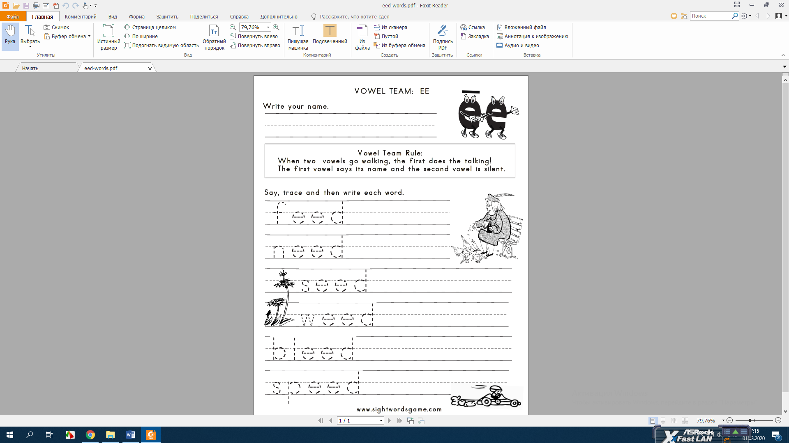 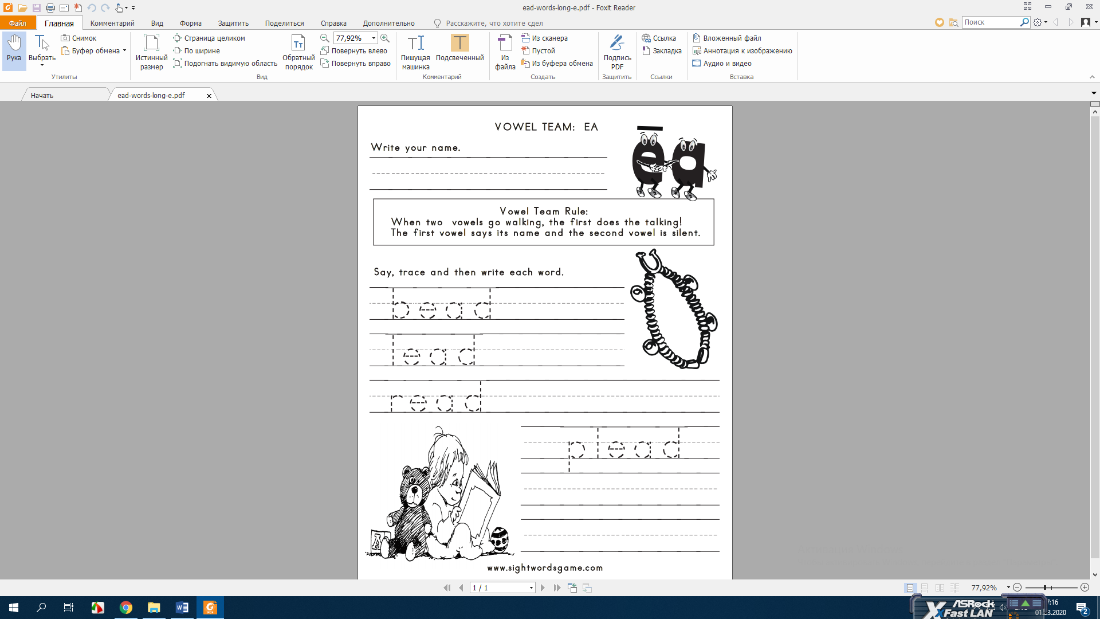 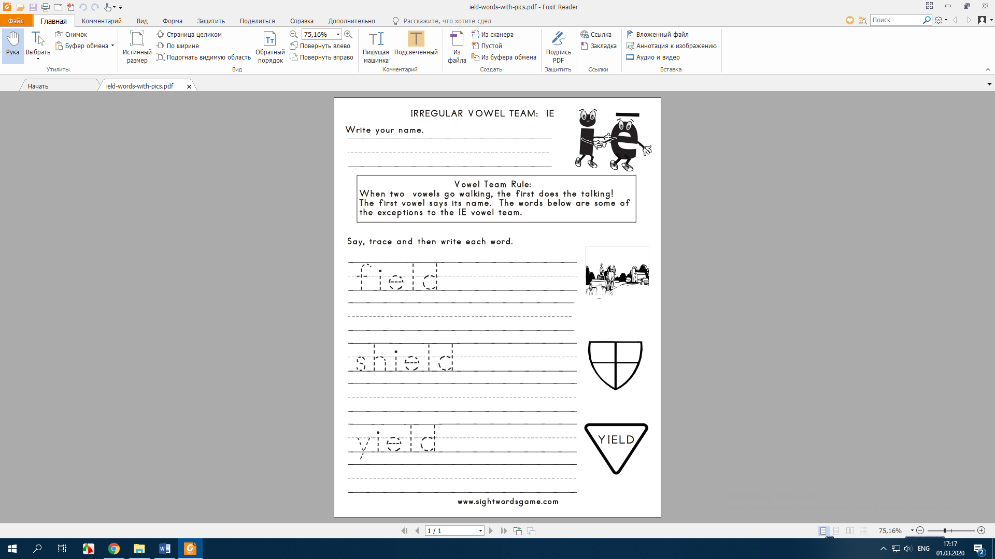 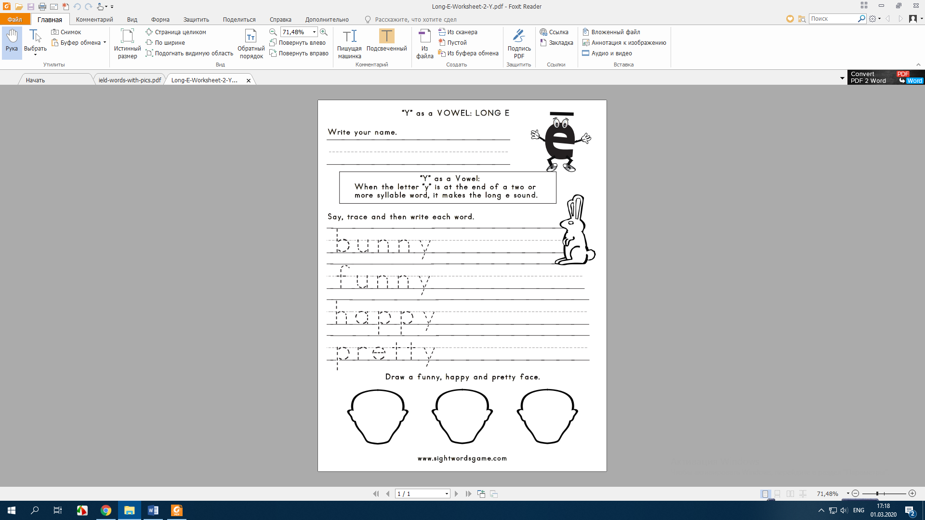

*(Students write and read)*

***III. Summing up*.**

**Teacher:** Pupils, what did we do on the lesson? I think that we have achieved our aim. We have practiced on the long ‘e’ sound. Thank you. Good bye.