**Teaching Dialogical Speech: Elementary to Advanced Levels**

**Elementary level**

Elementary level usually involves pupils of primary school in specialized schools and those of 4th or 5th grade in general comprehensive schools/ Though the age of the learners is different in these corresponding groups there are some ideas for teaching dialogical speech that might be useful and helpful in work with both groups of pupils. We’ll need such things:

* a book of Calvin and Hobbes cartoons or your other favorite cartoon from a book or the newspaper;
* several copies of an easy to read book that contains dialogue (we used the "Bunnicula" easy to read spin-off books);
* sentence strips;
* sharpie markers;
* paper and pencil for the kids;
* notes on paper for the kids – it is better to try using the reteach page that might come with the teacher’s language series.

The first step of dialogical teaching at the elementary level is brainstorm – we ask the kids what they already know about dialogue. What is it? They will probably say "people talking". The teacher is to guide them to tell more... what does it look like in a book? (quotation marks) How do you know who is speaking? (tag lines / "details") . . . one will be surprised how much they come up with when they can bounce ideas off each other. We may ask someone to give an example and write it on the board. The example can be used to help the teacher discuss the placement of the punctuation and tag line with the students. It is also possible to discuss how tag lines can be made more interesting by using adverbs to spice things up ("I have a stomachache," moaned Sara.) [12, 28]

The second step is to have kids write down what the class has brainstormed as part of their notes, including the example. We can provide some written notes on paper, but it is also good to have them add a few things. When they write it themselves, it is much more meaningful.

Then, we use our language series reteach page. It is very easy. It just lists a bunch of sentences written as a dialogue and the pupils very simply have to underline exactly the words that were said. All the students could do this very quickly, making this a good confidence booster.

The second task on the reteach page we can use is to have pupils write a 5 line conversation of their own. Instead of following the directions exactly here, we can have kids get into groups of 2 or 3 and make up the conversation together. The teacher should remember, we have only just barely introduced this so we don't feel the need to silent, solo seat work at this point.

The following step is to have pupils "perform" their conversations and discuss where they included punctuation.

During another lesson, it is useful to distribute copies of some easy to read books that contain dialogue. The teacher can use the Bunnicula spin-off books which are aimed at a 3rd grade reading level or lower. The task is to have pupils find the examples of dialogue like a scavenger hunt. Have them find one with the tag line in the beginning of the sentence, for example. Have them find one exclamatory, one declarative, one imperative and one interrogative sentence. Extend it as far as you want it to go. The teacher could give them one item to find at a time and the first pair that finds it correctly gets a point. The group with the most points at the end of the class could win an ice cream from the cafeteria or a small prize.

During a subsequent lesson, the teacher gives pupils a couple of frames from a Calvin and Hobbes cartoon. We can get cartoons from the paper or a book and have pupils work in pairs to take the dialogue in the speech balloons and write it as dialogue. Pupils can then put together their work as a class to complete the whole story [15, 32]

Another thing we can do is to write some quotations on sentence strips, cut them up and have pupils arrange them appropriately so they can show the teacher that they know where the punctuation goes. This makes a great centers activity and informal assessment.

For morning work or as an "exit ticket" it would be quite effective to chop up some tests that include dialogue. This way, pupils will be familiar with the kind of questions asked and the format of the test.

**Pre-intermediate level**

Pre-intermediate students perhaps can best be summarized with the following statement: They are in a state of transition, having acquired the basics of the language yet unable to use these elements consistently and accurately.  
The weakest of pre-intermediate students can handle short, basic conversations relegated to work, family, hobbies, and other areas of interest. In many cases, a lack of vocabulary sends the students scurrying for dictionaries, as they don't yet possess the ability to explain around unknown words. In fact, vocabulary usage remains quite low, and suffices for simple conversations. These conversations tend towards the reactive rather than the participatory. In other words, students can ask and answer questions, but little or no additional information or follow-up questions voluntarily occur. The conversations often feel more like an interview.  
Stronger students at this level similarly react to conversations, unless otherwise directed by the teacher. (For example, the teacher instructs the students to speak about two questions for at least five minutes, or assigns the class to ask additional questions based on a partner's response.) Stronger students may also speak with somewhat more ability and confidence on less familiar topics, yet they will do so with long pauses. These topics will need to focus more on concrete, everyday aspects like travel, friends, or work. Discussions on politics, the environment, and most current events will generate only the most elementary of responses, and will lead to frustration rather than a meaningful opportunity to practice the language [20,15].  
 In order to show the practical skills of pre-intermediate students we prepared some types of exercises such as ordering, matching, gap filling, finding your partner mill drills, completing the dialogue, relay dictation, stripper dialogues, incorrect dictation, Jigsaw listening as a review, freaky friday opposites, reconstructing dialogues, directed dialogues/role-plays, conveying attitudes, lost in translation, write and swap. These exercises are very helpful in improving speaking, listening, reading and writing skills.

***Ordering:***

The teachercut up the dialogue and pairs reorder.

***Matching:***

The students should match prompts with replies. Then the teacher cuts up cards and pairs match and type on paper. The task of students is to match individually in pairs. The students should practice reading with good intonation and pronunciation. Once matched drill chorally and individually. The teacher gives students prompts and elicit responses.

***Gap fill:***

The students’ task is to make a gap fill in order to highlight a grammar point or lexical set. They need to white out all future tenses (this could be a lead in to a grammar presentation) and white out all foods and drinks. The teacher may asked the students to write in their own ideas. This could work like a substitution drill.

***Find your partner mill drills:***

The teacher takes a pair of clear /obvious prompts and replies from several dialogues. Each prompt/reply should be written on a separate card. The students memorize their phrase. Student A walks around the class saying his phrases to other students. All students must listen to each other’s phrases. The goal is to find your partner. The partners have to stand together when they found each other. As a check, the teacher asks students to say their prompts/replies for the whole class. She might want to follow up by asking the class in what situation would they hear these phrases.

***Complete the dialogue:***

The teacher whites out one of the character’s lines in the dialogue. Pairs work together to complete the dialogue. Pairs compare with the original version.Then she leaves the first two lines of the original dialogue intact. The teacher whites out character B’s lines and gives the paper to student B and whites out character A’s lines and gives to student A. After that she pairs A’s together to complete their dialogues and pairs B’s together to complete their dialogue. The teacher switches pairs and puts A’s and B’s together, too. A’s and B’s read their side of the conversation to see if the whole conversation makes sense. They could discuss changes that should be made and compare with the original dialogue.

***Relay dictation***

The teacher explains the context and situation and elicits the sort of things people might say in this situation. The teacher posts sentences from the dialogue in a random order at back of room. Student A looks at the paper and memorizes the sentence. The teacher returns to team and dictates sentence to Student B. Student B goes to the back of the room and tries to memorize the next sentence. She returns to the team and dictates to student C. The team that finishes the first gets one point. The teacher explains that some sentences are spoken by the Person A and some by Person B. She asks students to identify which sentences are spoken by whom and to order the dialogue. Then she gives a copy of the original dialogue. Students can check the dictation (including spelling) and the order.

***Stripper dialogues***

The teacher boards a simple and short dialogue on the board. She drills it and erases the last part of the first sentence. She asks students to read aloud together; they must supply the language that has been erased. She erases the second half of the second sentence and repeats. She has to keep repeating this process until all of the dialogue has been erased and students are doing it from memory.

***Incorrect dictation***

The teacher tells students that her eyes are very tired. Then she explains that she will try to read a dialogue for them but that she might make mistakes. The teacher asks students to underline any part of the dialogue which differs from what she actually say. She reads the dialogue making deliberate mistakes (*house* instead of *hotel, drop you off* rather than *pick you up*). She checks the differences with students and asks what they have actually said (this is great for generating more vocabulary, such as antonyms or synonyms). Then she may asked some basic comprehension questions.

***Jigsaw listening as a review***

The teacher pre-records three or four dialogues on different blank tapes. She puts different groups into different rooms and asks them to answer some questions. For example: What is the situation? Who are the people? What is happening? How do they feel? How do you know? They can listen as many times as they’d like. When they are ready, the teacher asks one person from each listening group to form a new group for speaking. Each student can explain the situation to their partner in their own words. Perhaps they could wrap up by saying which conversation was most interesting, amusing, etc.

***Freaky Friday Opposites***

The teacher gives each pair a dialogue with the instruction that they should re-write it and make it opposite in meaning. So, if the dialogue says “Oh, I am very sorry, sir” then the students re-write it to say something like, “Serves you right, sir”. Or they change the following…*Teacher:* “Could you all please sit down and be quiet while I am talking?” *Students*: “Sorry, Ms. Calton.” New Dialogue: *Teacher*: “Could you all please stand up and shout while I am talking?” *Students:* “Of course Ms. Calton”. These can be quite funny depending on the situation. The teacher ask the students to perform this dialogue in front of the others.

***Reconstructing dialogues***

The teacher asks students to read through a dialogue. She tells them that they should try to remember as many details as possible and takes away the dialogues. In pairs the teacher asks students to write down key words that they can remember. Which pair could remember the most items? The students should compare their key words open class and board the words. The teacher asks them to work together and try to reconstruct the dialogue. Then the pairs compare dialogues and check against the original.

***Directed Dialogues/Role-plays***

As a warmer, the teacher gives students prompts. They should create their own dialogues. She can get inspiration from pre-made dialogues. For example:

Student A: Welcome your guest Student B: Respond

Student A: Ask about the journey Student B: Respond

(negatively)

Student A: Say you’re sorry. Student B: Respond

***Conveying attitudes***

We got this idea from a transactional psychology book we read recently. The teacher gives each student a role-card, explaining who he or she is, how she feels and why. (This book pointed out that we can assume different roles in any given situation and we have expectations for how people should respond to us in the given situations.) The student A should read his part in character and the student B should try to respond in an appropriate manner. Here we can consider the tone of voice, intonation patters, gestures, etc. The audience should try to guess what the student is trying to convey, how he feels and why. The teacher might also give the student, the freedom to adlib and add on.

***Lost in translation***

The teacher divides the class into groups. Each group is assigned the speech bubbles from one character. (This can be typed up on separate pieces of paper for each group). Each group translates their sentences/phrases into Ukrainian on a separate piece of paper. This can be done in class or as homework.Groups then exchange their translations with other groups. Now students must translate their classmates’ Ukrainian back into English. The teacher allows students in each group to consult each other.She compares it with the original dialogue and helps to highlight and drill any phrases or lexical chunks that students had difficulty with.

***Write and Swap***

The teacher gives students a situation, such as “Dealing with complaints”. She asks them to brainstorm around the topic. For example, she boards a list of what passengers may complain about and boards another list of phrases used to show sympathy, etc. Then she asks students to work in pairs to write their own dialogue by choosing some of the boarded items. Teacher checks dialogues. Then the pairs switch and perform another pairs dialogue for the class [16, 25].

**Intermediate level**

The Intermediate student is a very pleasant person to deal with. He/she has begun to communicate in English fairly well; can describe interests, preferences and daily activities, can inquire about matters of common interest and even about your health. This is the stage at which the student enjoys learning English the most. The student is happy to be able to converse in English; it is a newly found freedom of expression ( previously his thoughts and desires were confined to his own inner mind) which opens wide a window of opportunites including travel, study abroad and research [30, 214].

We designed a set of practical tasks and activities focused on developing speaking skills of intermediate students in the form of lesson on the topic “Pleasure or reading”. This lesson contains such teaching sections as grammar section, reading section, social English section.

This unit begins with the introductory debates. It’s common knowledge that reading is not popular among teenagers nowadays. In two groups the students should decide ‘Why to read?” The teacher divides the students into "optimists" and "pessimists". They use the previously learned material as the ideas and the language support follow the model for the debates given in their lessons.

The next task is making up and presenting stories. In two groups (the teacher should divide the students in groups according to their studying level. Group A is more advanced students and Group B is of lower level). The students make up a story using the words of narration and connectors and present their stories in class. The teacher can add some more words of narration. E.g:

- to begin with

- from the very start

- mentioned above

- before

- until

- as soon as

……………

Group A makes up a story using the pictures given by the teacher and Group В completes the story.

The second task is group or pair work. Each group or pair picks out two or more pictures and prepares a short presentation in a form of a chain story or a dialogue. One of the criteria for evaluation is using of connectors and words of narration.

Sample 1.

A chain story.

S1: At the beginning of the day my family had breakfast as usual.

S2: Afterwards I rode a bike to school because we don’t have a car.

S3: Just then I met my classmate…

Sample2.

A dialogue.

S1: - You see Frank, our lessons are over. Let’s first go to the swimming pool and then play football.

S2:- Although I like your idea I’m afraid I can’t.

S1:- But why?

S2: - Actually I must walk my dog and later on I should prepare or the test.

S1: - O.K. don’t mind. Anyhow we can play football on Sunday [36, 8]

The following grammar section helps students to improve their knowledge in future tenses.

*Task 1*

The teacher divides the jigsaw dialogue given in the exercise in parts. In pairs the students complete their part of the dialogue using suitable future forms. Then the pairs set out the logical turn of narration and act out the dialogue in chain.

*Task 2*

The teacher distributes the pictures and the captions among the students so as every student has either a picture or a caption. The students find their pairs matching a picture with the caption. Then they make up a short dialogue illustrating the situation in the picture using the caption.

E.g. S1: - What’s the matter? You are crying, dear.

S2: - I’m so upset. You don’t remember about my birthday!

S1: - Don’t be blue. I know I’ve forgotten about your birthday today but there’ll be others.

*Task 3*

The teacher combines the real life situations from parts A, B of the exercise from students’ book. The students in turn pick out the cards with these situations, tell about it to the class asking for advice. Other students give their piece of advice in turns following the criteria:

using future forms;

reasoning;

E.g. S1: - My mother is very tired after work and I’m hungry.

S2: - Are you going to warm the cooked stew from the fridge?

S3: - Will you go to the supermarket for some ready made food?

S4: - I think, you won’t die while your mother is having a short rest. Wait a bit.

S5: - ………………………………………………………….. [18, 152]

Reading Section presents the ideas of practising reading skills and carries out cognitive function.

*Task 1*

The teacher can arrange a jigsaw reading in three groups with filling in the format and exchanging the information.

Sample format

|  |  |  |  |
| --- | --- | --- | --- |
| questions | Group 1 | Group 2 | Group 3 |
| 1. The topic of the passage | The earliest books | Invention of printing | Famous libraries |
| 2.Historic period | Ancient times | Middle ages | 19th– 20th centuries |
| 3.The most peculiar facts | - on tablets of wood or pieces of bark;  - clay tablets and papyrus;  - skins of young animals;  - survived until the present days | - books were handwritten;  - libraries used to chain books;  -Johan Guttenberg invented printing first | - the system of public libraries appeared;  - the largest library is the Library of the US Congress (90 mln items);  -computers and electronic catalogues are used |

Then each group presents the information they’ve got from one of other groups. They may make presentation using any self-made visuals [ 24, 138]

The following Social English Section focused on pair work, reading for discussion, communication activities which develop fluency and give students practice in using the language under controlled conditions.

*Pair work*

The teacher distributes the pictures among the pairs. The students are to make up a short dialogues using “instead of doing smth” as in the example:

S1: - Dick, did you finish reading your book yesterday?

S2: - Oh, no. I was working in the garden instead of reading. Etc.[31, 110]

*Reading for discussion*

After reading the text the teacher offers the following communicative activities:

1) Guided dialogues.

While acting out the dialogues the students should be active and polite, using active lexis of the text.

Matilda Her Father

“Easy Cooking” the telly

you could buy me a book you’re getting spoiled

smth more interesting any problem, dear

Matilda The Librarian

The children’s books to help you

I can manage with a lot of pictures

Matilda The Librarian

I’ve finished What sort of a book

Grown-ups read try the book by

2) Class discussion

The teacher can organize the discussion if the events described in the story can or can’t happen in reality. The students should express their opinion and give reasons. Then the students do the next exersise in the form of an interview game. The students walk around the classroom asking the questions to collect the information suggested in the exercise. They should fill in the following format.

|  |  |  |  |  |
| --- | --- | --- | --- | --- |
| questions | S1 | S2 | S3 | ………….. |
| How often do you read books?  What kind of books do you prefer?  What authors do you like?  ……………… | Every day  Detectives  Christie  ……………. | Never  Poems  Pushkin  ………………. | Seldom  Humour stories  O’Henry  ……………. | ………….  …………  …………..  ………….. |

*ASSESSMENT*

The teacher offers two situations to the pairs of students. Each pair chooses one they like. The situations may be the following:

1. Make up a dialogue between a librarian and a student on the situation: the student doesn’t remember the name of the author and the title of the book he must read for his class. The librarian asks him questions and helps to find the necessary book [36, ]

2. You are going to your friend’s birthday and want to buy a book as a present. Your partner laughs at your idea because he thinks reading is out of fashion. Try to prove your choice.

Criteria for evaluation: - Be active and polite.

- Speak 2 – 2,5 minutes.

- Use topical vocabulary of the unit.

**Upper-intermidiate level**

Upper-intermediate learners have taken great strides in mastering English.  Vocabulary and grammar from the beginning stages of learning hasn't yet become automatic, but they can talk about a variety of everyday topics with relative ease.  In fact, when talking about the weather, hobbies, work, or subjects of personal interest, they sound much stronger ability-wise than in truth they are.  Discussion or dialogues on difficult, unfamiliar topics is achievable, too. Conversation strategies have begun to find their way into conversations, as upper-intermediate learners become increasingly aware of intonation; rates of speech; polite versus formal English; English for general conversation, making requests, or complaining.

What final words can summarize upper-intermediate students?  
1.  Experimentation with language goes hand-in-hand with this level, as they possess the foundation and skills to move beyond everyday topics.  
 2.  Mistakes are evident in even basic communicative tasks, but they don't usually hinder comprehension.

3.  And perhaps the best measure is the following: Upper-intermediate students can be understood by native English speakers with little difficulty, although some repetition may be needed.  What's more, even native speakers unfamiliar with the usual mistakes and idiosyncrasies connected with the ESL speaker's mother tongue can understand the conversation. [37, 2]

The set of practical tasks for upper-intermediate students as in previous intermediate level are presented in the form of lesson on topic “Sport in our life”.

Among different sections of the unit much attention is paid for grammar section in which we propose to practise subjunctive mood in communication through dialogues. It would help students to improve their knowledge of grammar on one hand and to practise communicative skills on the other hand.

*Task 1*

The teacher gives the photos of modern popular sportsmen (e.g. A.Kabayeva, E. Plushenko, D. Backham, etc.) to students. They match the pictures with the names of the sportsmen and the kind of sports. Then in groups the students choose any photo or picture they like, discuss all the info they know about this sportsman and make a short presentation.

*Task 2 Guessing game*

The students work in pairs. The first student takes a picture of sport equipment and doesn’t show it to partner. The second student asks questions to guess the sport. Possible questions:

Is it indoor or outdoor sport?

Where can people practise it?

What equipment is necessary? Etc.

*Task 3*

The students do the task given in the student’s book. In pairs they make a page in the guide book about sports in their city. They can use the material of the exercise as an example. Then the students should present their information in a dialogue between a stranger in their city who is interested in sports and a native person. The students can use the flowchart.

S1 – a stranger

S2 – a native

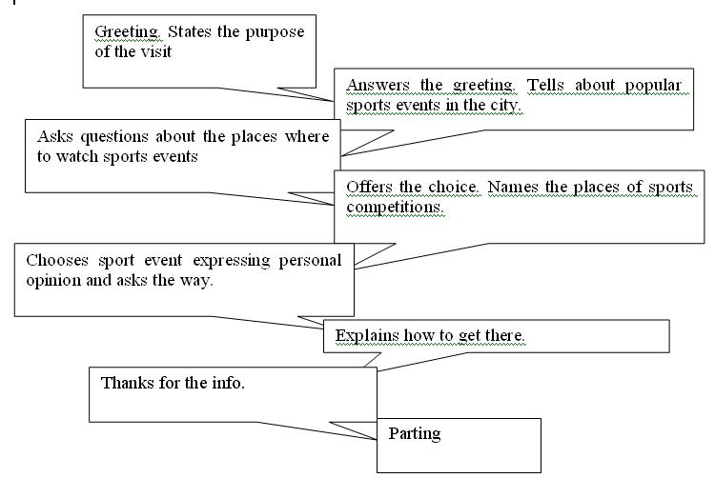

*Task 4*

The students work in small groups. Their task is to find out how often their friends go in for sports. They should ask other students about it and note their answers.

|  |  |  |  |
| --- | --- | --- | --- |
| Sport activity | Name | Frequency | Comments |
| Athletics  Football  Wrestling  Basketball  Martial arts  ……………. | Sasha  …………. | Twice a week  Never  Every day  ……………… | I’m not interested  I’d like to go in for  I’m going to give up  …………………. |

Then they collect the information from the other members of the group and report about the students they’ve interviewed.

*Task 5*

This task is the exercise from students’ book containing the verbs *to do* or *to make.*

The following steps of doing it:

1) teacher distribute the dialogues;

2) students in pairs find and correct the mistakes (the teacher should mention the number of mistakes beforehand. E.g three);

3) the pairs act out their corrected dialogues;

4) while acting the other pairs tick the mistakes in using the verbs *to do* and *to make* if there are any.

|  |  |
| --- | --- |
|  | Mistakes |
| Pair 1  Pair 2  ………… |  |

Sample dialogues:

The verbs in italics are used wrongly but in the students’ cards it is not shown.

S1 – Who *makes* housework in your family?

S2 – My mum makes dinner and I *make* the shopping. What do you do?

S1 – As for me, I do the washing up but I never *do* my bed.

S1 – I’ve heard you *do* progress in English.

S2 – You are right. It’s because I *make* my homework every day. By the way, have you done the translation for tomorrow?

S1 – Yes, I did my best but I’m not sure if I *did* no mistakes.

*Task 6*

Then in two groups students read the text “Ancient Olympics” and “Modern Olympics”. And the groups ask each other questions to fill in the format.

|  |  |  |  |
| --- | --- | --- | --- |
| questions | different | | common |
| ancient | modern |
| 1. purpose  2. participants  3. events  4. seasons  5.kinds of competitions  6. people | - Saluting gods  - only men  - racing; later chariot races, pentathlon, wrestling  - only summer  - sports, oratory, music and theatre  - only Greeks | - Saluting athletic talents  - both men and women  - different summer and winter sports  - summer and winter  - only sports  - international | - Conflicts must be stopped  - winners are awarded and honored  -showed their personal achievements and records |

The students should discuss the text with their partners and find out:

- if he / she finds this info interesting? Why?

- would he / she like to visit ancient or modern Olympics? Why?

- would he / she like to watch or participate in any? why?

In their dialogues they must use the active vocabulary of the text, different types of questions, phrases of politeness, speak about 1 – 1,5 minutes [32, 8].

*Grammar Section. Subjunctive Mood.*

To practise Subjunctive Mood in communication we offer to involve the students into guided dialogues on the following situations:

you want to keep fit;

you are often ill;

you are overweight;

…………………..

The students can ask their partners for advice.

E.g. S1: You see, I’ve got some problems.

S2: Really? What are they?

S1: I’ve put on weight and I’d like to stop it

S2: If I were you I would (join some sport club, give up eating cakes, etc.)

The certain unit is devoted to sports but the grammar, i.e. Subjunctive Mood, allows to speak on a wider range of topics. To make grammar section more communicative and not so boring we offer the following activities.

Students work in pairs and try to cope with the problems:

your bike has broken down;

your mobile phone was stolen yesterday;

you need to prepare a report for tomorrow;

your parents are away for a week; Etc.

E.g. S1- states the problem.

S2 – gives advice beginning with: If I were you I would….

*Running dictation.*

Students work in pairs. Each pair takes one card with a certain situation. Different phrases to develop the situation are displayed around the classroom. S1 “runs” about the classroom, reads the phrases and then repeats them to his / her partner who is at the desk and makes a list of them. The teacher limits the time (3-4 minutes) to collect the ideas. Then each pair makes up a short dialogue on the situation they’ve got using Subjunctive Mood.

Situations Developments

a) be in Ukraine - buy an expensive bike, mobile

phone, computer, etc.

b) see a ghost - take a picture

c) loose a mobile phone - have a shock

d) have a lot of money - report to the police

e) quarrel with the friend - (not) tell parents about it

f) miss the classes - be upset

g) go on a journey - hide my record book

h)………………. - be punished

- make friends with

- visit….places

- ……………………..

Sample dialogues:

S1: You see, Mike, I’ve quarreled with my friend and I don’t know what to do.

S2: If I were you I would cry. (If I quarreled with my friend I would be very upset.)

The following exercise can be done in two variants. Before doing the task the teacher draws the students’ attention to the criteria of evaluation (they can be displayed on the board if necessary):

correct Subjunctive;

sensibility of advice;

the number of ideas;

equal participation.

The teacher divides the students in groups. Each group gets a piece of the picture. They discuss what they would change. The groups display their parts on the board to make the whole picture and present their ideas. Groups have different pictures of rooms and the students discuss what they would change there. Then they present their pictures and ideas to the class.

*New Words to Learn.*

The teacher can practise the new words in the following way:

1. divide the students into two groups;
2. give each group equal number of cards with different new words or word combinations;
3. groups in turn take one card and make up a question with the word on the card for their opponents to answer it;
4. if the other group answers the question correctly then it’s their turn to ask. If not, group1 takes another card and asks the question again;
5. the winner is the group used all the cards in questions first [30, ];

*Listening comprehension.*

To develop speaking skill the teacher can organize a press conference with “Sophia” (S1) and “Patrick” (S2). The other students ask questions using ideas of exercise from students’ or their own ones and make notes to collect the information for a poster they are to make. After the conference the teacher divides the students into two groups. Each group makes a poster about “Sophia” or “Patrick”.

Criteria for evaluation:

- a catching title;

- informative;

- colorful;

- sport lexis is used.

*Discussing the topic.*

To get the students ready for the final assessment of the unit the teacher can organize the debates “What is more enjoyable – to watch or to do sports?” before the debates the teacher and the students discuss and make a list of criteria for evaluation. They may be:

1. all members of the team are active and polite;
2. each team generates ideas and give reasons;
3. the students find out their friends’ attitude and take them into account;
4. the teams’ arguments are convincing;

Organization: Two teams – "fans or viewers" and "sportsmen".

Procedure:

Step1 – Each team discusses their arguments to support their position.

Step2 – Think over the possible arguments of the opposite team and the way to criticize them.

Step3 – The teams in turn present their arguments to prove their position.

Step4 – The teams in turn criticize the opponents’ ideas.

Step5 – The teams try to come to agreement.

*ASSESSMENT*

You and your friend think about: joining a sport club; going to watch some sport competition; going to arrange a sport competition in your class / school.

In pairs choose the situation and make a list of three options for it:

be active and polite.

speak 2,5 – 3 minutes.

use informal language and sport lexis.

Discuss all the options and choose the one you both like [ 32, 5].

**Advanced level**

Questions and concerns often arise among teachers when it comes to advanced students: just what can a high-level learner do? They have cleared the hurdle of fluency problems, as much of the language has become automatic. In other words, they don't pre-translate and then speak. They also don't get hung up on particular words, and instead can explain around unknown vocabulary. When listening or reading, they don't need to translate, and can often guess the meaning of a new word, phrase, or difficult sentence through context. Advanced learners are able to participate in a conversation. At lower levels, students react to the conversation rather than fully join it. How many conversations have you had, or overheard, that progressed like an interview? One side asks a question, the other answers it, and if no further questions are asked, the conversation ends.   
They also can use speaking strategies. This ties into the above, as they adjust their speaking with intonation, rates of speech, nuance, and vocabulary to color a conversation. Advanced learners can talk at length on personal topics, as well as on current topics. Their ability to narrate and describe events and ideas, and to explain around unknown words or phrases, lets them speak uninterrupted for several minutes if necessary. They can also speak smoothly, and link ideas together, aiding long monologues needed for stories, presentations, or dialogues. With unfamiliar topics, or topics that don't hold much personal interest, lengthy discourse becomes more difficult. Some advanced students may enjoy working together,with a partner or in a small group, on a dialogue disclosing an issue of social concern [32, 6].

The practical lesson for advanced students is named “Who do you think?

The aim of this unit is to highlight how the same interactional work can be carried out using different language.

Preparation :

The teacher prepare some instructions for her students (A and B) on a task sheet or on separate cards (see below), and make enough photocopies for half the class.

Procedure:

1) The teacher divides the students into pairs. Then she explains how a discourse chain works. (A discourse chain is used to prompt a dialogue. Individual  
responses can vary but they should serve the same function within  
the frame of the given conversation.) The teacher should be make sure her students  
understand this before giving out the task sheets.

2) The teacher set the task in context and ask the students to take a role

each.

3) Ideally students should make a recording which can be played to  
the rest of the class. If tape recorders are not available, some of the  
pairs could perform the dialogue. The teacher should get the class to listen critically to each version so as to focus on the appropriacy of the different  
choices.

4) The teacher can substitute 'language school' in the task sheet for any organization or field of activity her students are familiar with.

Task sheet

Read this introduction:

A and B are colleagues in a language school and they meet in the corridor. A has heard a strong rumour that the Director, Peter West, who is retiring, is going to be replaced by John Stevens. John Stevens was until recently the Director of a rival organization, and A wants to discuss this. B has been given this information confidentially and wants to avoid the subject.

Now go on with the task:

Decide on which role each of you is going to take. Now read through the following model and try to understand your part in the conversation. You have five minutes to prepare what you might say. When you are ready start recording. Review the tape when you have finished and try to correct any expressions which sound inappropriate. Try again as many times as you want, but be ready to play your final tape to the whole class [33, 12]

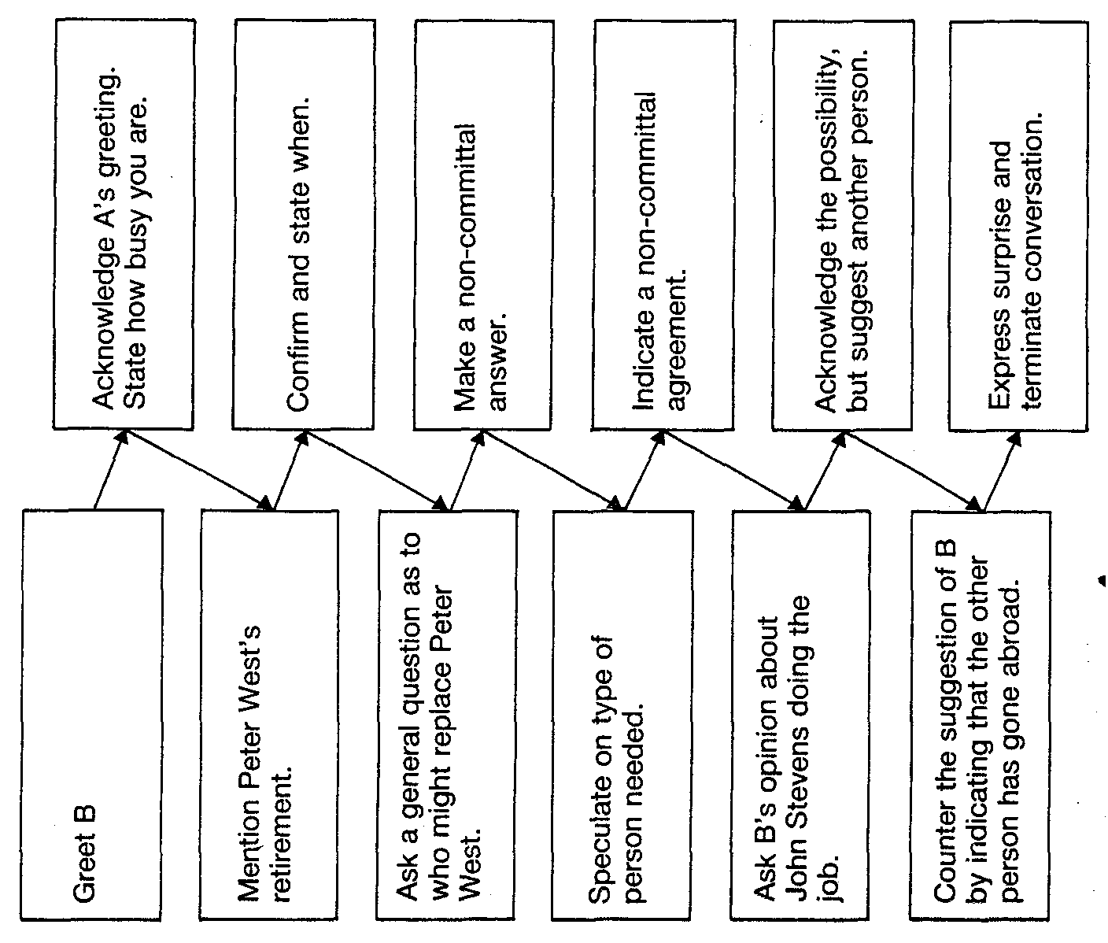

**Conclusions**

English has undoubtedly become an important – perhaps now the most important – language of international communication in the world. In fact, it has become a lingua franca, which is a common language used for communication over areas where several languages have usually been spoken. The knowledge of English allows to get access to the latest information in different fields and to effectively communicate with people throughout the world.

However, language learning is hard work. One must make an effort to understand, to repeat accurately, to manipulate newly understood language and to use the whole range of known language in conversation or written composition. Effort is required at every moment and must be maintained over a long period of time. Dialogues help and encourage a lot of learners to sustain their interest and work.

Dialogues also help the teacher to create contexts in which the language is useful and meaningful. The learners want to take part and in order to do so must understand what others are saying and they must speak in order to express their own point of view or give information. Contextual assumptions can, at best, be only partly shared – so that the same classroom interchange can never mean quite the same for any two people or at any two different moments – it may be impossible to move to any greater level of specificity in terms of prescribing good practice in the sense of ‘practice that can be copied’. However, it is at least possible to identify the various kinds of contexts in which classroom dialogue occurs, as a precursor to investigating what seem to be, or have been, rich learning experiences in the classroom.

In dialogic interactions, children are exposed to alternative perspectives and required to engage with another person’s point of view in ways that challenge and deepen their own conceptual understandings. It is the element of ‘dialectic’, understood as logical and rational argument, which distinguishes dialogue from mainstream oral or ‘interactive’ teaching as currently understood by many teachers.

Though most dialogues are easy to prepare and to administer, they should not be viewed as mere warm-up activities or time fillers. They merit a planned place in the lesson. Unlike most learning activities, dialogues can be as short or as long as teacher wish, so they are easily fitted into any lesson plan. This gives teacher lots of flexibility. For example, when planning lesson, teacher may find that she or he need only half of the full lesson time. Teacher can now choose areas of dialogue for enjoyable review or even present and playfully practice an entirely new but potentially useful structure. In this way, lessons become less predictable. Variety enhances the interest of the learning process.

Dialogues provide not only samples of spoken language which the learners need in order to build up their oral ability, but also a framework for using them: they show the learners how speakers interact.

In order to talk, we need something to talk about – a topic of some kind – and dialogues in course books, especially in the early stages of a course, rarely provide a vivid talk.

Nevertheless, it does not mean that dialogue is less effective then other methods of teaching foreign language. Advantages of dialogue:

a) it presents the spoken language directly in situations in which it is most commonly used;

b) it permits and encourages the learners to practice the language in the same way;

c) it encourages active participation in the lesson.

There have been discovered some problems in approaching to use dialogues. For instance, a lot of teachers pay a little attention to communication including dialogue. Instead of it they sometimes emphasize on grammar, rules or writing activities. The next problem lies in preparation. Dialogue should be considered taking into account the level of knowledge of the learners. Sometimes children do not feel enough motivated to make a long dialogue with the complicated structures they have learned and their dialogues contain only the simplest phrases. So, the teacher should be a rather creative person to find the proper motivation for the learners and to help them make their dialogues variable. It makes clear that some teachers avoid conversation because they do not like to speak or in opposite they speak the whole lesson so as no one can say a word.

The very important thing for a good dialogue is to know types of questions in order to manipulate with them freely. We have already mentioned some of them: yes/no ; question tag; either…or; simple factual; descriptive; narrative; speculative; hypothetical; justification of opinion questions. To learn them and to know in what situation they may use can help the practice. The teacher takes a step in this direction when he or she makes the learner adapt his language so that it reflects some aspects of nonlinguistic reality, such as the concrete situation, a picture, or personal knowledge. It is vital to help learners to use their knowledge in communication about different subjects. Question-and-answer activity based on the classroom situation or on visuals, which is so integral a part of “situational language teaching”, requires the learner to relate language to nonlinguistic reality in a similar way. It can be oral test which begins with a question and answer routine which deliberately asks about hobbies, interests, past experiences and other.

The realism and relevance of this language offer obvious advantages. In particular, they help to sustain learners’ motivation and make the activity more appropriate to their probable communicative needs in the future.

Using different types of dialogues in teaching English has a lot of advantages. The student learns to communicate about different subjects, to manipulate with different language characteristics, to express his own opinion and to listen to speaker carefully.

We have already mentioned different ways in which the teacher can introduce the dialogue. Thus, very useful are: cue cards, role cards, interview and blank dialogue. The teacher can adapt the level of difficulty of dialogue to knowledge of the learner.

Taking into consideration all the methodological principles and aspects, it should be singled out that depending on the level of the learner different strategies and types of exercises are applied in the teaching process. At the elementary level we use interview, blank dialogue; at the intermediate and advanced levels we use role cards, cue-cards or interview. Composing micro-dialogues or quite big dialogues can also help learners to develop their skills and create the subject or situation in which some event takes place. This task the teacher can introduce to the learners at the elementary level (composing micro-dialogues), at the intermediate level (composing quite big dialogues), at the upper-intermediate level (composing guided dialogues) or at the advanced level (composing complex and big dialogues) with expression of their opinion, showing agreement or disagreement, doubt, pity.

The most efficient communicator in foreign language is not always the person who is best at manipulating its structures. It is often the person who is most skilled at processing the complete situation involving himself and his hearer, taking account of what knowledge is already shared between them (e.g. from the situation or from the preceding conversation), and selecting items which will communicate his message effectively. Foreign language learners need opportunities to develop these skills, by being exposed to situations where the emphasis is on using their available resources for communicating meanings as efficiently and economically as possible. In the same way as for comprehension, the learner needs to acquire not only a repertoire of linguistic items, but also a repertoire of strategies for using them in concrete situation.

Hence, it goes without saying that any teacher must be able to teach his or her pupils through communication. To be exact, it is the axiom because it was proved long time ago. At the same time the very dialogue requires the learner to develop a moderate degree of independence in using the language he has learnt.