**Dangerous Floods in Zakarpattia**

The world’s weather is changing and becoming less predictable. Extreme events, such as high winds and storms, often result in flooding or droughts. Some regions naturally have more meteorological disasters than others because of their geographical features and position. Zakarpatska oblast in Ukraine is one of the most vulnerable regions in Europe. There are regular storms and flooding because 80 percent of it is mountainous, with high rainfall and snow in winter. Between 1980 and 2010 there were 13 major floods, affecting hundreds of thousands people.

In 2008, the floods were the worst for 100 years. Over 40,000 homes and around 34,000 hectares of farm land were flooded, while hundreds of bridges and roads were damaged. More than 20,000 people had to be evacuated. The operations to move and rescue people involved more than 2,7000 emergency workers and over 5000 vehicles. All in all it was a disaster costing $600-900 million.

Houses, roads and bridges all need to be rebuilt after floods. People can be away from their homes for long periods. That affects their jobs and education. Because of this, some years ago, the government started to look into ways of reducing the impact of floods.

Apart from the natural geographic factors causing floods, there are also local issues, in particular deforestation. When trees are removed from forests, the water cycle and local climate are affected. Fewer trees mean that when it rains, there is little to slow down the rate at which the water hits the earth. Therefore the water builds up quickly on the bare surface and causes flooding. As a result, the government has a reforestation programme. Today about 17 per cent of Ukraine is forest. There is an increase of 4,6 per cent in 1990, and the aim is for this figure to be 20 per cent eventually.

Forests are often used for wood. If large areas of a forest are cut down, there is an increased risk of flooding. Forest management has also changed in Ukraine. Trees are now selectively felled so the ground is not left bare. As a result, there are enough trees to reduce the impact of heavy rainfall. Flooding will not stop, but as the forests continue to grow, the damage should be a lot less.

**Worksheet 1**

***Match natural disasters with pictures. Which of the following disasters affect Ukraine?***

1.tsunamis; 2. tornadoes; 3. floods; 4. volcanic eruptions; 5.droughts; 6.storms; 7.earthquakes; 8.forest fires; 9.hurricanes.

1. **b) c)**

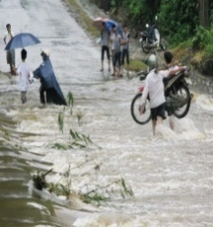 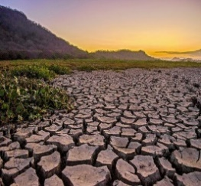 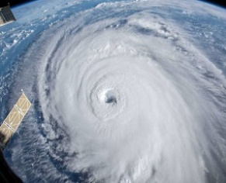

**d) e) f)**

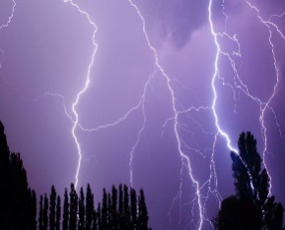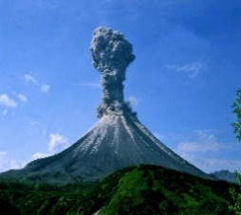

**g) h) i)**

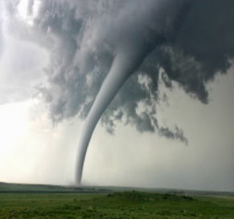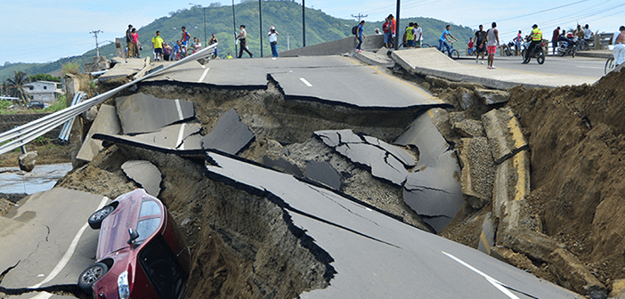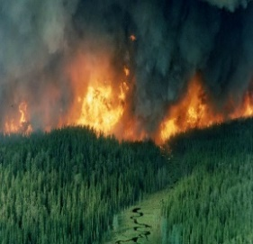

**Key:**

1. f 4. e 7. h

2. g 5. b 8. i

3. a 6. d 9. c

**Worksheet 2**

***Put the words (nouns, adjectives and verbs) describing people’s feelings in a disaster into the proper column.***

Scare, helpless, shake, terrible, destroy, fear, damage, horror, avoid, scared, keep away, horrible, happen, panic, escape, helplessness, shelter, awful, alarm, evacuate, terror, safe, terrifying, protect, despair, prevent.

|  |  |  |
| --- | --- | --- |
| Nouns | Adjectives | Verbs |
|  |  |  |

**Key:**

|  |  |  |
| --- | --- | --- |
| Nouns | Adjectives | Verbs |
| fear, damage, horror, panic, shelter, alarm, terror, despair | helpless, terrible, scared, horrible, helplessness, awful, safe, terrifying, | scare, shake, destroy, damage, avoid, keep away, happen, escape, evacuate, protect, prevent |

**Worksheet 3**

***Listen to the text. Are the statements true or false?***

1.Geographical features and position make Zakarpatska oblast likely to flood.

2.The surface of this region is mostly flat.

3.Floods only happen every 13 years.

4.Floods greatly influence people’s life.

5.Floods are not only caused by natural forces.

6.Nothing can be done to reduce the effect of the floods.

**Key:**

1.True

2.False

3.False

4.False

5.True

6.False

**Worksheet 4**

**Listen to the text and choose the best answer**

1.What environmental factors make Zakarpatska oblast likely to flood?

a)tsunamis; b)volcanic eruption; c)high wind and storms.

2.How many people have to move because of the floods in 2008?

a)2000; b)20000; c)200000.

3.What human activity increases the risk of floods?

a)cutting down the trees; b)agricultural missmanagment; c)hunting.

4.How much of Ukraine does the government want to be forest in the future?

a)17 per cent; b)4,6 per cent; c)20 per cent.

**Key:**

1. c

2.b

3.a

4.c

**Worksheet 5**

**Put the words in the correct order to make sentences**

1. less /The/predictable/world’s/becoming/weather/and/changing/is.

2. the most /one /Ukraine /regions /oblast/ in /is / of / vulnerable/ in/ Europe /Zakarpatska.

3. to be /floods /all / bridges /Houses,/ roads/ need / after /rebuild /and /.

4. periods /People/long/can/for/be/homes/away/their/from.

5. has /in/Forest/also/management/Ukraine/changed.

6. are /for /Forests/ wood/ used /often./

**Key:**

1. The world’s weather is changing and becoming less predictable.

2. Zakarpatska oblast in Ukraine is one of the most vulnerable regions in Europe.

3. Houses, roads and bridges all need to be rebuilt after floods.

4. People can be away from their homes for long periods.

5. Forest management has also changed in Ukraine.

6. Forests are often used for wood.

**Worksheet 6**

**Fill in the blanks with proper words**

1. All in all it was a  costing $600-900 million.

2. Many people had to be .

3. That  their jobs and education.

4. When trees are removed from forests, the  cycle and local climate are affected.

5. If large areas of a forest are cut down, there is an increased  of flooding.

6. As a result, the  has a reforestation programme.

**Key:**

1. All in all it was a disaster costing $600-900 million.

2. Many people had to be evacuated.

3. That affects their jobs and education.

4. When trees are removed from forests, the water cycle and local climate are affected.

5. If large areas of a forest are cut down, there is an increased risk of flooding.

6. As a result, the government has a reforestation programme.

**Worksheet 7**

***Listen to the statements and decide in advance of any you like. Walk and stand by the response of your choosing. Debate on statements. Prove your opinion***

1.Global climate changes greatly influence floods in Ukraine.

2.Floods are mostly caused by people.

3.People cut down trees because they need more place to build houses.

4.We need to find new sources of energy instead of wood.

5.Ukrainian government should adopt new laws to protect forests.

6.Local authorities should control the water level in rivers.

|  |  |  |
| --- | --- | --- |
| AGREE |  | DISAGREE |
|  |  |  |
| COMPLETELY AFREE |  | COMPLETELY DISAGREE |

**Worksheet 8**

*Write an essay 200-250 words about environmental issues. In your essay consider the following aspects:*

*-current threats to the environment in your region;*

*-what you think will happen to the environment in your region in the future;*

*-suggest any action that you believe should be taken.*