**Методична розробка уроку з іноземної мови на тему:**

AUSTRALIA

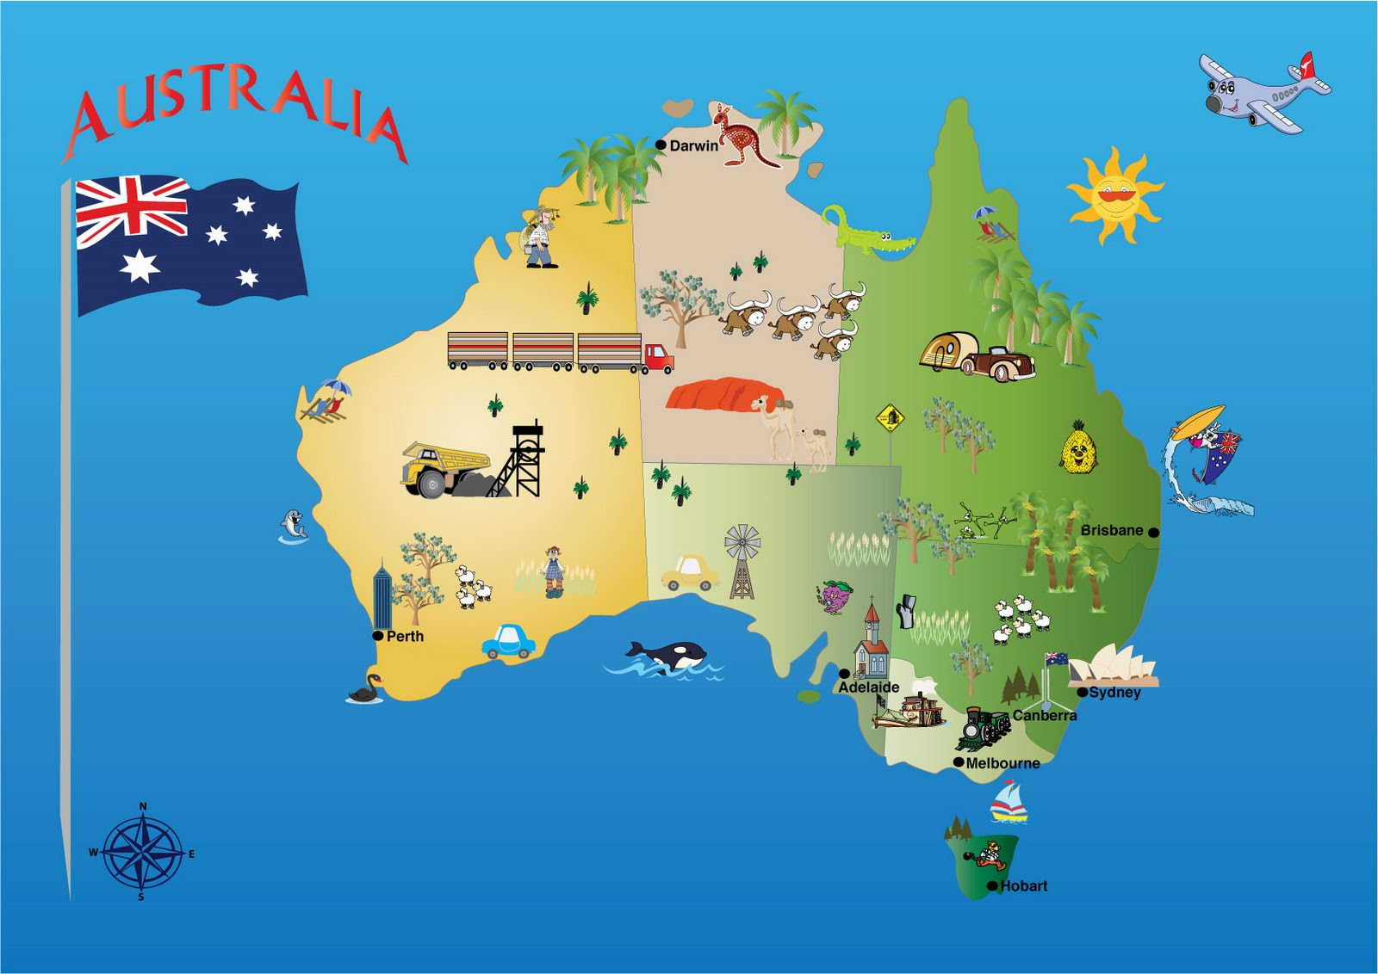

**План заняття**

**Предмет:** іноземна мова

**Викладач**: Лазько Т.М.

**Клас**: 11

**Тема заняття**: “Australia”.

**Вид заняття**: закріплення знань, умінь та навичок.

**Мета заняття**:

**Навчальна: -** систематизувати та узагальнити знання студентів з теми

- закріпити уміння студентів виділяти основне із

прослуханого та прочитаного;

- вести бесіду за темою, використовуючи лексику

країнознавчого характеру .

**Виховна:**  - виховувати повагу до культури країни мова якої вивчається;

- виховувати культуру спілкування, уміння вести дискусію.

**Розвиваюча:** - розвивати пам'ять, увагу, мислення, мовленнєві здібності

студентів;

* удосконалювати навички монологічного та діалогічного

мовлення;

* розвивати уміння вживати вивчену лексику в усному монологічному та діалогічному мовленні студентів, швидку мовну реакцію;
* розвивати уміння самостійного отримання необхідної інформації для створення творчих проектів;
* розвивати лінгвокраїнознавчі, соціокультурні, інформаційно-цифрові компетентності, ініціативність і підприємливість.

**Методична спрямованість заняття:** застосування інтерактивних форм і методів з метою оптимізації процесу навчання. Комунікативний підхід на етапі закріплення країнознавчої лексики.

**Методи навчання:** дискусія, постановка проблемних питань, пояснення, виконання лексико-граматичних вправ, робота в парах, метод проектів, аудіо-лінгвальний та аудіо-візуальний методи, комунікативний метод.

**Методи контролю знань:** фронтальне та індивідуальне усне опитування, презентація проектів, підготовлених студентами самостійно, «кросворд», аудіювання.

**Міждисциплінарні зв’язки:** українська мова, географія, всесвітня історія, культурологія, іноземна мова (за професійним спрямуванням).

**Методичне забезпечення заняття:** методична розробка заняття, робоча навчальна програма, роздатковий матеріал, ноутбук, мультимедійний проектор, слайди, відео фрагменти.

**Інформаційні джерела:**

1. Spotlight on Australia. Oxford Press, 2002
2. Гапонів О.Б. Лінгвокраїнознавство. Англомовні країни: Нова книга, 2018.
3. Рибкина К. Посібник по країнознавству. Каро, 2001
4. Полупан В.Л., Полупан О.П. English-Speaking Countries: English Reader, Харків, 2002.

**Ключові слова:** Australian outback, desert, Hemisphere, Equator, marsupial, harbor, convict, kangaroo, enormous, Ukrainian descent, Great Barrier Reef.

**Plan**

1. **Organizing moment. (2’)**
2. **Warming up. (5’)**
3. **The main part of the lesson:**
   1. **Conversation on the Topic (3’)**
   2. **Presentations (10’)**
   3. **Lexical Exercises (5’)**
   4. **Dialogue (5’)**
   5. **Reading (10’)**
   6. **Virtual Traveling (7’)**
   7. **Press – Conference ( 10’)**
   8. **Ukrainians in Australia (13’)**
   9. **English-Speaking Countries (7’)**
4. **Summarizing. Home task (3’)**

**Хід заняття:**

1. **Організаційний момент. Повідомлення теми і мети заняття.**

So, my dears. December has come and brought the beauty of winter days, excitement of coming holidays and charm of winter nature.

It is the time when we are all busy preparing for celebrations, rushing for presents for our families and friends and, of course, it’s a proper moment to look back and review what we’ve done and achieved lately.

This term, as you remember, was devoted to English-speaking countries.

Today English is the language of the world. Over 300 million people speak it as a mother tongue. The native speakers of English live in Great Britain, Australia, New Zealand and the United States of America. English is one of the official languages in the Irish Republic, Canada, and the South African Republic. English is not only the national or official language of some thirty states which represent different cultures, but it is also the major international language for communication in such areas as science, technology, business and mass entertainment. It is language of literature, education, modern music, international tourism, political organizations.

Today we are going to make our trip to one of the most wonderful and unique countries in the world, the country with a rich history, the country of beautiful landscapes and unique nature, the country of 6 states and 2 territories. The name of this country is AUSTRALIA!

I wish you good luck! Be active, attentive; remember all the things we’ve spoken about and everything will be all right.

So, the main aim of our lesson is to improve our vocabulary, to make it more flexible, to learn new words and word-combinations which will be useful for you through doing different kinds of oral and written exercises.

Look at the blackboard. Here is the plan of our lesson. The main part of it includes:

**ІІ. Актуалізація опорних знань студентів. Мовленнєва розминка.**

2.1 Let’s begin with phonetic exercise in order to brush up your pronunciation. Look at the screen. You see some proper names, you need to read them correctly:

Australia – Australian

Sidney – Sydneysiders

Melbourne – Brisbane

Indian – Pacific

Murrey – Darling

Equator – Hemisphere

Botany Bay – Coral Sea

Great Barrier Reef

Adelaide

2.2. The next task is to arrange the words in pairs of antonyms (I hope you remember that antonyms are the words that have opposite meanings). Half a minute is in your disposal:

1. South a) short

2. lowlands b) East

3. to separate c) undeveloped

4. suitable d) to join

5. long e) North

6. developed f) highlands

7. West g) unsuitable

Arrange the words in pairs of synonyms (the words with similar meanings):

1. region a) to fall into

2. to compose b) to divide

3. to flow into c) to make up

4. highlands d) chief

5. main e) hills

6. unsuitable f) area

7. to separate g) uncomfortable

2.3. In order to continue our conversation about Australia I’m sure that we should review one more thing – articles. We have already spoken about it during our previous lessons. So, look at the screen.

1. We do not use definite article *the* with the names of continents:

*Africa, Asia, North America*

1. We do not usually say *the* with the names of countries and states:

*France, Japan, Canada, Ukraine*

But if the name includes words like *republic, union, states, kingdom, federation*, we say:

*the USA, the United Kingdom*

1. We do not use article with the names of cities:

*Kyiv, Toronto, London*

1. Island groups usually have plural names with *the:*

*the Bahamas, the Canary Islands*

Individual islands usually have singular names without article:

*Bermuda, Newfoundland*

1. Mountain ranges usually have plural names with definite article:

*the Alps, the Cordillera, the Carpathians*

But individual mountains usually have names without *the*:

*Ben Nevis, Hoverla*

1. Lakes usually have names without article:

*Swytyaz, Lake Superior*

1. Names of oceans, seas, rivers, channels have article *the*:

*the Atlantic Ocean, the Black Sea, the Ontario, the English Channel*

2.4. Try to do an exercise. Fill in the blanks, if necessary. I think 1 minute will be enough for this task:

1. Last year we visited … Canada and … USA.
2. … Africa is much larger than … Europe.
3. … Rocky Mountains have nearly 300 flowering plants.
4. Most population lives along the shores of … Lake Erie and … Lake Ontario.
5. … Newfoundland is the least populated area.
6. … Kingston, … Toronto, … Montreal and … Vancouver are the largest cities in … Canada.

**III. Основна частина заняття.**

**3.1. Бесіда по темі:**

So, my dears, let’s proceed to the main part of our lesson and speak about Australia, one of the biggest and mysterious countries in the world, “Terra Incognita”, as it was named.

We have already spoken about it, so, try to answer the questions:

1. Where is Australia situated?
2. How many states and territories does it consist of?
3. What are the main parts of Australia?
4. What is the capital of this country?
5. What other big cities do you know?
6. What kind of state is Australia?
7. What is the official name of the country?
8. Who is the head of the state?
9. What is the official language of Australia?
10. Who discovered Australia?
11. When did Europeans settle in Australia?
12. Who are the Australian natives?
13. What is the population of this country?
14. What is their main occupation?
15. Which are the national colours?
16. Which two animals can you see on the Australian coats of arms?
17. What do you think, which is the hottest month of the year?

**3.2 Presentations.**

Our lesson is a bit unusual. The peculiar feature of it is that much information was prepared by the students, not by the teacher. In education practice we call this method of teaching – the method of projects. So, you got the themes of the projects in October and today I hope that you are ready to present your works.

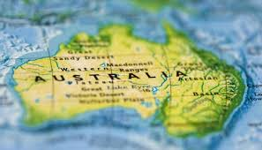

1. The first project is about general facts about Australia. As far as I know ______ and _______ decided to make it in the form of questions and answers with the help of slides.

* Where is Australia situated?
* Australia is in the Southern Hemisphere.
* Is it a continent or an island?
* It is the world’s largest island and the smallest continent.
* What bodies of water do wash the continent?
* It is washed by the Pacific and Indian Oceans.
* How many states are there in Australia? What are the Australian states? Name them.
* Australia is divided into 6 parts. They are Western Australia, Northern Territory, Queensland, South Australia, New South Wales and Victoria.
* Why do people from the south of the country often spend holidays in the northeast of Australia?
* Queensland is the tropical corner of Australia.
* What is Northern Territory famous for?
* Much of the land is a useless desert. Great deserts cover nearly 2000000 square kilometers.
* In what places of Australia are fruit, wheat and potatoes grown?
* Tasmania is called the apple island.
* What city is Australia’s capital?
* The capital of Australia is Canberra.
* What other big cities in Australia do you know?
* There are 5 big cities in Australia: Sydney, Melbourne, Adelaide, Perth and Brisbane.

Say is it true or false:

* Australia is the largest continent in the world. (-)
* It is situated in the Southern Hemisphere (+)
* Vast areas of desert cover most of Central and Western Australia (-)
* Melbourne is the capital of Victoria (+)
* The official name of the country is the Commonwealth of Australia (+)
* There are 6 states in Australia (+)
* Tasmania is an island state (+)
* Australia is washed by the waters of three oceans (-)
* Most people live in the north of the country (-)
* Queensland’s beaches are a popular place for holidaymakers (+)

1. **National Symbols.**

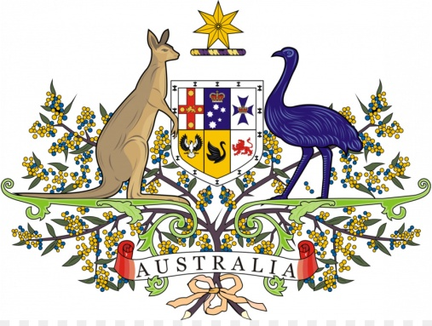

1. National symbols represent the central ideas and values of a nation. For example, National symbols of the USA. Floral national symbol of the United Kingdom

2. National symbols include a national flag, a national anthem, a coat of arms.

3. The national flag is flown by the government and citizens of that country.

4. Australian National Flag was chosen in 1901.

5. The Australian flag uses three prominent symbols, the Union Flag the Commonwealth Star

(also the federation star) and the Southern Cross.

6. A national anthem (also "national hymn", "song" etc.) is a generally patriotic musical

composition that evokes and eulogizes the history, traditions and struggles of its people, recognized either by a nation's government as the official national song, or by convention through use by the people. **Peter** **Dodds** **McCormick**, composer of Advance Australia Fair.

Listen to the Australian national anthem.

7. A coat of arms, in European tradition, is a design belonging to a particular person (or group of people) and used by them in a wide variety of ways. The official coat of arms that was granted by King Edward VII in 1908.

8. The coat of arms was adopted in 1912.

9. The story of Australia’s symbols is rich and colourful. Australian national symbols represent what is unique about the nation, reflecting different aspects of their cultural life and history.

Among the best-loved symbols are the featuring the stars of the Southern Cross, the Union Jack and Commonwealth or Federation Star; the floral emblem, the fragrant golden wattle; the celebratory national colours are green and gold and the vibrant gemstone, the Australian opal. The Australian National Anthem is also one of the most important national symbols.

1. The next presentation according to our plan is **Wild Life.** It is represented by _____ and ______ .

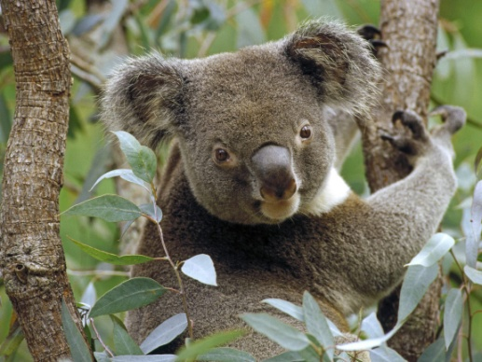

1. It is the world's largest island and its smallest continent. The continent is south of the Equator. Much of the land is a useless desert. Great deserts cover nearly 2,000,000 square kilometers.

Most of the continent is sunny most of the year. Its population is very small for such a huge country. Many people live far away from towns in the outback. Severe droughts, floods and cyclones happen very often on the continent. The people suffer from limited fresh water.

2. Thanks to Australia is cut off from the rest of the world, its wildlife is so unique. Australia's geological isolation has resulted in many species not found elsewhere. The most peculiar feature in Australia's animals is pouch. The best-known are kangaroo, the koala bear, the ostrich, the possum. Possums live in Central and South Australia. They eat insects, berries, fruit, and dog food. Wild possums do not live very long. People kill possums as food.

3. The koala is the best known and most loved animals in Australia. They seldom drink, and take enough water from leaves. The koala sleeps in the trees for most of the day, but moves and feeds at night. A koala’s life in the world is about 12 years, but they have been known to live for 15 years in captivity.

4. Kangaroos live in Australia, Tasmania, New Guinea and New Zealand.

Their strong legs and feet help them to hop and leap. They use their long tales for balancing. Each long, narrow foot has four toes. Their short paws are almost like human arms. The head is small; the ears are large and rounded; and the mouth is small, with o-shaped lips. They eat grass and leaves.

Kangaroos usually have one young baby. Kangaroos can be grey, dark grey or red. Their length is about 1.5 m; they have a tail 1m long; stand 2 m tall; and weight 90 kg.

5.

**1. Where do kangaroos live? 3. How many babies do they usually have?**

a) New Guinea a) three

b) Wales b) two

c) Scotland c) one

**2. What do kangaroos eat? 4. How many kilograms do kangaroos** **weight?**

a) bananas and kiwis a) fifty

b) grass and leaves b) seventy

c) mice and grass c) ninety

**3.3. Lexical Exercise. Crossword.**

And now let’s do a crossword puzzle. The key-words are Australian big cities. Think it over about a minute and be ready to check it up.

*Across*

2. Tropical climate. Population 70, 000. Capital of Northern Territory.

4. Tropical climate makes this city a year-round vacation place.

5. An industrial city. Population about 1 million.

8. Australia's oldest and largest city.

*Down*

1. Capital of Australian island-state of Tasmania. Cold winters.

3. Capital of Australia.

6. 2nd largest city of Australia. Hosted 1956 Olympics.

7. It has one of the best climates in Australia. Capital of Western Australia.

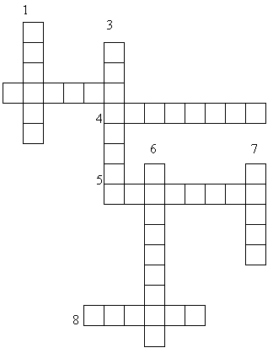

**Key:**1. Hobart. 2. Darwin. 3. Canberra. 4. Brisbane. 5. Adelaide. 6. Melbourne. 7. Perth. 8. Sydney.

Speaking about Australia you can come across new words. In your handouts match words with their definitions. A minute will be in your disposal.

|  |  |
| --- | --- |
| 1. cattle 2. cave 3. convict 4. desert 5. enormous 6. festival 7. flat 8. harbour 9. marsupial 10. state | 1. without hills or mountains; 2. a place where ships can stop safety next to the land; 3. an animal with an external abdominal pouch for nourishing and carrying; 4. a part of a large country which has its own government; 5. a large animal that gives us milk or meat; 6. very very big; 7. a criminal who has been sent to prison; 8. a hot dry place without water or trees; 9. a hole in the side of a hill or under the ground; 10. a time when a lot of events music films organized in one place |

**3.4. Dialogue.**

I see that you know the main and most important facts about Australia. It’s great. Let’s do the following task. You should make up a dialogue. Imagine that you meet an Australian friend. You are interested in Australia. Think of a conversation between you. The following questions will help you. Translate them into English.

* 1. Чи є відмінності між британською і австралійською англійською?
  2. Хто такі аборигени?
  3. Які в тебе перші враження від Австралії?
  4. Чи люблять австралійці природу?
  5. Чи багато людей інших національностей проживають в Австралії?

Right, my dears. And now I give a minute to make up a dialogue with the given phrases.

**3.5. Reading “Life in the Australian Outback”. Інформаційно-пошукове читання.**

I think that we live in difficult times now. To tell you the truth, young people are faced with the problem of unemployment very often. Young specialists who even got high education have very low salaries but they want to live fuller life. That’s why many people try to go somewhere abroad to earn money. They go to Italy, Poland, Russia, Portugal, America, Germany. Some people go to Australia and work in the Australian outback. I tried to find some information about this kind of job.

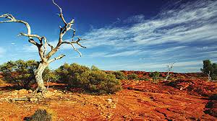

Look through 3 articles about people, working in the Australian outback. Read them without dictionaries and Google translator and try to catch the main idea. Then be ready to check it up. So, three stories about Kirstie, Simon and Lucy. You have 2 minutes to do this task.

***Kirstie***

I wanted to experience an outdoor life, so I spent a month on a ranch. It was dirty work but I enjoyed the riding, so I decided to try mustering cattle. I’m not receiving any wages, only board and lodging, but I get by. You see, I didn’t travel to the outback for money.

Mustering in the mountains is difficult. I often can’t see anyone else for miles, and I don’t always know where I’m going. Sometimes, I’ll come across a steep hill and I have to get off my horse and lead it down. That can be pretty frightening. And being in the mountains on your own can also be a bit confusing. I often mistake a dead tree for a cow. When I can’t see anyone else, I worry that I’ll get stuck here.

***Simon***

Since I arrived here four months ago, I’ve been on a large cattle station in outback Queensland. I do any job that’s going. You name it, I’ll do it! To tell the truth, the only work I really hate is fencing – digging all those deep holes, cutting trees for posts – it’s hard, it’s hot and you don’t get used to it. I’ve even done cattle musters on a motorbike instead of a horse but I didn’t enjoy those because I fell off!

The huge open spaces are a bit boring, though. There is nothing but flat ground and dusty tracks that go on for ever. Mind you, there are beautiful sunsets – they are really fantastic. It’s if the sky is on fire.

***Lucy***

I teach children on a ranch at the edge of Great Sandy Desert. I live in what you’d call a tin shed. Actually, the school’s just a caravan.

But the worst thing is the heat. It’s so difficult to cool down. You can’t escape from that. The generator for the electricity has to be turned off for two hours a day because it gets too hot. So, we can’t have the fridge on and all the food goes off.

Living here is certainly not easy but it’s what I wanted. Each day is exciting. One day, I heard the dogs barking, looked over and saw an enormous snake on the ground. I knew it was poisonous and all the kids started screaming. But luckily it decided to leave before we had a chance to do anything about it. I’m a good teacher, but I’m not very good with poisonous snakes!

1. Why did Kirstie want to work on a ranch?
2. to earn some money
3. to spend more time riding
4. to find out what an outdoor life was like
5. What does she find frightening?
6. not seeing anyone else for miles
7. mistaking dead trees for cows
8. leading her horse down a steep hill
9. What can Simon not get used to in Queensland?
10. having to be good at so many different jobs
11. doing hard physical work in the heat
12. living on such a large cattle station
13. What does he really enjoy?
14. the beautiful sunsets
15. the motorbike musters
16. the huge open spaces
17. What does Lucy dislike most of all about her life on the edge of the Great Sandy Desert?
18. the job she has
19. the tin shed she lives in
20. the high temperatures
21. What happened to her one day?
22. she was attacked by wild dogs
23. she spotted a poisonous creature
24. she saved the children from certain death

**Discussion**

Now I want you, my dears, to make a discussion for and against going to work in Australia. Some of you insist on going here, the other students try to argue. In a minute we’ll try to discuss this problematic question.

All these people went to Australia connecting with some employment agency. They had written a letter of application. So, read the letter, fill in the blanks with the prepositions. A minute will be enough for the task.

**Letter of application**

Dear Sir/ Madam

I’m applying 1______ the job of hotel receptionist 2______ the Highland Hotel, advertised 3______the Daily Post 4______20 September.

I’ve always been interested 5______working in the tourist industry, and during the school holidays I used to work part-time 6______a local hotel. Please rind details 7______ my qualifications and work experience 8______ the enclosed curriculum vitae.

I was a student 9______ Croft Secondary School until last July. Since then I have been working 10______a waitress 11______an Italian restaurant. 12______ my present job I have direct contact with customers and I also have to take telephone reservations. In addition, I am very experienced 13______ dealing with customer complaints.

I look forward 14______ hearing from you.

Yours faithfully

Helen Mitchell.

**3.6. Virtual Travelling to Australia. Віртуальна подорож до Австралії.**

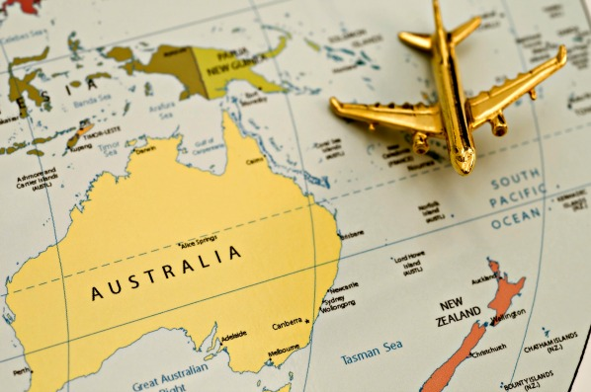

Imagine, that we decided to go to Australia. But the first thing we should do is to make airport reservations. Make up the conversation between the client and the travel agent.

Travel agent: *______________________.*

Client: I’d like to make a reservation to Sydney.

Travel agent: What day are you planning to leave for Sydney?

Client: *_____________________.*

Travel agent: I can make a reservation for a QANTAS flight. Are you going to travel business class or economy?

Client: *__________ .* How much will it be?

Travel agent: *______.*

Client: Are meals and drinks served on the flight?

Travel agent: *_______.*

Client: What is the flying time?

Travel agent: *__________.* How many days are you planning to stay in Australia?

Client: *_______.*

Travel agent: All right. Your name and address.

Client: …

Travel agent: And your telephone number?

Client: …

Travel agent: Will you pay by credit card?

Client:____________*.* When can I get my tickets?

Travel agent: *_____________________.*

And now let’s study the rules for passengers at the airport. Fill in the words into the following text!

***Boarding card, the Customs, the Customs officer, the Customs declaration, passport control, check-in-desk, duty free shop, departure lounge.***

**Travelling by air**

The rules for passengers who are going abroad are similar in most countries.

If you are supposed to begin with going through (1)_____, you’d better fill in (2)____ ____,

before you talk to (3) ___ ___.

Then you go to (4)____ where your ticket is looked at, your things are weighted and labeled and you are given (5)____ , which has a seat number on it. The next formality is filling in the immigration form and going through (6)____ ____.

After fulfilling all these formalities you go to (7)____ ____ where you can have a snack, read a paper, buy something in (8)____ ____ and wait for the announcement to board the plane.

Welcome to Sydney Airport! We are going to stay in Hilton Sydney Hotel with Five Star Accommodation. You should fill the following form in. In ten days we’ll meet and speak about our travelling impressions.

**Registration form**

Name of the Hotel or Inn or Address of House_____________

To be filled in immediately on arrival

1. Surname_______________

2. Christian names______________

3. Nationality_______________

4. Date of arrival__________

5. Sex______________

6. Particulars of registration Certificate or Passport_____________________

7. Arrived here from_____________________

(Give last address in full) _________________________

Signature of person to whom the above particulars relate_______________

To be filled in on departure

8. Date of departure________________

9. Destination (Give new address in full)_______________________

10. Signature of person to whom the above particulars relate________________

I hope your travelling was exciting. What are your impressions? Tell us about them.

* I spent the most amazing moments of my life and forgot all my worries and enjoyed the natural wonders at that beautiful place called the Great Barrier Island. One of the most wonderful and the remarkable gifts of Australia is the Great Barrier Reef. This reef in Australia is the world’s largest. The Great Barrier Reef is known to be one of the Seven Wonders of the World. I visited the Great Bas, the major underwater attractions which includes the world’s largest collection of corals, mollusks, dolphins, tropical fish and birds, reptiles such as sea turtles and giant clams which are over 120 years old. I also tried the surfing activity and diving. It was a wonderful special moment of my life.

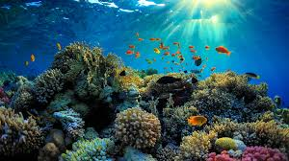

* And I visited Uluru, the world’s largest rock mass in the Red Centre. It is a part of the UNESCO World Heritage Centre. I was there at sunset and the view of the colour change was mysterious and magical. I took a lot of pictures. Look at them! They are wonderful!

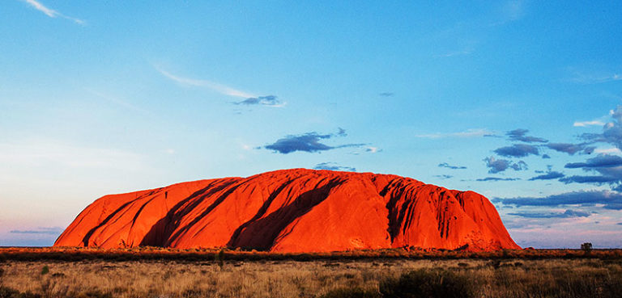

* But my great impression was Sydney. It was exciting to walk across the Sydney Harbour Bridge and admire a panoramic view of the city. I also visited the Opera House, which is built against the backdrop of the harbour. In the Opera House there was performance of the famous opera Tosca by Giacomo Puccini at that time. In spite of that fact that I’m not interested in operas, I enjoyed the performance very much.

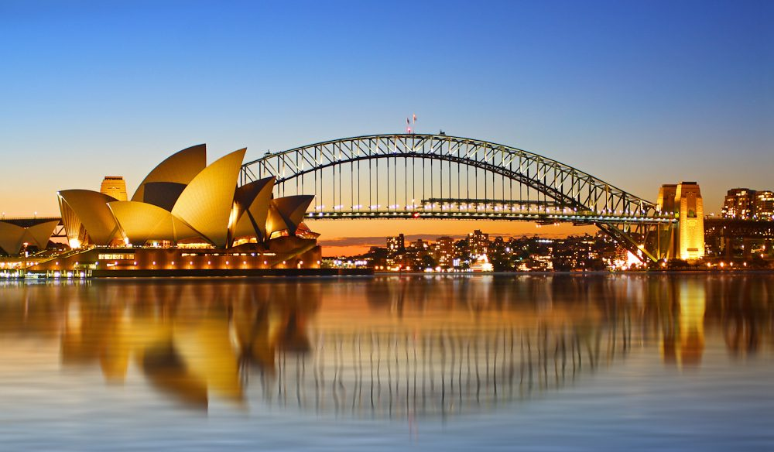

* If you know I’m interested in nature, that’s why I visited national parks of Australia. There was so much to see and explore in the Walpole Nornalup National Park. I was impressed by the glory of the wildflowers, the majesty of the trees and the world famous Valley of the Giants Tree Top Walk. I saw rare species of Eucalyptus there. Among the interesting places to see in Australia is Kings Canyon, which is situated in the Watarrka National Park. It is 270 meters deep. It was interesting to investigate the areas around the canyon. And also there was so much to do: boating and fishing, bush walking and climbing.

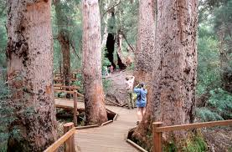

* And I adore animals. I wanted to see exotic Australian animals. My dreams came true. I saw kangaroos, emus, koala bears, and Kookaburras. These animal species are found only in Australia. You know the Kangaroo and the Emu are present on the Coat of Arms of Australia.

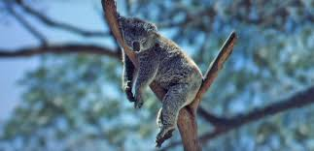

Well, thank you for your stories. They were wonderful.

**3.8. Press-conference**

Now I invite you to a conference hall. All of you are representatives of different high educational establishments of Vinnysia. Two students have recently visited Australia and are ready to tell you any information you like. So, name yourself, your educational establishment and ask your question.

1. I’m __________, a student of Institute of Trade and Economy. Have you heard any other names of Australia?

* Oh, yes! We heard many interesting names: The Land of Wattle (край акаций), Godzone( країна Господа), Alfland (Ельфляндия), The Lucky Country (Щаслива країна), Kangarooland (земля кенгуру), Aussieland, Never-Never Land (назва внутрішніх районів).

1. Hello! My name is _________, I’m a student of Vinnytsia College of National University of Food Technologies. Where did you go exactly?

* First we flew to Brisbane for a couple of days.
* Sorry, what is Brisbane?
* It’s the capital of state Queensland.
* Who was this state named after?
* After the British queen Victoria. The symbols of this state are Cooktown orchid and koala.

1. ___________, Vinnytsia Agrarian University. Where else did you go?

* We also went to the Great Corral Reef. It was definitely worth seeing!!
* Who named it so?
* Matthew Flinders,  an English navigator and cartographer, who was the leader of the first [circumnavigation](https://en.wikipedia.org/wiki/Circumnavigate) of Australia and identified it as a continent.

1. I’m __________, a student of Vinnytsia Pedagogical University. I see you are so impressed by this place, what did you do there?

* Oh, we swam and sunbathed.
* Did you see any whales and dolphins?
* No, we didn’t. But we saw dingo, Australian wild dog.

1. __________, Medical University. What were the best things about being in Australia?

* For me, I was impressed by ocean and beaches.
* Oh, I loved Fruit and Veggie bars where you can buy all sorts of really healthy food.
* I want to add, that the best thing is the way of life there – you can have a high standard of living at a low cost.

1. ___________, Vinnytsia Transport College. Everyone knows, that for every plus there is a minus. What were the worst things about being there?

* I would say, the sharks. We were on the beach one day when we heard the shark siren, and that was a bit of shock.
* Also, all the spiders, snakes and jellyfish. But it’s just the way of life here and it doesn’t seem to bother people too much. Bush fires and droughts are more of a threat to them.

1. ___________, a representative of Technical University. Was it easy to meet people?

* I should admit that Australians are very friendly.
* They are really happy-go-lucky kind of people.

1. Vinnytsia College of Design and Construction, _________ . Did you have any problems with the language?

* Although we are studying English at school, we did have the problems with certain Aussie expressions.
* Would you go back?
* Absolutely!!!

1. What advice would you give those people who want to visit Australia?

* I have prepared some rules for such people.
* Don’t ever put your hand down a hole.
* Always carry a stick.
* Do not attempt to use Australian slang, unless you are a trained linguist and good in a fistfight.
* Take good maps. Stopping to ask directions only works when there are people nearby.
* If you leave the urban areas, carry several liters of water with you all the times, or you will die.
* Don’t wear a Hawaiian shirt.
* Religion and politics are safe topics of conversation (Australians don’t care too much about either) but Sport is a minefield!
* The only correct answer to “So, how d’you like the country, eh?” is “Best country in the world!!!”

While in Australia we have made a short film about this beautiful country. Let’s watch it.

(film Australia Information Video) (https://www.youtube.com/watch?v=pj4PLSUNq1E)

**3.8. Ukrainians in Australia. Українська діаспора в Австралії.**

You know, that very many Ukrainians live in Australia. Practically all we know at least one person who lives there. **Ukrainian Australians** refers to [Australian](https://en.wikipedia.org/wiki/Australians) citizens of [Ukrainian](https://en.wikipedia.org/wiki/Ukrainians) descent, or [Ukraine](https://en.wikipedia.org/wiki/Ukraine)-born people who emigrated to [Australia](https://en.wikipedia.org/wiki/Australia). They are an ethnic minority in Australia, numbering about 38,000 people according to the 2011 Census. Currently, the main concentrations of Ukrainians are located in the cities of [Sydney](https://en.wikipedia.org/wiki/Sydney) and [Melbourne](https://en.wikipedia.org/wiki/Melbourne).

One of the first Ukrainian migrants to Australia was Mykhailo Hlyb, who in the 1860s established a sheep farm. A notable Ukrainian who visited Australia was [Nicholas Miklouho-Maclay](https://en.wikipedia.org/wiki/Nicholas_Miklouho-Maclay), an ethnographer and naturalist who came to Australia in 1878, and besides scientific and ethnographic studies, was responsible for the building of Australia's first biological field station at [Watson's Bay](https://en.wikipedia.org/wiki/Watson%27s_Bay).

Prior to [World War I](https://en.wikipedia.org/wiki/World_War_I), only about 5,000 Ukrainians migrated to Australia, with some settling in communities in Brisbane. However, the main body of Ukrainians [emigrated to Australia](https://en.wikipedia.org/wiki/Immigration_to_Australia) along with other nationalities in the post-World War II wave of refugees from [Europe](https://en.wikipedia.org/wiki/Europe). These refugees were called "[displaced persons](https://en.wikipedia.org/wiki/Displaced_person)" and started arriving in 1948 as part of the [International Refugee Organization](https://en.wikipedia.org/wiki/International_Refugee_Organization). The 1954 Census recorded 15000 Ukraine-born people.

The number of migrants from [Soviet Ukraine](https://en.wikipedia.org/wiki/Soviet_Ukraine) was minimal, though there was a limited migration of Ukrainians from communities in [Poland](https://en.wikipedia.org/wiki/Poland) and [Yugoslavia](https://en.wikipedia.org/wiki/Yugoslavia). In 1991 Ukraine gained independence, and over the next five years the Ukraine-born population increased for the first time in many decades, in Victoria from 3000 in 1991 to over 5000 in 1996. Many of these new post-independence migrants were young professionals in the fields of science, mathematics and computer technology. Unfortunately, young and talented people who can live and work for the benefit of Ukraine, not Australia.

The Ukrainian community in Australia was very active in the formation of a variety of cultural organizations, including choirs, folk dancing groups, and arts organizations like the "Ukrainian Artists Society of Australia".

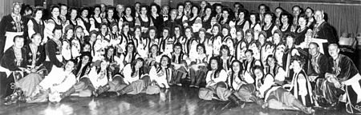

Ukrainian choir "Boyan" — director Vasyl Matiash (top row — centre), with the "Ukrainian Folk Ballet" — musical director and choreographer — Natalia Tyrawsky (top row — centre). Photo early 1970s, Sydney.

Look at the screen. Here is our Ukrainians at the Parade dedicated to the Australia Day.

(fragment) (<https://www.youtube.com/watch?v=boeZqTizz7E>)

I asked you to find information about famous and notable Ukrainians in Australia. So,….

* **Rachael Finch** (born 8 July 1988) is an [Australian](https://en.wikipedia.org/wiki/Australians) TV host, model, and beauty pageant titleholder. She was awarded the 'People's Choice Award' for the 2006 Miss Teen Australia and finished as 3rd runner-up at [Miss Universe 2009](https://en.wikipedia.org/wiki/Miss_Universe_2009). Since 2011, Finch has worked for [Seven Sport](https://en.wikipedia.org/wiki/Seven_Network) as a roving reporter at events such as the [Australian Open](https://en.wikipedia.org/wiki/Australian_Open), [Melbourne Cup](https://en.wikipedia.org/wiki/Melbourne_Cup) and [Olympics](https://en.wikipedia.org/wiki/Olympics). She is half-Ukrainian through her mother.
* **Alex Jesaulenko** (born 2 August 1945 in [Salzburg, Austria](https://en.wikipedia.org/wiki/Salzburg,_Austria)) is a former [Australian rules footballer](https://en.wikipedia.org/wiki/Australian_rules_football) and coach who represented [Carlton](https://en.wikipedia.org/wiki/Carlton_Football_Club) and [St Kilda](https://en.wikipedia.org/wiki/St_Kilda_Football_Club) in the [Victorian Football League](https://en.wikipedia.org/wiki/Victorian_Football_League_(1897%E2%80%931989)) (VFL) from the 1960s to the 1980s. He is regarded as one of the game's greatest-ever players and is an official Legend of the [Australian Football Hall of Fame](https://en.wikipedia.org/wiki/Australian_Football_Hall_of_Fame). In 2009 [*The Australian*](https://en.wikipedia.org/wiki/The_Australian)nominated Jesaulenko as one of the 25 greatest footballers. [Jesaulenko was born in [Salzburg, Austria](https://en.wikipedia.org/wiki/Salzburg,_Austria). His father, Vasil, was [Ukrainian](https://en.wikipedia.org/wiki/Ukrainians), his mother, Vera, was born in Russia.](https://en.wikipedia.org/wiki/Alex_Jesaulenko#cite_note-2)
* **Michael Kmit** ([Ukrainian](https://en.wikipedia.org/wiki/Ukrainian_language): Михайло Кміт) (25 July 1910 in [Stryi](https://en.wikipedia.org/wiki/Stryi), [Lviv](https://en.wikipedia.org/wiki/Lviv) – 22 May 1981 in [Sydney](https://en.wikipedia.org/wiki/Sydney), Australia) was a [Ukrainian](https://en.wikipedia.org/wiki/Ukrainians) [painter](https://en.wikipedia.org/wiki/Painting) who spent twenty-five years in Australia. He is notable for introducing a [neo-Byzantine](https://en.wikipedia.org/wiki/Neo-Byzantine) style of painting to Australia, and winning a number of major Australian art prizes including the [Blake Prize](https://en.wikipedia.org/wiki/Blake_Prize_for_Religious_Art) (1952) and the [Sulman Prize](https://en.wikipedia.org/wiki/Sir_John_Sulman_Prize) (in both 1957 and 1970). In 1969 the Australian artist and art critic [James Gleeson](https://en.wikipedia.org/wiki/James_Gleeson) described Kmit as "one of the most sumptuous colourists of our time".
* **Nikita Vadymovych Rukavytsya** . [Ukrainian](https://en.wikipedia.org/wiki/Ukrainian_language): Микита Вадимович Рукавиця (born 22 June 1987) is an [Australian](https://en.wikipedia.org/wiki/Australia) professional [football](https://en.wikipedia.org/wiki/Association_football) player who plays for [Maccabi Haifa](https://en.wikipedia.org/wiki/Maccabi_Haifa_F.C.) in the [Israeli Premier League](https://en.wikipedia.org/wiki/Israeli_Premier_League). He began his career as a [striker](https://en.wikipedia.org/wiki/Forward_(association_football)) at [Perth Glory](https://en.wikipedia.org/wiki/Perth_Glory_FC) but has played primarily as a [winger](https://en.wikipedia.org/wiki/Midfielder#Winger) since moving to Europe. He was born in Mykolaiv and the family moved to Australia when Mykyta was 14.

Good. Now I suggest you to watch a short film about prominent Australian painter of Ukrainian origin Leonid Denysenko.

(videofragment)( <https://www.youtube.com/watch?v=zM-Zceoc7VQ>)

So, I hope you’ve caught the main idea of the videofragment.

1. What is this videofragment about?
2. What is Leonid Denysenko?
3. So, what can you say about his art technique?
4. What are his paintings about?
5. How many paintings were exhibited?

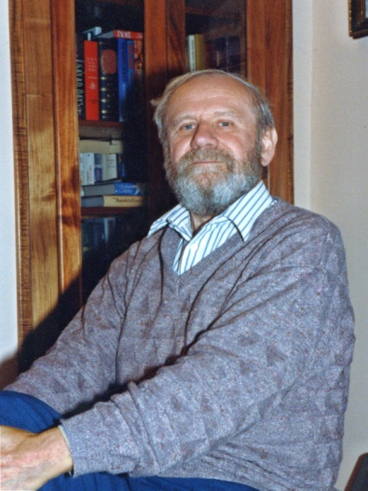

I’d like to add that Leonid Denysenko is the only surviving founding member of the [Ukrainian Artists Society of Australia](https://en.wikipedia.org/w/index.php?title=Ukrainian_Artists_Society_of_Australia&action=edit&redlink=1). He was born in Warsaw. His most famous work is the [icon](https://en.wikipedia.org/wiki/Icon) "God is Love", which features an image of [Jesus Christ](https://en.wikipedia.org/wiki/Jesus_Christ) using letters of the word *Love* written in 79 different languages.

All of you remember the tragic events which happened in February 2014 in Ukraine, the invasion of Russia, the annexation of the Crimea. People of Australia tried to support us. The 20th Summit took place in Brisbane, Australia. Practically all heads of powerful states gathered to discuss different actual economic, political, scientific and cultural problems. Look how Australians reacted on the Putin’s policy towards Ukraine.

(Australian news videofragment) (https://www.youtube.com/watch?v=UhzmCK42gXg)

**3.9. English-Speaking Countries. Англомовні країни.**

So, my dears, I hope that you imagine what Australia is. Imagine its endless territories, it’s beautiful landscapes, opportunities which this country gives people, you know how Ukrainians live there. This term we’ve studied English-speaking countries and now it’s high time to review the information. So, tell in a few words about the countries we have spoken about.

First of all let’s begin with Great Britain, the Motherland of the English language. The United Kingdom of Great Britain and Northern Ireland is situated on the British Isles. It is made up of 4 countries: England, Wales, Scotland and Northern Ireland.. The UK is one of the smallest countries in the world. The UK is a highly developed industrial country, it is a constitutional monarchy. Queen is the Head of the state, but the country is governed by the British Parliament.

I’d like to say a few words about America. The United States of America is the most powerful and highly developed country of the world. It occupies the southern part of North America and stretches from the Pacific to the Atlantic Ocean. The capital of the country is Washington, the largest cities are: New York, Los Angeles, Philadelphia, San-Francisco and others. The USA is made up of 50 states and the District of Columbia. The Americans are made up from nearly all races and nations.

Canada is a large country which is situated in the North America continent. It borders on the USA. Canada has two official languages – English and French. And the territory is divided into English- and French-speaking. The capital of Canada is Ottawa. Main cities are Toronto, Montreal and Vancouver. I know that over 1 million Ukrainians live in Canada. They try to retain our traditions, our language, our culture.

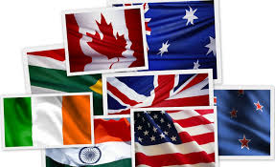

What English-speaking countries do you associate these words with?

* football (Great Britain), cowboy (the USA), bacon & eggs (Great Britain), Aborigines (Australia), St. Patrick (Ireland – it’s the name of the cathedral), Indians (the USA), the Queen ( the queen is associated with all countries of the British Commonwealth - Great Britain, Australia, Canada, New Zealand), baseball (the USA), maple leaf (Canada), surfing (Australia), whisky (Scotland and Ireland), hockey (Canada).

So, say me where are these sights situated:

* Stonehenge (GB), the Niagara Falls (Canada), the Grand Canyon (the USA), Ayers Rock (Australia), the Statue of Liberty (the USA), Westminster Abbey (GB), Loch Ness (GB Scotland), Twelve Apostles (Australia), the Great Barrier Reef (Australia), the Empire State Building (the USA), Mount Rushmore (the USA), Millennium Bridge (GB, London), Snowdonia (GB, Wales.

I tell you the names of famous persons; you try to answer their spheres of activity and the countries where they are from:

* Pierce Brosnan - he is an Irish actor, the most famous role is James Bond.
* Christopher Wren – he is a famous English architect. St. Paul’s Cathedral is his masterpiece.
* Tina Turner – she is a famous American singer.
* Charlie Chaplin – he is a famous actor. He was born in London, but became famous in the USA.
* Arthur Conan Doyle – he is a famous English writer, the father of Sherlock Holmes.
* Alfred Hitchcock – he is American and English producer of horror films.
* Margaret Thatcher – she is a former prime minister of GB, the “maiden lady”.
* Meryl Strip - she is an American film-star.
* Bernard Show – he is a great British writer, the author of “Pygmalion”.
* Anthony Esposito – he is a famous Canadian hockey player.

|  |  |  |  |  |
| --- | --- | --- | --- | --- |
|  | **Great Britain** | **the USA** | **Canada** | **Australia** |
| **capital** | London | Washington | Ottawa | Canberra |
| **largest cities** | Liverpool, Glasgow, Manchester, Cardiff | New York, Chicago, Dallas, Phoenix, Los Angeles, San Francisco | Toronto, Montreal, Vancouver, Winnipeg | Sydney, Melbourne, Perth, Brisbane |
| **rivers** |  |  |  |  |
| **mountain ranges** |  |  |  |  |
| **highest mountain** |  |  |  |  |
| **seas, oceans** |  |  |  |  |
| **lakes** |  |  |  |  |

**IV. Заключна частина заняття.**

Our lesson is coming to the end. I hope it was interesting for you. You worked a lot searching information in the Internet and libraries. Could you express your opinions? Say if it was difficult, interesting, boring or thrilling to work on the projects. What is unique about this kind of work?

This work has helped us to gain a better understanding of Australia. It stimulates cross-cultural approach to Australian studies. Thanks a lot for your work. We have done some grammar exercises, reviewed the rules of using articles with geographical names. I’m satisfied with our work. So, your marks for the lesson are… .

Your home task for the next lesson is to complete the given table.