Topic: School Life. Prepositions of Time.
Aim:
- to give students practice in talking about their school life;
- to raise students` awareness of using prepositions of time;
- to give students practice in using prepositions of time.

- Greeting.  - Good morning, pupils. I’m glad to see you.  - Warm up.  - Every day we go to school and … (complete my sentence)  - So we continue to speak about our school life. | 
- Word Smart.  - “Study Stack –Flash Cards”  https://www.studystack.com/flashcard-2445997  - Let’s start with our words, the names of school subjects.  - Be ready to recall them. Look, listen, repeat and translate. | 
2) “Study Stack – Targets”  - Let’s do one more exercise to know them better. You have to hit the targets.  https://www.studystack.com/studyslide-2445997 | 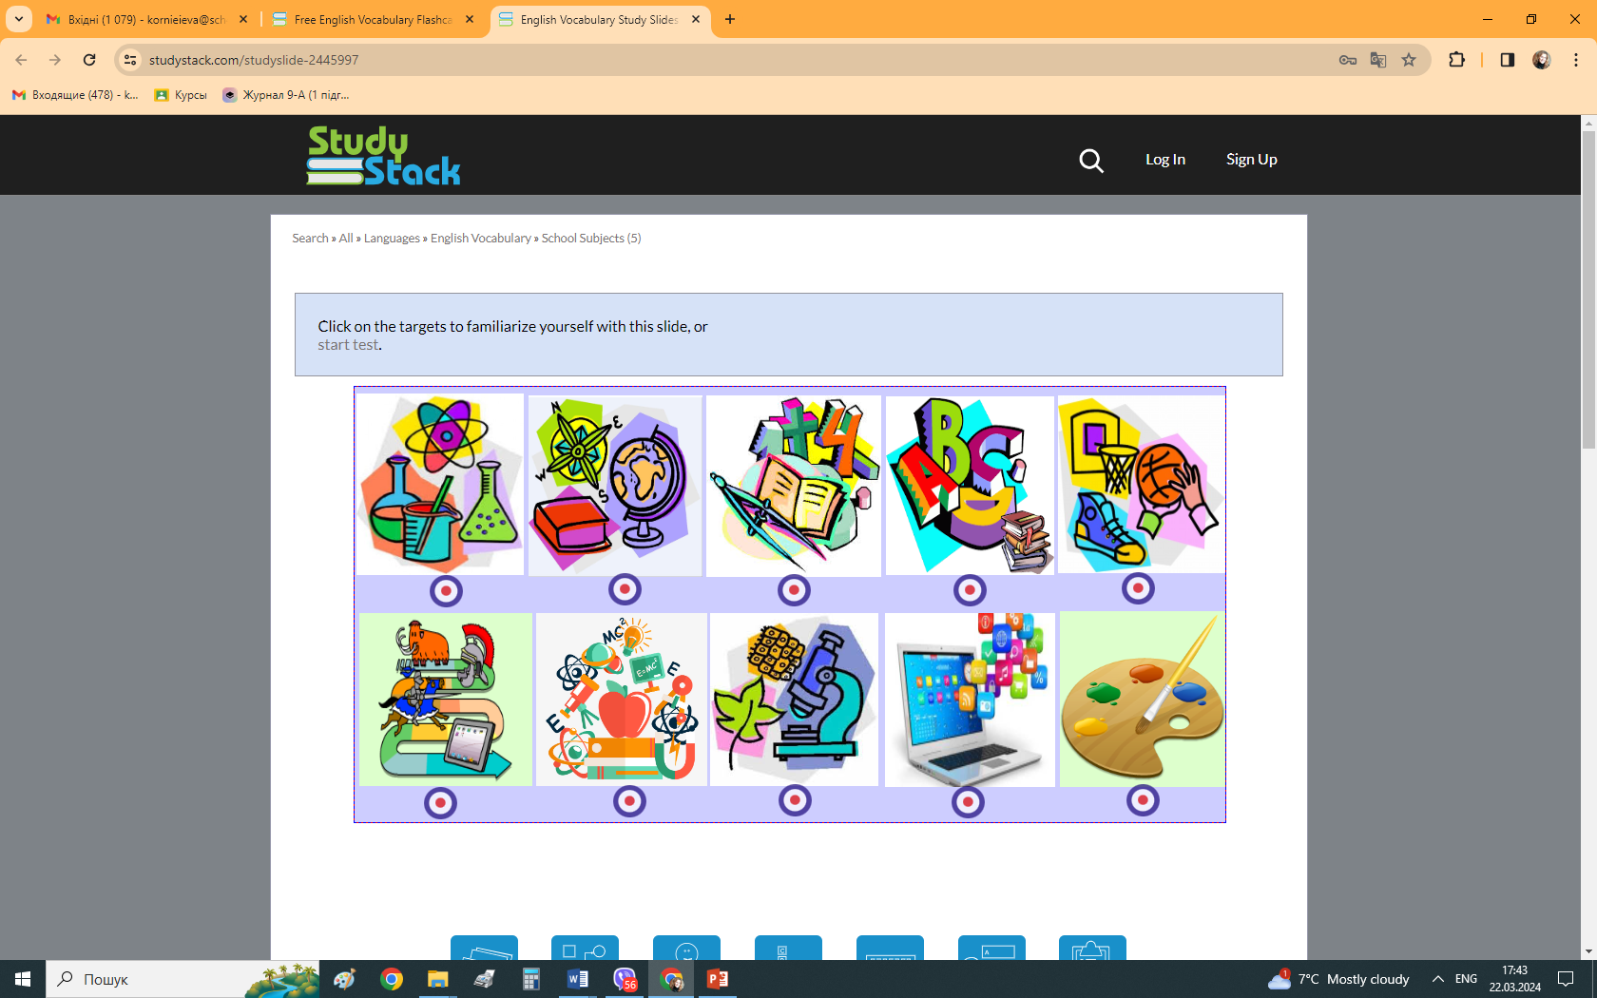
3) “Study Stack – Lexical Test (printed)”  - And now you are ready to write your lexical test. | 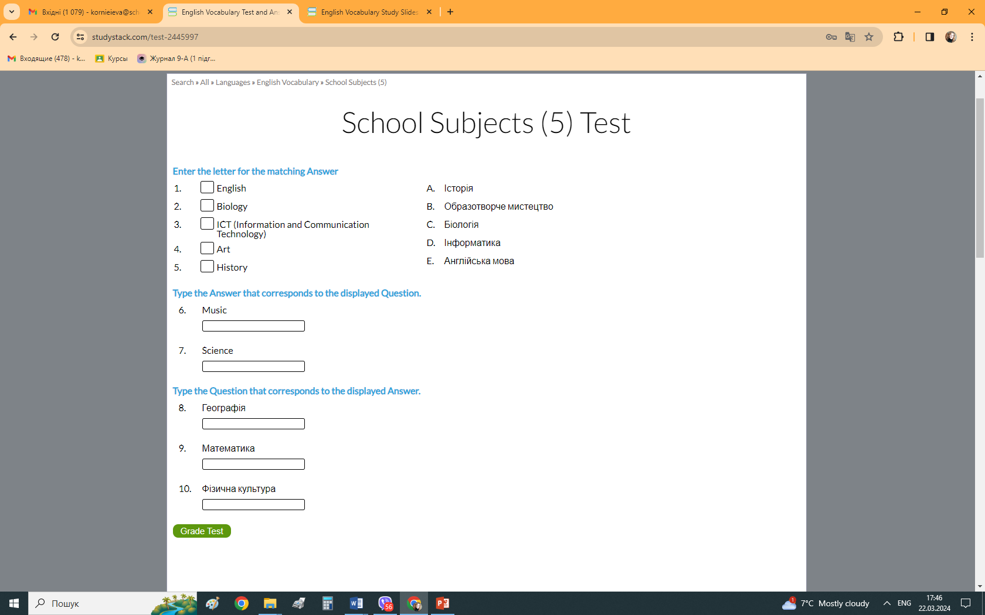
- Grammar Smart.  - “When have you got …”  - We have got a lot of classes on weekdays. Now look at the table, it will help you to answer my questions.  - We have got a lot of classes on weekdays. “On” is a preposition of time. | 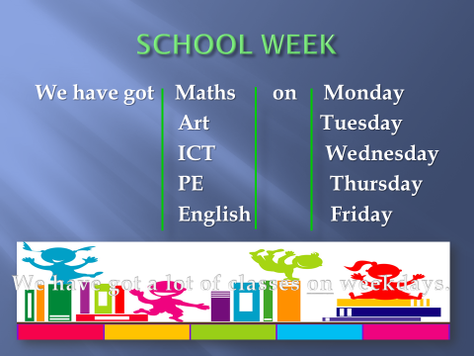
- “Prepositions of Time”  - Look at the board, repeat after me and try to remember.  - “Study Stack – Matching Quiz - Practice”  - Let’s practice a little. We have a matching test. Match the prepositions with the right time.  https://www.studystack.com/picmatch-2853853 | 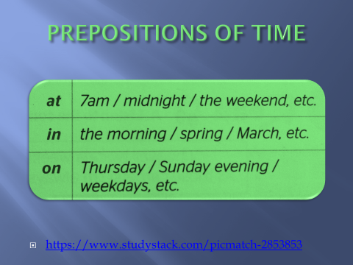
- Vocabulary Smart.  “ Study Stack – Lexical Test”  - Before our next task let’s recall some more words on the topic.  https://www.studystack.com/quiz-2855352 | 
- Speaking Smart.  “Study Stack – Matching Quiz (printed).  - And now we are ready to speak about our school life. These parts of sentences will help you. So match them.  - Let’s check. Thank you so much for your work! | 



