**Тест Full Blast 6 Module 5**

1. It is a ....

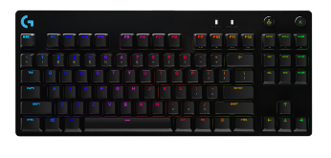

1. Keyboard
2. Laptop
3. Monitor
4. Screen
5. It is a ....

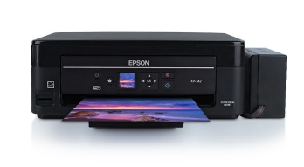

1. Screen
2. Monitor
3. Printer
4. Mouse
5. It is a ....

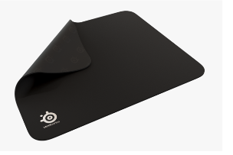

1. Laptop
2. mouse pad
3. USB flash drive
4. Keyboard
5. It is a ....

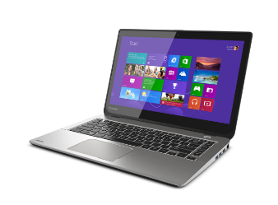

1. Speakers
2. Laptop
3. Screen
4. Monitor
5. It is a ....

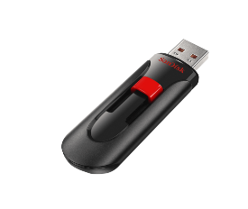

1. USB flash drive
2. Mouse
3. Cursor
4. Printer
5. It is a ....

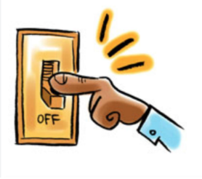

1. turn off the lights
2. turn off the tap
3. reuse
4. recycle
5. Look at the picture and choose the right answer

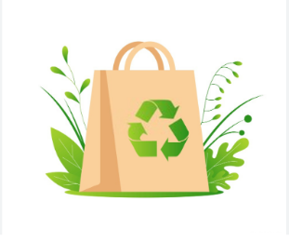

1. Reuse
2. collect rubbish
3. use paper bag
4. leaflet
5. Look at the picture and choose the right answer



1. Walk
2. plant trees
3. cut down trees
4. reuse
5. Look at the picture and choose the right answer

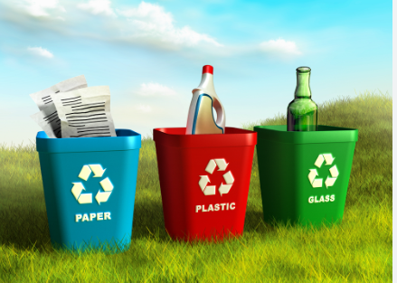

1. turn off the tap
2. recycle
3. use paper bags
4. plant trees
5. If you decide to go to the party, _________ me
6. Tell
7. will tell
8. If John wants to paint his bedroom, I ________ him
9. Help
10. will help
11. If we _________ protecting endangered species, they will disappear.
12. don't start
13. won't start
14. If you want to buy nice trainers, you ______ to that shop over there.
15. Go
16. can go
17. Lisa _______ very happy if she does well in Maths this year.
18. will be
19. is
20. We _______ get up without asking during the lesson. Our teacher will get angry.
21. mustn't
22. don't have to
23. didn't have to
24. I’m sorry sir. You ______ eat in the museum.
25. don't
26. don't have to
27. mustn't
28. My school is organising a fun run. Students ________run if they don’t want to.
29. have to
30. mustn't
31. don't have to
32. Nick _______ wait for the bus. I drove him to school.
33. had to
34. doesn’t have to
35. didn’t have to