Тема уроку : The British Writer s

Тип уроку:урок комплексного засвоєння знань

Обладнання : portraits of famous writers, cards

Мета: Продовжувати формувати фонетичні та лексичні навички, розвивати мовну здогадку та мовленнєву реакцію, вдосконалювати мовленнєві компетенції та навички аудіювання

Поглибити знання учнів про життя та творчість англійських письменників,розширити кругозір учнів, прищеплювати любов до читання різних жанрів літератури,виховувати учнів на прикладах життя і діяльності видатних письменників

Розвиток , корекція слухового, зорового сприймання

Хід уроку

1. **Мотивація навчальної діяльності**

T. Dear pupils! Look at these pictures.

Whom of these people in the pictures do you know? What unites all of them' What association do you have?

The teacher shows some portraits of famous English writers. Pupils say their

associations: all these people are English writers.)

1. 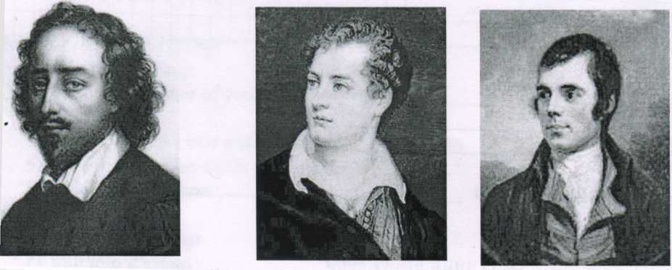

William Shakespeare

Robert Bums

Byron

2. Оголошення теми уроку

T. The theme of our lesson is “ The British writers”. Today we will focus on life and creative work of a well-known English poet. What English poets do you know? ( Children answer).

By the end of this lesson you will be able to:

read and listen to some stories about great poets of Britain;

get acquainted with some of their works;

exchange information on the basis of a given situation;

Warming up

Teacher. First I’d like to begin our talking with the words written by Pablo Picasso, an Italian painter:

“Literature washes away from our souls the dust of everyday life. ”

* **Translate it into Ukrainian all together**.
* Books are our friends. Read the poem about them**(Ex/9 P.121**
* What can you say about books as our friends and teachers?

(Children’s answers)

**Teacher.** It’s no doubt that a book is one of the greatest wonders in the world. Thanks to the books we can talk to person who lived in different ages and countries, we can broaden our knowledge and improve our life. Will you look at your cards please, and read the saying:“**Love books**, **they are the source of knowledge**, **and only knowledge can make us stronger and better.** ” **Gorky**

**Teacher:Let’s read other sayings about books**

**P1**.books and friends should be few but good

**P2** A room without books is a body without a soul

**P3** Books offer romance, history, adventure, and autobiography, science fiction in the form of short stories, novels, poetry and plays.

**P4** Wear the old coat and buy the new book

3. Phonetic Drills.

Teacher. The poets consider that books are human wisdom.

Listen to the poem by Adelaide Love and tell what the book is compared with.

“A Book”

A book, I think, is very like

A little golden door,

That takes me into places,

I’ve never been before.

It takes me into fairy lands

Or countries near and far.

But best of all, the golden door

Always stays ajar.

**Teacher:Repeat after me.**

* **What is the book compared with?**

**Основна частина уроку**

**Teacher.** I suppose that you understand the importance of books in our life. But today we are going to speak about people, who write books, about their lives and work.

**Teacher**. (Music is played.)

All the world’s stage,

And all the men and women merely players:

They have their exits and their entrances;

And one man in his time plays many parts,

His acts being seven ages.

Усе життя – театр,

А люди тут-актори

І кожен грає власні ролі

У п’єсі на сім дій.

**T:** Do you know the author of this work?

Would you like to make a journey through time and meet one of the greatest dramatist of the Renaissance.

*So! Get ready!* (Music is played)

Close your eyes and use your imagination. You are in the 16th century in London. Now you are going to visit a beautiful castle and be present at a grand ball. Ladies and gentlemen are dancing. You can hear the sounds of music... Now open your eyes.

So, listen to the story of this well-known writer.

**Teacher**: I was born on April 23, 1564 in Stratford-upon-Avon. My father was a glove-maker. I went to a grammar school and had a good education. I married when I was still a teenager. I had 3 children when I left for London in 1587. In London I began to act and to write. Most of my plays were performed in the Globe Theatre. I died in 1616.

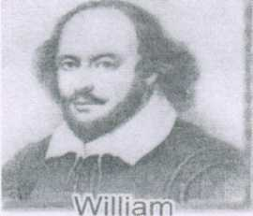

Shakespeare

**Teacher**.

**Look at your cards(screen), choose the correct answer**

1. Shakespeare was born on...

1. April 23,1616
2. April 23, 1564
3. April 23, 1603
4. Shakespeare was born in...
5. Stratford-upon-Avon
6. London
7. Oxford
8. Where did he build the Globe Theatre?
9. In Stratford
10. In London
11. In Cardiff
12. When did Shakespeare die?
13. In 1616
14. In 1666
15. In 1606
16. What his famous plays do you know?
17. “Hamlet”, “Robinson Crusoe”
18. “Othello”, “Mowgli”
19. “Hamlet”, “Othello”

**Teacher**: Dear children! I would like to tell you about one of the famous British poets Robert Burns. Robert Burns is a Scotland’s national poet who was born in a very poor family. There were seven children in the family and Robert was the eldest. I think you understand how hard it was for him to get a proper education and become a great poet of his country. Tell me please, have you ever heard about Robert Burns? What his poems do you know?

**Teacher: Look at page number 118 and read his famous poem “My heart’s in the Highland”**

**Children** read poems and traslation

Teacher:Our lesons won’t be full without such famous poet as **George Gordon Byron. But acquaintance with him we will do in unusual form. Ask and answer questions to find the missing information**

**«George Gordon Byron»**  
**George Gordon Byron, a famous English poet, was born in London in …… After the death of his father his mother left London and lived with her son in Scotland. When the boy was eleven his grandfather`s brother died and the boy inherited …….. At seventeen he entered …… and there his literary career began. The poet became famous in England and in other countries when he published his poem** **«Child Harold`s Pilgrimage». He wrote many other poetical works. Pushkin and Lermontov liked this English poet. They translated some of his poems into Russian. The poet travelled a lot.** **In …he fell ill with typhus and died in April in 1824. The poets name is well known in our country and all over the world.**

**Pupils 1: When……..?(was he born)**

**What …..(did he inherit)?**

**What……( university or school did he enter)?**

Where …..(did he feel ill)?

**«George Gordon Byron»**  
**George Gordon Byron, a famous English poet, was born in …. in 1788. …….. his mother left London and lived with her son in Scotland. When the boy was eleven his grandfather`s brother died and the boy inherited the title of the lord. At ….. he entered University Cambridge and there his literary career began. The poet became famous in England and in other countries when he published his poem** **«Child Harold`s Pilgrimage». He wrote many other poetical works. Pushkin and Lermontov liked this English poet. They translated some of his poems into Russian. The poet travelled a lot. In Greece he fell ill with typhus and died in April in …. The poets name is well known in our country and all over the world.**

**Pupils 2:** Where ……(was he born)?

When…..(…did his mother leave London)?

How old ……(was he ,when he entered to university?

What year ……(did he die?)

Teacher: read and translate this text

**Teacher**:I believe your life is full of books. Are you fond of reading?

Look at your cards again. Write your names, please. There is a matching exercise on it. Help these writers to find their books.

|  |  |  |
| --- | --- | --- |
| 1) | Charlotte Bronte | a) King Lear |
| 2) | Daniel Defoe | b) Three Men in a boat |
| 3) | Rudyard Kipling | c) The Last Leaf |
| 4) | Jonathan Swift | d) The Jungle Book |
| 5) | William Shakespeare | e) Sherlock Holmes |
| 6) | Conan Doyle | f) The Adventures of Tom Sawyer |
| 7) | Jerome K.Jerome | g) Gulliver's Travels ' |
| 8) | Lewis Carroll | h) Robinson Crusoe |
| 9) | Mark Twain | i) Jane Eyre |
| 10) | 0.Henry | j) Alice in Wonderland |

What do you know about these writers and their books?

1. What was the name of Tom Sawyer's younger brother? (Sid)
2. Who is the author of the poem "Six Serving Men"? (R.Kipling)
3. What was Robinson Crusoe friend's name? (Friday)
4. What is William Shakespeare's native town? (Stratford-on-Avon)
5. Who said these words: "To be or not to be"? (Hamlet)

Teachers: Well done!

Заключна частина уроку

HOMEWORK.

Teacher: Of course, We don’t have enough time to speak about other English writers and poets.But at home you will have opportunity to read about them. Your hometask is Ex.7 p.119

SUMMARIZING.

Teacher. Dear guests and dear students! Look at the blackboard and you can see some sentences, which sums up your knowledge about books, English literature.

* Complete the sentence.

Books play a very important role in our lives because...

* they teach us to live;
* they help us in self-education;
* they give us pleasant minutes;
* they help us to understand life;
* they teach us to respect other people;
* they help us in deciding problems of life;
* they develop our imagination;
* they broaden our outlook;
* they tell us about customs and traditions of different countries;
* they tell us how great and wonderful the world is;
* they open the door into the world of knowledge.

Teacher. Thanks for your work during the lesson. Taking into account your activity your marks are the following...