**Car-rot**

**Ca-ke**

**Cof-fe**

**Co - coa**

Cammy and Carly baked a carrot cake.

And coconut cookies they did also make

They carefully drank cocoa from a coffee cup

and ate they yummy cookies and the cake all up.

***Riddles***

***When I'm young I'm tall My friend is grey.   
When I'm old I'm short He likes to play.  
When I'm alive I glow He is warm and fat.  
Because of your breath I die I love my …(cat)***  
***What am I? (A candle)***

***Colours***

**Brown is mud. Blue is the ocean.**

**Brown is toast. Blue is the sky.**

**Brown is chocolate, Blue are the blueberries,**

**And a Sunday roast. I put into a pie.**

**Yellow is a star. Red is an apple.**

**Yellow is a sun. Red is a cherry.**

**Yellow is the moon, Red is a rose,**

**then the day is done. And a ripe strawberry.**

Tongue Twister

**A clever caterpillar could cartwheel over cars and cycle to a café to order caviar.**

**How can a clam cram in a clean cream can?**

Bal-loon

Ba-boon

Ba-na-na

Bobby Brown bought a blue balloon;

gave the balloon to his pet baboon.

He named his pet baboon Babette.

They became best buddies from the day they met.

***Riddles***

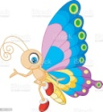

|  |
| --- |
| ***Картинки по запросу "bull  cartoon pictures"*** |
|  | |  |  | | |  | |
|  |
|  |
| ***Картинки по запросу "beast cartoon pictures"*** |
| ***Картинки по запросу "bread cartoon pictures"*** |  |  |  | | |  |
| ***Картинки по запросу "beetle cartoon pictures"*** |
|  |  |  |  | | |  |  | |

|  |
| --- |
|  |
|  |
|  |
|  |

Tongue Twister

**Bananas are a fruit that is fun to eat**

**You've gotta bounce biddy-bounce to the boppin' beat now.**

***Big, brown, bears blow bubbles in Brian’s bath.***

***A big black bug bit the big black bear, but the big black bear bit the big black bug black.***

**Poem**

**A big brown bear is looking at me,**

**With his great big eyes that I can see.**

**I think I better run away,**

**So I can go hiking on another day**

Dri – ver

Dra – gon – fish

Dau - ghter

David was a diver.

He dove in deep dark water.

He caught a baby dragonfish

to give to his dear daughter.

***Riddles***

***I can catch a frog. You place food on me   
I can sleep like a log. A. 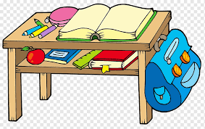 desk C. Dice clipart yellow dice, Picture #905439 dice clipart yellow dicedice  
I can find your sock.   
My name is? (a dog)  B. Area,Purple,Symbol PNG Clipart - Royalty Free SVG / PNG dish***

***I am used in games. You roll me and I tell you a number.***

***A. 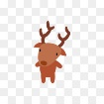 deer B. 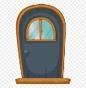door C. Dice clipart yellow dice, Picture #905439 dice clipart yellow dice dice***

***I am what you do to get in the pool.***

***A.  desk B. Area,Purple,Symbol PNG Clipart - Royalty Free SVG / PNG dish C. 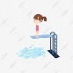 dive***

Tongue Twister

**Do you dare to draw a donkey driving a dump truck?**

**Poem**

**Letter D says, “Day, dog, dish!”**

**Straight line, one hump, if you wish!**

Ap – ple

Ap – ri – cot

Al – li – ga – tor

Alan ate an apple, and awesome it did taste.

Ava ate an apricot, and not a bite did waste.

Andy watched a little ant crawl along the ground.

And Allie watched an alligator swims without a sound.

***Riddles***

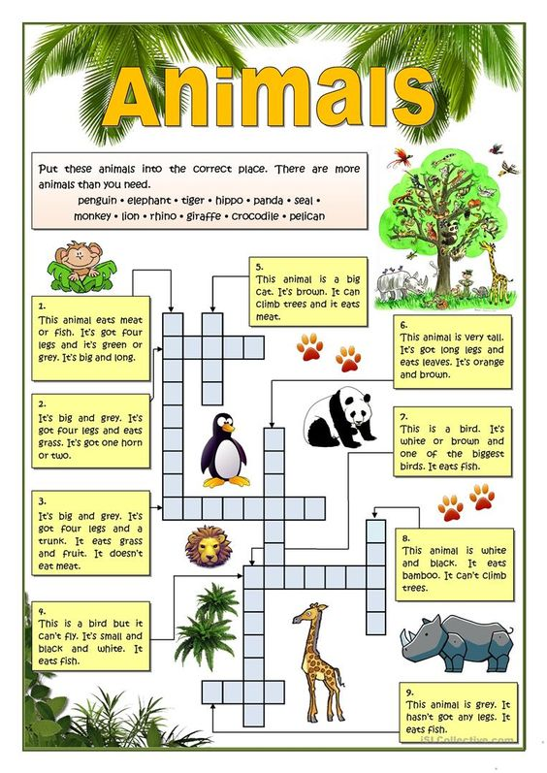

Tongue Twister

**Can an active actor always actually act accurately?**

***Ann Anteater ate Andy Alligator`s apples, so angry Andy Alligator ate Ann Anteater`s ant.***

**Poem**

**Letter A says, “Apple, ant!” Looks like a tent and that is that!**

<https://www.youtube.com/watch?v=PzK0-VSZPd4>

Tongue Twister

***Elephants and Easter eggs are exciting to me.***