**Topic**: Is new technology bad for your health?

**Learning outcomes:** by the end of the lesson learners will be able to understand the potential risks of new technology;

Indicate the advantages and disadvantages of new technology:

Suggest their tips for a healthy usage of technology.

**Mediation strategy**: ***streamlining a text,*** linking to previous knowledge, adapting language.

**Criteria:**

The usage of relevant information; accurate usage of vocabulary; active teamwork; creativity; expressing personal point of view; critical thinking, realia.

**Pre-reading task**:

Purpose: to encourage students to talk, to link to their previous knowledge and to introduce key vocabulary

1. The teacher organizes class into groups or pairs and encourages learners to answer the questions in order to activate prior knowledge (linking to previous knowledge)

* How often do you use your mobile phone or play video games?
* Have you ever had headaches after using technology?

The teacher encourages students to use language patterns (if it is needed) with the possible answers to the questions in order to support weaker students.

* I use my mobile phone approximately 2/5/7 hours every day.
* I play video games approximately 2/5/7 hours every day
* I have never had a headache after using technology.
* I sometimes have a headache after using technology.

1. The teacher introduces the key vocabulary to the learners

*Sore neck, bacteria, smartphone zombie, detect, sit up straight, home button, lamppost, pavement*.

Students who need more support match the words with the pictures .

Students who need to be challenged match the words with definitions.





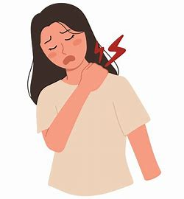



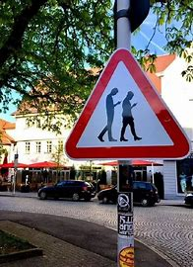

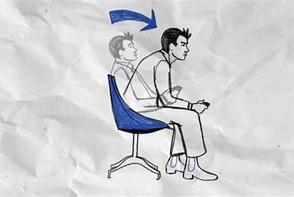

Sore neck – Pain in your neck, often from looking down for too long.

Bacteria – Tiny living things that can cause illness and grow on dirty surfaces.

Smartphone zombie – A person who walks while looking at their phone and doesn’t pay attention to their surroundings.

Detect – To notice or find something that is hidden or not obvious.

Sit up straight – To position your back and shoulders correctly when sitting.

Home button – The main button on a smartphone that takes you back to the home screen.

Lamppost – A tall pole with a light on top, usually found on streets.

Pavement – The path next to a road where people can walk safely.

1. Students listen to the text and in groups think about the best heading to each paragraph (A-C) in the text. Those who need more support or visual learners match pictures to headings.

**Reading task**

Purpose: to develop reading comprehension skills

Learners work in groups

The teacher encourages learners to read the text and do the following activities:

* Students who need extra support read the text, highlight new words and do True/False activity

(For fast finishers the task is to draw a mind map of the main ideas from each paragraph )

* Students who need to be challenged read the text independently and answer the special questions, e.g. *Why did Sahiholnasab invent the glasses? Why is hygiene important? How many times do people touch their phones according to this text?*
* Students who need to be challenged summarize each paragraph of the text in 2-3 sentences and explain key points to the others using simple language

**Post-reading task**

Purpose: to develop critical thinking skills

1. The teacher encourages students to take part in debates on the topic *“Is new technology bad for our health?”* and to use ideas from the text to justify the ideas. There is a visual support on the blackboard, e.g. *I think….because… Personally I think….*
2. The students create posters “Tips for healthy usage of technology”

