**Synopsis of the English lesson**

**on the topic "My family. Adverbs of manners"**

**6th grade**

**45 minutes**

Topic. "My family. Adverbs of manners"

The goal of the lesson:

**educational:**

• train students in vocabulary on the topic "Family";

• practice in composing monologic and dialogic statements according to the structure;

• to train in the use of Adverbs of manners by example.

**developing:**

• develop communication skills;

• develop spelling skills.

**educational:**

• to cultivate a sense of respect and benevolence towards the members of one's family;

• develop and maintain a steady interest in the English language, linguistic and cultural communication with each other.

Equipment: blackboard, thematic pictures, presentation, sets of didactic handouts, laptop.

Lesson plan:

I. Organizational moment (5 min)

II. Phonetic charge (3 min)

III. Training of learned vocabulary (5 min)

IV. The practice of using the verb Have / has got in sentences (5 min)

V. Work in pairs. Creating a dialogue ( 4 min)

VI. Physical education minute ( 5 min)

VII. Practical tasks (5 min)

VIII. Monologue ( 4 min)

IX. Reflection. ( 5 min)

X. Homework ( 2 min)

XI. Summary of the lesson, assessment ( 5 min)

Course of the lesson:

I. Organizational moment.

Greetings, verification of those present. Explanation of the course of the lesson.

Good morning, boys and girls!

Let’s start our lesson.

Nice to see you, my dear students! You are so good-

looking today! Your eyes are shining. And it’s high time to

start our lesson. Look at the blackboard and guess what we

are going to talk about today. Here you can see a crossword

puzzle. If you guess all the words correctly you will be able

to name the topic of our lesson

Thank you, sit down, please.

1.He is the father of your father.(grand- father)

2.She is the sister of your father.(aunt)

3.She is the mother of your sister.(mother)

4.She is the daughter of your mother.(sister)

5,He is the brother of your mother …

1 G R A N D F A T H E R

2 A U N T

3 M O T H E R

4 S I S T E R

5 U N C L E

6 Y

Know let’s listen a poem

This is my father, this is my mother,

This is my brother, this is my sister, Father, mother, sister, brother,

Hand in hand with one another.

I love my father; I love my mother.

I love my sister and my big brother.

Speaking

1. What is this poem about?

2. Say what the word "family" means.

So today we going to talk about family

**I. Phonetic charge.**

Now, our phonetic exercises,

Sing a song. <https://www.youtube.com/watch?v=yzzpwUIFmRQ>

“Are you sleeping”

Are you sleeping,

Are you sleeping,

Brother John,

Brother John?

Morning bells are ringing,

Morning bells are ringing,

Ding, ding, dong,

Ding, ding, dong.

Good, thank you. You’re clever boys and girls.

* 1. **Training of learned vocabulary.**

**Teacher** - Today we’ll revise some words.

Look at the board, please. Repeat after me.

MY FAMILY

mother / мати

father / батько

sister / сестра

brother / брат

son / син

daughter / дочка

grandmother / бабуся

grandfather / дідусь

parents / батьки

uncle / дядько

aunt / тітка

nephew / племінник

niece / племінниця

cousin / двоюрідний брат (сестра)

(Game quizlet <https://quizlet.com/822335298/my-family-flash-cards/>)

**Teacher -** Thank you, now I want to listen to everyone in English.

**Choose the correct translation:**

(I hand out cards-tables, students connect the words in the table)

|  |  |  |
| --- | --- | --- |
| mother |  | брат |
| father |  | мати |
| sister |  | бабуся |
| brother |  | дядько |
| grandmother |  | батько |
| grandfather |  | дідусь |
| uncle |  | сестра |
| aunt |  | тітка |
| son |  | батьки |
| daughter |  | племінник |
| parents |  | двоюрідний брат (сестра) |
| nephew |  | дочка |
| niece |  | син |
| cousin |  | племінниця |

**Students perform…**

**Studying the rules for forming the highest and highest degrees of comparison of adjectives and adverbs**

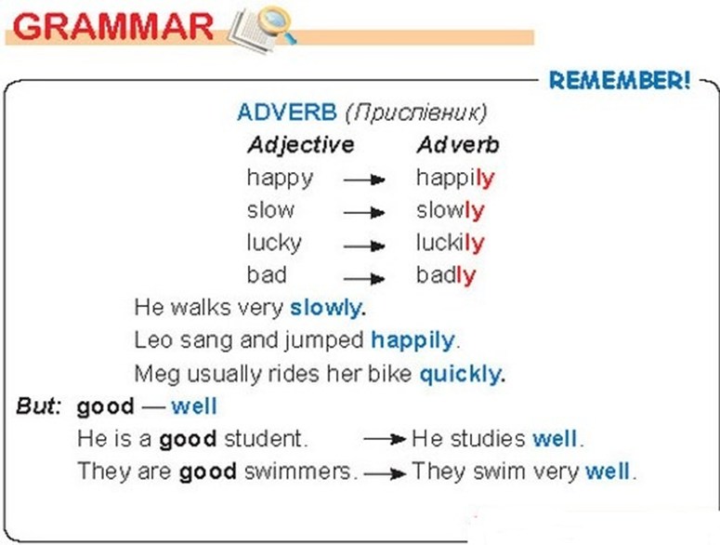

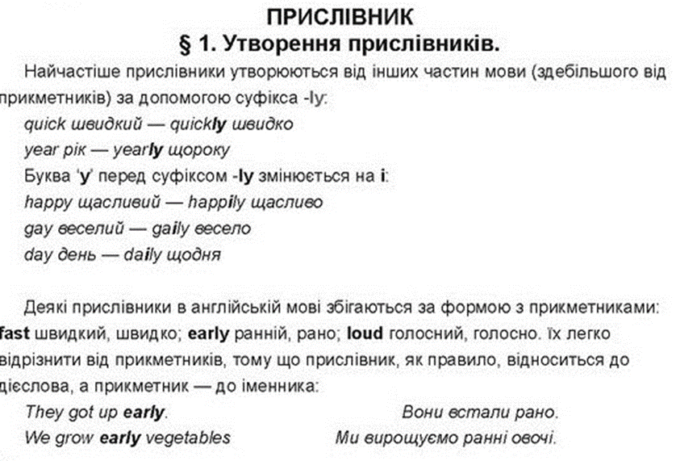

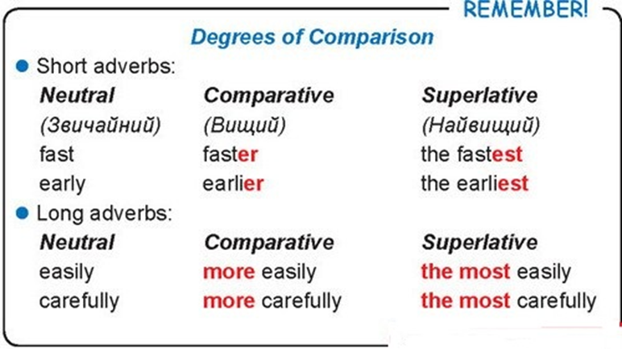

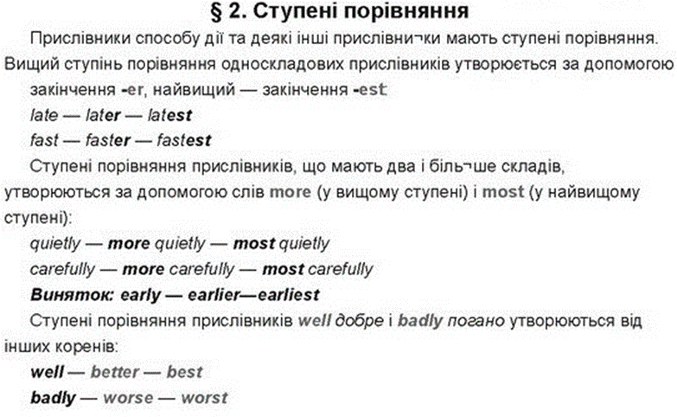

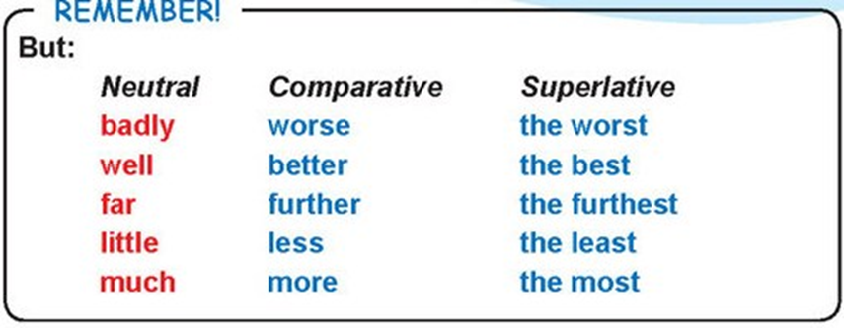

**IV Practical tasks And now, to consolidate knowledge on the comparison of adjectives and adverbs, complete the following exercises**

Exercise 1 page 34

Exercise 2 page 34

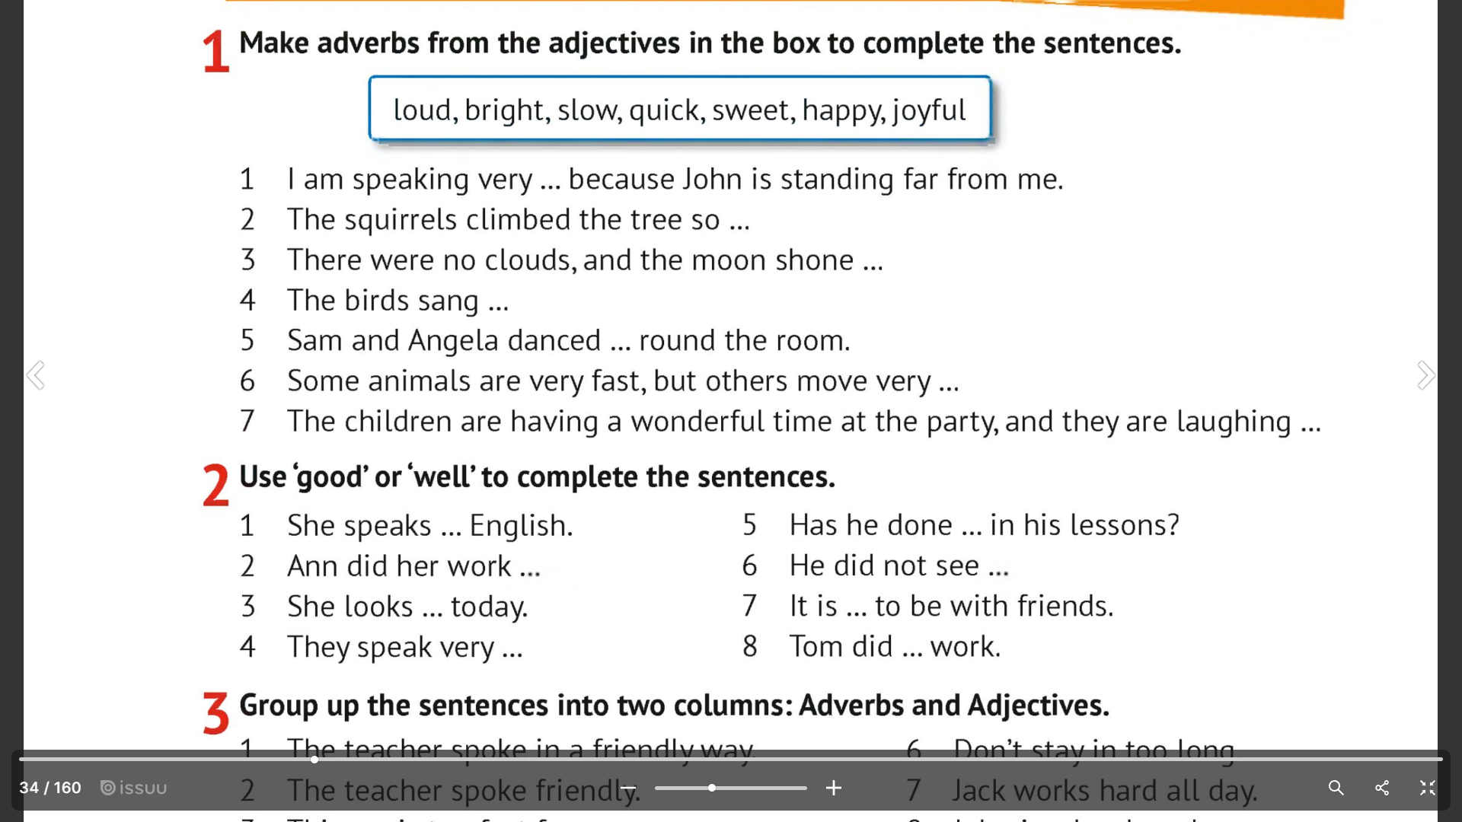

**Physical education minute.**

**Teacher -** I see that you look a little bit tired so let’s take relax and dance

**Teacher**- Good, thank you. Sit down, please. Take your places. Go on our work

<https://youtu.be/qoqYMv_V_3o?si=khlf2bAopZjE579x>

**VII. Monologue.**

**Teacher** - Make up a story about your family. Look at the board, please. I’ll give you 1 min

(I explain how to compose a monologue according to the scheme)

My name is… / Мене звати…

I have got a family. / У мене сім'я.

My family is big/ small. / Моя сім'я велика / мала.

I have got a mother/ father. / У мене є мати / батько.

My mother’s name is… / Мою маму звати…

My father’s name is… / Мого батька звати…

I have got a brother/ sister too. / У мене теж є брат / сестра.

My brother’s name is… / Звати мого брата ...

My sister’s name is… / Звати мою сестру ...

I like my family very much. / Мені дуже подобається моя родина.

**Reflection.**

**Teacher** - Today we talked about our family. Now answer the question.

What did I learn?

What did I learn?

**Homework.**

Write a story about your mother or one family member as you wish.

**Summary of the lesson. Assessment.**

- At the lesson, we got to know new words, made sentences based on the topic, worked in pairs, talking about our family, found pairs of words, etc.

Thank you for your work. Your marks for today are excellent.