Тема: Henry Longfellow. The Arrow and the Song.
Інтеграція: англійська мова + література
Вік учнів: 12-13 років
Тривалість: 40-45 хвилин

Мета уроку:
- Інтегрувати вивчення англійської мови та літератури через тему « Henry Longfellow. The Arrow and the Song».
- Поглибити знання учнів з літератури, познайомити їх з біографією та творчістю американського поета.
- Пояснити використання метафор у вірші, розтлумачити їх значення та визначити основний меседж твору (core message).
- Розширити словниковий запас учнів , використовуючи різні види пояснень ( за допомогою малюнків, дефініцій (English-English), переклад на рідну мову.
- Розвивати навички читання (про себе і вголос), вивчаючи поетичний твір.

Очікувані результати:
- формування мовної учнівської компетентності та культурної обізнаності через вивчення американської поезії;
- збагачення лексичного запасу та формування рецептивних граматичних навичок (Irregular Verbs);
- формування позитивного ставлення до іноземної мови та світової літератури;
- стимулювання учнів до критичного мислення та толерантного ставлення до інших культур;
- залучення учнів до скарбниці світової літератури, допомога в усвідомленні багатства та краси загальнолюдської культури;
- розширення читацького досвіду та культурно-естетичного тезаурусу учнів;
- формування естетичного смаку через сприйняття літературних творів як мистецьких явищ, розуміння їхньої художньої своєрідності та особливостей авторського стилю.

Warm-up
1. Brainstorming
- Look at the pictures. Do you know these people? What are their names? What are they famous for?
- 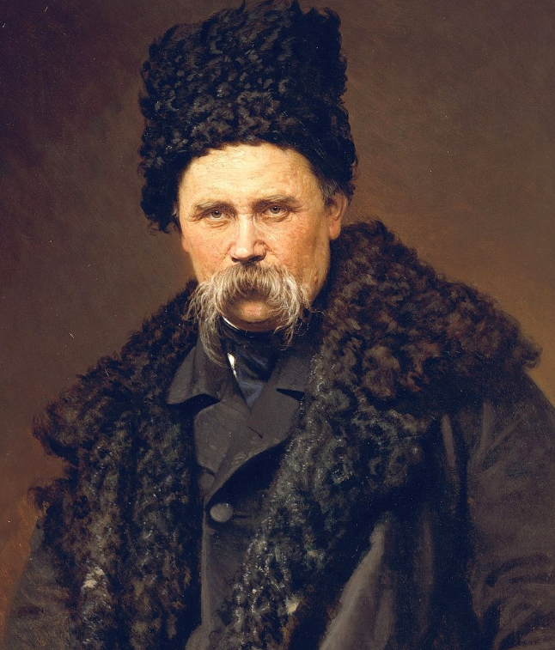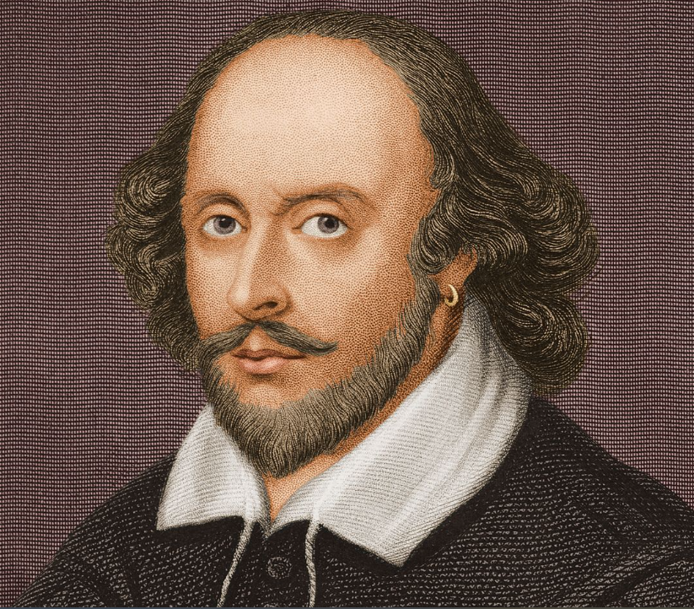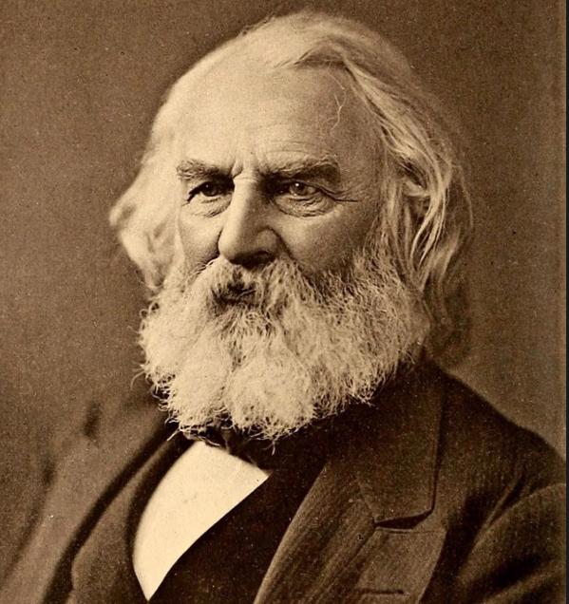
- Taras Shevchenko – great Ukrainian poet, writer, artist and public and political figure.
- William Shakespeare – an English playwright, poet and actor.
- Henry Wadsworth Longfellow – an American poet and educator.
What do you think all these great men have in common? - They wrote poems.
Can you predict the topic of the lesson? - Poetry and poems.
During this lesson you will get acquainted with biography of Henry Longfellow and his poet’s work.
2. Vocabulary extension
arrow -  , oak -  (tree);
swiftly – quickly, fast; sight – a thing can be seen; breathe – take air into lungs and then expel it;
keen – гострий, пронизливий; afterwards – далі, згодом.

3. Grammar review (Past Simple. Irregular Verbs)
1. Review Past Simple of Irregular Verbs shoot, fall, fly, know, find and a Regular Verb breathe.
https://learningapps.org/display?v=pd2g9sksk25
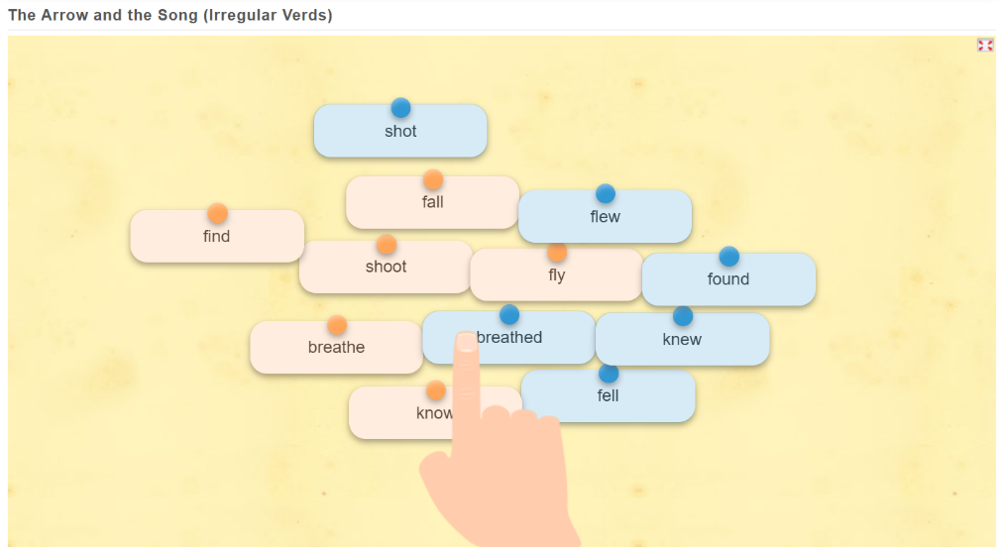
2. Complete the sentences with the verbs in brackets using Past Simple
1.The kids _____ arrows at a target in the yard. (shoot)
2. She slipped on the wet floor and _____ down. (fall)
3. The eagle _____ high above the mountains, soaring on the wind. (fly)
4. I _____ the answer to this question. (know)
5. At last, she _____ her lost keys in the kitchen. (find)
6. He _____ deeply to calm his nerves before the presentation. (breathe)
5. Reading
1. Biography of Henry Longfellow
Henry Wadsworth Longfellow is one of the most popular American poets. He contributed greatly to American literature. Longfellow was born in 1807 in Massachusetts. He showed an interest in writing at an early age. At age 18 he graduated from Bowdoin College, then he studied languages and literature in Spain, Italy, France, Germany and England. In 1829 Longfellow returned to the United States. He became a professor and a librarian. He worked at Harvard College and wrote a lot of poems including Voices of the Night, Poems on Slavery, The Song of Hiawatha, The arrow and the Song.
2. Watch the video and listen to the poem “The Arrow and the Song”
https://www.youtube.com/watch?v=9ZyR1Yft0n8&ab_channel=performingpoetry
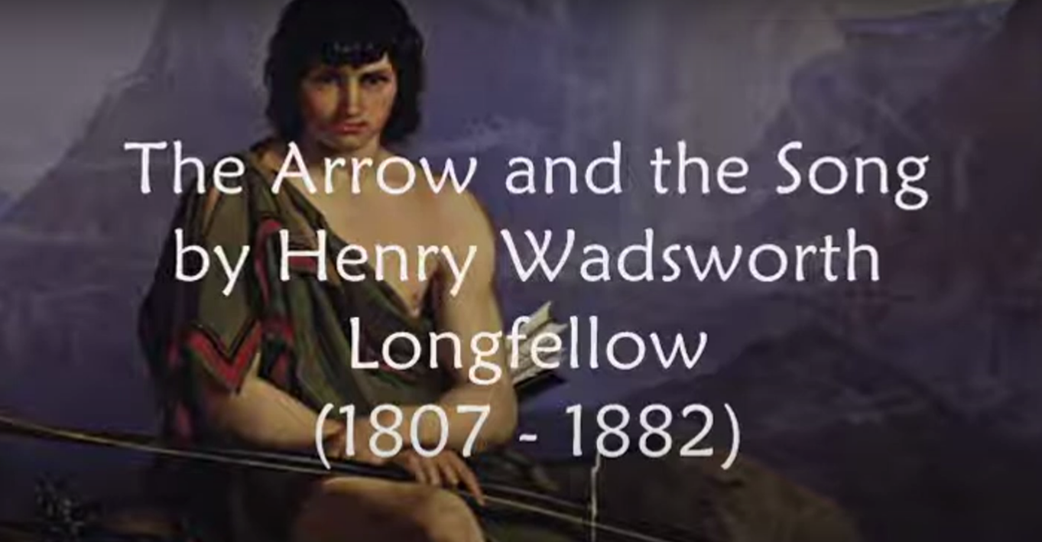

3.Read and translate the poem
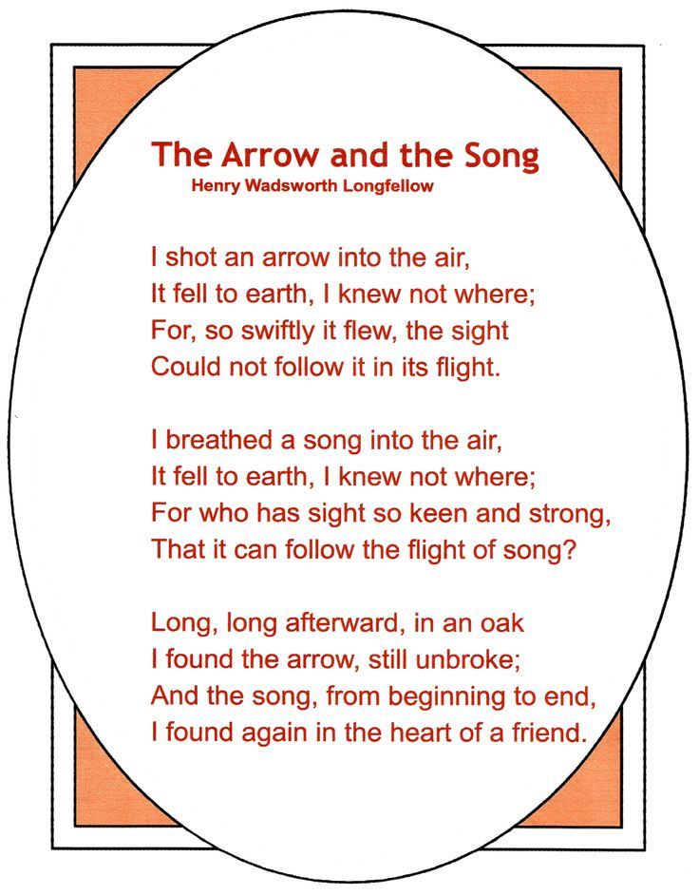
4.Memorization reading
I shot an ____ into the air,  It fell to earth, I knew not where;  For, so swiftly it flew, the sight  Could not follow it in its flight,  I breathed a song into the ___,  It fell to earth, I knew not where;  For who has sight so keen and strong, That it can follow the flight of song?  Long, ___ afterward, in an ___  I found the arrow, still unbroke;  And the song, from beginning to end,  I found in the heart of a friend. | I shot an ___ into the air,  It fell to earth, I knew not ___;  For, so swiftly it ___, the sight  Could not follow it in its flight,  I breathed a song into the ___,  It fell to ___, I knew not where;  For who has sight so ___ and strong, That it can follow the flight of song?  Long, ___ afterward, in an ___  I found the ___, still unbroke;  And the ___, from beginning to end,  I found in the heart of a friend.

I shot an ___ into the air,
It fell to ___, I knew not ___;
For, so swiftly it ___, the sight
Could not ___ it in its flight,

I breathed a song into the ___,
It fell to ___, I knew not ___;
For who has sight so ___ and strong,
That it can ___ the flight of ___?

Long, ___ afterward, in an ___
I found the ___, still unbroke;
And the ___, from beginning to ___,
I found in the ___ of a ___.

5.Watch the video and listen to a song.
The poem “The Arrow and the Song” was set to music.
https://www.youtube.com/watch?v=3czeVRy_LMw&ab_channel=MollyWhuppie
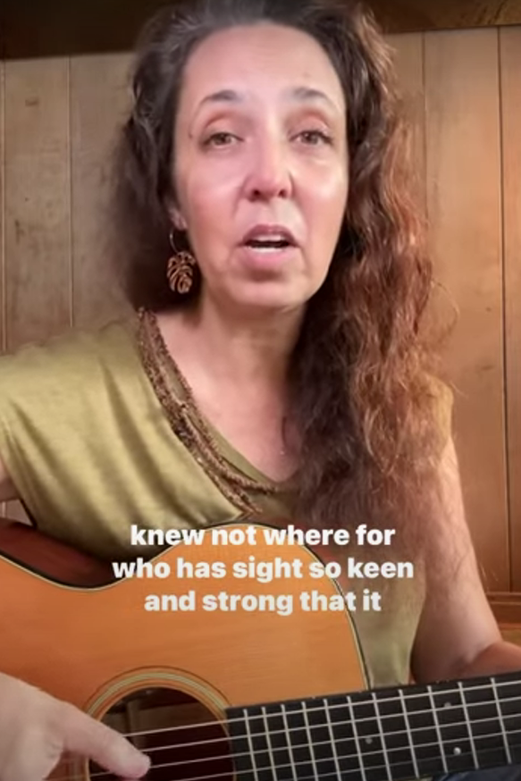

9. Discussion.
1.Read the definition of metaphor.
Metaphor – an expression, often found in literature, that describes a person or an object by referring to something that is considered to have similar characteristics to that person or object.
2.Answer the questions (questions and suggested answers)
- What did the poet shoot first into the air? – The poet first shot an arrow into the air.
- What did the poet shoot into the air then? – Then he shot a song into the air.
- Where did the arrow and the song fall? – They fell somewhere on the earth.
- Where did the poet find the arrow? – He found the arrow in an oak tree.
- Where did the poet find the song? – He found the song in the heart of his friend.
- What do you think the arrow symbolises? – The arrow symbolises harsh words and words that come out when angry.
- What do you think the song symbolises? – The song symbolises sweet words and anything pleasant.
- What message does the poem convey? – Harsh words hurt feelings of people in a negative way, while soft and gentle words influence people in a positive way.
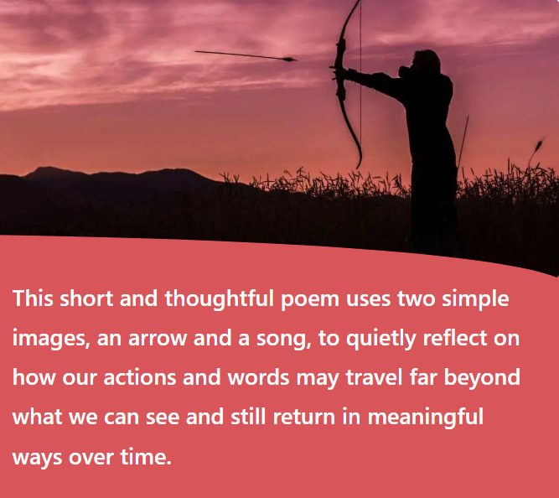
3.Read the translation of this poem into Ukrainian language
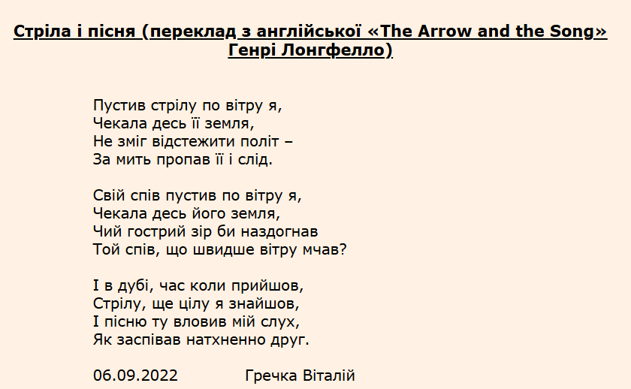

Warm down
10. Summing up. Giving likes. Saying goodbye.

