Subject: Shops and shopping
Objectives: to develop listening, reading, speaking and writing, skills;
to review the lexical material of the topic, to use in it the speech.
Equipment: pictures, cards, books, computer.

Plan
1. Greeting
T: - Hello! Glad to see everybody!
- Say Good morning to our guests!
- The weather is fine, the morning is bright. How are you?
I am all right. I am happy to see you.
So shiny (rainy, snowy) today.
And now I can tell. That you are very well.
- Who is apsent today?
2. Warming up.
T: My friend has birthday soon and I’ve bought her present. Do you want to know what I’ve bought? Then try to guess.
P1: Did you buy it at the department store?
T: No, I didn’t.
P2: Did you buy it at the market?
T: No, I didn’t.
P3: Did you buy it at the florist?
T: No, I didn’t.
P4: Did you buy it at the book-shop?
T: Yes, I did.
P5: Is this a postcard?
T: No, it isn’t.
P6: Is this a book?
T: No, it isn’t.
P7: Is this an album?
T: Yes, it is. It is a photo album.
3. Aim.
T: So, pupils as you have understood today we are talking about shops and shopping. We shall speak about different kinds of shops about things you can buy there, you will discuss with your classmates what you like to buy you will read the text and listen to the text about shopping.
- And now I want to repeat with you some names of things which we can buy in the shop.
- And now I repeat the kinds of shops.
- We buy bread in ………… ( the bakery).
- We buy sweets, cake in ………… ( the confectionery).
- We buy meat in ………… ( the butcher’s).
- We buy vegetables in ………… ( the greengrocer’s) .
- We buy milk , yoghurt, sour cream in ………… ( the dairy).
- We buy fish in ………… ( the fish-monger’s)?
- A person who buys is ………… ( a customer).
- A person who sells is ………… ( a seller, shop-assistant)?
Poem.
I want to be a shop-assistant
And sell you meat or fish
Cheese, sugar, jam or apples
Or anything you wish.

T: 2) I’ll give you cards and you must write the name of things and shops.
 | Name of things | Shops
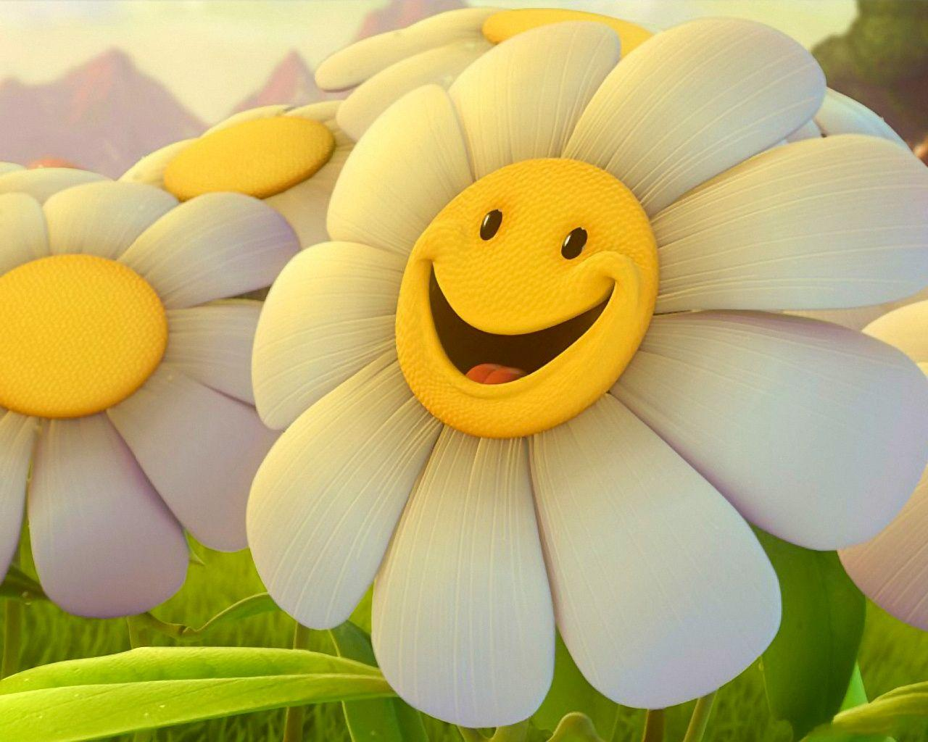
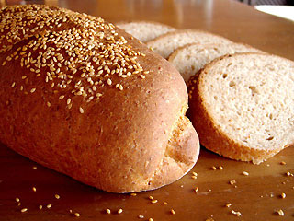
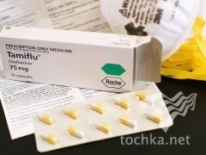
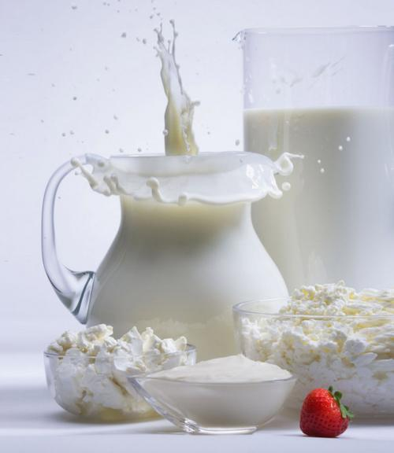
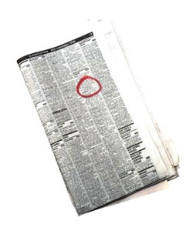
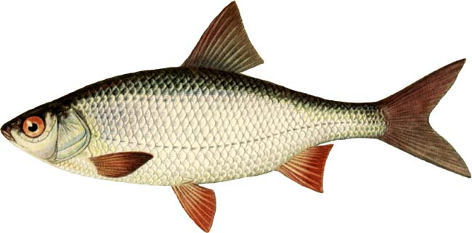
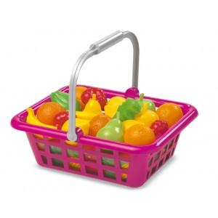
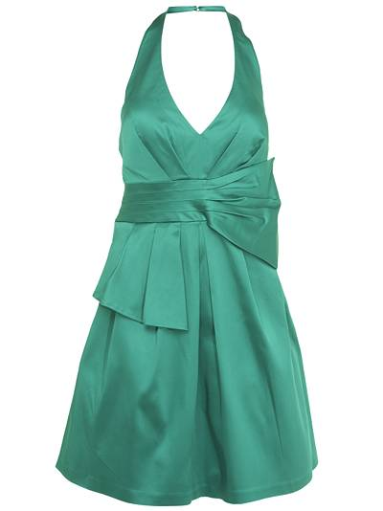

Name: clothes, fish, vegetables, newspapers magazines, bread, flowers, medicines, milk.
Shops: the greengrocer’s, the clothes department, the newsagent’s, the fish monger’s, the dairy, the florist shop, the bakery shop, the chemists.

Put the words in the correct category

backers
butter
Ice-cream
cheese

milk
hat
jacket
egg
coat
dairy
Fishmon-ger’s
Confec-tionery

Butcher’s
blouse
sugar

Green-grocer’s
dress
Depart-ment store
Backer’s
Super-market
shirt

Food | Clothes | Shops
sugar  egg  cheese  milk  butter  ice - cream | jacket  hat  coat  blouse  dress  shirt | the backer‘s  the greengrocer‘s  the supermarket  the department store  the confectionery  the fishmongers.

4. Speaking.
T: - And now children ask each other if you like to go shopping, what you, like to buy, how
often you go shopping.
- Let’s answer this question with he help of the song.
Song.
- Do you like to go shopping?
- Yes, of course.
- Do you like to go shopping?
- Yes, of course.
- Do you like to go shopping and buy some tea and coffee?
Do you like to go shopping?
- Yes, of course.
- Do you like to buy a present?
- Certainly.
- Do you like to buy a present?
- Certainly.
- Do you like to buy a present and give it to your parents?
Do you like to buy a present?
- Certainly.
T: I see pupils that you like to go shopping very much. And you know that a new supermarket has been opened in our town recently. It is a supermarket. We are lucky to have
the chief manager of this shop here.

P: (The chief manager) Good morning! I’m the chief manager of the new supermarket.
Our supermarket has many departments or sections:
The backer‘s , the dairy, the greengrocer’s, the confectionery and others. They sell all kinds of food or clothes.
- So, welcome to our supermarket.
T: Thank you for your information. It would be a good thing to attend this shop. Do you agree with me children? But don‘t forget to buy the right and healthy food, the food of vitamins.

P 1: Oh, I hear, somebody has pronounced my name. I am Vitamin A. Glad to see, you boys and girls I am in the carrot, butter, milk, eggs and some other product.

P2: And do you know me? I am Vitamin B. My place is in rye – bread, eggs, sea product and porridge. It‘s very useful food.

P3: Apples, lemons, oranges, are full of me of Vitamin C. When you are ill you usually drink tea with lemon and it helps you to get much better.

T: Thank you, vitamins, for your advertising.
- Do you want to go to the supermarket and buy something?

Dialogue № 1.
S: Good morning! Can I help you?
C: I‘d like a cheese.
What‘s the price of cheese?
S: What kind of cheese?
C: We have different kinds. Half a kilo at 15 hryvnias. I think it’s a good kind cheese.
S: That‘s right. But other kinds are also good. We don‘t have bad cheese.
C: Thanks. Good bye!

Dialogue № 2.
C: Good morning! How are you?
S: Hi. I‘m fine thanks you.
C: Yes, please I have many guests today I want to buy 15 chocolate. How much to pay?
S: 45 hryvnias.
C: Thank you very much.
Bye – bye!
S: Good bye!

Dialogue № 3.
C: Good morning!
I‘d like to buy a nice dress for my little daughter.
S: We have a wide choice of girl‘s dresses on sale. What size does your daughter wear?
C: She is neither tall nor small.
Her size is 32.
S: Look at this red and white dress. It is the best dress on sale.
C: Thanks you. Good bye!
S: Bye – bye!

Dialogue № 4.
C: Good morning!
S: Can I help you?
C: I‘m looking for potatoes.
S: How much would you like?
C: I want 3 kilo please.
S: Here you are. Do you want something else?
C: Yes, 2 kilo of tomatoes, please.
S: Here you are. That’s 10 hryvnias for tomatoes and potatoes.
C: Here the money. Thanks you. Good bye!

T. And now, children tell me please what food you will buy if you go to the new supermarket and why.

P1: As for me, I would buy meat and cheese because they make you strong and give you energy.

P2: As for me, I would buy fish and milk because they help you to grow.

P3: As for me, I would buy onion, eggs and cornflakes because they make our bones and teeth strong.

P4: I would buy oranges and apples because they have got a lot of Vitamin C.

P5: I would buy bread, sea products because they have got a lot of Vitamin C.
P6: I would like to buy, carrot because it has got a lot of Vitamin A and this vitamin is important for our eyes.

T: Well thanks you children. I see that you know what food to buy to be healthy and strong. But in out town there are many others shops where you can buy not only food, but clothes, foot, wear, presents and many other things.

5. Reading.
T: Well, you know children, that Ukraine we use hryvnias and kopiakas. But in Great Britain and the USA they use other money. Now read the next in Ex. 1 p. 120 and write what money
people use in the USA and Great Britain.

6. Writing.
1. In Ukraine people use _____ (y h v s n i r a) and _____ (p k o s i k y a).
2. In Great Britain people use _____ ( u p o d n s ) and ______ ( e p n c e ).
3. In the USA people use _____ (l a r d o s l) and _____ (n t e c s).

7. Listening.
T: Children, Adrnew is going shopping with his parents. They are going to buy some things. He will describe what things they are going to buy and you will try to guess and write them down in the shopping list. Write down in your copy books.
Things to buy.
1._______
2._______
3._______
4._______
5._______

1. You can dry yourself with it. It is long and soft. Holiday makes always take it to the beach.

2. It is very useful thing you can buy it as a birthday present for your friend you can take it in the library to read.

3. It is cold tasty and sweet. I like to eat it when it is hot outside. Ale children like to eat it in summer.

4. Mum loves them very much. She plants and waters them. Dad presents my mum with them on holidays.

5. You can wear them on your feet. You will heed them to go in for sport. They are nice and comfortable.

T: And now tell us please what things Andrew and his parents are going to buy.

Pupil’s answers: 1. a towel,
2. a book,
3. an ice – cream,
4. flowers,
5. trainers.

8. Homework.
Ex. 1,2 p .120 – to retell the text.

9. Summarizing.
T - Did you like the lesson?
P1 - Yes, I like the lesson.
P2– The lesson was very interesting.
T - What did you like most?
P1 – As for me I like put the words in correct category.
P2 – Listening about shopping.
T - What kinds of shops do you know?
P1 – I know many kinds of shops: the confectionery, the dairy, the butchers, the baker’s and others.
T - What did we do at the lesson?
P1 – We repeated the words and kind of shops.
P2 – We play games.

Shops & Shopping

І.Й.Школьницька

