Name _____________________________________ Form 4 - _________ I variant
All about us
- Match and write.
A castle, elegant, traffic, a lane, handsome, a shop.

 | a shop | 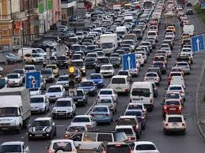
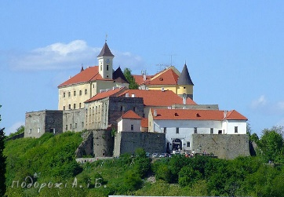 |  | 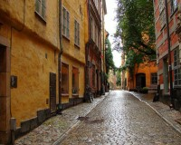
 |  | 

- Complete the sentences. Use the words is, are, was, were.
My village __________ not far from Kyiv.
The streets __________ clean and nice.
Orest __________ in Lviv last week.
They__________ in the restaurant.
Our school __________built in 1968.
My friend’s house __________ in the center of our village.

- Answer the questions.
What is your name?_______________________________________________
Where do you live? _______________________________________________
Do you have friends in London? _____________________________________
Where were you yesterday? ________________________________________

- Complete the sentences. Use the Present Simple or the Past Simple tenses.
We ____________________ (always / to fly a kite) in summer.
His brother ____________________ (to watch cartoons) yesterday.
Their friends ____________________ (to go) to the park two weeks ago.
Roman ____________________ (to live) in the village.
Name _____________________________________ Form 4 - _________ II variant
All about us
- Match and write.
Traffic lights, good-looking, a village, pretty, restaurant, a city.

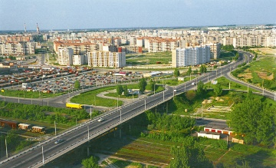 | a city | 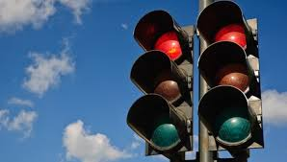
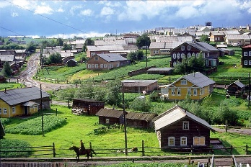 |  | 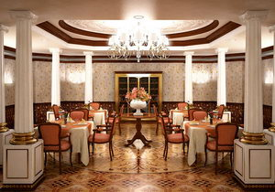
 |  | 

- Complete the sentences. Use the words is, are, was, were.
Dmytrivka __________ my village.
There __________ many cars and buses in our village.
My friends __________ in the mountains last summer.
The children __________ in the old castle.
His address __________ Number 10 Lisna Street.
My aunt lives in Rivne. Her house __________ comfortable.
- Answer the questions.
Where are you from? ______________________________________________
What’s your address? _____________________________________________
Where does your granny live? _______________________________________
Were you in England on holidays? ___________________________________

- Complete the sentences. Use the Present Simple or the Past Simple tenses.
He ____________________ (usually / to ride) a bike on Sundays.
Her sister ____________________ (to get up) early last weekend.
Svitlana ____________________ (to cook) breakfast yesterday.
Tom ____________________ (always / to send) a photo his granny.
Name _____________________________________ Form 4 - _________ I variant

Life in cities and villages

- Write the missing letters:

a b__thr__ __m
a fri__ge
a b__ds__de t__ble
a d__shw__sh__r
a kit__ __en
a c__rp__t

- Match the words.

____ cook
____ have
____ eat
____ do
____ help
____ take
- a shower
- grapes and apples
- photos
- in the kitchen
- the washing up
- about the house

- Fill in the prepositions.
in front of | in | above

There is a mirror _______________ the table.
There is a garden _______________ the house.
My mum is washing clothes _______________ the washing machine.

- Make up sentences.
always | I | clothes | the | wardrobe. | my | in | keep
_______________________________________________________________

have | the | I | always | a | morning. | shower | in
_______________________________________________________________

room. | carpet | the | Steve | his | in | vacuuming | is
_______________________________________________________________

dad | now. | repairing | My | is | chair | a
_______________________________________________________________

Name _____________________________________ Form 4 - _________ II variant

Life in cities and villages

- Write the missing letters:

a m__r __or
a b__dr__ __m
a w__ __dr__be
a b__lc__ny
a co__k__r
a l__v__ng r__ __m

- Match the words.

____ watch
____ feed
____ take
____ listen
____ clean
____ do
- a cat
- to music
- the room
- cartoons
- the shopping
- a bus

- Fill in the prepositions.
in the middle of | near | in

Molly is cleaning the window _______________ her room.
There is a carpet _______________ the living room.
There is a sofa _______________ the wall.

- Make up sentences.
always | morning. | bed | I | in | make | the | my
_______________________________________________________________

family | the | kitchen. | My | always | dinner | have | in
_______________________________________________________________

brother | room. | his | My | his | doing | lessons | in | is
_______________________________________________________________

vegetables. | Her | is | granny | growing
_______________________________________________________________

Name _____________________________________ Form 4 - _________ I variant
Free time
- Match and write.
Fishing, horse riding, swimming, cooking, skipping, travelling.
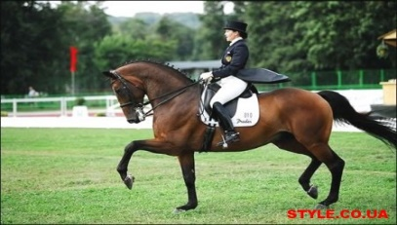 |  | 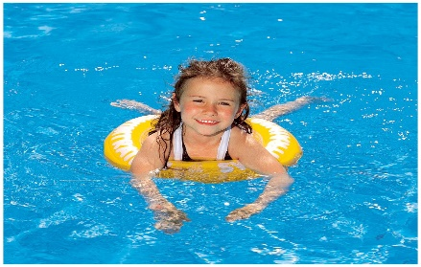
 |  | 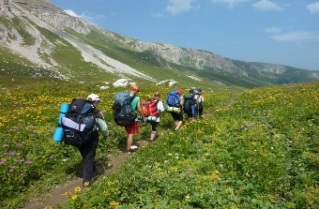
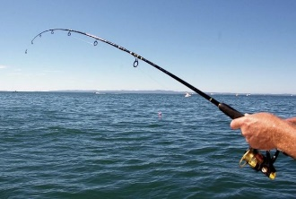 |  | 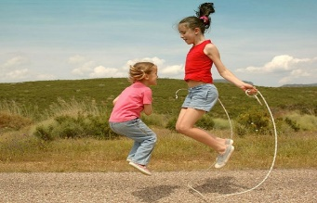

- Find the ends of the sentences.
 | He rides | - toy planes.
 | My friend likes to collect | - a sport programme two days ago.
 | They are having | - a bike after school.
 | His father watched | - a picnic on a bank now.

- Write what they / he / she did yesterday.
Tom visits his granny every Sunday. __________________________________
_______________________________________________________________
Alice listens to music every day. _____________________________________
_______________________________________________________________
They swim in the lake every summer. _________________________________
_______________________________________________________________
My sister always takes photos. ______________________________________
_______________________________________________________________

- Write about your hobby.
___________________________________________________________________________________________________________________________________________________________________________________________________________________________________________________________________________________________________________________________
Name _____________________________________ Form 4 - _________ II variant
Free time
- Match and write.
Watching cartoons, skateboarding, playing the guitar, painting, reading books, picking flowers.
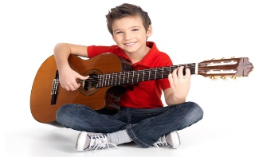 |  | 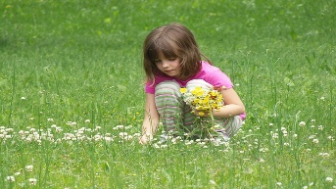
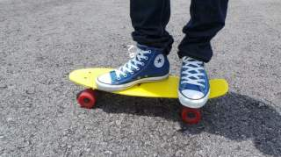 |  | 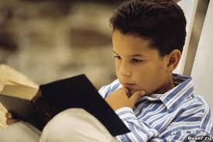
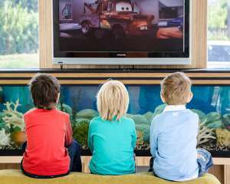 |  | 

- Find the ends of the sentences.
 | Jane likes playing | - hide-and-seek now.
 | Steve played | - badminton yesterday.
 | She rode | - a horse two weeks ago.
 | My mother always makes | - a big cake for me.

- Write what they / he / she did yesterday.
Ann eats sandwiches in the morning. _________________________________
_______________________________________________________________
Natalka always makes things after lessons. ____________________________
_______________________________________________________________
Steve and his friends play football in the afternoon. ______________________
_______________________________________________________________
They visit a café every day. _________________________________________
_______________________________________________________________

- Write about your collection.
___________________________________________________________________________________________________________________________________________________________________________________________________________________________________________________________________________________________________________________________
Name _____________________________________ Form 4 - _________ I variant

The world around us
- Complete the words with the right letters and match them to the pictures.

- a t__ger
- a p__rr__t
- to c__t down tr__es
- a wh__le
- an el__ph__nt
- n__t__re

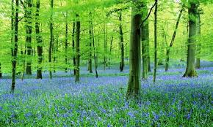 | 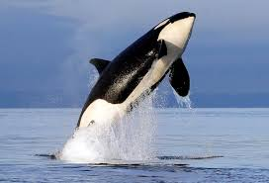 | 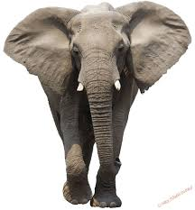
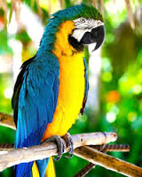 | 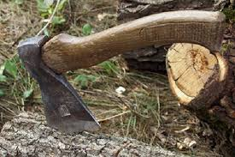 | 1 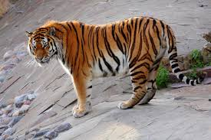
2. Choose a), b) or c) and complete the sentences.
Sharks and dolphins live _______________ .

- in the river.
- in the forest.
- in the ocean.

Foxes and hears live _______________ .

- in the sea.
- in the desert.
- in the forest.

Lions and zebras live _______________ .

- in the savanna.
- in the desert.
- in the jungle.

Pythons and cobras live _______________ .

- in the forest.
- in the ocean.
- in the jungle.

3. Answer the questions.
Which is faster: a lion or a snake? ____________________________________
Which is more dangerous: a cat or a crocodile? _________________________
Which animal is the fastest? ________________________________________
Which animal is the most beautiful? __________________________________
4. Put the words in the correct order to make sentences.
trees | Pupils | spring. | plant | in
_______________________________________________________________
do | We | pollute | water. | not
_______________________________________________________________
likes | My | sister | summer.
_______________________________________________________________
Name _____________________________________ Form 4 - _________ II variant
The world around us
- Complete the words with the right letters and match them to the pictures.

- a cr__co__ile
- n__t__re
- a ch__et__h
- to p__ll__te
- a d__lph__n
- a hi__po

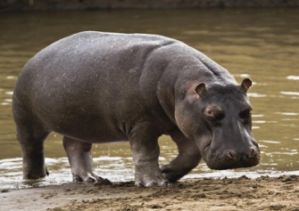 | 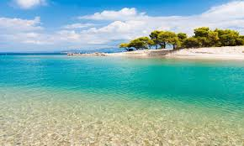 | 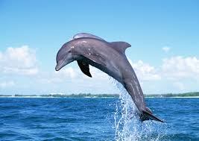
1 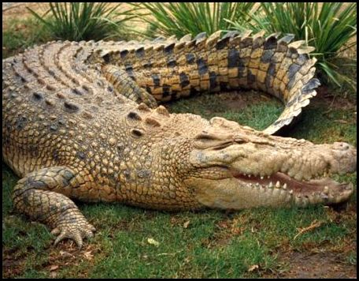 | 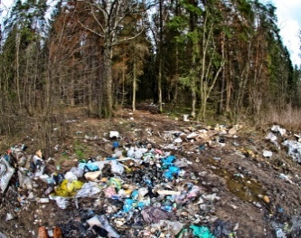 | 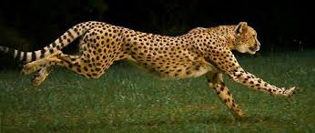

2. Choose a), b) or c) and complete the sentences.
Sharks and whales live _______________ .

- in the river.
- in the ocean.
- in the forest.

Wolves and bears live _______________ .

- in the forest.
- in the desert.
- in the savanna.

Elephants and zebras live _______________ .

- in the jungle.
- in the desert.
- in the savanna.

Pythons and monkeys live _______________ .

- in the ocean.
- in the jungle.
- in the forest.

3. Answer the questions.
Which is slower: a horse or a camel? _________________________________
Which is more dangerous: a cobra or a lion? ___________________________
Which animal is the strongest? ______________________________________
Which animal is the most beautiful? __________________________________
4. Put the words in the correct order to make sentences.
usually | winter. | is | It | in | cold
_______________________________________________________________
always | bird-houses. | We | make
_______________________________________________________________
do not | We | streets. | drop litter | in | the
_______________________________________________________________
Name _____________________________________ Form 4 - _________ I variant
Travelling
- Look at the pictures. Write as in the example.
 | People can travel by plane.______________________
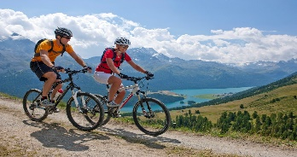 | _____________________________________________
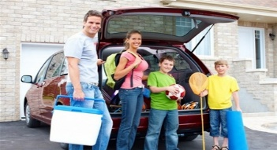 | _____________________________________________
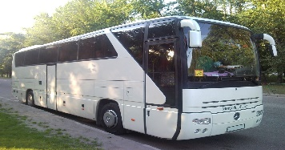 | _____________________________________________

- Complete the sentences.
I like to travel ____________________________________________________
I can have lunch in a ______________________________________________
People keep money in _____________________________________________
My mother buys fruit and vegetables at the _____________________________

- Write the correct item.
Tom can _______________ (to see) Big Ben in London.
Mr. Brown _______________ (to buy) souvenirs yesterday.
__________ you _______________ (to travel) by car?
Why __________ your father _______________ (to go) by taxi?

- Write about your trip to Kyiv.
___________________________________________________________________________________________________________________________________________________________________________________________________________________________________________________________________________________________________________________________

Name _____________________________________ Form 4 - _________ II variant
Travelling
- Look at the pictures. Write as in the example.
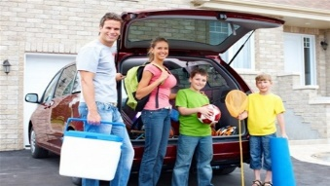 | People can travel by car.________________________
 | _____________________________________________
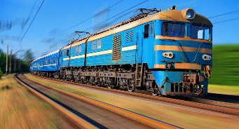 | _____________________________________________
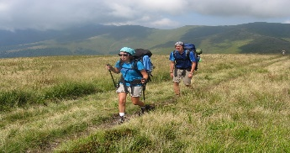 | _____________________________________________

- Complete the sentences.
I go to school ____________________________________________________
I always take books from the ________________________________________
They usually have competition at the __________________________________
We can watch a new cartoon in the ___________________________________

- Write the correct item.
How __________ we _______________ (to get) to the airport?
She _______________ (to take) photos in London last weekend.
They _______________ (to visit) museums in Kyiv yesterday.
He always _______________ (to fly) by plane.

- Write about your trip to London.
___________________________________________________________________________________________________________________________________________________________________________________________________________________________________________________________________________________________________________________________

Name _____________________________________ Form 4 - _________ I variant
Festivals and celebrations
- Write the numbers.
Example: 6 – six, 6-й – sixth.

26 - ________________________
92 - ________________________
38 - ________________________
15 - ________________________
14-й - ________________________
27-й - ________________________
54-й - ________________________
43-й - ________________________

- Look at the pictures and write as in the example:
Tom’s birthday is on the first of January.
 |  | 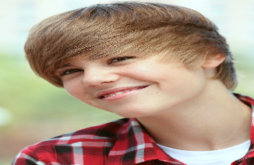 | 
Ann  20th  August | Beth  13th  December | Mike  31th  February | Kate  18th  May
____________________________________________________________________________________________________________________________________________________________________________________________________________________________________________________________

- Complete the sentences with the verbs in the Present Perfect Tense.
Jessica ________________________ ( already / to play) with her friends.
Bill ________________________ (to recite) a poem at Ribbon Festival.
My mum _______________________ (not / to cook) a tasty meal yet.
We _______________________ (to make) cards for our friends.
He _______________________ (just / to go) to the birthday party.
They _______________________ (to decorate) a Christmas tree.

- Use words to complete the questions. Answer the questions.
What | How | When | Who

_______ is your birthday? – _________________________________________
_______ do Ukrainians celebrate in August? – __________________________
_______ celebrates Halloween? – ___________________________________
_______ did you decorate your Christmas tree? – _______________________
Name _____________________________________ Form 4 - _________ II variant
Festivals and celebrations
- Write the numbers.
Example: 6 – six, 6-й – sixth.

37 - ________________________
84 - ________________________
75 - ________________________
12 - ________________________
15-й - ________________________
56-й - ________________________
48-й - ________________________
22-й - ________________________

- Look at the pictures and write as in the example:
Tom’s birthday is on the first of January.
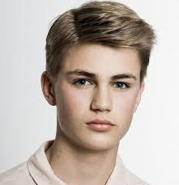 |  | 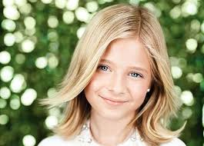 | 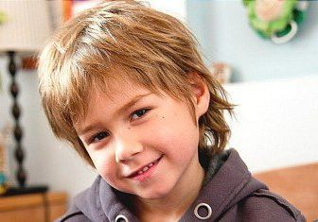
John  14th  March | Jill  8th  October | Meg  19th  June | Max  30th  September
____________________________________________________________________________________________________________________________________________________________________________________________________________________________________________________________

- Complete the sentences with the verbs in the Present Perfect Tense.
Jimmy ________________________ (already /to visit) his granny in the village.
She ________________________ (to sing) a song at the Ribbon Festival.
We ________________________ (to invite) our friends to the birthday party.
He ________________________ (to buy) a nice present for his wife.
Their mum ________________________ (not / to make) a cake yet.

- Use words to complete the questions. Answer the questions.
How | Where | What | When

_______ do you like to celebrate Christmas? – __________________________
_______ did you spend your last holidays? – ___________________________
_______ is your mum’s birthday? – ___________________________________
_______ do Ukrainians bake on Easter? – _____________________________
Name _____________________________________ Form 4 - _________ I variant
Everyday life
- Match words with pictures.
 |  |  | 

Maths Music Computer Studies English
Write what subjects you have on Thursday and Friday.
Thursday | Friday

- Fill in must or mustn’t.
You ____________ do homework every day.
You ____________ wear a school uniform.
You ____________ play computer games at the lessons.
You ____________ help your mother every day.

- Complete the sentences. Use the Present Simple, Present Continuous and Past Simple tenses.
They _______________ (to go) shopping yesterday.
He __________already ___________ (to do) a grammar exercise.
Alice _______________ (to draw) pictures now.
We _______________ (to have) English lessons yesterday.
I _______________ (to come) to school on time last Friday.
The girls _______________ (to sing) a song now.

- Write what you did on Saturday.
___________________________________________________________________________________________________________________________________________________________________________________________________________________________________________________________________________________________________________________________Name _____________________________________ Form 4 - _________ II variant
Everyday life
- Match words with pictures.
 |  |  | 

Reading Art Nature Study Ukrainian
Write what subjects you have on Monday and Tuesday.
Monday | Tuesday

- Fill in must or mustn’t.
You ____________ come to school on time.
You ____________ answer correctly.
You ____________ ride a bike in the corridors.
You ____________ clean your room.

- Complete the sentences. Use the Present Simple, Present Continuous and Past Simple tenses.
He ________ already _____________ (to watch) this film.
Sue ____________ (to eat) sandwiches now.
He ____________ (to buy) a new skateboard yesterday.
They ____________ (to meet) Tom at the airport yet.
He ____________ (to get) a bus five minutes ago.
Look. They ____________ (to play) football.

- Write what you did on Sunday.
___________________________________________________________________________________________________________________________________________________________________________________________________________________________________________________________________________________________________________________________

