**Відкритий урок**

***JOBS AND WORK***

Жанна Прядко, вчитель англійської мови загальноосвітньої спеціалізованої школи I-III ступенів №4 м. Кривий Ріг.

**Objectives:**

* To involve pupils in the process of communication in English using “Jobs and Work” words in their oral speech;
* To practice irregular verbs and Past Simple Tense;
* To develop listening, reading and comprehensive skills;
* To develop skills to work in groups and pairs;
* To motivate cognitive and creative thinking;
* To promote creativity and self-expression;
* To encourage pupils to express their point of view and provide extensive oral practice;
* To bring up respect and interest of children to different professions.

**Equipment:** multimedia complex, work-sheets, posters with quotations about job, pupils’ projects, tables, photos and pictures.

**PROCEDURE**

I. **Introduction.**

*Teacher*: Good morning, my dear friends. Nice to meet you again. I hope you are well and in a perfect mood. Today we are speaking about usual, unusual and famous jobs. The motto of our lesson is:

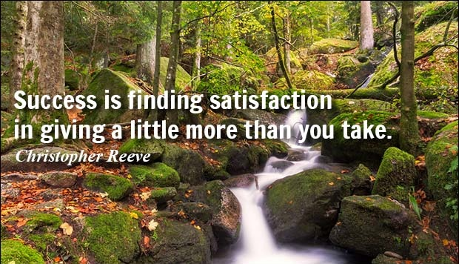

**Warming-up**

*Teacher*: First of all let’s train the sounds:

**[ ʤ ]** – job, jobless, job satisfaction, John’s journey to Japan.

**[ ʃ ]** – profession, occupation, possession, satisfaction.

**[ iə ]** – career, cheer. Can you hear clearly from here?

*Teacher*: So in order to remind the words on the topic, let’s play the game which is called “The chain”. The first pupil says a word which refers to “Jobs and Work”. The second pupil repeats the word and adds his own word. The third one has to repeat two words and add his one. For example: 1 – a doctor; 2 – a doctor, a farmer; 3 – a doctor, a farmer, a fireman.

(Pupils work one by one)

*Teacher*: Well done.

II. **The main part.**

1. **Lexical practice**

*Teacher*: Now, boys and girls, let’s revise the material about jobs and work.

First of all try to give the words of jobs to these definitions:

1. Someone who reports the news for a newspaper, a magazine, a TV show or a radio show.

2. Someone whose job is to build or repair houses.

3. Someone whose job is to look after your teeth.

4. Someone whose job is to clean the rooms in a building.

5. Someone who works in films or in theatre.

6. Someone who paints pictures.

7. Someone whose job is to cut people’s hair.

*Teacher*: Then try to give definitions to the words and pictures which you see on the screen:

a farmer

a shop assistant

a teacher

a cook

a musician

a writer

a computer programmer

1. **Speaking practice**

*Teacher*: And at last answer my questions:

* Do you want to be a singer ?

a vet doctor ?

an artist ?

a journalist ?

an interpreter ?

a businessman ?

a president ?

* What do you want to be?

In your answers use the expressions:

* Sure, I want to be a … .
* I want to be a … like my … (father,…) .
* I want to be a … because … .

**Work in pairs:**

*Teacher*: Decide which is the best job, in your opinion, and which is the worst. Give some reasons. Try to be active and creative.

What’s the best job, in your opinion?

Computer programmer. They earn a lot of money and they don’t have a deal with the general public.

I agree with you. / I don’t agree with you. I think the best job is …

1. **Listening**

*Teacher*: It’s time to relax. Let’s listen to the song which is called “Car Wash”.

On your desks, in front of you, you have work-sheets. Your task is to listen to the song carefully and, working in pairs, complete the song with the words in the box.

cars hard home star

pay rich star

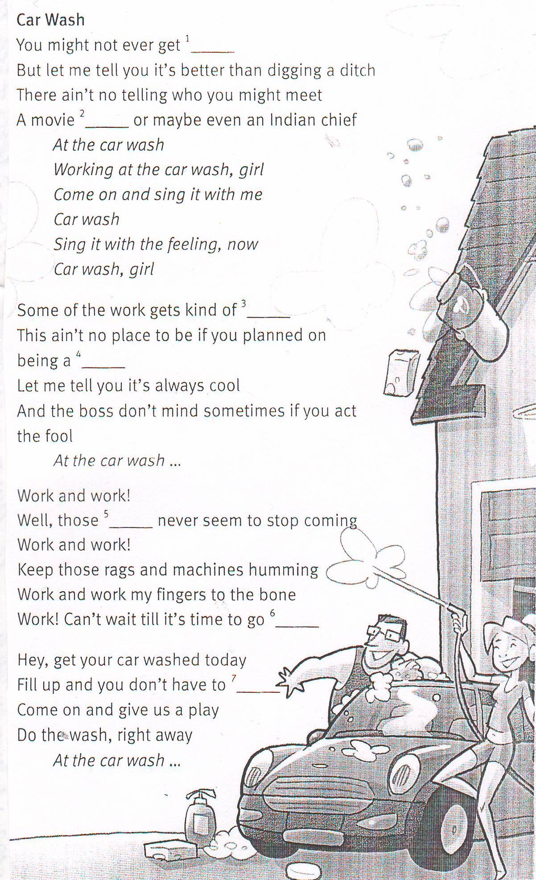

*Teacher*: Let’s check the answer:

Key:

1 - rich

2 - star

3 - hard

4 - star

5 - cars

6 - home

7 – pay

*Teacher*: Yes, that’s right!

1. **Projects presentation**

*Teacher*: The motto of this part of our lesson is “***Find joy in everything you choose to do***” (poster).

*Teacher*: As far as I know, you have prepared creative group projects about jobs you like. It was your homework.

The first group made a project about their parents’ jobs and professions.

You are welcome!

(The first group presents the project)

*Teacher*: The second creative group made the project about the jobs for teenagers. It seems to me it’s interesting, isn’t it? Let’s listen to them.

(The second group presents their project)

*Teacher*: It’s a great project! Thank you. So you see that your projects are perfect. Do you like them?

*Pupils:* Yes of course!

*Teacher*: Me too. You worked hard and creative and you got good results. By the way, a great person Jackson Brown told: “***Enjoy the satisfaction that comes from doing little sings well***”. You can see them on the screen. How do you translate and understand them?

*Pupils:* […]

*Teacher*: And what about the motto “***Find joy in everything you choose to do***”?

*Pupils:* […]

*Teacher*: You are right. I agree with you.

1. **Relaxation**

*Teacher*: I see that you are a bit tired. Let’s do some physical exercises in order to relax and you’ll be fresh in a minute.

(Listening to music pupils do some exercises for relaxation)

1. **Reading**

*Teacher*: Perfect! We spoke and wrote and listened to a song. I think it’s time to read.

**Pre-reading activity**

*Teacher*: Before reading look at the blackboard. You can see the table of words and expressions of time on it. We are going to learn them. Try to read and translate words and expressions one by one. If you can’t, I’ll help you.

***Words and expressions of time:***

* After that
* At the age of 16
* In 1997
* Next
* The following year
* Then
* Two years later
* When he was 11

(Pupils read and translate the expressions)

*Teacher*: Open your books on page101. Now we are going to read the biography of a great, famous Australian actor Heath Ledger.

(Pupils read the paragraphs one by one)

**Post-reading activity**

*Teacher*: Try to put the paragraphs in order – exercise 2, and do the exercise 3.

Work in pairs, please.

Key:

Exercise 2 Exercise 3

1. D 1 - B

2. A 2 - A

3. C 3 - D

4. B 4 - C

*Teacher*: Right you are. So, I see that you can understand the order of writing a biography, can’t you?

*Pupils*: Yes, we can.

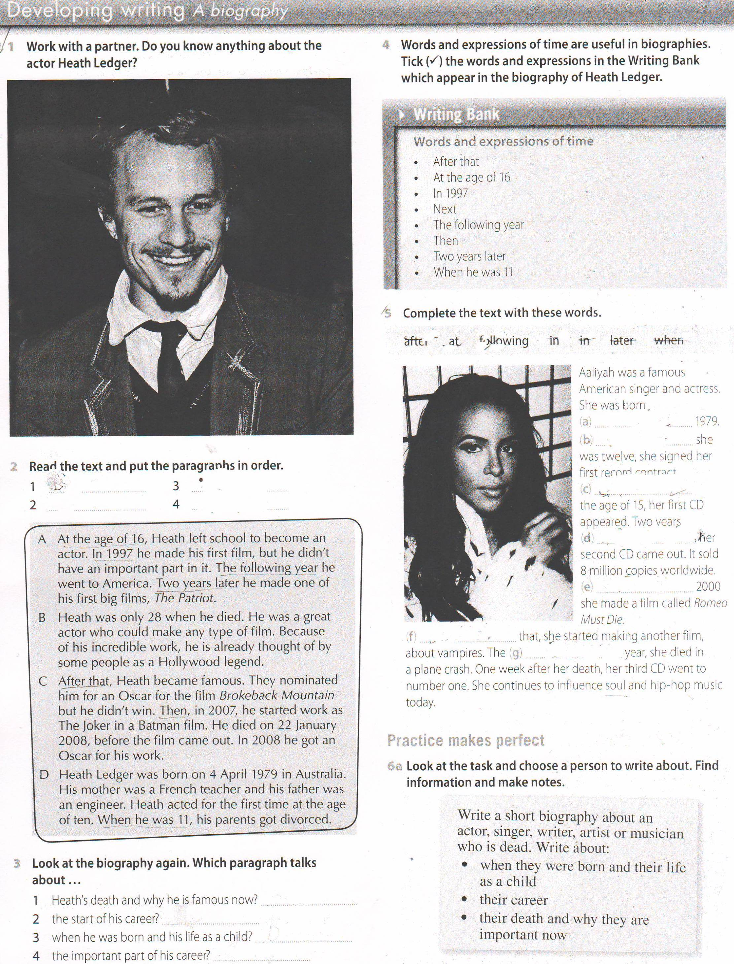

1. **Practice in using the expressions of time**

*Teacher*: It’s known that ***practice makes perfect***.

So try to do the exercise 5 and complete the text with time expressions. ***You are preparing to write a short biography at home.***

(Pupils do the exercise)

Your time is up!

Are you ready to answer? Let’s check your work.

(Pupils read the expressions they’ve put in)

*Teacher*: Fine, there are no mistakes. It’s OK.

1. **Writing**

*Teacher*: But there is one more task. It’s a grammar task. Which grammar tense did we use in the Biography of an Australian actor?

*Pupils*:We used Past Simple Tense.

*Teacher*: So your task is to look through the text again. Pupils of group A (brighter pupils) will underline irregular verbs in the Past Simple and pupils of group B (slower pupils) will underline Past Simple of regular verbs.

(Pupils work at the text)

*Teacher*: Are you ready?

*Pupils*: Yes, we are.

(Read and translate the verbs. Group B is the first, then group A)

*Teacher*: Good job!

III. **The end of the lesson.**

***Summarizing and estimating the work of the pupils***

*Teacher*: Dear friends, our time is up! Unfortunately we have to finish our lesson. Did you like it?

*Pupil 1*: Yes, we did.

*Teacher*: Why did you like it? Which new information have you got from the lesson? Will it be useful in your everyday life?

*Pupil 2*: As for me I like the lesson because we spoke much and made up dialogs about jobs and work.

*Pupil 3*: We prepared creative projects and learned many interesting things about our parents and teenagers and now we know that all the jobs are useful and interesting.

*Pupil 4*: I agree with you. But also we read the biography of a famous Australian actor and now we know how to organize the parts of the biography.

*Pupil 5*: And we listened to the song about car wash. I liked the song.

*Pupil 6*: Also we learned and discussed some quotations about jobs. I like them and I think they will be useful in our life.

*Teacher*: How do you fill?

*Pupils*: We fill happy, excited, energetic, emotional, brave and proud.

*Teacher*: As for me, I’m satisfied of your work today. You were active and creative, moreover you were full of bright ideas! I enjoyed your projects and discussions.

Your marks are…

***Your homework*** is to write a biography of a famous person using the exercise 6a on page 101 and do the exercises in your WB on page71.

See you tomorrow!