Level: A2/B1

**Wednesday**

Season 1, Episode 1

Scene

*Saying Good Bye to Mother*

**Materials**: a laptop/ a tap/ a mobile phone, Internet access

**Useful links:**

<https://www.dailymotion.com/video/x8fs5fz>

<https://quizlet.com/788653699/wednesday-season-1-part-1-flash-cards/?new>

<https://learningapps.org/watch?v=ph9zwvif323>

<https://www.online-stopwatch.com/random-name-pickers/name-picker-wheel/?r=dice>

**I can understand a scene of saying goodbye to Wednesday`s mother**

Lead-in

* Answer the questions:

*Have you ever been new to school? How did you feel when saying goodbye to your parents? How everything went later?*

* Look at picture of Wednesday, and answer the questions:

*Do you know who is she? What is the episode about?*

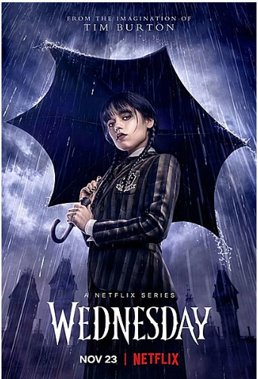

Activity 1

* Follow the link below and watch the scene of saying goodbye to Wednesday mother.

<https://www.dailymotion.com/video/x8fs5fz>

* Work in pairs. Answer the questions:
* *Does Wednesday feel the same as you did as a freshman?*

*What is different?*

Activity 2

* Follow the link, press the button *Flashcards* listen, practise the pronunciation and read the vocabulary. Press the following buttons *Lern – Test - Match* one by one and do the activities

<https://quizlet.com/788653699/wednesday-season-1-part-1-flash-cards/?new>

* Follow the link sent by your teacher into your chat and participate in competition.

Activity 3

* Follow the link below and complete the sentences.

<https://learningapps.org/watch?v=ph9zwvif323>

Activity 4

* Follow the link sent by your teacher into your chat. Work in groups and answer the questions.