План-конспект уроку
19.12.12
.

План-конспект уроку № 72 в 11-Б класі
Тема: Work
Підтема: Choosing a career
Цілі:
Практична:
- Активізувати вживання в мові учнів лексику по темі "Вибір професії" через різні види діяльності: читання, говоріння, аудіювання, письмо;
- Розвивати навики монологічного усного мовлення, вдосконалювати лексичні навики і розширювати лексичний запас учнів,
- Розвивати навики уміння спілкуватися англійською мовою.
Освітня: Розширювати лінгвокраїнознавчий та філологічний інтерес учнів.
Розвиваюча:
- Розвивати мовленнєві, інтелектуальні та пізнавальні здібності, зорову й довго- строкову пам'ять, увагу, уяву.
- Розвивати в учнів уміння аналізувати свої особистісні якості, стосовно даної професії;
- Сприяти розвитку вміння визначати професійні якості особистості.
Виховна: Сприяти вихованню розуміння в учнів важливості і необхідності реалізації своїх умінь і здібностей через обрану професію.

Обладнання уроку: Підручник з англійської мови для 11кл. Exam Accelerator, комп'ютер, мультимедійний проектор, презентація уроку, роздатковий матеріал (картки для роботи в групах, тести, календарики) постер.

Схематичний план уроку
I. Початок уроку. Організація класу.
1. Вітання (1min)
Good morning! Glad to see you! Did everyone get a present from St. Nicolas? I wonder whether all of you were obedient. Did anyone get a rod? Good for you!
I hope you all are satisfied with your presents. I believe your elated mood will create a positive atmosphere at our today’s lesson. Let’s start.

2. Введення в іншомовну атмосферу: Мовленнєва зарядка (3 min)
Could you please remind me the topic of our recent lessons?

Paraphrase the quotation and say whether you agree with it:

“The only place where success comes before work is a dictionary”
Vidal Sassoon (British hair stylist)

Before we start our lesson let us quickly revise active vocabulary related to our topic.
Lexical drill:
- Бухгалтер – accountant
- Біржовий маклер – stockbroker
- Радник, психолог – counselor
- Сміттяр – dustman (refuse-collector)
- Косметолог – beautician
- Стюардеса – flight-attendant
- Страховий агент – insurance agent
- Тренер – coach
- Будівельник – construction worker
- Роботодавець/робітник – employer/employee
- Покликання – true vocation
- Прибуток – income (profit)
- Зарплата – wages (salary)
- Декретна відпустка – maternity/paternity leave
- Чайові – tips
- Додаткові пільги – fringe benefits/perks
- Підпрацьовувати – to do odd jobs
- Позаштатний працівник – free-lance worker
- Перспектива кар’єрного росту – prospect of promotion
- Гнучкий робочий графік – flexible working hours (flexi-time)
- Начальство – superior(s) (in a superior position)
- Підлеглі – subordinates (in a junior position)
- Попасти під скорочення – to become redundant
- Безперспективна робота – dead-end job
- Прибуткова робота – lucrative job
- Стабільна робота – secure job
- Найняти – to hire
- Звільнити – to dismiss (to lay sb off, to sack, to give sb the sack, to give sb the fire)
- Звільнитися – quit/resign
- Одержувати субсидію – to be on the dole

Ex. 3, p.89
Choose the best answer
  - A man who buys and sells shares is called a…
- barrister b. stockbroker c. undertaker
  - Regular monthly pay for skilled work is called …
- a pension b. wages c. a salary
  - A satisfied customer leaves a ____________for the waiter.
a. bonus b. tip c. profit
  - Big companies are constantly on the lookout for cheap
- labour b. work c. employment

3. Перевірка домашнього завдання (6 min)
Think of a job and talk about it without telling anyone what the job is. The class have to guess which job you have chosen. Talk about: what you do – qualities – salary – reasons you like dislike it.

Повідомлення теми та цілей уроку (2 min)
Well, let’s start our lesson. First, I would like you to look at the screen, read today’s epigraph and tell me what we’re going to talk about at the lesson.

Slide 1.


The topic of today’s lesson is “Choosing a career”. Since you are the school-leaver this theme/problem is very much topical for you. Because in less than 4 months you will yourself face it. There are a lot of professions in the world, so it is rather difficult to choose the right one. We must take into consideration many factors. We must consider our tastes and abilities. We must satisfy our own requirements and the requirements of our society. That’s why during this lesson we will do our best not only to improve our communicative, writing, reading and listening skills through the usage of active vocabulary but we will try to achieve our primary aim: to help you make a career choice.

II. Основна частина уроку
1. Speaking (5 min)
1. What did you dream to be in your childhood and why? Have you changed your mind now?
2. Will you follow in the footsteps of your parents?
3. What profession would you never choose?
4. What jobs are in demand today?
5. Would you prefer to work with your hands or with your brain?

Slide 4.
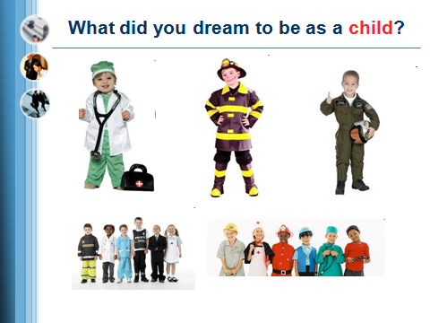
Comment on the statement:
Slide 3
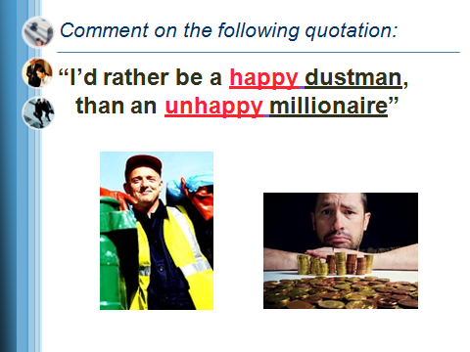
What are the most important things about the job? Rank them (from most important to least important). (3 min) You will work in groups of three. Probably sometimes your ideas will differ from those of your group-mates but you have to reach a compromise.
Pair-work

Slide 6.
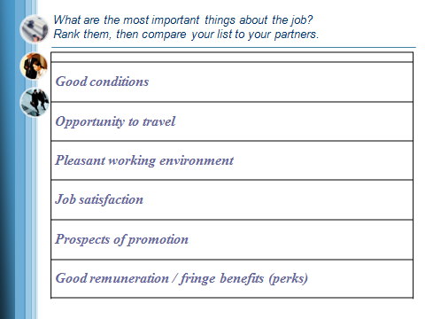

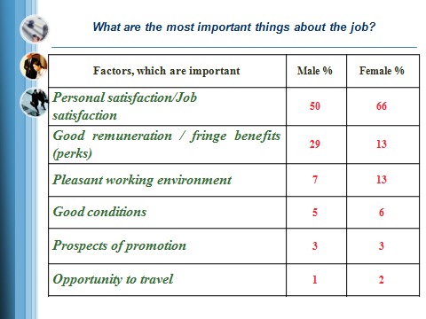

2. Writing
Group work (3 min)
In groups think over and name the professions which are:

Slide 8.
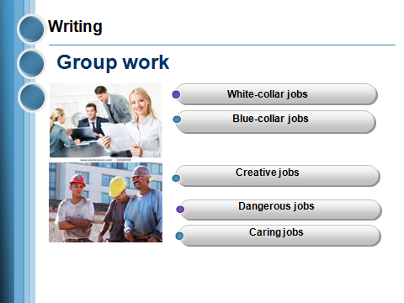

Group work (4min)
The task: You should advise your classmate to make the right choice. Сonsider the personal qualities of your classmates and the traits of character. Discuss the task in groups.

Slide 9.
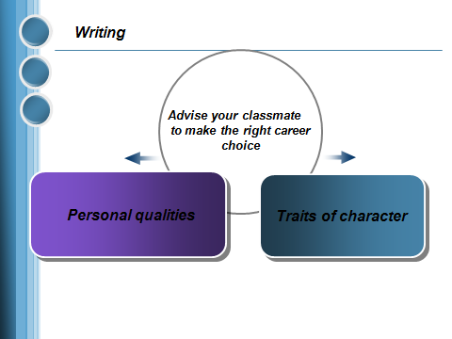

27 хв

RELAXATION Listening to “The Career Song”. – 3 min

Slide 10.
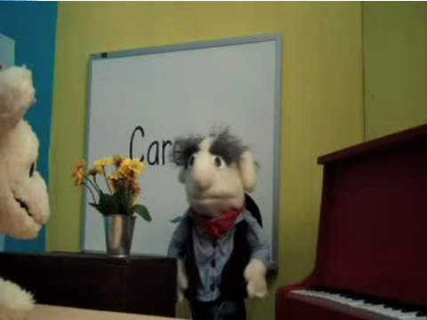

2. Reading (5 min)
Ex. 2, p.87 Read the text. In some of the lines there is a ward which should not be there. Write the extra words in the space after each line. Tick the correct line.

Slide 11
. 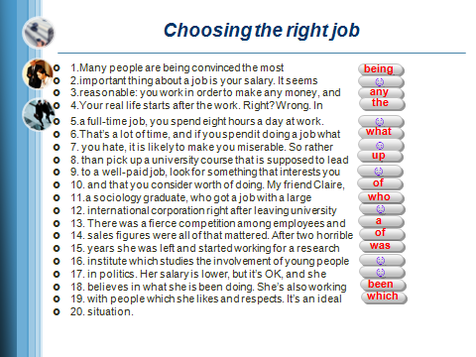

4. Listening (5 min)
Slide12.

SCRIPT
How to choose the right career?

How to choose the right career? With some effort, perseverance and guidance you will be able to choose the right career for you. You will need reflection, research and belief in yourself.
STEP 1.
List your passions and interests. Do you like working with your hands or sitting at a desk? Working with numbers or managing money. Teaching or helping people. Selling or creating things.
STEP 2.
Identify your strengths, skills and talents. Things that come easily, that you enjoy doing. Don’t let lack of skills limit your choices. You can always increase your knowledge and develop new skills.
STEP 3.
List your personal preferences and needs. What is the lowest income that you will accept? Are you going to commune or relocate. Can you go back to school for additional training?
STEP 4. Get professional advice by taking career assessment tests and tests that evaluate your personality and temperament. Some career-assessment tests are free, others are available from a career counselor.
STEP 5.
Research the job market to learn about careers that match your interest and personality. Check the US Department of Labour’s Occupational Outlook Handbook and Career Guide of Industries found online or at the library.
STEP 6.
Prepare to begin a new chapter in your life as you pursue a career that will make you happy and bring you satisfaction.

Did you know Vincent Van Gogh was a school master, a student priest missionary and an art dealer before he became a painter?

Put the steps in the correct order:.
Slide15.
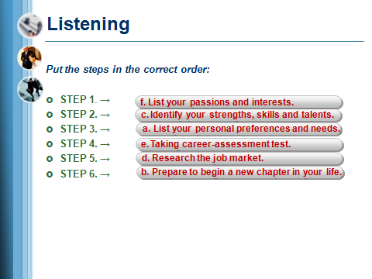
Do you know what type of job suits your personality type? Answer the questions and see what our career specialist says about you! You must put a cross in the box marked Yes or No. (3 min)
Slide 16.
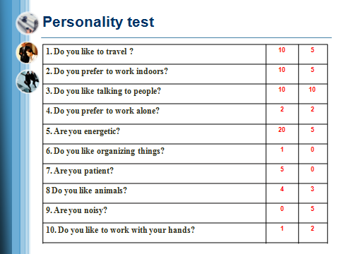

Slide 17.
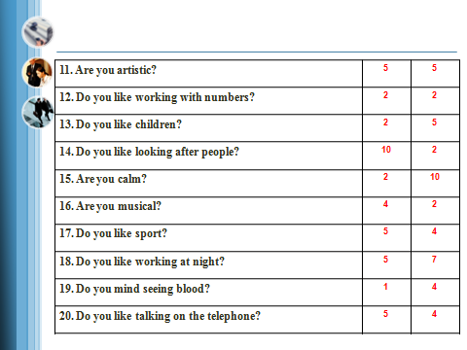

Check your answers and add up your score.
Slide 18.
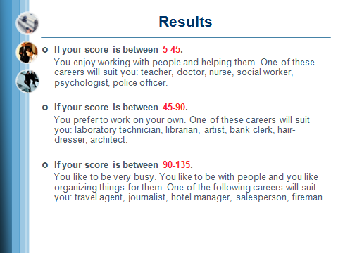

III. Заключна частина уроку.
- Підведення підсумків уроку – Summarizing (2min )
Кожен пише на дошці, ким він все ж вирішив стати
T. Thank you very much for your work at our lesson today. I’d like to finish it with English proverb «Success is a ladder that cannot be climbed with your hands in your packets» Do your best, act, create, don’t hesitate, don’t be afraid and you’ll have everything you want.
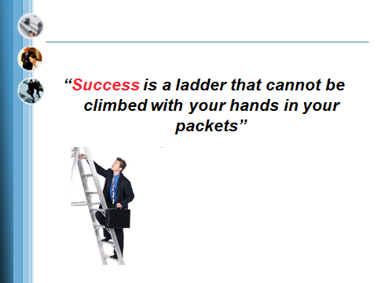

I am sure it doesn’t matter what job you do, it is important how you do it.
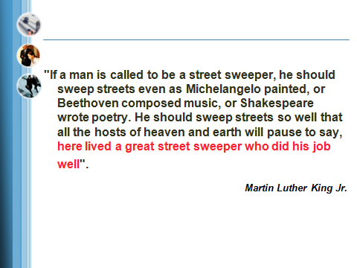

I wish you good luck and I wish you to make the right career choice!

- Домашнє завдання – пояснити виконання вправ (1 min)
Your home task for the next lesson is to write an essay “My future profession”.

- Оцінка діяльності учнів

