Test  *2__ grade*

# Pick the correct variant. Оберіть правильний варіант

1. I go to bed night.
   1. by **B**.at **C**.on **D**.in
2. My cousin plays basketball Wednesday and Friday.
   1. by **B**.at **C**.on **D**.in 3)We play tennis the weekend.

**A**.at **B**.by **C**.on **D**.in

1. Jim goes swimming Tuesday.
   1. on **B**.by **C**.at **D**.in
2. Bob goes to work the evening.
   1. at **B**.by **C**.on **D**.in 6)Anny goes to school boat.

**A**.by **B**.at **C**.on **D**.in

# Pick the correct variant. Оберіть правильний варіант

1. Rabbits jump. 2. I roller skate.

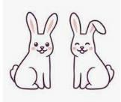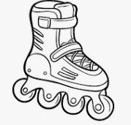

* 1. can **A**.can
  2. can't **B**.can't

1. She play video games. 4.My brother climb a tree.
   1. can **A**.can

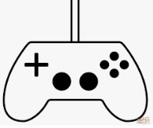

* 1. can't **B**.can't

# 3.Look at the pictures and pick the correct variant.

**Подивіться на малюнки та оберіть правильний варіант**



1. They _tomatoes.

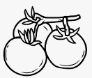

A.like B.likes C.don't like D.doesn't like

1. I pasta.



A.like B.likes C.don't like D.doesn't like

1. Bill peas.

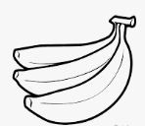

A.like B.likes C.don't like D.doesn't like

1. I bananas.

A. like B.likes C.doesn't like D.don't like

# Pick the correct variant. Оберіть правильний варіант

1. I am a pop star. I to work at the weekend.
   1. goes **B**.go
2. Mia is a nurse. She to work on Monday.
   1. goes **B**.go
3. They are dancers. They to work on Tuesday.
   1. go **B**. goes
4. Kim is a artist. He to work on Sunday.
   1. goes **B**.go

# Look and match. Подивіться та з"єднайте

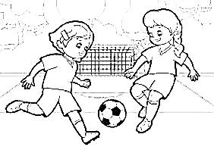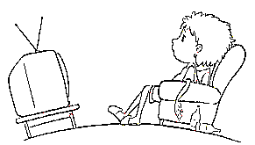

## She doesn't listen to music. He watches TV.

My cousin doesn't play tennis. We play football.

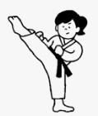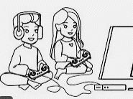

They don't play video games.

She does karate.